Supplementary Information for
Study on Adsorption Characteristics and Sensing Performance of Zr-MOF-808@GO for SF₆ Discharge Decomposition Gas

Tianxiang Lei^{1,*}, Ying Xu¹, Zhiyuan Hao¹, Tierui Zou¹, Zijian Gao¹, Ling Wang¹, Yuqi Zhao¹
1 State Grid Economic And Technological Research Institute Co,.LTD, CHINA
* Correspondence: narroson@126.com

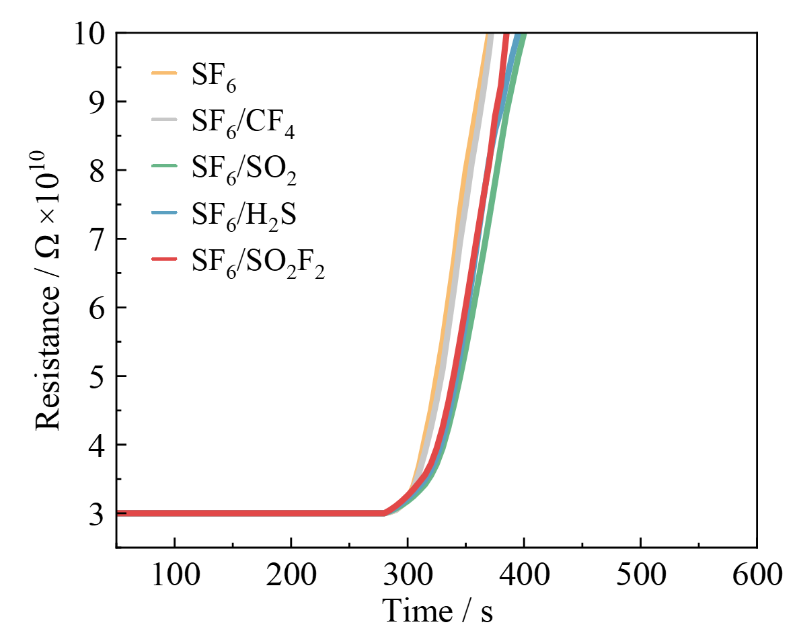
Figure S1. Gas sensing response of intrinsic Zr-MOF-808.

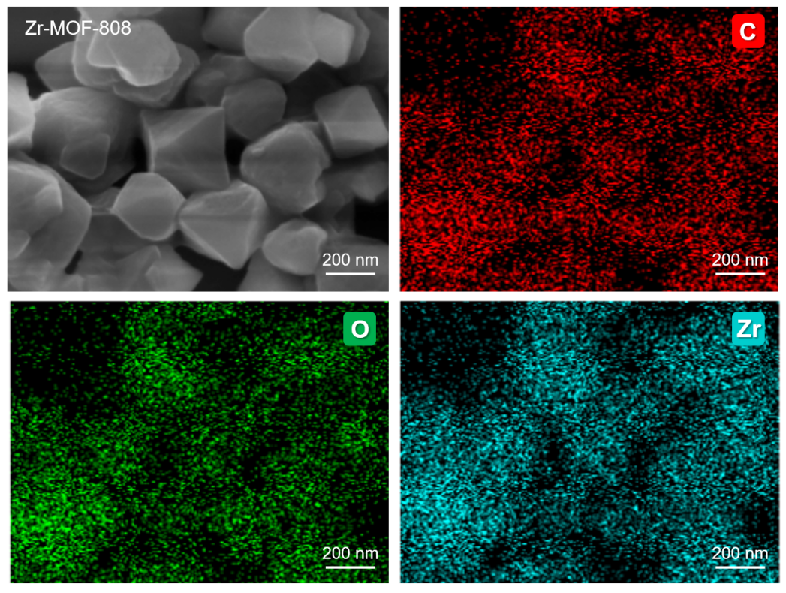
Figure S2. SEM image and corresponding elemental mapping of Zr-MOF-808.

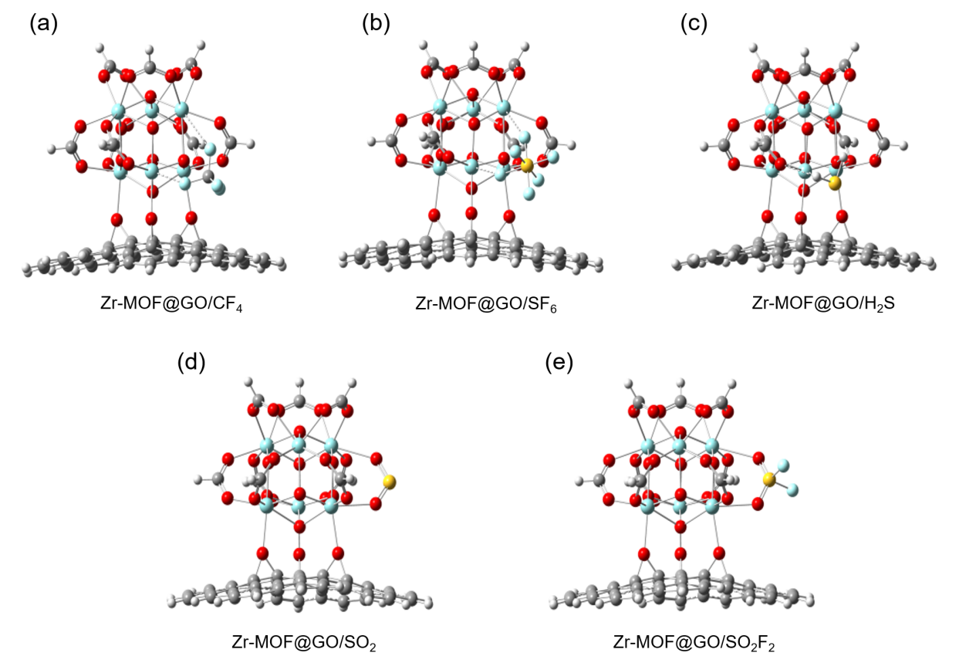
Figure S3. The composite molecular models of Zr-MOF@GO-808 after adsorbing various gases.

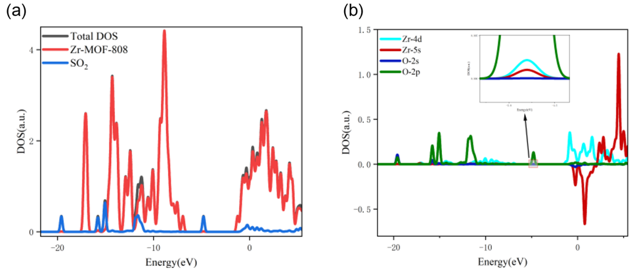
Figure S4. Density of states of Zr-MOF-808 and SO₂.

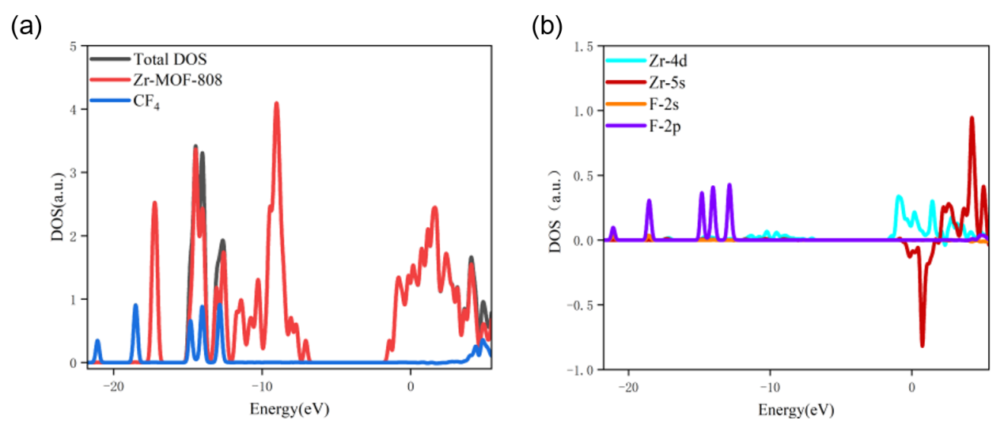
Figure S5. Density of states of Zr-MOF-808 and CF₄.

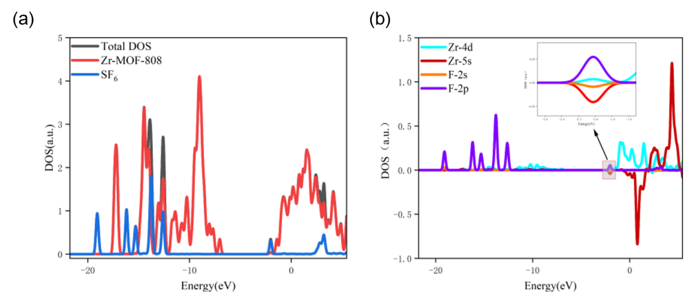
Figure S6. Density of states of Zr-MOF-808 and SF₆.

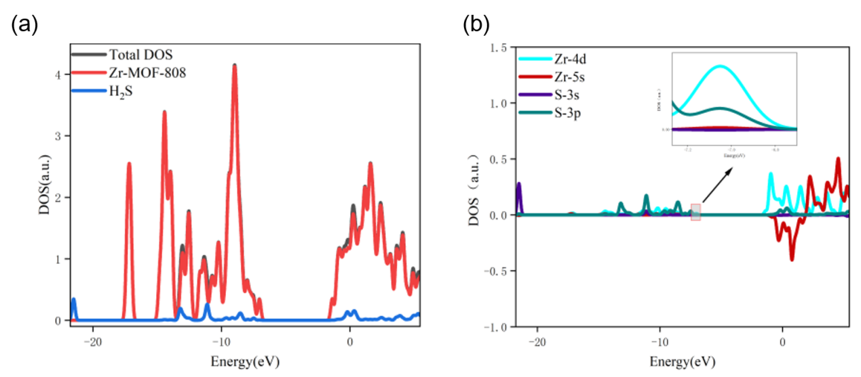
Figure S7. Density of states of Zr-MOF-808 and H₂S.
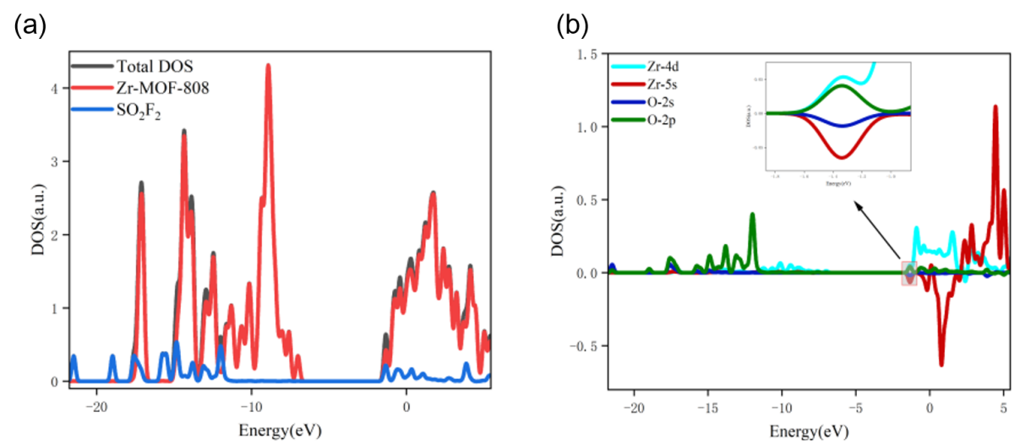
Figure S8. Density of states of Zr-MOF-808 and SO₂F₂.

