Supporting information
Study on the synergistic effect of TPF phenolic curing agent and OMMT on the cured multifunctional epoxy grafted by SAP
Zhuhuan Chen Shijie Zhang Ruobing Yu∗

ª School of Materials Science and Engineering, East China University of Science and Technology, Meilong Road 130#, Xuhui District, Shanghai 200237, China

* Email address: rbyu@ecust.edu.cn

Content
Table S1. Formulation for preparation of TASx and TAS10My
Figure S1. SEM image of impact fracture surface of the cured (a) TAS10M5, (b) TAS10M10 and (c) TAS10M15
Figure S2. Spline and solution changes of composite materials soaked in 98% H₂SO₄ and 25% NaOH for 7 days

Table S1 Formulation for preparation of TASx and TAS10My
Systems | SAP/g | AFG-90H/g | TPF/g | 2,4-EMI/g | OMMT/g
TAS0 | 0 | 100 | 27.2 | 0.5 | /
TAS5 | 5 | 95 | 25.8 | 0.5 | /
TAS10 | 10 | 90 | 24.5 | 0.5 | /
TAS15 | 15 | 85 | 23.1 | 0.5 | /
TAS20 | 20 | 80 | 21.7 | 0.5 | /
TAS10M5 | 10 | 90 | 24.5 | 0.5 | 5
TAS10M10 | 10 | 90 | 24.5 | 0.5 | 10
TAS10M15 | 10 | 90 | 24.5 | 0.5 | 15

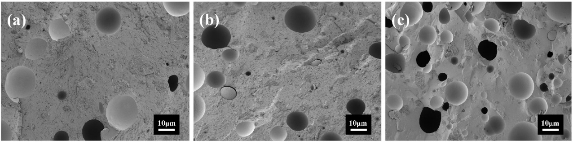
Figure S1. SEM image of impact fracture surface of the cured (a) TAS10M5, (b) TAS10M10 and (c) TAS10M15

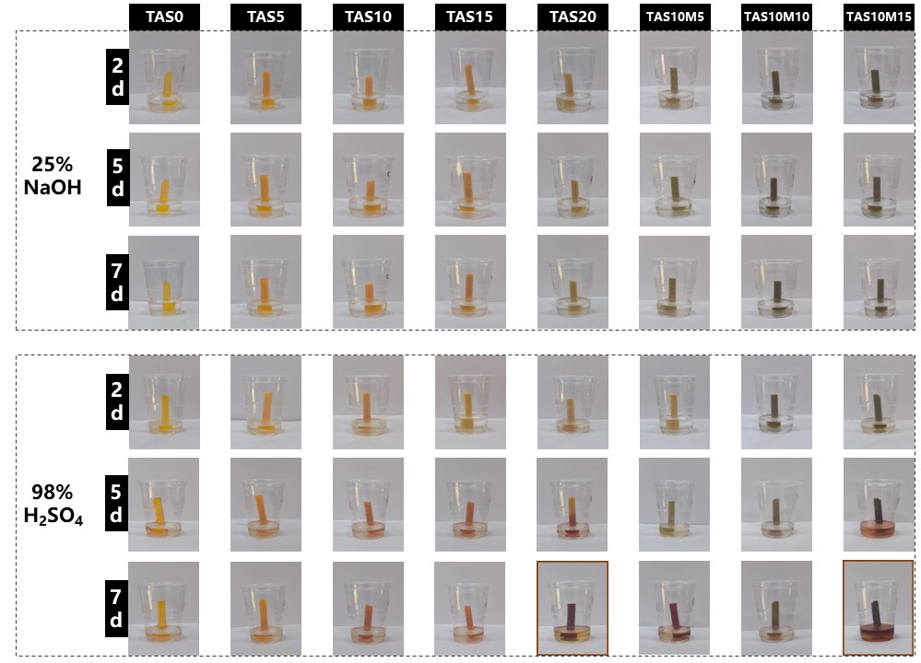
Figure S2. Spline and solution changes of composite materials soaked in 98% H₂SO₄ and 25% NaOH for 7 days

