Supporting Information

Scalable Synthesis of Iron Oxide–Based Composite Films as Freestanding Negative Electrodes with Ultra-High Areal Capacitances for High-Performance Asymmetric Supercapacitors
Jincy Parayangattil Jyothibasuª, Ruei-Hong Wangª, Kenneth Ong^{b}, Juping Hillary Lin Ong^{b}, and Rong-Ho Lee^{*a}

ª Department of Chemical Engineering, National Chung Hsing University, Taichung 402, Taiwan
^{b} WALT Taiwan Co., Ltd., Changhua County 51244, Taiwan.

* To whom all correspondence should be addressed.
Tel.: 886-4-22854308; Fax: 886-4-22854734
E-mail: rhl@nchu.edu.tw

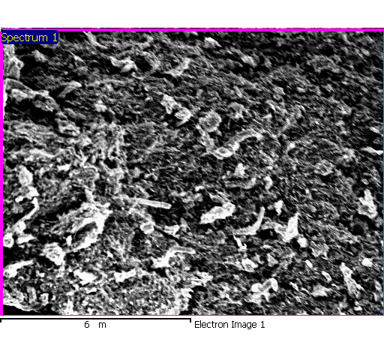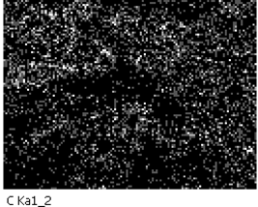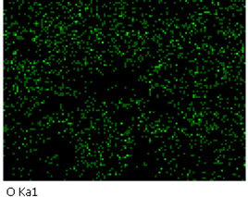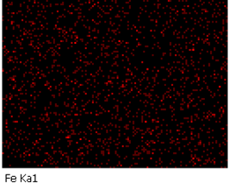
(a)
C
O
Fe
(b)
(c)
(d)

Fig. S1 (a) Low-magnification SEM image of the CCF-a composite and (b–d) corresponding EDX mapping patterns for (b) C, (c) O, and (d) Fe elements.

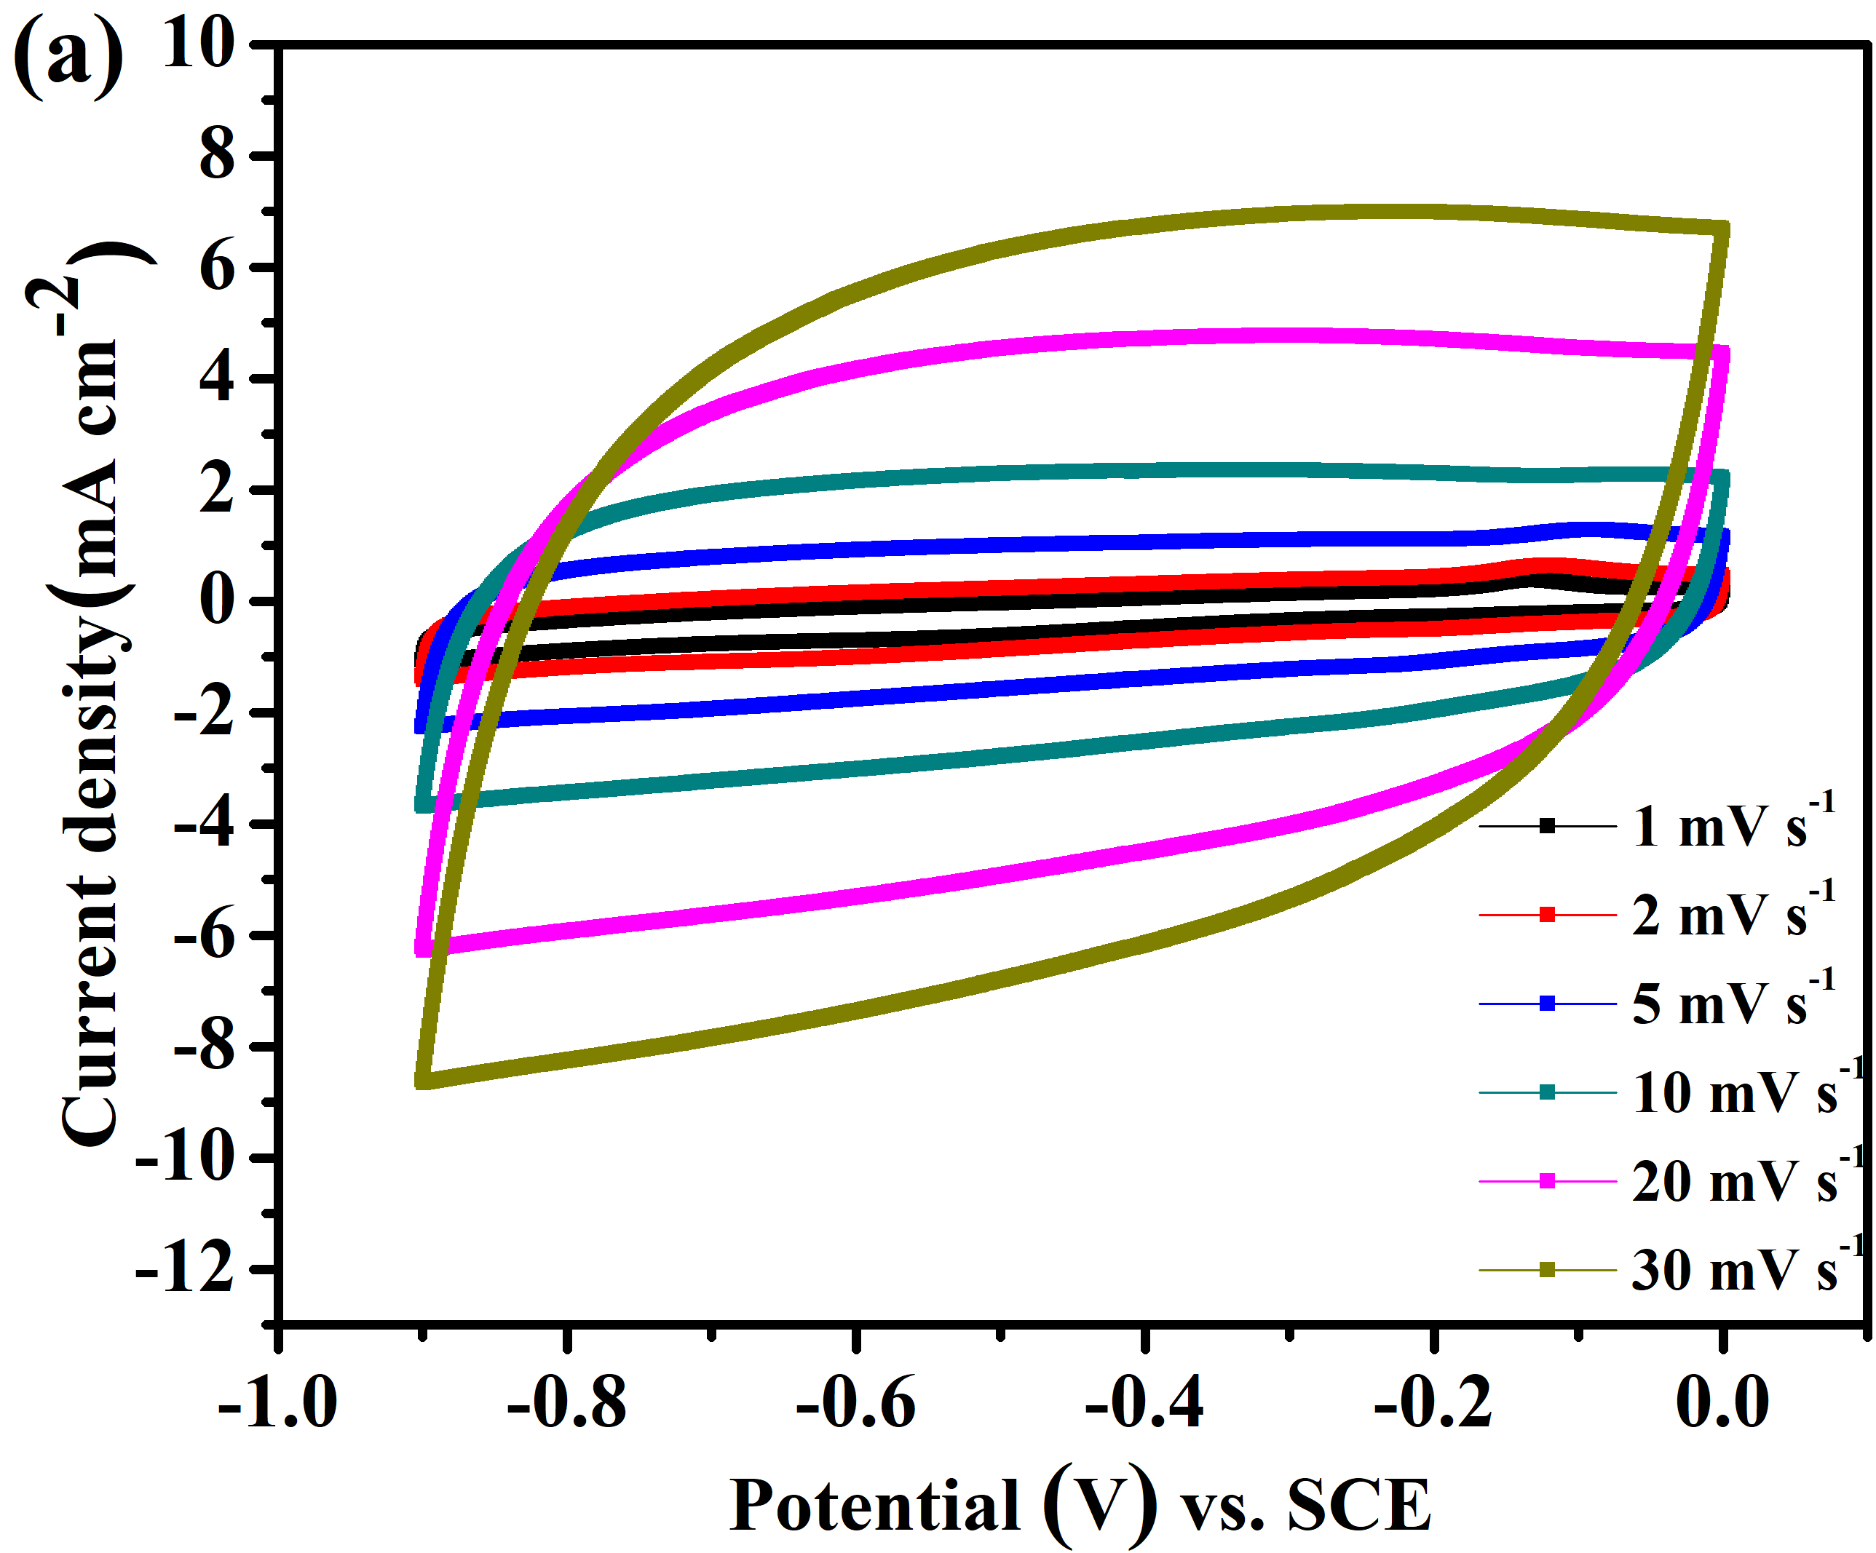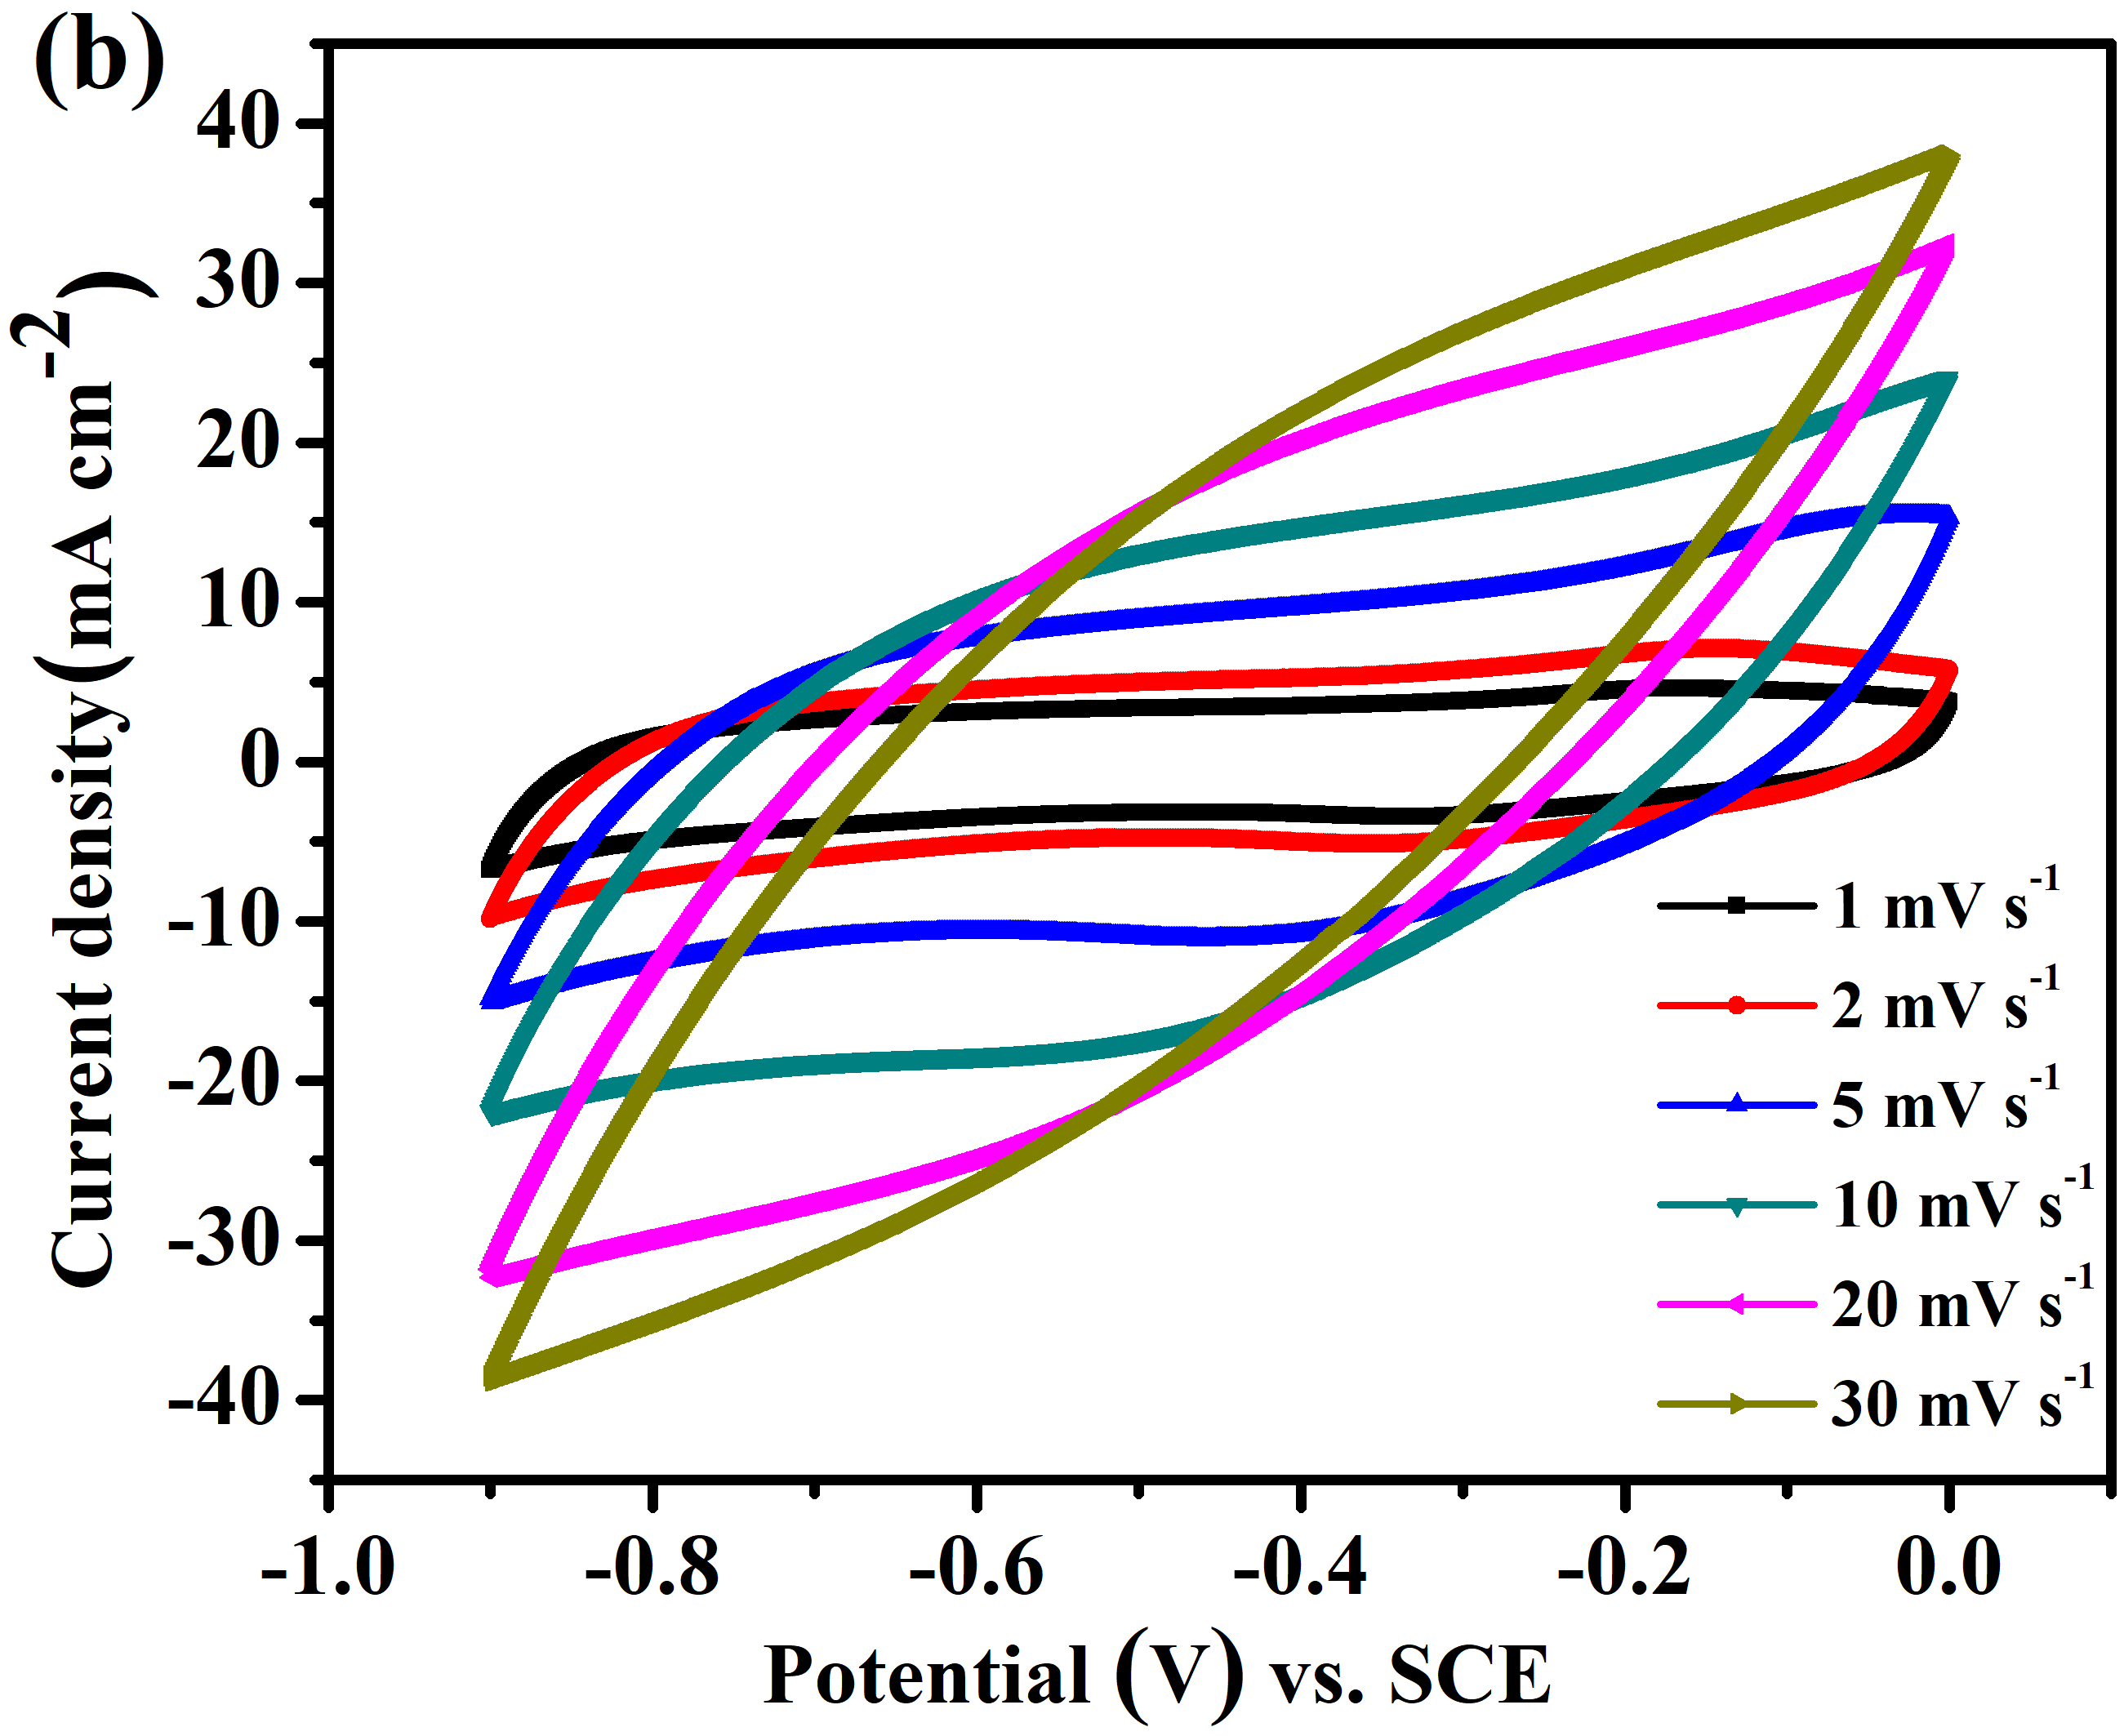
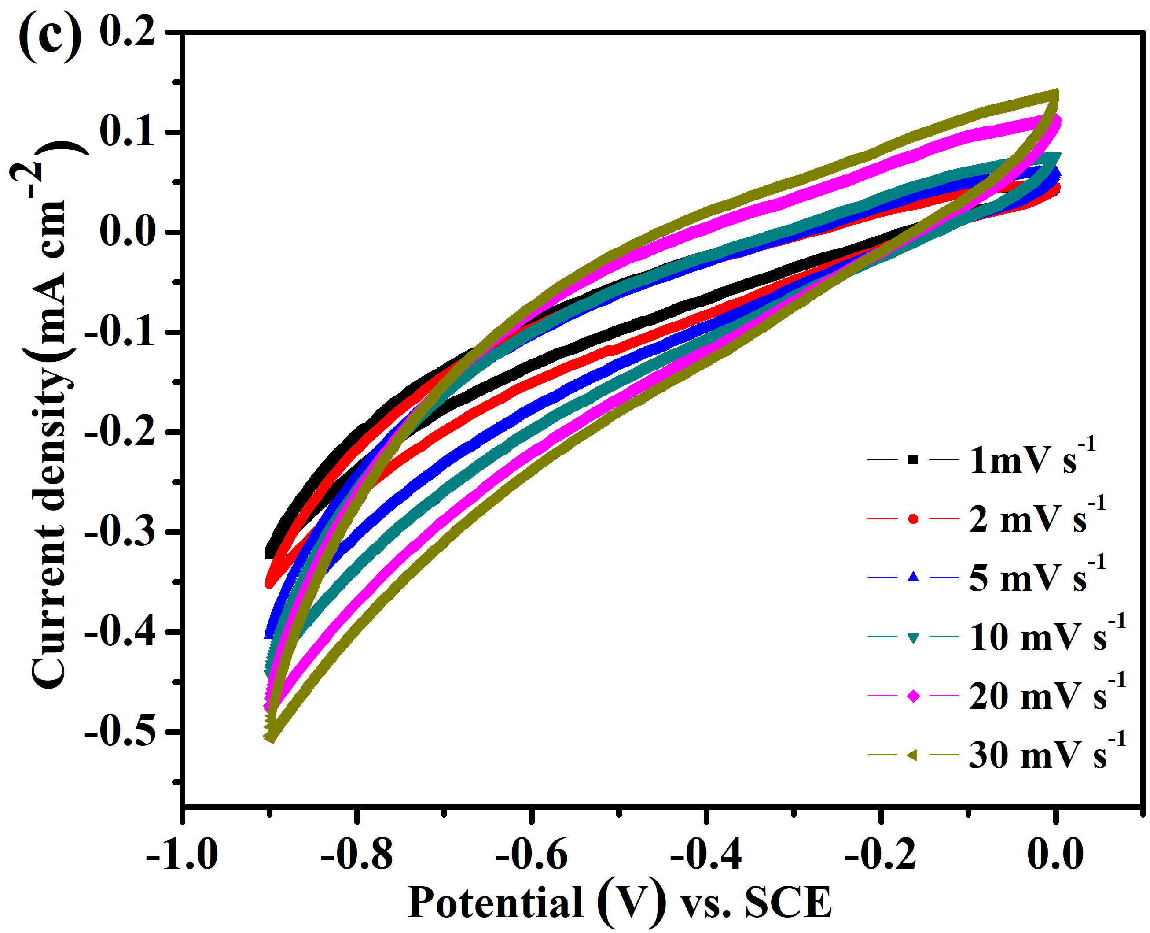
Fig. S2 CV curves, recorded at scan rates from 1 to 30 mV s^{–1}, of the (a) CC, (b) CCF-b, and (c) CF freestanding electrodes.

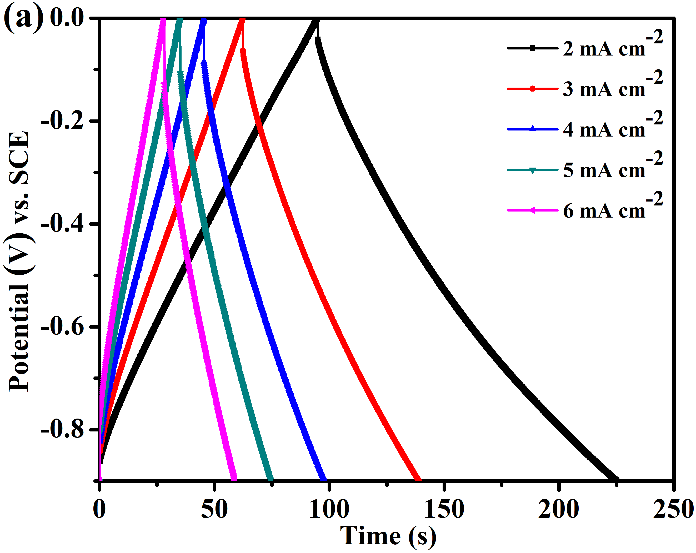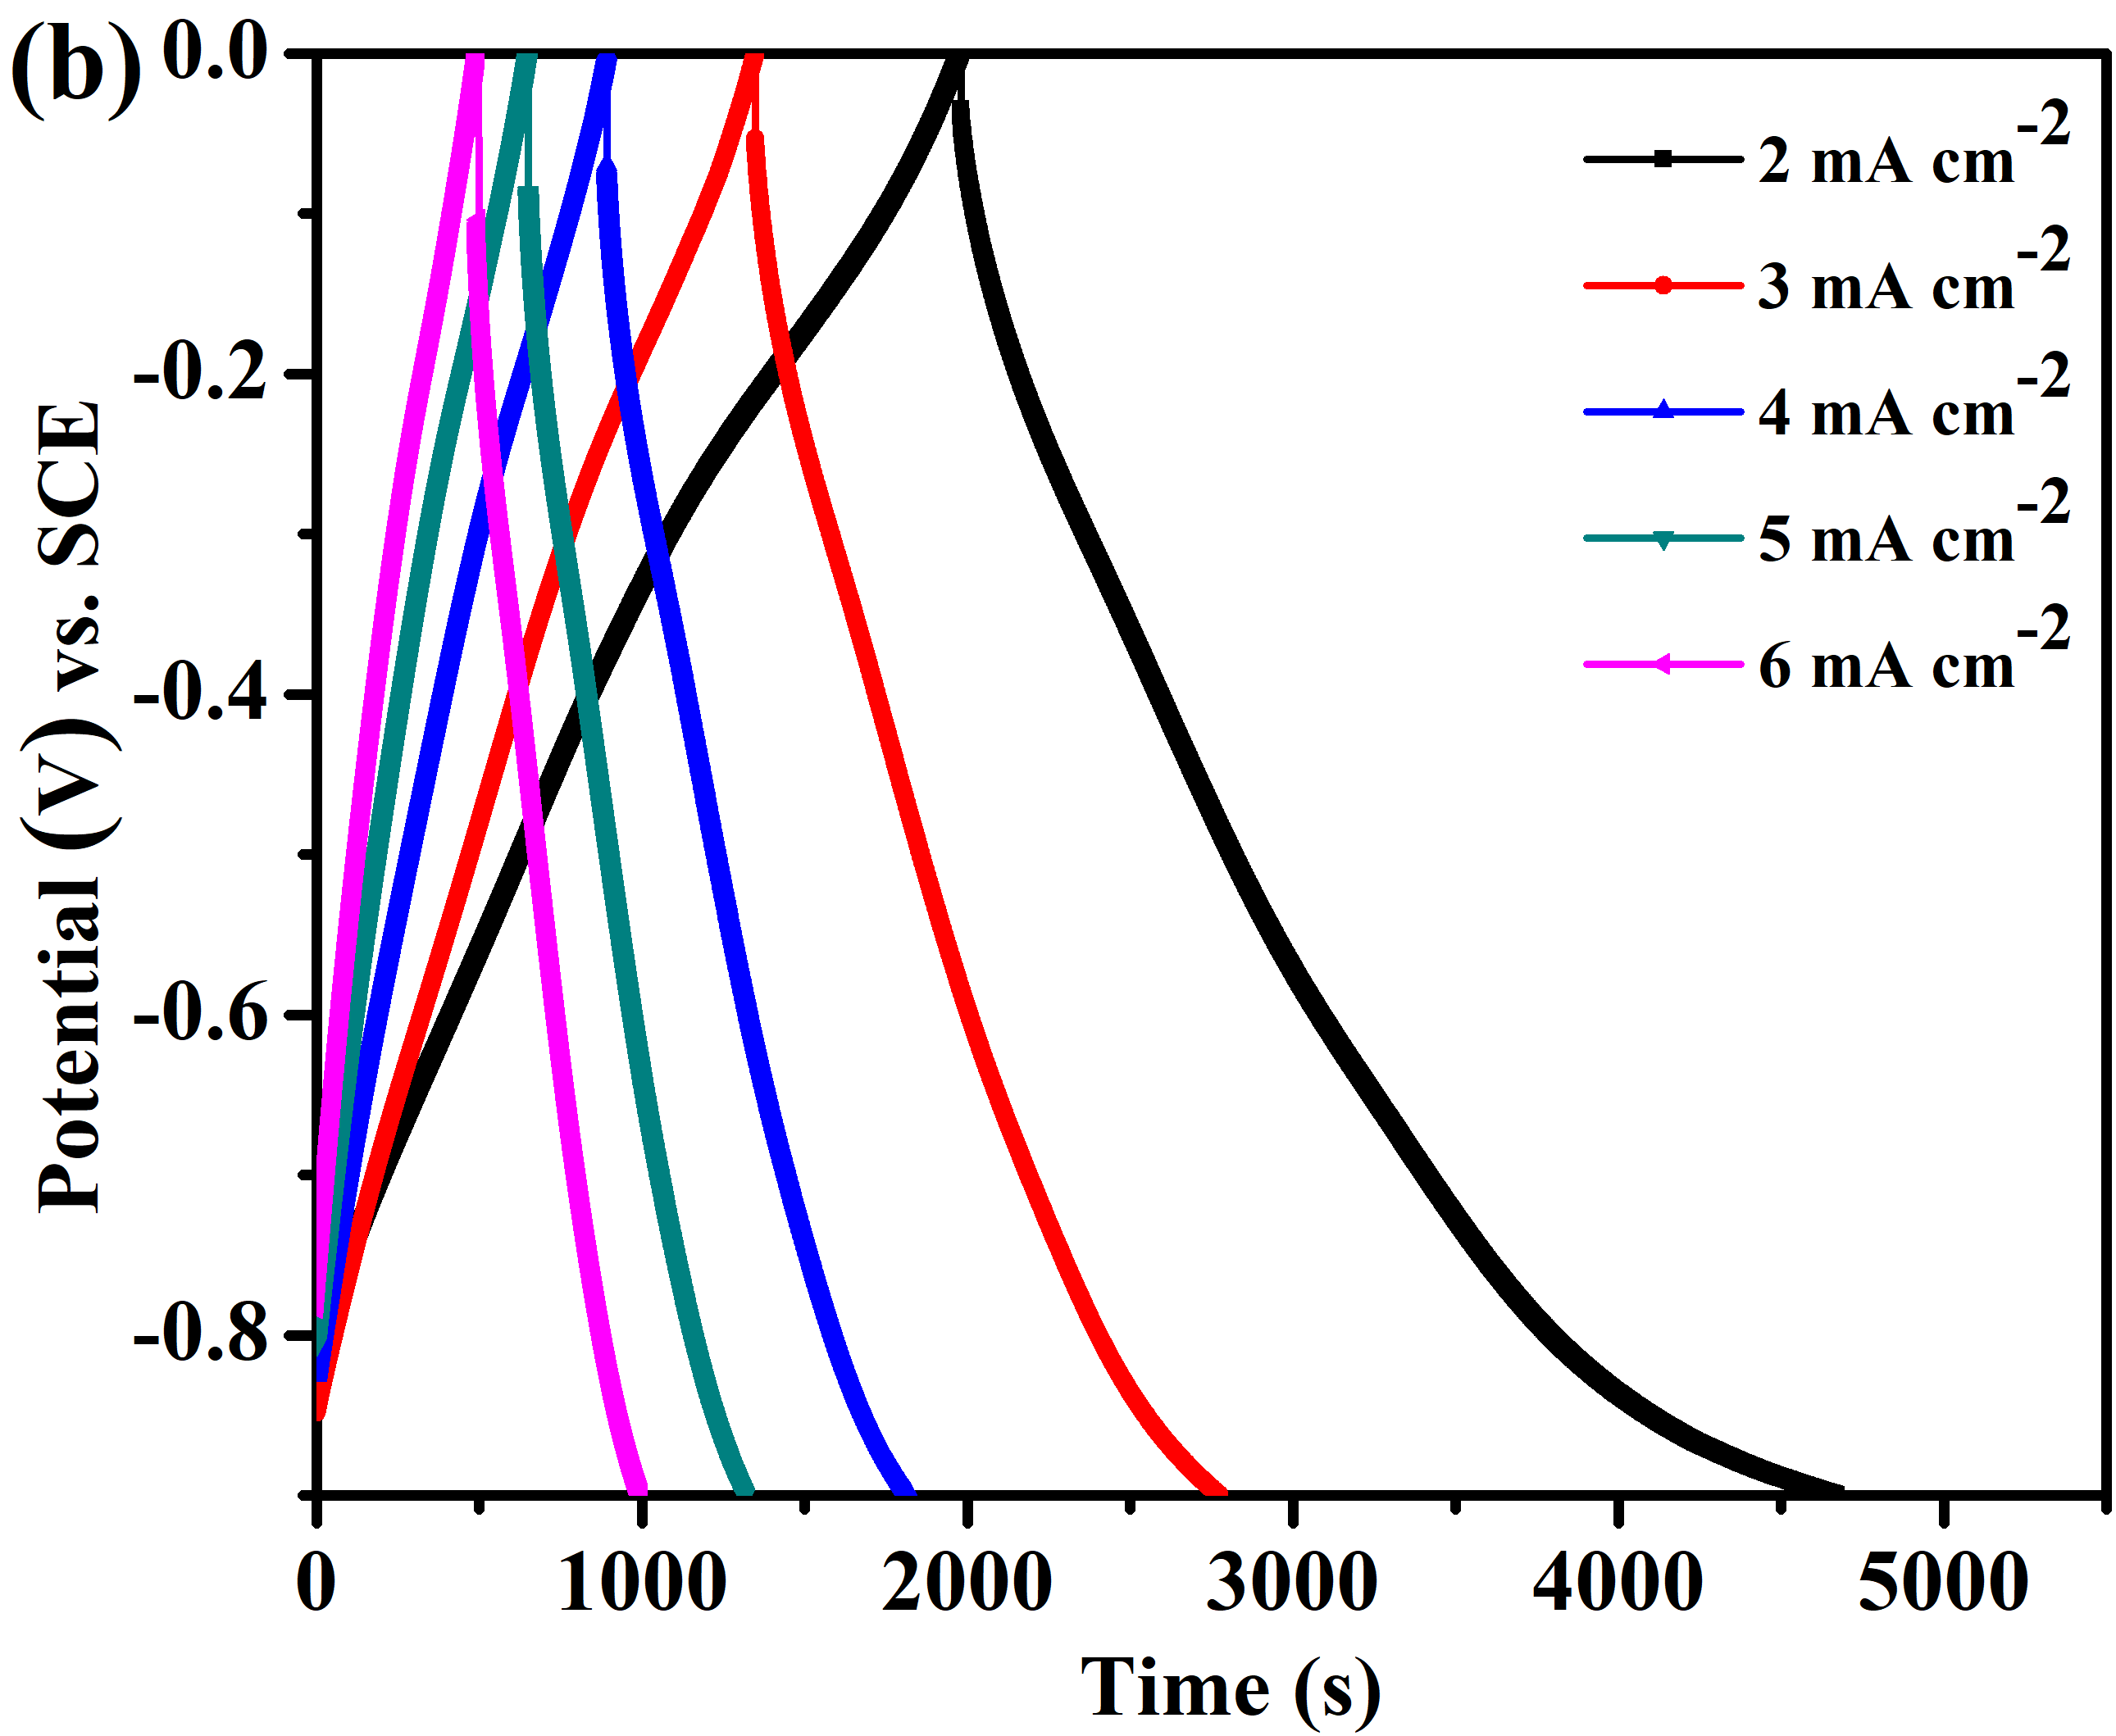
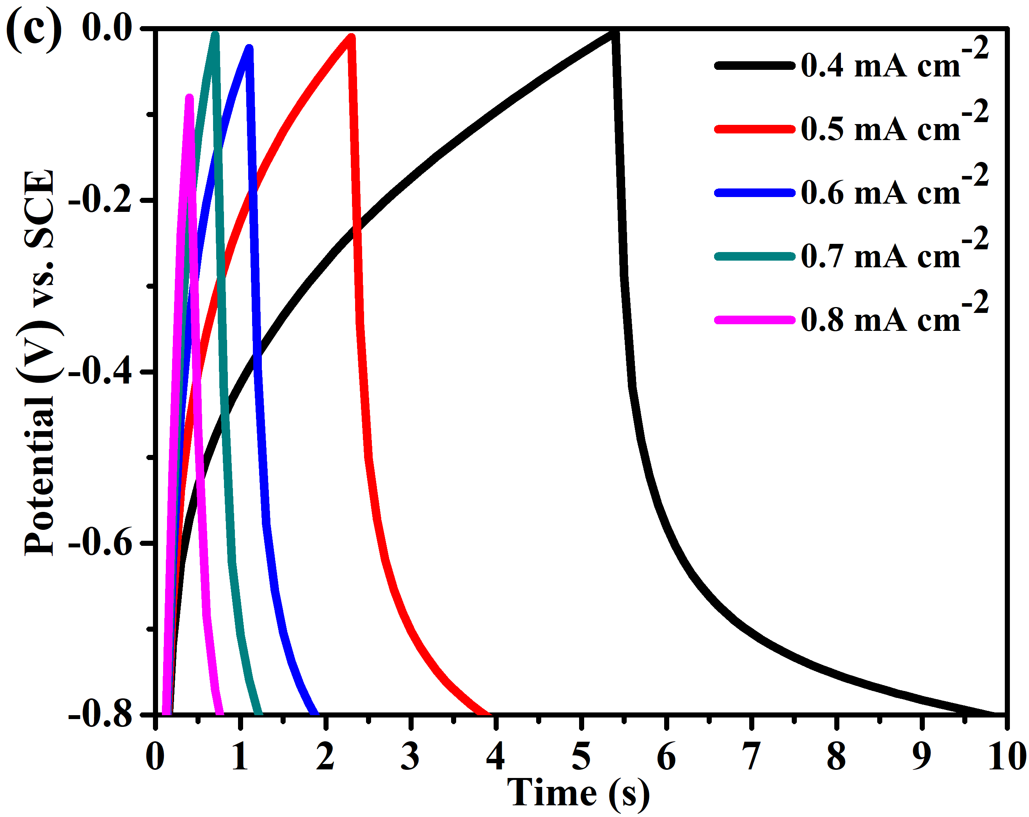
Fig. S3 (a, b) GCD curves, recorded at current densities from 2 to 6 mA cm^{–2}, of the (a) CC and (b) CCF-b freestanding electrodes. (c) GCD curves, recorded at current densities from 0.4 to 0.8 mA cm^{–2}, of the CF freestanding electrode.

Table S1 Capacitive performances of iron oxide–based negative electrodes reported previously in the literature and in this present study
Electrode  materials | Preparation  method | Electrolyte | Mass loading of active materials (mg cm^{–2}) | Specific capacitance of electrode (C_{s}) | Cycle life (%) | Reference
CCF-b freestanding electrode | One-step chemical co-precipitation (room temperature, 1 h) | 1 M Na₂SO₄ | 69.5 (Fe₂O₃)  77.3 (CNT + Fe₂O₃) | 9107.16 mF cm^{–2} (314 mF cm⁻³) at a current density of 2 mA cm^{–2} | 90.32% after 10,000 cycles | This study
Fe₂O₃ nanoplates coated on CC | Molten salt method (380 °C) | 6 M KOH | 3.33 | 4175.7 mF cm^{–2} | 95% after 10,000 cycles | ¹
α-Fe₂O₃/PANi/CNT hydrogel | Hydrothermal method (95 °C, 4 h) and post-sintering (550 °C, 2 h) for the preparation of α-Fe₂O₃ | 1 M Na₂SO₄ | 9.3 | 2434.7 mF cm^{–2} (261.8 F g^{–1}) | 96.3% after 10,000 cycles | ²
FNCs/CNTs-C | In situ growth technique (80 °C), followed by a post-heat treatment process (800 °C, 2 h) | 6 M KOH | 5 | 1687 mF cm^{–2} at 2 mA cm^{–2} | 95.8% after 20,000 cycles | ³
Fe₂O₃/graphene oxide paper | Hydrothermal method (120 °C, 6 h) and post-annealing (300 °C) | – | 1.2 | 3.08 F cm^{–2} at 5 mA cm^{–2} | 95% after 5000 cycles | ⁴
Fe₂O₃ nanospheres anchored on activated carbon cloth | One-step hydrothermal method (190 °C, 48 h) | 3M LiNO₃ | 1.87 | 2775 mF cm^{–2} | 92% after 10,000 cycles | ⁵
α-Fe₂O₃@MnCo₂O₄ composite | Hydrothermal method (200 °C, 6 h) and post-annealing (400 °C, 2 h) | 1 M KOH | – | 1073 mF cm^{–2} at 1 mA cm^{–2} | 77.8% after 6000 cycles | ⁶
α-Fe₂O₃@Co₃O₄ composite | Hydrothermal method (200 °C, 6 h) and post-annealing (400 °C, 2 h) | 1 M KOH | – | 490 mF cm^{–2} at 1 mA cm^{–2} | 74.6% after 6000 cycles | ⁶
Tetsubo-like α-Fe₂O₃/C nanoarrays | Sacrificial template-accelerated hydrolysis method to grow α‐Fe₂O₃ and post-annealing (400 °C, 30 min) | 1 M Na₂SO₄ | 1.1 | 430.8 mF cm^{–2} (391.8 F g^{–1}) at 1 mA cm^{–2} | 91.8% after 4000 cycles | ⁷
Oxygen-deficient α-Fe₂O₃ nanorods | Hydrothermal method (95 °C, 6 h) followed by thermal annealing (400 °C, 1 h) | 3 M LiCl | 4.3 | 382.7 mF cm^{–2} (equal to 89 F g^{–1} and 9.5 F cm^{–3}) at 0.5 mA cm^{–2} | 95.2%  after 10,000 cycles | ⁸
Hierarchical Tectorum-like α-Fe₂O₃/PPy nanoarrays | ZnO nanoarrays obtained via a hydrothermal method (85 °C, 24 h) used as sacrificial templates for α-Fe₂O₃ followed by thermal annealing (550 °C, 5 h) | 1 M Na₂SO₄ | 0.81 | 382.4 mF cm^{–2} at 0.5 mA cm^{–2} | 97.2% after 5000 cycles | ⁹
Fe₂O₃/ RGO/Fe₃O₄ nanocomposite | One-step hydrothermal growth (150 °C, 12 h) | 2 M KOH | 4.3 | 337.5 mF cm^{–2}, 78.49 F g^{–1} at 20 mA cm^{–2} | 95% after 5000 cycles | ¹⁰
CNT film/double-sided carbon tape/CNT film@Fe₂O₃ | Hydrothermal method (150 °C, 6 h) | 0.1 M Na₂SO₄ | 5.0 | 339.1 mF cm^{–2} at 1 mA cm^{–2} | – | ¹¹
Hematite nanocrystal–carbon cloth composite | Hydrothermal method | 1 M Na₂SO₄ | 0.9–1.0 | 1.66 F cm^{–2} at a current density of 2 mA cm^{–2} | 88.6% retention after 5000 cycles | ¹²
Ti-doped Fe₂O₃@PEDOT core/shell | Hydrothermal treatment (120 °C, 1 h) and sintering (300 °C, 1 h) | 5 M LiCl | – | 1.15 F cm^{–2} (311.6 F g^{–1}, 28.8 F cm^{–3}) at 1 mA cm^{–2} | 96.1% after 30,000 cycles | ¹³
Fe₂O₃ nanoparticle clusters/rGO paper | Hydrothermal synthesis (195 °C, 12 h) and thermal treatment (150 °C, 30 min) | 3 M KOH | 1.2 g cm^{–3} | 178.3 F cm^{–3} at 1 mV s^{–1} | – | ¹⁴
Metal-like fluorine-doped β-FeOOH nanorods | Hydrothermal synthesis (120 °C, 5 h) and post-annealing treatment (400 °C, 2 h) | 6 M KOH | 0.90–1.00 | 1.12 F cm^{–2} at a current density of 1 mA cm^{–2} | – | ¹⁵
SiC NWs@Fe₂O₃ NNAs) | Hydrothermal route (120 °C, 8 h)  followed by annealing treatment (450 °C, 2 h) | 2 M KOH | 1.4 | 1 F cm^{–2} at 2.8 mA cm^{–2} | – | ¹⁶
Plasma activated Fe₂O₃ nanorods on CC | Hydrothermal reaction (120 °C, 6 h), post thermal annealing (450 °C, 3 h), and plasma activation (300 °C, 1 h) | 1 M Na₂SO₄ | - | 340 mF cm⁻²(369 F g⁻¹) at 1 mA cm⁻² | 83%  after 5000 cycles | ¹⁷
GF-CNT@  Fe₂O₃ electrode | CVD method (750 °C) to construct GF-CNT and anatomic layer deposition (165 °C) to coat crystalline Fe₂O₃ | 2 M KOH | – | 470.5 mF cm^{–2} at 20 mA cm^{–2} | 111.2%  after 50,000 cycles | ¹⁸
Fe₂O₃ nanotubes grown on carbon fabric | Sacrificial template-accelerated hydrolysis and post-annealing (400 °C, 2 h) | 5 M LiCl | 0.71 | 180.4 mF cm^{–2} at 1 mA cm^{–2} | – | ¹⁹
Binder-free hematite NF electrode | Hydrothermal method (95 °C, 6 h) followed by annealing (550 °C, 1 h) | 3 M LiCl | 1.5 | 145.9 mF cm^{–2} (100.6 F g^{–1}) at 1 mA cm^{–2} | 87.2% after 5000 cycles | ²⁰
α-Fe₂O₃@PANI core–shell nanowire arrays | Electrodeposition (40 min) and calcination (500 °C, 2 h) | 1 M Na₂SO₄ | – | 103 mF cm^{–2} at 0.86 mA cm^{–2} | 100% after 2500 cycles | ²¹
Ni/GF/Fe₂O₃ | Hydrothermal synthesis (120 °C, 6 h) and post-annealing treatment (400 °C, 1 h) | 3 M KOH | – | 572 mF cm^{–2} at 1 mA cm^{–2} | 94.1% after 3000 cycles | ²²
Fe₂O₃-δ crystalline core/amorphous shell heterostructure | Hydrothermal synthesis (120 °C, 6 h) and post-annealing treatment (400 °C, 1 h) | 1 M LiOH | 1.3 | 701 F g^{–1} (701 mF cm^{–2}) at 1 A g^{–1} | 90% after 5000 cycles | ²³

Table S2 Capacitive performances of asymmetric supercapacitor devices reported previously in the literature and in this present study
Material | Electrolyte | Voltage window | Areal (volumetric)capacitance | Energy density | Power density | Reference
CCM//CCF-b | 1 M Na₂SO₄ | 1.8 V | 2907.1 mF cm^{–2} (26.4 F cm^{–3}) | 1.31 mW h cm^{–2} (11.9 mW h cm^{–3}) | 274.4 mW cm^{–2} (2.5 W h cm^{–3}) | This work
Mn₃O₄@CC//Fe₂O₃@CC | 6 M KOH | 2.0 V | 1047.9 mF cm^{–2} | 2.91 mW h cm^{–3} | 278 mW cm^{–3} | ¹
RuO₂//Fe₂O₃ | CMC/Na₂SO₄ | 1.5 V | 4.9 F cm^{–3} | 1.5 mW h cm^{–3} | 9.1 mW h cm^{–3} | ²⁴
TNT@α-Fe₂O₃//AC | 1 M KCl | 1.4 V | 142.86 mF cm^{–2} | 38.88 µW h cm^{–2} | 1.9 mW h cm^{–2} | ²⁵
CDC@MnO₂//CDC@ Fe₂O₃ | PVA/LiClO₄ | 2.1 V | 6.8 F cm^{–3} | 4.1 mW h cm^{–3} | 22.3 mW cm^{–3} | ¹¹
MnO₂//Fe₂O₃ | PVA/LiCl | 1.6 V | – | 0.55 mW h cm^{–3} | 139.1 mW cm^{–3} | ¹⁹
Fe₂O₃-P//MnO₂ | 1 M Na₂SO₄ | 1.6 V | - | 0.42 mWh/cm³ | 258.1 W cm⁻³ | ¹⁷
MnO₂//  Fe₂O₃/PPy- | PVA/LiCl | 1.6 V | 835.5 mF cm^{–3} | 0.22 mW h cm^{–2} | 165.6 mW cm^{–3} | ⁹
Fe₃O₄@Fe₂O ₃//Fe₃O₄ @MnO₂ | 1 M Na₂SO₄ | 2 V | 1.49 F cm^{–3} | 0.83 mW h cm^{–3} | 500 mW cm^{–3} | ²⁶
ASC MG/FG-t2 | 3 M KOH | 1.8 V | – | 0.056 W h cm^{–3} | 6.21 W cm^{–3} | ¹⁴
α-Fe₂O₃ @PANI//PANI | 1 M Na₂SO₄ | 1.5 V | 2.02 mF cm^{–3} | 0.35 mW h cm^{–3} | 120.51 mW cm^{–3} | ²¹
α-Fe₂O₃/C//α - Fe₂O₃/MnO_{x} | 1 M Na₂SO₄ | 2.0 V | 1.28 F cm^{–3} | 0.64 mW h cm^{–3} | 155 mW cm–3 | ²⁷
Co₃O₄/GN/BC// r‐Bi₂O₃/GN/BC | 6 M KOH | 1.6 V | – | 0.449 mW h cm^{–2} (7.74 mW h cm^{–3}) | 40 mW cm^{–2} (690 mW cm^{–3}) | ²⁸
PANi gel//α- Fe₂O₃/PANi | PVA/LiCl | 1.8 V | 1.5 C cm^{–3} | 0.31 mW h cm^{–3} | 67.1 mW cm^{–3} | ²⁹
MnO₂//Fe₂O₃ | PVA/LiCl | 1.6 V | 1.21 F cm^{–3} | 0.41 mW h cm^{–3} | 0.1 W cm^{–3} at 6 mA cm^{–2} | ⁸
MnO₂//α- Fe₂O₃/C | 1 M Na₂SO₄ | 2.0 V | 78.2 mF cm^{–2}  (1.15 F cm^{–3}) | 0.64 mW h cm^{–3} | 248.4 mW cm^{–3} | ⁷
MnO₂ //MXene@ Fe₂O₃ | PVA/LiCl | 1.8 V | 143.4 mF cm^{–2} | 1.61 mW h cm^{–3} | 495.6 mW cm ^{–3} | ³⁰
MnO₂//Ti-Fe₂O₃@PEDOT | PVA/LiCl | 1.6 V | 2.40 F cm^{–3} | 0.89 mW h cm^{–3} | 0.44 W cm^{–3} | ¹³
Ni/GF/H-CoMoO₄//Ni/GF/H-Fe₂O₃ | PVA/KOH | 1.5 | 3.6 F cm^{–3} | 1.13 mW h cm^{–3} | 150 mW cm^{–3} | ²²

References
1. Y. J. Gu, W. Wen, S. Zheng and J.-M. Wu, Mater. Chem. Front. 2020, 4, 2744-2753.
2. Z. Yang, A. Qiu, J. Ma and M. Chen, Compos Sci Technol. 2018, 156, 231-237.
3. R. Wang, S. Cai, Y. Yan, W. M. Yourey, W. Tong and H. Tang, J. Mater. Chem. A 2017, 5, 22648-22653.
4. S. Xie, M. Zhang, P. Liu, S. Wang, S. Liu, H. Feng, H. Zheng and F. Cheng, Mater. Res. Bull. 2017, 96, 413-418.
5. J. Li, Y. Wang, W. Xu, Y. Wang, B. Zhang, S. Luo, X. Zhou, C. Zhang, X. Gu and C. Hu, Nano Energy 2019, 57, 379-387.
6. X. Zheng, Z. Han, F. Chai, F. Qu, H. Xia and X. Wu, Dalton Trans. 2016, 45, 12862-12870.
7. D. Chen, S. Zhou, H. Quan, R. Zou, W. Gao, X. Luo and L. Guo, Chem. Eng. J. 2018, 341, 102-111.
8. X. Lu, Y. Zeng, M. Yu, T. Zhai, C. Liang, S. Xie, M. S. Balogun and Y. Tong, Adv. Mater. 2014, 26, 3148-3155.
9. L. Wang, H. Yang, X. Liu, R. Zeng, M. Li, Y. Huang and X. Hu, Angew. Chem. Int. Ed. 2017, 56, 1105-1110.
10. C. Zhao, X. Shao, Y. Zhang and X. Qian, ACS Appl. Mater. Interfaces 2016, 8, 30133-30142.
11. Y. Zhang, X. Yuan, W. Lu, Y. Yan, J. Zhu and T. W. Chou, Chem. Eng. J. 2019, 368, 525-532.
12. S. Peng, L. Yu, B. Lan, M. Sun, G. Cheng, S. Liao, H. Cao and Y. Deng, Nanotechnology 2016, 27, 505404.
13. Y. Zeng, Y. Han, Y. Zhao, Y. Zeng, M. Yu, Y. Liu, H. Tang, Y. Tong and X. Lu, Adv. Energy Mater. 2015, 5, 1402176.
14. Y. Hu, C. Guan, Q. Ke, Z. F. Yow, C. Cheng and J. Wang, Chem. Mater. 2016, 28, 7296-7303.
15. L. F. Chen, Z. Y. Yu, J. J. Wang, Q. X. Li, Z. Q. Tan, Y. W. Zhu and S. H. Yu, Nano Energy, 2015, 11, 119-128.
16. J. Zhao, Z. Li, X. Yuan, Z. Yang, M. Zhang, A. Meng and Q. Li, Adv. Energy Mater. 2018, 8, 1702787.
17. H. Liang, C. Xia, A.-H. Emwas, D. H. Anjum, X. Miao and H. N. Alshareef, Nano Energy 2018, 49, 155-162.
18. C. Guan, J. Liu, Y. Wang, L. Mao, Z. Fan, Z. Shen, H. Zhang and J. Wang, ACS Nano 2015, 9, 5198-5207.
19. P. Yang, Y. Ding, Z. Lin, Z. Chen, Y. Li, P. Qiang, M. Ebrahimi, W. Mai, C. P. Wong and Z. L. Wang, Nano Lett., 2014, 14, 731-736.
20. T. Liu, Y. Ling, Y. Yang, L. Finn, E. Collazo, T. Zhai, Y. Tong and Y. Li, Nano Energy 2015, 12, 169-177.
21. X. F. Lu, X. Y. Chen, W. Zhou, Y. X. Tong and G. R. Li, ACS Appl. Mater. Interfaces, 2015, 7, 14843-14850.
22. K. Chi, Z. Zhang, Q. Lv, C. Xie, J. Xiao, F. Xiao and S. Wang, ACS Appl. Mater. Interfaces 2017, 9, 6044-6053.
23. S. Sun, T. Zhai, C. Liang, S. V. Savilov and H. Xia, Nano Energy 2018, 45, 390-397.
24. Q. Wang, X. Liang, Y. Ma and D. Zhang, Dalton Trans. 2018, 47, 7747-7753.
25. S. T. Manikkoth, K. M. Thulasi, A. Paravannoor, S. Palantavida, M. Bhagiyalakshmi and B. K. Vijayan, Nano-Struct. Nano-Objects 2020, 24, 100543.
26. X. Tang, R. Jia, T. Zhai and H. Xia, ACS Appl. Mater. Interfaces 2015, 7, 27518-27525.
27. D. Sarkar, S. Pal, S. Mandal, A. Shukla and D. D. Sarma, J. Electrochem. Soc. 2017, 164, A2707-A2715.
28. R. Liu, L. Ma, G. Niu, X. Li, E. Li, Y. Bai and G. Yuan, Adv. Funct. Mater. 2017, 27, 1701635.
29. Z. Yang, L. Tang, J. Ye, D. Shi, S. Liu and M. Chen, Electrochim. Acta 2018, 269, 21-29.
30. F. Li, Y. L. Liu, G. G. Wang, H. Y. Zhang, B. Zhang, G. Z. Li, Z. P. Wu, L. Y. Dang and J. C. Han, J. Mater. Chem. A 2019, 7, 22631-22641.

