Supplementary File

Evaluation of the concordance of transcranial color flow imaging pulsatility index in the middle cerebral artery and internal carotid artery

Supplementary table 1. Hemoglobin levels for each disease.

Disease | Median, g/dL (IQR) | OR for (MCA-PI > ICA-PI)  adjusted with hemoglobin | p value＊＊
Subarachnoid hemorrhage | 9.6 (8.6-10.7) | 1.09 [0.50-2.38] | 0.824
Intracerebral hemorrhage | 11.8 (10.8-12.5) | 2.44 [0.83-7.83] | 0.104
Cerebral infarction | 12.0 (10.2-14.5) | 2.41 [0.59-12.13] | 0.224
Traumatic brain injury | 9.1 (8.6-11.5) | 0.21 [0.01-1.37] | 0.109
Hypoxic encephalopathy | 8.4 (7.8-9.1) | 0.71 [0.09-3.79] | 0.694
Epilepsy/Encephalitis | 9.9 (8.9-10.1) | 0.94 [0.18-4.65] | 0.948
Brain tumor | 13.1 (11.1-15.0) | na
Others＊ | 8.6 (7.8-9.9) | na
*Others: degenerative diseases, cerebral venous sinus thrombosis, post-craniotomy, etc.
**multivariable logistic regression
Abbreviations: OR, odds ratio; MCA-PI, pulsatility index at middle cerebral artery; ICA-PI, pulsatility index at internal carotid artery; IQR, interquartile range.

Supplementary figure 1. Subgroup analysis for correlation between MCA-PI and ICA-PI.

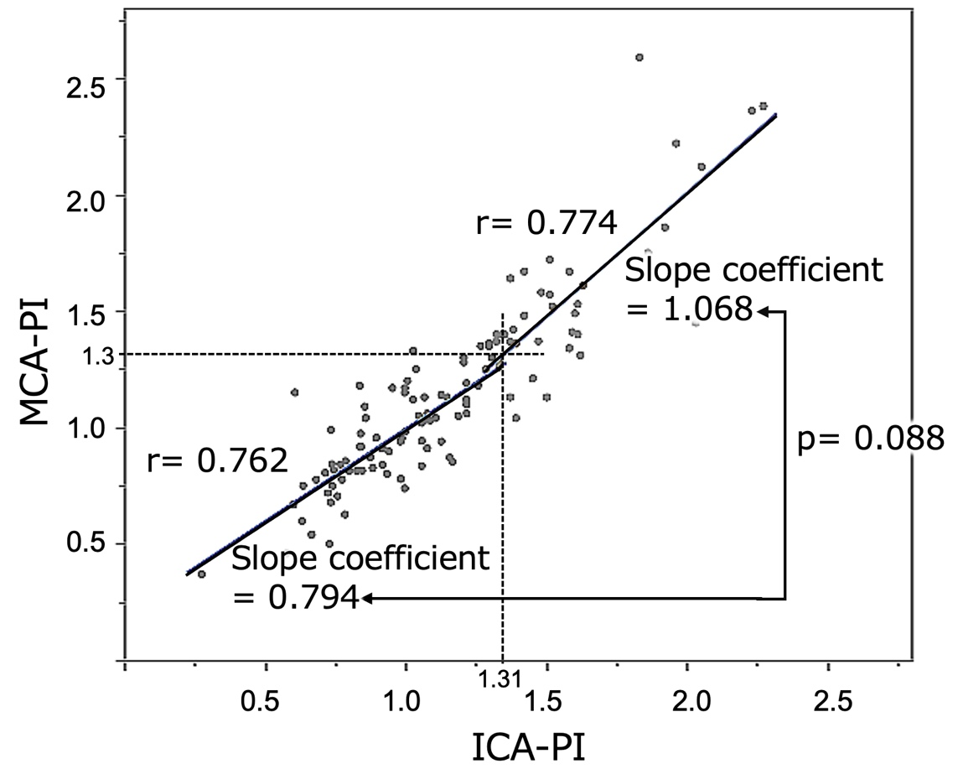
Abbreviations: MCA-PI, pulsatility index at middle cerebral artery; ICA-PI, pulsatility index at internal carotid artery.

