Supporting Information
for
Lignin-based chemical looping fuel cell using Ca₂Fe₂O₅ as oxygen carrier for power generation

Atsuhiro Sumiya,ª Naohiro Ikeda,ª & Takashi Hibino ^{a,b}*
ª Graduate School of Environmental Studies, Nagoya University, Nagoya 464-8601, Japan
^{b} Department of Research, Nagoya Industrial Science Research Institute, Nagoya 460-0008, Japan

Table of Contents

An image and diagrams of the three cells S1
Combustion and pyrolysis characteristics of lignosulfonate S2
Raman spectra of lignosulfonate before and after pyrolysis S3
Impedance spectra of the Ca₂Fe₂O₅ and Fe₂O₃ cells S4
Performance of Ca₂Fe₂O₅ and Fe₂O₃ cells using grass as fuel S5
V–time curves for cells using various OC materials S6
V–time curves for the Fe₂O₃ cell using various masses of lignosulfonate S7

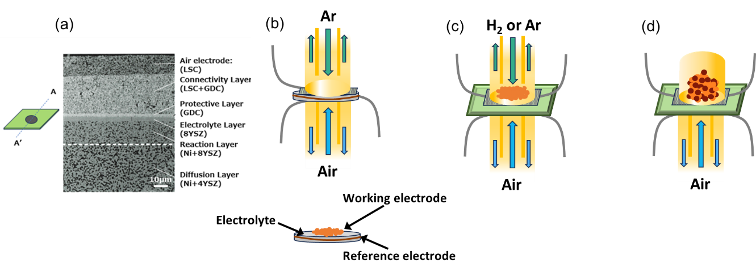
Figure S1. (a) A cross-sectional SEM image of the SOFC and diagrams of the (b) three-electrode, (c) flow and (d) batch cells. The scale bar in the SEM image is 10 μm. Two tubes open at both ends formed the anode chamber in the three-electrode and flow cells while a tube closed at one end was used in the batch cell. Double tubes comprised the cathode chamber in all cells.

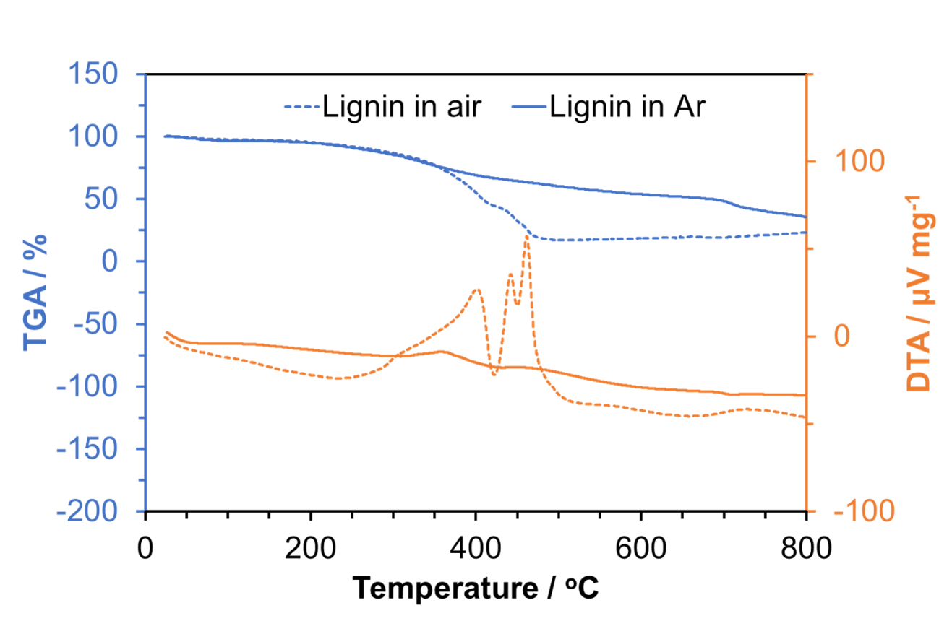
Figure S2. TG–DTA curves for lignosulfonate. The dotted and solid lines represent data obtained in air and Ar flows, respectively. The heating rate for both datasets was 6.6 °C min⁻¹.

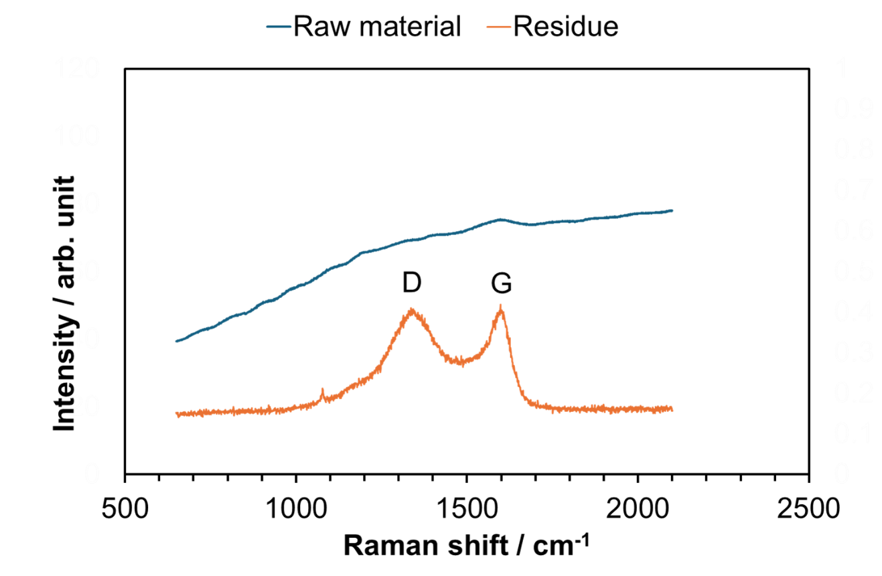
Figure S3. Raman spectra of raw lignosulfonate and of residue after pyrolysis. The peaks at 1320 and 1600 cm^{–1} are attributed to amorphous carbon (referred to here as the D band) and graphite (the G band), respectively.

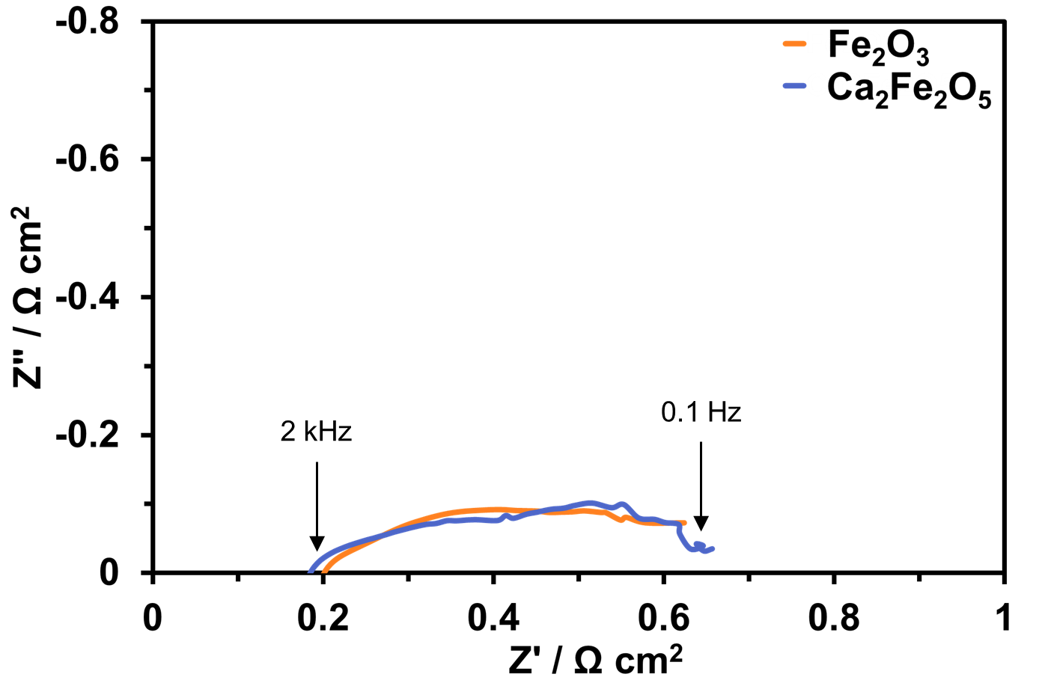
Figure S4. Impedance spectra of Ca₂Fe₂O₅ and Fe₂O₃ cells at 800 °C under OCV conditions.

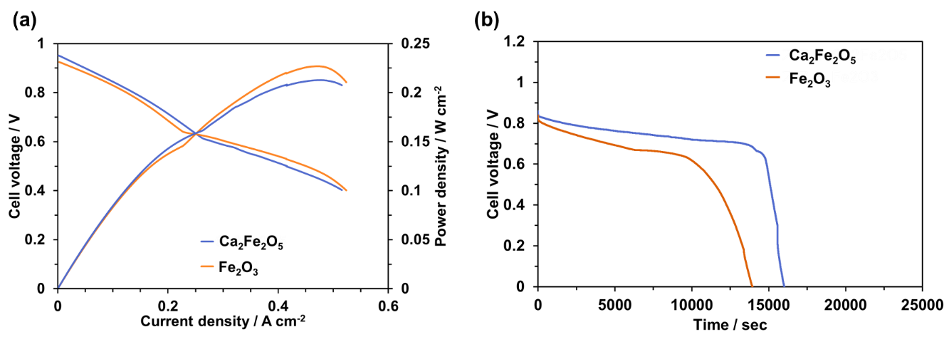
Figure S5. I–V and I–P curves and (b) V–time curves for Ca₂Fe₂O₅ and Fe₂O₃ cells using grass as a reducing agent at 800 °C. Note that unlike the lignosulfonate powder (0.25 g), the mass of the grass samples was increased to 0.3 g due to the use of a sheared sample.

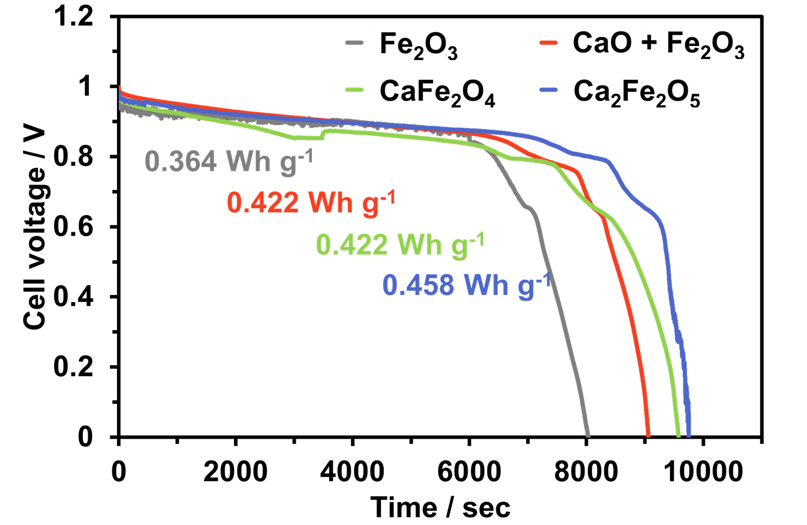
Figure S6. V–time curves for cells using various OC materials at 800 °C. The numerical values are energy densities.

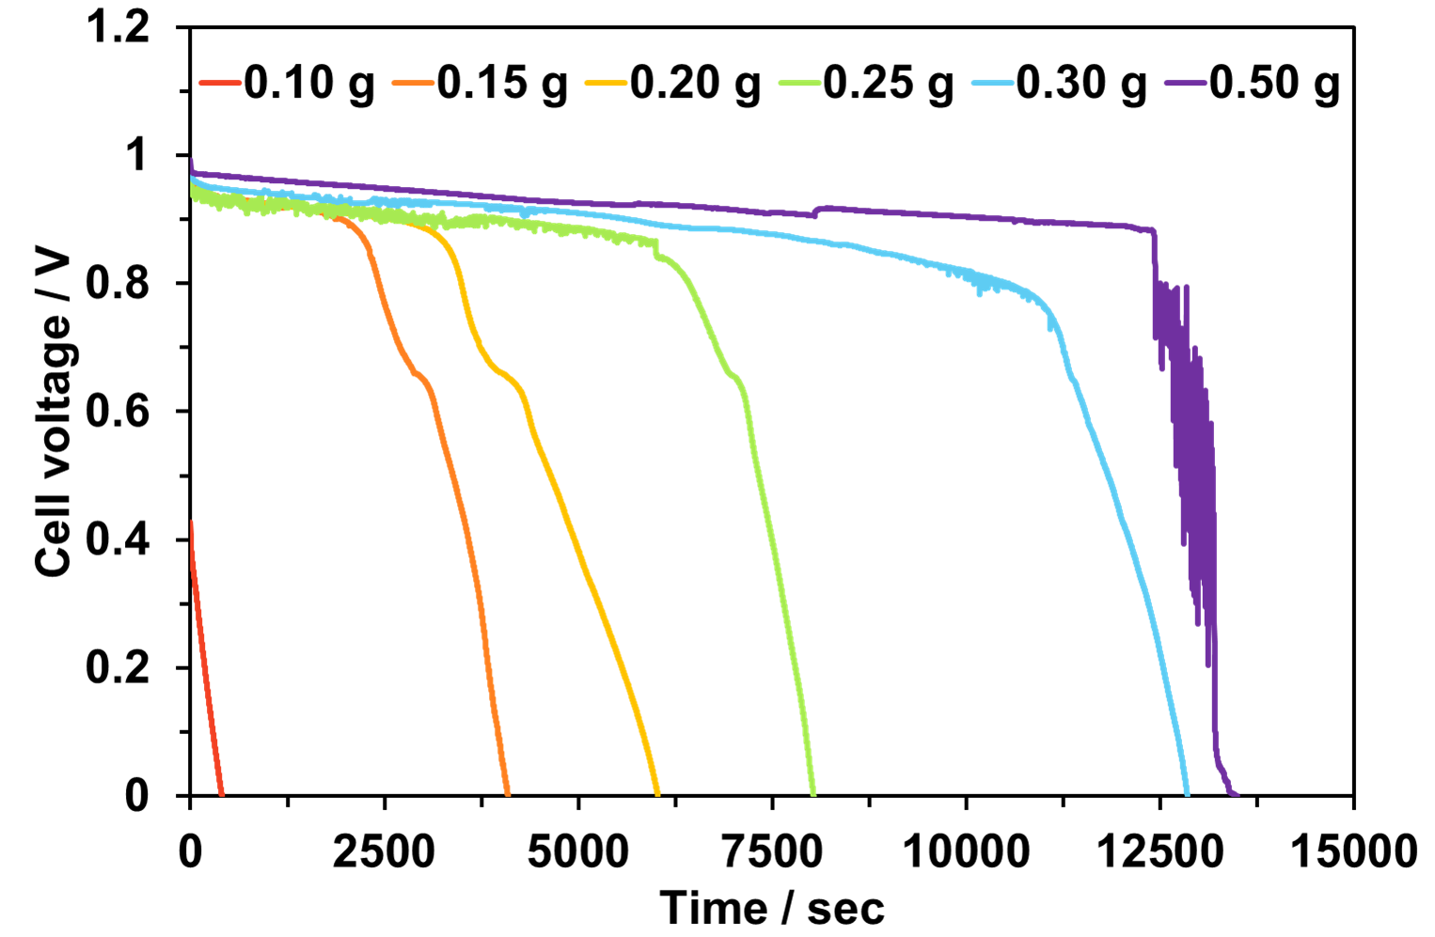
Figure S7. V–time curves for Fe₂O₃ cell using various masses of lignosulfonate at 800 °C. The mass of Fe₂O₃ was equivalent to 0.126 mmol Fe in all trials.

