Supporting Information for

Multiple Lines of Evidence Reveal Rapid, Seasonal Watershed Responses to Enhanced Weathering
Fengchao Sun^{1,2*}, Robert A. Rioux^{1,2}, Tim Jesper Suhrhoff ^{2,3}, Wyatt Tatge^{1,2}, Boriana Kalderon-Asael^{2,3}, Quinn Zacharias^{1,2}, William A. Miller-Brown^{1,2}, Aaron A. MacDonald^{1,2,4}, Esmeralda Garcia^{1,2,5}, James B. Shanley⁶, Peter A. Raymond^{1,2}, Noah J. Planavsky^{2,3}, James E. Saiers^{1,2}
¹ School of the Environment, Yale University, New Haven, CT, 06511, USA
² Yale Center for Natural Carbon Capture, Yale University, New Haven, CT, 06511, USA
³ Department of Earth and Planetary Sciences, Yale University, New Haven, CT, 06511, USA
⁴ Earth and Environmental Science Department, University of Illinois-Chicago, Chicago, IL, 60607, USA
⁵ McCormick School of Engineering, Northwestern University, Evanston, IL, 60208, USA
⁶ U.S. Geological Survey, New England Water Science Center, Montpelier, VT, 05602, USA
Table of Contents
Figure S1. Streamwater concentration changes before and after basalt application.. 2
Figure S2. Streamwater concentration-discharge (C-Q) relations at W-2 before basalt application (open circles, from May 2022 to June 2023) and for the two-year period following basalt application (solid squares, from July 2023 to April 2025).. 3
Figure S3. Streamwater Na-normalized elemental ratios (molar ratio) before (open circles) and after (solid squares) basalt application.. 4
Figure S4. δ⁷Li isotope values measured in streamwater samples collected before (blue circle) and after (red square) basalt application.. 4
Figure S5. Temporal dynamics of the ERW treatment effects and solute export rates.. 5
Figure S6 Quick- and slow-flow fractions vs. discharge, with fitted concentration-discharge relations for the pre-basalt application period (January 2008–May 2017 and May 2022–June 2023).. 6
Figure S7. Seasonal concentration-discharge (C-Q) relations and estimated concentrations of slow-/quick-flow endmembers pre- and post-basalt application.. 6
Table S1 Major oxide composition and loss on ignition (LOI) of the basalt feedstock 7
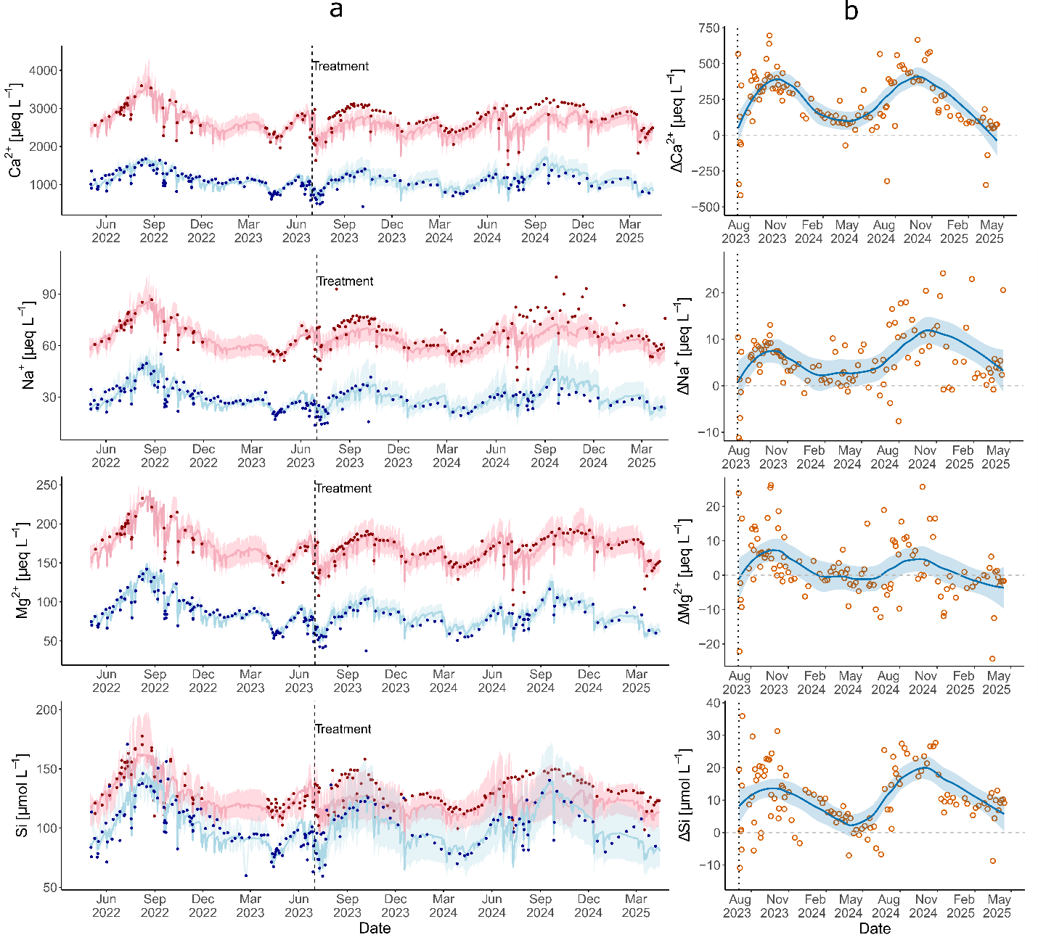

Figure S1. Streamwater concentration changes before and after basalt application. a, Observed and estimated concentrations of alkalinity at W-2 (treatment watershed) and W-9 streams (reference watershed) from May 2022 to April 2025, respectively. The red and blue data points represent the observed concentrations at W-2 and W-9 streams, respectively. The red and blue lines denote WRTDS-estimated concentrations with shading representing 95% confidence intervals of the estimates. b, Concentration changes after basalt application, indicated by the differences between observed concentrations and WRTDS-estimated concentrations (orange circles). Blue lines with shaded areas represent LOESS fits with 95% confidence intervals.
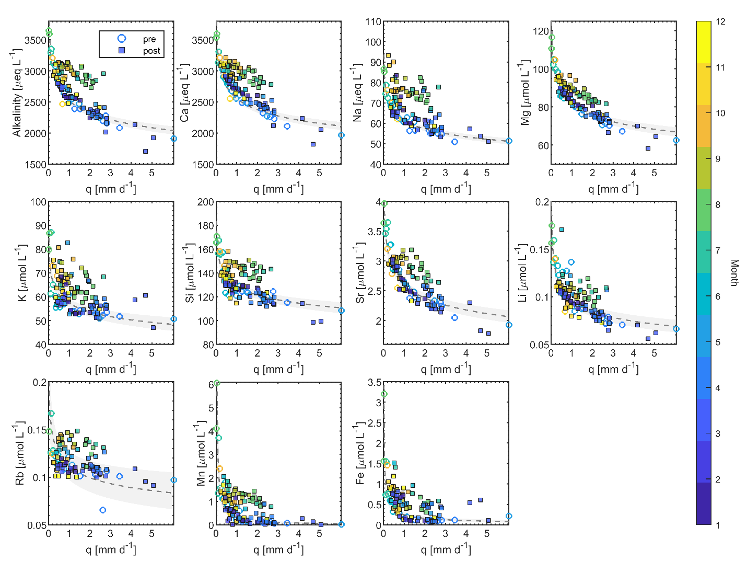

Figure S2. Streamwater concentration-discharge (C-Q) relations at W-2 before basalt application (open circles, from May 2022 to June 2023) and for the two-year period following basalt application (solid squares, from July 2023 to April 2025). Data were colored by month of year. Pre-application C-Q data were fitted using a power-law function (grey dashed line) with 95% confidence interval (grey shade). The variable $q$ represents the instantaneous discharge at the time of sample collection.

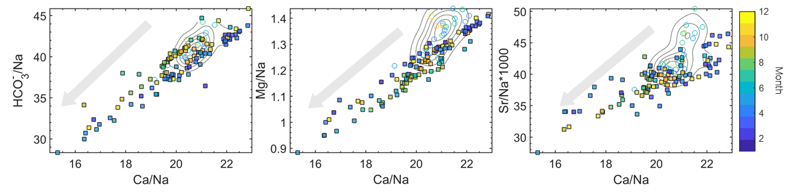

Figure S3. Streamwater Na-normalized elemental ratios (molar ratio) before (open circles) and after (solid squares) basalt application. Pre-application elemental ratios were contoured using kernel density estimation to show data density. Data were color-coded by month. The grey arrow indicates the direction of the elemental ratio shifts from carbonate rock weathering towards silicate rock weathering following basalt application.
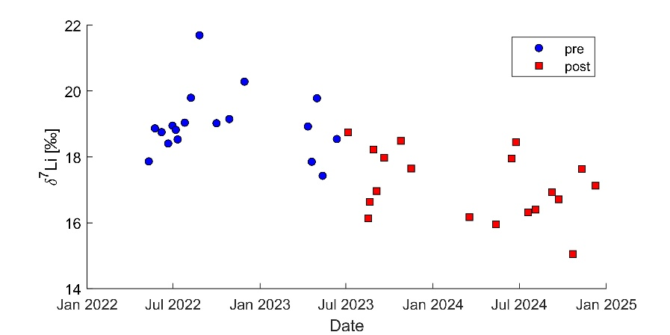

Figure S4. δ⁷Li isotope values measured in streamwater samples collected before (blue circle) and after (red square) basalt application. The δ⁷Li isotope value of Pioneer Valley Basalt (basalt) is 2.34 ± 0.65 ‰.
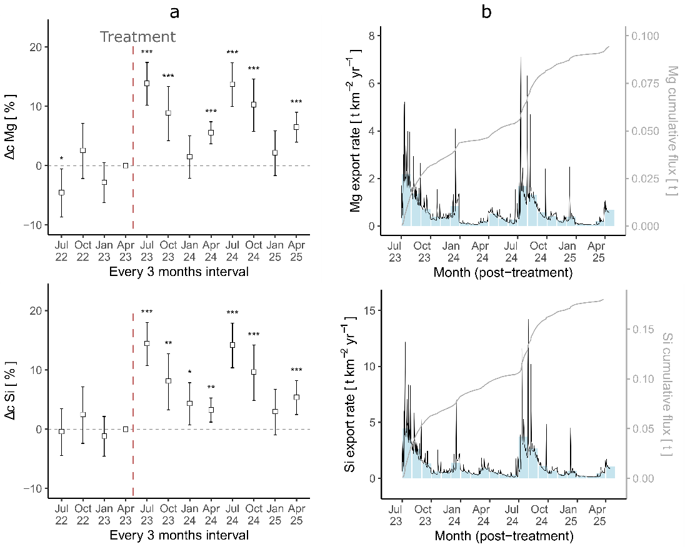

Figure S5. Temporal dynamics of the ERW treatment effects and solute export rates. a, Relative concentration changes from ERW ($Δc$), derived from GAM-DiD analysis (Generalized Additive Model coupled with Difference-in-Differences model). Significance levels are indicated as follows: *** p ≤ 0.001, ** p ≤ 0.01, * p ≤ 0.05, · p ≤ 0.1, and not significant (p > 0.1). The red dashed line separates the pre-basalt application period from the post-basalt application period. b, Daily (solid black line) and monthly average (blue bar) export rates of the weathering products from basalt. Gray solid lines represent the cumulative export flux of the weathering products from basalt.

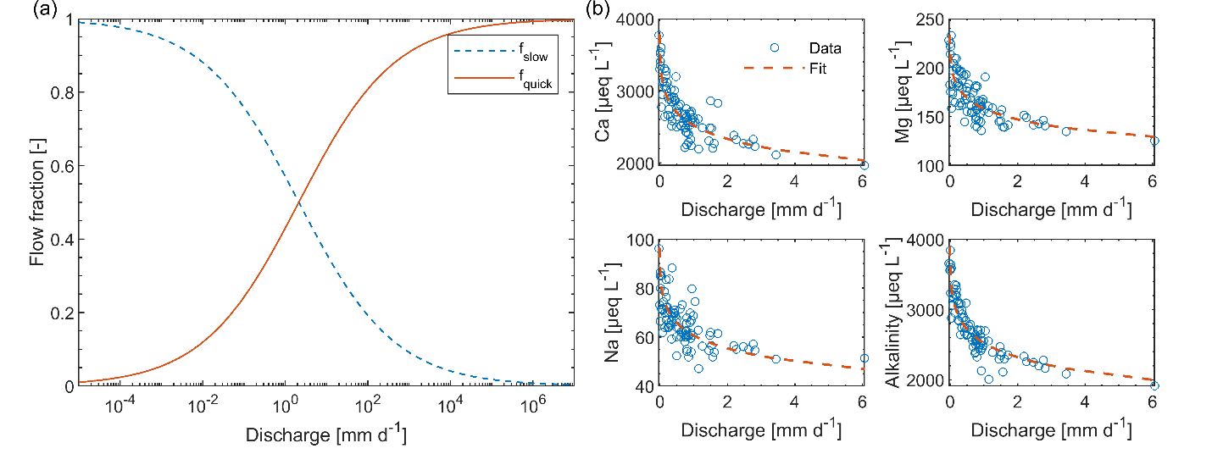Figure S6 Quick- and slow-flow fractions vs. discharge, with fitted concentration-discharge relations for the pre-basalt application period (January 2008–May 2017 and May 2022–June 2023). a, Proportions of quick-flow (red solid line) and slow-flow water (blue dashed line) of the W-2 streamflow, calculated from equations (4)–(6), with fitted parameters of $a_{slow}$ = 1.08, and $b_{slow}$ = 0.46. b, Observed (blue circles) and predicted (red dashed line) concentration-discharge relation of Ca, Mg, Na, and alkalinity in W-2 streamwater before basalt treatment.
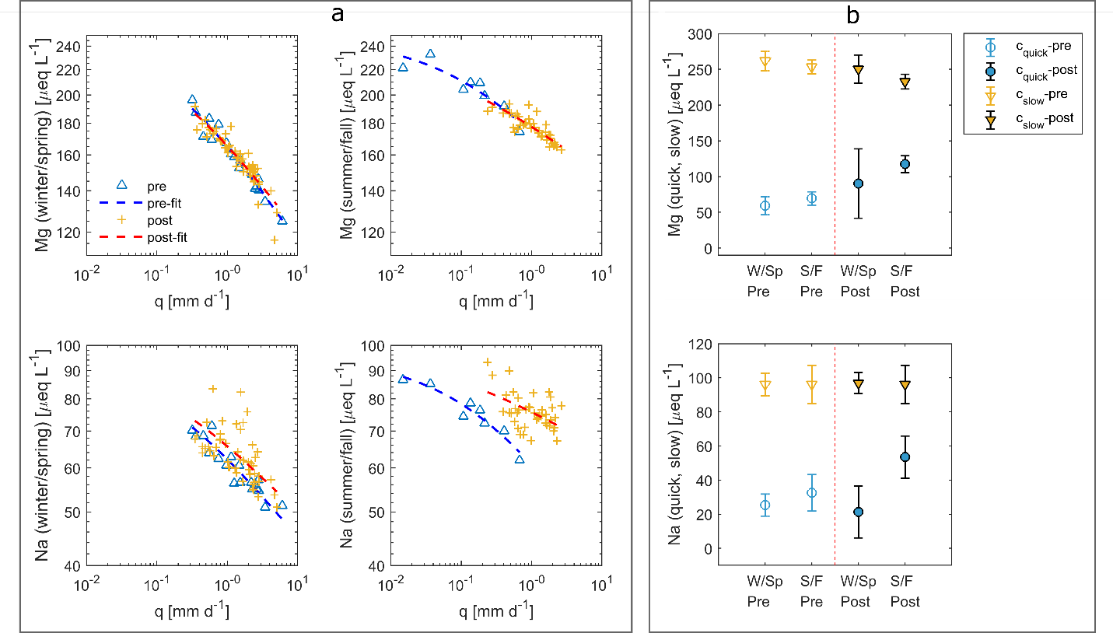

Figure S7. Seasonal concentration-discharge (C-Q) relations and estimated concentrations of slow-/quick-flow endmembers pre- and post-basalt application. a, C-Q relation for Mg and Na pre- (blue) and post-basalt (orange) application for winter/spring and summer/fall periods, fitted with equations (4)–(6). b, Mg, and Na concentrations from quick-flow (blue) and slow-flow (orange) endmembers pre- (open circles) and post-basalt (filled circles) application in winter/spring and summer/fall periods, estimated using equations (4)–(6).

Table S1 Major oxide composition and loss on ignition (LOI) of the basalt feedstock
Major Oxides and LOI | Content (%) FUS-ICP Analyses
Silicon dioxide (SiO₂) | 51.62
Aluminum oxide (Al₂O₃) | 13.64
Iron oxide (Fe₂O₃(T)) | 13.16
Magnesium oxide (MgO) | 5.77
Calcium oxide (CaO) | 9.15
Sodium oxide (Na₂O) | 2.98
Titanium dioxide (TiO₂) | 0.978
Potassium oxide (K₂O) | 0.87
Loss on Ignition (LOI) | 2.29

