Supplementary Material
Hierarchical (ZnO/ZnFe₂O₄/α-Fe₂O₃)–TiO₂ heterostructures with Strain-Tunable Photoluminescence
Koushik Saikia^{1,2*}, Subrata Biswas², Jayanta Hazarika³, Perumal Alagarsamy²
¹ Department of Physics, The Assam Royal Global University, Guwahati- 781035, Assam, India
² Department of Physics, Indian Institute of Technology, Guwahati, Guwahati- 781039, Assam, India
³Material Science Laboratory, Department of Physics, Pandu College, Guwahati-781012, Assam, India
*Correspondence address: ksaikia3@rgu.ac
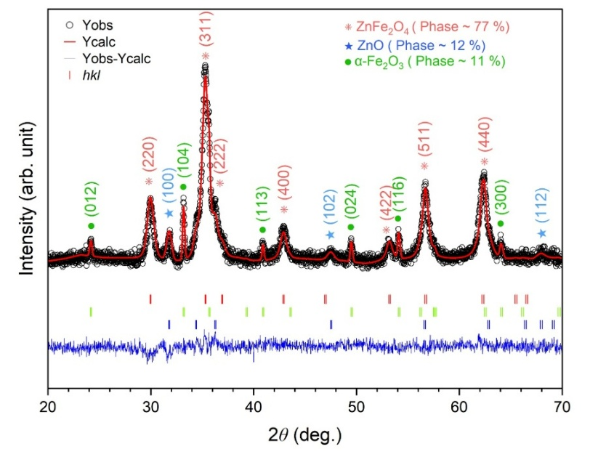

Figure S1
Figure S1 presents the Rietveld refinement of the XRD pattern for the ZF sample, revealing the presence and relative phase percentages of ZnFe₂O₄, ZnO, and α-Fe₂O₃. The good agreement between the experimental and calculated diffraction profiles confirms the successful fitting, indicating that the sample primarily consists of the spinel ZnFe₂O₄ phase along with minor contributions from ZnO and α-Fe₂O₃.
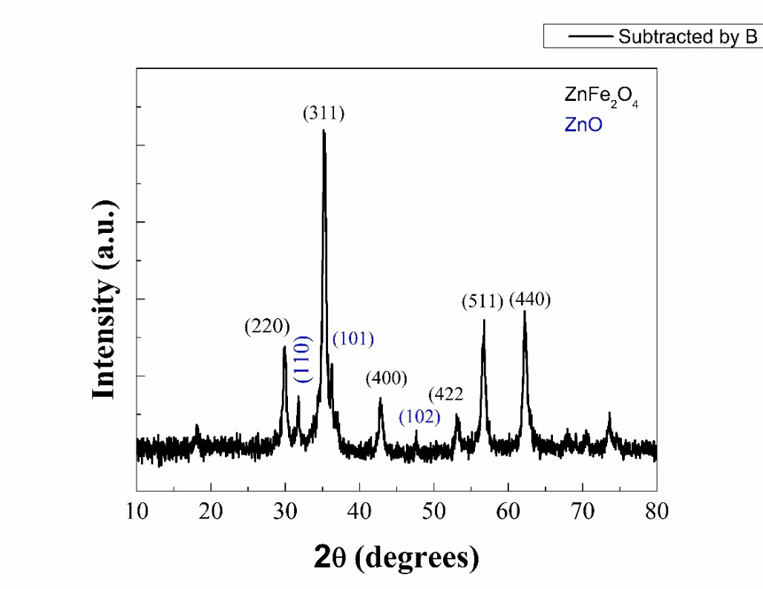
Figure S2
Figure S2 shows the XRD pattern of the sample which was prepared by annealing Fe-Zn glycolate at 400 °C. Based on this result a plausible mechanism has been proposed regrading the formation ZnO and subsequently both ZnO and α-Fe₂O₃ along with ZnFe₂O4 after annealing of Fe-Zn glycolate at 500 °C.
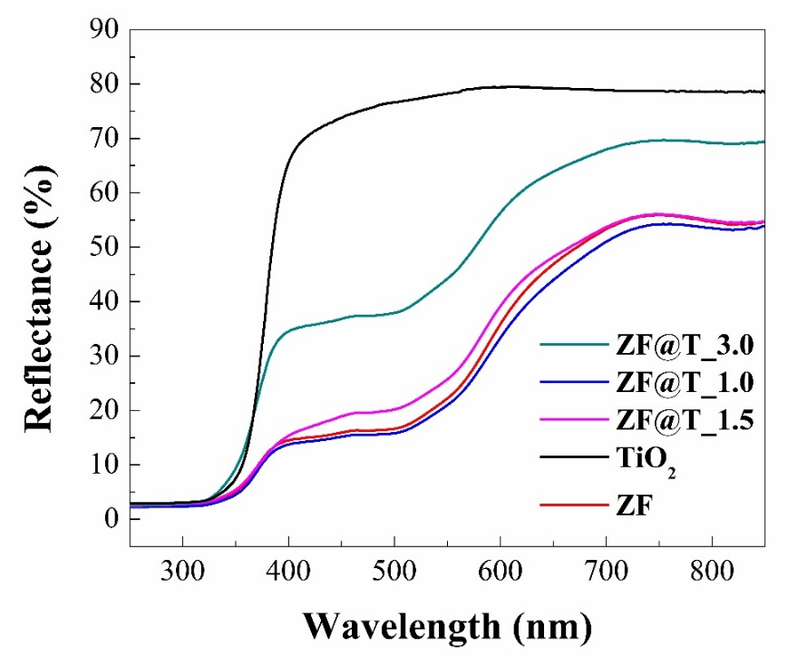
Figure S3
Figure S3 shows the reflectance data from which Kubelka Munk plots have been obtained.

