Appendix A.

Search Strategies
1 (Randomized Controlled Trial or Controlled Clinical Trial or Pragmatic Clinical Trial or Clinical Study or Adaptive Clinical Trial or Equivalence Trial).pt.
2 (Clinical Trial or Clinical Trial, Phase I or Clinical Trial, Phase II or Clinical Trial, Phase III or Clinical Trial, Phase IV or Clinical Trial Protocol).pt.
3 Multicenter Study.pt.
4 Clinical Studies as Topic/
5 exp Clinical Trial/ or exp Clinical Trials as Topic/ or Clinical Trial Protocol/ or Clinical Trial Protocols as Topic/ or exp "Clinical Trial (topic)"/
6 Multicenter Study/ or Multicenter Studies as Topic/ or "Multicenter Study (topic)"/
7 Randomization/
8 Random Allocation/
9 Double-Blind Method/
10 Double Blind Procedure/
11 Double-Blind Studies/
12 Single-Blind Method/
13 Single Blind Procedure/
14 Single-Blind Studies/
15 Placebos/
16 Placebo/
17 Control Groups/
18 Control Group/
19 Cross-Over Studies/ or Crossover Procedure/
20 (random* or sham or placebo*).ti,ab,hw,kf.
21 ((singl* or doubl*) adj (blind* or dumm* or mask*)).ti,ab,hw,kf.
22 ((tripl* or trebl*) adj (blind* or dumm* or mask*)).ti,ab,hw,kf.
23 (control* adj3 (study or studies or trial* or group*)).ti,ab,hw,kf.
24 (clinical adj3 (study or studies or trial*)).ti,ab,hw,kf. 7150541
25 (Nonrandom* or non random* or non-random* or quasi-random* or quasirandom*).ti,ab,hw,kf.
26 (phase adj6 (study or studies or trial*)).ti,ab,hw,kf.
27 ((crossover or cross-over) adj3 (study or studies or trial*)).ti,ab,hw,kf.
28 ((multicent* or multi-cent*) adj3 (study or studies or trial*)).ti,ab,hw,kf.
29 allocated.ti,ab,hw.
30 ((open label or open-label) adj5 (study or studies or trial*)).ti,ab,hw,kf.
31 ((equivalence or superiority or non-inferiority or noninferiority) adj3 (study or studies or trial*)).ti,ab,hw,kf.
32 (pragmatic study or pragmatic studies).ti,ab,hw,kf.
33 ((pragmatic or practical) adj3 trial*).ti,ab,hw,kf.
34 ((quasiexperimental or quasi-experimental) adj3 (study or studies or trial*)).ti,ab,hw,kf.
35 trial.ti,kf.
36 or/1-35
37 exp animals/
38 exp animal experimentation/
39 exp models animal/
40 exp animal experiment/
41 nonhuman/
42 exp vertebrate/
43 or/37-42
44 exp humans/
45 exp human experiment/
46 or/44-45
47 43 not 46
48 36 not 47
49 exp aged/ or middle aged/
50 (old* or senior* or geriatric* or adult* or elder* or (aged adj "50")).ti,ab,kf.
51 49 or 50
52 (Cognitive therap* or cognitive intervention or cognitive training or cognitive restoration or cognitive retraining or cognitive re-training or cognitive stimulation or cognitive rehabilitation or cognitive remediation or memory training).ti,ab,kf.
53 cognitive remediation therapy/
54 "cognitive enhancement therap*".ti,ab,kf.
55 CRT.ti,ab,kf.
56 52 or 53 or 54 or 55
57 48 and 51 and 56
58 exp dementia/ or mild cognitive impairment/
59 Lewy body/
60 (dement* or alzheimer* or (lewy* adj2 bod*) or (cognit* adj2 impair*)).ti,ab,kf.
61 MCI.ti,ab,kf.
62 58 or 59 or 60 or 61
63 57 and 58
64 limit 63 to english language
65 (cognitive adj2 (improv* or output*)).mp.
66 64 and 65
67 MMSE
68 66 and 67

Appendix B. Forest Plot depicting the efficacy of trials comparing DCRT with TAU (page 24 in the manuscript)

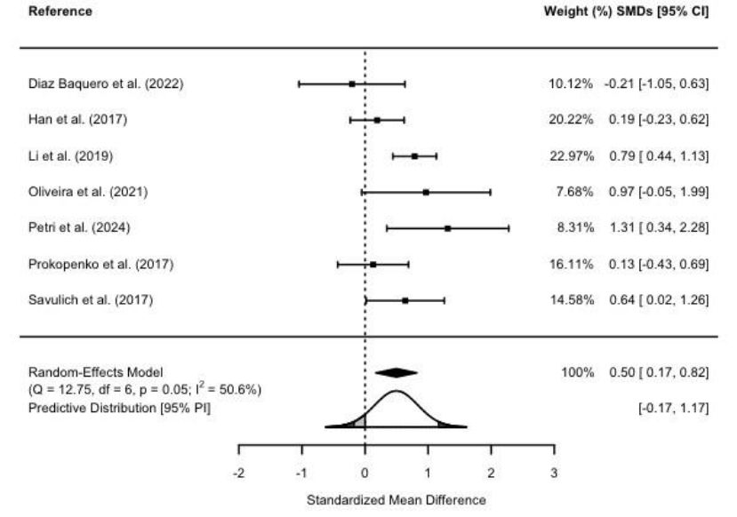
We add the forest plot of DCRT vs treatment-as-usual (TAU) as the supplementary material to show the effect size comparison between DCRT vs TAU alone, without placebo training. The forest plot shows that the effect size remains consistent when we exclude the placebo training.

