Additional File 3

Fig S1

  - Fig S2

  - Fig S3
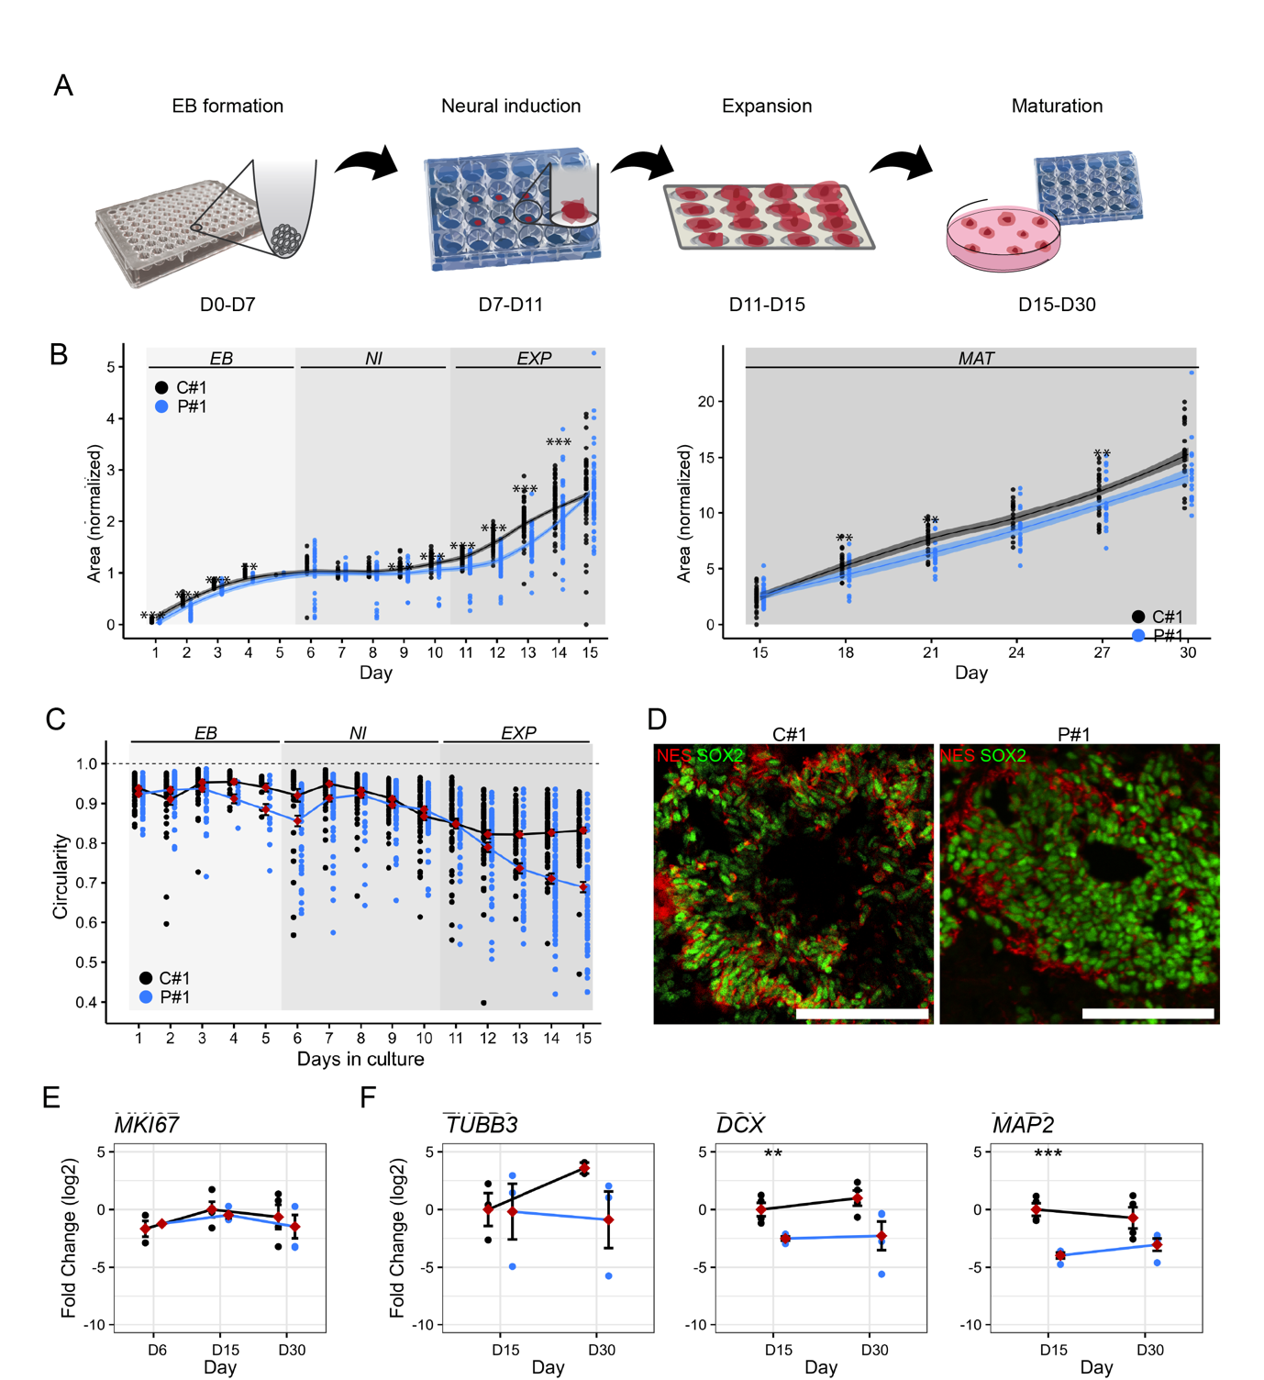

  - Fig S4
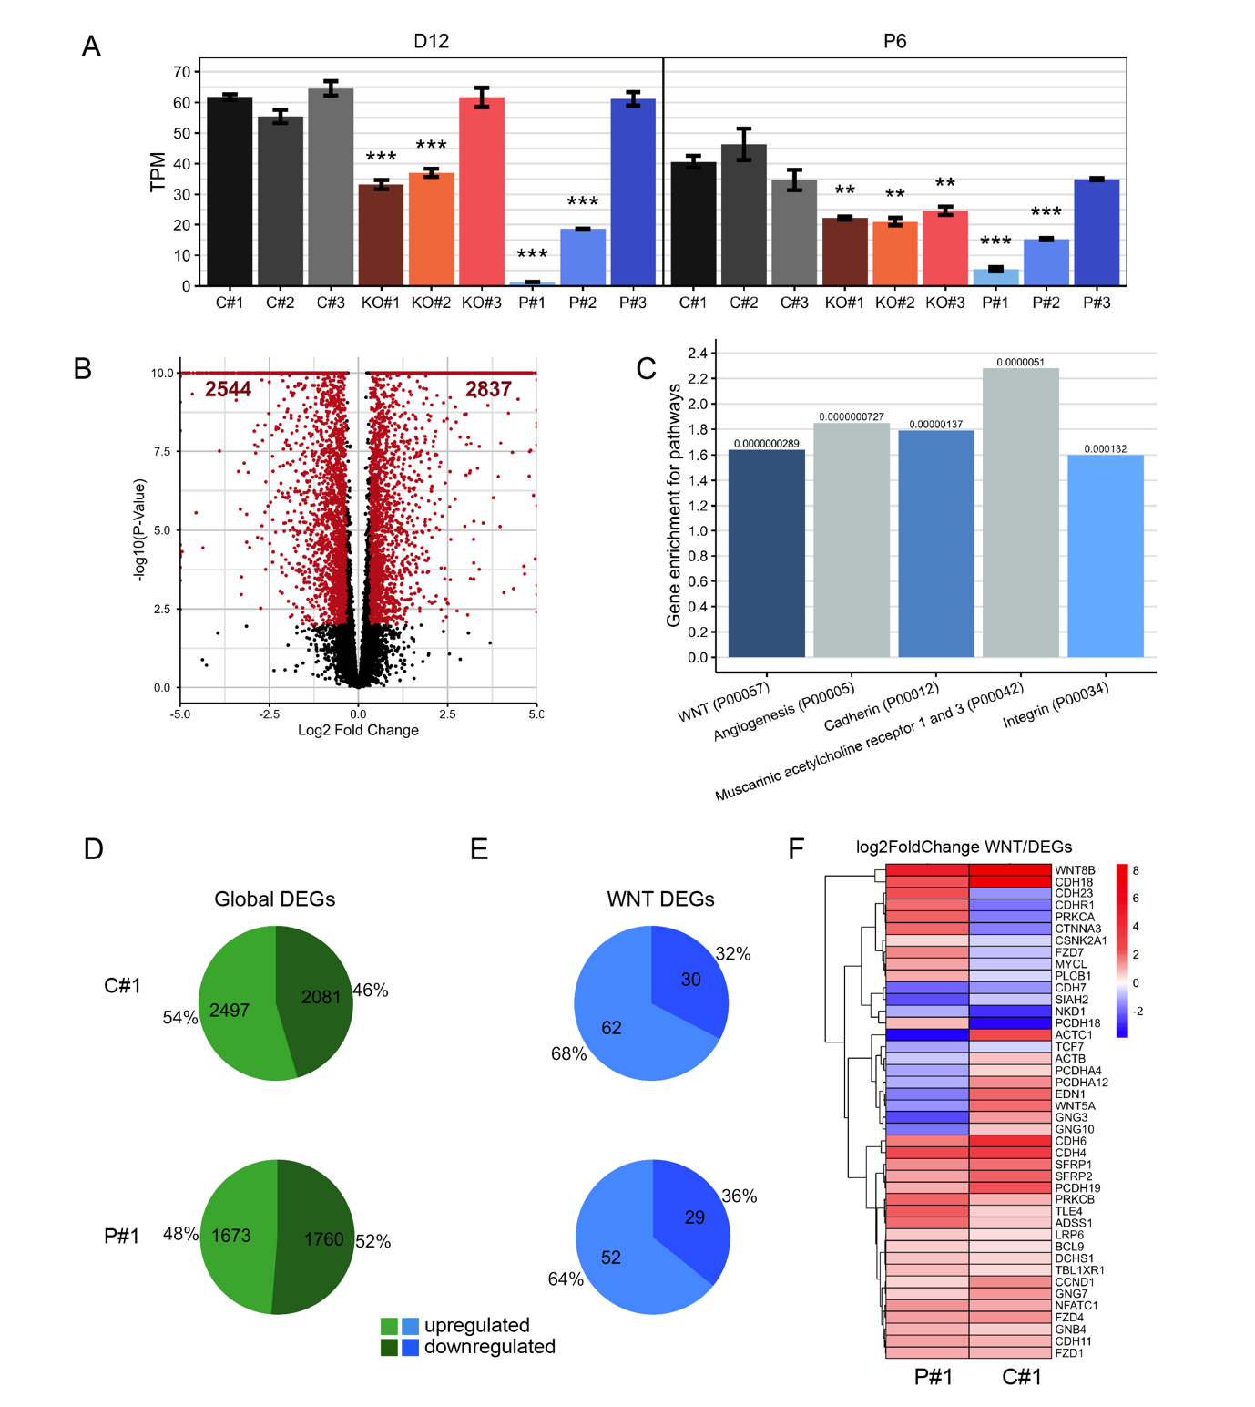

  - Fig S5

