Coverage Checker Supplementary Information
Supplementary Results
Checking the genome coverage of Kraken-identified taxa in simulated samples retains most classified reads while improving the F1 score
Kraken identified a total of 24,776 or 13,553 species across all 70 samples using the NCBI RefSeq V214 or Standard V2024-09-04 databases, respectively. Filtering based on the fraction of the reference genome present is most effective at increasing the F1 score of the GeCoCheck filtering methods that we employed (other methods tested were reads mapped to the reference genome by Bowtie2, proportion of Kraken-assigned reads mapped to the reference genome, average identity of reads mapped to the reference genome, and actual/expected genome fraction present; see Methods for further detail).
For the Standard V2024-09-04 database, the maximum F1 score obtained was 0.77 with a reference genome fraction of 1%, which was higher than that obtained by altering the confidence threshold (0.56 with a confidence threshold of 1.0). 64% of reads remained classified with a genome fraction of 1% while only 9.8% remained classified with a confidence threshold of 1.0 (Fig. S4). It is worth noting that the percentage of reads classified reflects species-level classifications; other studies have also mentioned this issue and have found that increasing redundancy in databases often leads to fewer species-level classifications, although a higher proportion of reads overall can be classified [1]. The difference between filtering by confidence threshold and by reference genome fraction present was largest at the lowest ANI (95%) and decreased with increasing ANI (Fig. S5).
Filtering the NCBI RefSeq V214 Kraken results on genome fraction present (≥0.5%) reduces the false positives from an average of 3,938 per sample to an average of 11 per sample. Examining the remaining false positives in more detail, there were 230 false positive species identified across all 70 simulated samples (median genome fraction present 0.86%), 127 of which were not present in the simulated reads of any samples (median genome fraction present 0.77%). Nine of these species had > 5% genome fraction in one or more samples (Campylobacter jejuni, Blattabacterium clevelandi, Streptococcus pneumoniae, Bacillus cereus, Bacillus thuriengiensis, Clostridium botulinum, Burkholderia vietnamiensis, Agrococcus sp. TF02-05, and Malaciobacter canalis), but all of these species came from genera that did have simulated reads within the samples. Similar reductions to the number of false positive taxa identified are seen for the Standard V2024-09-04 database (Fig. S6).
GeCoCheck also groups the read files for each taxonomy ID by metadata category or by project, so that it can be determined whether the same regions of a reference genome are covered by multiple samples and whether the genome fraction covered is additive. It can also be run using only these grouped reads rather than on a per sample basis, which dramatically speeds up the time taken to run. We therefore investigated whether comparable results could be obtained using these grouped reads, and used the species identified at different genome fraction thresholds within the metadata category (or across all samples) to filter the taxa within each sample. This did increase the F1 score compared with no filtering (maximum F1 score of 0.63 for metadata category or 0.38 within all samples) but did not increase it as much as filtering within individual samples (maximum F1 score 0.92; Fig. S7) and we therefore recommend that GeCoCheck be used at the individual sample level where possible.
Computational requirements of GeCoCheck
To determine the computational requirements for GeCoCheck, we used the output from classifications of the 70 Parks et al. simulated samples using Kraken and the Standard V2024-09-04 database that included 13,553 identified species and uncompressed total FASTQ file size of 279 GB. Using 36 threads on a server running Ubuntu 20.04.05 with 1.5 TB RAM and 4 × Intel(R) Xeon(R) CPU E7-8870 v4 @ 2.10GHz=40 cores (80 threads) this run took 78 hours 47 mins 24 secs and the maximum RAM usage was 17.31 GB for the 567,792 sample-taxon combinations (i.e., 70 samples, 7 sample groupings and all samples combined for the 12,042 prokaryotic taxa that had genomes in the NCBI RefSeq database at the time of running).

Supplementary Figures
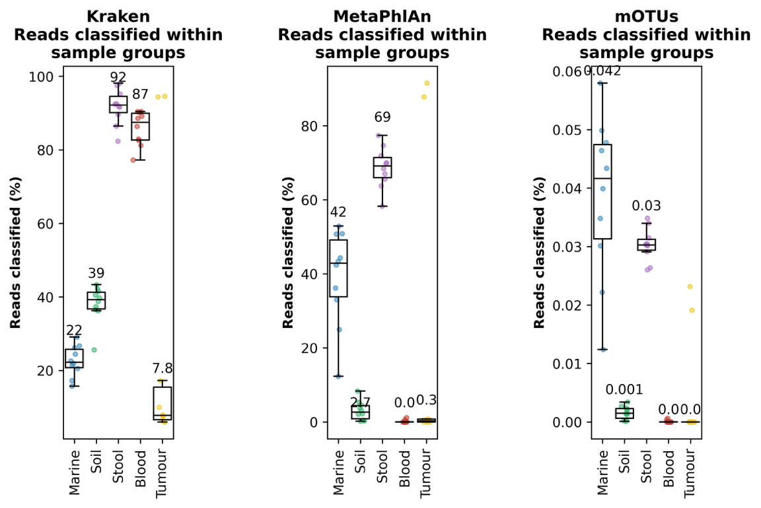
Figure S1. Proportion of reads classified by Kraken, MetaPhlAn and mOTUs within the Marine, Soil, Stool, Blood and Tumour datasets. Each dataset contains ten samples. Points within each plot represent an individual sample and boxplots and whiskers indicate the median and interquartile range, and 1.5 x the interquartile range, respectively. Numbers above boxplots indicate the median proportion of reads classified within that sample type by that metagenomic taxonomic classifier. Note that while Fig. 1 contains the number of non-eukaryotic species, these numbers also include eukaryotes where the classifier includes them.

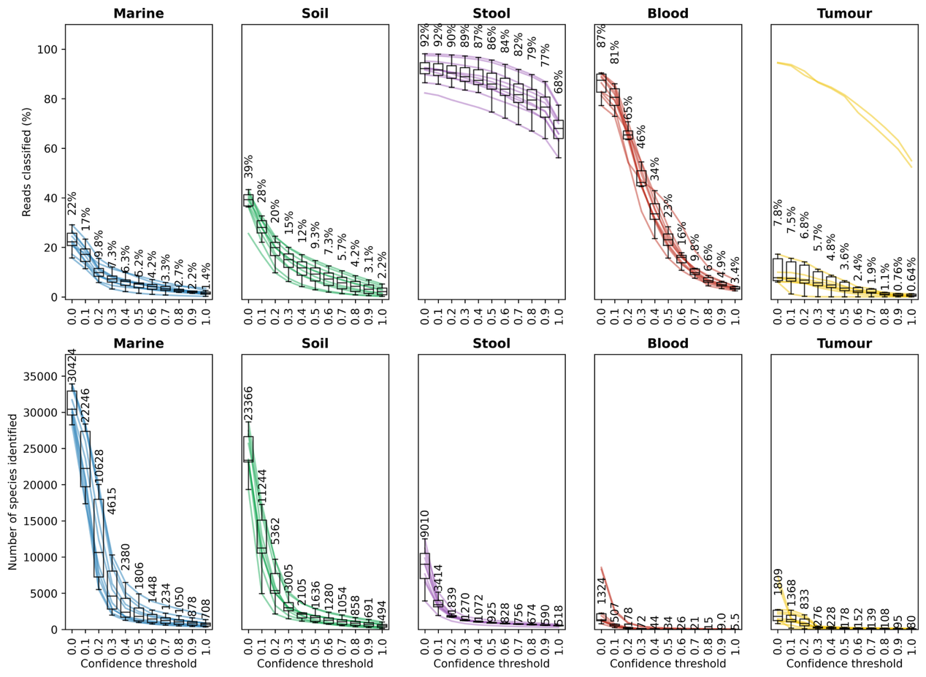
Figure S2. The number of reads classified (top) and species identified (bottom) with increasing Kraken confidence threshold (0.0-1.0) within Marine, Soil, Stool, Blood and Tumour datasets. Each sample is shown with a coloured line within each plot, and boxplots and whiskers indicate the median and interquartile range, and 1.5 x the interquartile range, respectively. Median numbers for each confidence threshold are indicated above the boxplots. Note that two of the tumour samples (samples 4 and 5) had much higher proportions of reads classified as bacterial and more species identified than the other tumour samples. These samples had comparable numbers of reads to the other samples but were the only ones to have any microbial genomes present >1% genome fraction (see Results Section 3.3.4).

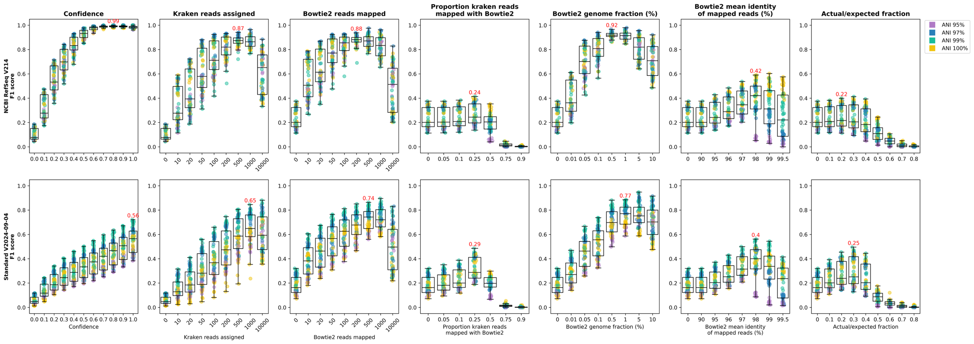
Figure S3. F1 scores for the simulated samples filtered using confidence threshold or Kraken reads assigned (left two columns) or a range of metrics provided by GeCoCheck (all other columns). The top row shows taxonomic classifications obtained using the NCBI RefSeq V214 database while the bottom row shows the Standard V2024-09-04 database. In each case, F1 scores are calculated as $2 × \frac{Precision × Recall}{Precision+Recall}$, where $Precision= \frac{True positives}{True positives+False positives}$ and $Recall= \frac{True positives}{True positives+False negatives}$. Points within each plot represent individual samples, coloured by their Average Nucleotide Identity (ANI) to reference databases, and boxplots and whiskers indicate the median and interquartile range, and 1.5 x the interquartile range, respectively. A red number in each panel indicates where the highest F1 score is located within each filtering method.

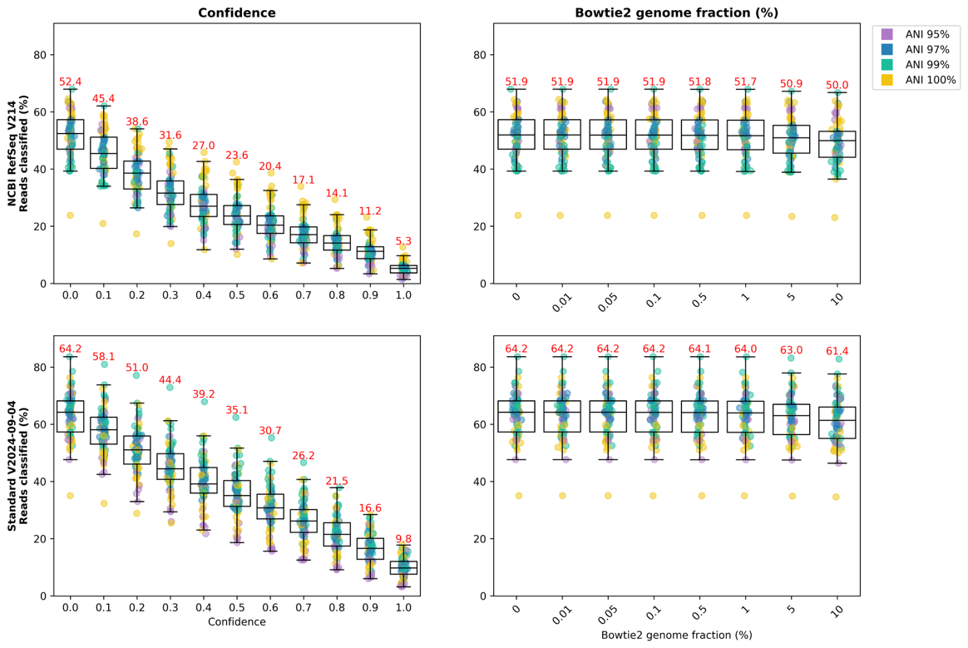
Figure S4. Proportion of reads classified at the species level for simulated samples filtered using confidence threshold (left) or genome fraction present within Bowtie 2-mapped reads (right). The top row shows taxonomic classifications obtained using the NCBI RefSeq V214 database while the bottom row shows the Standard V2024-09-04 database. Points within each plot represent individual samples, coloured by their Average Nucleotide Identity (ANI) to reference databases, and boxplots and whiskers indicate the median and interquartile range, and 1.5 x the interquartile range, respectively. Red numbers above boxplots show median values for each confidence threshold or genome fraction.

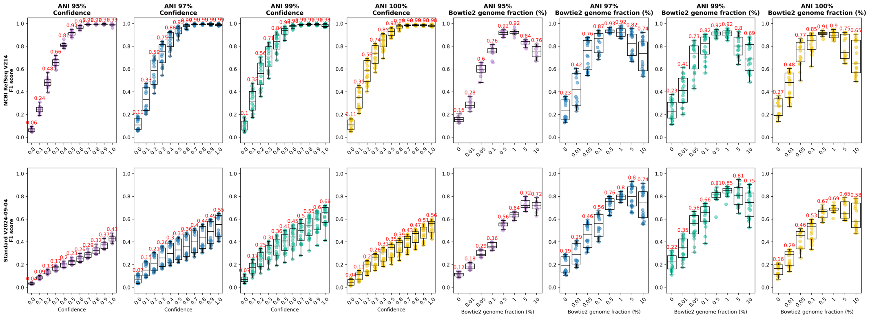
Figure S5. F1 scores for the simulated samples shown separately for each Average Nucleotide Identity (ANI) and filtered using confidence threshold (left four columns) or genome fraction (right four columns). The top row shows taxonomic classifications obtained using the NCBI RefSeq V214 database while the bottom row shows the Standard V2024-09-04 database. In each case, F1 scores are calculated as described in Fig. S3. Points within each plot represent individual samples, coloured by their Average Nucleotide Identity (ANI) to reference databases, and boxplots and whiskers indicate the median and interquartile range, and 1.5 x the interquartile range, respectively. Red numbers above boxplots show the median F1 score for each threshold/fraction.

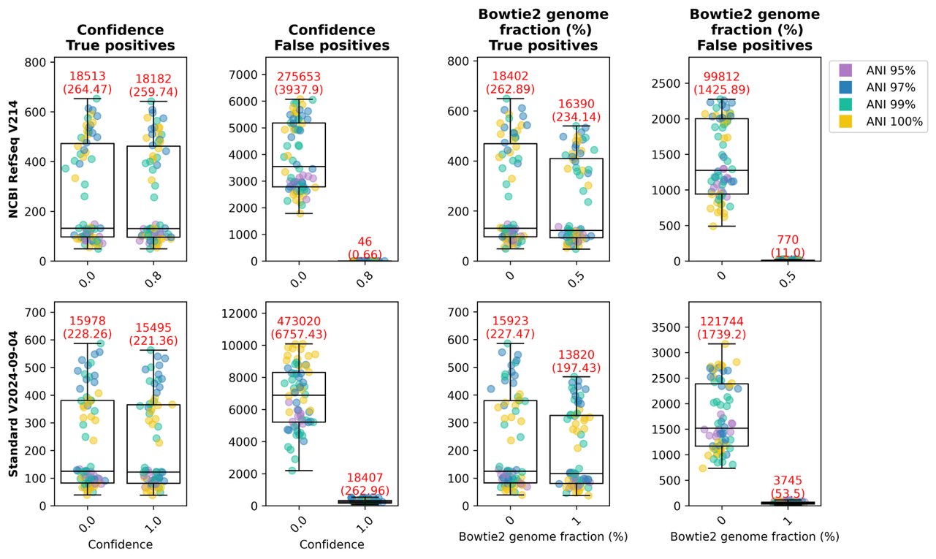
Figure S6. True and false positive taxa within simulated samples when the taxa present are filtered on confidence threshold (left two columns) or genome fraction (right two columns). The top row shows taxonomic classifications obtained using the NCBI RefSeq V214 database while the bottom row shows the Standard V2024-09-04 database. Points within each plot represent individual samples, coloured by their Average Nucleotide Identity (ANI) to reference databases, and boxplots and whiskers indicate the median and interquartile range, and 1.5 x the interquartile range, respectively. Red numbers above boxplots show the total number of true/false positive taxa as well as the average number per sample.

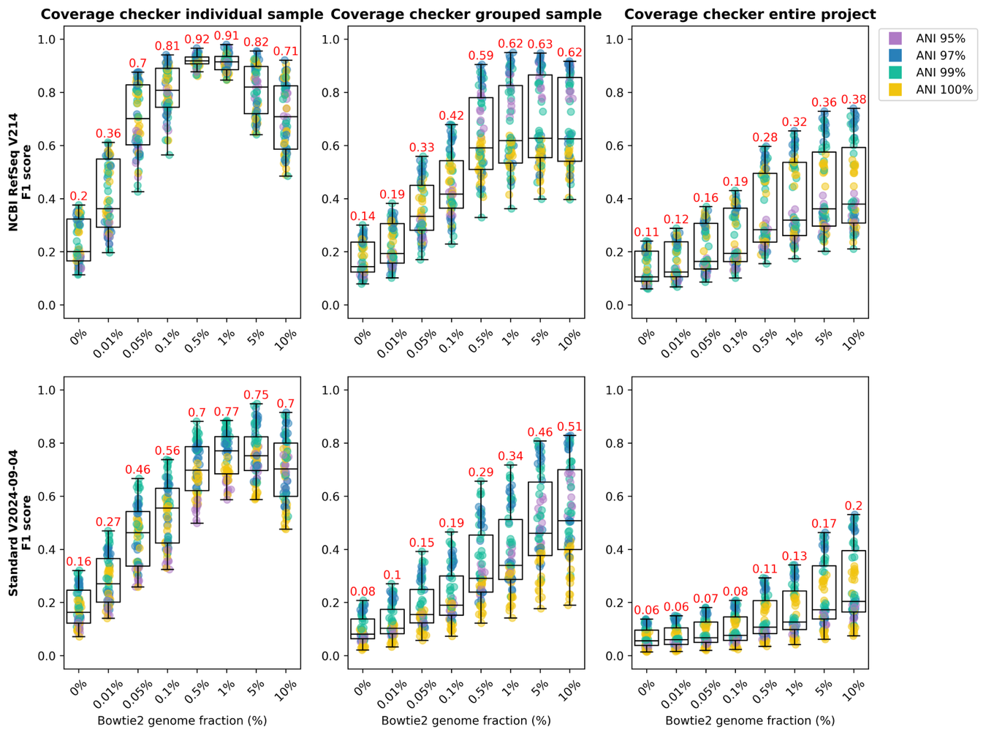
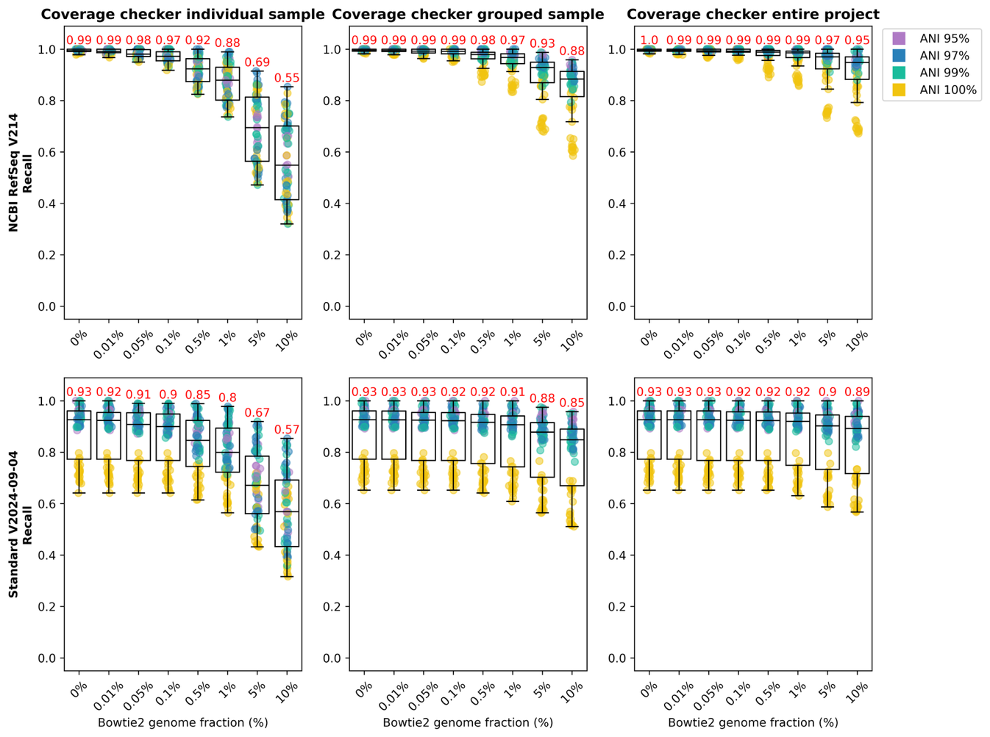
Figure S7. F1 scores (top two rows) and recall (bottom two rows) for species filtered by genome fraction in individual samples (left), within groupings of sample type (i.e., the same ANI and species diversity; middle) or within all samples (right). The first and third rows show taxonomic classifications obtained using the NCBI RefSeq V214 database and the second and fourth rows show the Standard V2024-09-04 database. Points within each plot represent individual samples, coloured by their Average Nucleotide Identity (ANI) to reference databases, and boxplots and whiskers indicate the median and interquartile range, and 1.5 x the interquartile range, respectively. Red numbers above boxplots show median values.

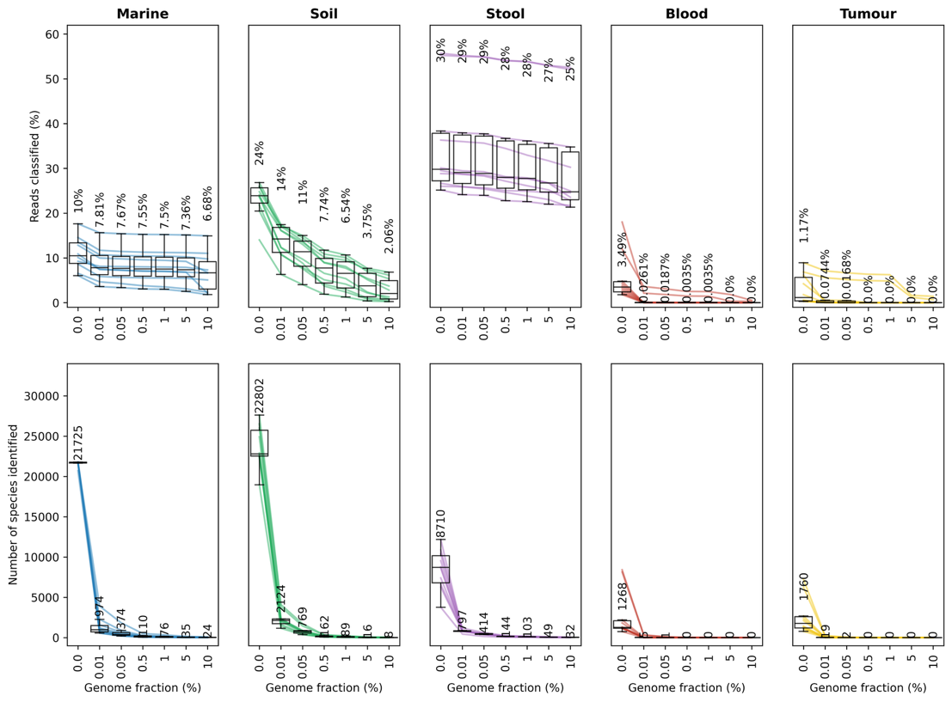
Figure S8. The number of reads classified (top) and species identified (bottom) with increasing genome fraction required to be present within Marine, Soil, Stool, Blood and Tumour datasets. Each sample is shown with a coloured line within each plot, and boxplots and whiskers indicate the median and interquartile range, and 1.5 x the interquartile range, respectively. Median numbers for each genome fraction are indicated above the boxplots.

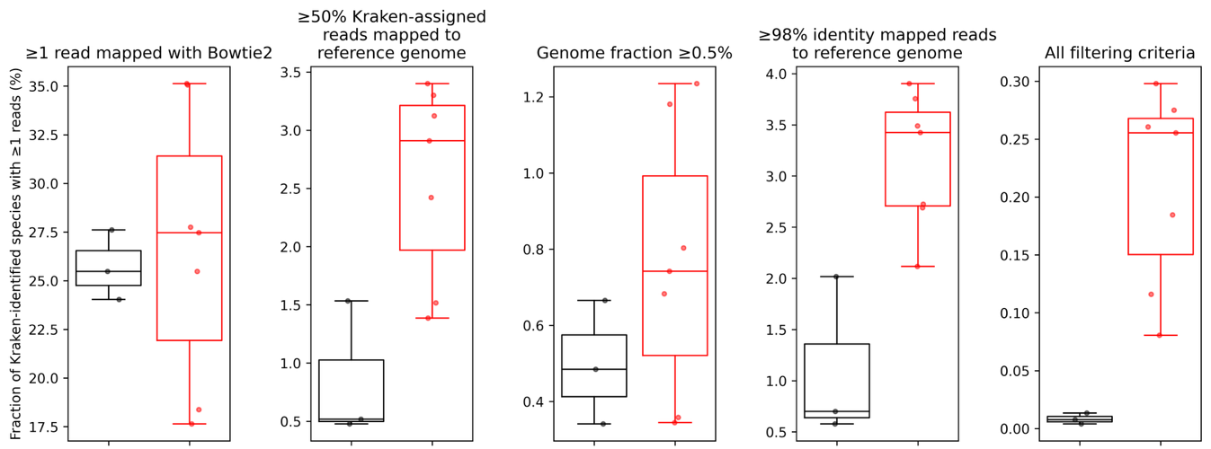
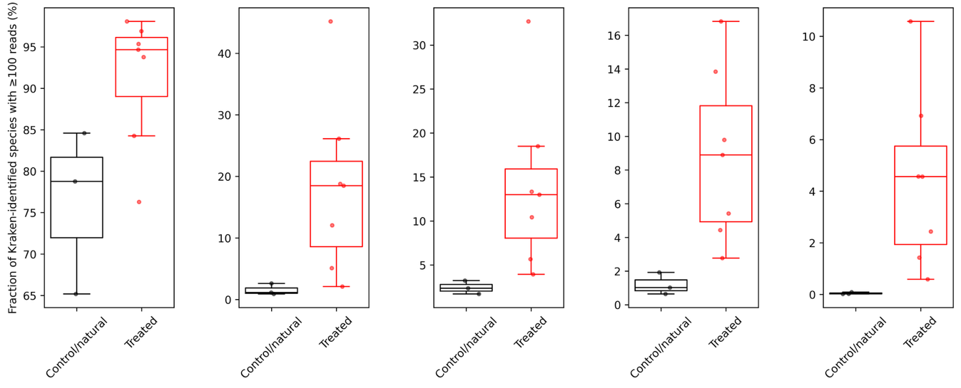
Figure S9. Species identified within Soil samples that meet certain filtering criteria (columns). The top row shows these as a percentage of all species that Kraken identified having at least 1 read, while the bottom row shows all species that Kraken identified having at least 100 reads. Samples are split by whether they came from control/natural or treated soils.

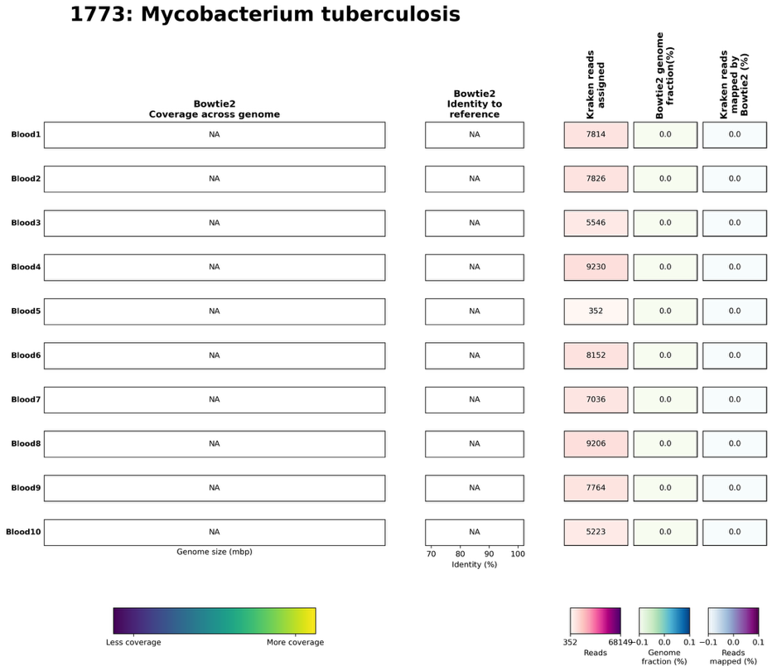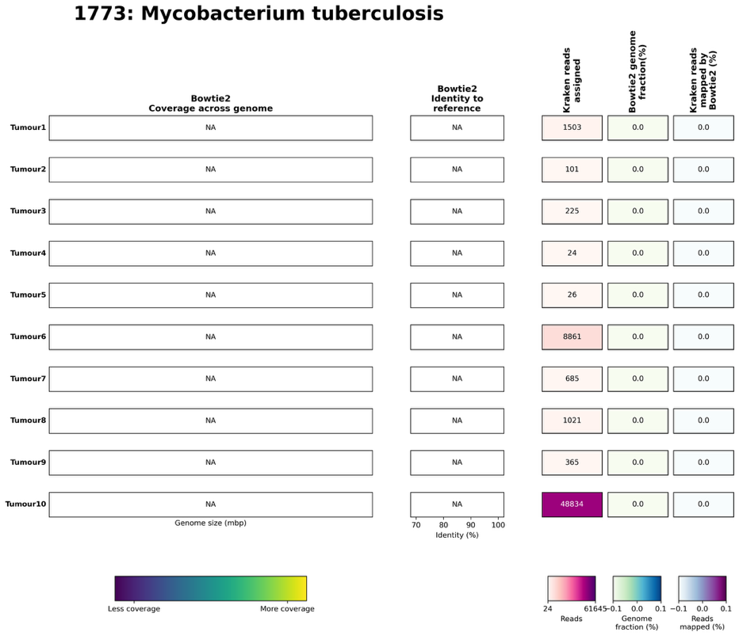
Figure S10. Mycobacterium tuberculosis reference genome coverage in Blood (left) or Tumour (right) samples. The plots for each dataset were produced using the GeCoCheck plotting script and – if any reads were mapped to the M. tuberculosis genome – would show: (i) the location of Bowtie 2-mapped reads across the length of the reference genomes, as well which regions have higher (yellow) or lower (blue) numbers of mapped reads (left box); (ii) the identity of the mapped reads to the reference genomes (middle box; each point represents the identity of a single read, with boxplots indicating the median and interquartile range and whiskers 1.5 x the interquartile range); and (iii) the number of reads assigned by Kraken to each species, the genome fraction (%) that has mapped reads, and the percentage of Kraken-assigned reads that can be mapped to the genome (right boxes). Cells here are coloured according the minimum or maximum numbers shown within the plot. The sample that Kraken-assigned reads came from is shown on the left (rows).

References
1. Nyström-Persson J, Bapatdhar N, Ghosh S. Precise and scalable metagenomic profiling with sample-Tailored minimizer libraries. NAR Genom Bioinform. Oxford University Press; 2025;7. https://doi.org/10.1093/nargab/lqaf076

