Gels and Blots image(s) supplementary materials

Fig2. Levels of BMP8A mRNA and protein in three designated cell lines.
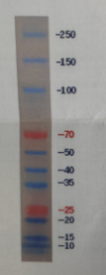
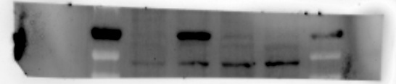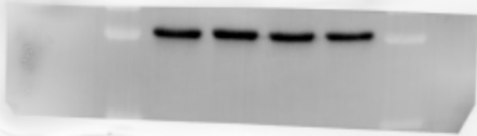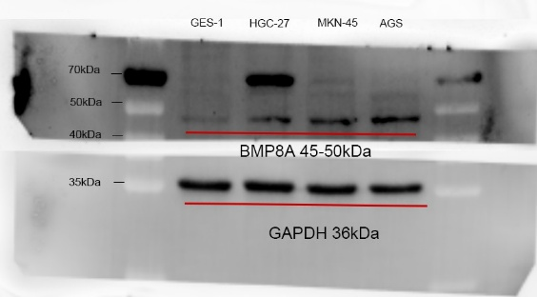
Fig2. protein expression of BMP8A in transfected cell HGC-27 and Fig3. protein expression of BMP8A in transfected cell GAS.
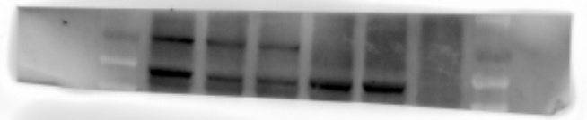
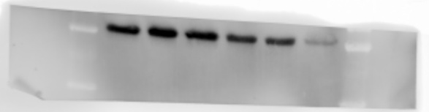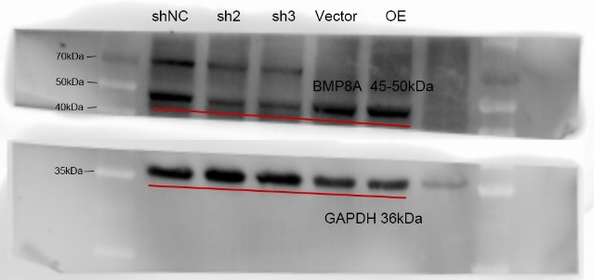

Fig2. protein expression of BMP8A in transfected cell MKN-45.
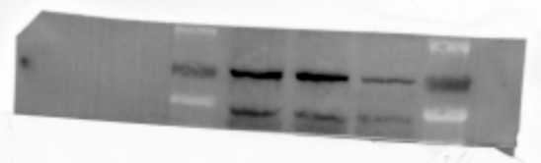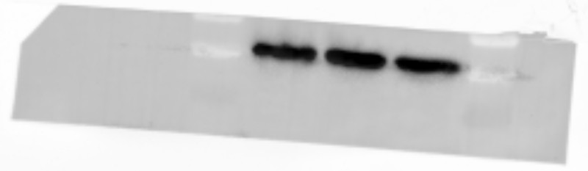 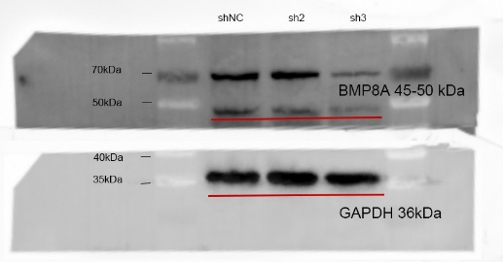

Fig4.protein expression of MMP2 and MMP14 in HGC-27 cells with BMP8A knockdown.
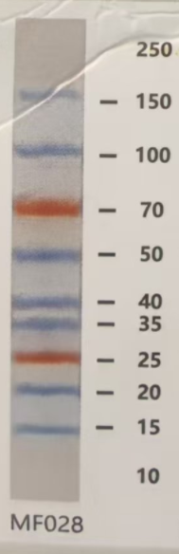

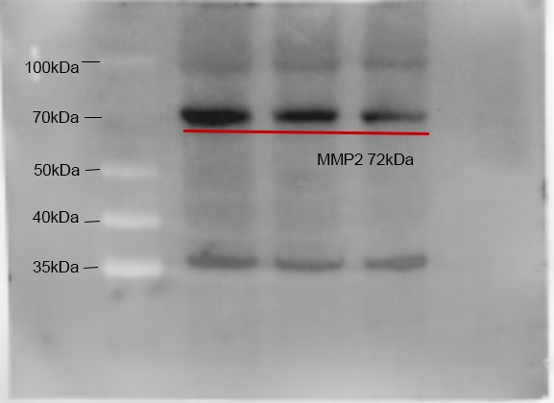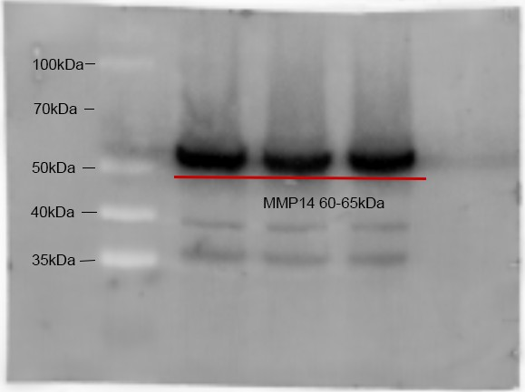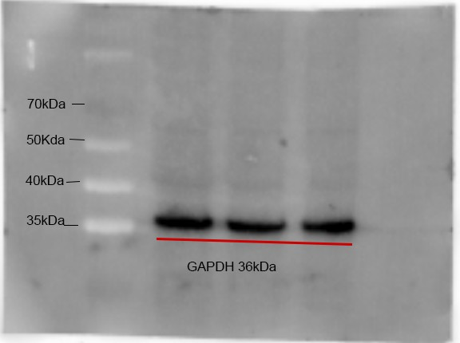

Fig4.protein expression of MMP2 and MMP14 in MKN-45 cells with BMP8A. knockdown
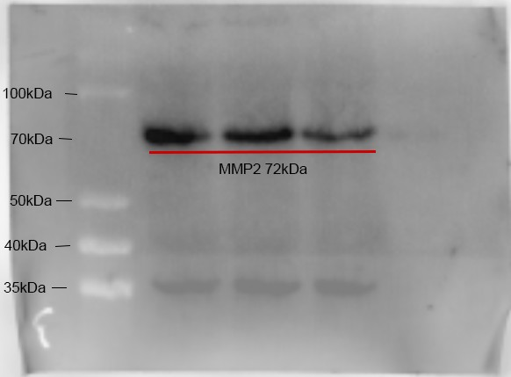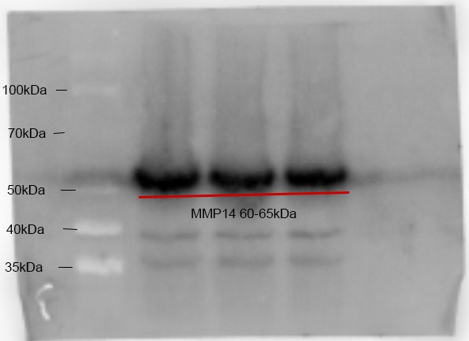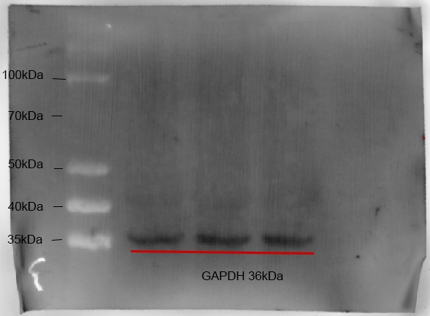

Fig4.protein expression levels of MMP2 and MMP14 in AGS cells with BMP8A overexpression.
