Supplemental Material
Supplemental Figures
Supplemental Figure S1. Generation and verification of Arabidopsis lines with GC-specific PGLP1 overexpression and antisense repression.
Supplemental Figure S2. Chlorophyll fluorescence parameters of Arabidopsis lines with GC-specific PGLP1 overexpression and antisense repression grown in air.
Supplemental Figure S3. Stomata parameters of Arabidopsis lines with GC-specific PGLP1 overexpression and antisense repression grown in air and high CO₂.
Supplemental Figure S4. Generation and verification of Arabidopsis lines with GC-specific SBPase overexpression and antisense repression.
Supplemental Figure S5. Phenotype, growth and photosynthesis of Arabidopsis lines with GC-specific SBPase overexpression and antisense repression.

Supplemental Tables
Supplemental Table S1. Quantitative growth data of Arabidopsis lines with GC-specific PGLP1 overexpression and antisense repression in air and high CO₂.
Supplemental Table S2. Numeric data of chlorophyll fluorescence measurements of Arabidopsis lines with GC-specific PGLP1 overexpression and antisense repression grown in air.
Supplemental Table S3. Calculated parameters from gas exchange light response curves of Arabidopsis lines with GC-specific PGLP1 overexpression and antisense repression grown in air.
Supplemental Table S4. Numeric data of light response curves of Arabidopsis lines with GC-specific PGLP1 overexpression and antisense repression grown in air.
Supplemental Table S5. Numeric data of O₂-dependent CO₂ response curves of Arabidopsis lines with GC-specific PGLP1 overexpression and antisense repression grown in air.
Supplemental Table S6. Numeric data of stomata parameters of Arabidopsis lines with GC-specific PGLP1 overexpression and antisense repression grown in air and high CO₂.
Supplemental Table S7. Numeric data of stomata parameters of Arabidopsis wildtype plants grown on different 2-PG concentrations in air.
Supplemental Table S8. Numeric data of the metabolite analysis of Arabidopsis lines with GC-specific PGLP1 overexpression and antisense repression grown in air.
Supplemental Table S9. Primers used for PCR amplification.
Supplemental Figures
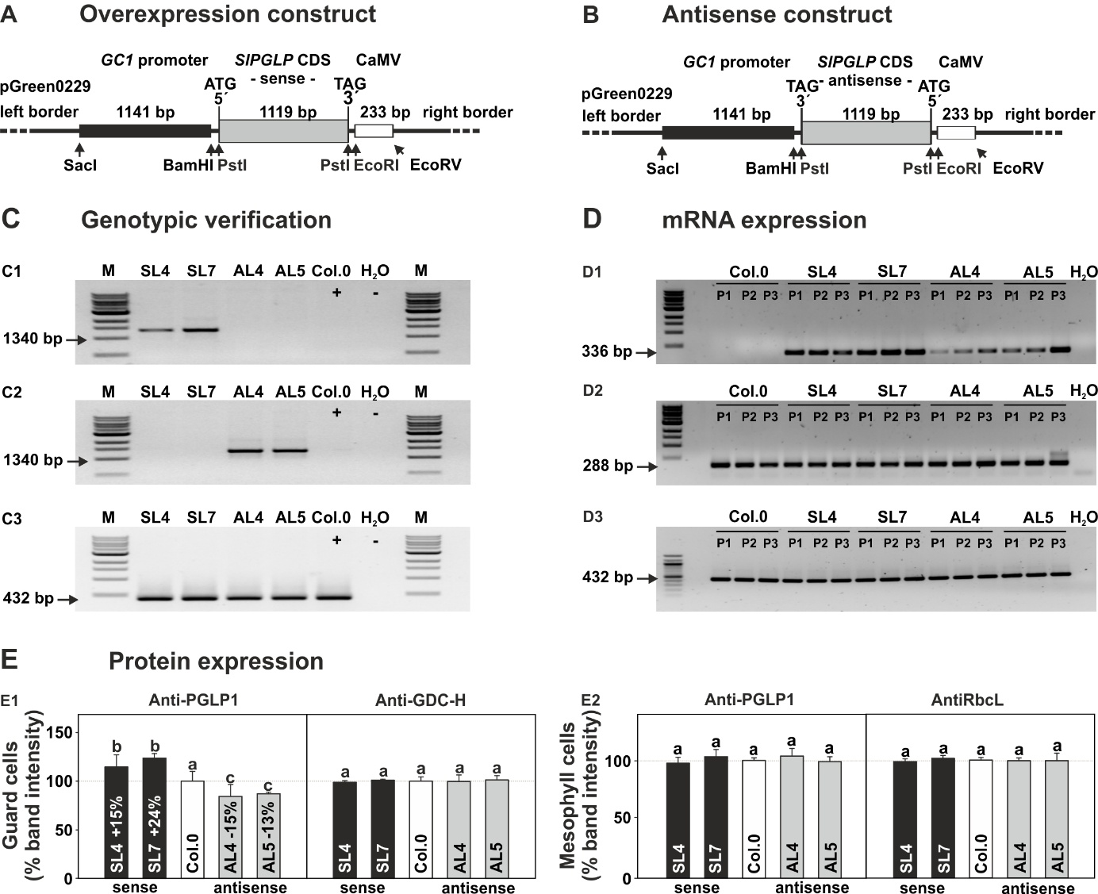
Supplemental Figure S1. Generation and verification of Arabidopsis lines with GC-specific PGLP1 overexpression and antisense repression.
Overview of the GC-specific PGLP1 (A) overexpression (sense) and (B) antisense repression constructs. (C) Genotypic validation of the transformed constructs into the genome of transgenic (C1) overexpression and (C2) antisense lines and the corresponding loading control (C3) via PCR. (D) RT-PCR validation of diagnostic fragments of the transgenic SlPGLP1 transcript in (D1) overexpression and (D2) antisense lines, in comparison with signals of the (D3) constitutively expressed 40S ribosomal protein S16 gene as control. (E) Densitometric analysis of PGLP1 protein expression analyzed via immunoblotting experiments of protein extracts from (E1) GC and (E2) MC, using a specific antibody against PGLP1 and GDC-H or RbcL as loading controls. Note, control immunoblots were essentially developed from the same membrane as used for PGLP1.

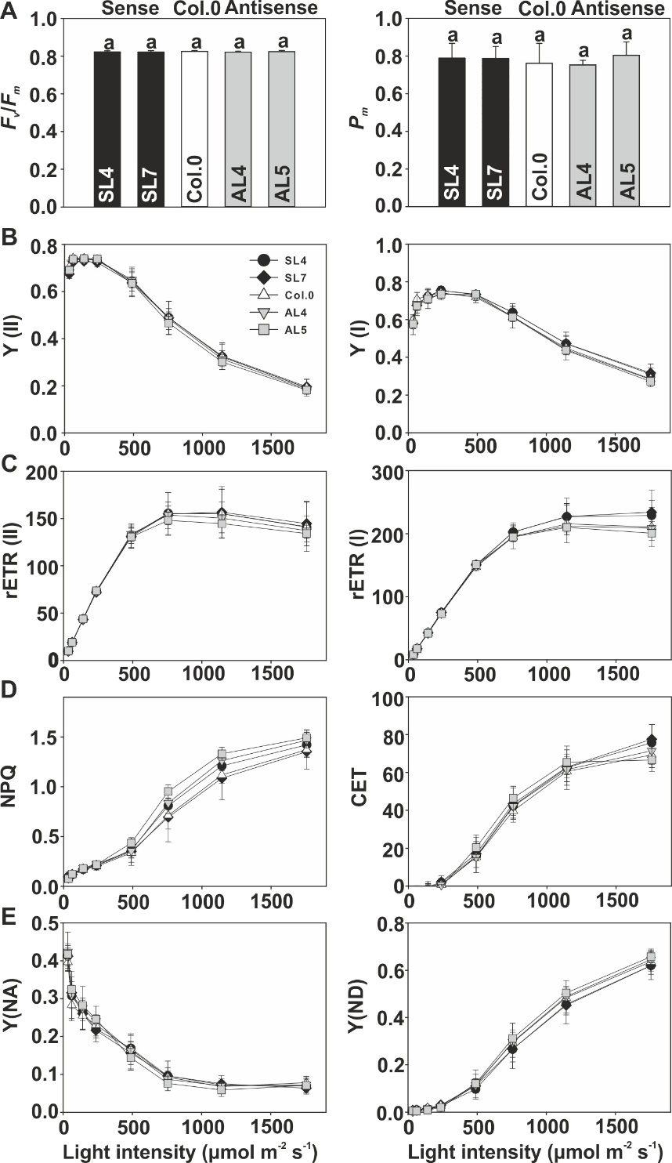
Supplemental Figure S2. Chlorophyll fluorescence parameters of Arabidopsis lines with GC-specific PGLP1 overexpression and antisense repression grown in air.
Given are selected PSII and PSI characteristics of all genotypes grown under standard growth conditions to stage 5.1 [43]. Displayed are: (A) Maximum efficiency of PSII (F_{v}/F_{m}) and maximum oxidizable P700 (P_{m}) from dark adapted plants; (B) photosynthetic efficiency curves of PSII (Y[II]) and PSI (Y[I]); (C) relative electron transport rates of PSII (rETR II) and PSI (rETR I); (D) non-photochemical quenching of PSII (NPQ) and cyclic electron flow around PSI (CET); and, (E) acceptor (Y[NA]) and donor (Y[ND]) side limitation of PSI. Shown are means ± SD of at least 6 biological replicates. Values that do not share the same letter are significantly different from each other as determined by ANOVA. Note, lack of significance letters in B to E is explained due to lack of statistical differences.
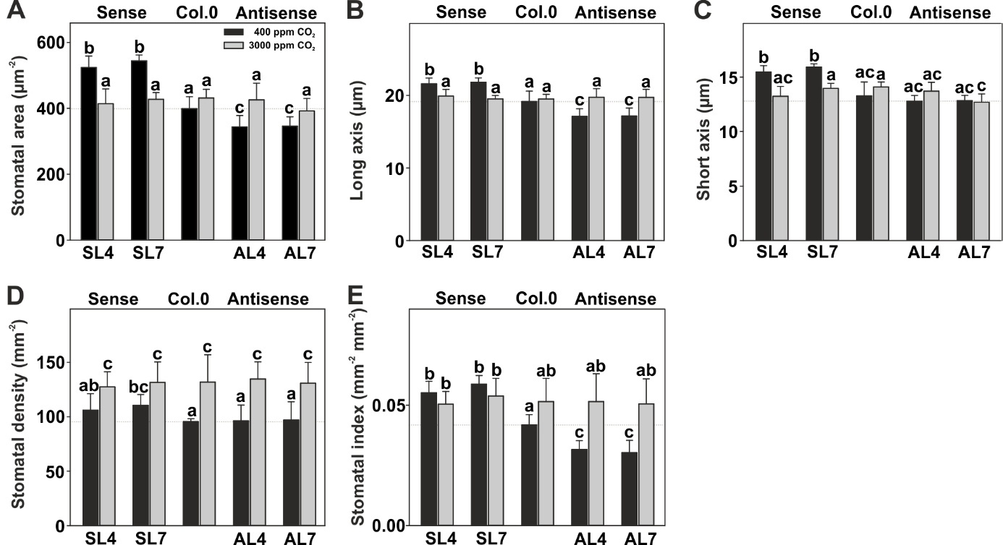
Supplemental Figure S3. Stomata parameters of Arabidopsis lines with GC-specific PGLP1 overexpression and antisense repression grown in air and high CO₂.
Plants were grown in air (400 ppm) and high CO₂ (3000 ppm) to stage 5.1 [43] to determine stomata parameters. Given are means ± SD (Σ 120 stomata per genotype was analyzed, from 4 biological replicates and 30 stomata per leaf) for: (A) stomata area, (B) stomata length, (C) stomata width, (D) stomatal density, and (E) stomatal index. Black bars show air and grey bars high CO₂ values. Values that do not share the same letter are significantly different from each other as determined by ANOVA. For full numerical data see Supp. Table S6.

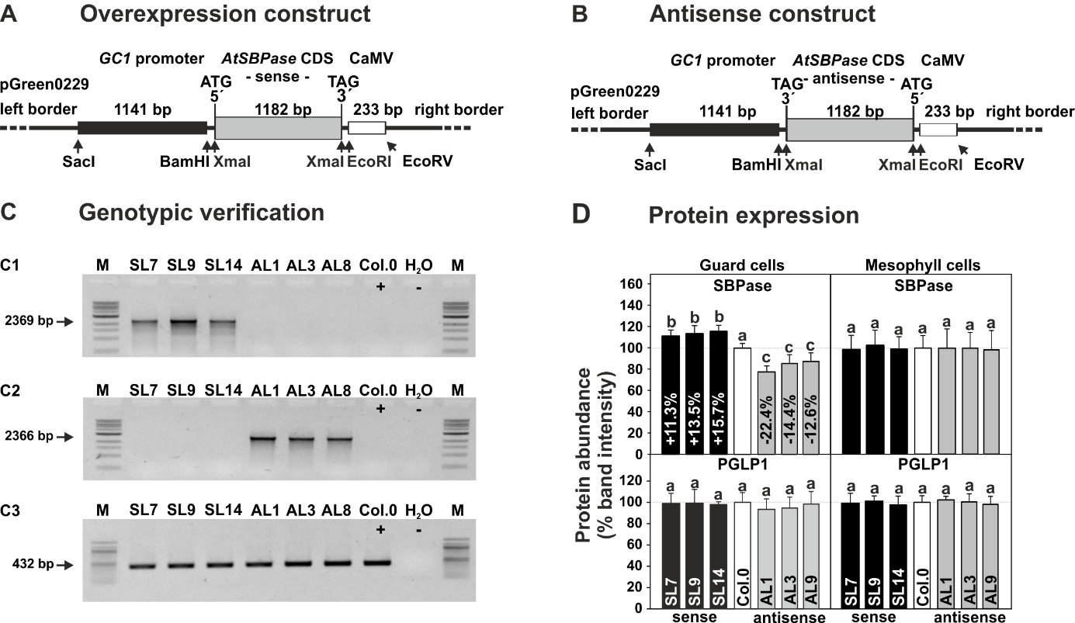
Supplemental Figure S4. Generation and verification of Arabidopsis lines with GC-specific SBPase overexpression and antisense repression.
Overview of the GC specific AtSBPase (A) overexpression (sense) and (B) antisense repression constructs. (C) Genotypic validation of the transformed constructs into the genome of transgenic (C1) overexpression and (C2) antisense lines and the corresponding loading control (C3) via PCR. (D) Densitometric analysis of SBPase (upper panel) and PGLP1 (lower panel) protein expression analyzed via immunoblotting experiments of protein extracts from GC (left) and MC (right), using a specific antibody against SBPase and PGLP1 as loading control. Note, control immunoblots were essentially developed from the same membrane as used for SBPase. Values that do not share the same letter are significantly different from each other as determined by ANOVA.

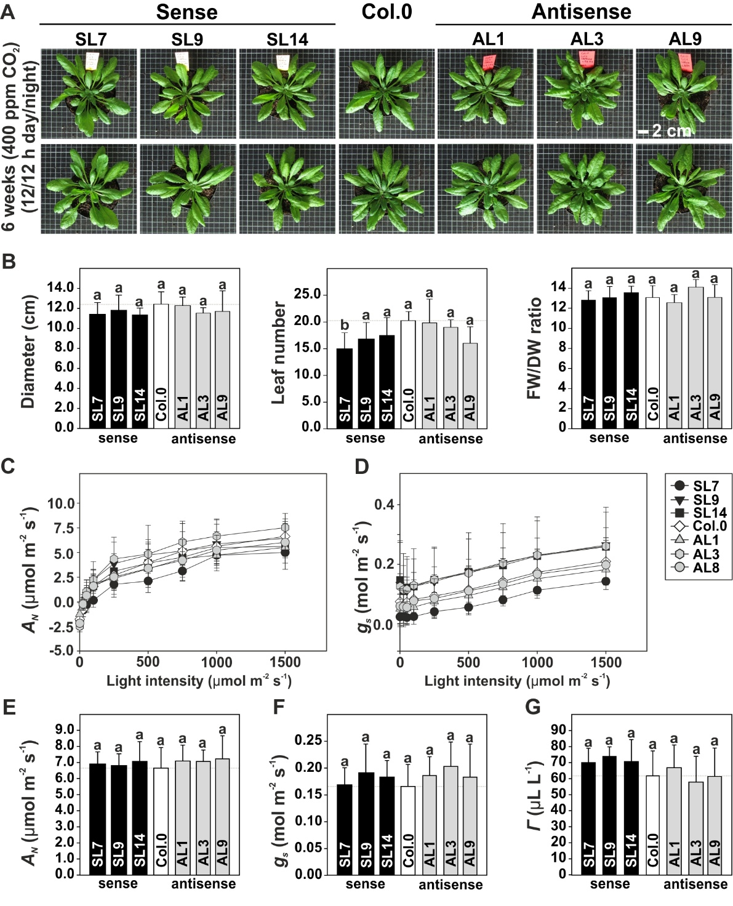
Supplemental Figure S5. Phenotype, growth and photosynthesis of Arabidopsis lines with GC-specific SBPase overexpression and antisense repression.
(A) Representative photographs and (B) selected diagnostic growth parameters of the transgenic lines compared to the wildtype following 6 weeks growth under standard conditions in air (400 ppm CO₂) with a 12/12 h day-/night-cycle. Selected parameters of the light response curves are given as follows: (C) Net CO₂ uptake rates (A_{N}) and, (D) stomatal conductance (g_{s}) and functions of increasing light intensities. Selected parameters of the CO₂ response curves are presented as follows: (E) A_{N}, (F) g_{s}, and (G) CO₂ compensation points (Γ). Shown are means ± SD of at least 6 biological replicates. Values that do not share the same letter are significantly different from each other as determined by ANOVA.

Supplemental Tables
Supplemental Table S1. Quantitative growth data of Arabidopsis lines with GC-specific PGLP1 overexpression and antisense repression in air and high CO₂.
Plants were grown under environmental controlled conditions in air (LC – low carbon; 400 ppm CO₂; 6 weeks) and high CO₂ (HC; 3000 ppm CO₂; 4 weeks) to growth stage 5.1 ([43]. Selected quantitative growth parameters are means ± SD of at least six biological replicates. Values that do not share the same letter (in bold) are significantly different from each other as determined by ANOVA analysis.

 | Genotype | Parameters
 | Genotype | Fresh weight (g) | Dry weight (g) | Diameter (cm) | Leaf number
LC | SL4 | 2.71 ± 0.43^{b} | 0.216 ± 0.027^{b} | 13.87 ± 0.66^{b} | 26.00 ± 2.01^{b}
LC | SL7 | 2.77 ± 0.27^{b} | 0.222 ± 0.016^{b} | 14.20 ± 0.55^{b} | 25.83 ± 2.23^{b}
LC | Col.0 | 1.93 ± 0.33ª | 0.162 ± 00.26ª | 12.55 ± 0.77ª | 19.67 ± 2.50ª
LC | AL4 | 1.47 ± 0.22^{c} | 0.125 ± 0.015^{c} | 10.95 ± 0.91^{c} | 16.83 ± 1.75^{c}
LC | AL5 | 1.35 ± 0.27^{c} | 0.108 ± 0.021^{c} | 11.27 ± 0.91^{c} | 17.67 ± 1.75^{c}
HC | SL4 | 1.04 ± 0.13ª | 0.117 ± 0.016ª | 9.17 ± 0.62ª | 17.50 ± 0.55ª
HC | SL7 | 1.05 ± 0.21ª | 0.122 ± 0.017ª | 9.47 ± 0.96ª | 17.83 ± 0.75ª
HC | Col.0 | 1.12 ± 0.24ª | 0.130 ± 0.021ª | 9.33 ± 1.02ª | 17.67 ± 0.82ª
HC | AL4 | 1.16 ± 0.14ª | 0.116 ± 0.021ª | 9.60 ± 0.95ª | 17.33 ± 1.21ª
HC | AL5 | 1.16 ± 0.19ª | 0.120 ± 0.019ª | 9.23 ± 0.94ª | 17.50 ± 0.84ª

Supplemental Table S2. Numeric data of chlorophyll fluorescence measurements of Arabidopsis lines with GC-specific PGLP1 overexpression and antisense repression grown in air.
Plants were grown under environmental controlled conditions in air (400 ppm CO₂) to growth stage 5.1 [43]. Light response curves were measured from low-to-high light (34, 62, 141, 237, 489, 756, 1144, and 1757 μmol m⁻² s⁻¹) following 10 min of dark adaptation. Shown are: photosynthetic efficiency of PSII (Y[II]) and PSI (Y[I]), relative electron transport rates of PSII (rETR II) and PSI (rETR I), non-photochemical quenching of PSI (NPQ), cyclic electron transport around PSI (CET) and acceptor (Y[NA]) and donor (Y[ND]) side limitation of PSI parameters. Values are means ± SD (n = 6). Values that do not share the same letter (in bold) are significantly different from each other as determined by ANOVA.
Parameter | Genotype | Light intensity (μmol protons m⁻² s⁻¹)
Parameter | Genotype | 34 | 62 | 141 | 237 | 489 | 756 | 1144 | 1757
Y(II) | SL4 | 0.69 ± 0.04ª | 0.74 ± 0.02ª | 0.74 ± 0.01ª | 0.73 ± 0.02ª | 0.64 ± 0.02ª | 0.49 ± 0.04ª | 0.32 ± 0.03ª | 0.19 ± 0.02ª
Y(II) | SL7 | 0.70 ±0.02ª | 0.73 ±0.01ª | 0.73 ±0.01ª | 0.72 ±0.02ª | 0.64 ±0.02ª | 0.49 ±0.07ª | 0.33 ±0.06ª | 0.20 ±0.03ª
Y(II) | Col.0 | 0.69 ± 0.03ª | 0.74 ± 0.01ª | 0.74 ± 0.01ª | 0.73 ± 0.01ª | 0.65 ± 0.01ª | 0.49 ± 0.07ª | 0.32 ± 0.05ª | 0.19 ± 0.04ª
Y(II) | AL4 | 0.69 ± 0.02ª | 0.74 ± 0.01ª | 0.74 ± 0.01ª | 0.73± 0.01ª | 0.64± 0.01ª | 0.48 ± 0.03ª | 0.31 ± 0.02ª | 0.19 ± 0.01ª
Y(II) | AL5 | 0.69 ± 0.02ª | 0.74 ± 0.01ª | 0.74 ± 0.01ª | 0.74 ± 0.01ª | 0.64 ± 0.01ª | 0.47 ± 0.02ª | 0.30 ± 0.02ª | 0.18 ± 0.01ª
Y(I) | SL4 | 0.10 ± 0.05ª | 0.12 ± 0.02ª | 0.17 ± 0.03ª | 0.21 ± 0.03ª | 0.37 ± 0.07ª | 0.81 ± 0.07ª | 1.21 ± 0.13ª | 1.42 ± 0.13ª
Y(I) | SL7 | 0.09 ± 0.02ª | 0.12 ± 0.01ª | 0.17 ± 0.01ª | 0.21 ± 0.02ª | 0.35 ± 0.14ª | 0.69 ± 0.25ª | 1.09 ± 0.22ª | 1.35 ± 0.17ª
Y(I) | Col.0 | 0.08 ± 0.04ª | 0.12 ± 0.01ª | 0.17 ± 0.01ª | 0.20 ± 0.04ª | 0.34 ± 0.10ª | 0.71 ± 0.14ª | 1.12 ± 0.08ª | 1.37 ± 0.07ª
Y(I) | AL4 | 0.08 ± 0.01ª | 0.13 ± 0.01ª | 0.18 ± 0.02ª | 0.22 ± 0.02ª | 0.36 ± 0.07ª | 0.84 ± 0.11ª | 1.26 ± 0.10ª | 1.47 ± 0.08ª
Y(I) | AL5 | 0.08 ± 0.01ª | 0.12 ± 0.01ª | 0.18 ± 0.01ª | 0.22 ± 0.02ª | 0.44 ± 0.05ª | 0.95 ± 0.07ª | 1.33 ± 0.07ª | 1.49 ± 0.08ª
rETR (II) | SL4 | 9.9 ± 0.5ª | 19.2 ± 0.5ª | 43.7 ± 0.8ª | 72.9 ± 1.7ª | 132.3 ± 8.7ª | 155.5 ± 12.0ª | 155.1 ± 12.5ª | 140.9 ± 11.9ª
rETR (II) | SL7 | 9.6 ± 0.3ª | 18.9 ± 0.3ª | 43.1 ± 0.7ª | 72.0 ± 1.8ª | 130.9 ± 12.2ª | 154.8 ± 22.5ª | 156.6 ± 27.1ª | 144.7 ± 23.4ª
rETR (II) | Col.0 | 10.0 ± 0.4ª | 19.3 ± 0.4ª | 43.8 ± 0.7ª | 73.1 ± 1.2ª | 132.0 ± 12.4ª | 155.2 ± 22.1ª | 155.0 ± 26.0ª | 141.3 ± 26.0ª
rETR (II) | AL4 | 9.9 ± 0.2ª | 19.1 ± 0.2ª | 43.6 ± 0.3ª | 73.0 ± 0.6ª | 133.5 ± 6.3ª | 153.7 ± 9.3ª | 150.4 ± 9.8ª | 137.1 ± 8.2ª
rETR (II) | AL5 | 9.9 ± 0.2ª | 19.2 ± 0.2ª | 43.8 ± 0.4ª | 73.6 ± 0.6ª | 147.9 ± 4.5ª | 148.0 ± 8.9ª | 144.5 ± 9.6ª | 134.1 ± 8.8ª
rETR (I) | SL4 | 8.3 ± 0.3ª | 17.8 ± 0.8ª | 42.7 ± 1.3ª | 75.1 ± 1.7ª | 150.7 ± 4.0ª | 202.6 ± 9.8ª | 226.8 ± 20.8ª | 228.9 ± 24.0ª
rETR (I) | SL7 | 8.3 ± 0.4ª | 17.6 ± 1.1ª | 42.9 ± 2.4ª | 75.0 ± 2.3ª | 150.5± 2.7ª | 202.4 ± 14.9ª | 227.3 ± 28.8ª | 233.9 ± 35.2ª
rETR (I) | Col.0 | 8.5 ± 0.3ª | 18.4 ± 0.9ª | 43.0 ± 1.8ª | 73.9 ± 1.8ª | 147.3 ± 5.8ª | 194.9 ± 18.9ª | 215.5 ± 30.0ª | 210.6 ± 30.9ª
rETR (I) | AL4 | 8.2 ± 0.7ª | 17.8 ± 1.6ª | 42.0 ± 3.0ª | 73.6 ± 3.5ª | 148.8 ± 4.7ª | 195.8 ± 7.4ª | 211.9 ± 9.4ª | 208.6 ± 10.8ª
rETR (I) | AL5 | 8.2 ± 0.3ª | 17.5 ± 0.6ª | 42.0 ± 0.9ª | 73.0 ± 1.1ª | 150.9 ± 2.8ª | 194.5 ± 7.2ª | 209.9 ± 11.6ª | 200.6 ± 11.2ª
NPQ | SL4 | 0.10 ± 0.05ª | 0.12 ± 0.02ª | 0.17 ± 0.03ª | 0.21 ± 0.03ª | 0.37 ± 0.07ª | 0.81 ± 0.07ª | 1.21 ± 0.13ª | 1.42 ± 0.13ª
NPQ | SL7 | 0.09 ± 0.02ª | 0.12 ± 0.01ª | 0.17 ± 0.01ª | 0.21 ± 0.02ª | 0.35 ± 0.14ª | 0.69 ± 0.25ª | 1.09 ± 0.17ª | 1.35 ± 0.17ª
NPQ | Col.0 | 0.09 ± 0.04ª | 0.12 ± 0.01ª | 0.17 ± 0.02ª | 0.20 ± 0.04ª | 0.34 ± 0.10ª | 0.71 ± 0.14ª | 1.12 ± 0.07ª | 1.37 ± 0.07ª
NPQ | AL4 | 0.08 ± 0.01ª | 0.13 ± 0.01ª | 0.18 ± 0.02ª | 0.22 ± 0.02ª | 0.36 ± 0.07ª | 0.84 ± 0.11ª | 1.26 ± 0.10ª | 1.47 ± 0.08ª
NPQ | AL5 | 0.08 ± 0.01ª | 0.12 ± 0.01ª | 0.18 ± 0.01ª | 0.22 ± 0.02ª | 0.44 ± 0.05ª | 0.95 ± 0.07ª | 1.33 ± 0.07ª | 1.49 ± 0.08ª
CET | SL4 | - 1.6 ± 0.5ª | - 1.3 ± 0.4ª | - 0.9 ± 1.4ª | 1.8 ± 2.0ª | 15.6 ± 2.1ª | 42.3 ± 5.0ª | 62.5 ± 11.4ª | 75.7 ± 9.5ª
CET | SL7 | - 1.4 ± 0.5ª | - 1.5 ± 1.1ª | - 0.4 ± 2.8ª | 2.2 ± 3.2ª | 17.1 ± 9.9ª | 43.5 ± 8.2ª | 62.9 ± 7.8ª | 77.6 ± 7.8ª
CET | Col.0 | - 1.5 ± 0.5ª | - 0.9 ± 0.8ª | - 0.8 ± 1.8ª | 0.7 ± 1.6ª | 15.3 ± 8.2ª | 39.7 ± 6.0ª | 60.5 ± 6.7ª | 69.3 ± 6.7ª
CET | AL4 | - 1.7 ± 0.7ª | - 1.4 ± 1.5ª | - 1.6 ± 2.9ª | 0.6 ± 3.5ª | 15.4 ± 5.5ª | 42.1 ± 6.2ª | 61.5 ± 7.4ª | 71.5 ± 7.4ª
CET | AL5 | - 1.6 ± 0.4ª | - 1.7 ± 0.6ª | - 1.9 ± 0.8ª | - 0.5 ± 1.4ª | 20.4 ± 5.5ª | 46.5 ± 6.2ª | 65.4 ± 6.1ª | 66.6 ± 6.1ª
Y (NA) | SL4 | 0.41 ± 0.03ª | 0.31 ± 0.03ª | 0.27 ± 0.02ª | 0.22 ± 0.02ª | 0.17 ± 0.02ª | 0.10 ± 0.01ª | 0.07 ± 0.01ª | 0.07 ± 0.01ª
Y (NA) | SL7 | 0.41 ± 0.03ª | 0.32 ± 0.04ª | 0.26 ± 0.04ª | 0.22 ± 0.03ª | 0.16 ± 0.05ª | 0.10 ± 0.04ª | 0.08 ± 0.02ª | 0.06 ± 0.02ª
Y (NA) | Col.0 | 0.40 ± 0.02ª | 0.28 ± 0.04ª | 0.26 ± 0.04ª | 0.23 ± 0.02ª | 0.17 ± 0.04ª | 0.09 ± 0.03ª | 0.07 ± 0.01ª | 0.08 ± 0.02ª
Y (NA) | AL4 | 0.42 ± 0.05ª | 0.31 ± 0.06ª | 0.28 ± 0.06ª | 0.24 ± 0.04ª | 0.16 ± 0.02ª | 0.09 ± 0.02ª | 0.07 ± 0.02ª | 0.07 ± 0.02ª
Y (NA) | AL5 | 0.42 ± 0.02ª | 0.32 ± 0.02ª | 0.28 ± 0.01ª | 0.25 ± 0.01ª | 0.14 ± 0.03ª | 0.08 ± 0.02ª | 0.06 ± 0.02ª | 0.07 ± 0.02ª
Y (ND) | SL4 | 0.005 ± 0.005ª | 0.009 ± 0.008ª | 0.014 ± 0.005ª | 0.026 ± 0.010ª | 0.097 ± 0.017ª | 0.266 ± 0.034ª | 0.456 ± 0.037ª | 0.620 ± 0.024ª
Y (ND) | SL7 | 0.008 ± 0.006ª | 0.009 ± 0.006ª | 0.015 ± 0.005ª | 0.030 ± 0.009ª | 0.111 ± 0.050ª | 0.266 ± 0.082ª | 0.452 ± 0.079ª | 0.620 ± 0.059ª
Y (ND) | Col.0 | 0.006 ± 0.003ª | 0.009 ± 0.008ª | 0.018 ± 0.009ª | 0.027 ± 0.008ª | 0.116 ± 0.062ª | 0.294 ± 0.082ª | 0.483 ± 0.073ª | 0.636 ± 0.053ª
Y (ND) | AL4 | 0.003 ± 0.003ª | 0.008 ± 0.006ª | 0.015 ± 0.010ª | 0.020 ± 0.004ª | 0.113 ± 0.028ª | 0.296 ± 0.027ª | 0.489 ± 0.022ª | 0.645 ± 0.013ª
Y (ND) | AL5 | 0.005 ± 0.003ª | 0.004 ± 0.004ª | 0.009 ± 0.004ª | 0.020 ± 0.006ª | 0.121 ± 0.021ª | 0.311 ± 0.027ª | 0.504 ± 0.026ª | 0.657 ± 0.026ª

Supplemental Table S3. Calculated parameters from gas exchange light response curves of Arabidopsis lines with GC-specific PGLP1 overexpression and antisense repression grown in air.
Estimations of the maximum photosynthetic rate (A_{max}) and initial slopes of the gas exchange light response curves (α_{p}) measured by from the transgenic lines in comparison with the wildtype grown under air conditions to stage 5.1 [43]. Given are means ± SD (n = 6). Values that do not share the same letter (in bold) are significantly different from each other as determined by ANOVA. Light response curves are shown in Fig. 2 and the corresponding full numerical data are provided as Supp. Table S4.

Genotype | Parameter
Genotype | A_{max} | α_{p}
SL4 | 9.76 ± 0.56^{b} | 0.098 ± 0.012^{b}
SL7 | 9.62 ± 0.51^{b} | 0.095 ± 0.007^{b}
Col.0 | 7.64 ± 0.79ª | 0.078 ± 0.009ª
AL4 | 5.83 ± 0.73^{c} | 0.059 ± 0.009^{c}
AL5 | 5.97 ± 0.81^{c} | 0.056 ± 0.012^{c}

Supplemental Table S4. Numeric data of light response curves of Arabidopsis lines with GC-specific PGLP1 overexpression and antisense repression grown in air.
Plants were grown under environmental controlled conditions in air (400 ppm CO₂) to growth stage 5.1 [43]. Light response curves were measured from high-to-low light (1600, 1200, 800, 400, 200, 100, 50, 25, and 0 μmol m⁻² s⁻¹) following 10 min of light adaptation at 1000 μmol m⁻² s⁻¹. Given are: net CO₂ assimilation rate (A_{N}), stomatal conductance (g_{s}), intracellular CO₂ concentration (C_{i}), transpiration rate (E); and intrinsic water use efficiency (WUE). Values are means ± SD (n = 6). Values that do not share the same letter (in bold) are significantly different from each other as determined by ANOVA. A_{N} and g_{s} graphs (in grey) are displayed in Fig. 2A-B and deduced values of A_{max} and α_{p} are provided in Supp. Table S3.
 |  | Light intensity (μmol protons m⁻² s⁻¹)
 | Genotype | 0 | 25 | 50 | 100 | 200 | 400 | 800 | 1200 | 1600
 | SL4 | - 1.46 ± 0.34ª | 0.63 ± 0.15ª | 1.74 ± 0.35^{b} | 3.85 ± 0.16^{b} | 6.73 ± 0.18^{b} | 8.21 ± 0.44^{b} | 9.09 ± 0.59^{b} | 9.89 ± 0.92^{b} | 9.98 ± 0.70^{b}
A_{N} | SL7 | - 1.12 ± 0.51ª | 0.50 ±0.20ª | 1.75 ± 0.23^{b} | 3.98 ± 0.32^{b} | 6.61 ± 0.21^{b} | 8.11 ± 0.22^{b} | 8.73 ± 0.45^{b} | 9.04 ± 0.39^{b} | 9.41 ± 45^{b}
(μmol CO₂ m⁻² s⁻¹) | Col.0 | - 1.16 ± 0.13ª | 0.32 ± 0.28ª | 1.37 ± 0.21^{ab} | 3.07 ± 0.48ª | 5.44 ± 0.59ª | 6.64 ± 0.61ª | 7.09 ± 0.63ª | 7.33 ± 0.94ª | 7.71 ± 0.83ª
 | AL4 | - 1.05 ± 0.27ª | 0.22 ± 0.27ª | 1.09 ± 0.30ª | 2.32 ± 0.51^{c} | 4.09 ± 0.92^{c} | 4.96 ± 0.76^{c} | 5.45 ± 0.91^{c} | 5.75 ± 0.73^{c} | 5.58 ± 0.87^{c}
 | AL5 | - 0.79 ± 0.12ª | 0.44 ± 0.16ª | 1.19 ± 0.24ª | 2.75 ± 0.07^{ac} | 4.70 ± 0.32^{c} | 5.57 ± 0.22^{c} | 6.11 ± 0.15^{c} | 6.14 ± 0.29^{c} | 6.07 ± 0.42^{c}
 | SL4 | 0.14 ± 0.02^{b} | 0.15 ± 0.01^{b} | 0.17 ± 0.01^{b} | 0.19 ± 0.01^{b} | 0.21 ± 0.01^{b} | 0.22 ± 0.01^{b} | 0.23 ± 0.01^{b} | 0.24 ± 0.02^{b} | 0.25 ± 0.02^{b}
g_{s} | SL7 | 0.14 ± 0.01^{b} | 0.15 ± 0.01^{b} | 0.17 ± 0.01^{b} | 0.19 ± 0.01^{b} | 0.21 ± 0.001^{b} | 0.23 ± 0.01^{b} | 0.24 ± 0.01^{b} | 0.25 ± 0.01^{b} | 0.26 ± 0.01^{b}
(mol m⁻² s⁻¹) | Col.0 | 0.11 ± 0.01ª | 0.12 ± 0.01ª | 0.13 ± 0.01ª | 0.14 ± 0.01ª | 0.16 ± 0.01ª | 0.17 ± 0.01ª | 0.18 ± 0.01ª | 0.18 ± 0.01ª | 0.20 ± 0.02ª
 | AL4 | 0.06 ± 0.03^{c} | 0.07 ± 0.03^{c} | 0.08 ± 0.03^{c} | 0.09 ± 0.03^{c} | 0.10 ± 0.03^{c} | 0.11 ± 0.03^{c} | 0.12 ± 0.03^{c} | 0.12 ± 0.03^{c} | 0.12 ± 0.03^{c}
 | AL5 | 0.06 ± 0.03^{c} | 0.07 ± 0.03^{c} | 0.08 ± 0.04^{c} | 0.09 ± 0.04^{c} | 0.10 ± 0.04^{c} | 0.11 ± 0.04^{c} | 0.12 ± 0.04^{c} | 0.12 ± 0.04^{c} | 0.11 ± 0.04^{c}
 | SL4 | 410.28 ± 4.19ª | 385.91 ± 1.98ª | 375.27 ± 3.59ª | 357.67 ± 2.91ª | 335.88 ± 2.97ª | 326.51 ± 2.99ª | 321.41 ± 3.10ª | 317.63 ± 2.19ª | 318.80 ± 4.54ª
C_{i} | SL7 | 406.35 ± 7.02ª | 386.47 ± 2.51ª | 374.32 ± 2.53ª | 356.10 ± 3.67ª | 337.13 ± 1.18ª | 328.65 ± 1.21ª | 326.50 ± 1.52ª | 326.25 ± 4.43ª | 326.63 ± 3.17ª
(μmol) | Col.0 | 410.63 ± 2.53ª | 387.93 ± 4.53ª | 374.42 ± 4.59ª | 355.95 ± 7.51ª | 333.11 ± 8.74ª | 324.60 ± 10.5^{ab} | 322.24 ± 8.43ª | 322.33 ± 8.36ª | 322.44 ± 8.12ª
 | AL4 | 440.38 ± 28.36^{b} | 389.11 ± 1.81ª | 361.91 ± 15.70ª | 339.99 ± 19.20ª | 314.24 ± 22.27^{ab} | 304.97 ± 16.42^{b} | 301.35 ± 15.38^{b} | 293.94 ± 12.02^{b} | 294.26 ± 16.87^{b}
 | AL5 | 421.74± 18.59^{ab} | 375.85 ± 11.85^{b} | 361.24 ± 9.06ª | 331.90 ± 20.54ª | 306.50 ± 20.04^{b} | 300.77 ± 18.05^{b} | 293.83 ± 20.65^{b} | 289.47 ± 23.77^{b} | 283.35 ± 27.54^{b}
 | SL4 | 1.49 ± 0.10^{b} | 1.61 ± 0.09^{b} | 1.76 ± 0.08^{b} | 1.95 ± 0.09^{b} | 2.14 ± 0.12^{b} | 2.35 ± 0.15^{b} | 2.64 ± 0.18^{b} | 2.64 ± 0.20^{b} | 3.27 ± 0.24^{b}
E | SL7 | 1.58 ± 0.07^{b} | 1.71 ± 0.08^{b} | 1.88 ± 0.07^{b} | 2.10 ± 0.07^{b} | 2.32 ± 0.07^{b} | 2.55 ± 0.09^{b} | 2.85 ± 0.11^{b} | 3.13 ± 0.11^{b} | 3.46 ± 0.10^{b}
(μmol H₂O m⁻² s⁻¹) | Col.0 | 1.18 ± 0.09ª | 1.27 ± 0.09ª | 1.38 ± 0.09ª | 1.53 ± 0.07ª | 1.68 ± 0.07ª | 1.85 ± 0.08ª | 2.06 ± 0.10ª | 2.28 ± 0.12ª | 2.56 ± 0.16ª
 | AL4 | 0.81 ± 0.38^{c} | 0.89 ± 0.43^{c} | 1.02 ± 0.46^{c} | 1.18 ± 0.49^{c} | 1.34 ± 0.48^{c} | 1.52 ± 0.51^{c} | 1.69 ± 0.53^{c} | 1.83 ± 0.55^{c} | 1.94 ± 0.53^{c}
 | AL5 | 0.83 ± 0.36^{c} | 0.92 ± 0.37^{c} | 1.06 ± 0.38^{c} | 1.23 ± 0.39^{c} | 1.41 ± 0.37^{c} | 1.57 ± 0.35^{c} | 1.72 ± 0.39^{c} | 1.79 ± 0.41^{c} | 1.80 ± 0.51^{c}
 | SL4 | - 0.99 ± 0.0.28ª | 0.39 ± 0.10ª | 0.99 ± 0.18ª | 1.98 ± 0.13ª | 3.15 ± 0.11ª | 3.51 ± 0.21ª | 3.45 ± 0.16^{s} | 3.36 ± 0.20ª | 3.06 ± 0.11ª
WUE | SL7 | - 0.72 ± 0.0.37ª | 0.29 ± 0.11ª | 0.93 ± 0.13ª | 1.89 ± 0.15ª | 2.85 ± 0.07ª | 3.18 ± 0.07ª | 3.07 ± 0.10^{b} | 2.89 ± 0.07^{b} | 2.72 ± 0.08^{b}
(μmol CO₂ mol⁻¹ H₂O) | Col.0 | - 0.98 ± 0.13ª | 0.25 ± 0.22ª | 1.00 ± 0.20ª | 2.00 ± 0.30ª | 3.23 ± 0.30ª | 3.59 ± 0.44ª | 3.44 ± 0.22ª | 3.21 ± 0.29^{ab} | 3.01 ± 0.23ª
 | AL4 | - 1.95 ± 1.16ª | 0.31 ± 0.25ª | 1.39 ± 0.55ª | 2.39 ± 0.69ª | 3.45 ± 0.85ª | 3.56 ± 0.70ª | 3.43 ± 0.62^{sb} | 3.29 ± 0.61^{ab} | 3.04 ± 0.70^{ab}
 | AL5 | - 1.25 ± 0.79ª | 0.61 ± 0.42ª | 1.25 ± 0.37ª | 2.48 ± 0.83ª | 3.55 ± 0.76ª | 3.69 ± 0.68ª | 3.72 ± 0.69^{ab} | 3.62 ± 0.68^{ab} | 3.58 ± 0.68^{d}

Supplemental Table S5. Numeric data of O₂-dependent CO₂ response curves of Arabidopsis lines with GC-specific PGLP1 overexpression and antisense repression grown in air.
Plants were grown under environmental controlled conditions in air (400 ppm CO₂) to growth stage 5.1 [43]. CO₂ response curves (400, 0, 50, 100, 200, 300, 400 ppm CO₂) were measured following 10 min of light adaptation (1000 μmol m⁻² s⁻¹) at 3, 21 and 40% O₂. Given are: net CO₂ assimilation rate (A_{N}), stomatal conductance (g_{s}), intracellular CO₂ concentration (C_{i}), transpiration rate (E), intrinsic water use efficiency (WUE) and net CO₂ compensation points (Γ). Values are means ± SD (n = 6). Values that do not share the same letter are significantly different (in bold) from each other as determined by ANOVA. Selected parameters (in grey) are displayed in Fig. 3D-F of the main manuscript.

O₂ | Genotype | A_{N} | g_{s} | C_{i} | E | WUE | Γ
 | Genotype | µmol CO₂ m⁻² s⁻¹ | mol m⁻² s⁻¹ | µmol | µmol H₂O m⁻² s⁻¹ | µmol CO₂ mol⁻¹ H₂O | µL L⁻¹
3% | SL4 | 10.61 ± 1.40ª | 0.18 ± 0.025ª | 284.8 ± 17.6ª | 4.18 ± 0.30ª | 59.4 ± 10.5ª | 15.2 ± 2.72ª
3% | SL7 | 10.00 ± 0.85ª | 0.15 ± 0.049ª | 258.1 ± 37.4ª | 3.96 ± 1.01ª | 73.9 ± 23.1ª | 13.3 ± 5.10ª
3% | Col.0 | 9.55 ± 0.84ª | 0.13 ± 0.048ª | 232.9 ± 38.8ª | 3.72 ± 1.11ª | 79.5 ± 23.4ª | 14.8 ± 4.23ª
3% | AL4 | 9.96 ± 0.99ª | 0.17 ± 0.051ª | 277.2 ± 21.5ª | 4.36 ± 1.61ª | 62.1 ± 13.6ª | 13.9 ± 3.9ª
3% | AL5 | 9.82 ± 0.85ª | 0.14 ± 0.033ª | 251.9 ± 32.9ª | 3.97 ± 0.79ª | 77.1 ± 20.5ª | 16.7 ± 5.9ª
21% | SL4 | 9.38 ± 0.32^{b} | 0.27 ± 0.054^{b} | 327.8 ± 10.7ª | 3.52 ± 0.33^{b} | 39.3 ± 7.0ª | 57.5 ± 6.17ª
21% | SL7 | 9.62 ± 0.94^{b} | 0.24 ± 0.042^{b} | 316.4 ± 9.4ª | 3.33 ± 0.53^{b} | 42.9 ± 6.3ª | 58.6 ± 3.60ª
21% | Col.0 | 7.83 ± 0.48ª | 0.19 ± 0.013ª | 324.7 ± 13.4ª | 2.58 ± 0.19ª | 38.9 ± 8.8ª | 65.3 ± 2.77ª
21% | AL4 | 6.63 ± 0.81^{c} | 0.16 ± 0.026^{c} | 329.2 ± 12.3ª | 2.00 ± 0.31^{c} | 36.0 ± 8.0ª | 75.1 ± 2.81ª
21% | AL5 | 6.82 ± 0.48^{c} | 0.15 ± 0.025^{c} | 325.5 ± 15.1ª | 1.95 ± 0.29^{c} | 37.9 ± 9.8ª | 74.5 ± 3.19ª
40% | SL4 | 7.38 ± 1.50^{b} | 0.21 ± 0.055^{b} | 317.5 ± 23.2ª | 4.43 ± 1.05^{b} | 39.6 ± 13.9ª | 108.5 ± 10.38ª
40% | SL7 | 7.45 ± 1.83^{b} | 0.19 ± 0.069^{b} | 310.3 ± 33.1ª | 4.64 ± 1.27^{b} | 42.7 ± 19.7ª | 105.0 ± 11.81ª
40% | Col.0 | 4.93 ± 1.23ª | 0.12 ± 0.036ª | 311.6 ± 15.5ª | 3.27 ± 0.72ª | 42.6 ± 9.7ª | 130.7 ± 6.18ª
40% | AL4 | 3.09 ± 0.46^{c} | 0.09 ± 0.032^{c} | 330.6 ± 10.5ª | 2.51 ± 0.54^{c} | 31.4 ± 6.2ª | 152.0 ± 7.32ª
40% | AL5 | 3.30 ± 0.39^{c} | 0.09 ± 0.010^{c} | 316.7 ± 8.3ª | 2.63 ± 0.30^{c} | 38.2 ± 5.3ª | 151.1 ± 8.03ª

Supplemental Table S6. Numeric data of stomata parameters of Arabidopsis lines with GC-specific PGLP1 overexpression and antisense repression grown in air and high CO₂.
Plant were grown in air (400 ppm) and high CO₂ (3000 ppm) to stage 5.1 [43] to determine stomata parameters, including stomata area, stomata length, stomata width, stomatal density, and stomatal index. Given are means ± SD (Σ 120 stomata per genotype was analyzed, from 4 biological replicates and 30 stomata per leaf). Values that do not share the same letter (in bold) are significantly different from each other as determined by ANOVA. This data relates to the correlation plots shown in Fig. 3A-J of the main manuscript and the comparative graphs are displayed as Supp. Fig S3.

CO₂ | Genotype | Parameter
concentration | Genotype | Stomatal area (μm⁻²) | Long axis (μm) | Short axis (μm) | Stomatal density (mm⁻²) | Stomatal index (mm ²mm⁻²)
400 ppm | SL4 | 524.25 ± 34.31^{b} | 21.59 ± 0.79^{b} | 15.45 ± 0.58^{b} | 105.99 ± 15.22^{ab} | 0.055 ± 0.0048^{b}
400 ppm | SL7 | 544.33 ± 17.49^{b} | 22.14 ± 1.02^{b} | 16.10 ± 0.53^{b} | 110.46 ± 9.99^{bc} | 0.059 ± 0.0036^{b}
400 ppm | Col.0 | 422.72 ± 36.76ª | 19.63 ± 0.91ª | 13.69 ± 0.62^{ac} | 95.59 ± 2.70ª | 0.043 ± 0.0037ª
400 ppm | AL4 | 356.11 ± 33.03^{c} | 17.11 ± 1.05^{c} | 12.77 ± 0.53^{ac} | 89.49 ± 11.93ª | 0.032 ± 0.0037^{c}
400 ppm | AL5 | 358.69 ± 18.52^{c} | 17.15 ± 1.09^{c} | 12.82 ± 0.48^{ac} | 88.04 ± 18.25ª | 0.030 ± 0.0052^{c}
3000 ppm | SL4 | 414.06 ± 44.98ª | 19.91 ± 0.91ª | 13.22 ± 0.90^{ac} | 127.47 ± 13.85^{c} | 0.051 ± 0.0053^{b}
3000 ppm | SL7 | 427.47 ± 20.41ª | 19.51 ± 0.47ª | 13.94 ± 0.46ª | 131.60 ± 18.81^{c} | 0.054 ± 0.0073^{b}
3000 ppm | Col.0 | 431.47 ± 26.13ª | 19.50 ± 0.64ª | 14.08 ± 0.45ª | 131.92 ± 25.02^{c} | 0.052 ± 0.0096^{ab}
3000 ppm | AL4 | 425.66 ± 50.81ª | 19.74 ± 1.19ª | 13.69 ± 0.81^{ac} | 134.70 ± 15.71^{c} | 0.052 ± 0.0116^{ab}
3000 ppm | AL5 | 393.17 ± 37.77^{ac} | 19.73 ± 1.10ª | 12.67 ± 0.77^{c} | 130.84 ± 19.07^{c} | 0.051 ± 0.0104^{ab}

Supplemental Table S7. Numeric data of stomata parameters of Arabidopsis wildtype plants grown in vitro with different 2-PG concentrations.
Plant were grown in air (400 ppm) on half strength MS media Supplemented with different 2-PG concentrations (0, 10, 50 and 100 µM). After 2-3 weeks stomata parameters were determined by microscopic analysis. Given are means ± SD (Σ 120 stomata per genotype was analyzed, from 4 biological replicates and 30 stomata per leaf) for: (A) stomata area, (B) stomata length, (C) stomata width, (D) stomatal density, and (E) stomatal index. Values that do not share the same letter (in bold) are significantly different from each other as determined by ANOVA. This data relates to the graphs shown in Fig. 3C of the main manuscript.

Parameters | 2-PG content
Parameters | 0 μM | 10 μM | 50 μM | 100 μM
Stomatal area (μm²) | 676.71 ± 58.28ª | 655.58 ± 43.36ª | 599.72 ± 35.52^{ab} | 525.75 ± 18.47^{b}
Long axis (μm) | 22.93 ± 0.93ª | 22.32 ± 51^{ab} | 21.42 ± 0.55^{b} | 20.60 ± 0.95^{b}
Short axis (μm) | 18.78 ± 0.92ª | 18.70 ± 0.88ª | 17.82 ± 0.64^{ab} | 16.26 ± 0.40^{b}
Stomatal density (mm²) | 163.68 ± 12.16ª | 150.62 ± 17.88ª | 147.38 ± 14.54ª | 152.14 ± 11.85ª
Stomatal index (mm² mm⁻²) | 0.111 ± 0.009ª | 0.099 ± 0.012^{ab} | 0.088 ± 0.004^{bc} | 0.080 ± 0.006^{c}

Supplemental Table S8. Numeric data of the metabolite analysis of Arabidopsis lines with GC-specific PGLP1 overexpression and antisense repression grown in air.
Plants were grown under environmental controlled conditions in air (400 ppm CO₂) or high CO₂ (3000 ppm, for guard cell starch and H₂O₂ control determinations) to growth stage 5.1 [43]. Leaf-material was harvested at end of the day (11 h illumination) and analysed by liquid chromatography coupled to tandem mass spectrometry (LC-MS/MS), gas chromatography (GC) and spectrophotometric analysis. Values are means ± SD (n > 5). Values that do not share the same letter (in bold) are significantly different from each other as determined by ANOVA analysis. Selected metabolites (in grey) are displayed in Fig. 4 of the main manuscript. Note, the following total counts are sum parameters including the following metabolites: total amino acids (alanine, arginine, asparagine, cysteine, cystine, glutamate, glutamine, glycine, histidine, isoleucine, leucine, lysine, methionine, phenylalanine, proline, serine, threonine, tryptophan, tyrosine, and valine); total organic acids (aconitate, citrate, fumarate, GABA, isocitrate, lactate, malate, and, succinate); total soluble sugars (glucose, fructose and sucrose)

Metabolites (nmol mg DW⁻¹) | Genotype
Metabolites (nmol mg DW⁻¹) | SL4 | SL7 | Col.0 | AL4 | A5
2-PG | 109.6 ± 24.7^{b} | 102.5 ± 22.1^{b} | 146.6 ± 21.1ª | 186.9 ± 39.4^{ab} | 223.1 ± 45.9^{b}
3-PGA | 238.8 ± 37.4^{b} | 245.4 ± 34.2^{b} | 188.5 ± 52.5ª | 155.8 ± 33.4^{c} | 124.2 ± 30.8^{c}
AMP | 139.0 ± 23.3ª | 146.6 ± 31.9ª | 135.9 ± 23.4ª | 133.3 ± 19.4ª | 155.1 ± 29.9ª
L-Argininosuccinic acid | 860.6 ± 253.2ª | 1099.3 ± 310.1ª | 692.0 ± 128.7ª | 916.5 ± 164.3ª | 924.3 ± 223.3ª
NAD⁺ | 0.9 ± 0.2^{b} | 0.7 ± 0.2^{b} | 1.2 ± 0.2ª | 1.6 ± 0.4^{c} | 1.8 ± 0.6^{c}
Ornithine | 37.0 ± 8.1ª | 45.7 ± 10.6ª | 34.8 ± 11.5ª | 33.0 ± 4.2ª | 40.4 ± 7.1ª
Alanine | 7862.6 ± 2313.2ª | 9524.2 ± 1409.6ª | 6597.5 ± 892.4ª | 7801.2 ± 1118.8ª | 7376.1 ± 1262.4ª
Arginine | 4708.1 ± 808.3ª | 5307.1 ± 1052.2ª | 3652.5 ± 1356.9^{ab} | 2595.9 ± 661.9^{b} | 3570.7 ± 516.0^{b}
Asparagine | 9558.1 ±895.5ª | 10823.8 ± 2111.2ª | 8632.0 ± 2529.9ª | 7164.9 ± 559.7ª | 8071.4 ± 1440.4ª
Citrulline | 881.2 ± 219.1ª | 905.5 ± 206.3ª | 772.6 ± 179.7ª | 763.9 ± 101.2ª | 815.4 ± 70.2ª
Cysteine | 27.0 ± 5.8ª | 35.8 ± 8.8ª | 21.9 ± 4.9ª | 33.0 ± 10.1ª | 29.9 ± 9.2ª
Glutamate | 53169.9 ± 5927.7^{b} | 61024.4 ± 9807.7^{b} | 46855.9 ± 2528.5ª | 43559.1 ± 4574.5ª | 44025.3 ± 4471.7ª
Glutamine | 52122.2 ± 5927.7ª | 58725.2 ± 8427.3ª | 42561.3 ± 4082.2ª | 41787.6 ± 4193.4ª | 44441.5 ± 5087.7ª
Glycine | 2006.4 ± 403.9ª | 2063.4 ± 191.8ª | 1901.8 ± 643.6ª | 1924.1 ± 522.5ª | 2119.8 ± 311.2ª
Histidine | 415.6 ± 64.0ª | 432.6 ± 115.4ª | 393.2 ± 59.2ª | 321.3 ± 41.6ª | 331.9 ± 97.5ª
Isoleucine | 556.7 ± 85.8^{b} | 588.7 ± 99.7^{b} | 375.3 ± 40.5ª | 343.7 ± 36.0ª | 398.2 ± 59.1ª
Leucine | 397.6 ± 125.2^{ab} | 480.5 ± 81.1^{b} | 329.4 ± 72.0ª | 309.6 ± 30.3ª | 377.2 ± 70.5ª
Lysine | 55082.3 ± 5264.5ª | 63290.9 ± 9256.6ª | 47245.0 ± 4532.0ª | 49437.0 ± 5411.1ª | 51043.3 ± 8465.9ª
Methionine | 245.0 ± 68.7ª | 241.4 ± 69.0ª | 190.5 ± 45.5ª | 212.8 ± 28.5ª | 197.39 ± 56.4ª
Phenylalanine | 1545.9 ± 178.3ª | 1642.9 ± 290.6ª | 1342.3 ± 137.4ª | 1195.2 ± 167.5ª | 1227.5 ± 232.2ª
Proline | 12306.2 ± 2680.4ª | 16447.7 ± 7622.0ª | 13302.2 ± 7917.9ª | 11254.5 ± 3115.7ª | 15311.4 ± 6854.3ª
Serine | 15852.8 ± 3319.6ª | 17133.3 ± 4187.7ª | 14418.1 ± 3342.7ª | 13864.9 ± 1737.7ª | 15587.9 ± 2305.6ª
Threonine | 14442.4 ± 2124.4ª | 15778.2 ± 3344.5ª | 11570.8 ± 2613.0ª | 11650.9 ± 1473.3ª | 12728.8 ± 1442.7ª
Tyrosine | 383.9 ± 64.2^{b} | 400.9 ± 118.53^{b} | 321.6 ± 51.75ª | 334.6 ± 71.7ª | 331.91 ± 42.7ª
Valine | 2440.2 ± 466.1ª | 2659.56 ± 479.1ª | 2187.3 ± 265.3ª | 2255.6 ± 319.8ª | 2246.1 ± 296.2ª
Succinate | 185.8 ± 54.3ª | 202.9 ± 54.8ª | 221.1 ± 94.8ª | 202.9 ± 75.4ª | 222.26 ± 87.6ª
Cis-Aconitate | 74.9 ± 23.3ª | 85.1 ± 17.8ª | 72.3 ± 13.0ª | 74.8 ± 11.9ª | 80.1 ± 17.5ª
Citrate | 55237.1 ± 18497.9ª | 68562.4 ± 16030.2ª | 60521.5 ± 11455.6ª | 66322.2 ± 18514.8ª | 71861.4 ± 15682.7ª
Fumarate | 1297.7 ± 444.3ª | 1371.2 ± 408.1ª | 1375.3 ± 427.7ª | 1396.1 ± 671.1ª | 1369.9 ± 604.8ª
GABA | 860.6 ± 253.2ª | 1099.3 ± 310.1ª | 691.9 ± 128.68ª | 916.5 ± 164.3ª | 924.3 ± 223.3ª
Isocitrate | 149510.8 ± 22324.8^{b} | 149486.5 ± 28788.3^{b} | 112278.6 ± 11777.34ª | 94837.6 ± 9928.2ª | 99599.0 ± 13170.0ª
Lactate | 194.5 ± 48.7ª | 198.3 ± 51.0ª | 168.6 ± 32.6ª | 149.8 ± 17.2ª | 130.6 ± 29.1ª
Malate | 172994.0 ± 21582.5ª | 178744.9 ± 33678.9ª | 169377.1 ± 24954.2ª | 153166.0 ± 39250.2ª | 157756.8 ± 40986.4ª
Total contents (nmol mg DW⁻¹)
Total amino acids | 158.98 ± 16.36^{b} | 155.36 ± 13.41^{b} | 133.15 ± 14.50ª | 117.19 ± 13.32^{c} | 127.22 ± 10.34ª
Total organic acids | 319.13 ± 26.99^{b} | 324.49 ± 49.29^{b} | 253.85 ± 41.03ª | 210.03 ± 49.65ª | 203.06 ± 38.17^{b}
Soluble sugars (µg g DW⁻¹)
Glucose | 2.48 ± 0.63^{b} | 2.52 ± 0.53^{b} | 1.61 ± 0.20ª | 1.07 ± 0.18^{c} | 1.15 ± 0.19^{c}
Fructose | 1.27 ± 0.10^{b} | 1.22 ± 0.14^{b} | 0.92 ± 0.12ª | 0.69 ± 0.11^{c} | 0.64 ± 0.16^{c}
Sucrose | 4.41 ± 0.27^{b} | 4.47 ± 0.49^{b} | 3.78 ± 0.28ª | 3.72 ± 0.33ª | 3.82 ± 0.30ª
Total soluble sugars | 8.44 ± 0.78^{b} | 8.09 ± 0.87^{b} | 6.30 ± 0.39ª | 5.26 ± 0.71^{c} | 5.32 ± 0.54^{c}
Starch (µmol g DW⁻¹) | 75.75 ± 3.99ª | 80.22 ± 21.85ª | 85.12 ± 28.16ª | 85.51 ± 20.66ª | 86.08 ± 25.33ª
Guard cell specific metabolites (area per stomata µm⁻²/ signal area per unit stomata µm⁻² µm⁻²)
Starch (air) | 20.52 ± 1.69^{b} | 21.61 ± 1.56^{b} | 17.26 ± 1.13ª | 12.16 ± 2.78^{c} | 11.86 ± 1.05^{c}
Starch (high CO₂) | 30.83 ± 4.08^{d} | 32.15 ± 1.93^{d} | 31.11 ± 4.10^{d} | 29.63 ± 5.82^{d} | 28.70 ± 2.62^{d}
H₂O₂ (air) | 0.0239 ± 0.0019^{b} | 0.0224 ± 0.0028^{b} | 0.0349 ± 0.0027ª | 0.0445 ± 0.0037^{c} | 0.0449 ± 0.0034^{c}
H₂O₂ (high CO₂) | 0.061 ± 0.007^{d} | 0.062 ± 0.004^{d} | 0.061 ± 0.010^{d} | 0.062 ± 0.004^{d} | 0.049 ± 0.007^{d}

Supplemental Table S9. Primers used for PCR amplification.
Underlined sequences indicate the introduced restriction sites in the primers used to produce expression constructs. ATG in bold print highlight the start codon for methionine.

Stock Number | Name | Sequence (5´-to3´)
P967 | AtSBPase_fw_XmaI | CCCGGGATGGAGACCATCGCGTGC
P968 | AtSBPase_rev_XmaI | CCCGGGCTAAGCGGTAACTCCAATGGG
P953 | SlPGLP1_fw | ATGCTAAGCATCAGAGTAACAGCAACC
P954 | SlPGLP1_rev | AACTGCAGCCGCTTTAATGGAGAG
P444 | S16-fw | GGCGACACAACCAGCTACTGA
P445 | S16-rev | CGGTAACTCTTCTGGTAACGA
P950 | AtGC1_S1141_SacI | GAGCTCATGGTTGCAACAGAGAGGATGAAT
P951 | AtGC1-AS-BamHI | GGATCCATTTCTTGAGTAGTGATTTTGAAG
P974 | SIPGLP-fw-Short | GGTTCAATGGTTGGTGCGATCC
P975 | SIPGLP-rev-End | GGATCCTCATTTTTCGAACTGC
P977 | AtPGLP-fw-Short | GGCTCTATGGTTGGTGCTCTTG
P978 | AtPGLP-rev-End | CGGAGACAGAAAATCGGAGATC

