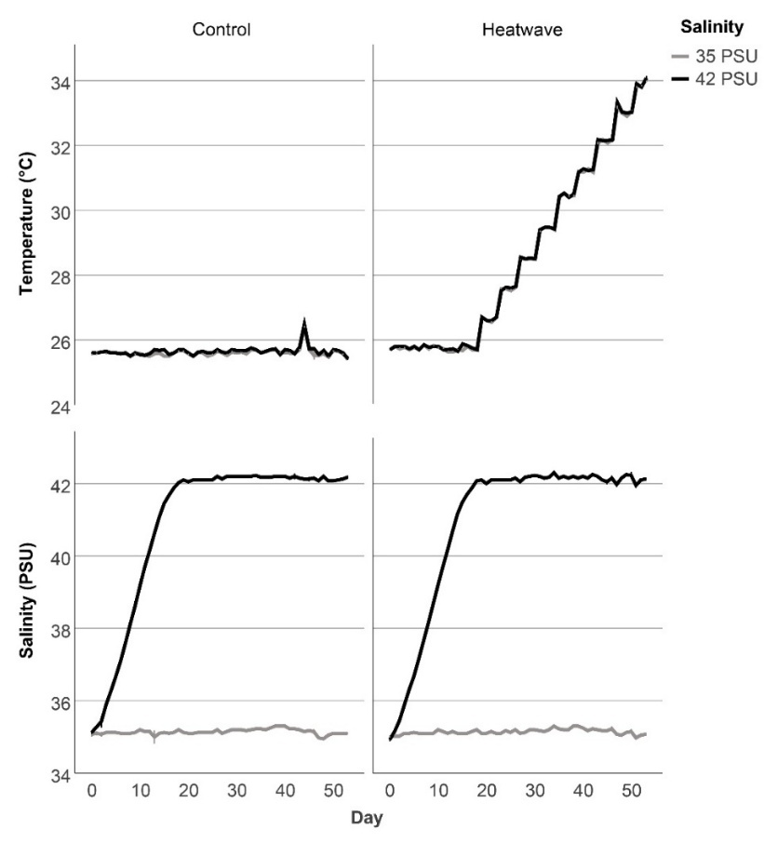
Supplementary Fig. 1 Temperature and salinity values in the 16 aquaria over the course of the experiment. Values are means ± s.e.m. (N=4 aquaria per treatment combination).

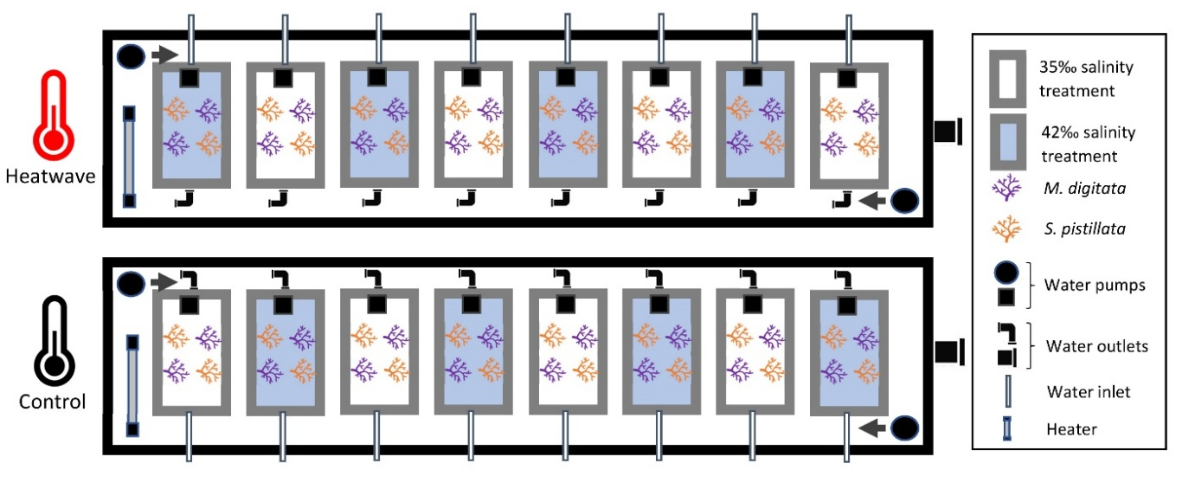
Supplementary Fig. 2 Overview of experimental setup. Replicates existed of 12L plastic aquaria (filled to ~8L seawater) each containing 2 S. pistillata (depicted in red) and 2 M. digitata (depicted in purple) microcolonies. Two basins each contained 8 aquaria, forming a control and heatwave group. All 16 aquaria were partially submerged in the water basins to ensure stable temperatures. Grey arrows depict circular water flow through the basins created by 8000 L h⁻¹ water pumps to prevent temperature gradients. Within each temperature treatment, 4 aquaria were exposed to a salinity of 42 PSU, while the other 4 aquaria were maintained at the control salinity of 35 PSU. Salinity treatments were placed alternated. Seawater was pumped into the aquaria through individual water inlets, while water outlets (20 mm PVC bulkheads) in each aquarium allowed excess seawater to flow out. This water was then released out of the system through water outlets in the basins. The seawater did not mix between any two aquaria, ensuring authentic replication. One 300 L h⁻¹ water pump within each aquarium created water motion. Heaters (300W in the control and 600W in the heatwave treatment) controlled by thermostats maintained the basins at the desired temperature.

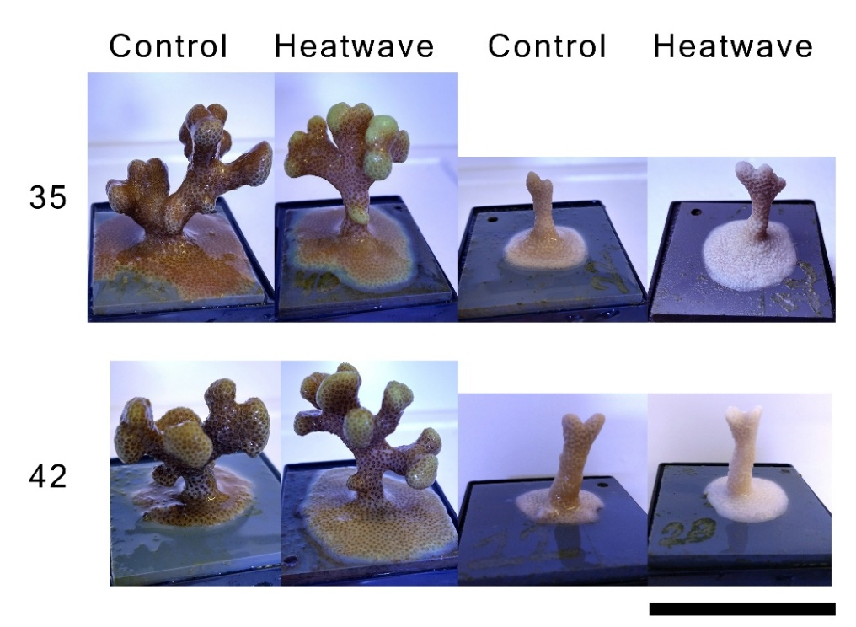
Supplementary Fig. 3 Microcolonies of S. pistillata (left) and M. digitata (right) of the control and heatwave treatments, cultured at either 35 or 42 PSU. Photographs were taken at day 52 (33.8 °C) for S. pistillata and day 46 (32.2 °C) for M. digitata. Note the slight tissue necrosis at the base of the S. pistillata microcolony cultured under the control temperature at 42 PSU, and at the base/center of the specimen exposed to the heatwave at 42 PSU. In addition, the S. pistillata microcolonies exposed to the heatwave at 35 PSU exhibited marked green colouration at the base periphery and tips. Also note some remaining polyp tissue for the M. digitata microcolony exposed to the heatwave at 35 PSU, in contrast to the dead specimen at 42 PSU. Black scale bar is 5 cm.

Supplementary Table 1 Mantel-Cox Log-Rank tests of equality of survival distributions of M. digitata for the four different treatments, and post-hoc tests comparing specific groups. Values of p<0.050 (indicated in bold) were considered significant, and were Bonferroni-adjusted for multiple comparisons.
Source | χ² | df | Sig.
Treatment | 20.366 | 3 | <.001
Control versus Heatwave 35 PSU | 7.000 | 1 | .032
Control versus Heatwave 42 PSU | 7.000 | 1 | .032
35 PSU versus 42 PSU Control | 2.320 | 1 | .512
35 PSU versus 42 PSU Heatwave | 7.000 | 1 | .032

Supplementary Table 2 Three-way mixed factorial ANOVA showing effects of time, temperature and salinity on effective PSII yield of S. pistillata over day 45 to 52 (32.1-33.8 °C), and follow-up simple effects contrasts indicating the effect of one factor at various levels of the other two. Data conformed to assumptions of normality (Shapiro-Wilk Test, p>0.05) and homogeneity of variances (Levene’s Test, p>0.05). As sphericity was violated (Mauchly’s Test, p<0.05), degrees of freedom were Greenhouse-Geisser corrected. Values of p<0.050 (indicated in bold) were considered significant, and were Bonferroni-adjusted for multiple comparisons.

Source |  |  | Type III Sum of Squares | df | F | Sig.
Time |  |  | .056 | 2.544 | 7.986 | <.001
Time * Temperature |  |  | .040 | 2.544 | 5.628 | .005
Time * Salinity |  |  | .003 | 2.544 | .372 | .742
Time * Temperature * Salinity |  |  | .005 | 2.544 | .653 | .563
Temperature |  |  | .056 | 1 | 33.504 | <.001
Salinity |  |  | .007 | 1 | 4.381 | .058
Temperature * Salinity |  |  | .011 | 1 | 6.725 | .024
Simple effects contrasts of Time * Temperature
Day 45 |  |  | .000 | 1 | 1.654 | .223
Day 46 |  |  | .000 | 1 | .206 | .658
Day 47 |  |  | .002 | 1 | 1.633 | .225
Day 48 |  |  | .004 | 1 | 4.887 | .047
Day 49 |  |  | .011 | 1 | 22.355 | <.001
Day 50 |  |  | .006 | 1 | 7.389 | .019
Day 51 |  |  | .032 | 1 | 12.207 | .004
Day 52 |  |  | .041 | 1 | 21.643 | <.001
Simple effects contrasts of Temperature * Salinity
Control |  |  | 2.634E-5 | 1 | .125 | .730
Heatwave |  |  | .002 | 1 | 10.981 | .006
35 PSU |  |  | .007 | 1 | 35.125 | <.001
42 PSU |  |  | .001 | 1 | 5.104 | .043

Supplementary Table 3 Three-way mixed factorial ANOVA showing effects of time, temperature and salinity on effective PSII yield of M. digitata over day 36 to 43 (30.5-32.1 °C), and follow-up simple effects contrasts indicating the effect of one factor at various levels of the other two. Data conformed to assumptions of normality (Shapiro-Wilk Test, p>0.05), homogeneity of variances (Levene’s Test, p>0.05) and sphericity (Mauchly’s Test, p>0.05). Values of p<0.050 (indicated in bold) were considered significant, and were Bonferroni-adjusted for multiple comparisons.
Source |  |  | Type III Sum of Squares | df | F | Sig.
Time |  |  | .055 | 7 | 19.877 | <.001
Time * Temperature |  |  | .020 | 7 | 7.132 | <.001
Time * Salinity |  |  | .011 | 7 | 3.879 | .001
Time * Temperature * Salinity |  |  | .011 | 7 | 4.080 | <.001
Temperature |  |  | .003 | 1 | 3.436 | .089
Salinity |  |  | .012 | 1 | 14.410 | .003
Temperature * Salinity |  |  | .019 | 1 | 23.376 | <.001
Simple effects contrasts of Time * Temperature * Salinity (Salinity effects shown)
Day 36 Control |  |  | 1.914E-5 | 1 | .095 | .763
Day 37 Control |  |  | 2.531E-6 | 1 | .009 | .927
Day 38 Control |  |  | 5.281E-6 | 1 | .010 | .923
Day 39 Control |  |  | .000 | 1 | .598 | .454
Day 40 Control |  |  | .000 | 1 | .468 | .507
Day 41 Control |  |  | 7.970E-5 | 1 | .113 | .743
Day 42 Control |  |  | .001 | 1 | 2.721 | .125
Day 43 Control |  |  | 9.113E-5 | 1 | .154 | .701
Day 36 Heatwave |  |  | 4.453E-5 | 1 | .222 | .646
Day 37 Heatwave |  |  | .000 | 1 | 1.506 | .243
Day 38 Heatwave |  |  | .002 | 1 | 3.446 | .088
Day 39 Heatwave |  |  | .004 | 1 | 6.629 | .024
Day 40 Heatwave |  |  | .000 | 1 | .492 | .497
Day 41 Heatwave |  |  | .011 | 1 | 15.084 | .002
Day 42 Heatwave |  |  | .005 | 1 | 20.547 | <.001
Day 43 Heatwave |  |  | .029 | 1 | 48.522 | <.001
Simple effects contrasts of Time * Temperature * Salinity (Temperature effects shown)
Day 36 35 PSU |  |  | .002 | 1 | 8.651 | .012
Day 37 35 PSU |  |  | .001 | 1 | 2.111 | .172
Day 38 35 PSU |  |  | .000 | 1 | .801 | .388
Day 39 35 PSU |  |  | .002 | 1 | 2.535 | .137
Day 40 35 PSU |  |  | 1.070E-5 | 1 | .033 | .859
Day 41 35 PSU |  |  | .001 | 1 | 1.247 | .286
Day 42 35 PSU |  |  | .000 | 1 | 1.058 | .324
Day 43 35 PSU |  |  | 3.125E-8 | 1 | .000 | .994
Day 36 42 PSU |  |  | .001 | 1 | 4.672 | .052
Day 37 42 PSU |  |  | 2.955E-5 | 1 | .102 | .755
Day 38 42 PSU |  |  | .000 | 1 | .745 | .405
Day 39 42 PSU |  |  | .002 | 1 | 3.084 | .105
Day 40 42 PSU |  |  | .001 | 1 | 2.456 | .143
Day 41 42 PSU |  |  | .004 | 1 | 5.910 | .032
Day 42 42 PSU |  |  | .007 | 1 | 26.562 | <.001
Day 43 42 PSU |  |  | .032 | 1 | 54.253 | <.001

Supplementary Table 4 Two-way factorial ANOVA showing effects of temperature and salinity on symbiont density of S. pistillata at day 53 (34.1 °C). Data conformed to assumptions of normality (Shapiro-Wilk Test, p>0.05) and homogeneity of variances (Levene’s Test, p>0.05). Values of p<0.050 (indicated in bold) were considered significant.

Source |  |  | Type III Sum of Squares | df | F | Sig.
Temperature |  |  | 5061434259297.797 | 1 | 33.538 | <.001
Salinity |  |  | 38782921950.001 | 1 | .257 | .623
Temperature * Salinity |  |  | 406718612970.785 | 1 | 2.695 | .132

Supplementary Table 5 Two-way factorial ANOVA showing effects of temperature and salinity on symbiont density of M. digitata at day 43 (32.1 °C). Data conformed to assumptions of normality (Shapiro-Wilk Test, p>0.05) and homogeneity of variances (Levene’s Test, p>0.05).
Source |  |  | Type III Sum of Squares | df | F | Sig.
Temperature |  |  | 11630108092.634 | 1 | .642 | .439
Salinity |  |  | 55823536680.578 | 1 | 3.081 | .105
Temperature * Salinity |  |  | 1921337567.569 | 1 | .106 | .750

Supplementary Table 6 Two-way factorial ANOVA showing effects of temperature and salinity on relative chlorophyll a fluorescence of S. pistillata at day 53 (34.1 °C), and follow-up simple effects contrasts indicating the effect of one factor at various levels of the other. Data conformed to assumptions of normality (Shapiro-Wilk Test, p>0.05) and homogeneity of variances (Levene’s Test, p>0.05). Values of p<0.050 (indicated in bold) were considered significant, and were Bonferroni-adjusted for multiple comparisons.

Source |  |  | Type III Sum of Squares | df | F | Sig.
Temperature |  |  | 35517.005 | 1 | 146.494 | <.001
Salinity |  |  | 259.290 | 1 | 1.069 | .325
Temperature * Salinity |  |  | 3908.496 | 1 | 16.121 | .002
Simple effects contrasts of Temperature * Salinity
Control |  |  | 3605.684 | 1 | 14.872 | .003
Heatwave |  |  | 942.549 | 1 | 3.888 | .077
35 PSU |  |  | 31494.858 | 1 | 129.904 | <.001
42 PSU |  |  | 7930.643 | 1 | 32.711 | <.001

Supplementary Table 7 Two-way factorial ANOVA showing effects of temperature and salinity on relative chlorophyll a fluorescence of M. digitata at day 43 (32.1 °C). Data conformed to assumptions of normality (Shapiro-Wilk Test, p>0.05) and homogeneity of variances (Levene’s Test, p>0.05). Values of p<0.050 (indicated in bold) were considered significant.

Source |  |  | Type III Sum of Squares | df | F | Sig.
Temperature |  |  | 1812.005 | 1 | 14.676 | .002
Salinity |  |  | 56.232 | 1 | .455 | .513
Temperature * Salinity |  |  | 89.187 | 1 | .722 | .412

Supplementary Table 8 Two-way factorial ANOVA showing effects of temperature and salinity on relative GFP fluorescence of S. pistillata at day 53 (34.1 °C). Data conformed to assumptions of normality (Shapiro-Wilk Test, p>0.05) and homogeneity of variances (Levene’s Test, p>0.05).

Source |  |  | Type III Sum of Squares | df | F | Sig.
Temperature |  |  | 1945.058 | 1 | 3.229 | .103
Salinity |  |  | 178.253 | 1 | .296 | .598
Temperature * Salinity |  |  | .077 | 1 | .000 | .991

Supplementary Table 9 Two-way factorial ANOVA showing effects of temperature and salinity on relative GFP fluorescence of M. digitata at day 43 (32.1 °C). Data conformed to assumptions of normality (Shapiro-Wilk Test, p>0.05) and homogeneity of variances (Levene’s Test, p>0.05).

Source |  |  | Type III Sum of Squares | df | F | Sig.
Temperature |  |  | 7.125 | 1 | .415 | .532
Salinity |  |  | 6.745 | 1 | .393 | .543
Temperature * Salinity |  |  | .153 | 1 | .009 | .926

