Supplementary Information
Supplementary Fig. S1
Supplementary Fig. S1. HPLC chromatogram of GSLs extracted from cabbage seedlings grown in soil samples along three vernalization time course (NV, V40, and AV). 1, progoitrin (PGT); 2, glucoraphanin (GRA); 3, Sinigrin (SIN); 4, Glucoalyssin (GAS); 5, Gluconapin (GNP); 6, 4-Hydroxyglucobrassicin (4-HGB); 7, Glucoerucin (GER); 8, Glucobrassicin (GBS); 9, 4-Methoxyglucobrassicin (4-MTGB); 10, gluconasturtiin (GNT); 11, Neoglucobrassicin (NGB).
Supplementary Fig. S2
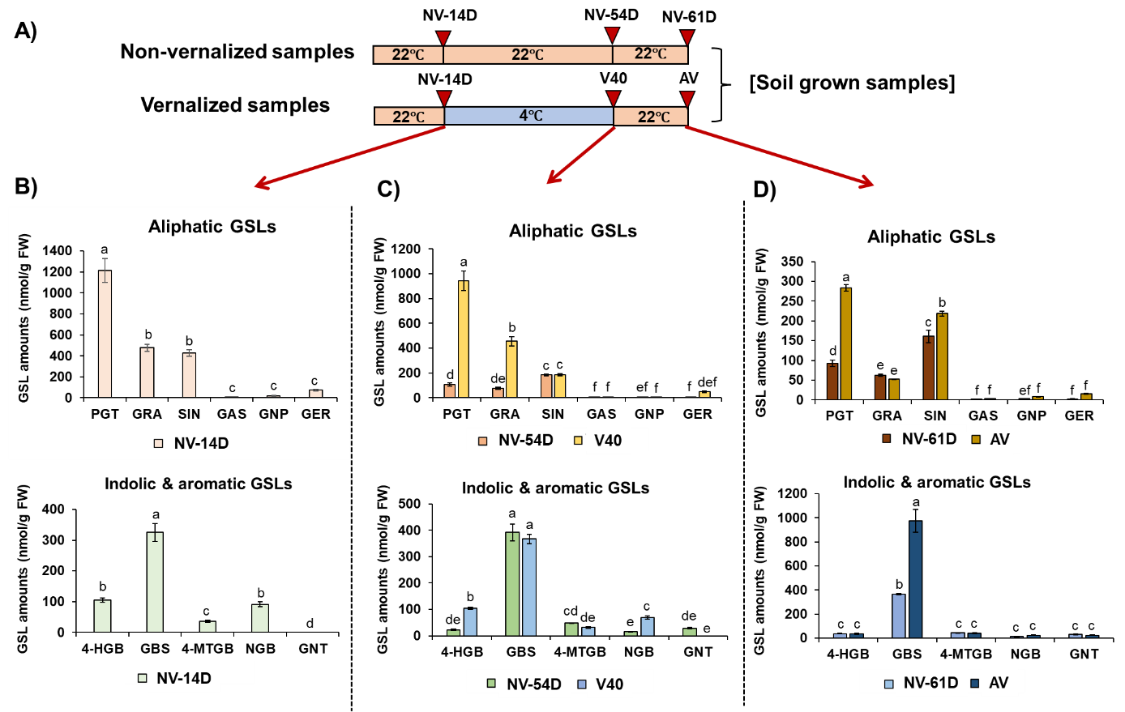
Supplementary Fig. S2. Quantification of aliphatic and indolic GSL compounds of cabbage grown in soil during non-vernalized three time course (NV-14 days, NV-54 days, and NV-61 days) or vernalized three time course (NV-14 days, V40, and AV). A) A diagram showing sampling time points for non-vernalized three time points (NV-14D, NV-54D, and NV-61D) and vernalized three time points (NV-14D, V40, and AV) used for HPLC analysis. Each time point for sampling was indicated with red downward arrowhead. NV-14D: non-vernalized cabbage seedlings grown for 14 days; NV-54D: non-vernalized cabbage seedlings grown for 54 days; NV-61D: non-vernalized cabbage seedlings grown for 61 days. V40: 2-week-old seedlings were transferred to cold (4℃) and incubated for 40 days under short-day (8h light: 16 dark) condition; AV: Vernalized cabbage seedlings at 4℃ for 40 days were returned to warm (22℃) temperature for further growth for 7 days. Non-vernalized seedlings were continuously grown in soil under long day (16h light: 8h dark) condition. B) Quantification of six aliphatic GSLs (upper panel) and four indolic GSLs and one aromatic GSL compound (lower panel) of 2-week cabbage seedling samples (NV-14D) C) Quantification of six aliphatic GSLs (upper panel) and four indolic GSLs and one aromatic GSL compound (lower panel) of non-vernalized NV-54D samples and corresponding vernalized V40 samples. D) Quantification of six aliphatic GSLs (upper panel) and four indolic GSLs and one aromatic GSL compound (lower panel) of non-vernalized NV-61D samples and corresponding vernalized AV samples. B)~D) One aromatic GSL compound was very lowly detected in our HPLC detection system used for soil-grown samples.
Supplementary Fig. S3.
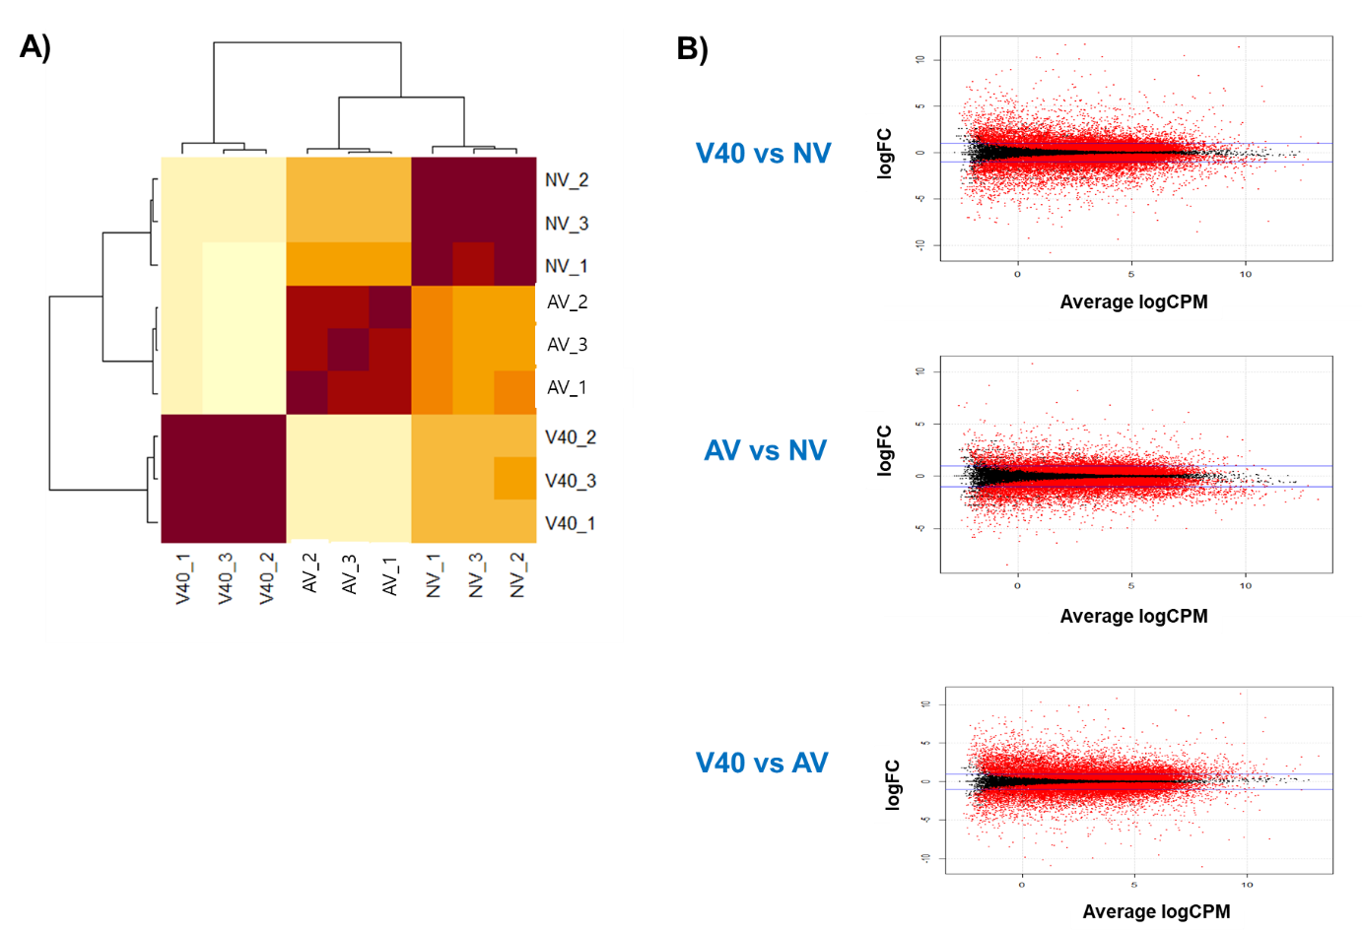
Supplementary Fig. S3. Profiling of nine RNA-Seq libraries. A) A heatmap of Pearson correlation coefficients among total nine RNA-seq samples along vernalization time course (NV, V40, and AV). Distinct and close clustered groups were shown within samples in the same time point, indicating that the RNA-seq libraries were properly produced. This heatmap was generated using R software (ver 3.6.0) (https://www.r-project.org/). B) PlotSmear analysis showing differentially expressed genes using pair-wise comparison between V40 and NV samples (upper panel), AV and NV samples (middle panel), V40 and AV (lower panel). X -axis is the log2 value of read counts per million (CPM). Y -axis is log2 fold change (FC). Black dots represent the genes with no significant differential expression. Red dots represent significantly differentially expressed genes. PlotSmear was generated using R software (ver. 3.6.0) (https://www.r-project.org/).
Supplementary Fig. S4.
Supplementary Fig. S4. Integrative Genomics Viewer (IGV) illustration of normalized RNA-seq read counts of the five B. oleracea MYB homologs (BoMYB28a, BoMYB28b, BoMYB28c, BoMYB29a, and BoMYB29b) regulating aliphatic GSL biosynthesis (A) and three B. oleracea MYB homologs (BoMYB34, BoMYB51, and BoMYB122). The annotated transcript reads for each B. oleracea MYB homologs were presented along three vernalization time course (NV, V40, and AV). Normalized read counts of each time point was shown with three biological replicates. Read coverage normalized using total number of mapped reads (RPKM) were indicated at the top right corner of each track in parentheses. NV: non-vernalized; V40: 40-day cold; AV: 40-day cold followed by growth for seven days under warm temperature.
Supplementary Table S1. The result of RNA-seq quality check.
No | Sample name | Read Order | Yield(Bases) | Reads | % of >= Q30 Bases(PF)
1 | NV_1 | R1 | 3,286,652,312 | 32,541,112 | 95.35
2 | NV_1 | R2 | 3,286,652,312 | 32,541,112 | 91.07
3 | NV_2 | R1 | 3,237,005,156 | 32,049,556 | 95.34
4 | NV_2 | R2 | 3,237,005,156 | 32,049,556 | 92.55
5 | NV_3 | R1 | 2,768,452,723 | 27,410,423 | 95.21
6 | NV_3 | R2 | 2,768,452,723 | 27,410,423 | 93.03
7 | V40_1 | R1 | 4,113,181,469 | 40,724,569 | 95.42
8 | V40_1 | R2 | 4,113,181,469 | 40,724,569 | 92.73
9 | V40_2 | R1 | 3,277,309,408 | 32,448,608 | 95.28
10 | V40_2 | R2 | 3,277,309,408 | 32,448,608 | 92.66
11 | V40_3 | R1 | 3,477,277,187 | 34,428,487 | 95.53
12 | V40_3 | R2 | 3,477,277,187 | 34,428,487 | 93.36
13 | AV_1 | R1 | 3,804,168,838 | 37,665,038 | 95.34
14 | AV_1 | R2 | 3,804,168,838 | 37,665,038 | 92.14
15 | AV_2 | R1 | 3,311,655,670 | 32,788,670 | 95.32
16 | AV_2 | R2 | 3,311,655,670 | 32,788,670 | 93.38
17 | AV_3 | R1 | 2,880,722,606 | 28,522,006 | 95.26
18 | AV_3 | R2 | 2,880,722,606 | 28,522,006 | 89.94

Supplementary Table S2. A total of 78 GSLs pathway genes in cabbage found from the B. oleracea genome database
Group | BRAD database ID | Annotation
Aliphatic GSL | BolC05g008230.2J | BoMYB28a
Aliphatic GSL | BolC07g043460.2J | BoMYB28b
Aliphatic GSL | BolC09g007690.2J | BoMYB28c
Aliphatic GSL | BolC09g064700.2J | BoMYB29a
Aliphatic GSL | BolC03g003550.2J | BoMYB29b
Aliphatic GSL | BolC05g044530.2J | BoBCAT4a
Aliphatic GSL | BolC03g046400.2J | BoBCAT4b
Aliphatic GSL | BolC03g032630.2J | BoBAT5a
Aliphatic GSL | BolC03g032530.2J | BoBAT5b
Aliphatic GSL | BolC09g031400.2J | BoBAT5c
Aliphatic GSL | BolC07g042920.2J | BoMAM1a
Aliphatic GSL | BolC07g042910.2J | BoMAM1b
Aliphatic GSL | BolC02g038580.2J | BoMAM3a
Aliphatic GSL | BolC03g062920.2J | BoMAM3b
Aliphatic GSL | BolC02g059950.2J | BoMAM3c
Aliphatic GSL | BolC08g008400.2J | BoIPMI_LSU1a
Aliphatic GSL | BolC04g041670.2J | BoIPMI_LSU1b
Aliphatic GSL | BolC04g004590.2J | BoIPMI_SSU2
Aliphatic GSL | BolC02g006120.2J | BoIMD1a
Aliphatic GSL | BolC02g035990.2J | BoIMD1b
Aliphatic GSL | BolC06g050880.2J | BoIMD1c
Aliphatic GSL | BolC08g033700.2J | BoBCAT3a
Aliphatic GSL | BolC01g029190.2J | BoBCAT3b
Aliphatic GSL | BolC05g014000.2J | BoCYP79F1
Aliphatic GSL | BolC04g041440.2J | BoCYP83A1a
Aliphatic GSL | BolC04g065390.2J | BoCYP83A1b
Aliphatic GSL | BolC05g063320.2J | BoGSTF11
Aliphatic GSL | BolC06g029190.2J | BoGSTU20
Aliphatic GSL | BolC05g022270.2J | BoUGT74B1
Aliphatic GSL | BolC04g017450.2J | BoUGT74C1a
Aliphatic GSL | BolC04g058020.2J | BoUGT74C1b
Aliphatic GSL | BolC03g082140.2J | BoGGP1a
Aliphatic GSL | BolC07g055380.2J | BoGGP1b
Aliphatic GSL | BolC01g008500.2J | BoGGP1c
Aliphatic GSL | BolC07g000300.2J | BoSUR1a
Aliphatic GSL | BolC09g014020.2J | BoSUR1b
Aliphatic GSL | BolC05g016200.2J | BoSOT17
Aliphatic GSL | BolC06g045520.2J | BoSOT18a
Aliphatic GSL | BolC06g045530.2J | BoSOT18b
Aliphatic GSL | BolC09g021310.2J | BoSOT18c
Aliphatic GSL | BolC09g021280.2J | BoSOT18d
Indolic GSL | BolC05g005480.2J | BoOBP2
Indolic GSL | BolC07g043000.2J | BoMYB34
Indolic GSL | BolC08g027110.2J | BoMYB51
Indolic GSL | BolC02g030750.2J | BoMYB122
Indolic GSL | BolC01g000930.2J | BoCYP79B2a
Indolic GSL | BolC03g073270.2J | BoCYP79B2b
Indolic GSL | BolC07g059740.2J | BoCYP79B2c
Indolic GSL | BolC04g049480.2J | BoCYP79B3
Indolic GSL | BolC08g009600.2J | BoCYP83B1
Indolic GSL | BolC04g057100.2J | BoGSTF9a
Indolic GSL | BolC03g018460.2J | BoGSTF9b
Indolic GSL | BolC03g018470.2J | BoGSTF10
Indolic GSL | BolC02g030760.2J | BoSOT16a
Indolic GSL | BolC06g045540.2J | BoSOT16b
Indolic GSL | BolC09g045820.2J | BoCYP81F2a
Indolic GSL | BolC02g015480.2J | BoCYP81F2b
Indolic GSL | BolC03g013900.2J | BoCYP81F2c
Indolic GSL | BolC05g019240.2J | BoIGMT1
Indolic GSL | BolC07g021570.2J | BoIGMT2
Indolic GSL | BolC05g019210.2J | BoIGMT3
Indolic GSL | BolC08g029040.2J | BoIGMT4
Indolic GSL | BolC05g019260.2J | BoIGMT5
Indolic GSL | BolC07g021580.2J | BoIGMT6
Indolic GSL | BolC08g029030.2J | BoIGMT7
Indolic GSL | BolC05g019180.2J | BoIGMT8
Indolic GSL | BolC07g021590.2J | BoIGMT9
Aromatic GSL genes | BolC03g046090.2J | BoBZO1a
Aromatic GSL genes | BolC06g037140.2J | BoBZO1b
Both of Aliphatic and Indolic GSL genes | BolC03g051190.2J | BoAPK1a
Both of Aliphatic and Indolic GSL genes | BolC09g011620.2J | BoAPK1b
Both of Aliphatic and Indolic GSL genes | BolC03g073230.2J | BoAPK2a
Both of Aliphatic and Indolic GSL genes | BolC01g000920.2J | BoAPK2b
Both of Aliphatic and Indolic GSL genes | BolC07g059810.2J | BoAPK2c
Both of Aliphatic and Indolic GSL genes | BolC07g059750.2J | BoAPK2d
Both of Aliphatic and Indolic GSL genes | BolC01g027020.2J | BoAPS1a
Both of Aliphatic and Indolic GSL genes | BolC03g048340.2J | BoAPS1b
Both of Aliphatic and Indolic GSL genes | BolC05g039450.2J | BoAPS1c

Supplementary Table S3. A total of 13,962 differentially expressed genes (DEGs).
[separately attached]
Supplementary Table S4. Lists of genes belonging to ‘Type 1’ ~ ‘Type 5’ categories which were classified based on the expression patterns during vernalization time course.
Type 1
No. | Gene ID | Annotation
1 | BolC03g073270.2J | BoCYP79B2b
2 | BolC01g029190.2J | BoBCAT3b
3 | BolC03g003550.2J | BoMYB29b
4 | BolC02g059950.2J | BoMAM3c
5 | BolC03g062920.2J | BoMAM3b
6 | BolC07g042910.2J | BoMAM1b
7 | BolC03g032530.2J | BoBAT5b
8 | BolC03g032630.2J | BoBAT5a
9 | BolC02g006120.2J | BoIMD1a
10 | BolC04g004590.2J | BoIPMI_SSU2
11 | BolC09g031400.2J | BoBAT5c
12 | BolC07g042920.2J | BoMAM1a
13 | BolC01g000930.2J | BoCYP79B2a
14 | BolC01g000920.2J | BoAPK2b
15 | BolC04g058020.2J | BoUGT74C1b
16 | BolC07g059750.2J | BoAPK2d
17 | BolC07g059810.2J | BoAPK2c
18 | BolC09g021280.2J | BoSOT18d
19 | BolC01g008500.2J | BoGGP1c
20 | BolC08g033700.2J | BoBCAT3a
21 | BolC09g064700.2J | BoMYB29a
Type 2
No. | Gene ID | Annotation
1 | BolC02g035990.2J | BoIMD1b
2 | BolC02g030750.2J | BoMYB122
3 | BolC03g048340.2J | BoAPS1b
4 | BolC06g029190.2J | BoGSTU20
5 | BolC04g065390.2J | BoCYP83A1b
6 | BolC04g017450.2J | BoUGT74C1a
7 | BolC05g063320.2J | BoGSTF11
8 | BolC04g049480.2J | BoCYP79B3
9 | BolC05g044530.2J | BoBCAT4a
10 | BolC06g050880.2J | BoIMD1c
11 | BolC08g008400.2J | BoIPMI_LSU1a
12 | BolC02g015480.2J | BoCYP81F2b
13 | BolC03g018460.2J | BoGSTF9b
14 | BolC04g041440.2J | BoCYP83A1a
15 | BolC05g039450.2J | BoAPS1c
16 | BolC04g057100.2J | BoGSTF9a
17 | BolC05g022270.2J | BoUGT74B1
18 | BolC03g018470.2J | BoGSTF10
19 | BolC07g043460.2J | BoMYB28b
20 | BolC08g029030.2J | BoIGMT7
21 | BolC05g008230.2J | BoMYB28a
22 | BolC09g007690.2J | BoMYB28c
Type 3
No. | Gene ID | Annotation
1 | BolC03g046090.2J | BoBZO1a
2 | BolC07g043000.2J | BoMYB34
3 | BolC07g059740.2J | BoCYP79B2c
Type 4
No. | Gene ID | Annotation
1 | BolC01g027020.2J | BoAPS1a
2 | BolC03g082140.2J | BoGGP1a
3 | BolC08g027110.2J | BoMYB51
4 | BolC02g030760.2J | BoSOT16a
5 | BolC07g000300.2J | BoSUR1a
6 | BolC05g016200.2J | BoSOT17
7 | BolC09g011620.2J | BoAPK1b
8 | BolC07g055380.2J | BoGGP1b
9 | BolC06g045520.2J | BoSOT18a
10 | BolC08g009600.2J | BoCYP83B1
Type 5
No. | Gene ID | Annotation
1 | BolC04g041670.2J | BoIPMI_LSU1b
2 | BolC05g014000.2J | BoCYP79F1
3 | BolC03g051190.2J | BoAPK1a
4 | BolC05g019260.2J | BoIGMT5
5 | BolC05g019210.2J | BoIGMT3
6 | BolC05g019240.2J | BoIGMT1
7 | BolC09g045820.2J | BoCYP81F2a
8 | BolC05g005480.2J | BoOBP2
9 | BolC05g019180.2J | BoIGMT8
10 | BolC07g021580.2J | BoIGMT6
11 | BolC07g021570.2J | BoIGMT2
12 | BolC08g029040.2J | BoIGMT4
13 | BolC09g021310.2J | BoSOT18c
14 | BolC06g045540.2J | BoSOT16b
Supplementary Table S5. List of genes belonging to VRGs (Vernalization-Repressed GSL genes) group.
Type | Gene ID | Annotation
1 | BolC01g000920.2J | BoAPK2b
1 | BolC07g059810.2J | BoAPK2c
1 | BolC07g059750.2J | BoAPK2d
1 | BolC08g033700.2J | BoBCAT3a
1 | BolC01g029190.2J | BoBCAT3b
1 | BolC01g000930.2J | BoCYP79B2a
1 | BolC03g073270.2J | BoCYP79B2b
1 | BolC01g008500.2J | BoGGP1c
1 | BolC07g042910.2J | BoMAM1b
1 | BolC09g064700.2J | BoMYB29a
1 | BolC09g021280.2J | BoSOT18d
1 | BolC04g058020.2J | BoUT74C1b
3 | BolC03g046090.2J | BoBZO1a
3 | BolC07g059740.2J | BoCYP79B2c
3 | BolC07g043000.2J | BoMYB34

Supplementary Table S6. List of genes belonging to VIGs (Vernalization-Induced GSL genes) group.
Type | Gene ID | Annotation
4 | BolC02g030760.2J | BoSOT16a
4 | BolC06g045520.2J | BoSOT18a
5 | BolC03g051190.2J | BoAPK1a
5 | BolC05g014000.2J | BoCYP79F1
5 | BolC09g045820.2J | BoCYP81F2a
5 | BolC05g019240.2J | BoIGMT1
5 | BolC07g021570.2J | BoIGMT2
5 | BolC05g019210.2J | BoIGMT3
5 | BolC08g029040.2J | BoIGMT4
5 | BolC05g019260.2J | BoIGMT5
5 | BolC07g021580.2J | BoIGMT6
5 | BolC05g019180.2J | BoIGMT8
5 | BolC04g041670.2J | BoIPMI_LSU1b
5 | BolC05g005480.2J | BoOBP2
5 | BolC09g021310.2J | BoSOT18c

Supplementary Table S7. List of primers used for the qRT-PCR analysis in this study
Name | Sequence
BoBCAT3a_LP | GCA ACT ACG CTG CAG TAC TGA AAG C
BoBCAT3a_RP | CTC GTC AAC TGT CAC ATT CCG TTC C
BoBCAT3b_LP | CAG TCG GTG GCA AAA GCC AAA GG
BoBCAT3b_RP | GAC AAC CAC AGC GGT TCC AGT GC
BoUGT74C1b_LP | GAC TCA ACT GGA TGT TTC GTG ACG C
BoUGT74C1b_RP | CAA CAA TGC ATC TCG CAA TCT CTT CC
BoGGP1c_LP | CGG AAA CGA GAT TCC GAA TAG CAT AGC C
BoGGP1c_RP | CTT GCT TGA TGA AGC CAA GAC GAA G
BoMYB29a_LP | CAG CTT CCA TGG AAG GAT CCT TAA TTC G
BoMYB29a_RP | GGA GAT CTT GGT TAT ATC CTC CAA TGG C
BoMYB34_LP | CCG ACA ACT GTT CTT TCT CCG ATG G
BoMYB34_RP | CAG TTA CGT TAA CCT CAG GCG AGT C
BoSOT18a_LP | GAG AGC TGA TCC TTT GCC GTA TGT GAA GAG G
BoSOT18a_RP | CGA CCA ATC TCC AAC CTT ACC TTT CC
BoIGMT2_LP | CAT GAT TGG ACT GAC GAG GAC TGT G
BoIGMT2_RP | CAA TGG TAG AAG CCA GAA GCT GCA GCC
BoIGMT6_LP | GAG AGG TCT CGA GCT GAG TTT GAA GCG
BoIGMT6_RP | GAA TCC GAC CCT TCA TGG TGA TTG C
BoIGMT8_LP | GAA CTA GTC ACG CCT GAT GAC GCT GAG
BoIGMT8_RP | CCA GCA GTG ATA AGC GGG ACA AAC G

Supplementary Table S8. List of standard 11 GSL compounds used in the HPLC analysis
Compounds Name | Molecular Formula | Groups | Cat. No
Progoitrin (PGT) | C₁₁H₁₈KNO₁₀S₂ | Aliphatic | 21087-77-4*
Glucoraphanin (GRA) | C₁₂H₂₂KNO₁₀S₃ | Aliphatic | 21414-41-5
Sinigrin (SIN) | C₁₀H₁₆KNO9S₂ | Aliphatic | 3952-98-5
Glucoalyssin (GAS) | C₁₃H₂₄KNO₁₀S₃ | Aliphatic | 499-37-6
Gluconapin (GNP) | C₁₁H₁₈KNO₉S₂ | Aliphatic | 245550-57-6
Glucoerucin (GER) | C₁₂H₂₂KNO₉S₃ | Aliphatic | 15592-37-7
Glucobrassicin (GBS) | C₁₆H₁₉KN₂O₉S₂ | Indolic | 4356-52-9
4-Methoxyglucobrassicin (4-MTGB) | C₁₇H₂₁KN₂O₁₀S₂ | Indolic | 833327-21-3
4-Methoxyglucobrassicin (4-HGB) | C₁₆H₁₉KN₂O₁₀S₂ | Indolic | 833327-20-2
Neoglucobrassicin (NGB) | C₁₇H₂₁KN₂O₁₀S₂ | Indolic | 5187-84-8
Gluconasturtiin (GNT) | C₁₅H₂₀KNO₉S₂ | Aromatic | 18425-76-8
*All the GSLs standard compounds was purchased from Phytoplan (Germany), except the sinigrin that was purchased from Sigma-aldrich (USA).

