Figure S1. Zero-shot evaluation of classical models across four datasets. Rows correspond to evaluation metrics (Accuracy, MCC, F1-score, AUROC, AUPRC); columns correspond to codlncRNA datasets (Dataset1-4, from highest to lowest evidence confidence).

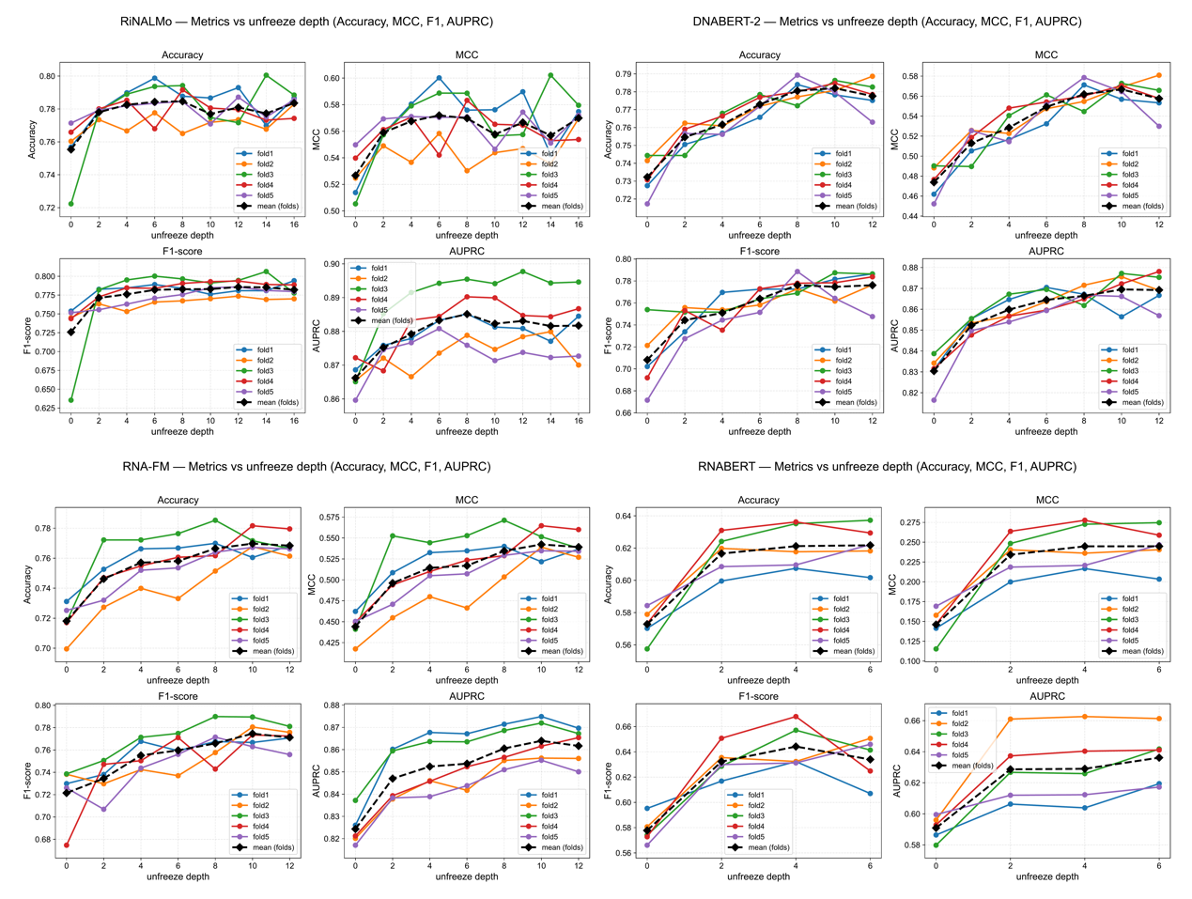
Figure S2. Performance dynamics of nucleic acid foundation models under progressive layer-wise unfreezing. The performance metrics of RiNALMo, DNABERT-2, RNA-FM, and RNABERT were evaluated across different unfreeze depths using 5-fold cross-validation. Each colored curve represents an individual fold (fold1-fold5), and the black dashed line denotes the averaged performance across folds.

Figure S3. Cross-species generalization across Arabidopsis, mouse, and rat datasets. Rows correspond to evaluation metrics (Accuracy, MCC, F1-score, AUROC, AUPRC); columns correspond to the three non-human species (Arabidopsis, mouse, rat).

