Supplementary materials
Table S1. Variance inflation factors (VIFs) for covariates included in the multivariable models.
 | GVIF | Df | GVIF^(1/(2*Df))
AISI | 3.54 | 1.00 | 1.88
RCII | 2.78 | 1.00 | 1.67
IBI | 2.90 | 1.00 | 1.70
SIRI | 3.94 | 1.00 | 1.99
Gender | 1.38 | 1.00 | 1.17
Age | 1.50 | 1.00 | 1.23
Race | 1.16 | 1.00 | 1.08
Marriage | 1.15 | 1.00 | 1.07
PIR | 1.19 | 1.00 | 1.09
smoking | 1.30 | 2.00 | 1.07
Hypertension | 1.25 | 1.00 | 1.12
Diabetes | 1.12 | 1.00 | 1.06
Coronary Heart Disease | 1.46 | 1.00 | 1.21
Heart Attack | 1.45 | 1.00 | 1.20
Albumin | 1.21 | 1.00 | 1.10
LDL cholesterol | 1.07 | 1.00 | 1.04
alcohol | 1.09 | 1.00 | 1.04
GGT | 1.06 | 1.00 | 1.03
HDL cholesterol | 1.21 | 1.00 | 1.10
Note: GVIF = generalized variance inflation factor; Df = degrees of freedom for the variable (number of levels - 1 for categorical variables; 1 for continuous variables). GVIF^(1/(2*Df)) is the adjusted GVIF to make GVIF values comparable to standard VIF (for use when Df > 1). Variables included in the table were those considered for multivariable logistic regression models; a prespecified VIF threshold < 5 was used to retain covariates.
Abbreviations: IBI = Inflammatory Burden Index; SIRI = Systemic Inflammation Response Index; AISI = Aggregate Index of Systemic Inflammation; RCII = Remnant Cholesterol Inflammatory Index; PIR = poverty income ratio; GGT = gamma-glutamyl transferase; HDL-C = high-density lipoprotein cholesterol; LDL-C = low-density lipoprotein cholesterol.
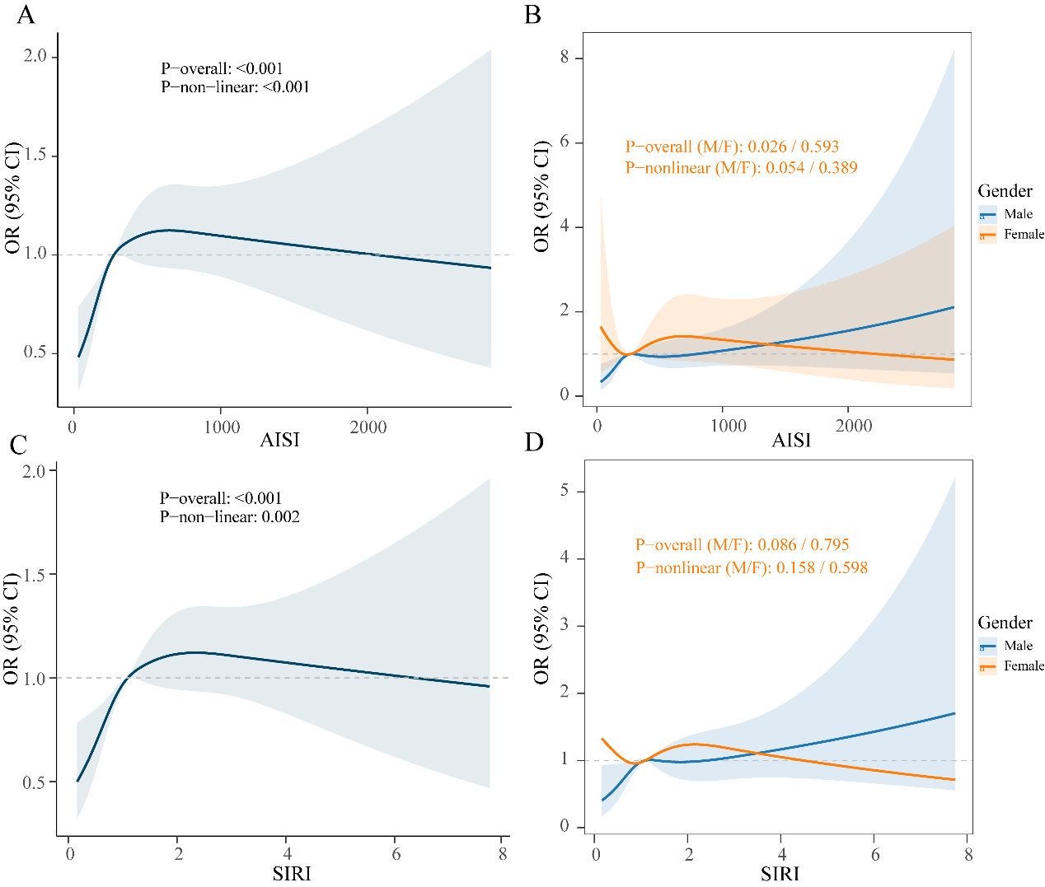
Figure S1. RCS curves for the relationship between AISI, SIRI, and MASLD. A. RCS curve for AISI; B. RCS curves for different genders of AISI; C. RCS curve for SIRI; D. RCS curves for different genders of SIRI.
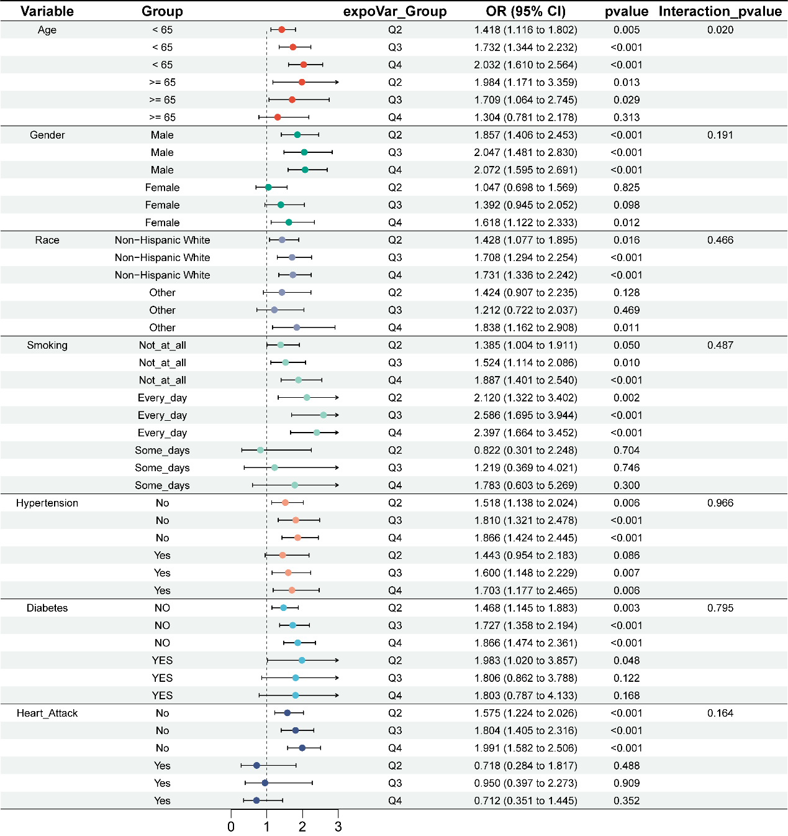
Figure S2. Subgroup analysis chart for AISI.
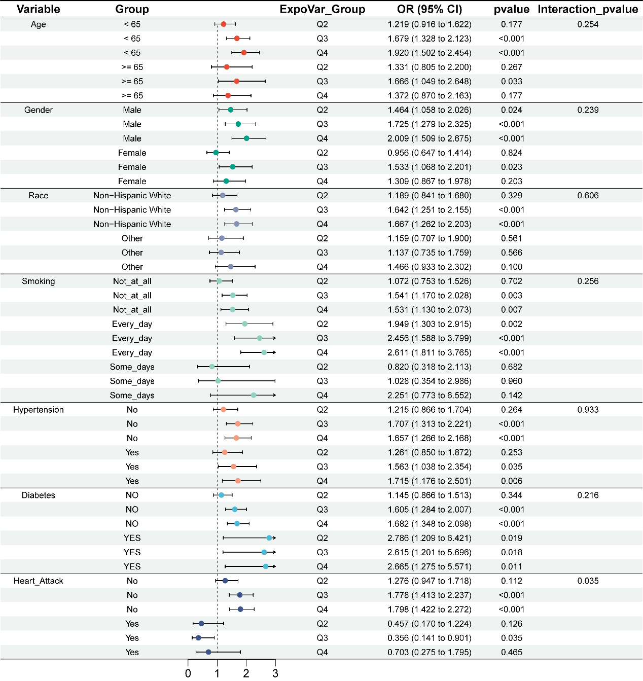
Figure S3. Subgroup analysis chart for SIRI.
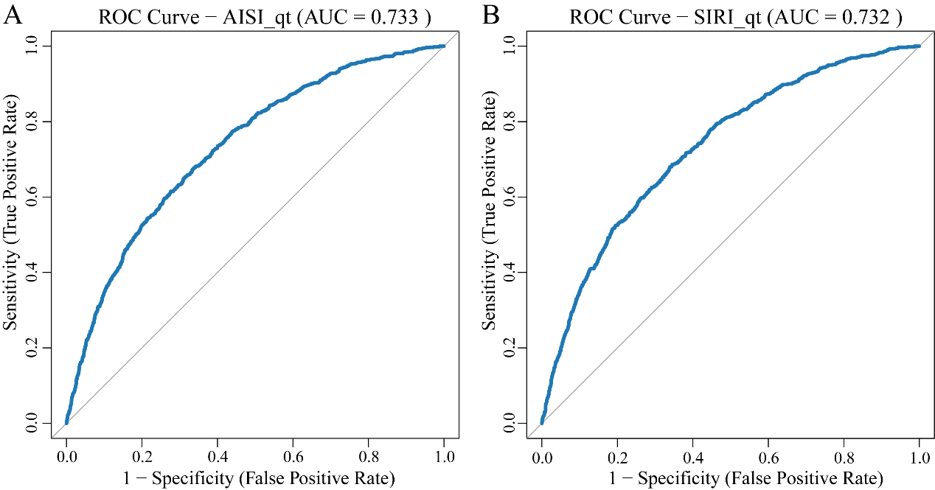
Figure S4. ROC analysis of AISI, SIRI, and MASLD.
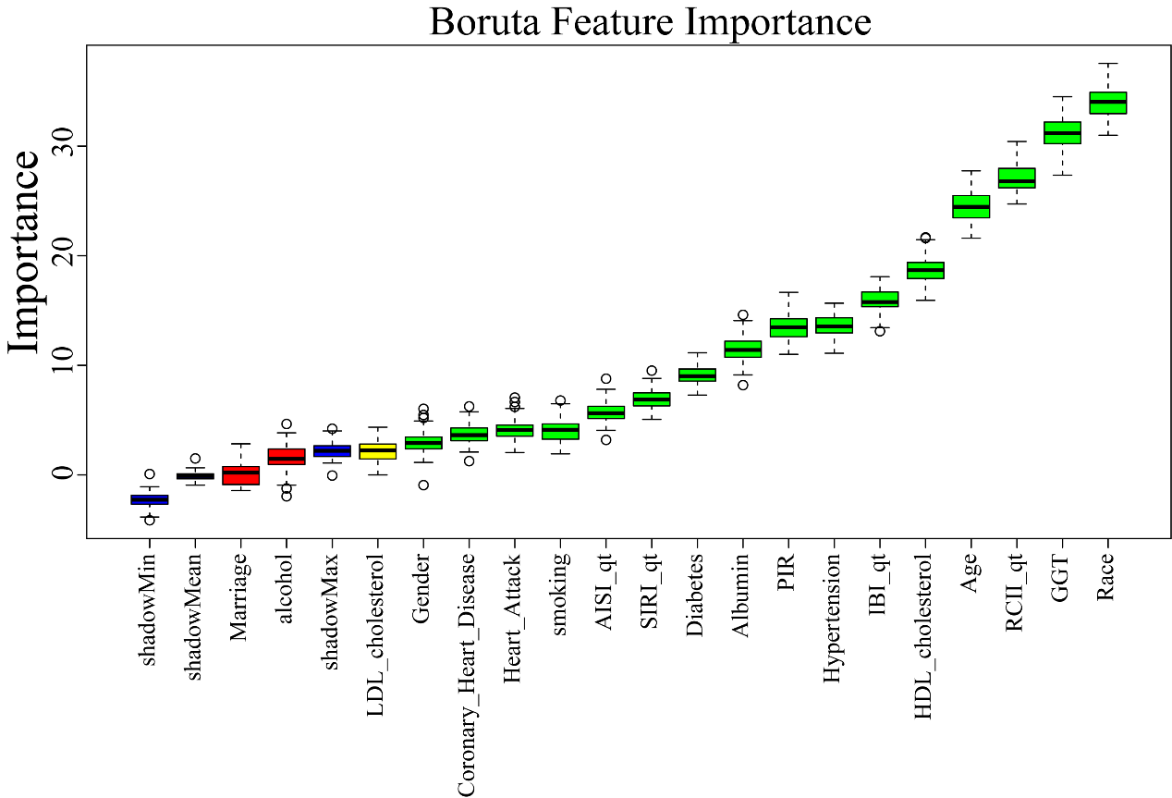
Figure S5. Feature selection based on the Boruta algorithm.
Note: The horizontal axis represents the name of each variable, and the vertical axis represents the Z value of each variable. The box plot shows the Z value of each variable during model calculation. Blue represents the baseline, green boxes represent important variables, red boxes represent unimportant variables, and yellow boxes represent tentative variables.

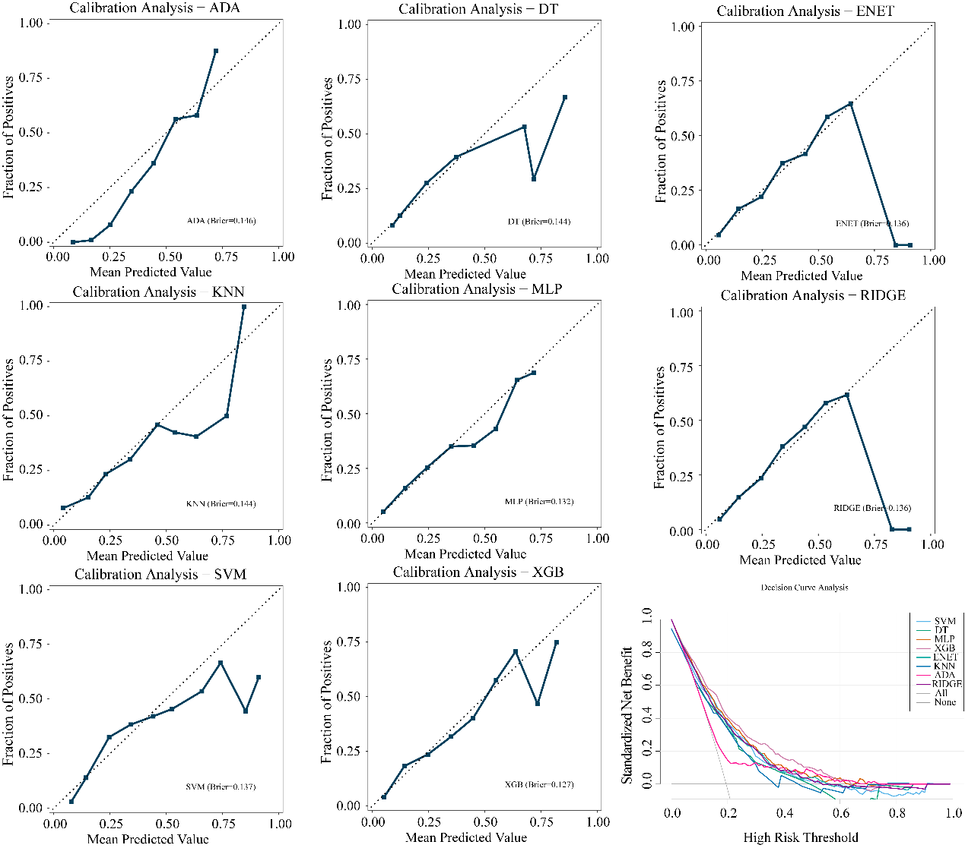
Figure S6. Calibration curve (A) and DCA curve (B).

