Supplementary figures

 | x-axis  starting point | y-axis  starting point | x-axis endpoint | y-axis endpoint | $$∆ x$$ | $$∆ y$$
Position 1 | 597.13 | 658.77 | 596.15 | 659.65 | -0.98 | 0.88
Position 2 | 596.88 | 657.33 | 596.20 | 659.04 | -0.68 | 1.71
P-value |  |  |  |  | 0.229 | 0.123

Supplementary Table S1. Eye deviation ($∆)$ in pixels from moment of stimulus onset till offset for array 1. P-values compare net pixel displacement in x- and y-axis using independent samples t-test between both positions. Positions reference to the positions as displayed in figure 1B.

 | x-axis  starting point | y-axis  starting  point | x-axis endpoint | y-axis endpoint | $$∆ x$$ | $$∆ y$$
Pos. 1 | 648.92 | 517.71 | 648.86 | 517.30 | -0.06 | -0.41
Pos. 2 | 648.64 | 518.39 | 648.99 | 520.07 | 0.35 | 1.68
Pos. 3 | 645.94 | 529.83 | 646.57 | 529.30 | 0.63 | -0.53
Pos. 4 | 649.68 | 516.48 | 650.35 | 516.57 | 0.67 | 0.09
Pos. 5 | 648.97 | 515.97 | 649.41 | 517.33 | 0.45 | 1.36
P-value
 | Pos.1 | Pos. 2 | Pos. 3 | Pos. 4 | Pos.5
Pos. 1 | 1 | 0.024 | 0.922 | 0.603 | 0.068
Pos. 2 | 0.537 | 1 | 0.050 | 0.067 | 0.724
Pos. 3 | 0.417 | 0.725 | 1 | 0.600 | 0.115
Pos. 4 | 0.267 | 0.604 | 0.958 | 1 | 0.164
Pos. 5 | 0.470 | 0.880 | 0.835 | 0.738 | 1

Supplementary Table S2. Eye deviation ($∆)$ in pixels from moment of stimulus onset till offset for array 2. P-values compare net pixel displacement in x-axis (orange) and y-axis (green) using independent samples t-test between both positions. Positions reference to the positions as displayed in figure 1B.

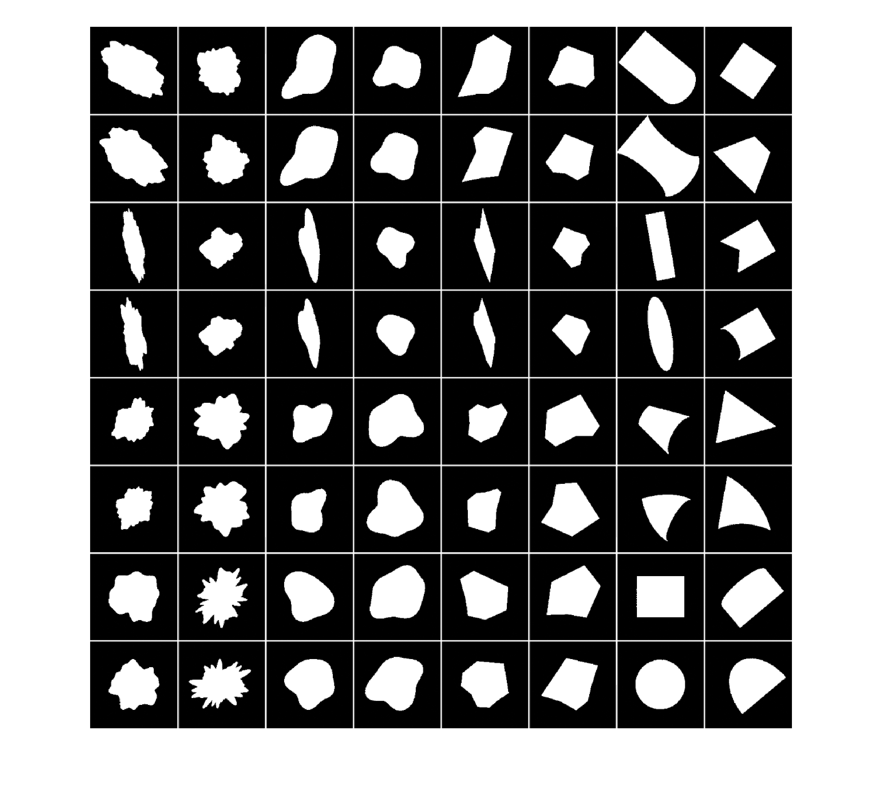
Supplementary Figure S1. All 64 simple shapes that were presented in 2 positions within the receptive field in array 1.

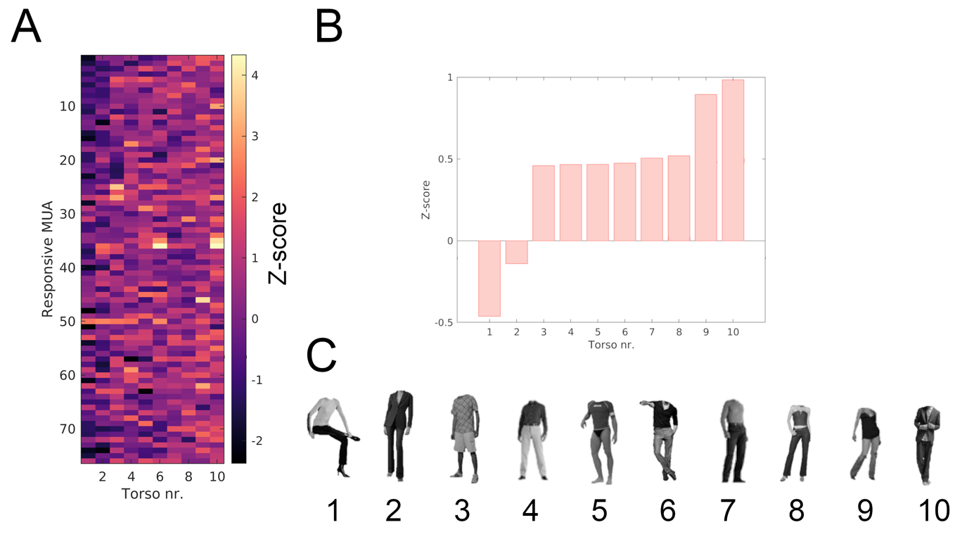
Supplementary Figure S2. Selection of the preferred torso for receptive field mapping. A) Overview of the average Z-normalized responses within the response window (250 - 400 ms) for 76 visually responsive multi-units from array 2 across 10 different torso images. The torsos are arranged from left to right in ascending order of average response across all multi-units. B) Average Z-normalized responses for each torso across all responsive multi-units, sorted in ascending order. C) Visualization of the 10 torso images used. Torso 10 elicited the highest average response across all multi-units and was therefore selected for receptive field mapping.

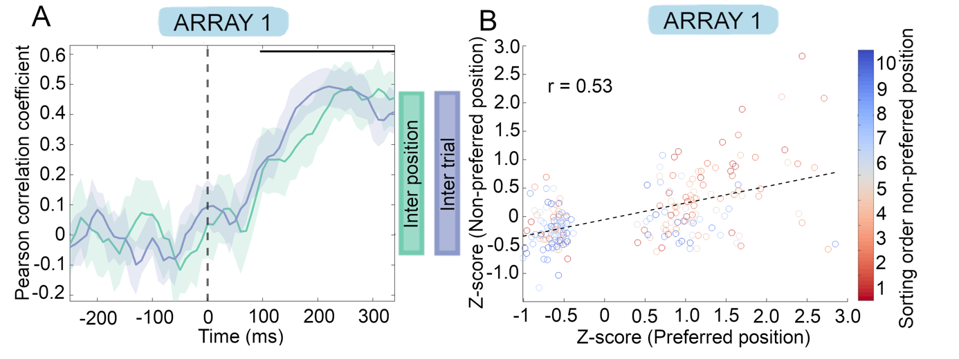
Supplementary Figure S3. A) Pearson correlation coefficient over time for sorted stimuli in the preferred and non-preferred locations (green line) when only the 5 best and worst stimuli are used per single-unit. The blue line represents intertrial variability, providing the theoretical maximum possible correlation for the green line. Shaded regions indicate 95% confidence intervals. Horizontal bars mark time intervals where the correlation was significantly higher than expected under random label shuffling (p < 0.001, one-sided permutation test with a minimum of three consecutive significant time points). B) Scatter plot illustrating the responses in the preferred location (x-axis) against the corresponding sorted responses in non-preferred locations (y-axis) at peak correlation (260–360 ms). Dotted line represents a fitted linear regression. Note that the scatter plot doesn’t show a continuous cloud because only the 5 best and 5 worst stimuli were used per single unit.

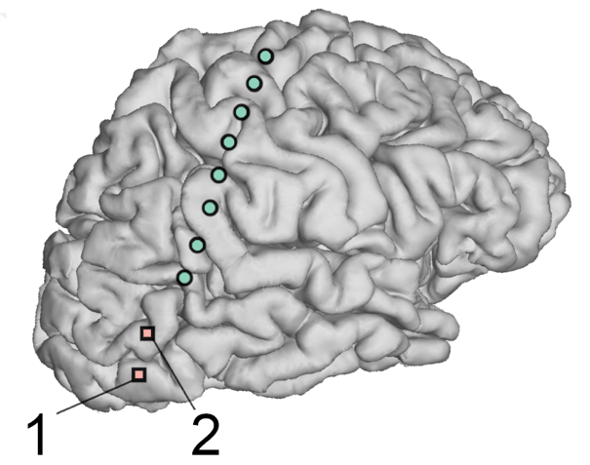
Supplementary Figure S4. Array locations in relationship to the implanted subdural grid (green dots) in left lateral occipital cortex.

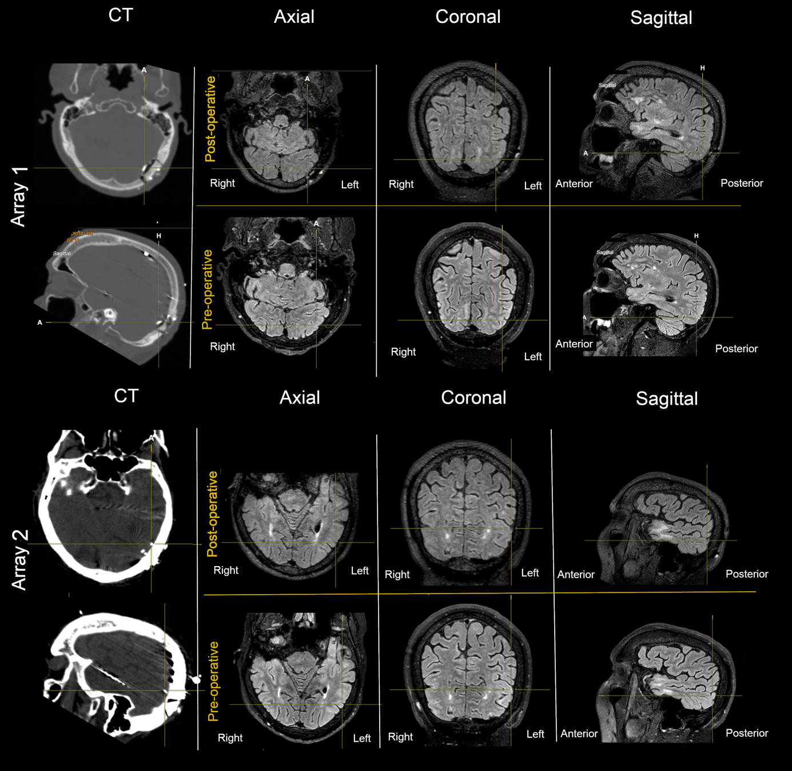
Supplementary Figure S5. Array localization. Axial, coronal, and sagittal slices of pre-implantation and post-explantation MRI (FLAIR) scans are presented. Pre-implantation MRI, post-explantation MRI, and post-implantation/pre-explantation CT scans were co-registered using Brainlab Elements software. The exact location of the array was determined based on CT imaging. Notably, no lesions were visible on the post-explantation MRI in the area where the array was inserted.

