Scenario-based Inventory Modelling for Prospective Life Cycle Assessment of Mineral Raw Materials (SIMPL-Minerals)

Jonas Klimt^{1,*}, Robert Istrate¹, Valerio Barbarossa¹, Antoine Beylot², Frederic Lai², Bernhard Steubing¹

¹ Institute of Environmental Sciences (CML), Leiden University, 2333 CC Leiden, The Netherlands
² BRGM, F-45060 Orléans, France
* Correspondence: j.b.j.klimt@cml.leidenuniv.nl

Supplementary Information 3

SI3.1 Extended results from the SIMPL-Minerals approach

PESTEL checklist
Table 1 presents the completed PESTEL checklist, which was used to identify key factors influencing the future development of generic mineral value chains. To maintain a concise overview, certain elements, such as mineral commodity prices, have been intentionally excluded. When applying the PESTEL checklist to a specific case study, practitioners are encouraged to adapt it by adding or removing factors to better reflect the characteristics of the respective mineral value chain. It is important to note that each listed factor is influenced by multiple underlying background drivers that are not explicitly included in the table. For example, the factor social acceptance of mining can be affected by the distance between the mine and nearby urban areas, the type of surface cover in the extraction zone, and the nature and extent of information shared by mining companies with the public, among other considerations. A similar evaluation can be conducted for any factor on the list. Practitioners are therefore encouraged to reflect on and incorporate such background influences where relevant to their specific context.

Table 1 Factor identification using the PESTEL checklist
PESTEL | Factor | Description
Political | Environmental policy | Policy to protect the environment and to favor less harmful practices, e.g., mineral specific (emission targets for primary commodity supply, phase out of less environmentally friendly production routes, etc…) and general policies aiming at decarbonizing economic activities (chemical production, fuel production, etc…)
Political | Circular economy policies | Policies encouraging to maintain, repair, reuse, refurbish, and remanufacture products, as well as favoring recycling routes over primary extraction
Political | Primary supply policies | Policies aiming at increasing primary supply, domestic production, or diversifying supply
Political | Demand side reduction measures | Measures introduced by policies to reduce RM demand, e.g., sharing economy or other policy proposals of degrowth scholars
Economical | Primary RM supply | RM supply from mining and concentration stages
Economical | Secondary RM supply | RM supply from collection and pre-treatment stages
Economical | Commodity demand | Total RM demand which implicitly considers overarching macro factors such as population growth and GDP development
Economical | Primary supply cost | Cost of mining, concentration, purification and refining
Economical | Secondary supply cost | Cost of collection, pre-treatment, purification and refining
Economical | RM price | The price of the RM for both primary and secondary supply
Sociocultural | Social acceptance of mining | Societies view on mining practices and willingness to resist mining activities
Technological | Decarbonization | Decarbonization of the entire economy through renewable energy technologies
Technological | Digitalization | Digitalization of the entire economy
Technological | R&D | Research and development into advancing mining, recycling and metallurgical technologies
Technological | Substitutability | Substitutability of the RM under study
Technological | Final product alternatives | Over time alternatives using less or none of the RM in the same technology might penetrate the market, e.g., different battery types
Technological | Primary supply capacity | The total possible mineral extraction rate over a given time horizon. An increase or decrease can be a change in production from existing infrastructure or a change in site numbers, which is closely related to exploration
Technological | Product lifetime | Lifetime of the product containing the RM, which is available as waste and the EoL of the respective product
Technological | Secondary supply capacity | Similar to mining capacity but relating to the amount of waste material that can be processed in recycling infrastructure
Environmental | Deposit quality | Generic deposit quality measure encompassing all deposit characteristics parameters (e.g., ore grade, strip ratio, impurities, etc.)
Environmental | Available reserves | Known economically recoverable ore bodies
Legal | Environmental legislation | Legislation to protect the environment, e.g., permittance of deposit exploitation, prohibition of tailings disposal into water bodies

Modelling granularity
Modelling granularity should be considered hierarchically based on data availability (Figure 1). The preferred approach is to use site-specific data for all sites included in the study. If such data are unavailable, average production pathway data should be used. Production pathways can be characterized by a combination of distinct deposit types, ore grades, processing technologies, and countries or regions. For case studies focused on a single site or company, there is a strong preference for site-specific data (e.g., Khakmardan et al., 2025). If secondary data are required to fill gaps, they should ideally correspond to the same deposit type, similar ore grade, processing technology, and country or region as the site under study. For analyses with a regional or global scope, site-specific data from all relevant sites should be used wherever possible. Regional or global assessments typically rely on company reports and other secondary sources (Eckelman, 2010; Northey et al., 2013; Schenker & Pfister, 2025; Weng et al., 2016). If site-specific data are unavailable, the value chain should be disaggregated into multiple distinct production pathways (Figure 3). For example, Ambrose and Kendall (2020) performed a pLCA for lithium using a combination of deposit types (brine/pegmatite) and ore grade categories (low/medium/high). Similarly, van der Meide et al. (2022) conducted a pLCA on cobalt, disaggregating the global value chain by cobalt from copper, nickel laterite, and nickel sulfate production, as well as hydro- and pyrometallurgical treatment of Li-ion battery waste.

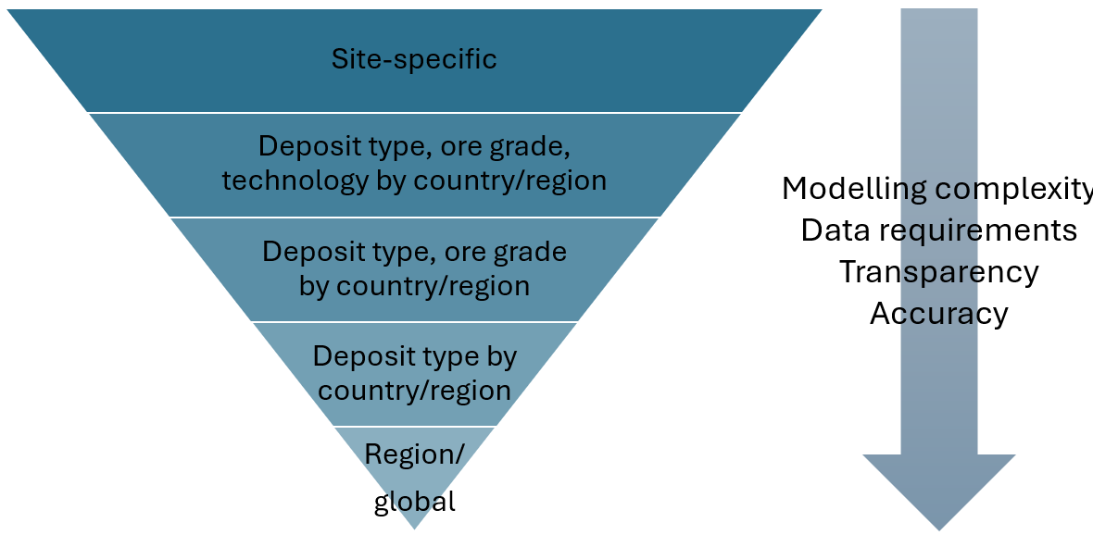
Fig 1 Hierarchy of modelling granularities to be used for constructing the inventory.

RQ archetypes
Table 2 provides examples of RQ archetypes, which focus they have, and if they correspond to site, company, regional, or global scope of analysis.

Table 2 Research question examples addressed by pLCA, grouped by thematic focus. For each RQ, the applied geographical scope can be one single site, a company consisting of multiple single sites, a region defined as subnational, national or supranational, or global scope.
Focus | RQ example (simplified) | Site | Company | Regional | Global
Technology | What is the environmental impact mitigation potential of new/emerging technologies compared to the current practices? | ✔ | ✔ | ✔ | ✔
Technology | How do changes in resource characteristics influence future environmental impacts? | ✔ | ✔ | ✔ | ✔
System configuration | How do alternative mineral value chains compare in terms of environmental impacts? |  | ✔ | ✔ | ✔
Circularity | How do recycling and circular strategies influence future environmental impacts of mineral commodity supply? |  | ✔ | ✔ | ✔
Policy | How do prospective mineral value chains align with or diverge from international environmental policy targets? |  |  | ✔ | ✔
Policy | How will environmental impacts of demand of mineral raw materials develop in the future and what are possible mitigation levers? |  |  | ✔ | ✔

SI3.2 Showcasing SIMPL-Minerals

Inventory analysis
Inventory data and software
The foreground inventories for primary supply were taken from Roy et al. (2025) and scaled to differentiate between stages represented as unit processes. Since Roy et al. (2025) report inventories aggregated into a single stage, based on a functional unit of 1 kg Ni equivalent, we disaggregated the stages to align with those identified in the inventory model blueprint (mining, concentration, purification, refining). This was achieved by scaling inventory flows to match the production output of each stage. The calculations used for scaling the inventories are provided in SI 2.4. Additionally, inventories were complemented with average nickel mine data from Eckelman (2010) and ecoinvent 3.10 inventories for mining and concentration, as well as nickel Class I to nickel sulfate processing (Wernet et al., 2016) to supplement the FS route. Inventories for secondary supply were taken from Kallitsis et al. (2022).
The background database was created using the superstructure approach (Steubing & de Koning, 2021) via premise (Sacchi et al., 2022), incorporating scenarios from the Integrated Assessment Model (IAM) REMIND (Tino et al., 2023). As a result, the background parameter for chemical reagent decarbonization is only indirectly accounted for: the energy supply for chemical reagent production is decarbonized, but direct emissions from chemical production processes are not included.
Multifunctionality was addressed using mass-based allocation, with one exception. In the FS purification process, sulfuric acid is produced as a by-product when converting sulfidic ore into nickel matte. This by-product is typically used in nearby operations, such as leaching processes, or sold on the market. Sulfuric acid production is relatively inexpensive, and the conversion of sulfur dioxide to sulfuric acid is required to prevent acid rain and comply with environmental regulations, while the primary aim of the process remains nickel production. Therefore, an allocation factor of zero was assigned to sulfuric acid and one to nickel matte. This conservative approach likely overestimates the environmental impacts allocated to the final product. This effect is expected to increase in future scenarios, as global sulfuric acid supply could decline due to reduced reliance on fossil fuels—where sulfuric acid is commonly produced as a by-product—potentially raising prices. Economic allocation was not used, consistent with most LCA studies in the mineral value chain, which typically address high-volume, low-value products (Lai et al., 2021).

Limitations of case study
The real-life applicability of the presented case study is subject to several limitations. Ore grade decline, which influences energy demand, is implemented in the LCI model using a linear rather than exponential correlation, potentially underestimating its effect on energy-intensive impact categories, such as climate change. The modeled primary production pathways do not cover the entire nickel sulfate market, as certain routes, such as nickel pig iron (NPI) and mixed sulfide precipitate (MSP) production, are excluded due to complex processing requirements, including toxic gas handling during high-pressure acid leaching (HPAL), and the assumption that lower-cost routes such as ferronickel (FeNi) and mixed hydroxide precipitate (MHP) will continue to dominate. Emerging production technologies, including deep-sea mining, pytho mining, and tailings reprocessing, are also not included. Secondary production pathways do not account for potential future processes, such as direct recycling, and the corresponding inventories remain unchanged across different battery cell chemistries. Co-product recovery efficiencies are assumed to develop in line with the main product, keeping mass allocation factors constant over time. Additionally, ore composition is assumed to remain static, and transportation processes are not included in the inventories. Finally, the study focuses exclusively on nickel sulfate demand for battery electric vehicles (BEVs), excluding other potential end-use applications.

References
Aboumahboub, T., Auer, C., Bauer, N., Baumstark, L., Bertram, C., Bi, S., Dietrich, J., Dirnaichner, A., Giannousakis, A., Haller, M., Hilaire, J., Klein, D., Koch, J., Körner, A., Kriegler, E., Leimbach, M., Levesque, A., Lorenz, A., Luderer, G., … Ueckerdt, F. (2020). REMIND - REgional Model of INvestments and Development (2.1.0). Zenodo. https://doi.org/10.5281/zenodo.3730919
Ambrose, H., & Kendall, A. (2020). Understanding the future of lithium: Part 2, temporally and spatially resolved life-cycle assessment modeling. Journal of Industrial Ecology, 24(1), 90–100. https://doi.org/10.1111/jiec.12942
Eckelman, M. J. (2010). Facility-level energy and greenhouse gas life-cycle assessment of the global nickel industry. Resources, Conservation and Recycling, 54(4), 256–266. https://doi.org/10.1016/j.resconrec.2009.08.008
Kallitsis, E., Korre, A., & Kelsall, G. H. (2022). Life cycle assessment of recycling options for automotive Li-ion battery packs. Journal of Cleaner Production, 371, 133636. https://doi.org/10.1016/j.jclepro.2022.133636
Khakmardan, S., Crawford, R. H., Giurco, D., & Li, W. (2025). Constructing a life cycle inventory of Spodumene concentrate production: Greenbushes case, Western Australia. Journal of Cleaner Production, 145123. https://doi.org/10.1016/j.jclepro.2025.145123
Lai, F., Laurent, F., Beylot, A., & Villeneuve, J. (2021). Solving multifunctionality in the carbon footprint assessment of primary metals production: Comparison of different approaches. Minerals Engineering, 170, 107053. https://doi.org/10.1016/j.mineng.2021.107053
Northey, S., Haque, N., & Mudd, G. (2013). Using sustainability reporting to assess the environmental footprint of copper mining. Journal of Cleaner Production, 40, 118–128. https://doi.org/10.1016/j.jclepro.2012.09.027
Roy, S., Moustafa, H., Vaidya, K., Harvey, J.-P., & Fradette, L. (2025). On process-based granular reconstruction of life cycle inventories: Sustainably coherent planning of primary battery-grade nickel. https://doi.org/10.1038/s44296-025-00059-7
Sacchi, R., Terlouw, T., Siala, K., Dirnaichner, A., Bauer, C., Cox, B., Mutel, C., Daioglou, V., & Luderer, G. (2022). PRospective EnvironMental Impact asSEment (premise): A streamlined approach to producing databases for prospective life cycle assessment using integrated assessment models. Renewable and Sustainable Energy Reviews, 160, 112311. https://doi.org/10.1016/j.rser.2022.112311
Schenker, V., & Pfister, S. (2025). Current and Future Impacts of Lithium Carbonate from Brines: A Global Regionalized Life Cycle Assessment Model. Environmental Science & Technology, 59(13), 6543–6555. https://doi.org/10.1021/acs.est.4c12619
Steubing, B., & de Koning, D. (2021). Making the use of scenarios in LCA easier: The superstructure approach. The International Journal of Life Cycle Assessment, 26(11), 2248–2262. https://doi.org/10.1007/s11367-021-01974-2
Steubing, B., Koning, D. de, Haas, A., & Mutel, C. L. (2020). The Activity Browser—An open source LCA software building on top of the brightway framework. Software Impacts, 3. https://doi.org/10.1016/j.simpa.2019.100012
van der Meide, M., Harpprecht, C., Northey, S., Yang, Y., & Steubing, B. (2022). Effects of the energy transition on environmental impacts of cobalt supply: A prospective life cycle assessment study on future supply of cobalt. Journal of Industrial Ecology, 26(5), 1631–1645. https://doi.org/10.1111/jiec.13258
Weng, Z., Haque, N., Mudd, G. M., & Jowitt, S. M. (2016). Assessing the energy requirements and global warming potential of the production of rare earth elements. Journal of Cleaner Production, 139, 1282–1297. https://doi.org/10.1016/j.jclepro.2016.08.132
Wernet, G., Bauer, C., Steubing, B., Reinhard, J., Moreno-Ruiz, E., & Weidema, B. (2016). The ecoinvent database version 3 (part I): Overview and methodology. The International Journal of Life Cycle Assessment, 21(9), 1218–1230. https://doi.org/10.1007/s11367-016-1087-8

