Supplementary file 1.
CUE-Dx (Comprehensive Usability Evaluation for Diagnostics): a usability assessment framework
The CUE-Dx framework organizes usability into three interrelated domains: core domains (effectiveness, efficiency, errors and use safety) representing the minimum constructs required for safe and accurate test use; complementary domains (learnability, memorability and satisfaction) capturing additional aspects of user experience; and contextual domains representing environmental, organizational, and system-level factors that influence usability in practice. The framework integrates regulatory guidance (e.g., FDA, ISO 62366), usability theory, and contextual factors to support the evaluation of diagnostic tools across development and deployment phases.

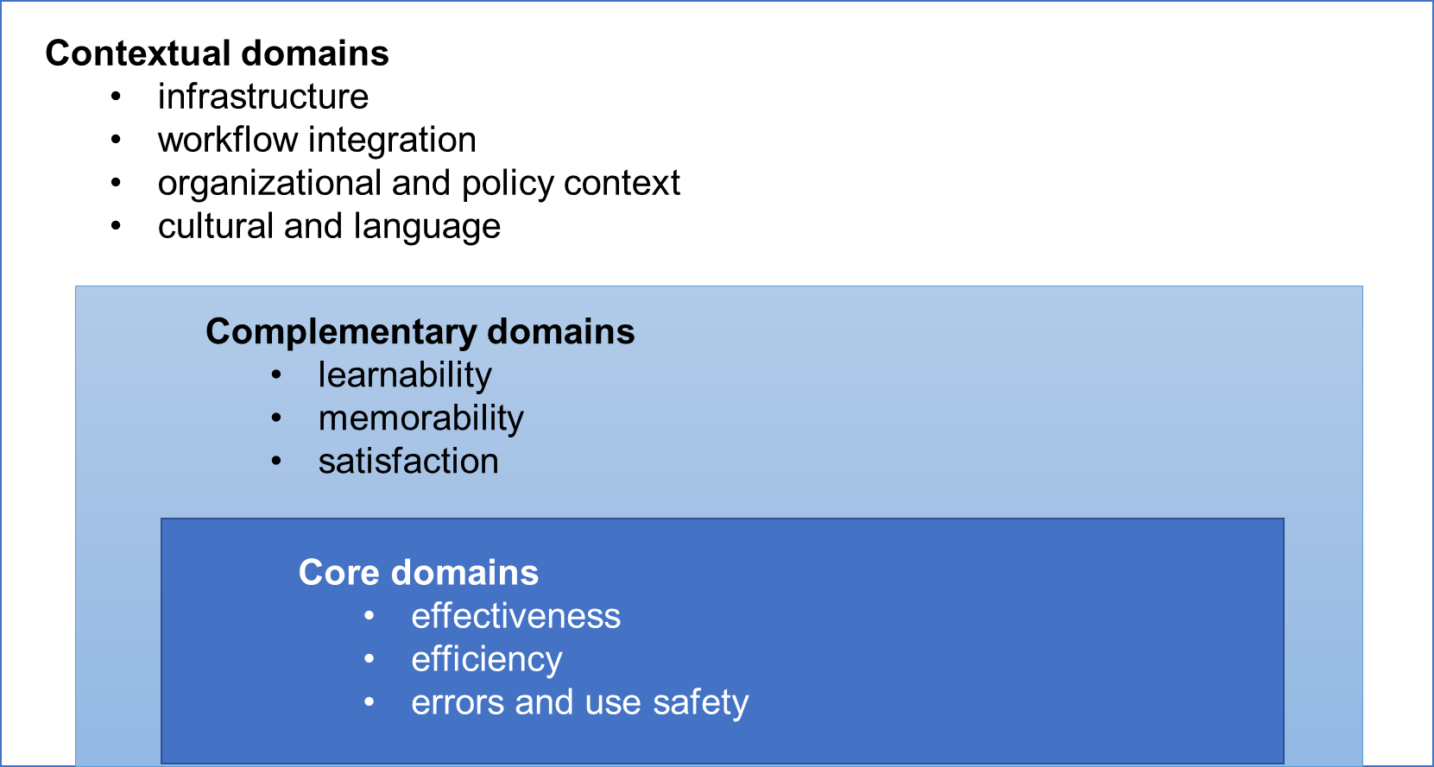
Figure. Interrelated constructs to measure usability of a POC diagnostic test
Core Domains
- Use Safety: Freedom from unacceptable use-related risk. [1]
Derived from FDA and ISO definitions, this domain encompasses the ability of the test and its interface to prevent harm to users or patients during normal use, including risks associated with incorrect operation or interpretation.
- Use Error: A user action (or inaction) that deviates from the manufacturer’s intended use and caused a result that (1) was different from the result expected by the user and (2) was not caused solely by device failure and (3) did or could result in harm. [1]
Use errors are observable events and may serve as indicators of deficiencies in effectiveness or safety.
- Effectiveness: The accuracy and completeness with which users achieve specified goals in a particular context. [2]
This refers to successful completion of diagnostic tasks, including correct operation, result interpretation, and appropriate action based on the result.
- Efficiency: The resources (e.g., time, effort, number of steps) used to achieve effective performance. [2]
Efficiency reflects the relationship between task completion and the amount of user burden required, without compromising accuracy or safety.
Complementary Domains
- Learnability: The extent to which new users can effectively interact with the test after minimal exposure or instruction. [3]
Relevant in settings where formal training is limited or when tests are intended for self-use.
- Memorability: The ease with which users can recall how to use the test after a period of non-use, without retraining. [3]
Important for infrequent users or repeat testing scenarios.
- Satisfaction: The degree to which the user finds the system acceptable, comfortable, and aligned with their expectations. [4][3]
Includes subjective impressions related to usability, perceived control, emotional response, and overall acceptability.
Contextual Domains
While not part of usability as defined by regulatory guidance (e.g., FDA, ISO), contextual domains represent external system-level factors that shape how usability is enacted in real-world conditions. They influence the feasibility, consistency, and interpretation of usability outcomes by modulating how a diagnostic test is used, perceived, or integrated within a given setting.
Including these domains allows evaluators to bridge human factors engineering with implementation considerations such as infrastructure constraints, workflow demands, and context.
- Infrastructure Factors: The availability, adequacy, and reliability of material and human resources needed to conduct testing.
Includes access to electricity, storage, equipment, and supplies that affect implementation feasibility.
- Workflow Integration: The extent to which the test fits into existing clinical, laboratory, or community workflows.
Captures whether the test disrupts or aligns with current routines and staff responsibilities.
- Organizational and Policy Context: The broader institutional and regulatory environment that influences usability.
Includes leadership engagement, task-shifting regulations, and test prioritization systems.
- Cultural and Language Considerations: The influence of local cultural norms, language, and literacy on test comprehension and acceptability.
Affects instruction interpretation, consent, communication of results, and perceived legitimacy of the test.
- Interruptions and Competing Demands: The degree to which usability is affected by distractions, workload, or environmental pressures during testing.
Particularly relevant for multitasking health workers or self-testers in informal settings.

References
1 Applying-Human-Factors-and-Usability-Engineering-to-Medical-Devices---Guidance-for-Industry-and-Food-and-Drug-Administration-Staff.pdf (accessed 6 September 2023)
2 ISO. Medical devices – Part 1: Application of usability engineering to medical devices.
3 Nielsen J. Usability Engineering. San Francisco: Morgan Kaufmann 1993.
4 ISO. Ergonomics of human-system interaction. Part 210: Human-centred design for interactive systems.

