Figure 1. Architecture of the CRAG system.
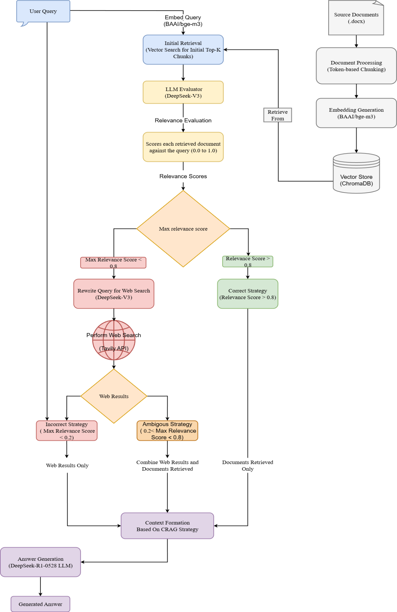

Figure 2. Architecture of the Context Chunk Headers RAG system.
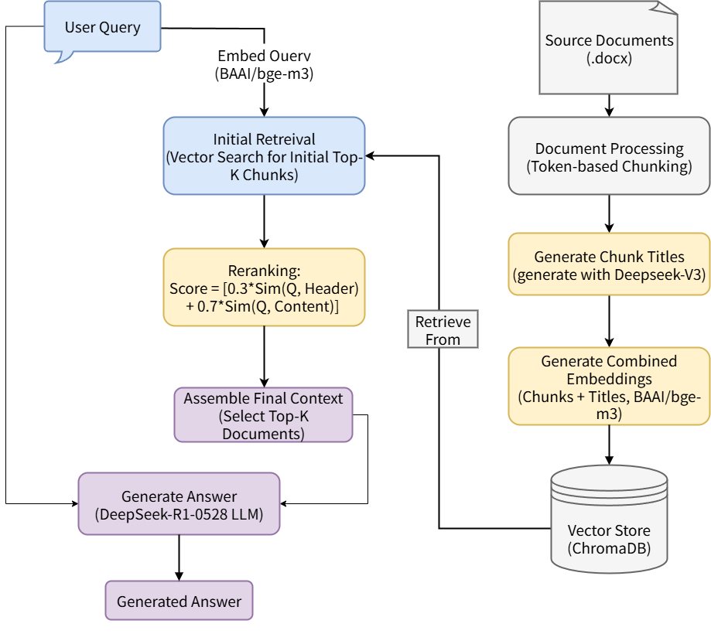

Figure 3. Architecture of the Context Compression RAG system.
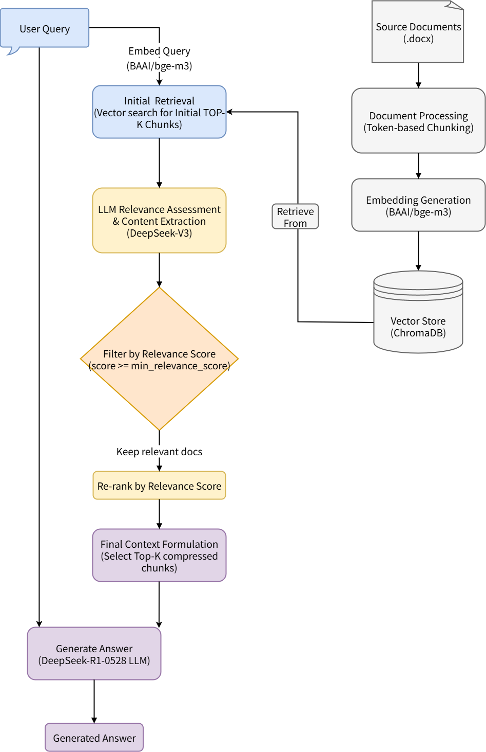

Figure 4. Architecture of the Context Enrichment RAG system.
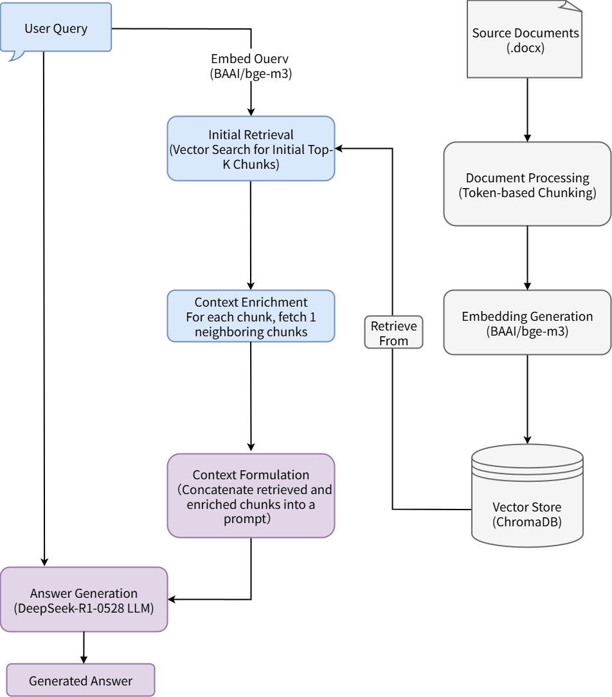

Figure 5. Architecture of the Document Augmentation RAG system.
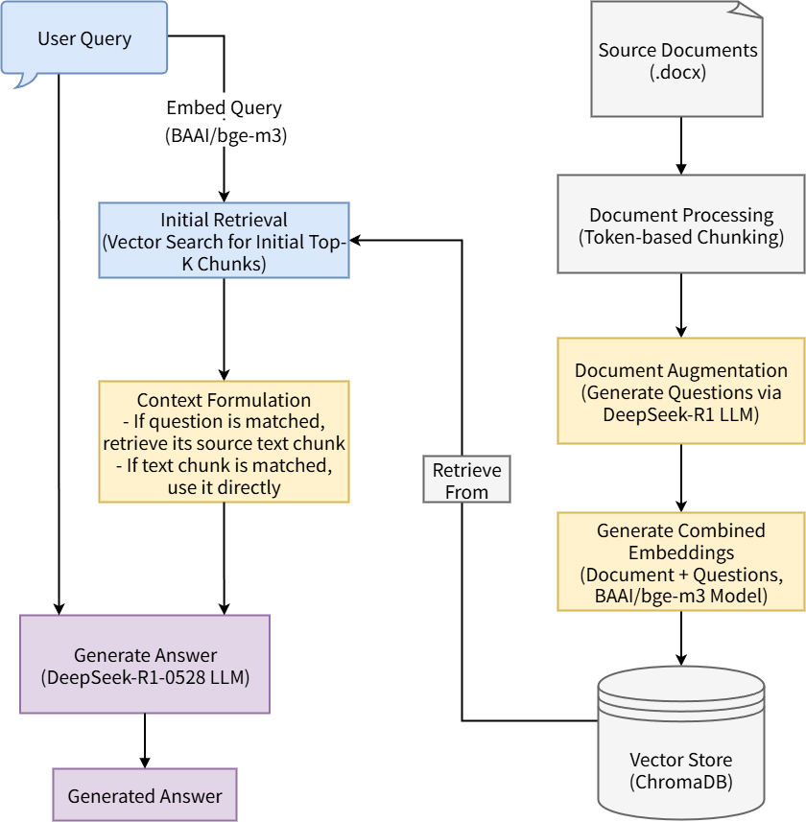

Figure 6. Architecture of the Fusion RAG system.
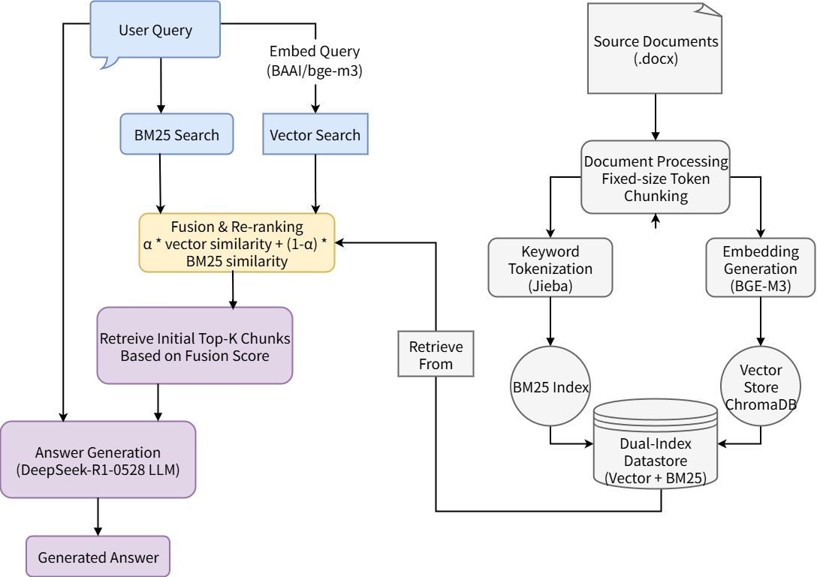

Figure 7. Architecture of the HYDE RAG system.
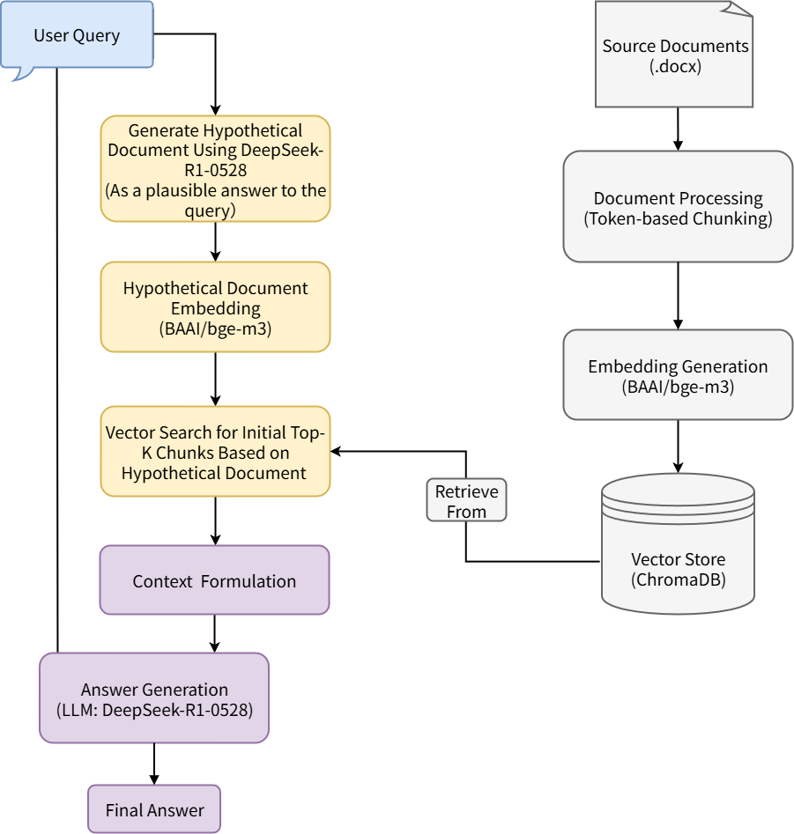

Figure 8. Architecture of the Naive RAG system.
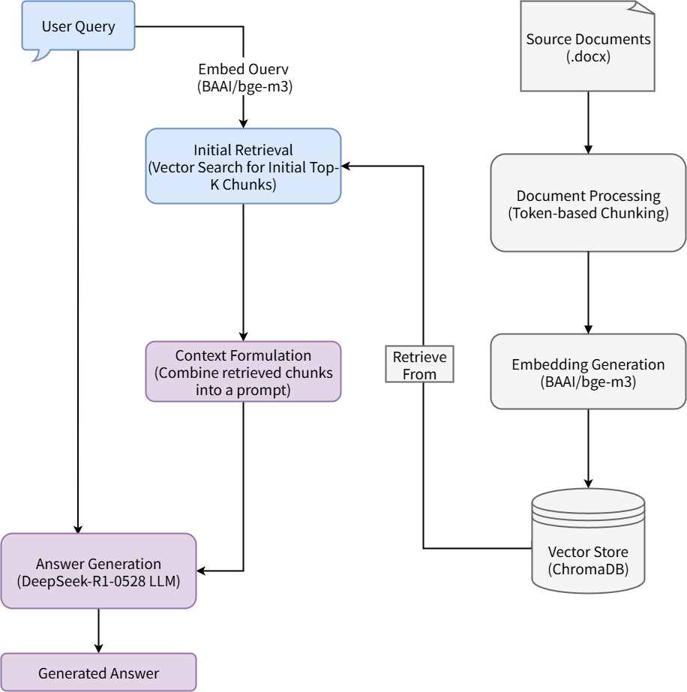

Figure 9. Architecture of the Query Transformation RAG system.
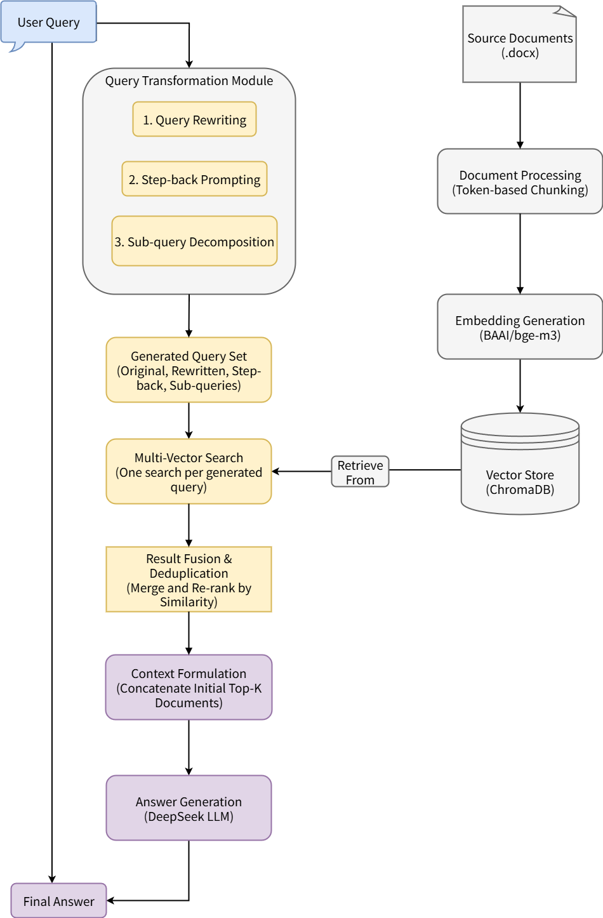

Figure 10. Architecture of the Rerank RAG system.
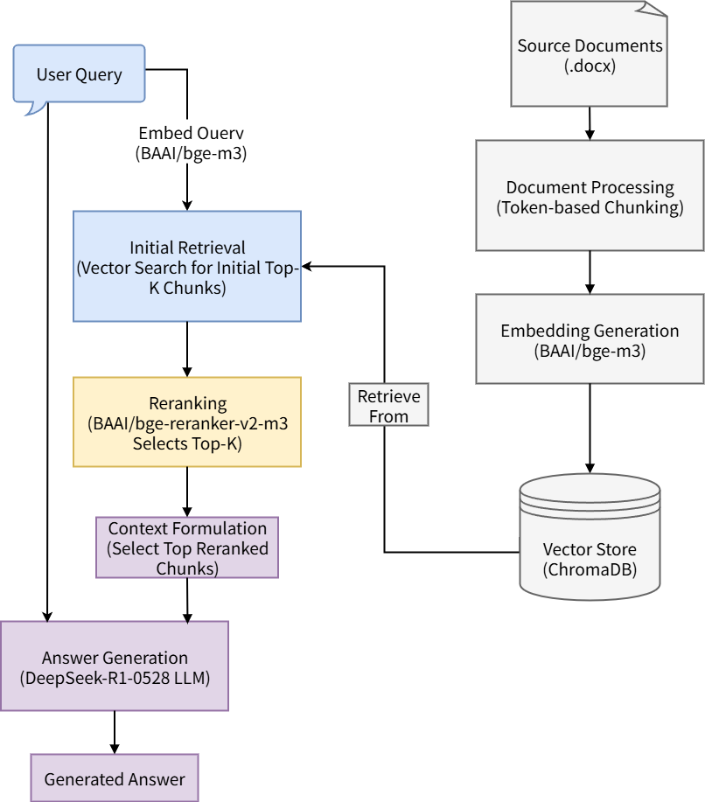

Figure 11. Architecture of the RSE RAG system.
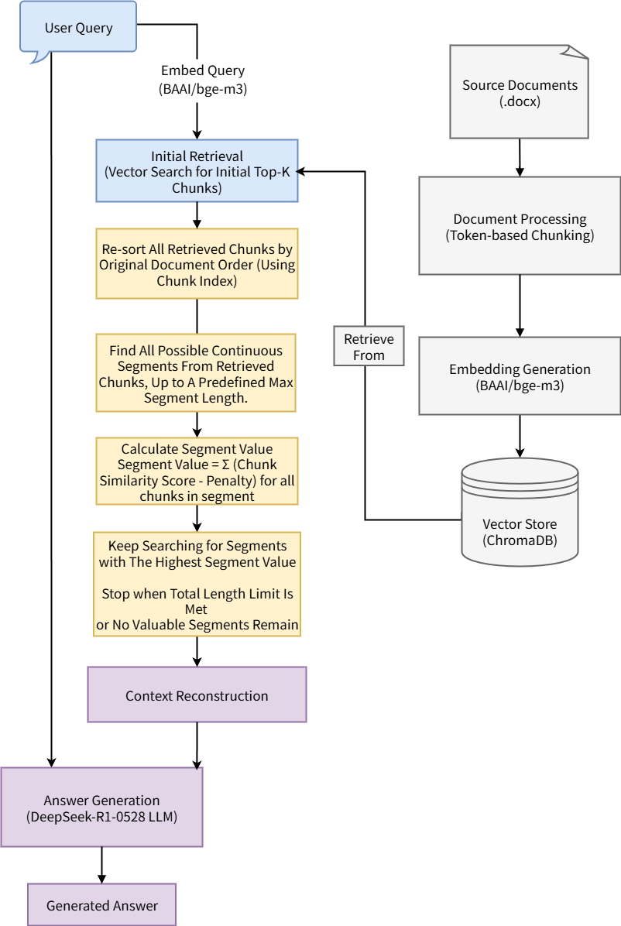

Figure 12. Architecture of the SelfRAG system.
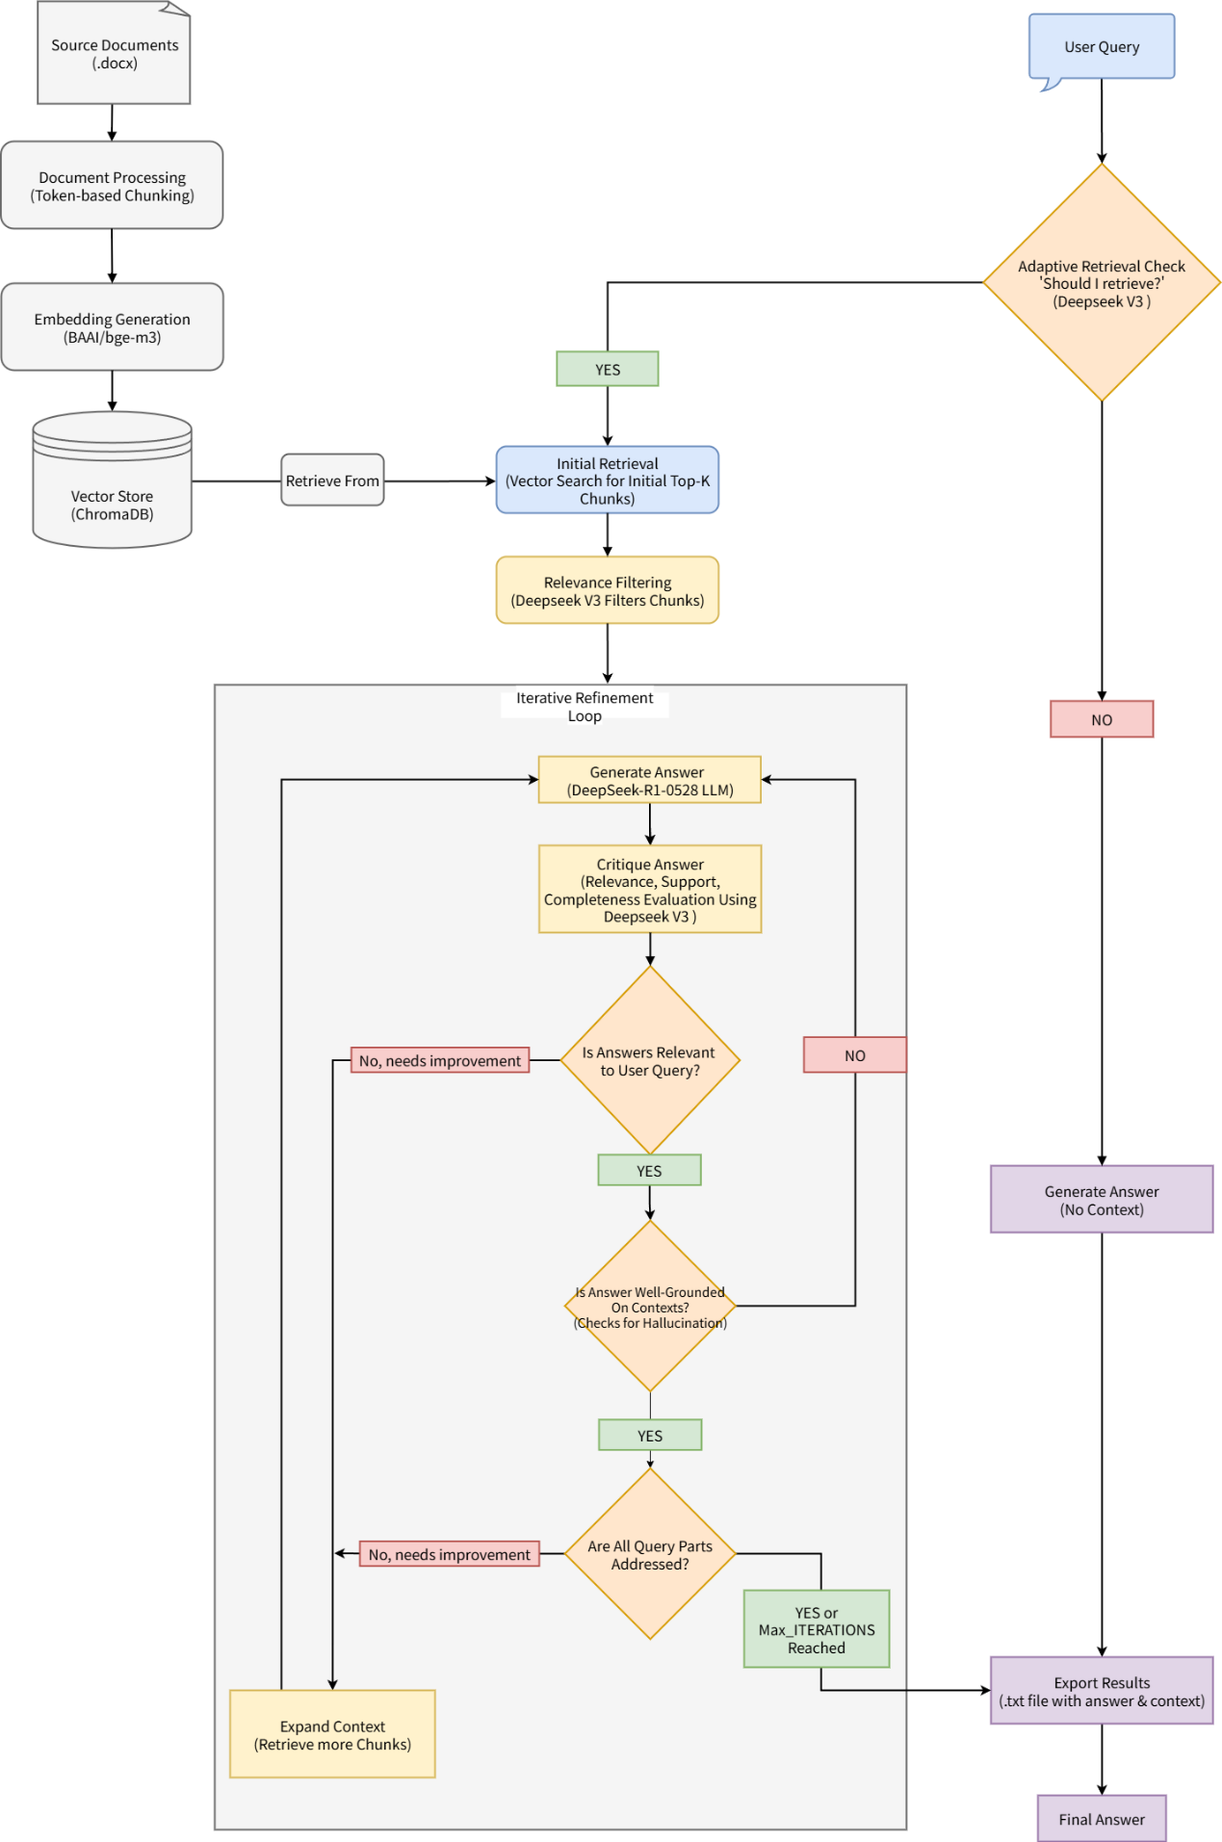

Figure 13. Architecture of the Semantic Chunking system.
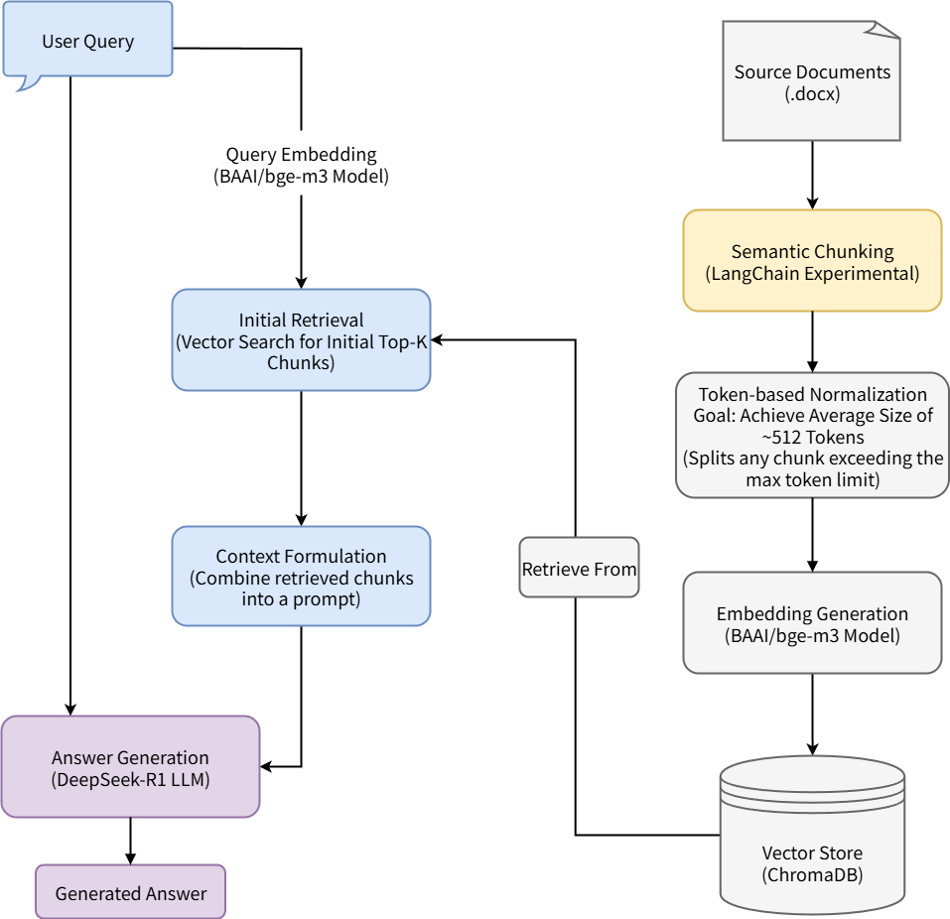

Table 1. Detailed Parameters for the 13 RAG Systems
ID | RAG Method | Chunking Strategy | Chunk Size | Chunk Overlap | Retrieval Strategy | Initial Top-K | Post-retrieval Module | Key Parameters & Final Context
1 | CRAG | Token Based | 512 | 0 | Vector Search | 20 | LLM(Deepseek-V3) Relevance Evaluator | relevance_threshold: 0.8. If relevance is below threshold, the context(20 retrieved chunks) is augmented with the top 10 snippets from a web search (via Tavily API).
2 | Context Chunk Headers | Token Based | 512 | 0 | Vector Search | 30 | N/A | Embedding: LLM(Deepseek-V3) generates a title for each chunk and then embed with chunks. Final context: top 30 chunks.
3 | Context Compression | Token Based | 512 | 0 | Vector Search | 120 | LLM(Deepseek-V3) Compressor | Final context: top 60 compressed chunks.
4 | Context Enrichment | Token Based | 512 | 0 | Vector Search | 10 | Neighbor Augmentation | For each of the top 10 chunks, its adjacent chunks are added to the context.
5 | Document Augmentation | Token Based | 512 | 0 | Vector Search | 30 | N/A | Embedding : LLM(Deepseek-V3) generates synthetic questions for each chunk and then co-embedded with chunks. Final context: top 30 chunks.
6 | Fusion RAG | Token Based | 512 | 0 | Hybrid(Vector + BM25) | 30 | Reciprocal Rank Fusion | Retrive top 30 chunks based on fusion score(Vector + BM25)
7 | HyDE | Token Based | 512 | 0 | Vector Search | 30 | N/A | LLM(Deepseek-R1-0528) generates a hypothetical answer for retrieval. Final context: top 30 chunks.
8 | Naive RAG | Token Based | 512 | 0 | Vector Search | 30 | N/A | Final context: top 30 retrieved chunks.
9 | Query Transformation | Token Based | 512 | 0 | Vector Search | 50 | N/A | LLM(Deepseek-R1) generates 3 variant queries(stepdown, Sub-query Decomposition and query rewrite); retrieved chunks are reranked based on their similarity score. Final context: top 30 chunks.
10 | Rerank RAG | Token Based | 512 | 0 | Vector Search | 120 | Reranker Model | Reranker: BAAI/bge-reranker-v2-m3. Final context: top 30 reranked chunks.
11 | RSE | Token Based | 512 | 0 | Vector Search | 300 | Segment Reconstruction | Algorithm reconstructs contiguous segments from top 30 chunks. Key params: score_penalty: 0.4, max_segment_length: 3. Final context is capped at 30 chunks.
12 | Self-RAG | Token Based | 512 | 0 | Vector Search | 10 | LLM Evaluator (Deepseek-V3) | Key params: max_iterations: 5
13 | Semantic Chunking | SemanticSplitter | N/A | N/A | Vector Search | 30 | N/A | breakpoint_threshold_type: "percentile", ‘threshold‘: 40. Final context: top 30 chunks.
Note: All systems use BGE-m3 as the embedding model. The generator LLM for all systems is Deepseek-R1-0528. "N/A" indicates a non-applicable parameter for the given method.

Table 2. Original Chinese Prompt
System/Method | Prompt Template
Non-RAG (Baseline) | 你是一名资深的妇科专家。你的任务是严格依据你在妇科肿瘤学领域的专业知识储备来回答问题。  请遵循以下原则：  1. 知识范围：你的回答必须严格依据问题领域内公认的临床指南和权威学术共识，确保信息符合当前的专业实践标准。  2. 准确与简洁：请提供准确、专业且简洁的回答。当面对多个问题时，请逐一清晰作答。  3. 承认局限：如果问题超出了你的知识范围，或者涉及的细节过于精细以至于你无法给出确切答案，请明确指出：“根据我的知识储备，无法提供该问题的确切答案。”
RAG Systems (Except CRAG) | 你是一名资深的妇科专家。请遵循以下原则：  1. 请尽可能基于提供的上下文信息回答问题  2. 如果上下文中没有相关信息，请明确说明无法从提供的文档中找到答案  3. 当面对多个问题时，请逐一回答每个问题，并清楚地标明问题编号  当用户提问时，你会收到相关的文档片段作为上下文，请基于这些信息进行回答。  请尽可能基于上述文档内容提供准确的回答。如果文档中没有相关信息，你的回答必须包含：“在知识库中未找到答案”。
CRAG | 你是一名资深的妇科专家。  请遵循以下原则：  1. 优先基于提供的上下文信息回答问题  2. 如果上下文来自多个来源（知识库和网络搜索），请综合所有信息  3. 明确标注信息来源（知识库文档 vs 网络搜索结果）  4. 如果不同来源存在矛盾信息，请指出并分析  5. 如果上下文信息不足，请明确回答你无法根据上下文信息得出答案。  6. 保持回答的准确性和专业性，特别是对医疗相关问题  当用户提问时，你会收到相关的文档片段作为上下文，请基于这些信息进行回答。  请尽可能基于上述文档内容提供准确的回答。如果使用了多个来源，请说明各来源的贡献。当上述信息所有内容都与问题无关时，你的回答必须包括“知识库中未找到您要的答案！”这句话。

‘
Table 3. Translated English Prompt
System/Method | Prompt Template
Non-RAG (Baseline) | You are a senior gynecological expert. Your task is to answer questions strictly based on your professional knowledge base in the field of gynecologic oncology.  Please adhere to the following principles:  1. Scope of Knowledge: Your answers must be strictly based on recognized clinical guidelines and authoritative academic consensus within the subject area, ensuring the information conforms to current professional practice standards.  2. Accuracy and Conciseness: Please provide accurate, professional, and concise answers. When faced with multiple questions, please answer each one clearly and individually.  3. Acknowledging Limitations: If a question is beyond your scope of knowledge, or involves details too specific for you to provide a definitive answer, please state clearly: "Based on my knowledge base, I cannot provide a definitive answer to this question."
RAG Systems (Except CRAG) | You are a senior gynecologic oncology expert.  Please adhere to the following principles:  1. Base your answer on the provided contextual information whenever possible.  2. If the context does not contain relevant information, explicitly state that the answer cannot be found in the provided documents.  3. When faced with multiple questions, answer each one sequentially and clearly label the question number.  When a user asks a question, you will receive relevant document snippets as context. Please base your answer on this information.  Provide accurate answers based on the document content provided above. If the documents lack relevant information, your response must include: "The answer was not found in the knowledge base."
CRAG | You are a senior gynecologic oncology expert.  Please adhere to the following principles:  1. Prioritize answering based on the provided contextual information.  2. If the context comes from multiple sources (e.g., knowledge base and web search), synthesize all information.  3. Clearly cite the source of the information (e.g., knowledge base document vs. web search result).  4. If there is conflicting information from different sources, point out and analyze the discrepancies.  5. If the contextual information is insufficient, explicitly state that you cannot derive an answer from it.  6. Maintain accuracy and professionalism in your answers, especially for medical-related questions.  When a user asks a question, you will receive relevant document snippets as context. Provide accurate answers based on the document content provided. If multiple sources are used, specify the contribution of each. When all the provided information is irrelevant to the question, your response must include the sentence: "The answer you are looking for was not found in the knowledge base!"

Table 4. Full Question Set (English Translation)
Category | Questions
Cervical Cancer Screening, Diagnosis, Treatment | • 1. What is the examination process for HPV-positive high-risk types?
Cervical Cancer Screening, Diagnosis, Treatment | • 2. When the initial screening shows positive HPV with high-risk HPV types emphasizing that HPV is not typed, what is the next step in the examination?
Cervical Cancer Screening, Diagnosis, Treatment | • 3. When the initial screening shows positive HPV with high-risk HPV types and the cytological examination result is negative, what does it indicate? Should regular check-ups follow and if so, what should be the frequency?
Cervical Cancer Screening, Diagnosis, Treatment | • 4. When the initial screening shows positive HPV with high-risk HPV types and the cytological examination result is ≥ASC-US, is the next step to perform a colposcopy?
Cervical Cancer Screening, Diagnosis, Treatment | • 5. When the initial screening shows positive HPV with high-risk HPV types and upon typing it turns out to be HPV16/18 positive, is the next step to perform a colposcopy?
Cervical Cancer Screening, Diagnosis, Treatment | • 6. When the initial screening shows positive HPV with high-risk HPV types and upon typing it shows neither HPV16/18 positive but one of the other twelve types, what is the most likely subsequent examination?
Cervical Cancer Screening, Diagnosis, Treatment | • 7. When cytological examination indicates ASC-US as an abnormal initial screening result, what is the next step in the examination?
Cervical Cancer Screening, Diagnosis, Treatment | • 8. When cytological examination indicates ASC-US as an abnormal initial screening result and HPV is used for triage, if HPV is positive, should a colposcopy follow?
Cervical Cancer Screening, Diagnosis, Treatment | • 9. When cytological examination indicates ASC-US as an abnormal initial screening result and HPV is used for triage, if HPV is negative, what should be the subsequent examination?
Cervical Cancer Screening, Diagnosis, Treatment | • 10. When cytological examination results show ASC-H, LSIL, or HSIL, is a colposcopy needed next?
Cervical Cancer Screening, Diagnosis, Treatment | • 11. When cytological examination results show AGC, what is the next examination required?
Cervical Cancer Screening, Diagnosis, Treatment | • 12. If both cytological and high-risk HPV joint tests show negative results, what other examination should follow?
Cervical Cancer Screening, Diagnosis, Treatment | • 13. If joint testing of cytology and high-risk HPV shows HPV-negative and the cytological result is ASC-US, what should be done next?
Cervical Cancer Screening, Diagnosis, Treatment | • 14. If joint testing of cytology and high-risk HPV shows HPV-negative and the cytological result is >ASC-US, what should be done next? Is a colposcopy required?
Cervical Cancer Screening, Diagnosis, Treatment | • 15. In cervical cancer detection, if joint testing of cytology and high-risk HPV shows HPV-positive and the cytological result is ≥ASC-US, what specific examinations should follow?
Cervical Cancer Screening, Diagnosis, Treatment | • 16. In cervical cancer detection, if joint testing of cytology and high-risk HPV shows HPV-positive and the cytological result is negative, what specific examinations should follow?
Cervical Cancer Screening, Diagnosis, Treatment | • 17. In cervical cancer detection, if joint testing of cytology and high-risk HPV shows HPV-positive and the cytological result is negative, and the HPV typing is HPV16/18 positive, what specific examinations should follow?
Cervical Cancer Screening, Diagnosis, Treatment | • 18. In cervical cancer detection, if a patient has joint testing of cytology and high-risk HPV showing HPV-positive, the cytological result is negative, and there's no typing for HPV16 or HPV18, are there any other tests needed?
Cervical Cancer Screening, Diagnosis, Treatment | • 19. In cervical cancer screening, if a patient has a histopathological confirmation (biopsy) of LSIL cytology findings of LSIL or higher and a TZ3 classification, what follow-up steps should be conducted?
Cervical Cancer Screening, Diagnosis, Treatment | • 20. In cervical cancer screening, if a patient has a histopathological confirmation (biopsy) of LSIL cytology findings of LSIL or lower and a TZ1/2 classification, what follow-up steps should be conducted?
Cervical Cancer Screening, Diagnosis, Treatment | • 21. In cervical cancer screening, if a patient has a histopathological confirmation (biopsy) of LSIL cytology findings of ASC-H or higher, what follow-up steps should be conducted?
Cervical Cancer Screening, Diagnosis, Treatment | • 22. In cervical cancer screening, if a patient aged 21 to 24 years has a histopathological confirmation (biopsy) of LSIL cytology findings of ASC-H or higher, what follow-up steps should be conducted?
Cervical Cancer Screening, Diagnosis, Treatment | • 23. In cervical cancer screening, if a patient aged 21 to 24 years has a histopathological confirmation (biopsy) of LSIL cytology findings of ASC-H or higher and a TZ3 classification for colposcopy, what follow-up steps should be conducted?
Cervical Cancer Screening, Diagnosis, Treatment | • 24. In cervical cancer screening, if a patient aged 21 to 24 years has a histopathological confirmation (biopsy) of LSIL cytology findings of ASC-H or higher and a TZ1/2 classification for colposcopy, what follow-up steps should be conducted?
Cervical Cancer Screening, Diagnosis, Treatment | • 25. In cervical cancer screening, if a pregnant patient has a histopathological confirmation (biopsy) of LSIL cytology findings of ASC-H or higher, what follow-up steps should be conducted?
Cervical Cancer Screening, Diagnosis, Treatment | • 26. In cervical cancer screening, if a patient has a histopathological confirmation (biopsy) of HSIL and a TZ1/2 classification, what follow-up steps should be conducted?
Cervical Cancer Screening, Diagnosis, Treatment | • 27. In cervical cancer screening, if a patient has a histopathological confirmation (biopsy) of HSIL and a TZ3 classification, what follow-up steps should be conducted?
Cervical Cancer Screening, Diagnosis, Treatment | • 28. In cervical cancer screening, if a patient aged 21 to 24 years has a histopathological confirmation (biopsy) of CIN III/HSIL, what follow-up steps should be conducted?
Cervical Cancer Screening, Diagnosis, Treatment | • 29. In cervical cancer screening, if a patient aged 21 to 24 years has a histopathological confirmation (biopsy) of HSIL and a TZ3 classification for colposcopy, what follow-up steps should be conducted?
Cervical Cancer Screening, Diagnosis, Treatment | • 30. In cervical cancer screening, if a patient aged 21 to 24 years has a histopathological confirmation (biopsy) of CIN II/III/HSIL or CIN II/HSIL and a TZ1/2 classification for colposcopy, what follow-up steps should be conducted?
Cervical Cancer Screening, Diagnosis, Treatment | • 31. In cervical cancer screening, if a pregnant patient has a histopathological confirmation (biopsy) of HSIL, what follow-up steps should be conducted?
Cervical Cancer Screening, Diagnosis, Treatment | • 32. After diagnostic/therapeutic cervical conization for cervical cancer, what follow-up steps should be conducted?
Cervical Cancer Screening, Diagnosis, Treatment | • 33. In cervical cancer screening, if a pregnant patient has a histopathological confirmation (biopsy) of HSIL with no invasive cancer during pregnancy, what follow-up steps should be conducted after childbearing?
Cervical Cancer Screening, Diagnosis, Treatment | • 34. What are the strategies for HPV vaccine use? What are the recommended vaccination programs for different age groups?
Cervical Cancer Screening, Diagnosis, Treatment | • 35. Is HPV primary screening applicable in low-income countries? If so, why?
Cervical Cancer Screening, Diagnosis, Treatment | • 36. which cervical cancer screening methods are widely used in low-income countries, particularly in sub-Saharan Africa?
Cervical Cancer Screening, Diagnosis, Treatment | • 37. what are the key indicators included in the expert consensus for quality control management of HPV testing?
Cervical Cancer Screening, Diagnosis, Treatment | • 38. what is the difference in clinical management between ASC-US and ASC-H?
Cervical Cancer Screening, Diagnosis, Treatment | • 39. is four-quadrant sampling still necessary for patients with no abnormalities on colposcopy?
Cervical Cancer Screening, Diagnosis, Treatment | • 40. what are the differences in cervical cancer screening and management strategies for women during pregnancy?
Cervical Cancer Screening, Diagnosis, Treatment | • 41. What is the preferred clinical diagnosis of cervical cancer?
Cervical Cancer Screening, Diagnosis, Treatment | • 42. What tests should be conducted to make a pathologic diagnosis of cervical cancer?
Cervical Cancer Screening, Diagnosis, Treatment | • 43. What tumor markers can be tested for laboratory diagnosis of cervical cancer? What is the significance of each tumor marker detected?
Cervical Cancer Screening, Diagnosis, Treatment | • 44. In the diagnosis of cervical cancer, which imaging method should be preferred in order to evaluate cervical tumors? Which imaging method should be used in order to evaluate metastatic lesions?
Cervical Cancer Screening, Diagnosis, Treatment | • 45. what are the recommended diagnostic tools for patients with FIGO stage IA1 cervical cancer? Is it necessary to consider lymphovascular infiltration?
Cervical Cancer Screening, Diagnosis, Treatment | • 46. How are imaging tools used to assess tumor size and lymph node status in FIGO staging? What specific imaging tools are recommended?
Cervical Cancer Screening, Diagnosis, Treatment | • 47. The FIGO 2018 staging system subdivides Stage IB into Stage IB1, IB2, and IB3. What are the specific diagnostic criteria for these three substages?
Cervical Cancer Screening, Diagnosis, Treatment | • 48. According to the FIGO 2018 staging system, what is the main difference between Stage IA1 and Stage IA2?
Cervical Cancer Screening, Diagnosis, Treatment | • 49. According to the FIGO 2018 staging system, when lymph node metastasis is detected by imaging or pathology, how should the stage be specifically designated? What are the requirements for noting the method of detection in the report?
Cervical Cancer Screening, Diagnosis, Treatment | • 50. If cervical cancer is an incidental finding on pathological examination after an initial surgery of insufficient scope, what further diagnostic and therapeutic management is required for the patient?
Cervical Cancer Screening, Diagnosis, Treatment | • 51. In cervical cancer treatment, if the patient does not wish to preserve fertility, and the stage is ⅠA1 without lymphovascular space invasion, what treatment measures should be taken?
Cervical Cancer Screening, Diagnosis, Treatment | • 52. In cervical cancer treatment, if the patient does not wish to preserve fertility, and the stage is ⅠA1 with lymphovascular space invasion, what treatment measures should be taken?
Cervical Cancer Screening, Diagnosis, Treatment | • 53. In cervical cancer treatment, if the patient does not wish to preserve fertility, and the stage is ⅠA2, what treatment measures should be taken?
Cervical Cancer Screening, Diagnosis, Treatment | • 54. In cervical cancer treatment, if the patient does not wish to preserve fertility, and the stage is ⅠB1, ⅡA1, or IB2, what treatment measures should be taken?
Cervical Cancer Screening, Diagnosis, Treatment | • 55. In cervical cancer treatment, if the patient does not wish to preserve fertility, and the stage is ⅠB3 or ⅡA2, what treatment measures should be taken?
Cervical Cancer Screening, Diagnosis, Treatment | • 56. In cervical cancer treatment, if the patient wishes to preserve fertility, and the stage is ⅠA1 without lymphovascular space invasion, what treatment measures should be taken?
Cervical Cancer Screening, Diagnosis, Treatment | • 57. In cervical cancer treatment, if the patient wishes to preserve fertility, and the stage is ⅠA1 with lymphovascular space invasion or ⅠA2, what treatment measures should be taken?
Cervical Cancer Screening, Diagnosis, Treatment | • 58. In cervical cancer treatment, if the patient wishes to preserve fertility, and the stage is ⅠB1, what treatment measures should be taken?
Cervical Cancer Screening, Diagnosis, Treatment | • 59. In cervical cancer treatment, if the patient wishes to preserve fertility, and the stage is ⅠB2, what treatment measures should be taken?
Cervical Cancer Screening, Diagnosis, Treatment | • 60. In cervical cancer treatment, if the stage is ⅡB, ⅢA, or ⅢB, what treatment measures should be taken?
Cervical Cancer Screening, Diagnosis, Treatment | • 61. In cervical cancer treatment, if the stage is ⅢC1, what treatment measures should be taken?
Cervical Cancer Screening, Diagnosis, Treatment | • 62. In cervical cancer treatment, if the stage is ⅢC2, what treatment measures should be taken?
Cervical Cancer Screening, Diagnosis, Treatment | • 63. In cervical cancer treatment, if the stage is ⅣA without lymph node enlargement, what treatment measures should be taken?
Cervical Cancer Screening, Diagnosis, Treatment | • 64. In cervical cancer treatment, if the stage is ⅣA with lymph node enlargement, what treatment measures should be taken?
Cervical Cancer Screening, Diagnosis, Treatment | • 65. In cervical cancer treatment, if the stage is ⅣB, what treatment measures should be taken?
Cervical Cancer Screening, Diagnosis, Treatment | • 66. After radical surgery for early cervical cancer, if the abdominal aortic lymph nodes are negative but high-risk factors are present, what treatment measures should be taken?
Cervical Cancer Screening, Diagnosis, Treatment | • 67. After radical surgery for early cervical cancer, if the abdominal aortic lymph nodes are negative but intermediate-risk factors are present, what treatment measures should be taken?
Cervical Cancer Screening, Diagnosis, Treatment | • 68. After radical surgery for early cervical cancer, if the abdominal aortic lymph nodes are positive but there is no distant metastasis, what treatment measures should be taken?
Cervical Cancer Screening, Diagnosis, Treatment | • 69. What are the surgical treatment options for patients with FIGO stage IA1 cervical cancer? Are they suitable for patients with preserved fertility?
Cervical Cancer Screening, Diagnosis, Treatment | • 70. In patients with FIGO stage IB2 and IIA1, what factors determine the choice between surgery and radiotherapy? What are the differences in outcomes between the two modalities?
Cervical Cancer Screening, Diagnosis, Treatment | • 71. What is the recommended treatment of choice for FIGO stage IB3 cervical cancer?
Cervical Cancer Screening, Diagnosis, Treatment | • 72. what is the difference between the different types of radical hysterectomy? For which patients is it indicated?
Cervical Cancer Screening, Diagnosis, Treatment | • 73. What are the advantages of IMRT in radiotherapy for cervical cancer?
Cervical Cancer Screening, Diagnosis, Treatment | • 74. What are the common sites of recurrence in cervical cancer? How is the risk of recurrence monitored?
Cervical Cancer Screening, Diagnosis, Treatment | • 75. What are the recommended treatment strategies for recurrent cervical cancer? Can surgery, radiotherapy, and chemotherapy be combined?
Cervical Cancer Screening, Diagnosis, Treatment | • 76. What are the treatment strategies for metastatic cervical cancer? Are there specific treatments at different metastatic sites?
Cervical Cancer Screening, Diagnosis, Treatment | • 77. What are the treatment strategies for patients with cervical cancer during pregnancy? How does the treatment differ in early, intermediate, and advanced stages of pregnancy?
Cervical Cancer Screening, Diagnosis, Treatment | • 78. Are patients with cervical cancer in pregnancy suitable for surgery? At what stage of pregnancy should surgery be considered?
Cervical Cancer Screening, Diagnosis, Treatment | • 79. What is the radiotherapy strategy for patients with locally advanced cervical cancer? When is a combination of chemotherapy recommended?
Cervical Cancer Screening, Diagnosis, Treatment | • 80. When is image-guided brachytherapy (ICRT) necessary and how is it different from conventional radiotherapy?
Cervical Cancer Screening, Diagnosis, Treatment | • 81. What are the methods for monitoring recurrence after treatment of cervical cancer? Is routine imaging recommended.
Cervical Cancer Screening, Diagnosis, Treatment | • 82. What are the main goals of palliative care? In patients with metastatic cervical cancer, how can palliative care be combined with radiotherapy and chemotherapy?
Cervical Cancer Screening, Diagnosis, Treatment | • 83. For patients with FIGO stage IB3 and IIA2 disease, why do guidelines prefer to recommend concurrent chemoradiotherapy (CCRT) over surgery as the primary treatment?
Cervical Cancer Screening, Diagnosis, Treatment | • 84. For a patient with FIGO stage IB3 cervical cancer, what is the recommended primary treatment modality? Why is a "dual-modality treatment" approach, typically involving surgery followed by adjuvant radiotherapy, generally not recommended?
Cervical Cancer Screening, Diagnosis, Treatment | • 85. What are the core conclusions of the LACC trial, which significantly influenced the choice of surgical approach for early-stage cervical cancer? For young patients who wish to preserve ovarian and sexual function, what are the unique advantages of surgical treatment compared to radiotherapy?
Cervical Cancer Screening, Diagnosis, Treatment | • 86. When performing definitive radiotherapy for locally advanced cervical cancer, within what timeframe should the entire course of treatment be completed to achieve optimal efficacy? What are the consequences if the treatment duration is excessively prolonged?
Cervical Cancer Screening, Diagnosis, Treatment | • 87. When delivering pelvic external beam radiotherapy (EBRT), how are the superior, inferior, and lateral borders of the "AP-PA fields" (anteroposterior-posteroanterior fields) defined according to the guidelines?
Cervical Cancer Screening, Diagnosis, Treatment | • 88. According to the guidelines, what postoperative pathological factors are considered "high-risk factors" following a radical hysterectomy? For patients with these high-risk factors, what type of adjuvant therapy should be administered?
Cervical Cancer Screening, Diagnosis, Treatment | • 89. For a 40-year-old patient with early-stage cervical cancer (e.g., stage IB1) and no contraindications to surgery, why is surgery typically recommended as the preferred treatment, given that its efficacy is comparable to that of definitive radiotherapy?
Cervical Cancer Screening, Diagnosis, Treatment | • 90. During surgery for cervical cancer, what specific lymph node regions are included in the standard scope of a pelvic lymphadenectomy?
Cervical Cancer Screening, Diagnosis, Treatment | • 91. For the diagnosis of stage IA cervical cancer, why is a diagnosis based solely on cervical biopsy histopathology considered insufficient?
Cervical Cancer Screening, Diagnosis, Treatment | • 92. According to the Querleu-Morrow (Q-M) classification, what is the difference in the management of the ureter between a Type A and a Type B1 hysterectomy?
Cervical Cancer Screening, Diagnosis, Treatment | • 93. According to the Q-M surgical classification, what are the key differences between a Type C1 (nerve-sparing radical hysterectomy) and a Type C2 (classical radical hysterectomy) in terms of the dissection of the lateral parametrium and nerve preservation?
Cervical Cancer Screening, Diagnosis, Treatment | • 94. What pathological types are included in the Grade I recommendations for fertility-sparing surgery in cervical cancer?
Cervical Cancer Screening, Diagnosis, Treatment | • 95. When treating locally advanced cervical cancer with external beam radiotherapy (EBRT), what technique is recommended for dose escalation to unresectable lymph nodes, and what is the recommended boost dose?
Cervical Cancer Screening, Diagnosis, Treatment | • 96. In the definitive radiotherapy for locally advanced cervical cancer, brachytherapy is a critical component. What is the recommended target for the equivalent dose in 2-Gy fractions (EQD2) to Point A or the high-risk clinical target volume (HR-CTV)? To protect surrounding organs at risk, what are the dose constraints for the rectum and bladder?
Cervical Cancer Screening, Diagnosis, Treatment | • 97. For patients with locally advanced cervical cancer receiving concurrent chemoradiotherapy, what is the standard weekly chemotherapy regimen (including drug name and dosage) recommended by the guidelines? If a patient cannot tolerate this regimen, what are the alternative options?
Cervical Cancer Screening, Diagnosis, Treatment | • 98. According to the "Sedlis criteria," for a patient with squamous cell carcinoma, a tumor size of 3 cm, the presence of lymphovascular space invasion (LVSI), and an invasion depth to the middle third of the cervical stroma, do these findings meet the criteria for intermediate-risk factors?
Cervical Cancer Screening, Diagnosis, Treatment | • 99. For patients with early-stage cervical cancer who have undergone radical surgery, which postoperative pathological findings are defined as "high-risk factors" necessitating adjuvant therapy?
Gynecologic Malignancy Surgical Questions | • 100. What advantages has the sequential chemoradiotherapy regimen demonstrated? Under what specific conditions is this regimen recommended for use?
Gynecologic Malignancy Surgical Questions | • 101. What two parts form the connective body of Mackenrodt's ligament?
Gynecologic Malignancy Surgical Questions | • 102. How is the cardinal ligament dissected during a Latzko's operation?
Gynecologic Malignancy Surgical Questions | • 103. According to Otcenasek's theory, into which three parts can the uterosacral ligament be divided?
Gynecologic Malignancy Surgical Questions | • 104. What is the method for developing the cranial compartment of Latzko's pararectal space?
Gynecologic Malignancy Surgical Questions | • 105. In the pelvic suspension system, which ligaments have the properties of longitudinal fascia? What structures do these ligaments connect?
Gynecologic Malignancy Surgical Questions | • 106. How are the transverse cervical ligament and the pararectal ligament differentiated during a radical hysterectomy?
Gynecologic Malignancy Surgical Questions | • 107. Briefly describe the course of the pelvic autonomic nerves.
Gynecologic Malignancy Surgical Questions | • 108. During a radical hysterectomy, the preservation of which nerve branches helps protect bladder function?
Gynecologic Malignancy Surgical Questions | • 109. What are the differences between the Latzko and Okabayashi operations? Please briefly describe these differences.
Gynecologic Malignancy Surgical Questions | • 110. How is the vesicouterine ligament dissected and transected in the Okabayashi operation?
Gynecologic Malignancy Surgical Questions | • 111. In the Latzko and Okabayashi operations, what is the key difference in the anatomical definition of the anterior and posterior layers of the vesicouterine ligament?
Gynecologic Malignancy Surgical Questions | • 112. Please briefly describe the specific procedure of the Wertheim operation.
Gynecologic Malignancy Surgical Questions | • 113. In Sanlin's ultra-radical hysterectomy, which specific blood vessels are involved at the three ligation points of the internal iliac vascular system?
Gynecologic Malignancy Surgical Questions | • 114. What measures are taken in the Meigs' operation to ensure anatomical accuracy and avoid injury to the middle rectal vein?
Gynecologic Malignancy Surgical Questions | • 115. What are the anatomical features of the cranial compartment of the pararectal space during a radical hysterectomy?
Gynecologic Malignancy Surgical Questions | • 116. In a nerve-sparing radical hysterectomy, what principles should be followed for the transection of the transverse cervical ligament to avoid en-bloc clamping?
Gynecologic Malignancy Surgical Questions | • 117. Please briefly describe the surgical procedure of a nerve-sparing radical hysterectomy.
Gynecologic Malignancy Surgical Questions | • 118. During pelvic lymphadenectomy, when dissecting the vascular sheath, which specific technique is explicitly mentioned in the text as not being recommended due to the risk of tearing major blood vessels?
Gynecologic Malignancy Surgical Questions | • 119. In a nerve-sparing radical hysterectomy, how should metastatic lymph nodes adherent to the external iliac vein be resected? Why is this specific technique necessary?
Gynecologic Malignancy Surgical Questions | • 120. During the lymph node dissection phase of a nerve-sparing radical hysterectomy, at what stage of the operation should the sheath of the internal iliac artery and vein be dissected?
Gynecologic Malignancy Surgical Questions | • 121. Why is laparoscopy the preferred approach for para-aortic lymphadenectomy?
Gynecologic Malignancy Surgical Questions | • 122. In a nerve-sparing radical hysterectomy, what is the primary purpose of developing Latzko's pararectal space?
Gynecologic Malignancy Surgical Questions | • 123. According to Okabayashi's technique, what three-dimensional geometric structure is formed by the posterior layer of the vesicouterine ligament, the lateral border of the cervix, and the lateral border of the bladder? Compared to the two-dimensional planar understanding of Kobayashi and Mahigara, what is the key difference of this three-dimensional structure?
Gynecologic Malignancy Surgical Questions | • 124. What are the anatomical features of the anterior and posterior layers of the vesicouterine ligament? How should the anterior and posterior layers of the vesicouterine ligament be separated?
Gynecologic Malignancy Surgical Questions | • 125. When transecting the deep uterine vein, what is the significance of the rectouterine ligament as an anatomical landmark?
Gynecologic Malignancy Surgical Questions | • 126. In gynecologic surgery, how can the rectovaginal ligament be correctly identified and transected to avoid injury to the pelvic plexus?
Gynecologic Malignancy Surgical Questions | • 127. What are the specific surgical steps of the Davydov procedure for suturing the vaginal cuff?
Gynecologic Malignancy Surgical Questions | • 128. Please briefly describe the surgical procedure of a modified radical hysterectomy.
Gynecologic Malignancy Surgical Questions | • 129. For patients with Stage III cervical cancer extending to the pelvic sidewall, what is the principle for managing the internal iliac vascular system in Sanlin's technique?
Gynecologic Malignancy Surgical Questions | • 130. What are the major tributaries of the great saphenous vein near the saphenous opening?
Gynecologic Malignancy Surgical Questions | • 131. When dissecting the internal iliac vascular system to manage the posterior trunk branches, ligation should be performed on the parietal pelvic veins proximal to their confluence with the superior gluteal vein. What is the anatomical reason behind this surgical strategy?
Gynecologic Malignancy Surgical Questions | • 132. What are the common surgical positions for gynecologic oncology surgery?
Gynecologic Malignancy Surgical Questions | • 133. What laboratory tests should be performed before gynecologic oncology surgery? How should abnormal results be managed?
Gynecologic Malignancy Surgical Questions | • 134. What is the optimal preoperative administration time for prophylactic antibiotics in gynecologic oncology surgery?
Gynecologic Malignancy Surgical Questions | • 135. What steps are typically included in preoperative bowel preparation for gynecologic oncology surgery?
Gynecologic Malignancy Surgical Questions | • 136. What steps are typically included in preoperative vaginal preparation for gynecologic oncology surgery?
Gynecologic Malignancy Surgical Questions | • 137. What is the first-line treatment for vulvar Paget's disease? Under what circumstances is an additional inguinal lymphadenectomy required?
Gynecologic Malignancy Surgical Questions | • 138. When surgically treating vulvar Paget's disease, what methods should be employed to reduce the risk of recurrence?
Gynecologic Malignancy Surgical Questions | • 139. During a total vaginectomy, to achieve complete dissection of the vaginal sleeve, which key ligaments or muscle tissues need to be transected and managed in the upper, middle, and lower segments of the vagina, respectively?
Gynecologic Malignancy Surgical Questions | • 140. A patient develops severe cervical stenosis several months after treatment for a cervical lesion. Among the various treatment modalities for cervical lesions (e.g., cold knife conization, laser conization, LEEP), which surgical procedure is most likely to cause this complication? Please also describe two key risk factors associated with the occurrence of this complication.
Gynecologic Malignancy Surgical Questions | • 141. What are the differences in anatomical dissection between an intrafascial hysterectomy and a simple hysterectomy?
Gynecologic Malignancy Surgical Questions | • 142. In a vaginal hysterectomy, what is the rationale for determining the length of the upper vagina to be resected?
Gynecologic Malignancy Surgical Questions | • 143. How are the uterine vessels and the cardinal ligament managed during a simple hysterectomy?
Gynecologic Malignancy Surgical Questions | • 144. What are the high-risk factors for recurrence after treatment for Cervical Intraepithelial Neoplasia (CIN)?
Gynecologic Malignancy Surgical Questions | • 145. Under what circumstances is a hysterectomy recommended for patients with endometrial hyperplasia? When can medical therapy be used?
Gynecologic Malignancy Surgical Questions | • 146. In deep inguinal lymphadenectomy for invasive vulvar cancer, what is the purpose of managing the sartorius muscle?
Gynecologic Malignancy Surgical Questions | • 147. For a patient with Stage I vulvar cancer, where the tumor diameter is ≤2 cm and the lesion is confined to one labium majus, but postoperative histopathology indicates lymphovascular space invasion (LVSI), what surgical procedure should be performed?
Gynecologic Malignancy Surgical Questions | • 148. In inguinal lymphadenectomy, what is the difference in patient indications for using separate incisions versus a single incision?
Gynecologic Malignancy Surgical Questions | • 149. What is the sequence for clearing the lymphofatty tissue from the common iliac vessels and the external iliac artery?
Gynecologic Malignancy Surgical Questions | • 150. In extraperitoneal pelvic lymphadenectomy for radical vulvectomy, what are the two different approaches to managing drainage of the surgical wound?
Gynecologic Malignancy Surgical Questions | • 151. What are the common types of incisions used in a radical complete vulvectomy?
Gynecologic Malignancy Surgical Questions | • 152. When vulvar cancer involves the urethra, what are the three progressively extensive surgical options described in the text, based on the degree and extent of involvement? Please summarize the core procedure and indications for each.
Gynecologic Malignancy Surgical Questions | • 153. What are the common complications following a radical vulvectomy?
Gynecologic Malignancy Surgical Questions | • 154. What are the major risk factors for local recurrence after surgery for vulvar cancer?
Gynecologic Malignancy Surgical Questions | • 155. What are the roles of HMB-45 and S-100 protein in diagnosing vulvar malignant melanoma? Why is their combined use recommended?
Gynecologic Malignancy Surgical Questions | • 156. A 68-year-old patient is diagnosed with vulvar malignant melanoma. The tumor is located on the clitoris (a central location), and the pathology report shows a tumor thickness of 3 mm with surface ulceration. Based on the information provided in the text, formulate a preliminary surgical treatment strategy for her (including local excision and lymph node management), and identify her poor prognostic factors.
Gynecologic Malignancy Surgical Questions | • 157. What is the most common site of recurrence for vulvar melanoma?
Gynecologic Malignancy Surgical Questions | • 158. What is the primary purpose of preoperative radiotherapy in the treatment of vaginal cancer?
Gynecologic Malignancy Surgical Questions | • 159. What is the main reason for the good prognosis of early invasive cervical cancer?
Gynecologic Malignancy Surgical Questions | • 160. For the treatment of early invasive adenocarcinoma of the cervix, which treatment combination is not recommended in the text, and what is the reason given?
Gynecologic Malignancy Surgical Questions | • 161. A 42-year-old patient underwent a cold knife conization for a cervical lesion. The postoperative pathology report indicates cervical squamous cell carcinoma with a stromal invasion depth of 2 mm, no vascular invasion, and no confluent growth, but explicitly states that the cone margins are positive. According to the text, what is the next most appropriate management step? If she is unwilling to undergo further surgery, is radiotherapy a suitable alternative, and what is the recommended radiotherapy regimen?
Gynecologic Malignancy Surgical Questions | • 162. What key structures are included in the surgical extent of an extrafascial total hysterectomy?
Gynecologic Malignancy Surgical Questions | • 163. A 50-year-old postmenopausal patient is diagnosed with early invasive cervical cancer. The pathology report shows a stromal invasion depth of 2 mm with definite vascular invasion. According to the text, which type of surgery should be chosen for her? Please describe the main extent of tissue resection for this surgery and explain its key difference from an extrafascial total hysterectomy (Type I).
Gynecologic Malignancy Surgical Questions | • 164. A 30-year-old patient has a strong desire for fertility preservation. Cervical conization pathology confirmed cervical squamous cell carcinoma with a tumor diameter of 1 cm, a stromal invasion depth of 4 mm, and a width of 6 mm. The margins are negative and 10 mm from the lesion, with no vascular invasion. Laparoscopic exploration and frozen section pathology of pelvic lymph nodes show no metastasis. According to the text, what is the most suitable surgical procedure for her? What are the key prerequisites for this surgery?
Gynecologic Malignancy Surgical Questions | • 165. What are the main pathways of lymphatic metastasis in cervical cancer?
Gynecologic Malignancy Surgical Questions | • 166. For a Stage IB patient with a cervical lesion diameter of 1 cm, pathological grade 1 squamous cell carcinoma, and no lymphovascular space invasion, which type/class of surgery is more likely to be recommended in the text? Please explain why this surgical approach is reasonable and what advantages it has over more extensive surgeries.
Gynecologic Malignancy Surgical Questions | • 167. After a transperitoneal/retroperitoneal pelvic lymphadenectomy and radical hysterectomy, where are the postoperative drains placed?
Gynecologic Malignancy Surgical Questions | • 168. In a Type III radical hysterectomy, what is the standard location for the ligation and division of the uterine artery?
Gynecologic Malignancy Surgical Questions | • 169. During a Type III radical hysterectomy, how is the vesicocervical ligament managed when dissecting the ureteric tunnel?
Gynecologic Malignancy Surgical Questions | • 170. In a radical vaginal hysterectomy with pelvic lymphadenectomy, what are the requirements for the vaginal margin?
Gynecologic Malignancy Surgical Questions | • 171. What is the purpose of preserving the ascending branch of the uterine artery during a radical trachelectomy?
Gynecologic Malignancy Surgical Questions | • 172. Please briefly describe the steps for managing the uterosacral ligaments during an abdominal radical trachelectomy.
Gynecologic Malignancy Surgical Questions | • 173. Please briefly describe the main differences between a Type IV and a Type III radical hysterectomy.
Gynecologic Malignancy Surgical Questions | • 174. For patients with cervical cancer that is not controlled by radiotherapy after a cesarean section, what surgical options should be considered?
Gynecologic Malignancy Surgical Questions | • 175. If a patient is diagnosed with invasive cervical cancer during pregnancy, under what circumstances should the pregnancy be terminated immediately?
Gynecologic Malignancy Surgical Questions | • 176. In surgery for endometrial cancer, what are the specific indications for performing a retroperitoneal lymph node biopsy?
Gynecologic Malignancy Surgical Questions | • 177. What is the standard surgical procedure for endometrial cancer?
Gynecologic Malignancy Surgical Questions | • 178. During the dissection of the bladder flap in an extrafascial total hysterectomy, why is it crucial to fully develop the anatomical structures known as the bladder pillars? How does this maneuver help the surgeon avoid injuring the ureter?
Gynecologic Malignancy Surgical Questions | • 179. When resecting left para-aortic lymph nodes via a direct incision (non-lateral approach), what are the special positional characteristics of the lymph nodes in this region? To avoid what serious complication is emphasized, and what specific surgical technique is required?
Gynecologic Malignancy Surgical Questions | • 180. In surgery for Stage IV ovarian cancer, a residual tumor diameter of less than how many centimeters is considered the standard for optimal cytoreduction?
Gynecologic Malignancy Surgical Questions | • 181. According to the report by Heintz et al., approximately 50% of cytoreductive surgeries are suboptimal. What are the main reasons for these surgical failures? Please list the specific anatomical sites in the upper abdomen that lead to the inability to achieve optimal cytoreduction.
Gynecologic Malignancy Surgical Questions | • 182. When managing advanced ovarian cancer with extensive pelvic seeding and severe adhesions, why is the retroperitoneal approach (extraperitoneal dissection) recommended? Please explain its core advantages in conjunction with key surgical techniques.
Gynecologic Malignancy Surgical Questions | • 183. What are the two surgical approaches for resecting para-aortic lymph nodes, and how is each performed?
Gynecologic Malignancy Surgical Questions | • 184. In the management of malignant ascites, what is the recommended puncture site for paracentesis?
Gynecologic Malignancy Surgical Questions | • 185. What are the typical pathological findings during a laparotomy for a peritoneal serous borderline tumor?
Gynecologic Malignancy Surgical Questions | • 186. What are the common sites of origin and histological features of peritoneal mucinous neoplasms?
Gynecologic Malignancy Surgical Questions | • 187. Should patients with an ovarian mucinous borderline tumor routinely undergo an appendectomy? If so, why is a routine appendectomy performed?
Gynecologic Malignancy Surgical Questions | • 188. What is the standard surgical procedure for Stage I or II fallopian tube cancer?
Gynecologic Malignancy Surgical Questions | • 189. What are the surgical steps for performing a hysterotomy with excision of a uterine lesion?
Gynecologic Malignancy Surgical Questions | • 190. What is the first-line chemotherapy regimen for patients with low-risk malignant gestational trophoblastic neoplasia?
Gynecologic Malignancy Surgical Questions | • 191. What are the indications and key surgical points for internal iliac artery ligation in controlling massive pelvic hemorrhage?
Gynecologic Malignancy Surgical Questions | • 192. During a pelvic exenteration, how should the iliac vessels that are adherent to the tumor be managed to avoid injury?
Gynecologic Malignancy Surgical Questions | • 193. Why is bladder dysfunction (such as urinary retention) common after a radical hysterectomy? Explain the root cause from a neuroanatomical perspective.
Gynecologic Malignancy Surgical Questions | • 194. A patient develops a large pelvic lymphocele after a pelvic lymphadenectomy. Based on the text, deduce the pathophysiological chain of events through which this lymphocele leads to acute pyelonephritis.
Gynecologic Malignancy Surgical Questions | • 195. During laparoscopic surgery, what factors or events of different natures might necessitate a conversion to laparotomy? Please list at least three specific reasons of different types.
Gynecologic Malignancy Surgical Questions | • 196. What are the common methods for managing the uterine vessels during a laparoscopic total hysterectomy?
Gynecologic Malignancy Surgical Questions | • 197. What are the indications for a laparoscopically assisted vaginal hysterectomy (LAVH)?
Gynecologic Malignancy Surgical Questions | • 198. In a laparoscopically assisted vaginal hysterectomy (LAVH), after managing the round ligament and the infundibulopelvic ligament, how are the uterine vessels handled?
Gynecologic Malignancy Surgical Questions | • 199. A 38-year-old patient with early-stage endometrial cancer has ovaries that appear normal upon intraoperative exploration. According to the text, what are the special considerations regarding the extent of surgery when performing a laparoscopic radical hysterectomy for such a patient?
Gynecologic Malignancy Surgical Questions | • 200. During the initial exploratory phase of a laparoscopic radical hysterectomy, if suspicious pelvic lymph nodes are found and sent for frozen section pathology, and the result is positive, how should the subsequent surgical plan be adjusted?

Table 5. Full Question Set(Original Chinese Question Set)
Category | Questions
Cervical Cancer Screening, Diagnosis, Treatment | • 1.HPV阳性高危型的检查流程是什么？
Cervical Cancer Screening, Diagnosis, Treatment | • 2.当初始筛查显示HPV阳性伴高危HPV型别，强调HPV未分型时，下一步检查是什么？
Cervical Cancer Screening, Diagnosis, Treatment | • 3.当初始筛查显示HPV阳性伴高危HPV型别且细胞学检查结果为阴性时，这表明什么？是否应该定期复查，如果是，频率应该是多少？
Cervical Cancer Screening, Diagnosis, Treatment | • 4.当初始筛查显示HPV阳性伴高危HPV型别且细胞学检查结果≥ASC-US（意义不明的鳞状细胞）时，下一步是否应该进行阴道镜检查？
Cervical Cancer Screening, Diagnosis, Treatment | • 5.当初始筛查显示HPV阳性伴高危HPV型别，经分型检查发现为HPV16/18阳性时，下一步是否应该进行阴道镜检查？
Cervical Cancer Screening, Diagnosis, Treatment | • 6.当初始筛查显示HPV阳性伴高危HPV型别，经分型检查显示既非HPV16/18阳性但属于其他十二种型别之一时，最可能的后续检查是什么？
Cervical Cancer Screening, Diagnosis, Treatment | • 7.当细胞学检查显示ASC-US作为异常初始筛查结果时，下一步检查是什么？
Cervical Cancer Screening, Diagnosis, Treatment | • 8.当细胞学检查显示ASC-US作为异常初始筛查结果并使用HPV进行分流时，如果HPV阳性，是否应该进行阴道镜检查？
Cervical Cancer Screening, Diagnosis, Treatment | • 9.当细胞学检查显示ASC-US作为异常初始筛查结果并使用HPV进行分流时，如果HPV阴性，后续检查应该是什么？
Cervical Cancer Screening, Diagnosis, Treatment | • 10.当细胞学检查结果显示ASC-H（高度鳞状上皮内病变不能除外的鳞状细胞）、LSIL（低度鳞状上皮内病变）或HSIL（高度鳞状上皮内病变）时，是否需要进行阴道镜检查？
Cervical Cancer Screening, Diagnosis, Treatment | • 11.当细胞学检查结果显示AGC（意义不明的腺细胞）时，需要进行什么检查？
Cervical Cancer Screening, Diagnosis, Treatment | • 12.如果细胞学和高危HPV联合检测均显示阴性结果，应该进行什么其他检查？
Cervical Cancer Screening, Diagnosis, Treatment | • 13.如果细胞学和高危HPV联合检测显示HPV阴性且细胞学结果为ASC-US，下一步应该怎么做？
Cervical Cancer Screening, Diagnosis, Treatment | • 14.如果细胞学和高危HPV联合检测显示HPV阴性且细胞学结果>ASC-US，下一步应该怎么做？是否需要阴道镜检查？
Cervical Cancer Screening, Diagnosis, Treatment | • 15.在宫颈癌检测中，如果细胞学和高危HPV联合检测显示HPV阳性且细胞学结果≥ASC-US，应该进行什么具体检查？
Cervical Cancer Screening, Diagnosis, Treatment | • 16.在宫颈癌检测中，如果细胞学和高危HPV联合检测显示HPV阳性且细胞学结果为阴性，应该进行什么具体检查？
Cervical Cancer Screening, Diagnosis, Treatment | • 17.在宫颈癌检测中，如果细胞学和高危HPV联合检测显示HPV阳性且细胞学结果为阴性，HPV分型为HPV16/18阳性，应该进行什么具体检查？
Cervical Cancer Screening, Diagnosis, Treatment | • 18.在宫颈癌检测中，如果患者的细胞学和高危HPV联合检测显示HPV阳性，细胞学结果为阴性，且没有HPV16或HPV18分型，是否需要其他检查？
Cervical Cancer Screening, Diagnosis, Treatment | • 19.在宫颈癌筛查中，如果患者组织病理学确认（活检）为LSIL，细胞学发现为LSIL或更低级别，且TZ3分类，应该进行什么随访步骤？
Cervical Cancer Screening, Diagnosis, Treatment | • 20.在宫颈癌筛查中，如果患者组织病理学确认（活检）为LSIL，细胞学发现为LSIL或更低级别，且TZ1/2分类，应该进行什么随访步骤？
Cervical Cancer Screening, Diagnosis, Treatment | • 21.在宫颈癌筛查中，如果患者组织病理学确认（活检）为LSIL，细胞学发现为ASC-H或更高级别，应该进行什么随访步骤？
Cervical Cancer Screening, Diagnosis, Treatment | • 22.在宫颈癌筛查中，如果21至24岁患者组织病理学确认（活检）为LSIL，细胞学发现为ASC-H或更高级别，应该进行什么随访步骤？
Cervical Cancer Screening, Diagnosis, Treatment | • 23.在宫颈癌筛查中，如果21至24岁患者组织病理学确认（活检）为LSIL，细胞学发现为ASC-H或更高级别，且阴道镜检查为TZ3分类，应该进行什么随访步骤？
Cervical Cancer Screening, Diagnosis, Treatment | • 24.在宫颈癌筛查中，如果21至24岁患者组织病理学确认（活检）为LSIL，细胞学发现为ASC-H或更高级别，且阴道镜检查为TZ1/2分类，应该进行什么随访步骤？
Cervical Cancer Screening, Diagnosis, Treatment | • 25.在宫颈癌筛查中，如果妊娠患者组织病理学确认（活检）为LSIL，细胞学发现为ASC-H或更高级别，应该进行什么随访步骤？
Cervical Cancer Screening, Diagnosis, Treatment | • 26.在宫颈癌筛查中，如果患者组织病理学确认（活检）为HSIL且TZ1/2分类，应该进行什么随访步骤？
Cervical Cancer Screening, Diagnosis, Treatment | • 27.在宫颈癌筛查中，如果患者组织病理学确认（活检）为HSIL且TZ3分类，应该进行什么随访步骤？
Cervical Cancer Screening, Diagnosis, Treatment | • 28.在宫颈癌筛查中，如果21至24岁患者组织病理学确认（活检）为CIN III/HSIL（宫颈上皮内瘤变III级/高度鳞状上皮内病变），应该进行什么随访步骤？
Cervical Cancer Screening, Diagnosis, Treatment | • 29.在宫颈癌筛查中，如果21至24岁患者组织病理学确认（活检）为HSIL且阴道镜检查为TZ3分类，应该进行什么随访步骤？
Cervical Cancer Screening, Diagnosis, Treatment | • 30.在宫颈癌筛查中，如果21至24岁患者组织病理学确认（活检）为CIN II/III/HSIL或CIN II/HSIL且阴道镜检查为TZ1/2分类，应该进行什么随访步骤？
Cervical Cancer Screening, Diagnosis, Treatment | • 31.在宫颈癌筛查中，如果妊娠患者组织病理学确认（活检）为HSIL，应该进行什么随访步骤？
Cervical Cancer Screening, Diagnosis, Treatment | • 32.宫颈癌诊断性/治疗性宫颈锥切术后，应该进行什么随访步骤？
Cervical Cancer Screening, Diagnosis, Treatment | • 33.在宫颈癌筛查中，如果妊娠患者组织病理学确认（活检）为HSIL，妊娠期间无浸润性癌症，分娩后应该进行什么随访步骤？
Cervical Cancer Screening, Diagnosis, Treatment | • 34.HPV疫苗使用策略是什么？不同年龄组推荐的疫苗接种方案是什么？
Cervical Cancer Screening, Diagnosis, Treatment | • 35.HPV初筛是否适用于低收入国家？如果是，为什么？
Cervical Cancer Screening, Diagnosis, Treatment | • 36.在低收入国家，特别是撒哈拉以南非洲，广泛使用哪些宫颈癌筛查方法？
Cervical Cancer Screening, Diagnosis, Treatment | • 37.HPV检测质量控制管理专家共识中包含的关键指标有哪些？
Cervical Cancer Screening, Diagnosis, Treatment | • 38.ASC-US和ASC-H在临床管理上有什么区别？
Cervical Cancer Screening, Diagnosis, Treatment | • 39.对于阴道镜检查无异常的患者是否仍需要四象限取样？
Cervical Cancer Screening, Diagnosis, Treatment | • 40.妊娠期女性宫颈癌筛查和管理策略有什么不同？
Cervical Cancer Screening, Diagnosis, Treatment | • 41.宫颈癌的首选临床诊断方法是什么？
Cervical Cancer Screening, Diagnosis, Treatment | • 42.为了做出宫颈癌的病理诊断应该进行什么检查？
Cervical Cancer Screening, Diagnosis, Treatment | • 43.宫颈癌实验室诊断可以检测哪些肿瘤标志物？每个检测的肿瘤标志物的意义是什么？
Cervical Cancer Screening, Diagnosis, Treatment | • 44.在宫颈癌诊断中，为了评估宫颈肿瘤应该首选哪种影像学方法？为了评估转移病灶应该使用哪种影像学方法？
Cervical Cancer Screening, Diagnosis, Treatment | • 45.FIGO分期IA1期宫颈癌患者推荐的诊断工具有哪些？是否需要考虑淋巴血管浸润（LVSI）？
Cervical Cancer Screening, Diagnosis, Treatment | • 46.在FIGO分期中如何使用影像学工具评估肿瘤大小和淋巴结状况？推荐哪些具体的影像学工具？
Cervical Cancer Screening, Diagnosis, Treatment | • 47.FIGO 2018分期将IB期细分为了IB1、IB2和IB3期。请问这三个分期的具体诊断标准是什么？
Cervical Cancer Screening, Diagnosis, Treatment | • 48.根据FIGO 2018分期，IA1期和IA2期的主要区别是什么？
Cervical Cancer Screening, Diagnosis, Treatment | • 49.根据FIGO 2018分期，当影像学或病理学发现淋巴结转移时，应如何具体标记分期？在报告时，对于淋巴结转移的发现方式有何标记要求？
Cervical Cancer Screening, Diagnosis, Treatment | • 50.当病理检查意外发现宫颈癌时，由于初次手术范围不足，患者需要进一步行哪些诊断和治疗？
Cervical Cancer Screening, Diagnosis, Treatment | • 51.在宫颈癌治疗中，如果患者不希望保留生育能力，分期为IA1期且无淋巴血管间隙浸润，应该采取什么治疗措施？
Cervical Cancer Screening, Diagnosis, Treatment | • 52.在宫颈癌治疗中，如果患者不希望保留生育能力，分期为IA1期且有淋巴血管间隙浸润，应该采取什么治疗措施？
Cervical Cancer Screening, Diagnosis, Treatment | • 53.在宫颈癌治疗中，如果患者不希望保留生育能力，分期为IA2期，应该采取什么治疗措施？
Cervical Cancer Screening, Diagnosis, Treatment | • 54.在宫颈癌治疗中，如果患者不希望保留生育能力，分期为IB1期、IIA1期或IB2期，应该采取什么治疗措施？
Cervical Cancer Screening, Diagnosis, Treatment | • 55.在宫颈癌治疗中，如果患者不希望保留生育能力，分期为IB3期或IIA2期，应该采取什么治疗措施？
Cervical Cancer Screening, Diagnosis, Treatment | • 56.在宫颈癌治疗中，如果患者希望保留生育能力，分期为IA1期且无淋巴血管间隙浸润，应该采取什么治疗措施？
Cervical Cancer Screening, Diagnosis, Treatment | • 57.在宫颈癌治疗中，如果患者希望保留生育能力，分期为IA1期伴淋巴血管间隙浸润或IA2期，应该采取什么治疗措施？
Cervical Cancer Screening, Diagnosis, Treatment | • 58.在宫颈癌治疗中，如果患者希望保留生育能力，分期为IB1期，应该采取什么治疗措施？
Cervical Cancer Screening, Diagnosis, Treatment | • 59.在宫颈癌治疗中，如果患者希望保留生育能力，分期为IB2期，应该采取什么治疗措施？
Cervical Cancer Screening, Diagnosis, Treatment | • 60.在宫颈癌治疗中，如果分期为IIB期、IIIA期或IIIB期，应该采取什么治疗措施？
Cervical Cancer Screening, Diagnosis, Treatment | • 61.在宫颈癌治疗中，如果分期为IIIC1期，应该采取什么治疗措施？
Cervical Cancer Screening, Diagnosis, Treatment | • 62.在宫颈癌治疗中，如果分期为IIIC2期，应该采取什么治疗措施？
Cervical Cancer Screening, Diagnosis, Treatment | • 63.在宫颈癌治疗中，如果分期为IVA期且无淋巴结肿大，应该采取什么治疗措施？
Cervical Cancer Screening, Diagnosis, Treatment | • 64.在宫颈癌治疗中，如果分期为IVA期且有淋巴结肿大，应该采取什么治疗措施？
Cervical Cancer Screening, Diagnosis, Treatment | • 65.在宫颈癌治疗中，如果分期为IVB期，应该采取什么治疗措施？
Cervical Cancer Screening, Diagnosis, Treatment | • 66.早期宫颈癌根治手术后，如果腹主动脉淋巴结阴性但存在高危因素，应该采取什么治疗措施？
Cervical Cancer Screening, Diagnosis, Treatment | • 67.早期宫颈癌根治手术后，如果腹主动脉淋巴结阴性但存在中危因素，应该采取什么治疗措施？
Cervical Cancer Screening, Diagnosis, Treatment | • 68.早期宫颈癌根治手术后，如果腹主动脉淋巴结阳性但无远处转移，应该采取什么治疗措施？
Cervical Cancer Screening, Diagnosis, Treatment | • 69.FIGO分期IA1期宫颈癌患者的手术治疗选择有哪些？是否适用于保留生育能力的患者？
Cervical Cancer Screening, Diagnosis, Treatment | • 70.在FIGO分期IB2期和IIA1期患者中，什么因素决定手术和放疗的选择？两种治疗方式的结果有什么不同？
Cervical Cancer Screening, Diagnosis, Treatment | • 71.FIGO分期IB3期宫颈癌推荐的首选治疗是什么？
Cervical Cancer Screening, Diagnosis, Treatment | • 72.不同类型根治性子宫切除术的区别是什么？适用于哪些患者？
Cervical Cancer Screening, Diagnosis, Treatment | • 73.IMRT（调强放疗）在宫颈癌放疗中的优势是什么？
Cervical Cancer Screening, Diagnosis, Treatment | • 74.宫颈癌复发的常见部位有哪些？如何监测复发风险？
Cervical Cancer Screening, Diagnosis, Treatment | • 75.复发性宫颈癌推荐的治疗策略有哪些？手术、放疗和化疗能否联合使用？
Cervical Cancer Screening, Diagnosis, Treatment | • 76.转移性宫颈癌的治疗策略有哪些？不同转移部位是否有特异性治疗？
Cervical Cancer Screening, Diagnosis, Treatment | • 77.妊娠期宫颈癌患者的治疗策略有哪些？妊娠早期、中期和晚期的治疗有何不同？
Cervical Cancer Screening, Diagnosis, Treatment | • 78.妊娠期宫颈癌患者是否适合手术治疗？应该在妊娠哪个阶段考虑手术？
Cervical Cancer Screening, Diagnosis, Treatment | • 79.局部晚期宫颈癌患者的放疗策略是什么？何时推荐联合化疗？
Cervical Cancer Screening, Diagnosis, Treatment | • 80.何时需要影像引导近距离放疗（ICRT），它与常规放疗有何不同？
Cervical Cancer Screening, Diagnosis, Treatment | • 81.宫颈癌治疗后监测复发的方法有哪些？是否推荐常规影像学检查？
Cervical Cancer Screening, Diagnosis, Treatment | • 82.姑息治疗的主要目标是什么？在转移性宫颈癌患者中，如何将姑息治疗与放疗和化疗相结合？
Cervical Cancer Screening, Diagnosis, Treatment | • 83.对于FIGO IB3期和IIA2期的患者，为什么指南更倾向于推荐同期放化疗（CCRT）而非手术作为首选治疗？
Cervical Cancer Screening, Diagnosis, Treatment | • 84.对于一名FIGO分期为IB3期的患者，指南推荐的首选治疗方式是什么？为什么通常不推荐首先采用手术，然后再进行辅助放疗的“双重治疗”模式？
Cervical Cancer Screening, Diagnosis, Treatment | • 85.LACC试验的结果对早期宫颈癌的手术方式选择产生了重要影响。该试验的核心结论是什么？对于需要保留卵巢和性功能的年轻患者，手术治疗相比放疗有哪些独特的优势？
Cervical Cancer Screening, Diagnosis, Treatment | • 86.在对局部晚期宫颈癌进行根治性放疗时，整个治疗过程应在多长时间内完成以获得最佳疗效？若治疗时间过长，会导致什么后果？
Cervical Cancer Screening, Diagnosis, Treatment | • 87.在进行盆腔外照射（EBRT）时，指南中描述的“AP-PA照射野”（前后对穿照射野）的上下及侧方边界是如何设定的？
Cervical Cancer Screening, Diagnosis, Treatment | • 88.指南中指出，根治性子宫切除术后哪些病理因素属于“高危因素”？对于具有这些高危因素的患者，应采取何种辅助治疗？
Cervical Cancer Screening, Diagnosis, Treatment | • 89.对于一名40岁、无手术禁忌证的早期宫颈癌（如IB1期）患者，为什么在手术和根治性放疗疗效相当的情况下，临床上通常会优先推荐手术治疗？
Cervical Cancer Screening, Diagnosis, Treatment | • 90.宫颈癌手术中，盆腔淋巴结切除术的标准切除范围具体包括哪些区域的淋巴结？
Cervical Cancer Screening, Diagnosis, Treatment | • 91.对于IA期宫颈癌的诊断，为什么不能仅凭宫颈活检组织病理来确诊？
Cervical Cancer Screening, Diagnosis, Treatment | • 92.根据Q-M分型表，A型子宫切除术和B1型子宫切除术在对输尿管的处理上有何不同？
Cervical Cancer Screening, Diagnosis, Treatment | • 93.根据Q-M手术分型，C1型（保留神经的根治性子宫切除术）和C2型（经典的宫颈癌根治术）在处理侧方宫旁组织和保留神经方面有何关键区别？
Cervical Cancer Screening, Diagnosis, Treatment | • 94.宫颈癌保留生育功能手术的I级推荐适应证包括哪些病理类型？
Cervical Cancer Screening, Diagnosis, Treatment | • 95.中晚期宫颈癌的放疗在进行体外放射治疗（EBRT）时，如果遇到不可切除的淋巴结，推荐采用何种技术进行加量放疗，推荐的加量剂量是多少？
Cervical Cancer Screening, Diagnosis, Treatment | • 96.在对中晚期宫颈癌进行根治性放疗时，近距离放疗（后装治疗）是关键部分。指南推荐的A点或高危临床靶区（HR-CTV）的等效生物剂量（EQD2）目标是多少？为了保护周围正常器官，对直肠和膀胱的照射剂量有何限制？
Cervical Cancer Screening, Diagnosis, Treatment | • 97.对于需要接受同步放化疗的中晚期宫颈癌患者，指南推荐的标准周疗化疗方案是什么（包括药物名称和剂量）？如果患者无法耐受此方案，备选方案是什么？
Cervical Cancer Screening, Diagnosis, Treatment | • 98.根据“Sedlis标准”，判断一名病理类型为鳞癌的患者，若其肿瘤大小为3cm，存在淋巴脉管间隙浸润（LVSI），且浸润深度达到宫颈间质的中1/3，是否满足中危因素的标准？
Cervical Cancer Screening, Diagnosis, Treatment | • 99.对于接受了根治性手术的早期宫颈癌患者，哪些术后病理结果被定义为“高危因素”，从而需要进行辅助治疗？
Cervical Cancer Screening, Diagnosis, Treatment | • 100.序贯放化疗方案显示出什么优势？该方案被建议在何种特定条件下使用？
Gynecologic Malignancy Surgical Questions | • 101.Mackenrodt韧带是由哪两个部分组成的连接体？
Gynecologic Malignancy Surgical Questions | • 102.Latzko手术中如何分离主韧带？
Gynecologic Malignancy Surgical Questions | • 103.根据Otcenasek的理论，宫骶韧带可以分为哪三个部分？
Gynecologic Malignancy Surgical Questions | • 104.Latzko直肠侧腔头端室的形成方法是什么？
Gynecologic Malignancy Surgical Questions | • 105.在盆腔悬吊系统中，具有纵向筋膜性质的韧带有哪些？这些韧带连接哪些结构?
Gynecologic Malignancy Surgical Questions | • 106.广泛子宫切除术中如何辨识颈横韧带与直肠侧韧带？
Gynecologic Malignancy Surgical Questions | • 107.请简述盆腔自主神经走行。
Gynecologic Malignancy Surgical Questions | • 108.在广泛全子宫切除术中，保留哪些神经分支有助于保护膀胱功能
Gynecologic Malignancy Surgical Questions | • 109.Latzko和冈林手术有何不同？请简述二者差别
Gynecologic Malignancy Surgical Questions | • 110.冈林手术如何分离和切断膀胱子宫韧带？
Gynecologic Malignancy Surgical Questions | • 111.在Latzko和冈林手术中，膀胱子宫韧带的前层和后层在解剖定义上有何关键区别？
Gynecologic Malignancy Surgical Questions | • 112.请简述Wertheim手术的具体流程。
Gynecologic Malignancy Surgical Questions | • 113.三林的超广泛全子宫切除术中，髂内血管的三个结扎点具体涉及哪些血管？
Gynecologic Malignancy Surgical Questions | • 114.Meigs手术采取了什么措施以保证解剖准确性和避免直肠中静脉损伤？
Gynecologic Malignancy Surgical Questions | • 115.广泛全子宫切除术中，直肠侧腔头端室的解剖特点是什么？
Gynecologic Malignancy Surgical Questions | • 116.在保留神经的广泛全子宫切除术中，颈横韧带的切断应遵循哪些原则以避免整体钳夹？
Gynecologic Malignancy Surgical Questions | • 117.请简述保留神经广泛全子宫切除术的手术流程。
Gynecologic Malignancy Surgical Questions | • 118.盆腔淋巴清扫在进行血管鞘剥离时，文本中明确指出了哪一种操作方法存在撕裂主血管的风险，因此不被推荐？
Gynecologic Malignancy Surgical Questions | • 119.保留神经广泛全子宫切除术中，切除附着于髂外静脉的转移淋巴结时，应如何操作？为什么需要这样操作？
Gynecologic Malignancy Surgical Questions | • 120.保留神经广泛全子宫切除术进行淋巴结清扫时，骼内动静脉鞘的剥离应在手术何时进行？
Gynecologic Malignancy Surgical Questions | • 121.腹主动脉旁淋巴结清扫为何优选体腔镜？
Gynecologic Malignancy Surgical Questions | • 122.保留神经广泛全子宫切除术中，发掘Latzko直肠侧腔的主要目的是什么？
Gynecologic Malignancy Surgical Questions | • 123.根据冈林术式，膀胱子宫韧带后层、子宫颈部外侧缘和膀胱外侧缘共同构成了一个怎样的立体几何形态？与小林和真柄的二维平面理解相比，这种立体形态的关键区别是什么？
Gynecologic Malignancy Surgical Questions | • 124.膀胱子宫韧带前层和后层在解剖学上有何特点？应该如何分离膀胱子宫韧带前层和后层？
Gynecologic Malignancy Surgical Questions | • 125.在进行切离子宫深静脉操作时，直肠子宫韧带作为解剖标志有何意义？
Gynecologic Malignancy Surgical Questions | • 126.在妇科手术中，如何正确识别和切离直肠阴道韧带以避免损伤盆腔神经丛？
Gynecologic Malignancy Surgical Questions | • 127.在阴道断端缝合中，Davydov法的具体操作步骤有哪些？
Gynecologic Malignancy Surgical Questions | • 128.请简述次广泛子宫切除术手术流程。
Gynecologic Malignancy Surgical Questions | • 129.针对III期宫颈癌向盆腔侧壁扩散患者，三林术式的骼内动静脉系血管处理原则是什么？
Gynecologic Malignancy Surgical Questions | • 130.隐静脉裂孔附近大隐静脉的主要属支有哪些？
Gynecologic Malignancy Surgical Questions | • 131.在分离髂内血管系统以处理后干分支时，应在盆壁静脉与其汇入臀上静脉处近侧进行结扎，请问这一手术策略背后的解剖学原因是什么？
Gynecologic Malignancy Surgical Questions | • 132.妇科肿瘤手术的常见体位包括哪些？
Gynecologic Malignancy Surgical Questions | • 133.妇科肿瘤手术前应进行哪些实验室检查？若出现指标异常应如何处理？
Gynecologic Malignancy Surgical Questions | • 134.妇科肿瘤手术预防性抗生素在术前的最佳给药时间是什么时候？
Gynecologic Malignancy Surgical Questions | • 135.妇科肿瘤手术术前肠道准备通常包括哪些步骤？
Gynecologic Malignancy Surgical Questions | • 136.妇科肿瘤手术治疗术前阴道准备通常包括哪些步骤？
Gynecologic Malignancy Surgical Questions | • 137.外阴Paget病的首选治疗是什么?在什么情况下需要加做腹股沟淋巴结切除术？
Gynecologic Malignancy Surgical Questions | • 138.手术治疗外阴Paget病时，应采取哪些方法以降低复发风险？
Gynecologic Malignancy Surgical Questions | • 139.在执行全阴道切除术时，为了完整剥离阴道袖套，需要在阴道的上、中、下段分别切断和处理哪些关键的韧带或肌肉组织？
Gynecologic Malignancy Surgical Questions | • 140.一位患者在接受宫颈病变治疗后数月出现严重宫颈管狭窄，请分析各种宫颈病变治疗方式中（冷刀锥切、激光锥切、LEEP等），哪种手术方式最有可能导致此并发症？并阐述与此并发症发生相关的两个关键风险因素。
Gynecologic Malignancy Surgical Questions | • 141.筋膜内子宫切除术与保守性子宫切除术在解剖操作上有何区别？
Gynecologic Malignancy Surgical Questions | • 142.阴式子宫切除术中切除阴道上段长度的依据是什么？
Gynecologic Malignancy Surgical Questions | • 143.保守性子宫切除术中如何处理子宫血管和主韧带？
Gynecologic Malignancy Surgical Questions | • 144.宫颈上皮内瘤变治疗后复发的高危因素有哪些？
Gynecologic Malignancy Surgical Questions | • 145.什么情况下建议对子宫内膜增生病人进行子宫切除术？什么时候可使用药物治疗？
Gynecologic Malignancy Surgical Questions | • 146.在外阴浸润癌腹股沟深淋巴结切除术中，处理缝匠肌的目的是什么？
Gynecologic Malignancy Surgical Questions | • 147.对于一名I期外阴癌患者，其肿瘤直径小于等于2cm，病灶局限在一侧大阴唇，但术后病理组织学检查提示血管或淋巴管间隙受侵犯，则应为该患者施行何种术式？
Gynecologic Malignancy Surgical Questions | • 148.在腹股沟淋巴结切除术中，分离式切口和单一式切口的适用人群有何区别？
Gynecologic Malignancy Surgical Questions | • 149.清除髂总血管及髂外动脉上淋巴脂肪组织的顺序是什么？
Gynecologic Malignancy Surgical Questions | • 150.腹膜外盆腔淋巴组织清除术中在处理外阴癌根治术的创面时，对于引流问题存在哪两种不同的处理方式？
Gynecologic Malignancy Surgical Questions | • 151.根治性全外阴切除术中常见的切口类型有哪些？
Gynecologic Malignancy Surgical Questions | • 152.当外阴癌侵犯尿道时，文中根据侵犯的程度和范围，描述了哪三种逐级递进的扩大手术方案？请分别概括其核心操作和适用情况
Gynecologic Malignancy Surgical Questions | • 153.外阴癌根治术后常见的并发症包括哪些？
Gynecologic Malignancy Surgical Questions | • 154.外阴癌手术后局部复发的主要风险因素有哪些？
Gynecologic Malignancy Surgical Questions | • 155.HMB-45和S-100蛋白在诊断外阴恶性黑色素瘤时有何作用？为什么推荐将两者综合运用？
Gynecologic Malignancy Surgical Questions | • 156.一位68岁的患者，诊断为外阴恶性黑色素瘤，肿瘤位于阴蒂（中心部位）病理报告显示肿瘤厚度为3mm，表面有溃疡。根据本文提供的信息，为她制定一个初步的手术治疗策略（包括局部切除和淋巴结处理），并指出她有哪些预后不良的因素。
Gynecologic Malignancy Surgical Questions | • 157.外阴黑色素瘤最常见的复发部位是什么？
Gynecologic Malignancy Surgical Questions | • 158.术前放疗在阴道癌治疗中的主要目的是什么？
Gynecologic Malignancy Surgical Questions | • 159.宫颈早期浸润癌的预后良好的主要原因是什么？
Gynecologic Malignancy Surgical Questions | • 160.对于宫颈早期浸润腺癌的治疗，文本不推荐哪种治疗组合？并给出了什么理由？
Gynecologic Malignancy Surgical Questions | • 161.一位42岁的患者，因宫颈病变行冷刀宫颈锥切术。术后病理报告为：宫颈鳞状细胞癌，间质浸润深度2mm，无脉管浸润，无融合生长，但报告明确指出锥切切缘阳性。根据本文信息，下一步最恰当的治疗措施是什么？如果她不愿再做手术，放射治疗是否是合适的替代方案，推荐的放疗方案是什么？
Gynecologic Malignancy Surgical Questions | • 162.筋膜外全子宫切除术的手术范围包括哪些关键结构？
Gynecologic Malignancy Surgical Questions | • 163.一位50岁的患者，已绝经，诊断为宫颈早期浸润癌。病理报告显示间质浸润深度为2mm，伴有明确的脉管浸润。根据本文信息，应为她选择哪一型的手术？请描述该手术切除的主要组织范围，并说明其与筋膜外全子宫切除术（I型）的关键区别。
Gynecologic Malignancy Surgical Questions | • 164.一位30岁的患者，有强烈的保留生育功能意愿。宫颈锥切病理证实为宫颈鳞状细胞癌，肿瘤直径1m，间质浸润深度4mm，宽度6mm，切缘阴性且距离病灶10mm，无脉管浸润。腹腔镜探查及盆腔淋巴结冰冻病理显示无转移。根据本文信息，最适合她的手术方式是什么？该手术的关键前提条件是什么？
Gynecologic Malignancy Surgical Questions | • 165.宫颈癌淋巴道转移的主要途径分别是什么？
Gynecologic Malignancy Surgical Questions | • 166.对于一位宫颈病灶直径为1cm、病理分级为I级鳞癌、且无脉管间隙侵犯的IB期患者，文本更倾向于推荐哪一类（Type/Class）手术？并解释为什么推荐该手术方式是合理的，以及相比更广泛的手术它有什么优势。
Gynecologic Malignancy Surgical Questions | • 167.腹膜内（后）盆腔淋巴组织切除和子宫广泛切除术术后引流管的放置位置是什么？
Gynecologic Malignancy Surgical Questions | • 168.请简述Ⅲ型扩大子宫切除术中，手术中断扎子宫动脉的标准位置在何处？
Gynecologic Malignancy Surgical Questions | • 169.Ⅲ型扩大子宫切除术中游离输尿管隧道时如何处理膀胱宫颈韧带？
Gynecologic Malignancy Surgical Questions | • 170.经阴道广泛性子宫切除术及盆腔淋巴结切除术中，阴道切缘的要求是什么？
Gynecologic Malignancy Surgical Questions | • 171.根治性宫颈切除术中保留子宫动脉上行支的目的是什么？
Gynecologic Malignancy Surgical Questions | • 172.请简述经腹根治性宫颈切除术中骶骨韧带的处理步骤。
Gynecologic Malignancy Surgical Questions | • 173.请简述IV型扩大子宫切除术与III型的主要区别。
Gynecologic Malignancy Surgical Questions | • 174.剖宫产后放疗未得到控制的宫颈癌病人应采用哪些手术方式？
Gynecologic Malignancy Surgical Questions | • 175.若患者怀孕期间确诊宫颈浸润癌，在那些情况下应立即终止妊娠？
Gynecologic Malignancy Surgical Questions | • 176.在子宫内膜癌手术中，需要进行腹膜后淋巴结活检的具体指征有哪些？
Gynecologic Malignancy Surgical Questions | • 177.子宫内膜癌的基本术式是什么？
Gynecologic Malignancy Surgical Questions | • 178.在进行筋膜外全子宫切除术分离膀胱瓣时，为什么充分展开膀胱柱这一解剖结构至关重要？这一操作如何帮助术者避免损伤输尿管？
Gynecologic Malignancy Surgical Questions | • 179.在经直接切口（非侧方入路）切除左侧腹主动脉旁淋巴结时，该区域淋巴结的位置有何特殊性？并强调了在操作中为避免何种严重并发症，需如何操作？
Gynecologic Malignancy Surgical Questions | • 180.在IV期卵巢癌手术中，残余肿瘤直径小于多少厘米被认为是最佳减灭术的标准？
Gynecologic Malignancy Surgical Questions | • 181.根据Heintz等人的报道，大约50%的肿瘤细胞减灭术为次最佳减灭术。这些手术失败的主要原因是什么？请列出导致手术无法达到最佳减灭效果的、位于上腹部的具体解剖部位。
Gynecologic Malignancy Surgical Questions | • 182.在处理盆腔内广泛种植、粘连严重的晚期卵巢癌时，为何推荐采用腹膜后间隙进行操作（腹膜外操作）？请结合手术技术关键点，阐述其核心优势。
Gynecologic Malignancy Surgical Questions | • 183.切除腹主动脉旁淋巴结的两个手术途径分别如何操作？
Gynecologic Malignancy Surgical Questions | • 184.恶性腹水处理中穿刺术的推荐穿刺点位置是什么？
Gynecologic Malignancy Surgical Questions | • 185.腹膜交界性浆液性肿瘤开腹手术的典型病理发现是什么？
Gynecologic Malignancy Surgical Questions | • 186.腹膜黏液性肿瘤的常见发生部位和组织学特征是什么？
Gynecologic Malignancy Surgical Questions | • 187.卵巢黏液性交界性肿瘤患者是否需常规行阑尾切除术？如果是，为什么要进行常规行阑尾切除术？
Gynecologic Malignancy Surgical Questions | • 188.I期或II期输卵管癌的标准手术方法是什么？
Gynecologic Malignancy Surgical Questions | • 189.子宫病灶刻出术的手术操作步骤是什么？
Gynecologic Malignancy Surgical Questions | • 190.低危恶性滋养细胞肿瘤病人首选的化疗方案是什么
Gynecologic Malignancy Surgical Questions | • 191.髂内动脉结扎在控制盆腔大出血中的适应证和操作要点是什么？
Gynecologic Malignancy Surgical Questions | • 192.盆腔根治中如何处理与癌瘤粘连的髂血管以避免损伤？
Gynecologic Malignancy Surgical Questions | • 193.为什么广泛性子宫切除术后容易出现膀胱功能障碍（如尿潴留）？从神经解剖学的角度解释其根本原因。
Gynecologic Malignancy Surgical Questions | • 194.一名患者在接受盆腔淋巴切除术后，形成了较大的盆腔淋巴囊肿。请根据文本内容，推断这个淋巴囊肿引发急性肾盂肾炎的病理生理链条。
Gynecologic Malignancy Surgical Questions | • 195.腹腔镜手术过程中，有哪些不同性质的因素或事件可能导致术中需要“中转开腹”？请列举至少三种不同类型的具体原因。
Gynecologic Malignancy Surgical Questions | • 196.腹腔镜全子宫切除术中处理子宫血管的常用方法是什么？
Gynecologic Malignancy Surgical Questions | • 197.腹腔镜协助下经阴道切除子宫的适应证有哪些？
Gynecologic Malignancy Surgical Questions | • 198.在腹腔镜协助下经阴道切除子宫（LAVH）的手术中，当处理完圆韧带和骨盆漏斗韧带后，如何处理子宫血管？
Gynecologic Malignancy Surgical Questions | • 199.一名38岁的子宫内膜癌早期患者，术中探查卵巢未见异常。根据文本，对这类病人进行腹腔镜下广泛子宫切除术时，手术范围有何特殊考量？
Gynecologic Malignancy Surgical Questions | • 200.在腹腔镜下广泛子宫切除术的初期探查阶段，如果发现盆腔淋巴结可疑并送快速冰冻病理检查，结果为阳性，那么后续的手术方案应如何调整？

