Supplementary Information.
Supplementary Table 1: Flowcytometry descriptive statistics and between group analysis.

 | median [IQR] % |  | Min - Max % |  | Rejection vs. No rejection group comparison
Group →  Variable ⤵ | Rejection | No rejection | Rejection | No rejection | Wilcoxon U statistic | Significance (p)
CD3⁺ Lymphocytes | 55.60 [54.24 – 61.13] | 65.31 [55.93 – 71.43] | 50.32 - 77.56 | 51.07 - 77.85 | 10 | 0.53
CD4⁺ | 67.21 [61.53 – 71.04] | 50.94 [32.40 – 64.26] | 53.15 - 73.87 | 30.48 - 71.02 | 22 | 0.16
CD8⁺ | 24.35 [22.89 – 29.47] | 39.46 [30.84 – 59.73] | 21.75 - 41.60 | 19.56 - 64.87 | 7 | 0.23
CD4⁻ CD8⁻ | 5.49 [4.53 – 6.88] | 7.13 [4.28 – 9.25] | 2.99 - 9.71 | 1.62 - 10.80 | 13 | 0.93
CD4⁺ CD8⁺ | 0.63 [0.46 – 0.88] | 0.25 [0.17 – 0.50] | 0.21 - 1.40 | 0.05 - 1.01 | 20 | 0.32
Treg | 5.87 [5.13 – 6.53] | 5.11 [4.18 – 6.36] | 4.30 - 7.12 | 2.92 - 6.93 | 17 | 0.65
Naive Treg | 23.04 [9.73 – 35.60] | 5.37 [3.40 – 31.43] | 5.96 - 37.17 | 0.00 - 36.41 | 21 | 0.23
Memory Treg | 76.97 [64.40 – 90.24] | 94.63 [68.57 – 96.60] | 62.83 - 93.92 | 63.59 - 100.00 | 7 | 0.23
Naive CD8⁺ T cells | 22.19 [17.30 – 26.87] | 10.87 [2.91 – 18.88] | 7.97 - 35.58 | 2.24 - 24.22 | 21 | 0.23
Central Memory CD8⁺ T cells | 3.72 [2.09 – 5.51] | 4.00 [1.63 – 4.47] | 1.35 - 6.72 | 1.43 - 9.17 | 15 | 0.93
Effector Memory CD8⁺ T cells | 38.24 [29.58 – 46.42] | 23.58 [14.35 – 63.60] | 20.83 - 53.75 | 8.92 - 73.13 | 15 | 0.93
CD8⁺ TEMRA | 42.10 [34.83 – 43.65] | 56.38 [16.35 – 72.18] | 15.56 - 45.75 | 12.08 - 85.28 | 11 | 0.65
Naive CD4⁺ conventional T cells | 28.32 [23.40 – 36.53] | 3.05 [1.80 – 26.81] | 20.32 - 49.53 | 0.11 - 36.10 | 21 | 0.23
Central memory CD4⁺ conventional T cells | 32.07 [20.59 – 41.90] | 23.00 [14.38 – 32.45] | 13.58 - 43.95 | 12.32 - 40.79 | 18 | 0.53
Effector Memory CD4⁺ conventional T cells | 33.72 [30.78 – 36.79] | 47.96 [33.99 – 69.40] | 25.43 - 42.54 | 29.95 - 83.65 | 7 | 0.23
Terminally differentiated CD4⁺ conventional T cells | 1.96 [1.56 – 4.51] | 2.11 [1.81 – 11.24] | 0.86 - 11.68 | 0.60 - 36.66 | 12 | 0.79
CD25⁻ Naive CD8⁺ T cells | 87.82 [76.81 – 96.54] | 95.58 [93.12 – 97.14] | 69.59 - 96.92 | 88.72 - 98.88 | 10 | 0.53
CD25⁺ Naive CD8⁺ T cells | 12.33 [3.49 – 23.38] | 4.42 [2.87 – 6.88] | 3.08 - 30.41 | 1.12 - 11.28 | 18 | 0.53
CD25⁻ Central Memory CD8⁺ T cells | 44.93 [32.36 – 60.63] | 66.23 [43.42 – 76.90] | 26.34 - 76.03 | 37.23 - 87.72 | 8 | 0.32
CD25⁺ Central Memory CD8⁺ T cells | 55.07 [39.44 – 67.65] | 34.44 [23.11 – 56.59] | 24.24 - 73.66 | 12.28 - 62.77 | 20 | 0.32
CD25⁻ Effector Memory CD8⁺ T cells | 77.29 [70.59 – 86.33] | 89.36 [85.16 – 92.03] | 70.41 - 93.55 | 69.74 - 98.06 | 8 | 0.32
CD25⁺ Effector Memory CD8⁺ T cells | 22.72 [13.68 – 29.42] | 10.73 [8.05 – 14.85] | 6.48 - 29.63 | 1.94 - 30.33 | 20 | 0.32
CD25⁻ CD8⁺ TEMRA | 96.12 [87.33 – 96.90] | 98.99 [95.27 – 99.23] | 62.50 - 97.68 | 92.54 - 99.52 | 8 | 0.32
CD25⁺ CD8⁺ TEMRA | 3.90 [3.15 – 12.68] | 1.04 [0.78 – 4.73] | 2.39 - 37.50 | 0.48 - 7.55 | 20 | 0.32
CD25⁻ Naive CD4⁺ conventional T cells | 45.12 [20.28 – 70.78] | 46.15 [19.39 – 54.68] | 3.80 - 89.71 | 0.00 - 80.98 | 17 | 0.65
CD25⁺ Naive CD4⁺ Conventional T cells | 54.96 [29.29 – 79.78] | 53.85 [45.33 – 80.64] | 10.31 - 96.20 | 19.01 - 100.00 | 11 | 0.65
CD25⁻ Central memory CD4⁺ conventional T cells | 18.57 [9.82 – 27.68] | 16.86 [16.10 – 30.90] | 5.06 - 33.50 | 11.24 - 42.78 | 11 | 0.65
CD25⁺ Central memory CD4⁺ conventional T cells | 81.45 [72.36 – 90.19] | 83.12 [69.19 – 84.09] | 66.54 - 94.94 | 57.22 - 88.80 | 17 | 0.65
CD25⁻ Effector memory CD4⁺ conventional T cells | 24.79 [20.42 – 27.63] | 35.70 [24.45 – 67.30] | 13.65 - 29.80 | 18.82 - 89.45 | 7 | 0.23
CD25⁺ Effector memory CD4⁺ conventional T cells | 75.24 [72.43 – 79.59] | 64.30 [32.78– 75.61] | 70.30 - 86.35 | 10.55 - 81.18 | 21 | 0.23
CD25⁻ Terminally differentiated CD4⁺ T cells | 66.30 [49.91 – 72.57] | 77.87 [68.01 – 96.98] | 17.97 - 74.17 | 41.43 - 99.51 | 7 | 0.23
CD25⁺ Terminally Differentiated CD4⁺ T cells | 33.96 [27.80 – 50.10] | 22.13 [3.02 – 31.94] | 25.83 - 82.03 | 0.49 - 58.57 | 21 | 0.23
SD; Standard deviation, IQR; Inter quartile range, min; minimum, max; maximum, U; U-value (Wilcoxon Rank Sum Test), p; p-value, Treg; regulatory T cells, TEMRA; Terminally Differentiated Effector Memory T cells re-expressing CD45RA.

Supplementary Figure 1: Flowchart of patient enrolment, exclusion, and final study population.
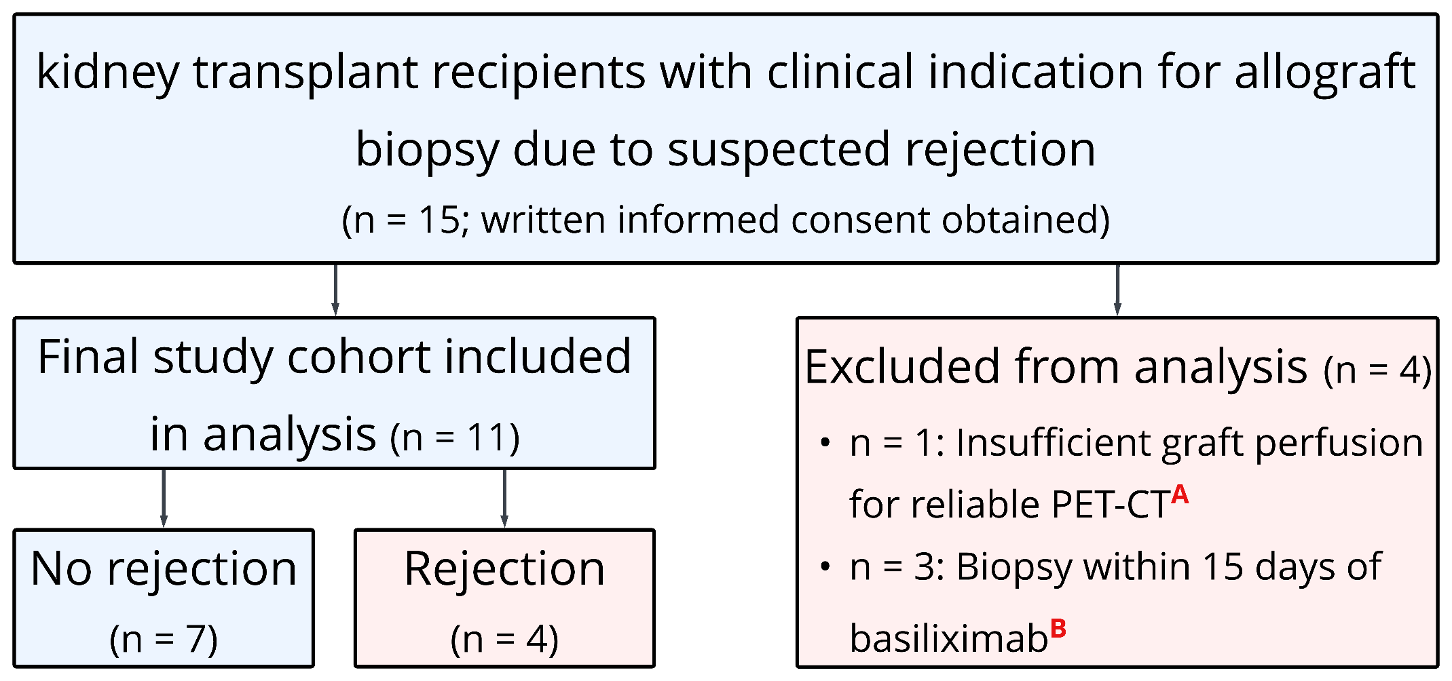

n; number, PET-CT; positron emission tomography–computed tomography.
A: Based on repeated renography.
B: Protocol exclusion criteria.
Supplementary Figures 2A-B: Significance heatmaps with statistical significance of correlations between [¹⁸F]FB-IL2 PET-CT imaging parameters and clinical, immunological, and histopathological features of kidney allograft rejection.
A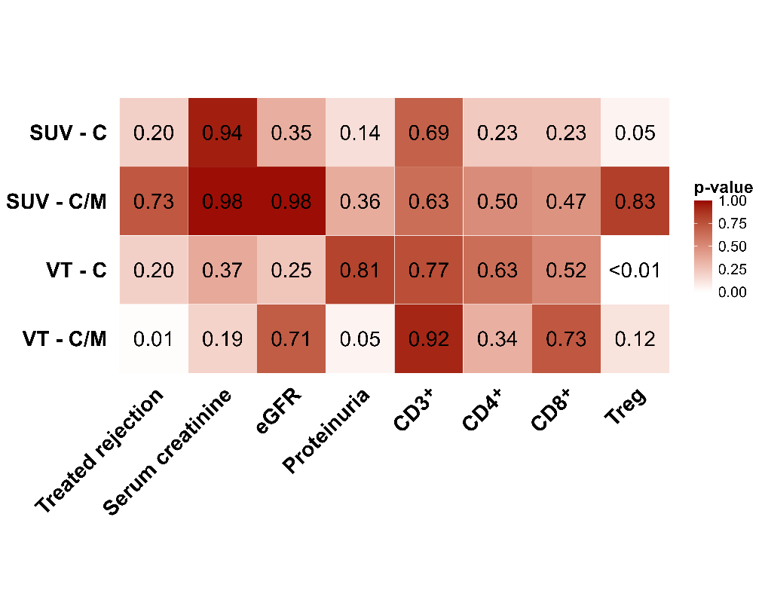B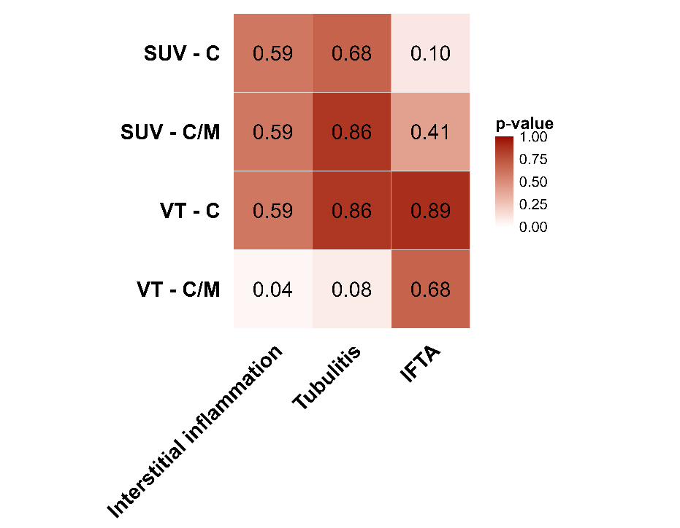
[¹⁸F]FB-IL2; fluorine-18–labeled fluoro-benzoyl interleukin-2, PET-CT; positron emission tomography–computed tomography, SUV - C; mean cortical standardised uptake value, SUV – C/M; mean standerdised uptake value cortex-to-medulla ratio V_{T}* - C; apparent cortical volume of distribution, V_{T}* – C/M; apparent volume of distribution cortex-to-medulla ratio, eGFR; estimated glomerular filtration rate, CD3⁺; CD4⁺; CD8⁺; peripheral T cell subsets, Treg; regulatory T cells, IFTA; interstitial fibrosis and tubular atrophy.
(A) Heatmap showing two-sided Spearman p-values for correlations between PET-CT parameters and clinical variables, including treated rejection, kidney function markers, and peripheral immune cell subsets (n = 11). (B) Heatmap showing p-values for correlations between PET-CT parameters and Banff histological scores (n = 9; 2 biopsies excluded due to non-interpretable sampling).
Color intensity reflects the strength of statistical significance (darker = lower p-value). p < 0.05 was considered statistically significant; p < 0.1 was interpreted as a trend. These data correspond to the correlation coefficients shown in Figure 2A–2B.

