Supplementary Data
Machine Learning Driven Land Surface Temperature Prediction and Urban Heat Risk Assessment in The Gambia
Rodrigue Samb^{a,c}, Adyasha Jena^{b}, S. Manavvi*, Uttam Kumar Royª, and Basant Yadav^{b}
ª Department of Architecture and Planning, Indian Institute of Technology, Roorkee, Uttarakhand, India
^{b} Department of Water Resources Development and Management, Indian Institute of Technology, Roorkee, Uttarakhand, India
^{c} School of Engineering and Architecture, University of the Gambia, Banjul, Gambia
*Corresponding Author: E-mail: manavvi.suneja@ar.iitr.ac.in (Dr. S. Manavvi)

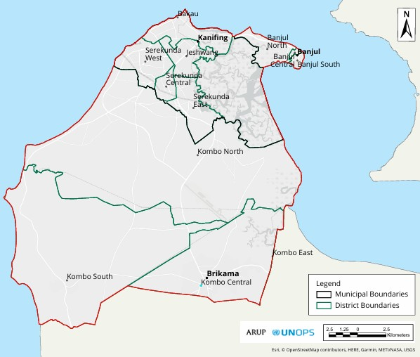
Fig_A: Municipal boundary Map of Greater Banjul Area (GBA), The Gambia.
Source: (“Greater Banjul Area 2040 Development Plan,” 2022)

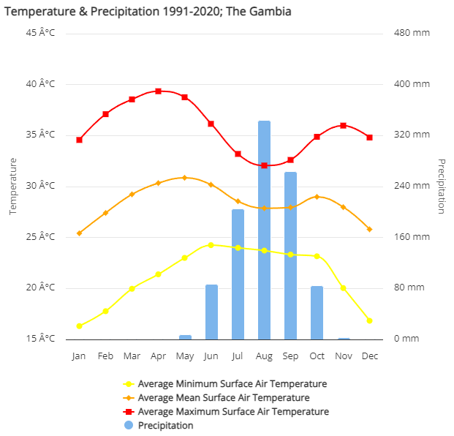
Fig_B : Temperature and Precipitation graph Source: (World Bank Climate Change Knowledge Portal, 2024)

TEXT A : Producer’s Accuracy and User’s Accuracy for Kappa coefficient
Table A: Table: Detailed Kappa coefficient for accuracy assessment.
 | Year-1990
 | Classified Data | Water Body | Trees | Flooded Vegetation | Crop Land | Built Area | Bare Land | Range Land | Total | U_ (Accuracy) (%) | Kappa (%)
 | Water Body | 13 | 0 | 0 | 0 | 0 | 0 | 0 | 13 | 1 | 0
 | Trees | 0 | 41 | 0 | 0 | 0 | 0 | 1 | 42 | 0.98 | 0
 | Flooded Vegetation | 1 | 0 | 31 | 0 | 0 | 0 | 0 | 32 | 0.97 | 0
 | Crops | 0 | 2 | 0 | 79 | 0 | 0 | 0 | 81 | 0.98 | 0
 | Built Area | 0 | 6 | 0 | 1 | 52 | 2 | 1 | 62 | 0.84 | 0
 | Bare Ground | 0 | 1 | 5 | 0 | 1 | 20 | 1 | 28 | 0.71 | 0
 | Rangeland | 1 | 7 | 0 | 0 | 0 | 3 | 231 | 242 | 0.95 | 0
 | Total | 15 | 57 | 36 | 80 | 53 | 25 | 234 | 500 | 0 | 0
 | P_Accuracy | 0.87 | 0.72 | 0.86 | 0.99 | 0.98 | 0.8 | 0.99 | 0 | 0.93 | 0
 | Kappa | 0 | 0 | 0 | 0 | 0 | 0 | 0 | 0 | 0 | 0.91
Year-2006
 | Water Body | 7 | 0 | 0 | 0 | 1 | 0 | 0 | 8 | 0.875 | 0
 | Trees | 0 | 24 | 0 | 0 | 0 | 0 | 0 | 24 | 1 | 0
 | Flooded Vegetation | 0 | 0 | 35 | 0 | 0 | 0 | 0 | 35 | 1 | 0
 | Crops | 0 | 0 | 0 | 124 | 0 | 0 | 0 | 124 | 1 | 0
 | Built Area | 0 | 1 | 0 | 3 | 222 | 2 | 2 | 230 | 0.97 | 0
 | Bare Ground | 0 | 0 | 0 | 0 | 0 | 10 | 0 | 10 | 1.00 | 0
 | Rangeland | 0 | 7 | 0 | 0 | 0 | 0 | 61 | 68 | 0.90 | 0
 | Total | 7 | 32 | 35 | 127 | 223 | 12 | 63 | 499 | 0.00 | 0
 | P_Accuracy | 1 | 0.75 | 1 | 0.976 | 0.996 | 0.83 | 0.97 | 0 | 0.97 | 0
 | Kappa | 0 | 0 | 0 | 0 | 0 | 0 | 0 | 0 | 0 | 0.95
Year-2010
 | Water Body | 1 | 0 | 0 | 0 | 0 | 0 | 0 | 1 | 1 | 0
 | Trees | 0 | 75 | 0 | 1 | 0 | 1 | 2 | 79 | 0.95 | 0
 | Flooded Vegetation | 1 | 0 | 47 | 0 | 2 | 0 | 0 | 50 | 0.94 | 0
 | Crops | 0 | 1 | 0 | 41 | 0 | 0 | 0 | 42 | 0.98 | 0
 | Built Area | 0 | 4 | 0 | 7 | 231 | 1 | 6 | 249 | 0.93 | 0
 | Bare Ground | 0 | 0 | 0 | 0 | 0 | 12 | 0 | 12 | 1 | 0
 | Range Land | 0 | 6 | 3 | 1 | 1 | 0 | 56 | 67 | 0.84 | 0
 | Total | 2 | 86 | 50 | 50 | 234 | 14 | 64 | 500 | 0 | 0
 | P_Accuracy | 0.5 | 0.87 | 0.94 | 0.82 | 0.99 | 0.86 | 0.875 | 0 | 0.926 | 0
 | Kappa | 0 | 0 | 0 | 0 | 0 | 0 | 0 | 0 | 0 | 0.89
Year-2020
 | Water Body | 2 | 0 | 0 | 0 | 0 | 0 | 0 | 2 | 1 | 0
 | Trees | 0 | 5 | 0 | 0 | 0 | 0 | 0 | 5 | 1.00 | 0
 | Flooded Vegetation | 0 | 0 | 13 | 0 | 0 | 1 | 0 | 14 | 0.928571 | 0
 | Crops | 0 | 0 | 0 | 3 | 1 | 0 | 0 | 4 | 0.75 | 0
 | Built Area | 0 | 1 | 0 | 0 | 55 | 0 | 0 | 56 | 0.98 | 0
 | Bare Gand | 0 | 0 | 0 | 0 | 0 | 0 | 0 | 0 | 0 | 0
 | Rangeland | 0 | 1 | 0 | 0 | 0 | 0 | 16 | 17 | 0.94 | 0
 | Total | 2 | 7 | 13 | 3 | 56 | 0 | 16 | 98 | 0 | 0
 | P_Accuracy | 1 | 0.71 | 1 | 1 | 0.98 | 1.00 | 1 | 0 | 0.959184 | 0
 | Kappa | 0 | 0 | 0 | 0 | 0 | 0 | 0 | 0 | 0 | 0.93

A.2: NDVI Calculation in Google Earth Engine (GEE)

Image Collections Used:
- Landsat 5 (1990, 2006, 2010): 'LANDSAT/LT05/C02/T1_L2'
- Landsat 8 (2020): 'LANDSAT/LC08/C02/T1_L2'
- Sentinel-2 (2020): 'COPERNICUS/S2'

General Processing Steps:
- Define ROI: Upload shapefile of the GBA to GEE Assets.
- Filter Imagery: Select images from specified year with less than 20% cloud cover.
- Apply Scaling:
  - Optical Bands: Multiply by 0.0000275 and subtract 0.2
  - Thermal Band: Multiply by 0.00341802 and add 149.0
- NDVI Formula Used:
NDVI = (NIR−Red) / ​(NIR+Red)
  - For Landsat: SR_B4 (NIR), SR_B3 (Red)
  - For Sentinel-2: B8 (NIR), B4 (Red)
- Classification Thresholds:
  - Bare/urban/open land: NDVI < 0.1
  - Scrub/agriculture: NDVI 0.1–0.3
  - Vegetation/forest: NDVI > 0.3
- Visualization Palette:
  - ['#FF0000', '#FFFF00', '#00FF00', '#006400']
(Red → Yellow → Green → Dark Green)
- Export:
  - NDVI maps exported as GeoTIFF to Google Drive.
  - Files imported to ArcMap and classified into five vegetation classes for further analysis.

A.3: Sentinel-2 Cloud Masking and NDVI
- Cloud Masking: QA60 band used.
  - Cirrus cloud bit: 11th bit
  - Cloud bit: 10th bit
Bitmask Function Used in GEE:
var maskClouds = function(image) {
var qa = image.select('QA60');
var cloudBitMask = 1 << 10;
var cirrusBitMask = 1 << 11;
var mask = qa.bitwiseAnd(cloudBitMask).eq(0)
.and(qa.bitwiseAnd(cirrusBitMask).eq(0));
return image.updateMask(mask);
};

A.4: Normalized Difference Built-Up Index (NDBI)
- Formula:
NDBI = (SWIR−NIR) / (SWIR+NIR)​
- Bands Used:
  - Landsat 5: SR_B5 (NIR), SR_B6 (SWIR)
  - Landsat 8: SR_B5 (NIR), SR_B6 (SWIR)
- Processing Steps in GEE:
  - Filter images by year.
  - Apply the formula directly on image collections.
  - Apply a mean reducer to generate annual NDBI composites.
- Output:
  - NDBI maps were exported as GeoTIFFs to Google Drive.
  - Higher values indicate more urban/built-up areas.

A.5: Export and post-processing
- Export Format: GeoTIFF (.tif) files
- GEE Export Code Example:

Export.image.toDrive({
image: final_ndvi_clip,
description: 'NDVI_2020',
scale: 30,
region: ROI,
fileFormat: 'GeoTIFF'
});
- ArcMap post-processing:
  - Imported exported layers.
  - Applied color ramps and classified layers based on NDVI/NDBI ranges.
  - Generated maps and graphs for interpretation.

