Supporting Information

Nonmetallic plasmonic heterostructures with multi-synergies on boosting hot electron generation for CO₂ photoreduction

Changhai Lu,^{1,#} Xinru Li,^{3,#} Juan Li,¹ Liang Mao,⁴ Xuandong Wang,² Qin Chen,¹ Long Wen,ª Mingshan Zhu,^{2,}* Baojun Li, ^{1,}* and Zaizhu Lou^{1,5,}*

¹ Institute of Nanophotonics, Jinan University, Guangzhou, 511443, China
² School of Environment, Jinan University, Guangzhou, 511443, China
³ Shenzhen University, Shenzhen, 518060, China
⁴ School of Material Science and Physics, China University of Mining and Technology, Xuzhou, 221116, China
⁵ State Key Laboratory for Crystal Materials, Shandong University, Jinan, 250100, China

Corresponding Authors:
*Email: zzlou@jnu.edu.cn, baojunli@jnu.edu.cn, zhumingshan@jnu.edu.cn

Supplementary Fig. 1. TEM and HR-TEM images of layered BP (a, b) and WO nanowires (c,d).

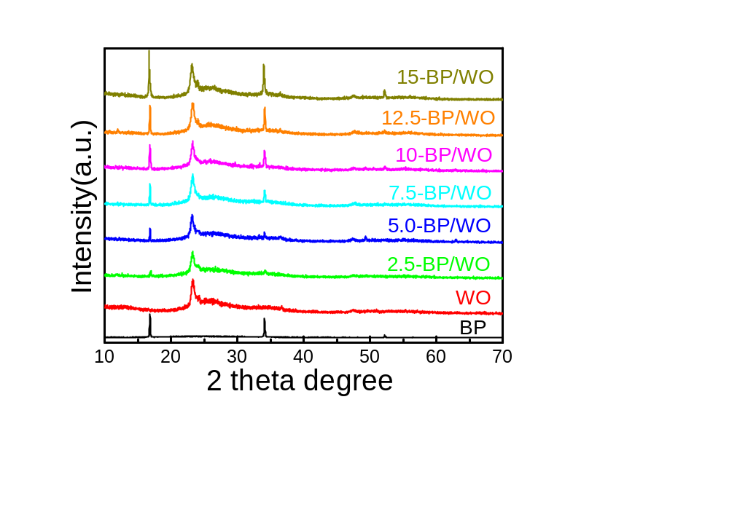
Supplementary Fig. 2. XRD patters of BP, WO and BP/WO heterostructures with different compositions, respectively.
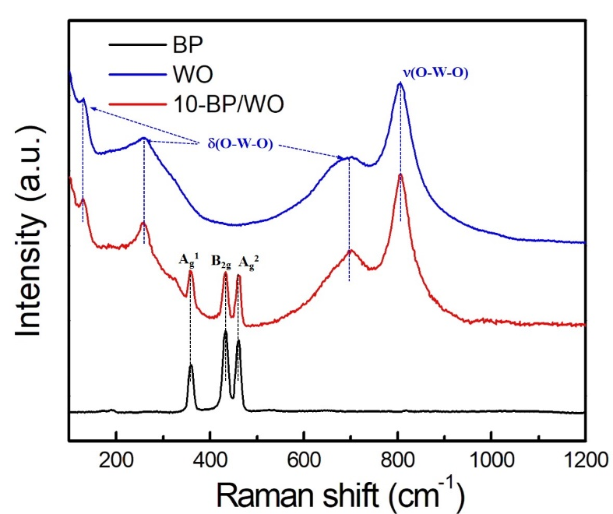
Supplementary Fig. 3 Raman spectra of BP, WO and 10-BP/WO heterostructures.

Supplementary Fig. 4 Fourier transform infrared (FTIR) spectra of 10-BP/WO heterostructures.

Supplementary Fig. 5. X-ray photoelectron spectra (XPS) of O 1s (f) in samples WO and 10-BP/WO heterostructures.
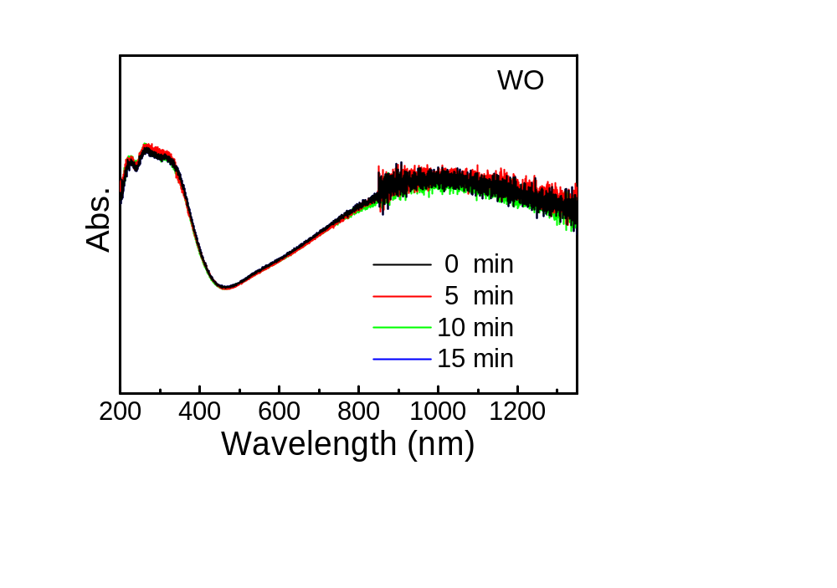
Supplementary Fig. 6. DRS of plasmonic WO under Vis-NIR light irradiation.

Supplementary Fig.7. Product generation rates over BP, WO and 10-BP/WO as photocatalysts during CO₂-RR under visible-NIR light irradiation.

Supplementary Fig. 8. CO generation over different samples of 2.5-BP/WO, 5.0-BP/WO, 7.5-BP/WO, 10-BP/WO, 12.5-BP/WO and 15-BP/WO as photocatalysts, respectively.

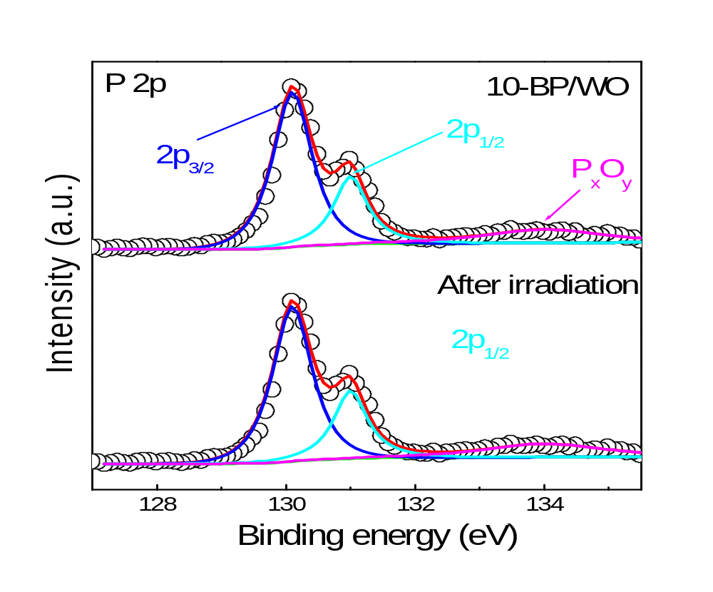

Supplementary Fig. 9. XPS of P 2p in 10-BP/WO heterostructures before and after Vis-NIR-driven photocatalysis.

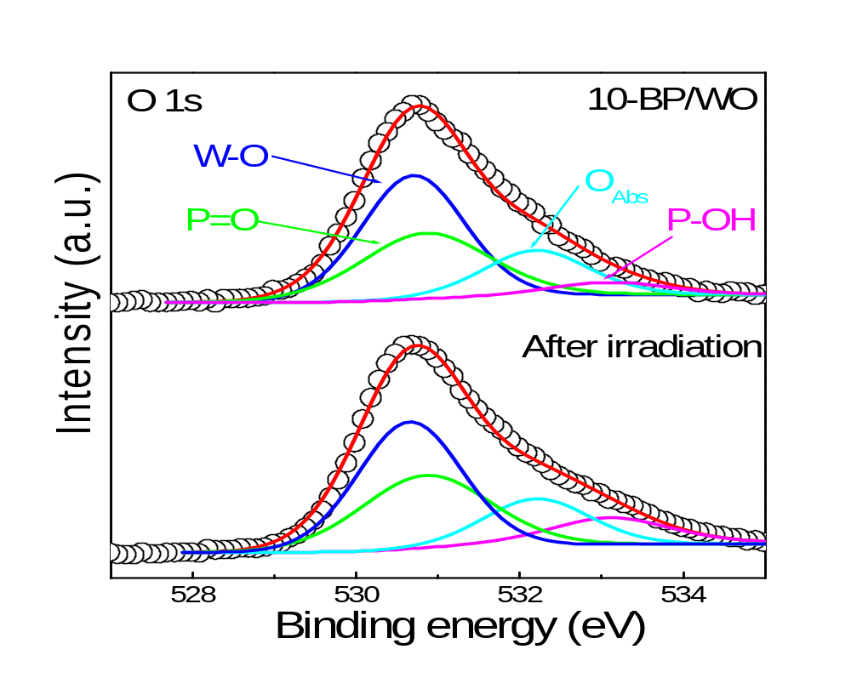

Supplementary Fig. 10. XPS of O 1s in 10-BP/WO heterostructures before and after Vis-NIR-driven photocatalysis.

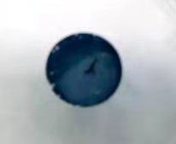
Supplementary Fig. 11. 10-BP/WO loaded plates used for thermal images and photocatalytic CO₂-RR

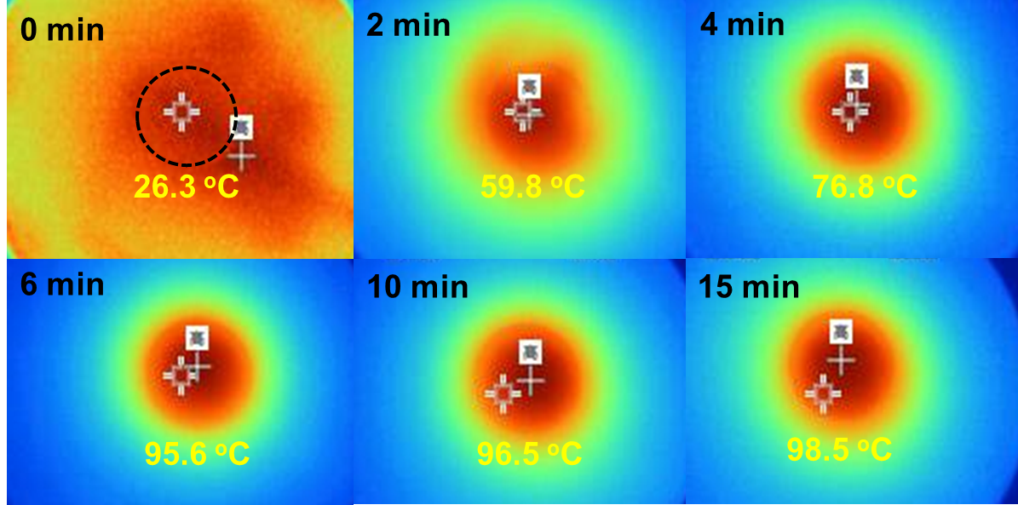
Supplementary Fig. 12. Thermal images of 10-BP/WO loaded plates under UV-Vis-NIR light irradiation.

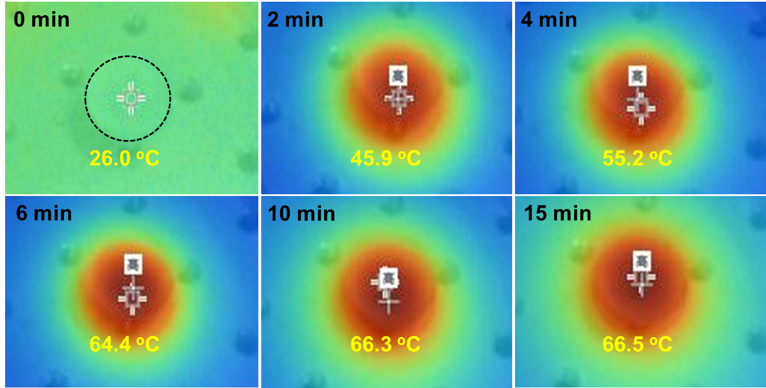
Supplementary Fig. 13. Thermal images of 10-BP/WO loaded plates under UV-Vis light irradiation.

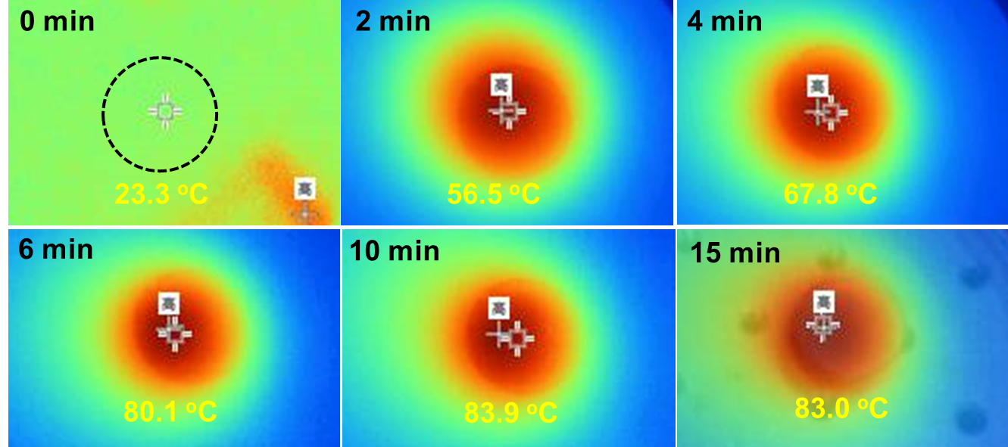
Supplementary Fig. 14. Thermal images of 10-BP/WO loaded plates under NIR light irradiation.

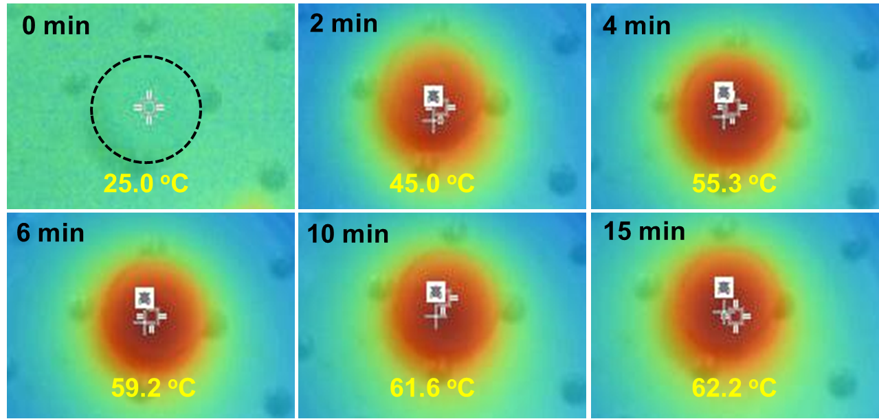
Supplementary Fig. 15. Thermal images of 10-BP/WO loaded plates under visible light irradiation.

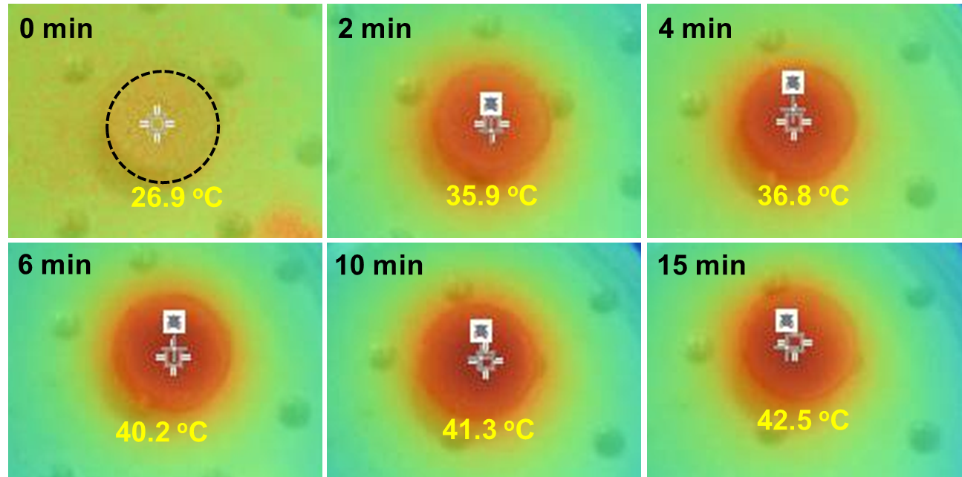
Supplementary Fig. 16. Thermal images of 10-BP/WO loaded plates under UV light irradiation.

