Supplementary Information
Hydrogel-Based Electrodes for High-Fidelity sEMG Signal Acquisition Applied to Robotic Hand Control in Limb Function Reconstruction
Ziqing Yu ^{a,b}, Yunqing Gu ^{a,b,*}, Yun Ren ^{c}, Hongxin Ding ^{a,b}, Denghao Wu ^{a,b}, Zhenxing Wu ^{a,b}, Jiegang Mou ^{a,b}.
ª College of Metrology Measurement and Instrument, China Jiliang University, Hangzhou, 310018,
China
^{b} Zhejiang Engineering Research Center of Fluid Equipment and Measurement and Control Technology, Hangzhou, 310018, China
^{c} Zhijiang College, Zhejiang University of Technology, Shaoxing 312030, PR, China
* Corresponding author.
E-mail address: guyunqing@cjlu.edu.cn (Yunqing Gu).

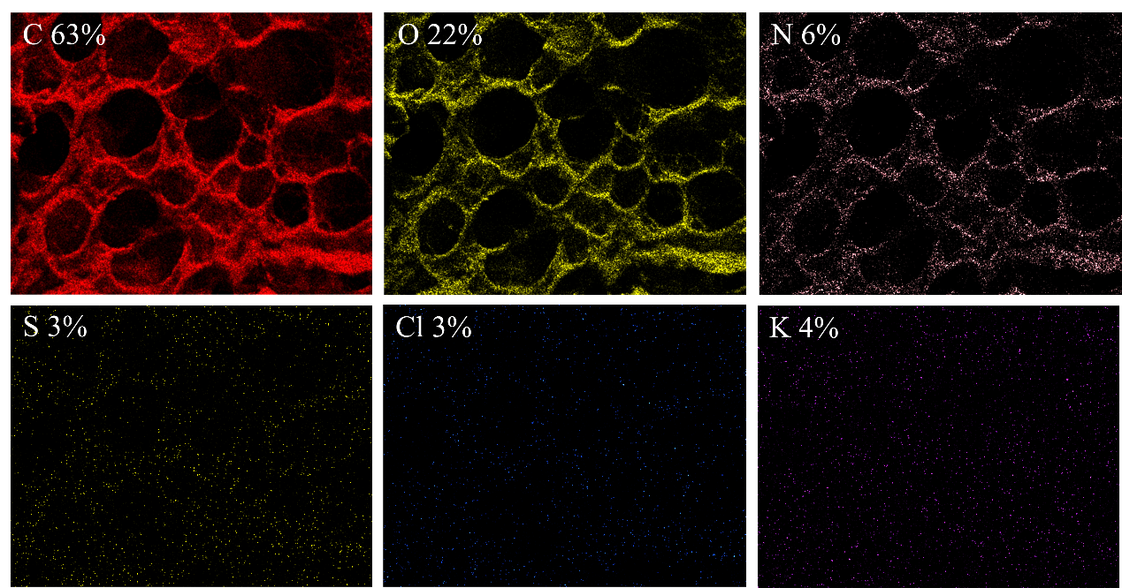
Supplementary Figure 1. Distribution of elements C, O, N, S, Cl and K in PCGK-CT hydrogels.
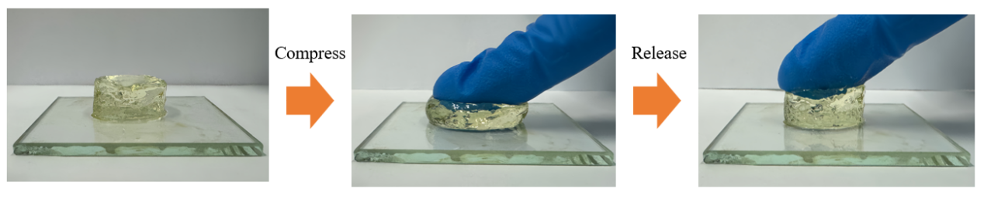
Supplementary Figure 2. Compressive deformation of hydrogels. gel compression deformation.
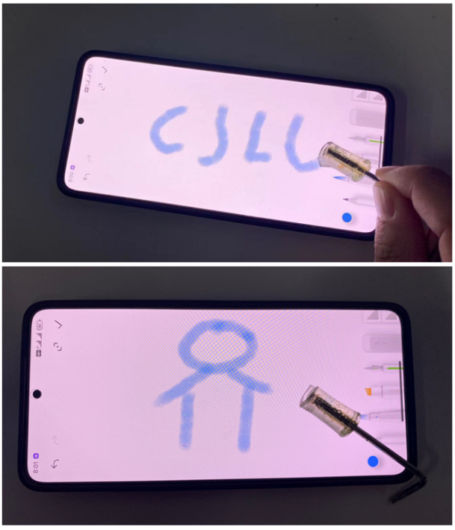
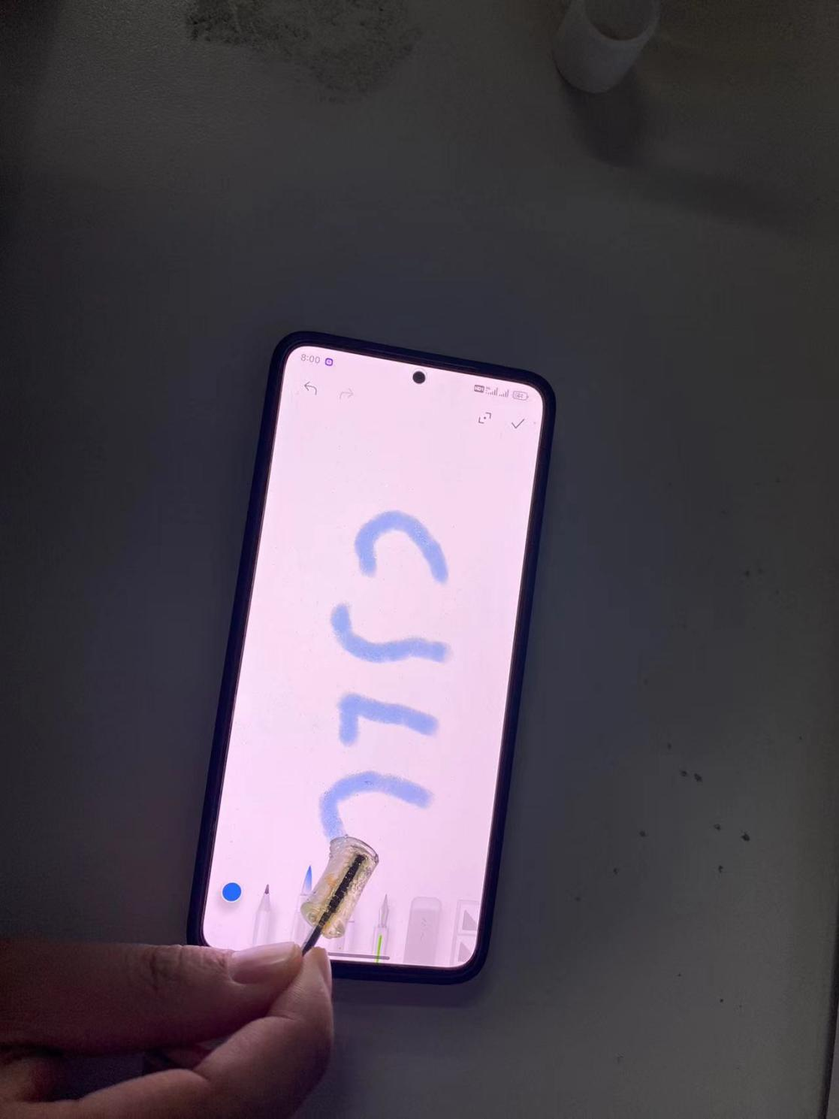
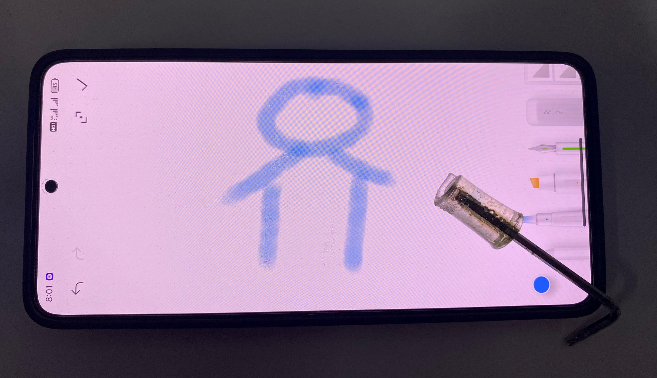
Supplementary Figure 3. Using PCGK-CT hydrogel to write letters (CJLU) and draw (villains) on smartphones.
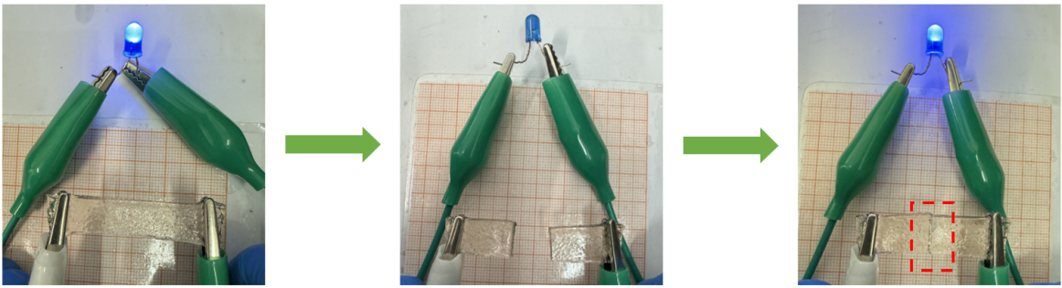
Supplementary Figure 4. The self-repairing behavior of the hydrogel in the light-emitting diode circuit.
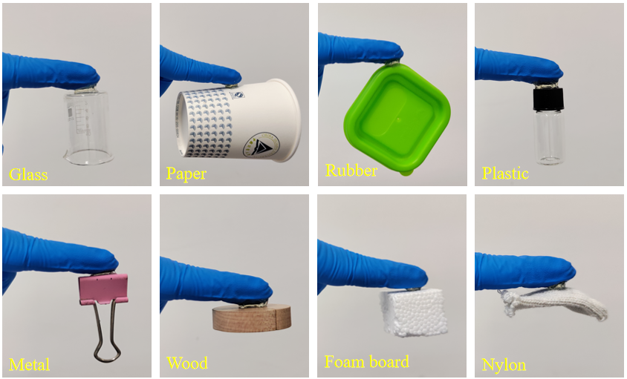
Supplementary Figure 5. PCGK-CT hydrogels adhere to different materials, including glass, paper, rubber, plastic, metal, wood, foam and nylon
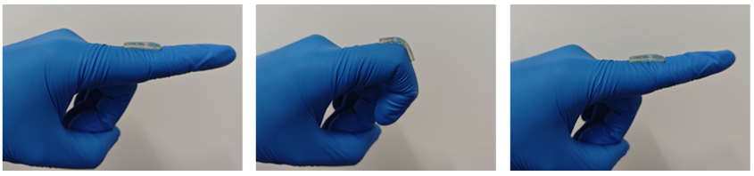
Supplementary Figure 6. Hydrogels adhere to finger joints
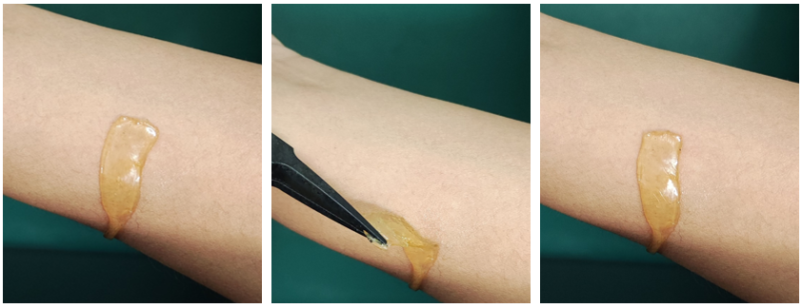
Supplementary Figure 7. Peel and re-adhere to forearm skin
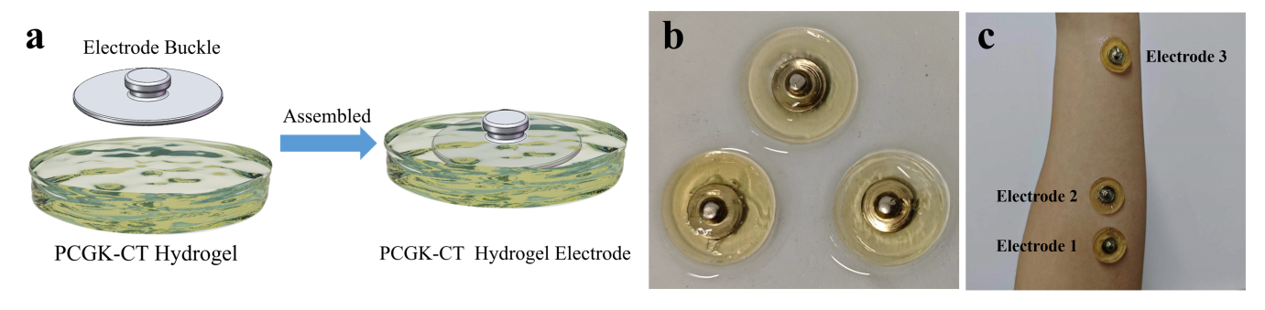
Supplementary Figure 8. a Schematic diagram of PCGK-CT hydrogel electrode assembly. b PCGK-CT hydrogel electrode. c Electrode adhering to the skin surface of forearm.
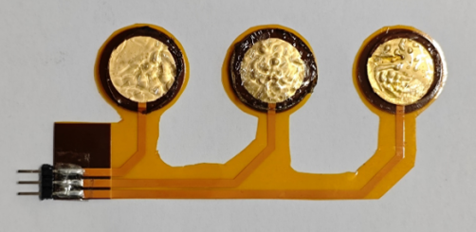
Supplementary Figure 9. Physical diagram of hydrogel electrode integration design.
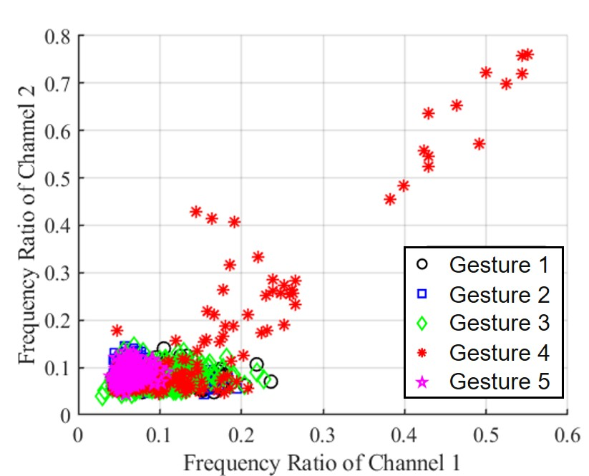
Supplementary Figure 10. Frequency ratio scatter plot
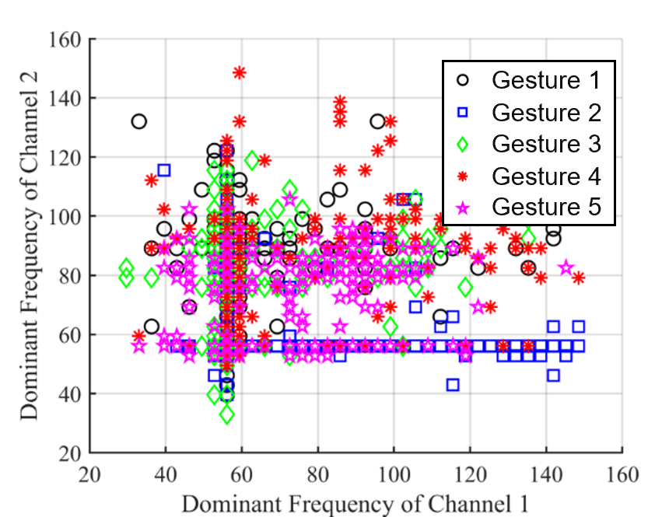
Supplementary Figure 11. Dominant Frequency scatter plot
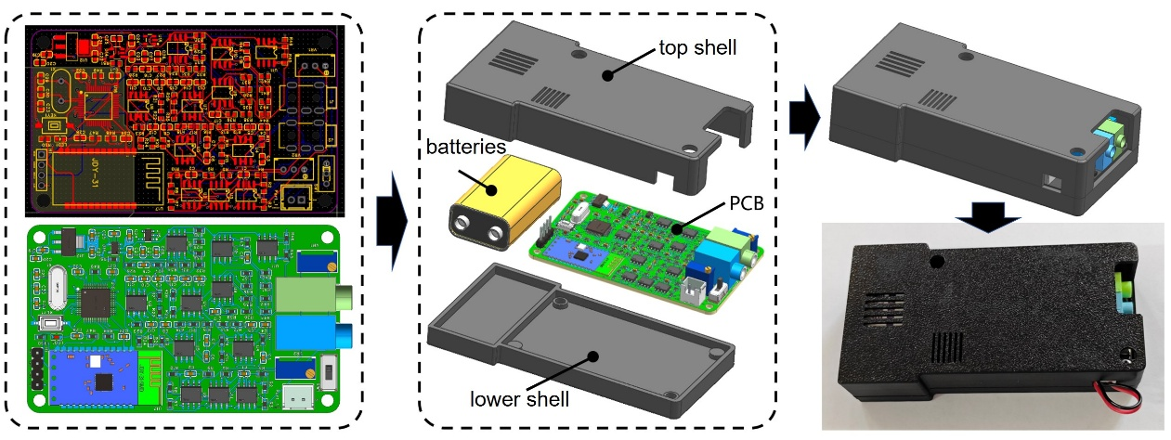
Supplementary Figure 12. Circuit design of the sEMG acquisition system
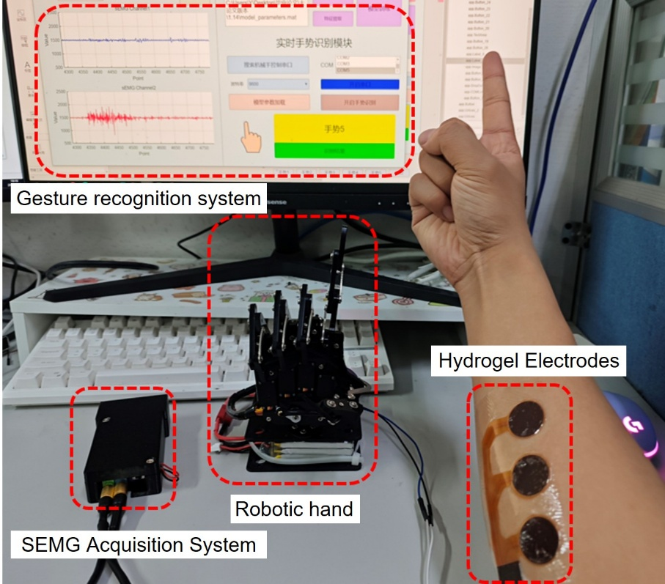
Supplementary Figure 13. Physical drawing of the experimental platform

