Table S1 Univariable and multivariable analysis of prognostic factors associated with overall survival
SRLRNU = single-position retroperitoneal laparoscopic radical nephroureterectomy. TRLRNU = typically retroperitoneal laparoscopic radical nephroureterectomy. ASA = American Society of Anesthesiologists. HR = hazard ratio. 95%CI = 95% confidence intervals. P < 0.05 indicates statistical significance.

 | SRLRNU |  |  |  |  |  | TRLRNU
 | Univariable analysis |  |  | Multivariable analysis |  |  | Univariable analysis |  |  | Multivariable analysis
 | HR | 95%CI | P value | HR | 95%CI | P value | HR | 95%CI | P value | HR | 95%CI | P value
Sex  (Male VS Female) | 0.71 | 0.38 - 1.31 | 0.27 | 0.68 | 0.37 - 1.27 | 0.229 | 1.12 | 0.49 - 2.56 | 0.79 | 1.24 | 0.53 - 2.92 | 0.617
Age  (≤65 vs＞65) | 1.06 | 1.02 - 1.09 | <0.05 | 1.06 | 1.02 - 1.10 | <0.01 | 0.97 | 0.43 - 2.12 | 0.93 | 1.21 | 0.47 - 3.12 | 0.697
Pathologic stage  (≤T2 vs＞T2) | 3.40 | 1.20 - 9.59 | <0.05 | 3.30 | 1.14 - 9.55 | <0.05 | 0.56 | 0.13 - 2.39 | 0.43 | / | / | /
Pathological grade  (Low VS High) | 1.17 | 0.49 - 2.78 | 0.721 | 1.86 | 0.73 - 4.72 | 0.195 | 0.38 | 0.11 - 1.28 | 0.12 | 0.49 | 0.14 - 1.71 | 0.264
Tumor Location  (Ureter VS Renal Pelvis) | 0.92 | 0.50 - 1.68 | 0.790 | 1.00 | 0.53 - 1.89 | 0.997 | 0.44 | 0.19 - 1.01 | ＞0.05 | 0.49 | 0.19 - 1.24 | 0.132
ASA score  (≤2 VS＞2) | 0.38 | 0.20 - 0.75 | <0.01 | 0.45 | 0.22 - 0.90 | <0.05 | 2.67 | 1.14 - 6.28 | <0.05 | 3.13 | 1.21 - 8.12 | <0.05
Clavien-Dindo  grade (≤1 VS＞1) | 1.05 | 0.46 - 2.38 | 0.911 | 1.02 | 0.44 - 2.38 | 0.957 | 0.02 | 0.004-0.12 | <0.01 | / | / | /

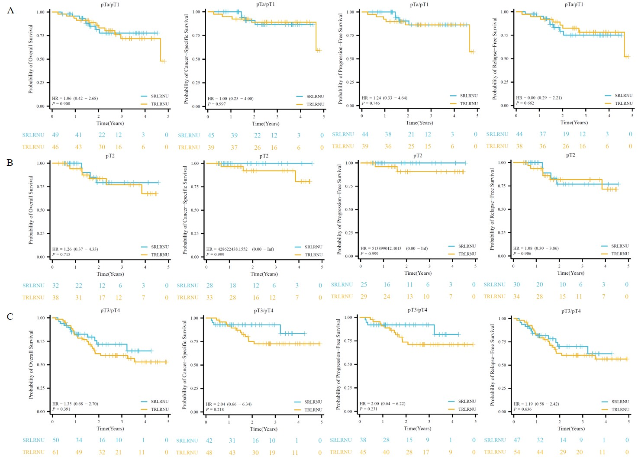
Fig. S1 Subgroup analyses by T stage for overall survival, cancer-specific survival, progression-free survival, and recurrence-free survival in the SRLRNU and TRLRNU groups. A is Ta-T1, B is T2, C is T3-T4. SRLRNU = single-position retroperitoneal laparoscopic radical nephroureterectomy. TRLRNU = typically retroperitoneal laparoscopic radical nephroureterectomy. HR = hazard ratio. The values in parentheses represent the 95% confidence intervals. P < 0.05 indicates statistical significance.

