Supporting Information

Macrocyclization of Native Peptides through (Thio)urea Crosslinking of Two Amines
Jinyao Liu ª, Peiru Chen ª, Meilin Tang ª, Qiuyu Chen ª, Yixin Liao ª, Yu Liu ª, Shafi Ullah ª, Jinwu Zhao*ª, Yubo Long^{*c}, Gong Chen*^{b}, Wenfang Xiong*ª

ª School of Pharmacy, Guangdong Medical University, Dongguan, China
* E-mail: jwzhao@gdmu.edu.cn, xiongwf@gdmu.edu.cn
^{b} State Key Laboratory and Institute of Elemento-Organic Chemistry, College of Chemistry, Nankai University, Tianjin, China
* E-mail: gongchen@nankai.edu.cn
^{c} Research Institute of Interdisciplinary Science, School of Materials Science and Engineering, Dongguan University of Technology, Dongguan, China
* E-mail: longyubo@dgut.edu.cn

List of contents
A. Reagents & Instruments S3
B. General procedure for the synthesis of (thio)urea-containing cyclic peptides S5
C. Optimization of reaction conditions S5
D. Characterization of (thio)urea-containing cyclic peptides S6
E. General procedure for the synthesis of dithio-urea containing macrocyclic peptides S41
F. Characterization of dithio-urea containing macrocyclic peptides S41
G. Characterization of macrocyclic bioactive peptides S43
H. Characterization of peptide 23a S50
I. Characterization of fluorescently labeled cyclopeptides S51
J. Evaluation of stability of cyclopeptides S55
Stability under oxidative conditions S55
Stability in pH 10.0 buffer conditions S58
Stability under trypsin incubation S60
Results of stability under H₂O_{2,} pH 10.0 buffer and trypsin incubation S62
K. Integrin binding assay S62
L. The cytotoxicity of cyclopeptides on tumor cells S63
Cell cultures and cell viability assay: S63
Results of data processing S64
M. MTT assay for cyclic peptides safety evaluation S65
General procedures for cyclic peptides safety evaluation S65
Results of data processing S65
N. Flow cytometry of A549-Luc cell S66
O. Cellular uptake experiment S69
P. Cell apoptosis analysis. S70
Q. Network pharmacology S71
Construction of protein interaction networks and screening of targets S71
Gene function and pathway enrichment analysis of target proteins S73
R. Molecular docking S74
Molecular docking of P13 and 13b S74
Molecular docking of P23 and 23c S75
S. References S77
T. NMR spectra S77

Reagents & Instruments
All commercial chemical reagents were used without further purification unless otherwise noted, chemicals were purchased from Shanghai Macklin Biochemical Co., Ltd., Bide Pharmatech Ltd., Shanghai Yinli Chemical Technology Co., Ltd., Energy Chemical, Sarn Chemical Technology (Shanghai) Co., Ltd., Shanghai Aladdin Biochemical Technology Co., Ltd.. All commercial biological reagents were used without further purification unless otherwise noted, biological reagents were purchased from Grand Island Biological Company, Procell Life Science&Technology Co., Ltd., Shanghai Biyuntian Biotechnology Co., Ltd., Lianke Biotechnology Co., Ltd.. Linear peptides were synthesized by peptide Biotechnology Co., Ltd (Hangzhou, China), Gutuo Biotechnology Co., Ltd (Hangzhou, China), Tengyi Biotechnology Co., Ltd (Nanjing, China) and Pharmaceutical Technology Co., Ltd (Shanghai, China), Jill Biochemical (Shanghai) Co., Ltd (Shanghai China).
¹H NMR spectra was recorded on a Bruker AMX-400 (400 MHz). Chemical shifts were expressed in parts per million (ppm) with respect to the residue solvent peak. The following abbreviations was used to explain multiplicities: s = singlet, d = doublet, t = triplet, q = quartet, m = multiplet, br = broad. Coupling constants (J) were reported in Hertz (Hz). ¹³C NMR spectra were recorded on Bruker AMX-400 instrument (100 MHz), and were fully decoupled by broadband proton decoupling. High Resolution Mass Spectra (HRMS) was recorded on Thenmo Scientific Q ExactiyeTM HF-X mass spectrometer equipped with an APCI ion source. Analytical HPLC was performed on an Agilent 1260 Infinity II system and EClassical 3200 Liquid Chromatography system. Preparative HPLC was performed on High-performance liquid chromatography system (Ruihe Technology, China). A freeze dryer was purchased from Beijing Songyuan Huaxing Technology Development Co., Ltd.. Fluorescence imaging was conducted using a Leica SP8 laser scanning confocal microscope equipped with a 63×/1.40 oil immersion objective. The following excitation/emission settings were used: 405 nm / 410–480 nm for Hoechst and 488 nm / 494–631 nm for FITC. Flow cytometry was performed on a FongCyte™ flow cytometer.
HPLC methods for Macrocyclic Peptide Products
Analytical HPLC analysis was performed using HPLCONE 10C18A (10 μm, 4.6 x 250 mm) analytical columns with mobile phase of water-acetonitrile-(0.1% TFA) at a flow rate of 1.0 mL/min. Detection: UV at 210 nm-280 nm.
RP-HPLC purification of Macrocyclic Peptide Products
The crude peptide was dissolved in a mixture water/methanol and purified by semi-preparative RP-HPLC (YMC-1025-S-10, 10 mm x 250 mm, Wuhan Ruihe Chromatography Technology Co., Ltd.); Solvent A: 0.1% TFA in water (v/v); Solvent B:0.1% TFA in acetonitrile (v/v); Flow: 3.0 mL/min. Detection: UV at 210 nm, 220 nm.
General procedure for the synthesis of (thio)urea-containing cyclic peptides
To a solution of lysine-containing peptides in DMSO (0.01 mmol, 0.001 M, 10 mL), a solution of N, N’-carbonyldiimidazole (CDI, 1.5 equiv., 0.015 M in DMSO, 10 mL) and Et₃N (7 equiv., 0.0035 M) was added dropwise successively via a constant-pressure dropping funnel under stirring. The reaction mixture was stirred at room temperature for 6 hours. After the reaction was completed. The crude mixture was quenched with excess 1,3-propanediamine to terminate the reaction, followed by the analysis of HPLC and LCMS. The yields were based on the absorbance at 220 nm in the room temperature in HPLC analysis. Finally, the crude mixture was purified by semi-preparative high-performance liquid chromatography (HPLC) with a reverse-phase C18 column to obtain the desired product.
Optimization of reaction conditions
Table S1. Optimization of reaction conditions.
Entry | Variations from the above conditions | Yield ª (%)
1 | none | 88 (76^{b})
2 | DIPEA instead of NEt₃ | 64
3 | DBU instead of NEt₃ | n.d.
4 | DABCO instead of NEt₃ | 67
5 | TBD instead of NEt₃ | n.r.
6 | t-BuOK instead of NEt₃ | 61
7 | no NEt₃ | 22
8 | DMF instead of DMSO | 48
9 | MeCN instead of DMSO | 9
10 | MeOH instead of DMSO | n.r.
11 | PBS buffer (pH 8.5, 1 M) instead of DMSO | n.r.
12 | DMSO: PBS buffer (pH 8.5, 1 M) (v: v = 1:1) instead of DMSO | n.d.
13 | 1.0 mM instead of 0.5 mM reaction molarity | 36
14 | 2.0 mM instead of 0.5 mM reaction molarity | 25
Reaction conditions: P1 (0.01 mmol), 2 (1.5 equiv.), base (7 equiv.), air, r.t., 6 h. ª Yield of 1a was determined by HPLC based on absorbance at 220 nm. ^{b} Isolated yields. n. r. = no reaction. n. d. = no detected.
Characterization of (thio)urea-containing cyclic peptides
Compound 1a was isolated in 76% yield (4.3 mg, 0.0076 mmol) as a white powder; the HPLC yield was 88% based on absorbance at 220 nm.
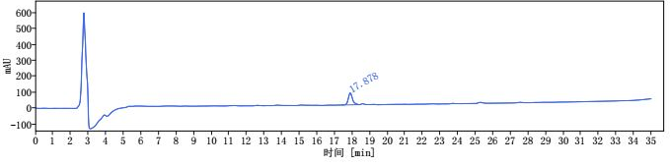
i
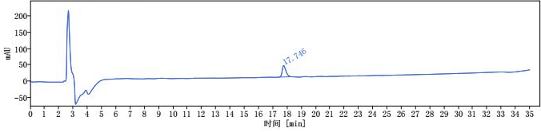
ii
Scheme S1. i) HPLC trace of reaction mixture of compound 1a. ii) HPLC trace of purified compound 1a [1 mL/min, 10% to 60% MeCN for 30 min, then 60% to 95% MeCN 30-35 min, HPLCONE 10C18A (10 μm, 4.6 x 250 mm), λ = 220 nm].
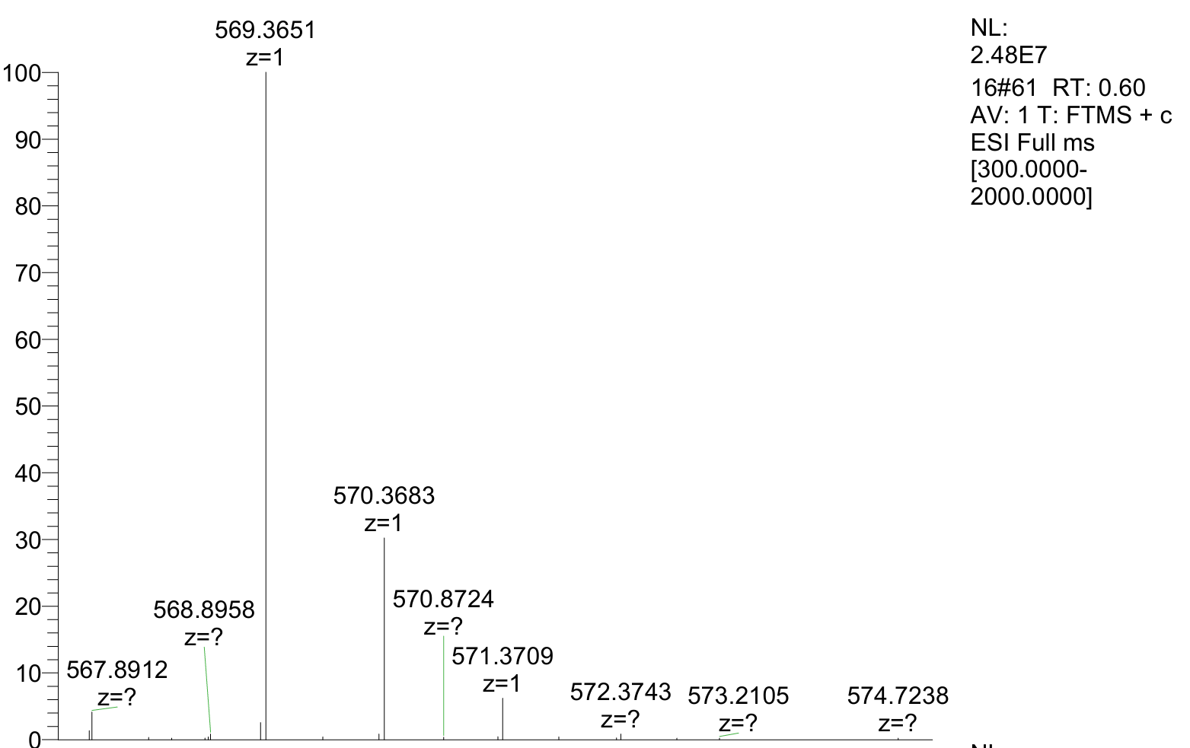
HRMS of compound 1a: Calcd for [M+H]⁺ C₂₇H₄₉N₆O₇⁺: 569.3657; found: 569.3651.
¹H NMR (400 MHz, DMSO-d₆) δ 8.34 – 8.22 (m, 2 H), 8.07 (d, J = 5.6 Hz, 1 H), 7.91 (d, J = 7.8 Hz, 1 H), 5.95 (s, 1 H), 5.41 (s, 1 H), 4.37 – 4.26 (m, 2 H), 4.23 – 4.18 (m, 1 H), 3.99 – 3.95 (m, 1 H), 3.60 (s, 3 H), 3.22 – 2.84 (m, 5 H), 1.98 – 1.90 (m, 1 H), 1.82 (s, 3 H), 1.73 – 1.50 (m, 6 H), 1.44 – 1.39 (m, 2 H), 1.36 – 1.24 (m, 6 H), 0.97 – 0.81 (m, 12 H). ¹³C NMR (100 MHz, DMSO-d₆) δ 173.9, 173.0, 171.6, 171.5, 169.1, 158.6, 59.2, 52.2, 52.2, 51.6, 51.2, 40.8, 31.8, 30.0, 29.7, 28.4, 27.9, 24.3, 23.4, 22.9, 22.4, 22.1, 21.7, 19.7, 19.4.
Compound 1b was isolated in 45% yield (2.6 mg, 0.0045 mmol) as a white powder; the HPLC yield was 50% based on absorbance at 250 nm.
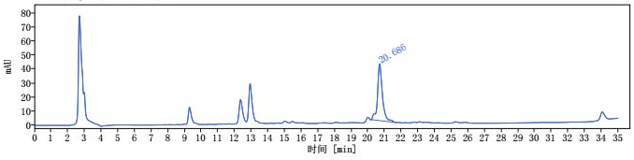
i
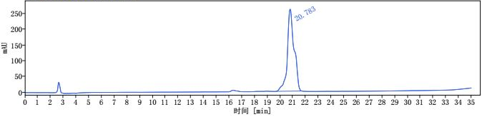
ii
Scheme S2. i) HPLC trace of reaction mixture of compound 1b. ii) HPLC trace of purified compound 1b [1 mL/min, 10% to 60% MeCN for 30 min, then 60% to 95% MeCN 30-35 min, HPLCONE 10C18A (10 μm, 4.6 x 250 mm), λ = 250 nm].
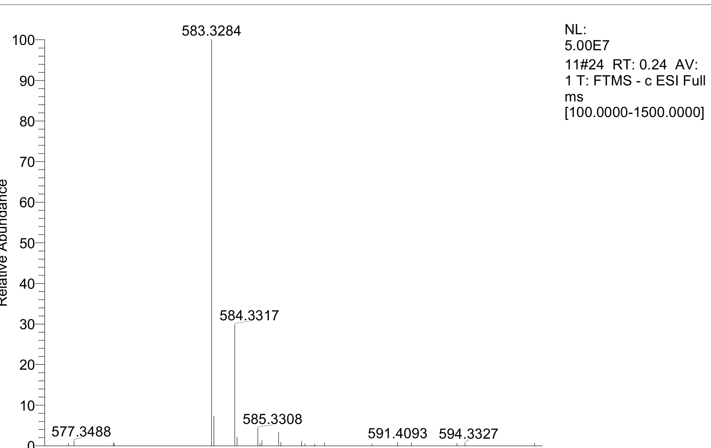
HRMS of compound 1b: Calcd for [M-H]⁻ C₂₇H₄₇N₆O₆S⁻: 583.3283; found:583.3284.
¹H NMR (400 MHz, DMSO-d₆) δ 8.30 (d, J = 8.4 Hz, 1 H), 8.18 (d, J = 6.0 Hz, 1 H), 7.99 – 7.90 (m, 1 H), 7.87 – 7.66 (m, 1 H), 7.37 (s, 1 H), 7.14 – 6.59 (m, 1 H), 4.38 – 4.16 (m, 3 H), 3.97 (t, J = 7.8 Hz, 1 H), 3.53 – 3.41 (m, 5 H), 3.25 – 3.13 (m, 2 H), 3.04 – 2.69 (m, 1 H), 2.00 – 1.89 (m, 1 H), 1.80 (s, 3 H), 1.77 – 1.53 (m, 6 H), 1.47 – 1.26 (m, 8 H), 0.98 – 0.81 (m, 12 H).
Compound 4a was isolated in 61% yield (2.4 mg, 0.0061 mmol) as a white powder; the HPLC yield was 71% based on absorbance at 210 nm.
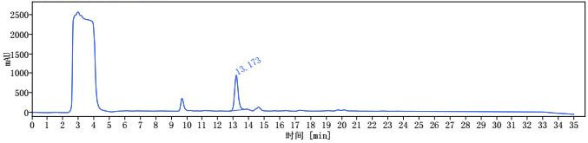
i
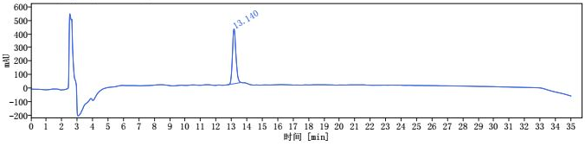
ii
Scheme S3. i) HPLC trace of reaction mixture of compound 4a. ii) HPLC trace of purified compound 4a [1 mL/min, 10% to 60% MeCN for 30 min, then 60% to 95% MeCN 30-35 min, HPLCONE 10C18A (10 μm, 4.6 x 250 mm), λ = 210 nm].
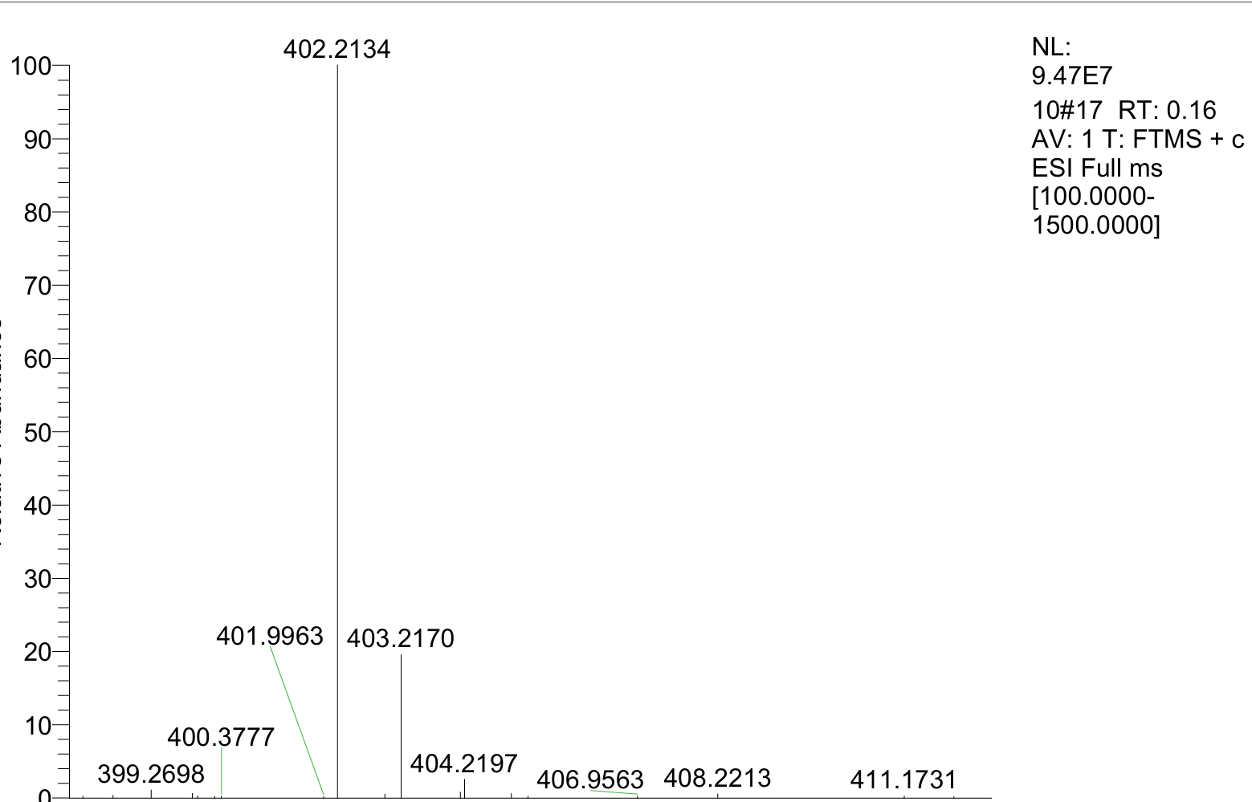
HRMS of compound 4a: Calcd for [M+H]⁺ C₂₀H₂₈N₅O₄⁺: 402.2136; found: 402.2134
Compound 4b was isolated in 54% yield (2.3 mg, 0.0054 mmol) as a white powder; the HPLC yield was 65% based on absorbance at 250 nm.
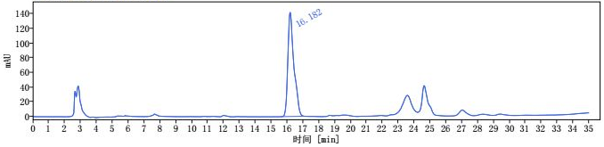
i
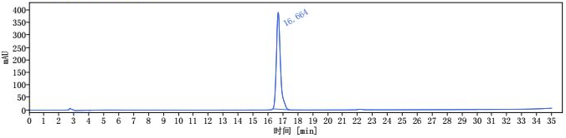
ii
Scheme S4. i) HPLC trace of reaction mixture of compound 4b. ii) HPLC trace of purified compound 4b [1 mL/min, 10% to 60% MeCN for 30 min, then 60% to 95% MeCN 30-35 min, HPLCONE 10C18A (10 μm, 4.6 x 250 mm), λ = 250 nm].
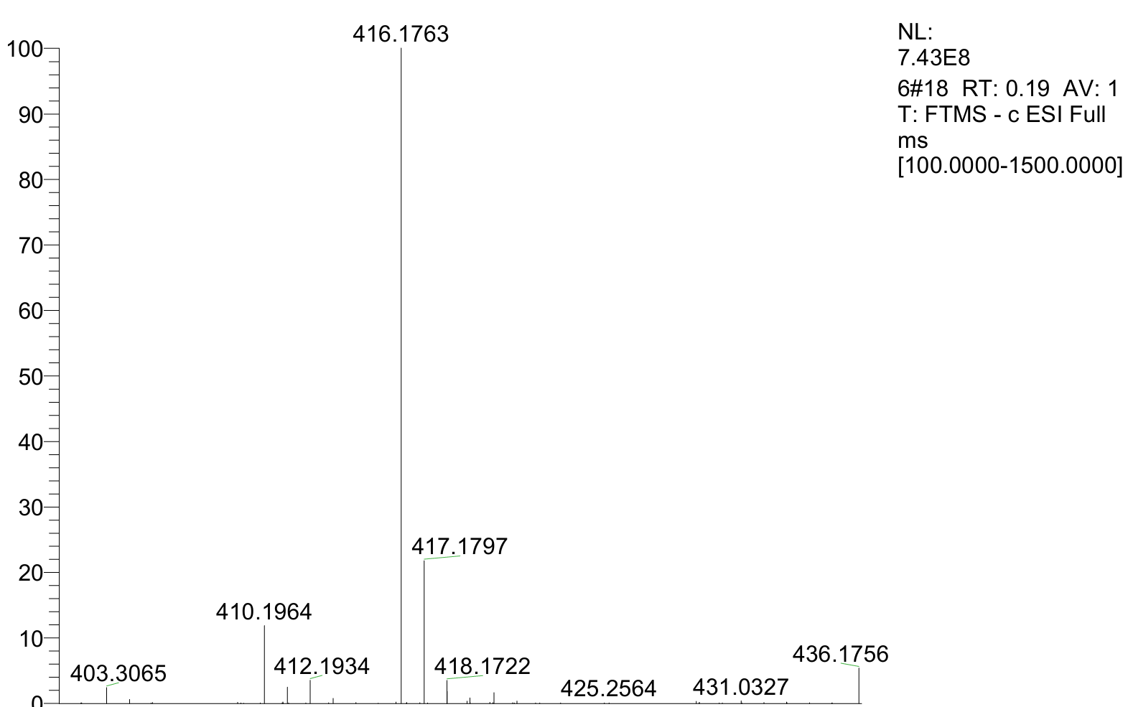
HRMS of compound 4b: Calcd for [M-H]⁻ C₂₀H₂₆N₅O₃S⁻: 416.1762; found: 416.1763.
Compound 5b was isolated in 38% yield (1.7 mg, 0.0038 mmol) as a white powder; the HPLC yield was 44% based on absorbance at 240 nm.
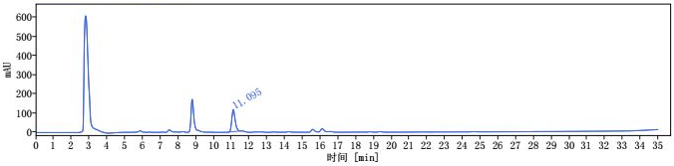
i
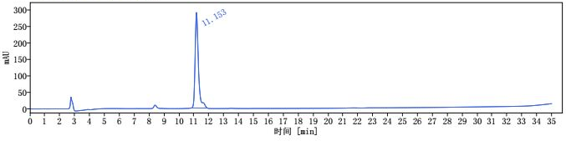
ii
Scheme S5. i) HPLC trace of reaction mixture of compound 5b. ii) HPLC trace of purified compound 5b [1 mL/min, 10% to 60% MeCN for 30 min, then 60% to 95% MeCN 30-35 min, HPLCONE 10C18A (10 μm, 4.6 x 250 mm), λ = 240 nm].
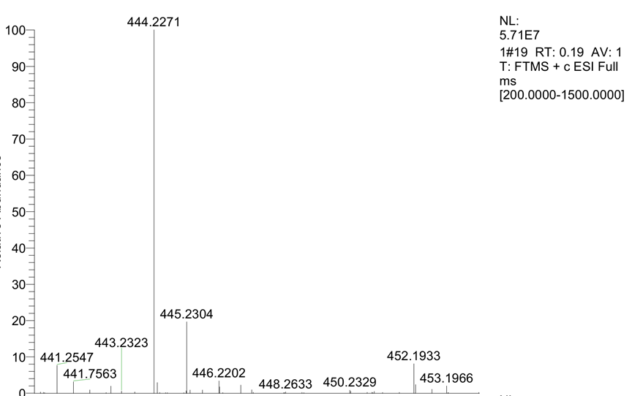
HRMS of compound 5b: Calcd for [M+H]⁺ C₁₉H₃₄N₅O₅S⁺: 444.2275; found: 444.2271.
Compound 6a was isolated in 39% yield (2.1 mg, 0.0039 mmol) as a white powder; the HPLC yield was 45% based on absorbance at 220 nm.
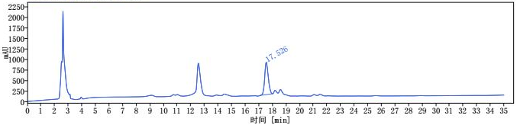
i
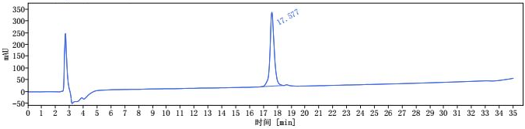
ii
Scheme S6. i) HPLC trace of reaction mixture of compound 6a. ii) HPLC trace of purified compound 6a [1 mL/min, 10% to 60% MeCN for 30 min, then 60% to 95% MeCN 30-35 min, HPLCONE 10C18A (10 μm, 4.6 x 250 mm), λ = 220 nm].
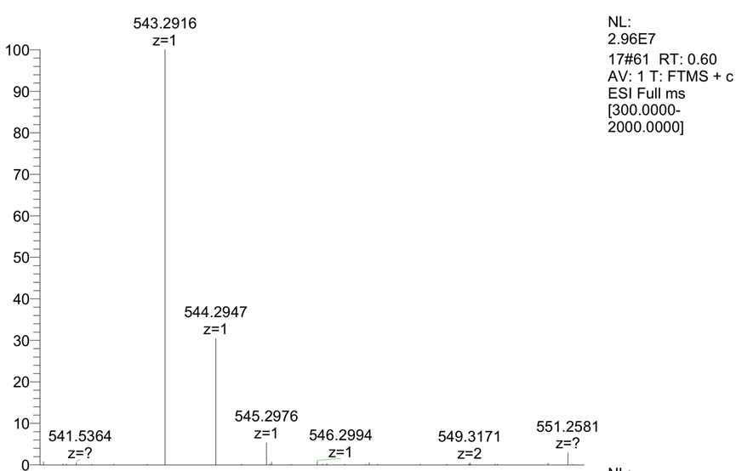
HRMS of compound 6a: Calcd for [M+H]⁺C₂₇H₃₉N₆O₆⁺: 543.2926; found: 543.2916.
¹H NMR (400 MHz, DMSO-d₆) δ 10.81 (s, 1 H), 8.33 (d, J = 8.3 Hz, 1 H), 8.08 (d, J = 8.4 Hz, 1 H), 7.83 (d, J = 7.7 Hz, 1 H), 7.57 (d, J = 7.8 Hz, 1 H), 7.30 (d, J = 8.0 Hz, 1 H), 7.10 (d, J = 2.3 Hz, 1 H), 7.04 (t, J = 7.5 Hz, 1 H), 6.95 (t, J = 7.4 Hz, 1 H), 5.66 – 5.56 (m, 2 H), 4.70 – 4.63 (m, 1 H), 4.38 – 4.29 (m, 2 H), 3.59 (s, 3 H), 3.21 – 3.11 (m, 2 H), 3.09 – 3.05 (m, 1 H), 2.94 – 2.90 (m, 1 H), 2.87 – 2.81 (m, 2 H), 1.83 (s, 3 H), 1.72 – 1.53 (m, 4 H), 1.50 – 1.35 (m, 4 H), 1.24 – 1.19 (m, 4 H). ¹³C NMR (100 MHz, DMSO-d₆) δ 172.9, 171.7, 171.4, 169.2, 158.5, 136.4, 128.0, 124.1, 121.2, 118.8, 118.6, 111.6, 110.0, 53.4, 52.5, 52.3, 51.9, 40.9, 39.2, 32.6, 31.5, 29.8, 29.6, 28.7, 23.2, 22.9, 22.4.
Compound 6b was isolated in 53% yield (3.0 mg, 0.0053 mmol) as a white powder; the HPLC yield was 61% based on absorbance at 210 nm.
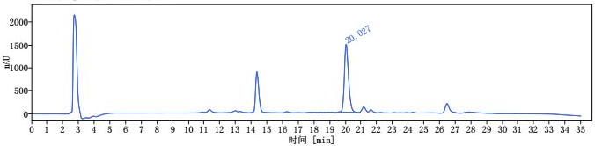
i
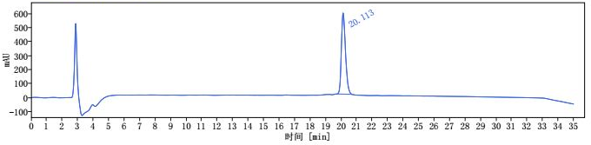
ii
Scheme S7. i) HPLC trace of reaction mixture of compound 6b. ii) HPLC trace of purified compound 6b [1 mL/min, 10% to 60% MeCN for 30 min, then 60% to 95% MeCN 30-35 min, HPLCONE 10C18A (10 μm, 4.6 x 250 mm), λ = 210 nm].
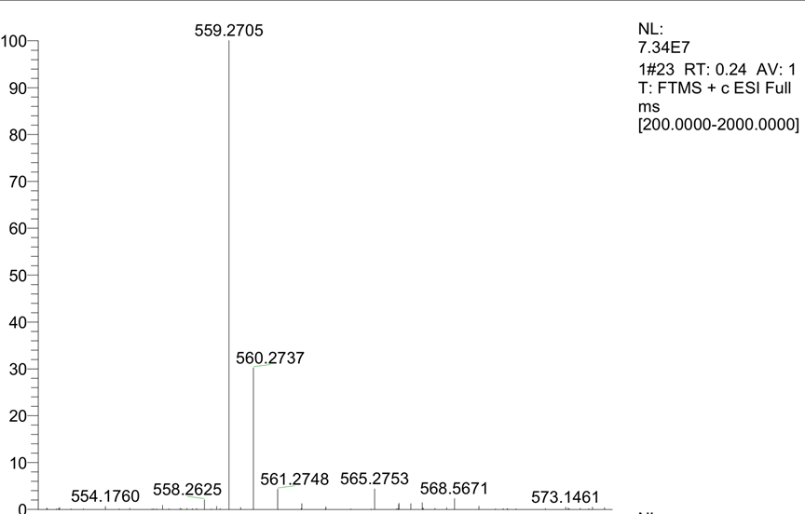HRMS of compound 6b: Calcd for [M+H]⁺C₂₇H₃₉N₆O₅S⁺: 559.2697; found:559.2705.
¹H NMR (400 MHz, DMSO-d₆) δ10.80 (s, 1 H), 8.37 – 8.03 (m, 2 H), 7.83 (d, J = 7.7 Hz, 1 H), 7.57 (d, J = 7.8 Hz, 1 H), 7.30 (d, J = 8.0 Hz, 1 H), 7.27 – 7.17 (m, 1 H), 7.10 (d, J = 2.3 Hz, 1 H), 7.04 (t, J = 7.5 Hz, 1 H), 6.95 (t, J = 7.4 Hz, 1 H), 4.67 – 4.56 (m, 1 H), 4.40 – 4.22 (m, 2 H), 3.78 – 3.72 (m, 3 H), 3.30 – 3.19 (m, 2 H), 3.12 – 3.05 (m, 1 H), 2.96 – 2.89 (m, 1 H), 1.83 (s, 3 H), 1.70 – 1.58 (m, 3 H), 1.56 – 1.45 (m, 3 H), 1.41 – 1.21 (m, 6 H).
Compounds 7b was isolated in 65% yield (3.6 mg, 0.0065 mmol) as a white powder; the HPLC yield was 72% based on absorbance at 210 nm.
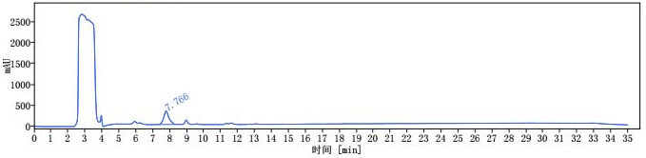
i
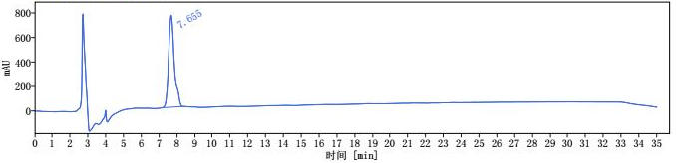
ii
Scheme S8. i) HPLC trace of reaction mixture of compound 7b. ii) HPLC trace of purified compound 7b [1 mL/min, 10% to 60% MeCN for 30 min, then 60% to 95% MeCN 30-35 min, HPLCONE 10C18A (10 μm, 4.6 x 250 mm), λ = 210 nm].
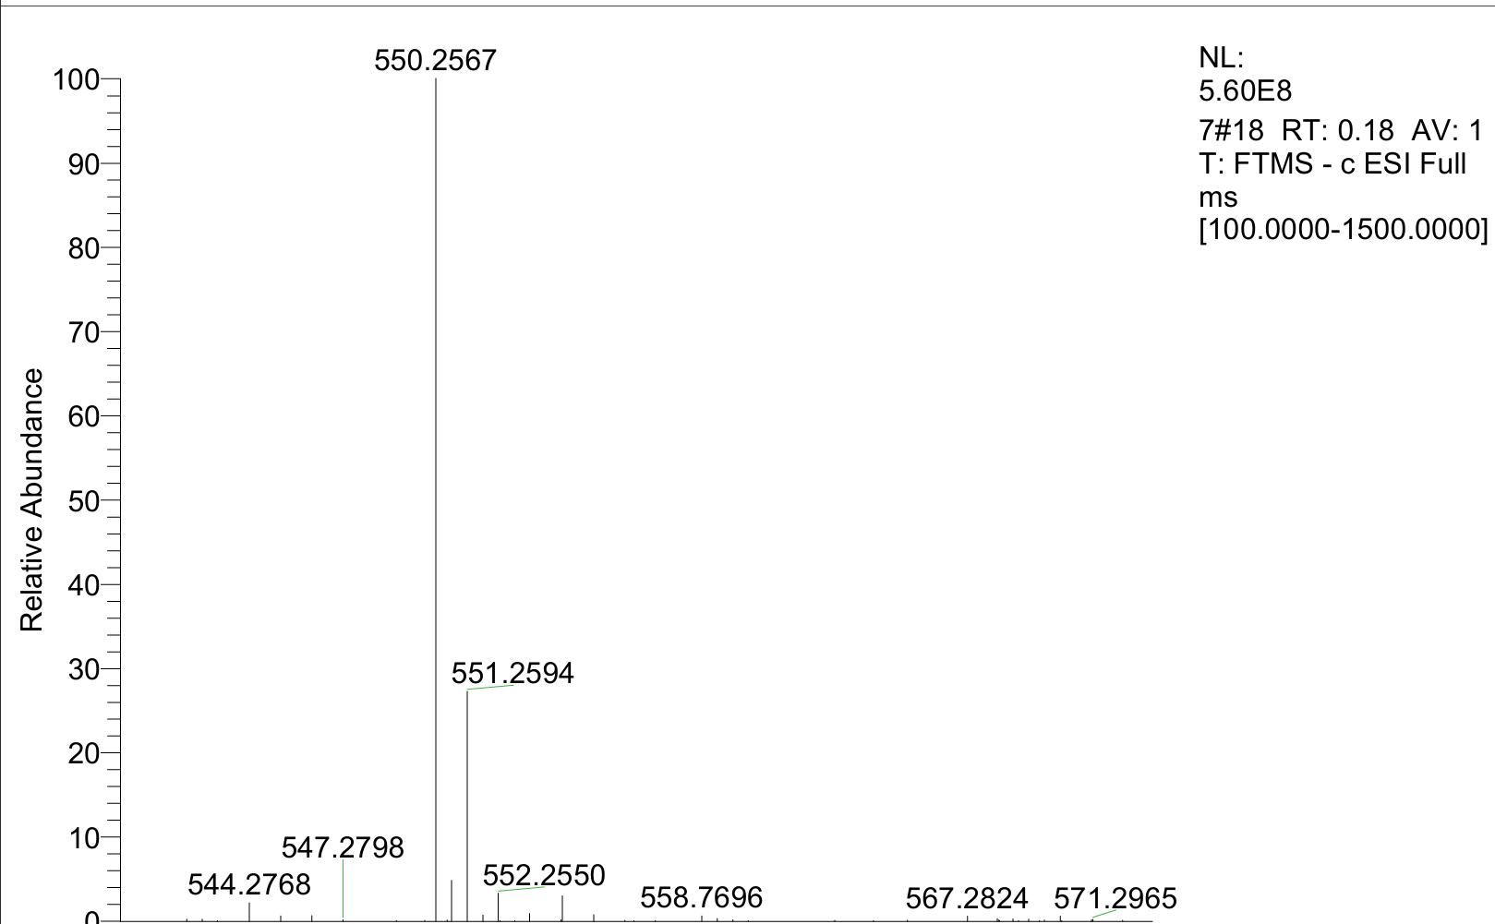
HRMS of compound 7b: Calcd for [M-H]⁻C₂₃H₃₆N₉O₅S⁻: 550.2566; found: 550.2567.
Compound 8a was isolated in 10% yield (0.69 mg, 0.0010 mmol) as a white powder; the HPLC yield was 14% based on absorbance at 220 nm.
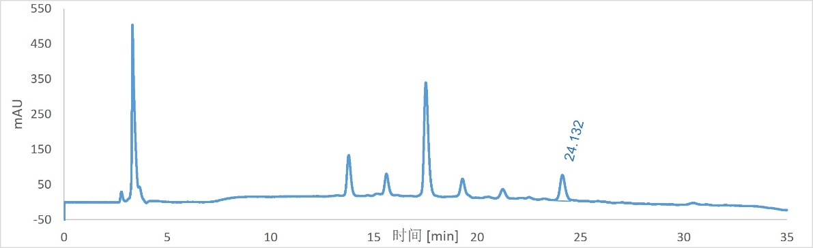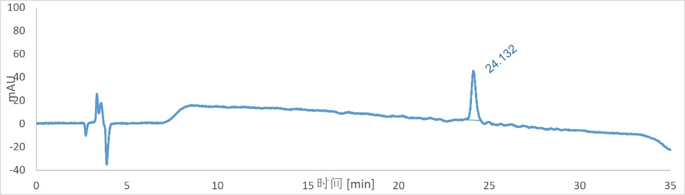
i
ii
Scheme S9. i) HPLC trace of reaction mixture of compound 8a. ii) HPLC trace of purified compound 8a [1 mL/min, 10% to 60% MeCN for 30 min, then 60% to 95% MeCN 30-35 min, HPLCONE 10C18A (10 μm, 4.6 x 250 mm), λ = 220 nm].
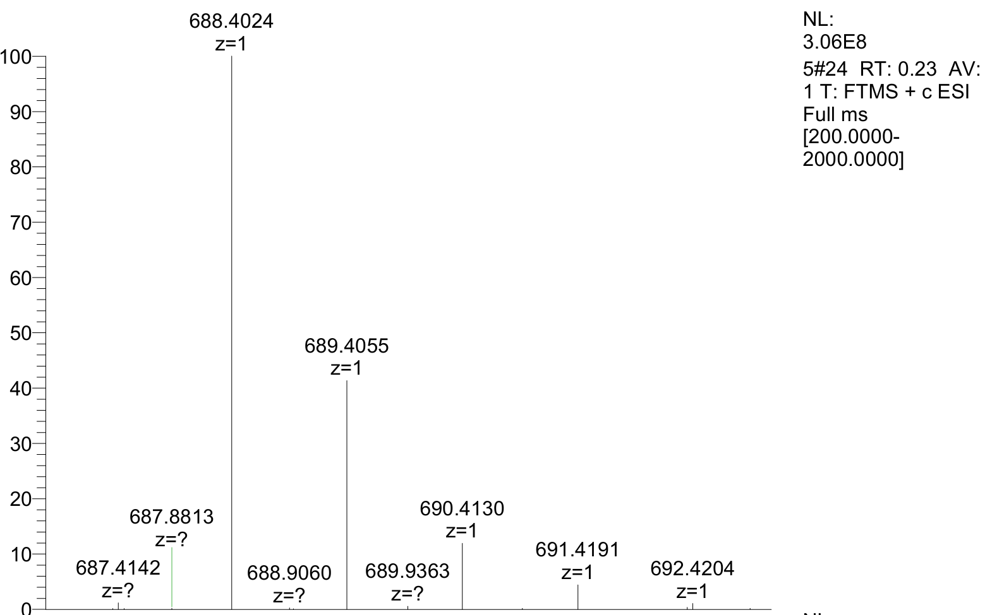
HRMS of compound 8a: Calcd for [M+H]⁺C₃₄H₅₄N₇O₈⁺: 688.4028; found: 688.4024.
Compound 8b was isolated in 61% yield (4.3 mg, 0.0061 mmol) as a white powder; the HPLC yield was 67% based on absorbance at 250 nm.
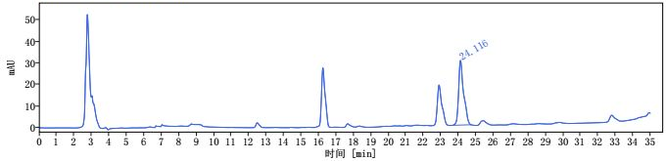
i
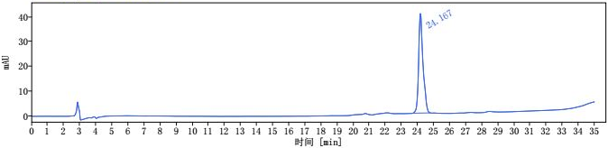
ii
Scheme S10. i) HPLC trace of reaction mixture of compound 8b. ii) HPLC trace of purified compound 8b [1 mL/min, 10% to 60% MeCN for 30 min, then 60% to 95% MeCN 30-35 min, HPLCONE 10C18A (10 μm, 4.6 x 250 mm), λ = 250 nm].
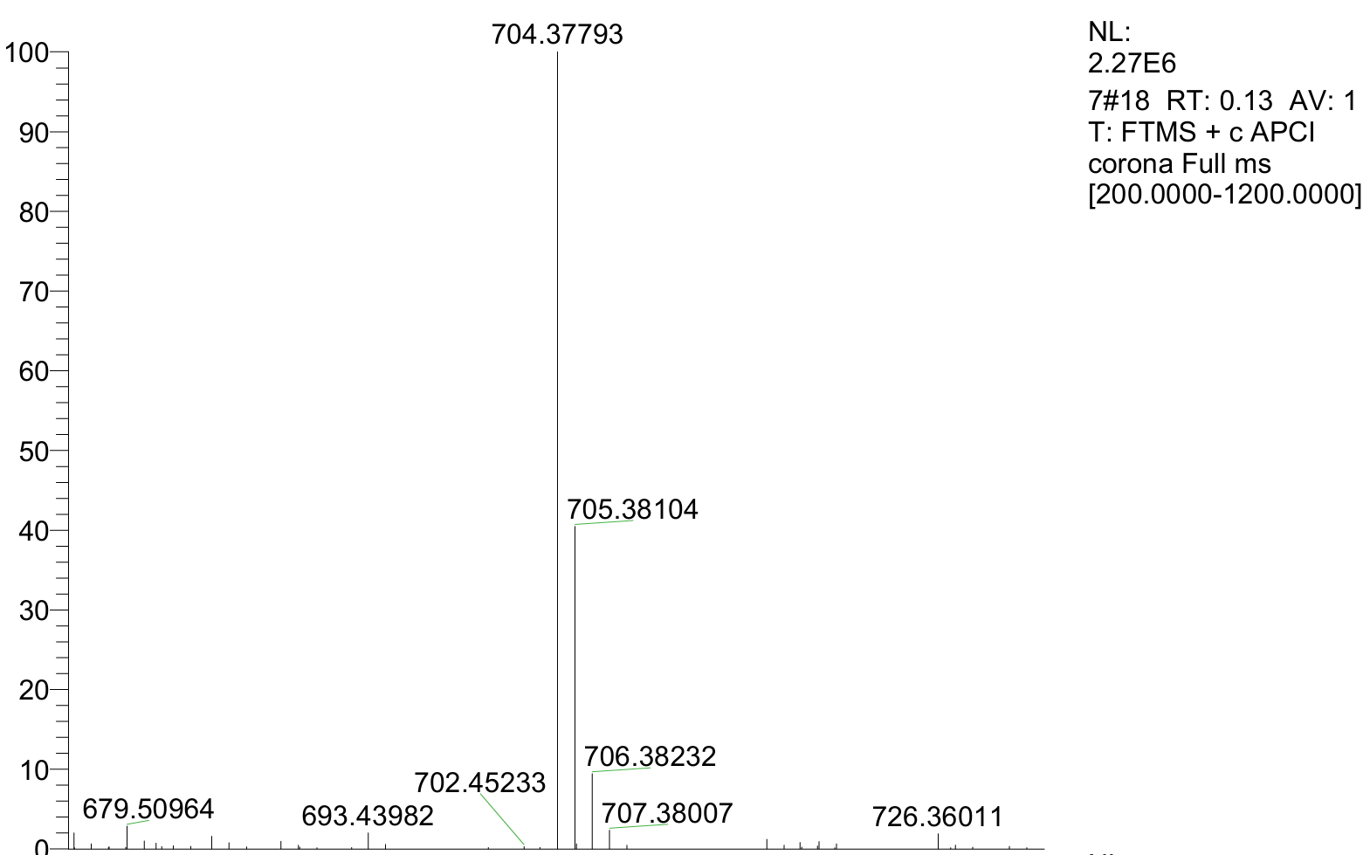
HRMS of compound 8b: Calcd for [M+H]⁺C₃₄H₅₄N₇O₇S⁺:704.37999; found: 704.37793.
Compound 9a was isolated in 71% yield (5.7 mg, 0.0071 mmol) as a white powder; the HPLC yield was 78% based on absorbance at 220 nm.
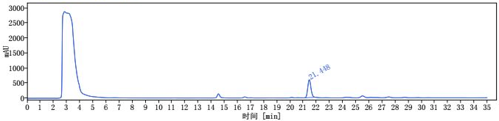
i
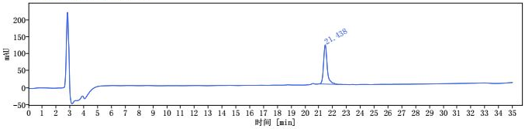
ii
Scheme S11. i) HPLC trace of reaction mixture of compound 9a. ii) HPLC trace of purified compound 9a [1 mL/min, 10% to 60% MeCN for 30 min, then 60% to 95% MeCN 30-35 min, HPLCONE 10C18A (10 μm, 4.6 x 250 mm), λ = 220 nm].
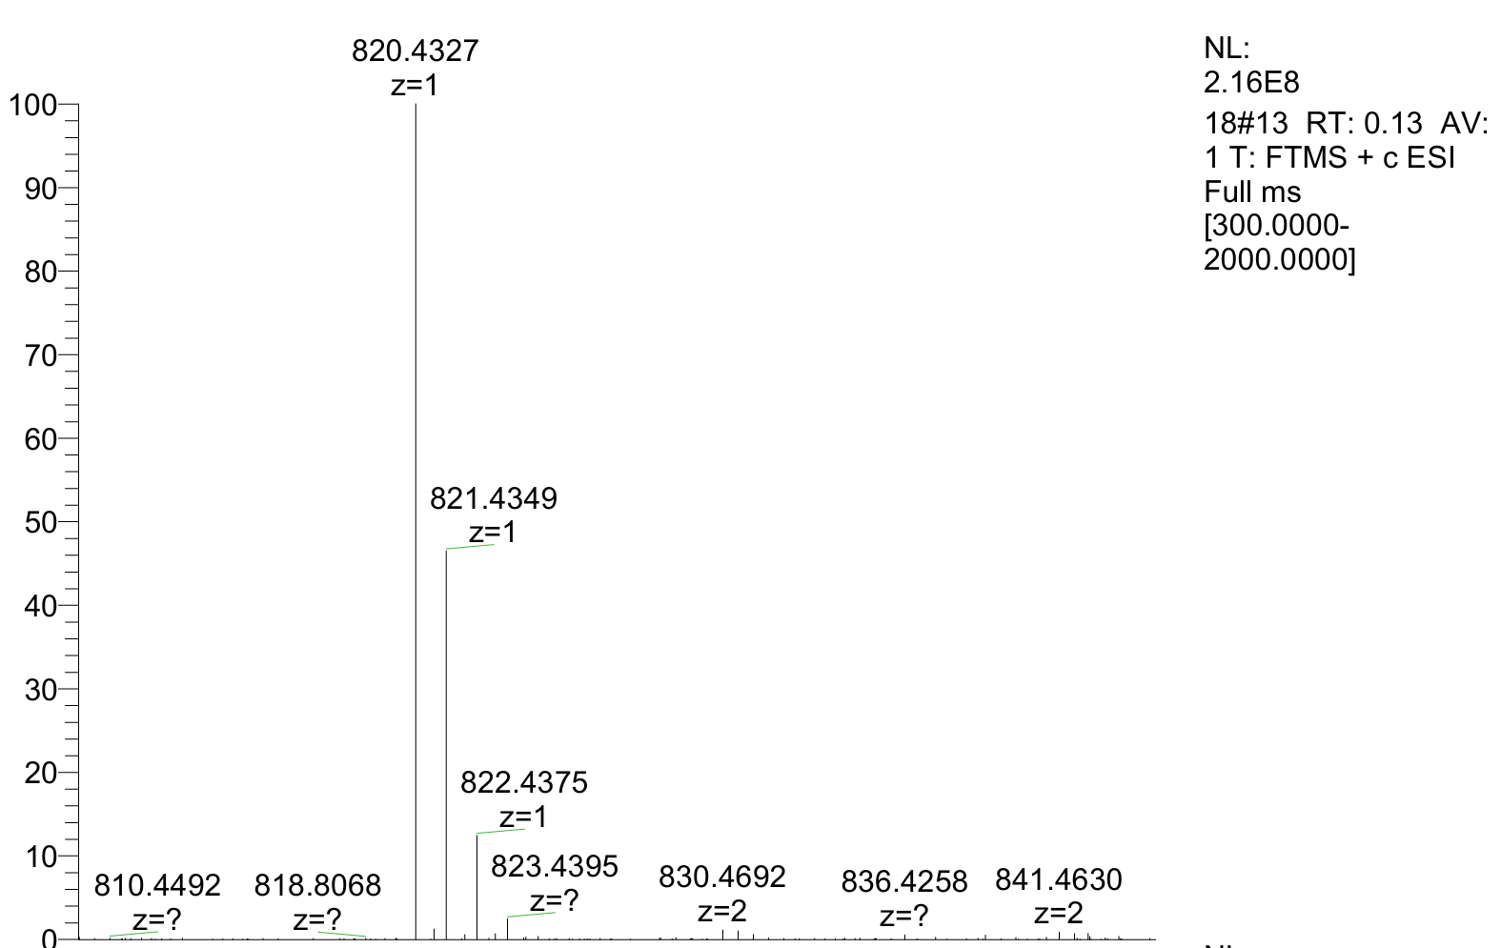
HRMS of compound 9a: Calcd for [M+Na]⁺ C₃₉H₅₉N₉O₉Na⁺: 820.4328; found: 820.4327.
Compound 9b was isolated in 51% yield (4.2 mg, 0.0051 mmol) as a white powder; the HPLC yield was 77% based on absorbance at 250 nm.
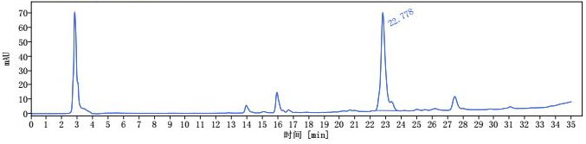
i
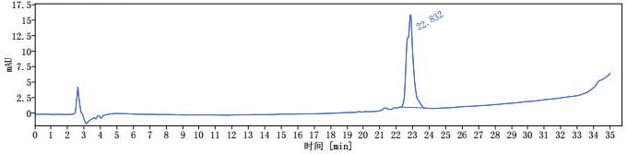
ii
Scheme S12. i) HPLC trace of reaction mixture of compound 9b. ii) HPLC trace of purified compound 9b [1 mL/min, 10% to 60% MeCN for 30 min, then 60% to 95% MeCN 30-35 min, HPLCONE 10C18A (10 μm, 4.6 x 250 mm), λ = 250 nm].
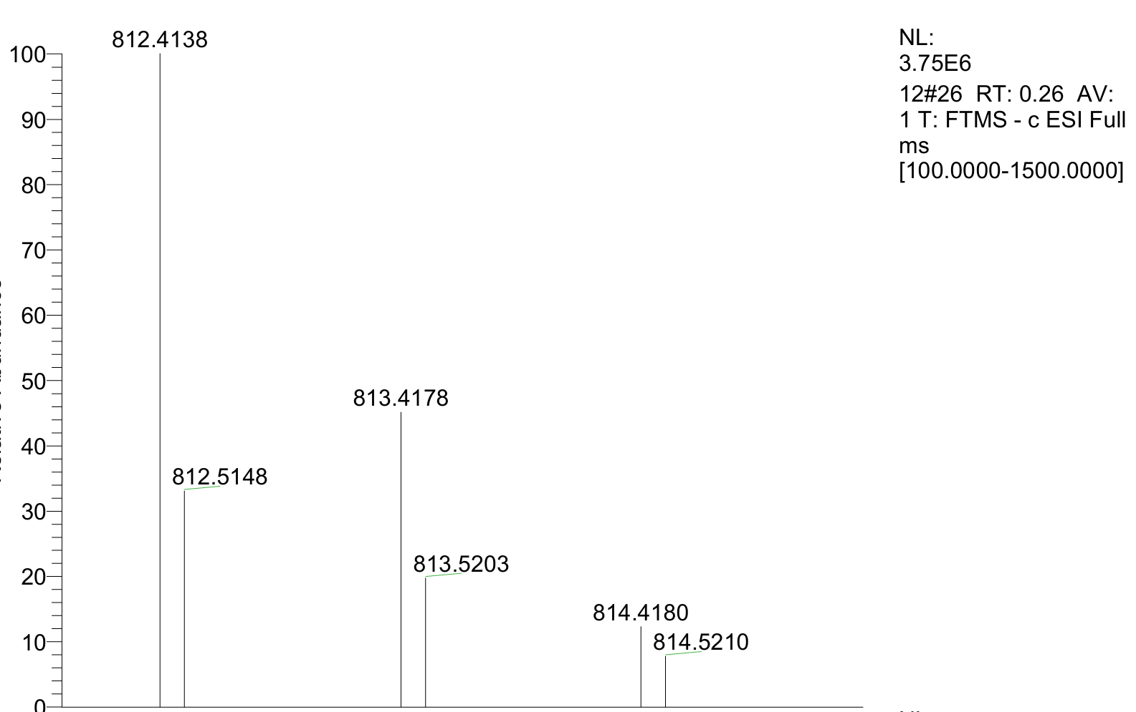
HRMS of compound 9b: Calcd for [M-H]⁻ C₃₉H₅₈N₉O₈S⁻: 812.4135; found: 812.4138.
Compound 10a was isolated in 38% yield (3.1 mg, 0.0038 mmol) as a white powder; the HPLC yield was 47% based on absorbance at 220 nm.
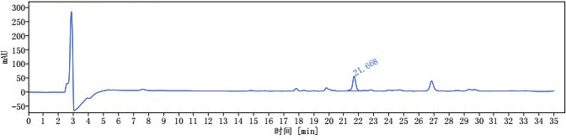
i
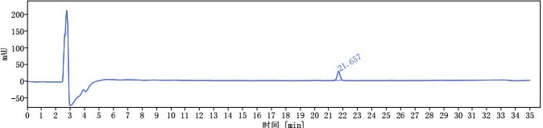
ii
Scheme S13. i) HPLC trace of reaction mixture of compound 10a. ii) HPLC trace of purified compound 10a [1 mL/min, 10% to 60% MeCN for 30 min, then 60% to 95% MeCN 30-35 min, HPLCONE 10C18A (10 μm, 4.6 x 250 mm), λ = 220 nm].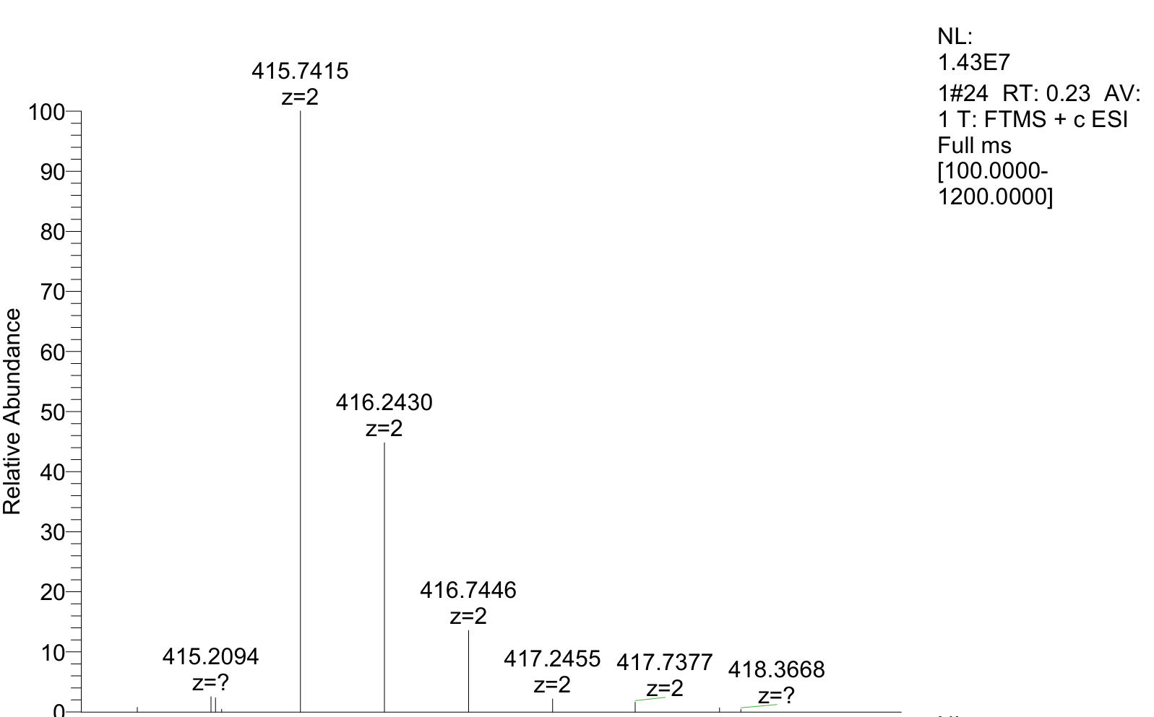
HRMS of compound 10a: Calcd for [(M+2H⁺)/2] C₄₀H₆₅N₉O₁₀²⁺: 415.7422; found: 415.7415.
Compound 10b was isolated in 40% yield as (3.4mg, 0.0040 mmol) a white powder; the HPLC yield was 64% based on absorbance at 250 nm.
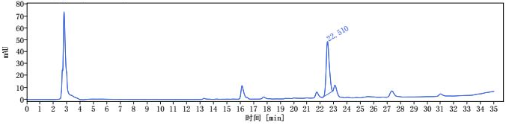
i
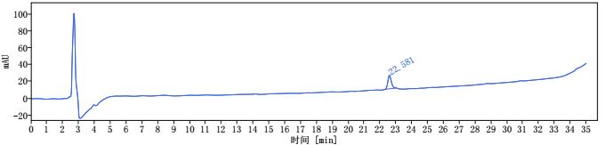
ii
Scheme S14. i) HPLC trace of reaction mixture of compound 10b. ii) HPLC trace of purified compound 10b [1 mL/min, 10% to 60% MeCN for 30 min, then 60% to 95% MeCN 30-35 min, HPLCONE 10C18A (10 μm, 4.6 x 250 mm), λ = 250 nm].
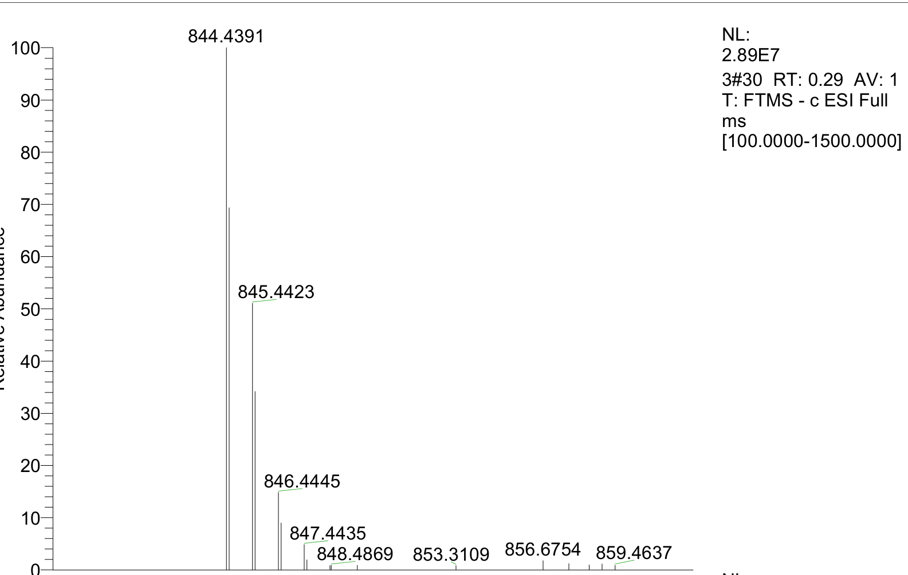
HRMS of compound 10b: Calcd for [M-H]⁻ C₄₀H₆₂N₉O₉S⁻: 844.4397; found: 844.4391.
Compound 11a was isolated in 43% yield (4.6 mg, 0.0043 mmol) as a white powder; the HPLC yield was 52% based on absorbance at 220 nm.
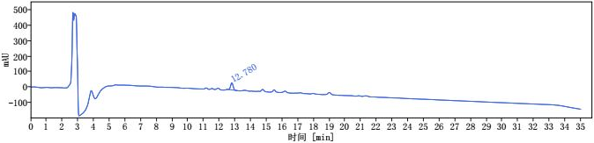
i
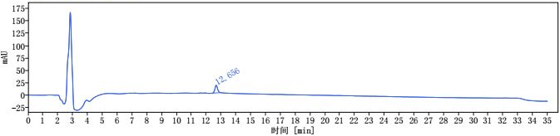
ii
Scheme S15. i) HPLC trace of reaction mixture of compound 11a. ii) HPLC trace of purified compound 11a [1 mL/min, 10% to 60% MeCN for 30 min, then 60% to 95% MeCN 30-35 min, HPLCONE 10C18A (10 μm, 4.6 x 250 mm), λ = 220 nm].
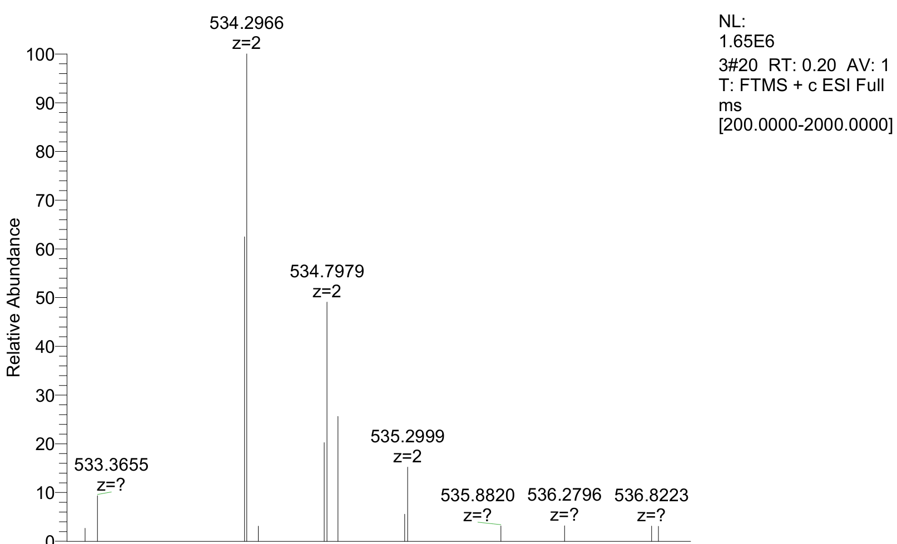HRMS of compound 11a: Calcd for [(M+2H⁺)/2] C₄₆H₈₀N₁₄O₁₅²⁺: 534.2958; found: 534.2966.
Compound 11b was isolated in 51% yield (5.5 mg, 0.0051 mmol) as a white powder; the HPLC yield was 75% based on absorbance at 240 nm.
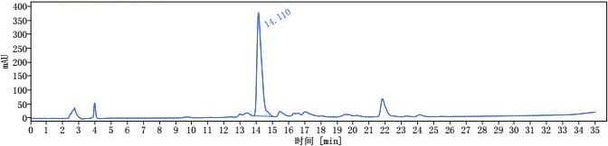
i
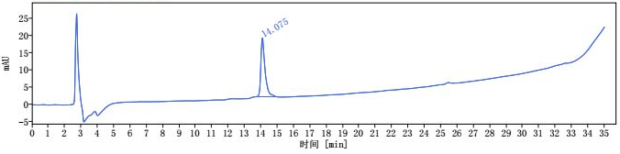
ii
Scheme S16. i) HPLC trace of reaction mixture of compound 11b. ii) HPLC trace of purified compound 11b [1 mL/min, 10% to 60% MeCN for 30 min, then 60% to 95% MeCN 30-35 min, HPLCONE 10C18A (10 μm, 4.6 x 250 mm), λ = 240 nm].
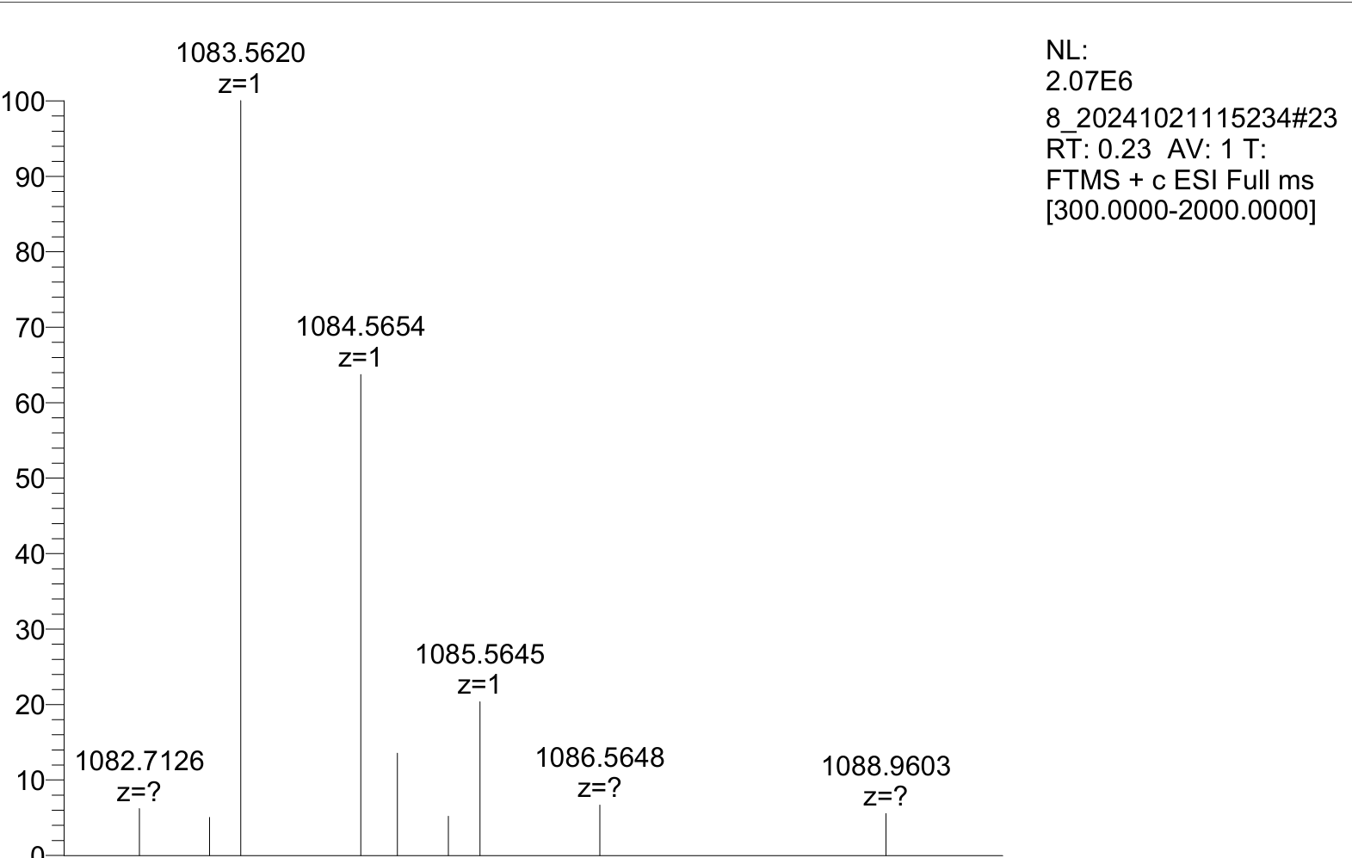HRMS of compound 11b: Calcd for [M+H]⁺ C₄₆H₇₉N₁₄O₁₄S⁺: 1083.5615; found: 1083.5620.
Compound 12b was isolated in 78% yield (5.5 mg, 0.0078 mmol) as a white powder; the HPLC yield was 85% based on absorbance at 220 nm.
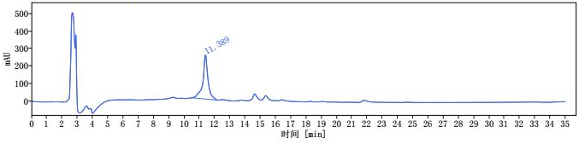
i
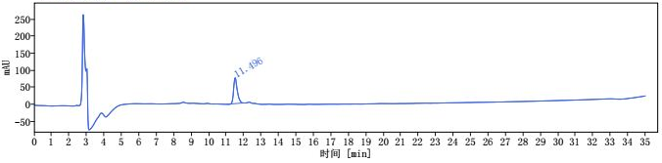
ii
Scheme S17. i) HPLC trace of reaction mixture of compound 12b. ii) HPLC trace of purified compound 12b [1 mL/min, 10% to 60% MeCN for 30 min, then 60% to 95% MeCN 30-35 min, HPLCONE 10C18A (10 μm, 4.6 x 250 mm), λ = 220 nm].
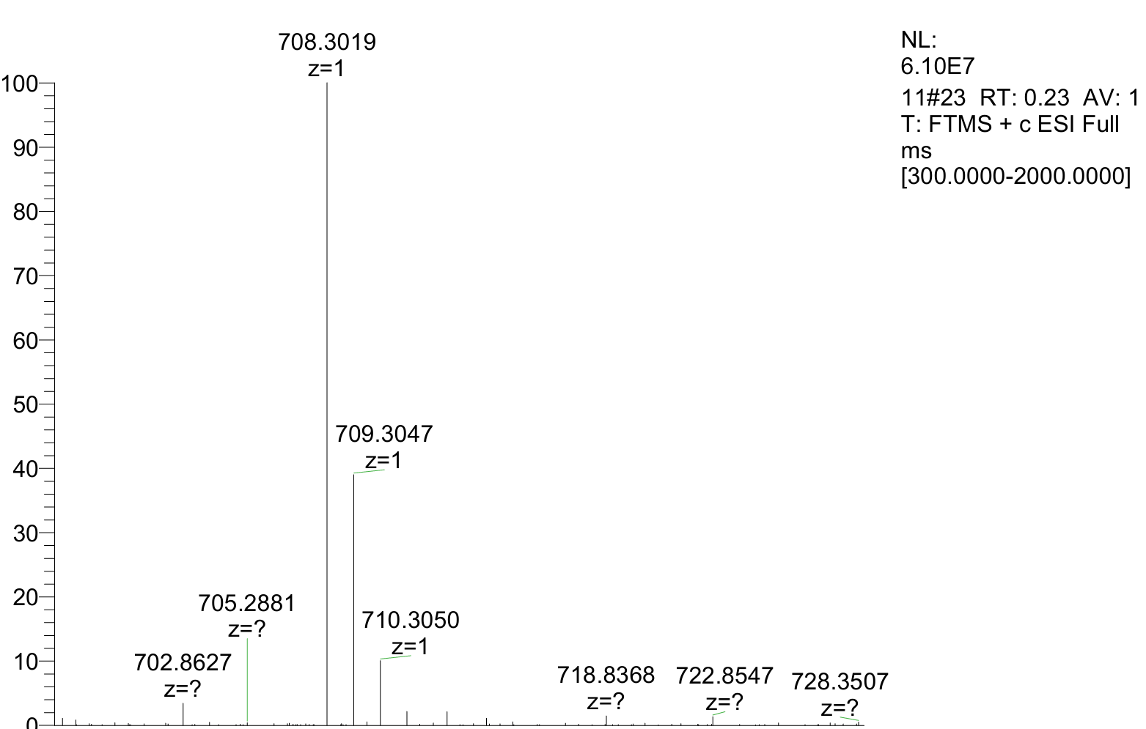
HRMS of compound 12b: Calcd for [M+H]⁺ C₃₁H₄₆N₇O₁₀S⁺: 708.3021; found: 708.3019.
Compound 13b was isolated in 63% yield (6.8 mg, 0.0063 mmol) as a white powder; the HPLC yield was 71% based on absorbance at 220 nm.
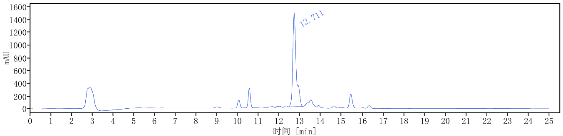
i
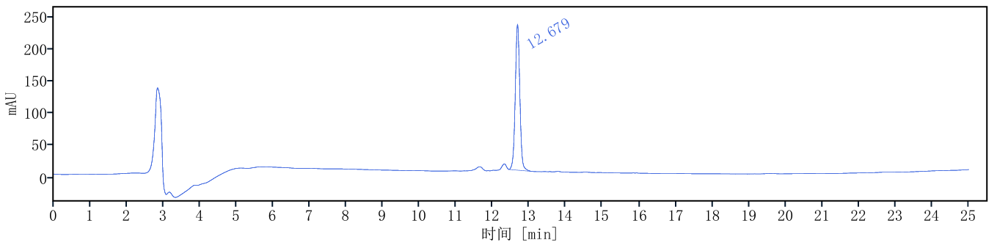
ii
Scheme S18. i) HPLC trace of reaction mixture of compound 13b. ii) HPLC trace of purified compound 13b [1 mL/min, 10% to 60% MeCN for 30 min, then 60% to 95%
MeCN 30-35 min, HPLCONE 10C18A (10 μm, 4.6 x 250 mm), λ = 220 nm].
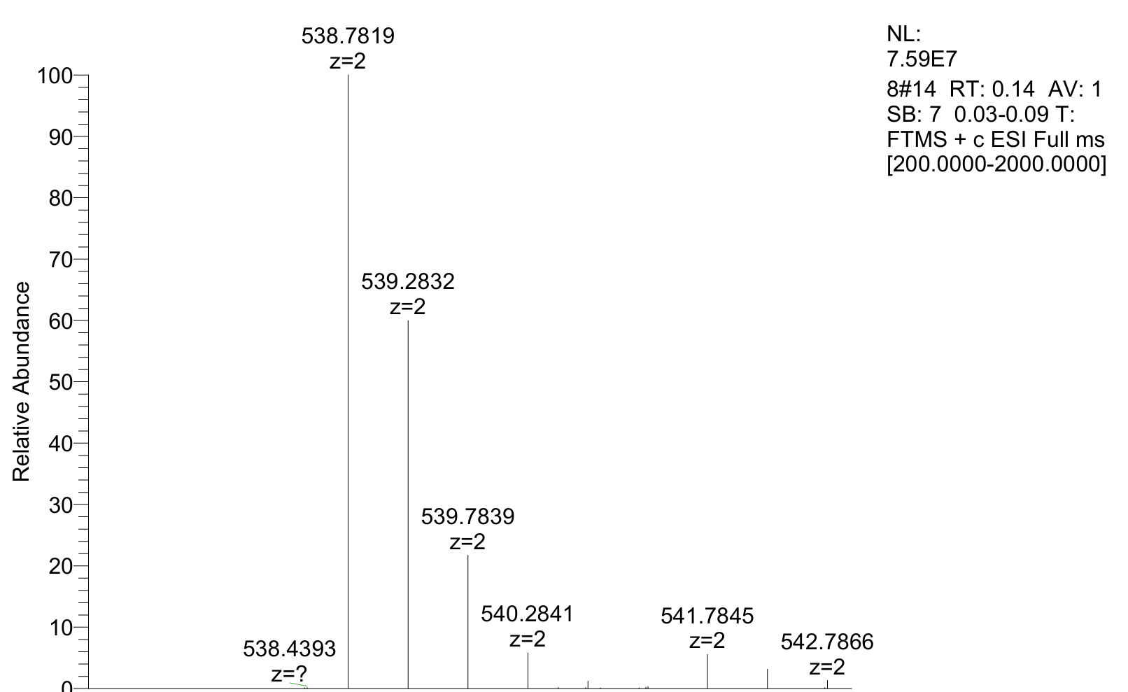
HRMS of compound 13b: Calcd for [(M+2H⁺)/2] C₄₈H₇₉N₁₃O₁₃S²⁺: 538.7815; found: 538.7819.
Compound 14b was isolated in 34% yield (5.7 mg, 0.0034 mmol) as a white powder; the HPLC yield was 57% based on absorbance at 220 nm.
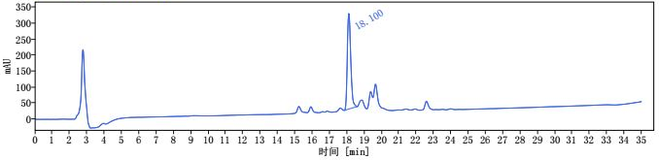
i
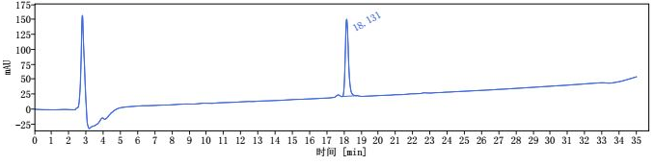
ii
Scheme S19. i) HPLC trace of reaction mixture of compound 14b. ii) HPLC trace of purified compound 14b [1 mL/min, 10% to 60% MeCN for 30 min, then 60% to 95% MeCN 30-35 min, HPLCONE 10C18A (10 μm, 4.6 x 250 mm), λ = 220 nm].
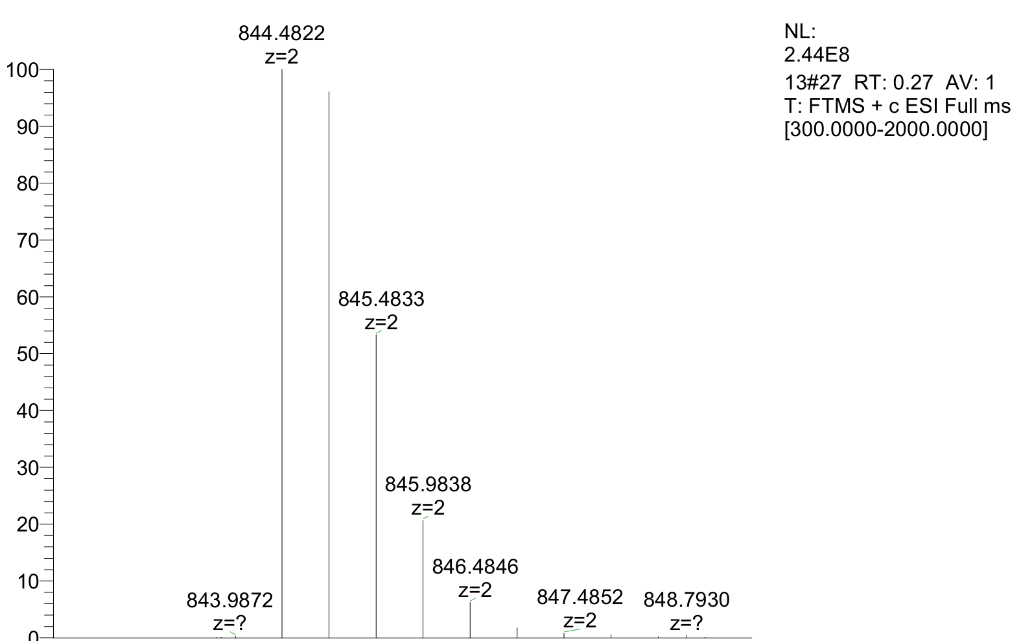
HRMS of compound 14b: Calcd for [(M+2H⁺)/2] C₇₈H₁₂₈N₂₄O₁₆S²⁺: 844.4825; found: 844.4822.
Compound 15b was isolated in 37% yield (6.2 mg, 0.0037 mmol) as a white powder; the HPLC yield was 64% based on absorbance at 220 nm.
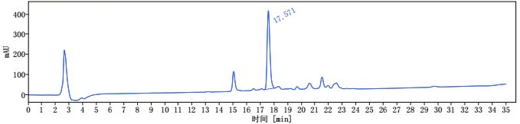
i
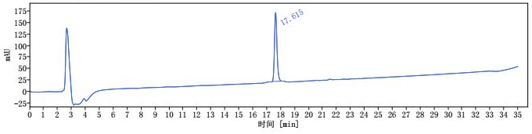
ii
Scheme S20. i) HPLC trace of reaction mixture of compound 15b. ii) HPLC trace of purified compound 15b [1 mL/min, 10% to 60% MeCN for 30 min, then 60% to 95% MeCN 30-35 min, HPLCONE 10C18A (10 μm, 4.6 x 250 mm), λ = 220 nm].
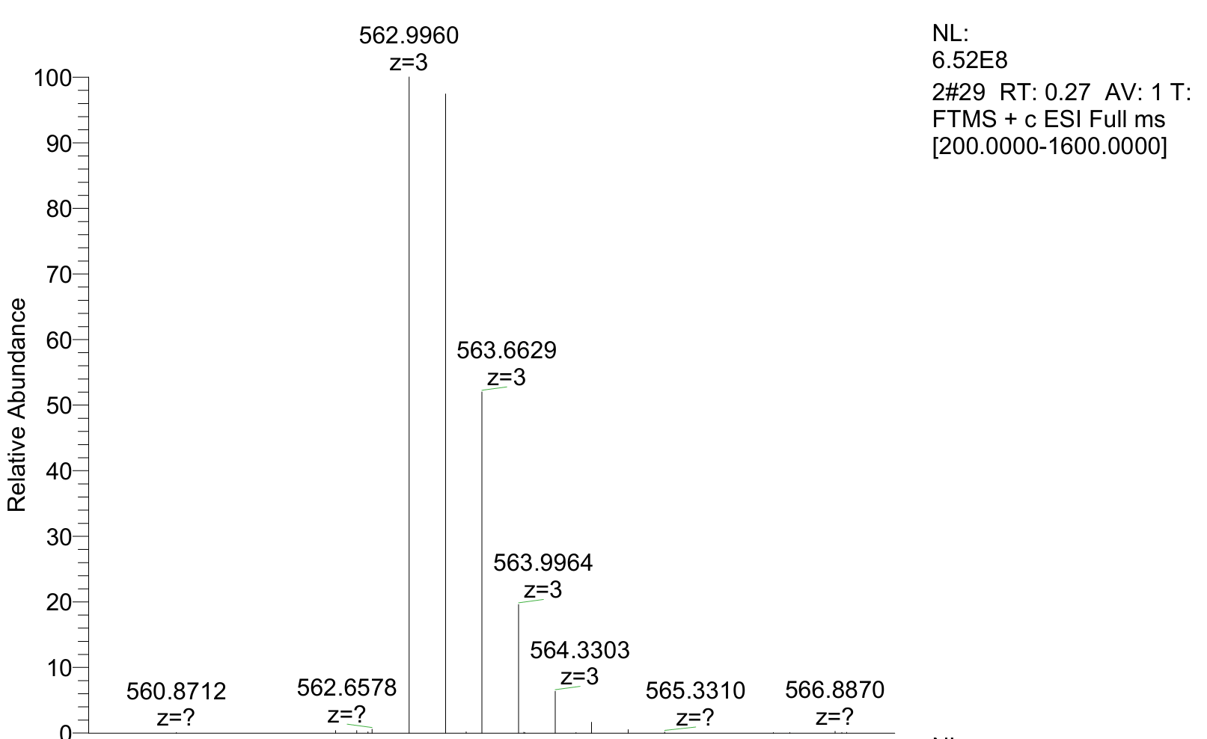
HRMS of compound 15b: Calcd for [(M+3H⁺)/3] C₇₈H₁₃₀N₂₅O₁₅S³⁺: 562.9961; found:562.9960.
Compound 16b was isolated in 41% yield (6.0 mg, 0.0041 mmol) as a white powder; the HPLC yield was 56% based on absorbance at 220 nm.
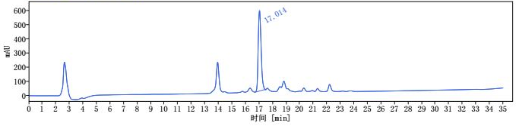
i
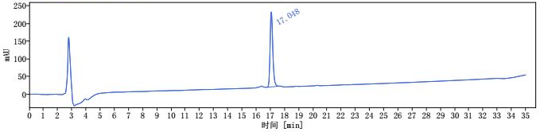
ii
Scheme S21. i) HPLC trace of reaction mixture of compound 16b. ii) HPLC trace of purified compound 16b [1 mL/min, 10% to 60% MeCN for 30 min, then 60% to 95% MeCN 30-35 min, HPLCONE 10C18A (10 μm, 4.6 x 250 mm), λ = 220 nm].
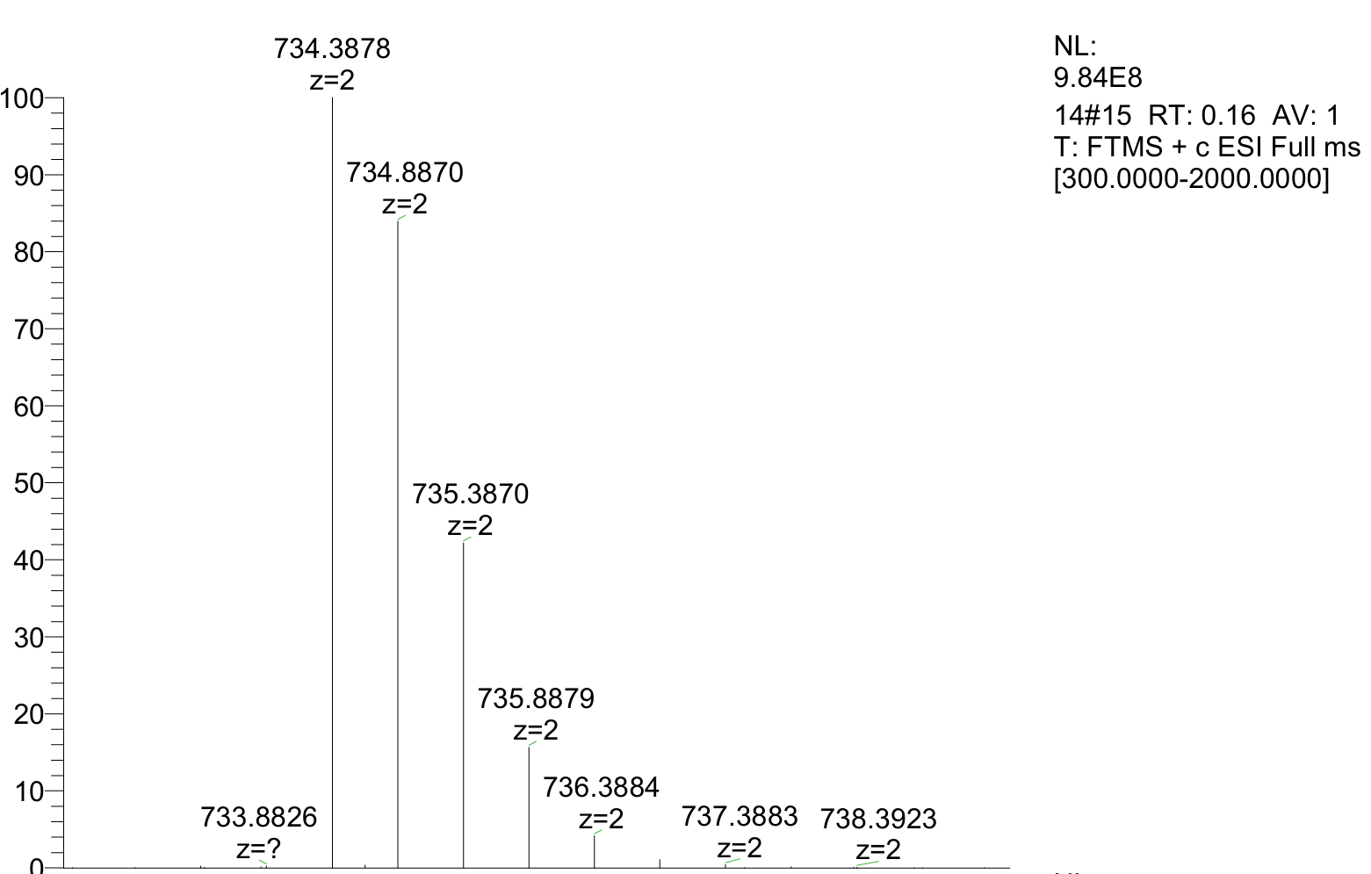
HRMS of compound 16b: Calcd for [(M+2H⁺)/2] C₆₉H₁₀₄N₂₀O₁₄S²⁺: 734.3875; found: 734.3878.
Compound 17b was isolated in 64% yield (8.1 mg, 0.0064 mmol) as a white powder; the HPLC yield was 75% based on absorbance at 240 nm.
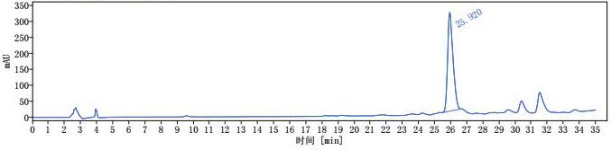
ii
i
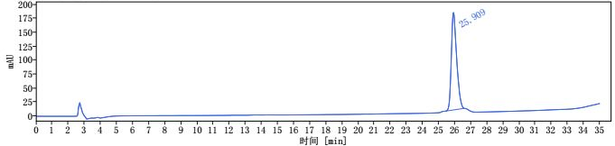
Scheme S22. i) HPLC trace of reaction mixture of compound 17b. ii) HPLC trace of purified compound 17b [1 mL/min, 10% to 60% MeCN for 30 min, then 60% to 95% MeCN 30-35 min, HPLCONE 10C18A (10 μm, 4.6 x 250 mm), λ = 240 nm].
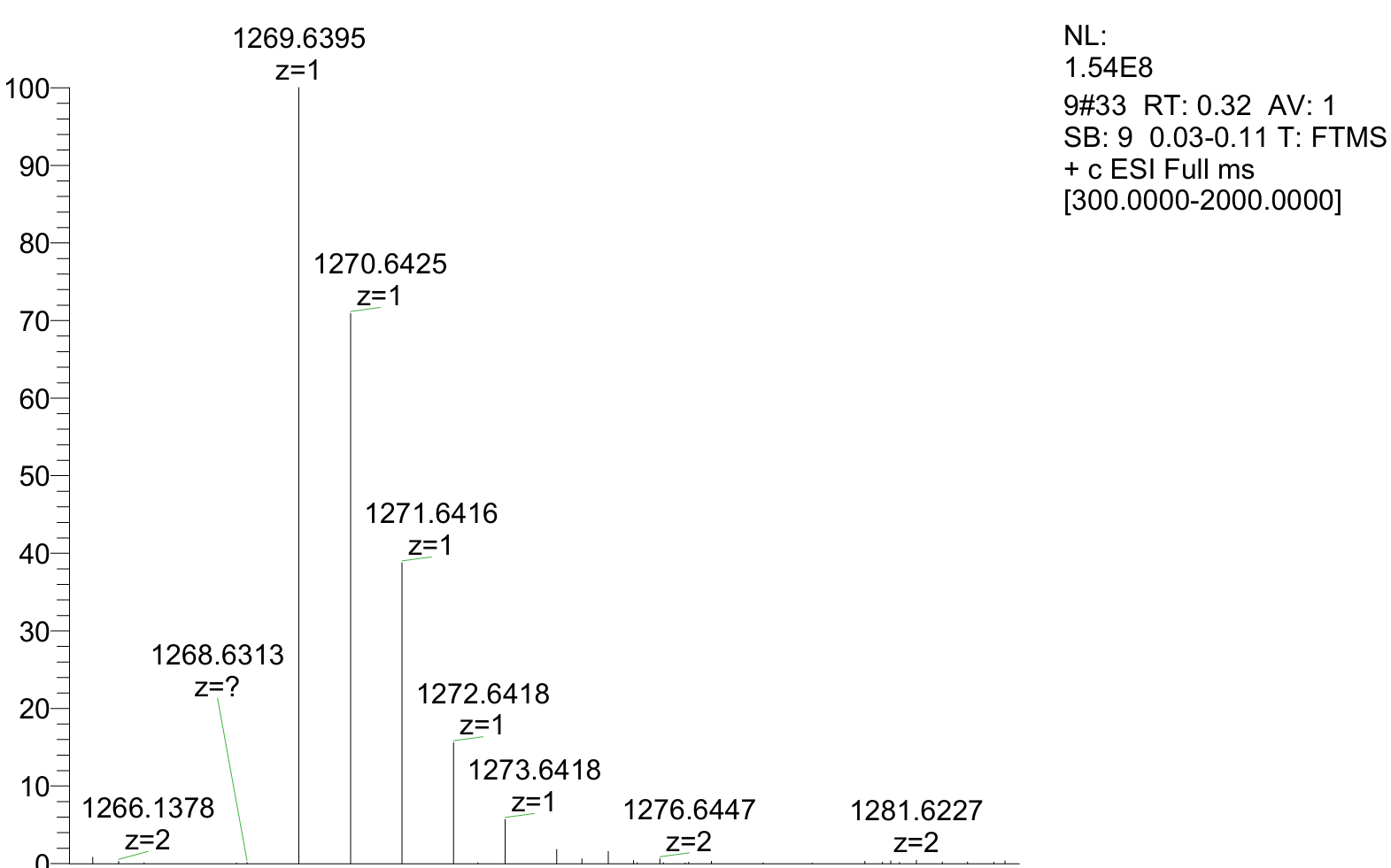
HRMS of compound 17b: Calcd for [M+H]⁺ C₅₇H₉₇N₁₂O₁₄S₃⁺: 1269.6404; found: 1269.6395.
Compound 18b was isolated in 42% yield (7.6 mg, 0.0042 mmol) as a white powder; the HPLC yield was 70% based on absorbance at 250 nm.
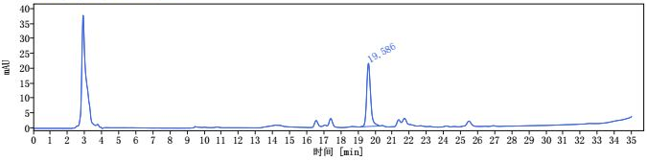
i
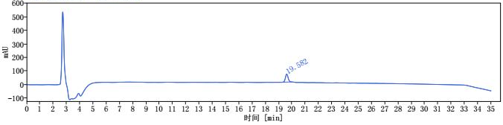
ii
Scheme S23. i) HPLC trace of reaction mixture of compound 18b. ii) HPLC trace of purified compound 18b [1 mL/min, 10% to 60% MeCN for 30 min, then 60% to 95% MeCN 30-35 min, HPLCONE 10C18A (10 μm, 4.6 x 250 mm), λ = 250 nm].
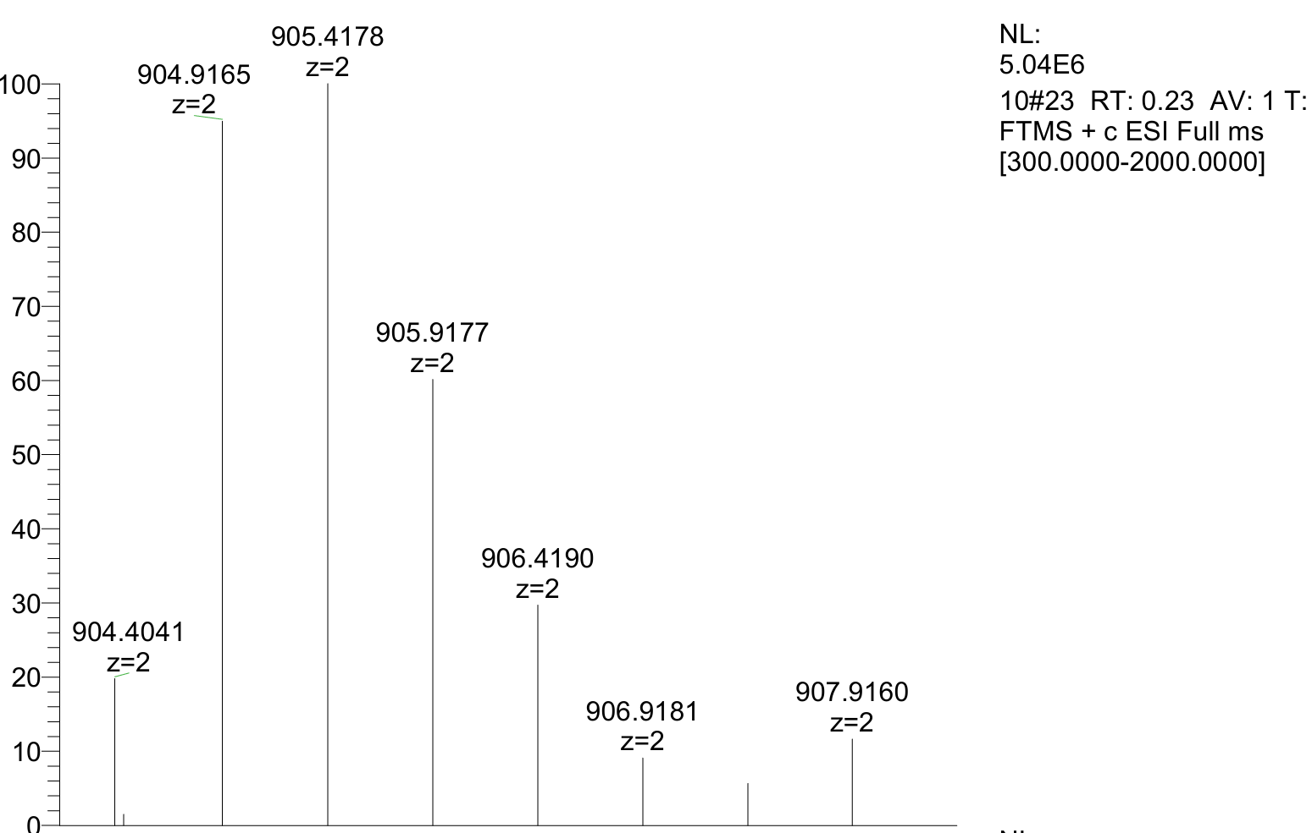
HRMS of compound 18b: Calcd for [(M+2H⁺)/2] C₈₃H₁₁₉N₂₁O₂₁S₂²⁺: 904.9160; found: 904.9165.
Compound 21b was isolated in 57% yield (4.3 mg, 0.0057 mmol) as a white powder; the HPLC yield was 63% based on absorbance at 270 nm.
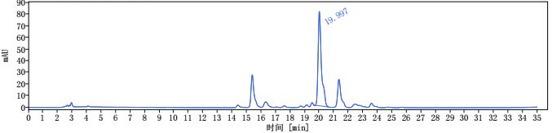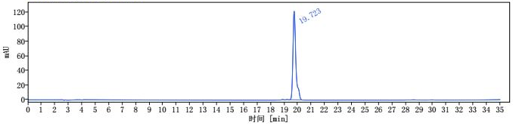
ii
i
Scheme S24. i) HPLC trace of reaction mixture of compound 21b. ii) HPLC trace of purified compound 21b [1 mL/min, 10% to 60% MeCN for 30 min, then 60% to 95% MeCN 30-35 min, HPLCONE 10C18A (10 μm, 4.6 x 250 mm), λ = 270 nm].
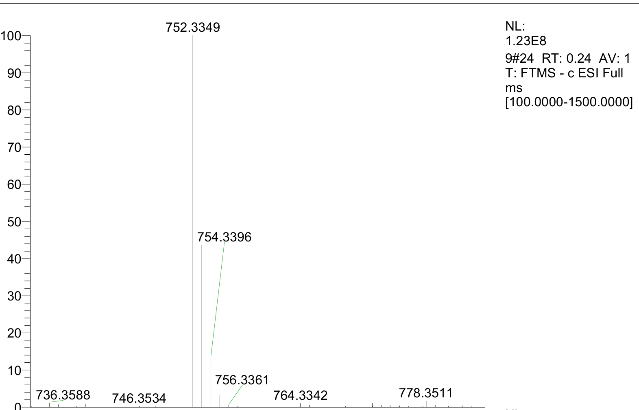
HRMS of compound 21b: Calcd for [M-H]⁻ C₃₉H₄₆N₉O₅S⁻:752.3348; found: 752.3349.
Compound 22b was isolated in 40 % yield (6.3 mg, 0.0040 mmol) as a white powder; the HPLC yield was 63% based on absorbance at 250 nm.
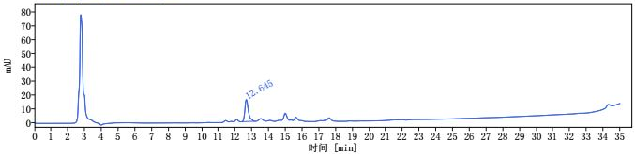
i
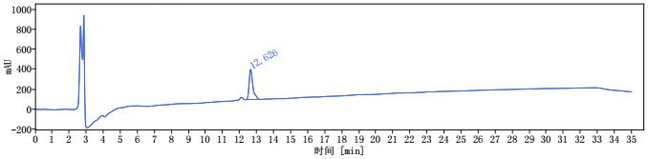
ii
Scheme S25. i) HPLC trace of reaction mixture of compound 22b. ii) HPLC trace of purified compound 22b [1 mL/min, 10% to 60% MeCN for 30 min, then 60% to 95% MeCN 30-35 min, HPLCONE 10C18A (10 μm, 4.6 x 250 mm), λ = 250 nm].
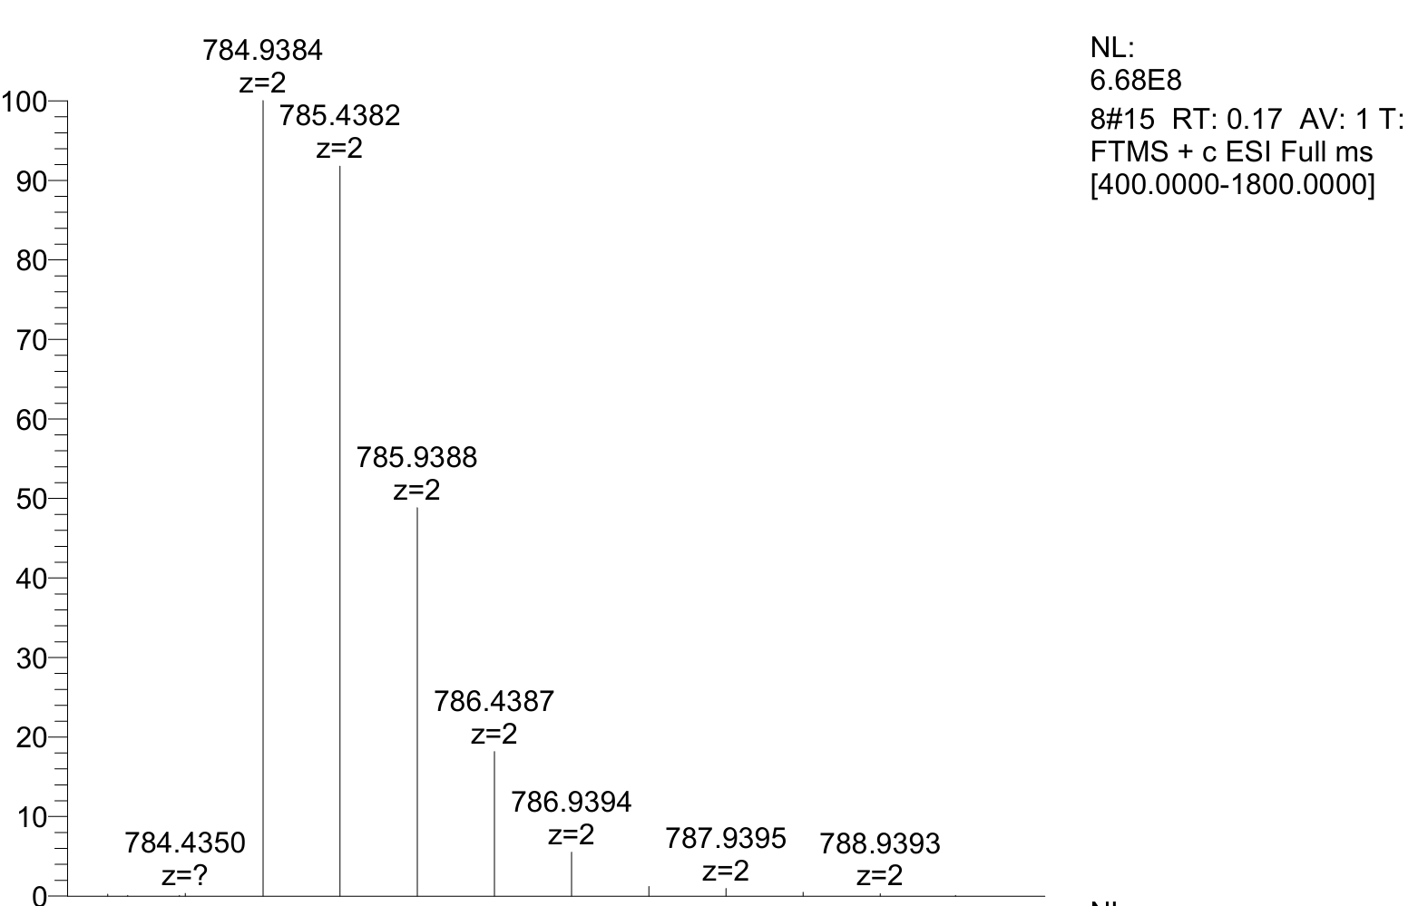
HRMS of compound 22b: Calcd for [(M+2H⁺)/2] C₆₆H₁₁₉N₂₃O₁₉S²⁺: 784.9381; found: 784.9384.
General procedure for the synthesis of dithio-urea containing macrocyclic peptides
To a solution of lysine-containing peptides in DMF (0.01 mmol, 0.002 M, 5 mL), the N, N’-thiocyanyldiimidazole (TCDI, 4 equiv., 0.008 M) and Et₃N (1 equiv., 0.002 M) was then added under stirring. The reaction mixture was stirred at room temperature for 12 hours. Reaction progress was monitored by withdrawing a small aliquot for mass spectrometry (LCMS/MS) analysis to confirm intermediate formation. Subsequently, a solution of 1,3-propanediamine (2 equiv., 0.001 M, 20 mL) in the same solvent was prepared and then slowly added dropwise to the reaction mixture using a constant pressure dropping funnel under continued stirring at room temperature overnight. After the reaction was completed. The crude mixture was analyzed by HPLC and LCMS/MS. The yields were based on the absorbance at 220 nm in the room temperature in HPLC analysis. Finally, the crude mixture was purified by semi-preparative high-performance liquid chromatography (HPLC) with a reverse-phase C18 column to obtain the desired product.
Characterization of dithio-urea containing macrocyclic peptides
Compound 1c was isolated in 25% yield (1.7 mg, 0.0025 mmol) as a white powder; the HPLC yield was 28% based on absorbance at 220 nm.
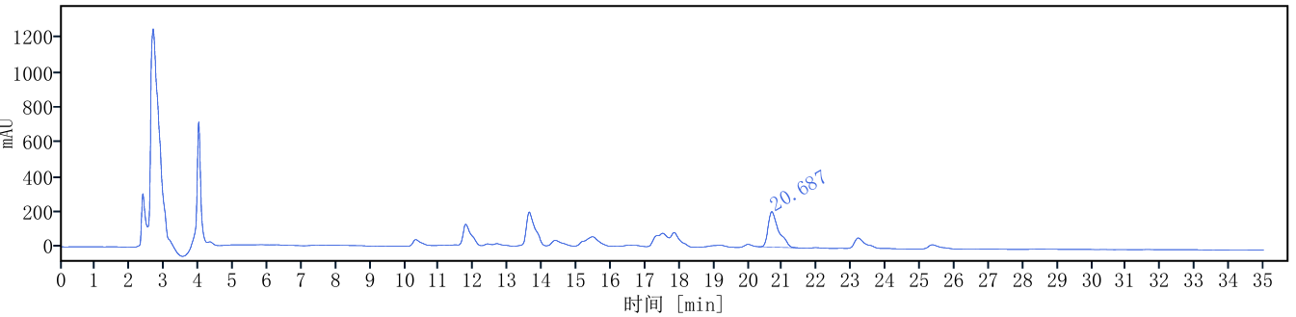
i
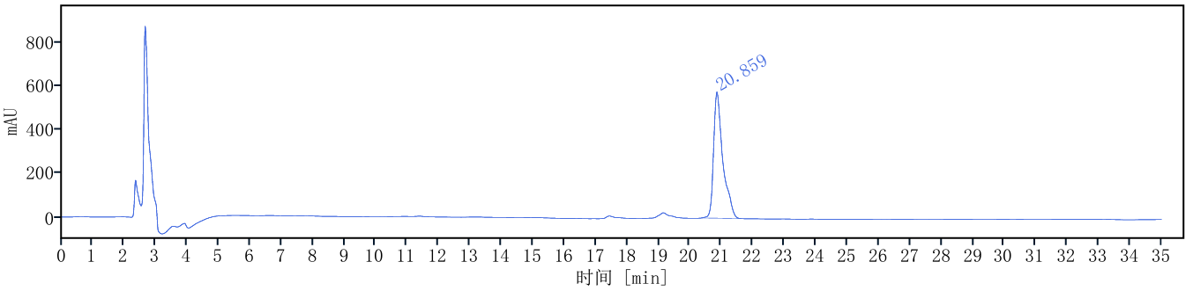
ii
Scheme S26. i) HPLC trace of reaction mixture of compound 1c. ii) HPLC trace of purified compound 1c [1 mL/min, 10% to 60% MeCN for 30 min, then 60% to 95% MeCN 30-35 min, HPLCONE 10C18A (10 μm, 4.6 x 250 mm), λ = 220 nm].
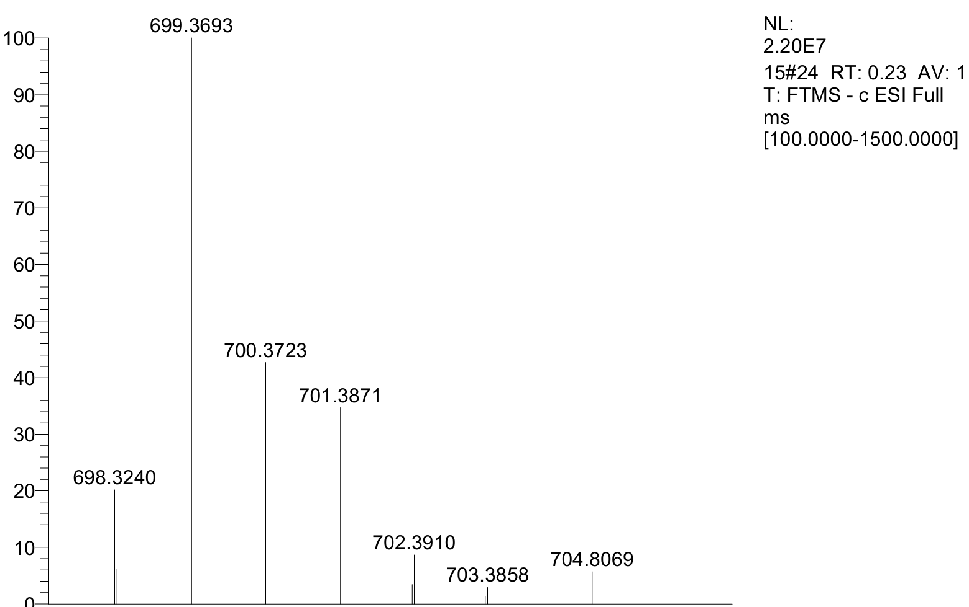
HRMS of compound 1c: Calcd for [M-H]⁻ C₃₁H₅₅N₈O₆S₂⁻: 699.3691; found: 699.3693.
Characterization of macrocyclic bioactive peptides
Compound 23a was isolated in 33% yield (3.9 mg, 0.0033 mmol) as a white powder; the HPLC yield was 41% based on absorbance at 210 nm.
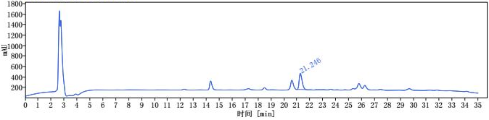
i
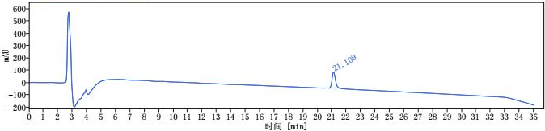
ii
Scheme S27. i) HPLC trace of reaction mixture of compound 23a. ii) HPLC trace of purified compound 23a [1 mL/min, 10% to 60% MeCN for 30 min, then 60% to 95% MeCN 30-35 min, HPLCONE 10C18A (10 μm, 4.6 x 250 mm), λ = 210 nm].
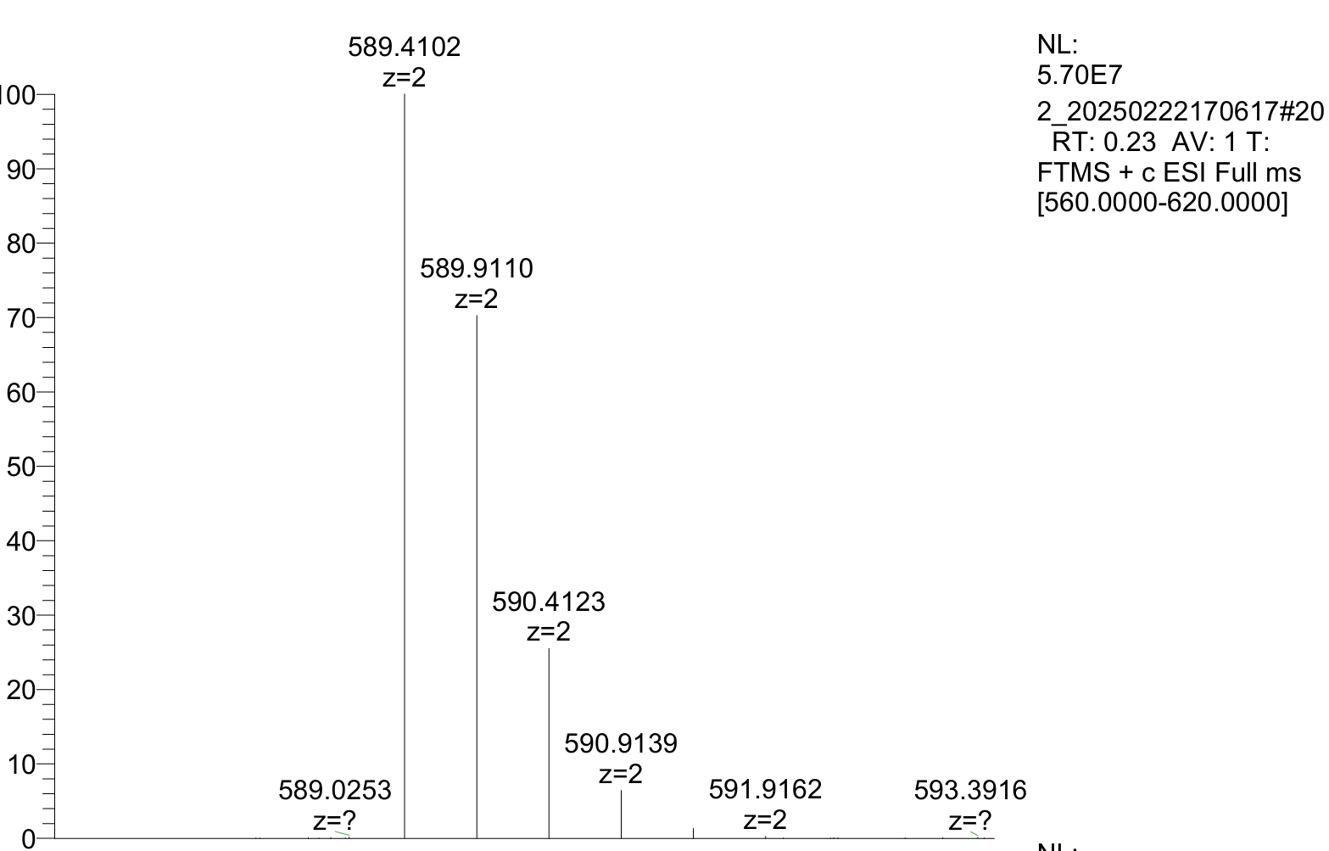
HRMS of compound 23a: Calcd for [(M+2H⁺)/2] C₅₆H₁₀₆N₁₆O₁₁²⁺: 589.4108; found: 589.4102.
Compound 23b was isolated in 57% yield (6.8 mg, 0.0057 mmol) as a white powder; the HPLC yield was 79% based on absorbance at 240 nm.
i
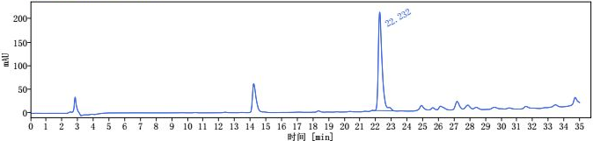
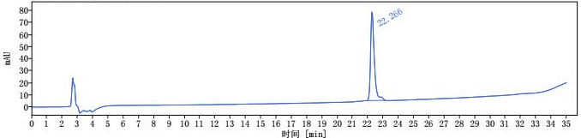
ii
Scheme S28. i) HPLC trace of reaction mixture of compound 23b. ii) HPLC trace of purified compound 23b [1 mL/min, 10% to 60% MeCN for 30 min, then 60% to 95% MeCN 30-35 min, HPLCONE 10C18A (10 μm, 4.6 x 250 mm), λ = 240 nm].
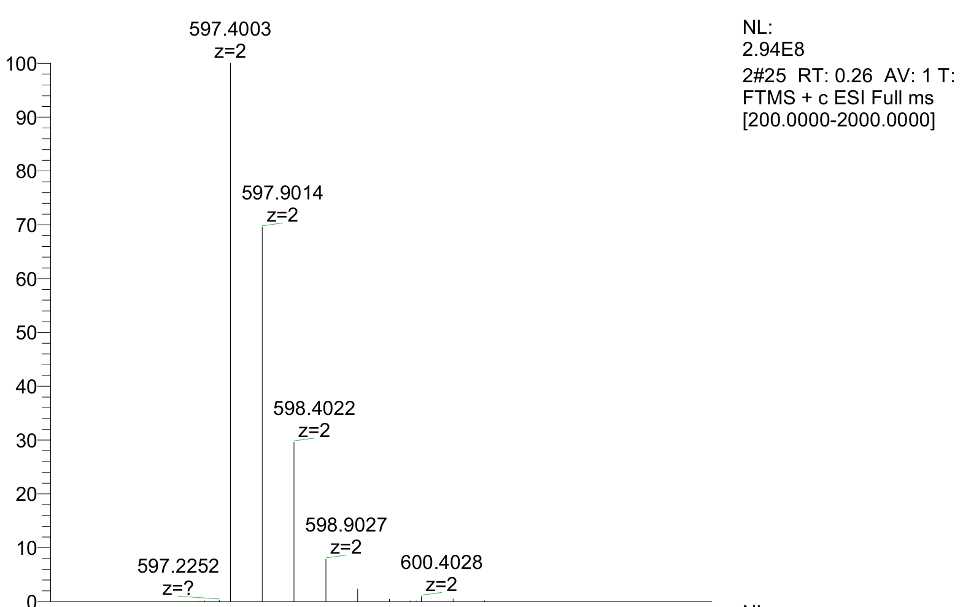
HRMS of compound 23b: Calcd for [(M+2H⁺)/2] C₅₆H₁₀₆N₁₆O₁₀S²⁺: 597.3994; found: 597.4003.
Compound 23c was isolated in 13% yield (1.7 mg, 0.0013 mmol) as a white powder; the HPLC yield was 20% based on absorbance at 220 nm.
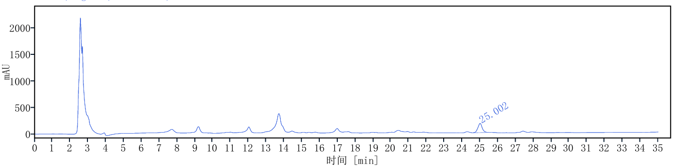
i
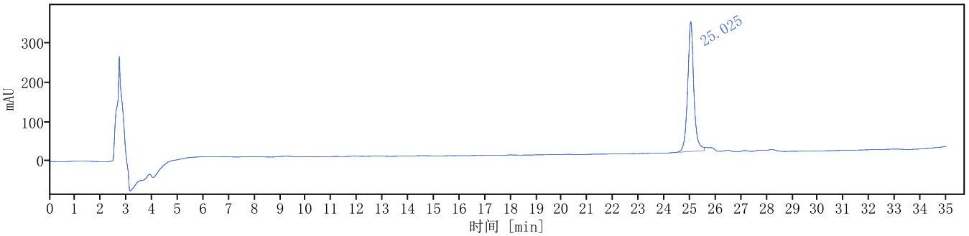
ii
Scheme S29. i) HPLC trace of reaction mixture of compound 23c. ii) HPLC trace of purified compound 23c [1 mL/min, 10% to 60% MeCN for 30 min, then 60% to 95% MeCN 30-35 min, HPLCONE 10C18A (10 μm, 4.6 x 250 mm), λ = 220 nm].
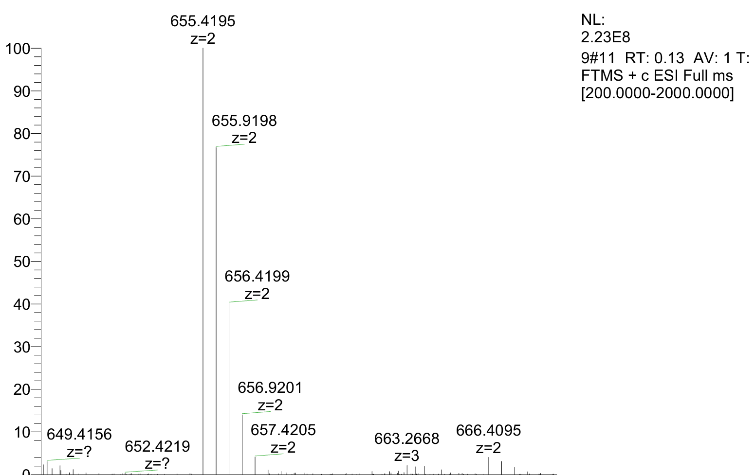
HRMS of compound 23c: Calcd for [(M+2H⁺)/2] C₆₀H₁₁₄N₁₈O₁₀S₂²⁺: 655.4198; found: 655.4195.
Compound 24a was isolated in 27% yield (4.1 mg, 0.0027 mmol) as a white powder; the HPLC yield was 32% based on absorbance at 250 nm.
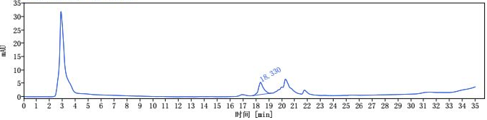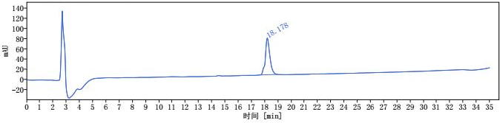
ii
i
Scheme S30. i) HPLC trace of reaction mixture of compound 24a. ii) HPLC trace of purified compound 24a [1 mL/min, 10% to 60% MeCN for 30 min, then 60% to 95% MeCN 30-35 min, HPLCONE 10C18A (10 μm, 4.6 x 250 mm), λ = 250 nm].
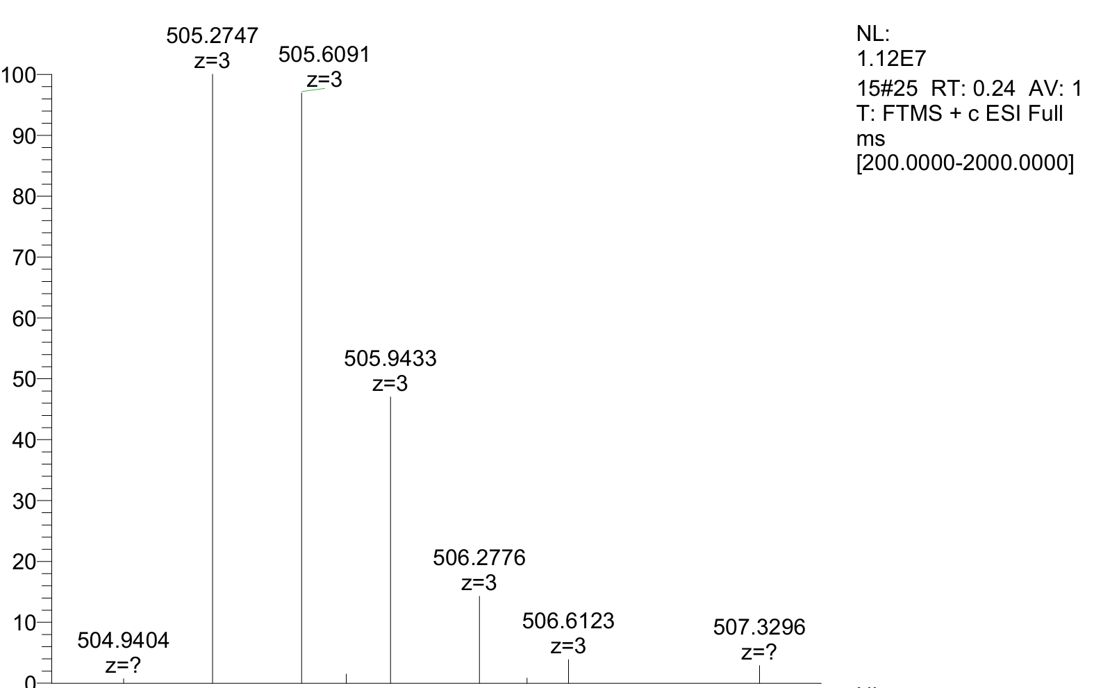
HRMS of compound 24a: Calcd for [(M+3H⁺)/3] C₇₅H₁₀₃N₂₄O₁₁³⁺: 505.2741; found: 505.2747.
Compound 24b was isolated in 45% yield (6.9 mg, 0.0045 mmol) as a white powder; the HPLC yield was 60% based on absorbance at 240 nm.
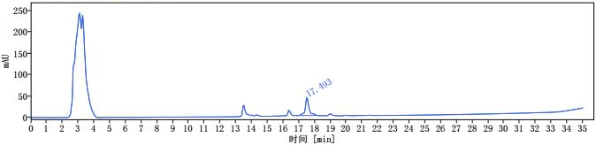
i
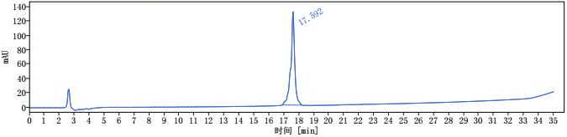
ii
Scheme S31. i) HPLC trace of reaction mixture of compound 24b. ii) HPLC trace of purified compound 24b [1 mL/min, 10% to 60% MeCN for 30 min, then 60% to 95% MeCN 30-35 min, HPLCONE 10C18A (10 μm, 4.6 x 250 mm), λ = 240 nm].
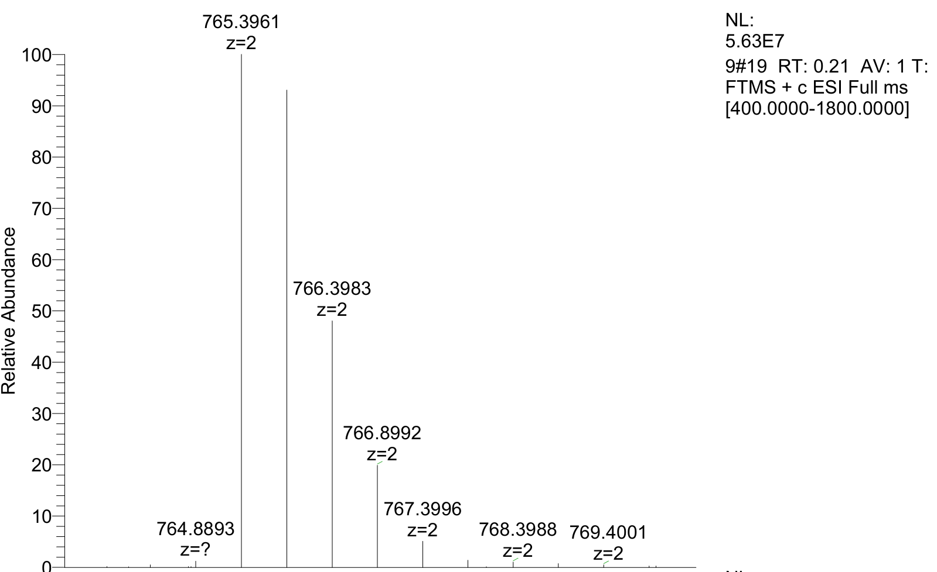
HRMS of compound 24b: Calcd for [(M+2H⁺)/2] C₇₅H₁₀₂N₂₄O₁₀S²⁺: 765.3960; found: 765.3961.
Characterization of peptide 23a
The N-terminal amino acid sequence of peptide product 23a, modified via N, N'-carbonyldiimidazole (CDI)-mediated cyclization, was analyzed using the classical Edman degradation method. As shown in the figure S1, the sequence data of the first three N-terminal amino acid residues (specifically glycine(A), leucine(B), and leucine(C)) were successfully obtained through multiple cycles of phenyl isothiocyanate (PTC) coupling, acid-catalyzed cleavage, and high-performance liquid chromatography (HPLC) identification. Comparison with the theoretical sequence revealed complete consistency in both the types and order of these amino acids. These results indicate the presence of N-terminal free amino group of 23a after the cyclization reaction. This finding indirectly confirms that the cyclized product 23a primarily underwent side chain-to-side chain lysine cyclization, rather than the cyclization between N-terminal amino and side chain lysine.
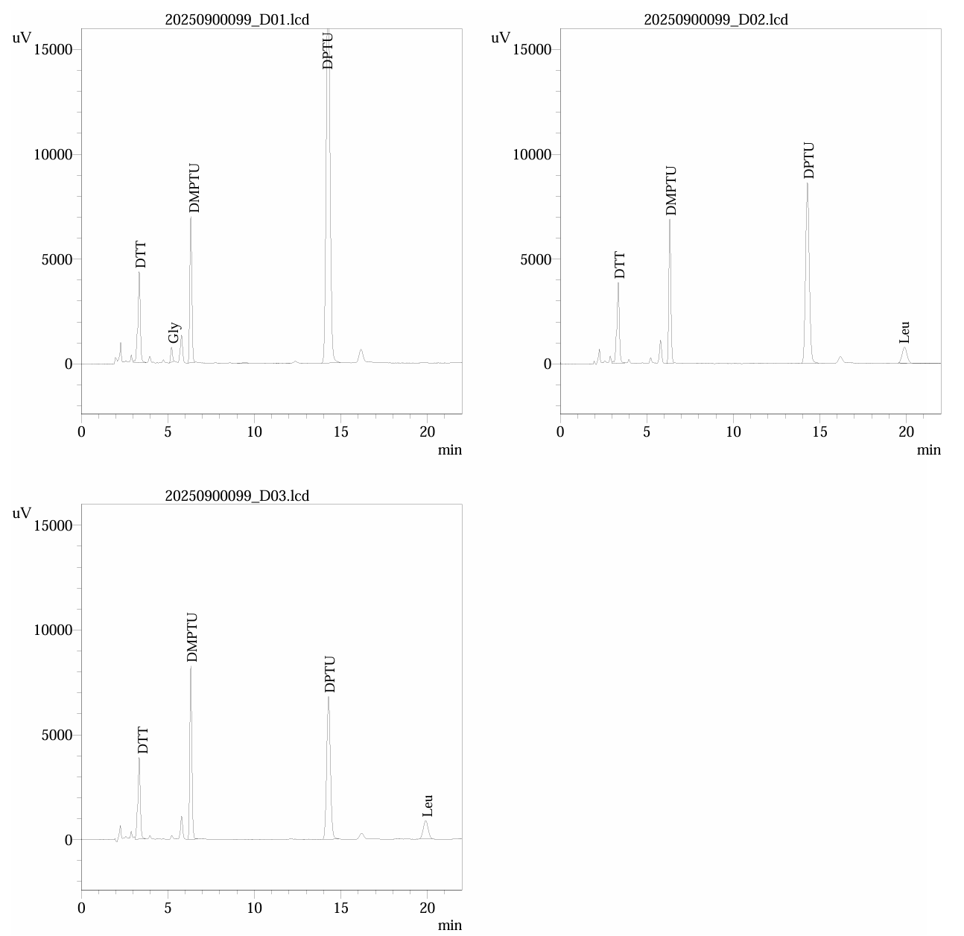
Figure S1. N-terminal sequence determination of peptide 23a by Edman degradation.
Characterization of fluorescently labeled cyclopeptides
Compound 25a was isolated in 36% yield (7.6 mg, 0.0036 mmol) as a white powder; the HPLC yield was 42% based on absorbance at 210 nm.
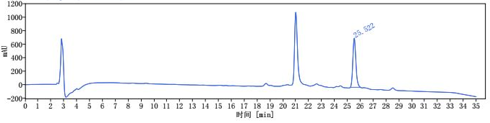
i
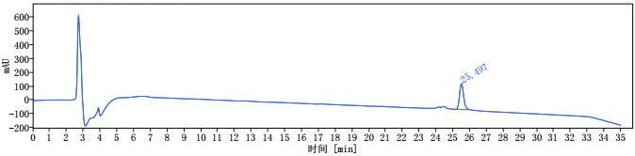
ii
Scheme S32. i) HPLC trace of reaction mixture of compound 25a. ii) HPLC trace of purified compound 25a [1 mL/min, 10% to 60% MeCN for 30 min, then 60% to 95% MeCN 30-35 min, HPLCONE 10C18A (10 μm, 4.6 x 250 mm), λ = 210 nm].
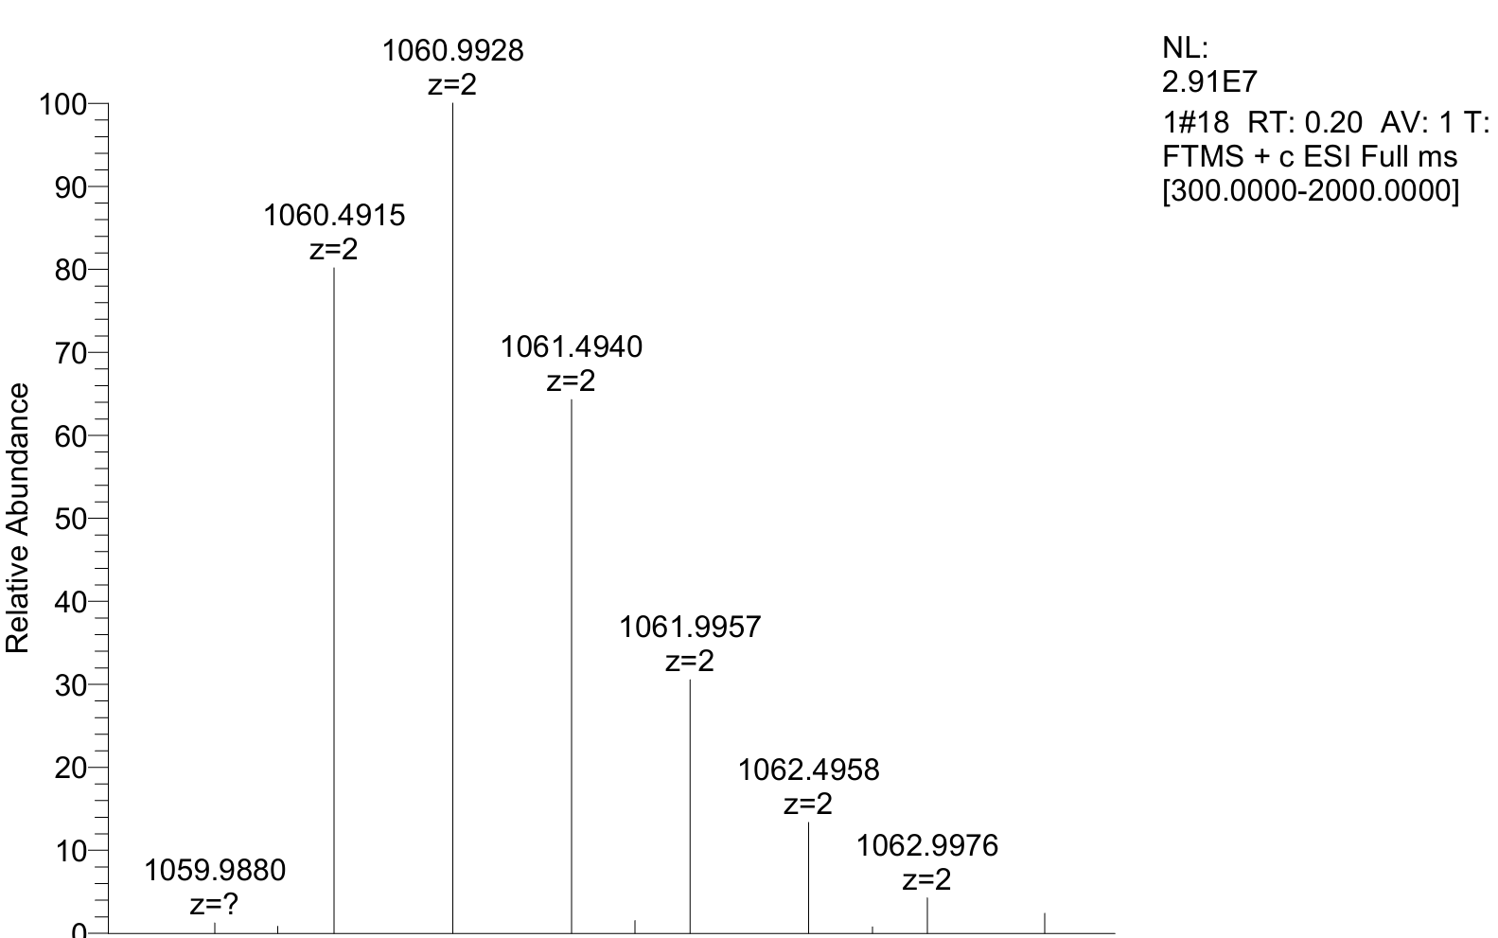
HRMS of compound 25a: Calcd for [(M+2H⁺)/2] C₁₀₅H₁₃₆N₂₂O₂₄S²⁺: 1060.9921; found: 1060.9928.
Compound 25b was isolated in 43% yield (9.2 mg, 0.0043 mmol) as a white powder; the HPLC yield was 52% based on absorbance at 220 nm.
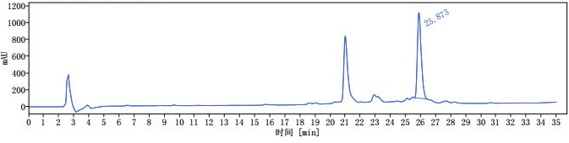
i
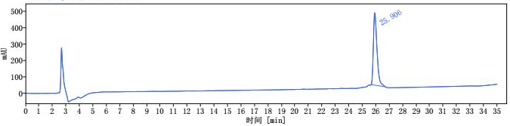
ii
Scheme S33. i) HPLC trace of reaction mixture of compound 25b. ii) HPLC trace of purified compound 25b [1 mL/min, 10% to 60% MeCN for 30 min, then 60% to 95% MeCN 30-35 min, HPLCONE 10C18A (10 μm, 4.6 x 250 mm), λ = 220 nm].
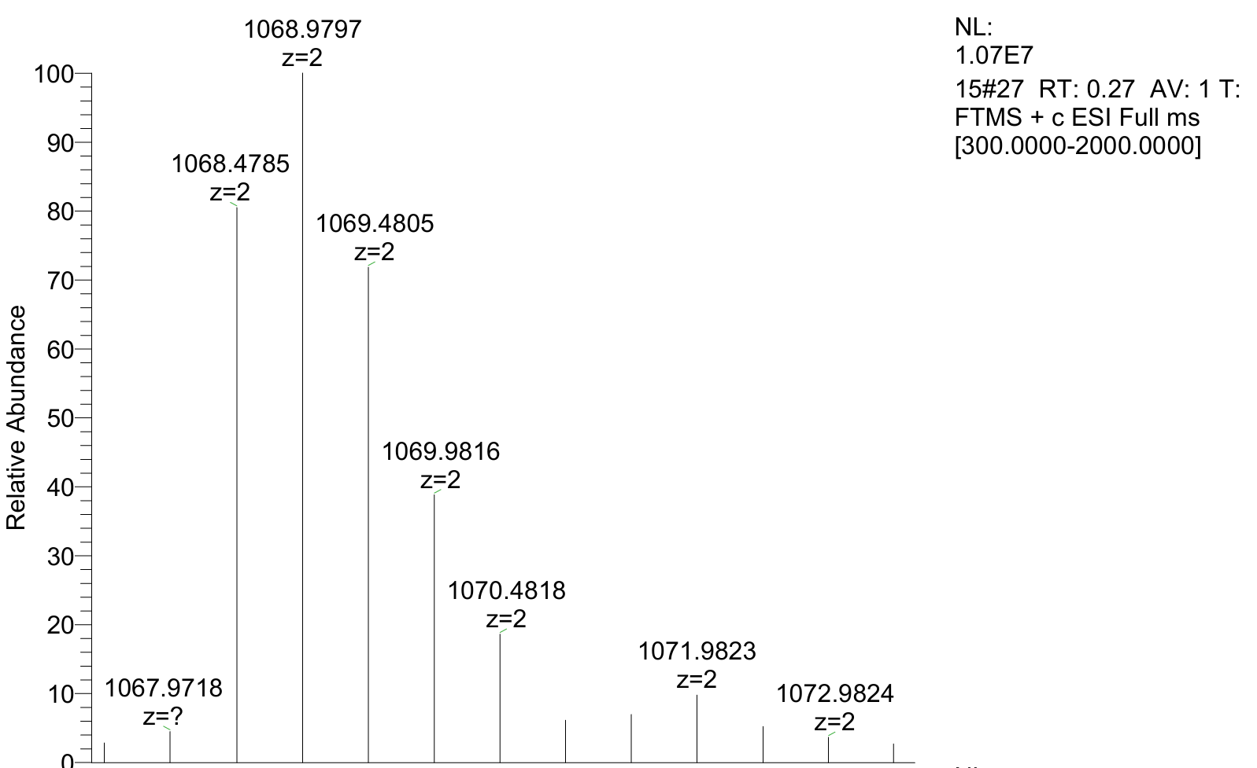
HRMS of compound 25b: Calcd for [(M+2H⁺)/2] C₁₀₅H₁₃₆N₂₂O₂₃S₂²⁺: 1068.9806; found: 1068.9797.
Compound 25c was isolated in 41% yield (9.2 mg, 0.0041 mmol) as a white powder; the HPLC yield was 57% based on absorbance at 220 nm.
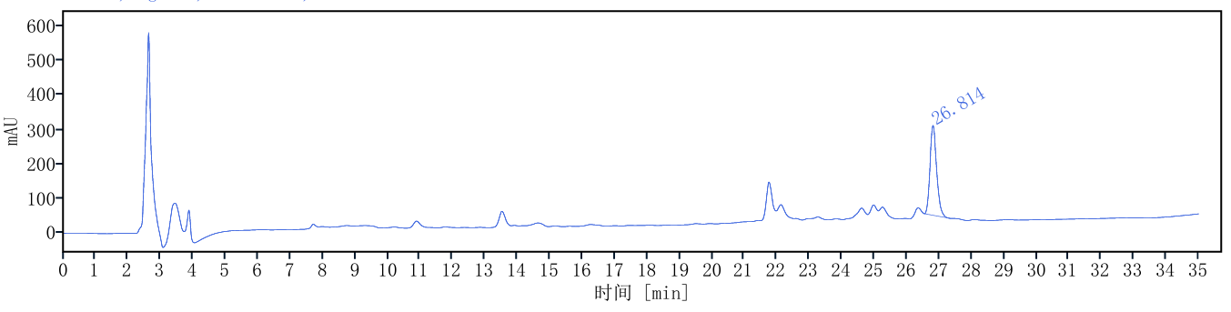
i
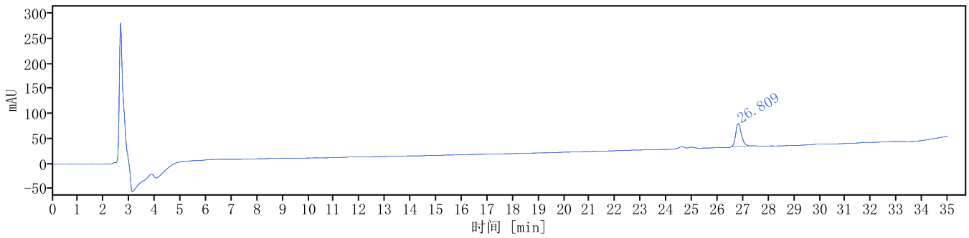
ii
Scheme S34. i) HPLC trace of reaction mixture of compound 25c. ii) HPLC trace of purified compound 25c [1 mL/min, 10% to 60% MeCN for 30 min, then 60% to 95% MeCN 30-35 min, HPLCONE 10C18A (10 μm, 4.6 x 250 mm), λ = 220 nm].
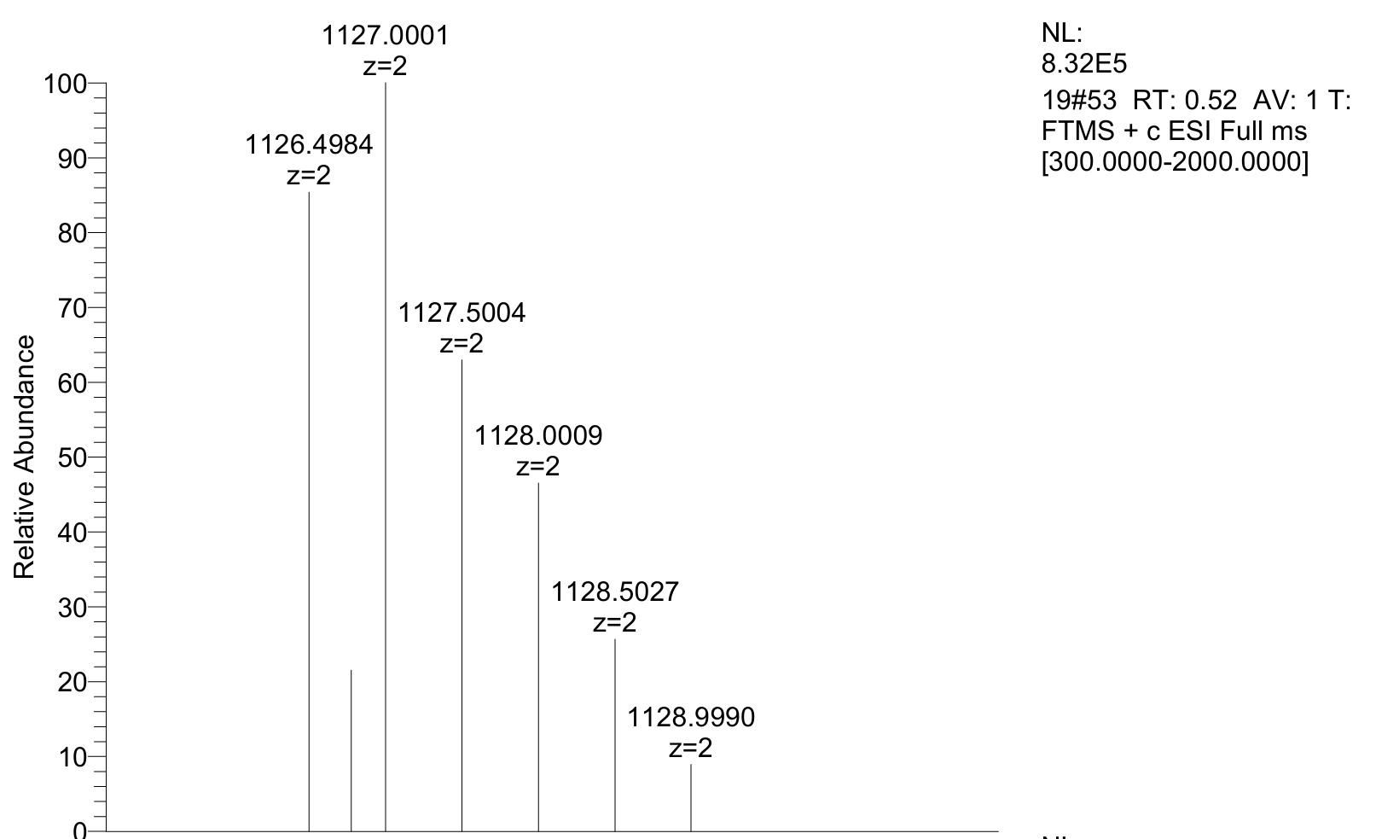
HRMS of compound 25c: Calcd for [(M+2H⁺)/2] C₁₀₉H₁₄₄N₂₄O₂₃S₃²⁺: 1127.0010 found: 1127.0001.
Evaluation of stability of cyclopeptides
Stability under oxidative conditions
A 2 mL EP tube was charged with 160 µL H₂O₂ (100 mM), 20 µL of 1.0 M Tris Buffer (pH 8.0), 20 µL of peptide (10 mM stock solution). The resulting reaction mixture was capped and incubated in 37 °C water bath for 4 hours. At each time point from 0 to 4 hours, 5 μL of the crude reaction mixture was taken, quenched with 195 μL of a 50:50 (v/v) water/acetonitrile solution, and analyzed by HPLC.
P24, t = 1 h

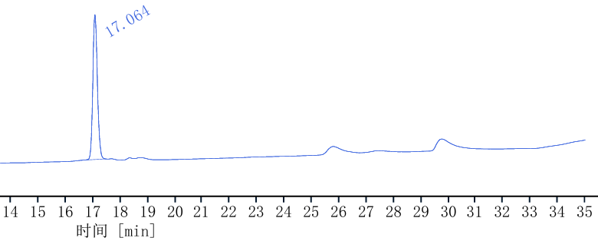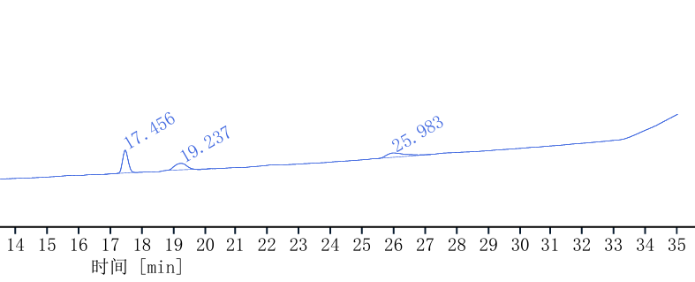
P24, t = 0 h

P24, t = 3 h

P24, t = 2 h

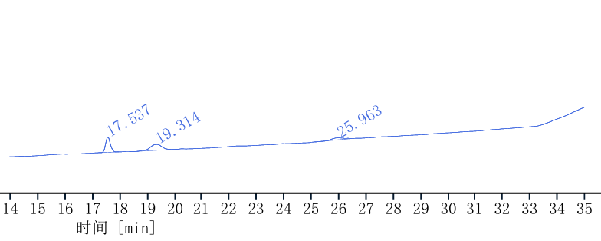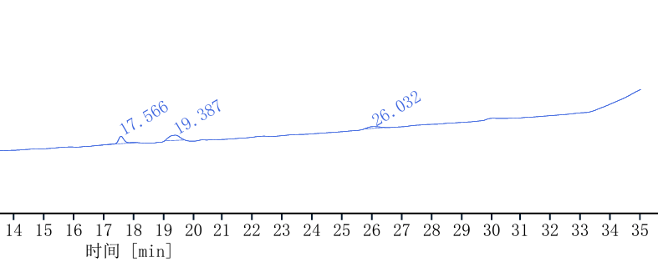
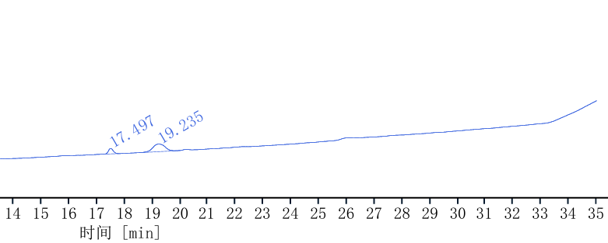
P24, t = 4 h

Figure S2. Oxidative stability of P24 assessed by HPLC over 4 hours.

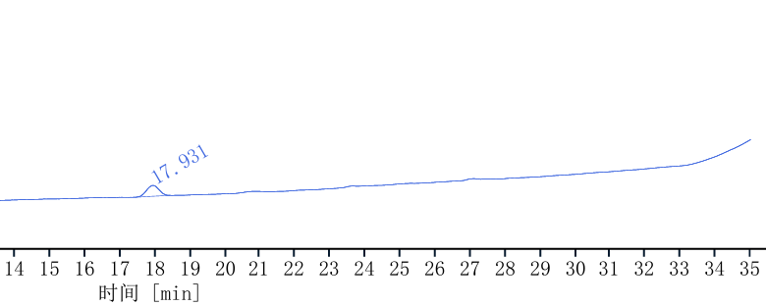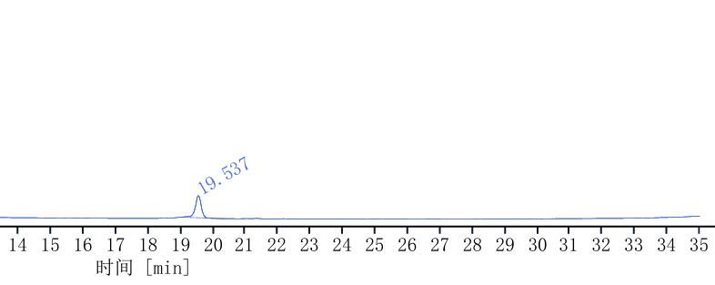
24b, t = 0 h

24a, t = 0 h

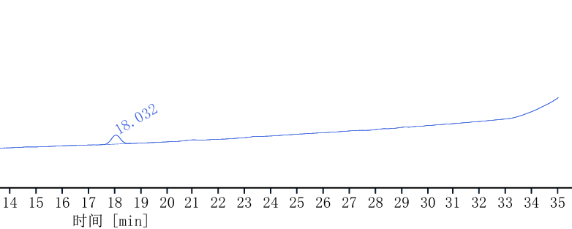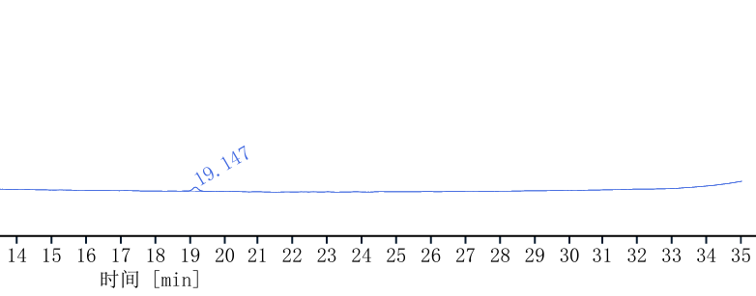
24b, t = 1 h

24a, t = 1 h

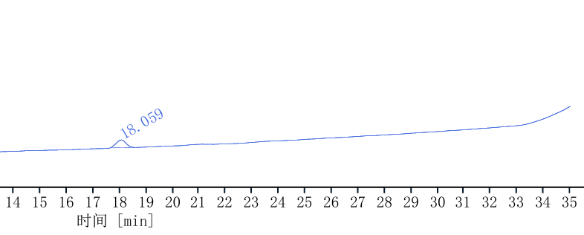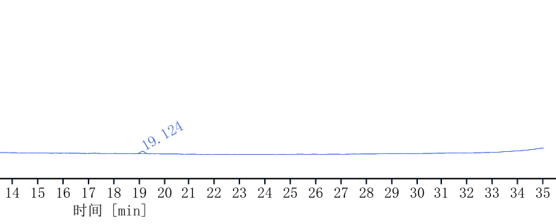
24a, t = 2 h

24b, t = 2 h h

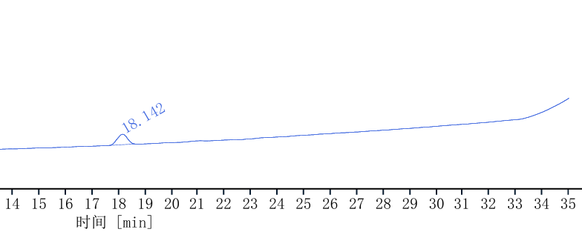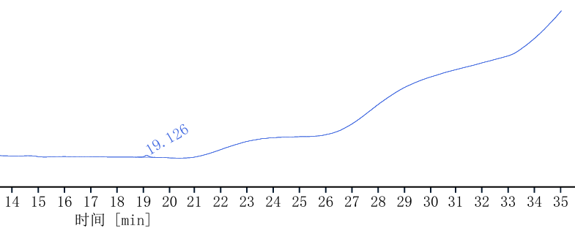
24a, t = 3 h

24b, t = 3 h

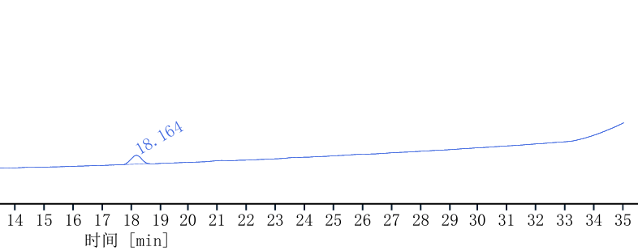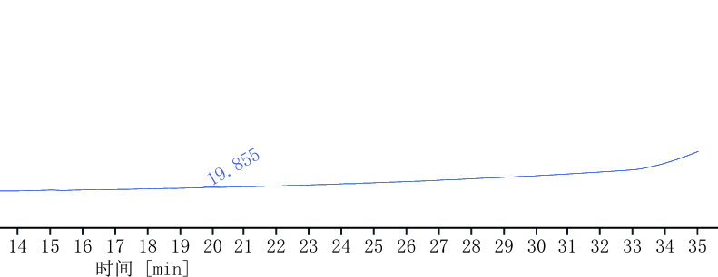
24b, t = 4 h

24a, t = 4 h

Figure S3. Oxidative stability of 24a and 24b assessed by HPLC over 4 hours.
Stability in pH 10.0 buffer conditions
A 2 mL EP tube was charged with 160 µL of deionized H₂O,40 µL of 0.05 M CAPS Buffer (pH 10.0), 20 µL of peptide (10 mM stock solution). The resulting reaction mixture was capped and incubated in 37 °C water bath for 4 hours. At each time point from 0 to 4 hours, 5 μL of the crude reaction mixture was taken, quenched with 195 μL of a 50:50 (v/v) water/acetonitrile solution, and analyzed by HPLC.
P24, t = 1 h

P24, t = 0 h

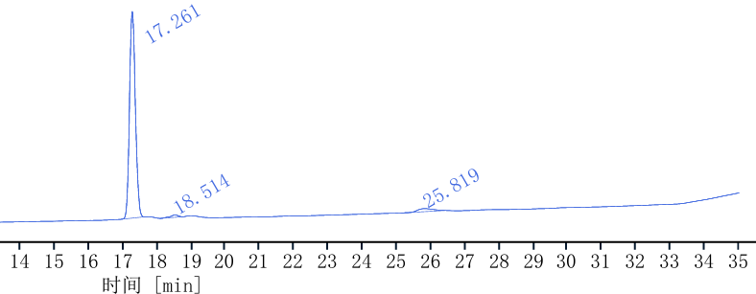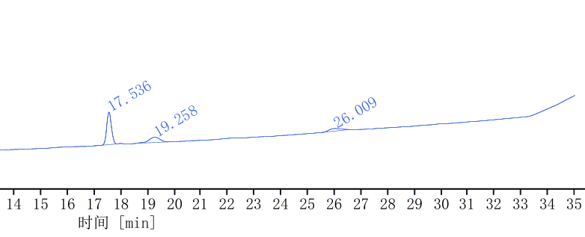
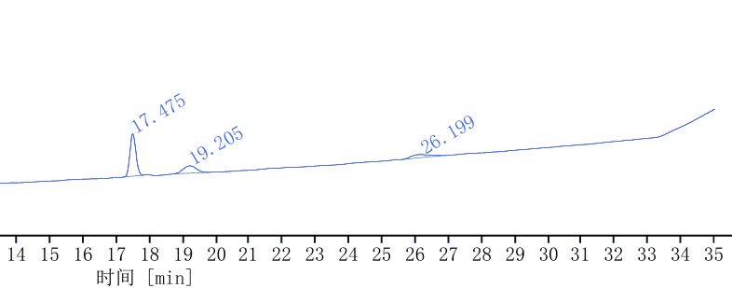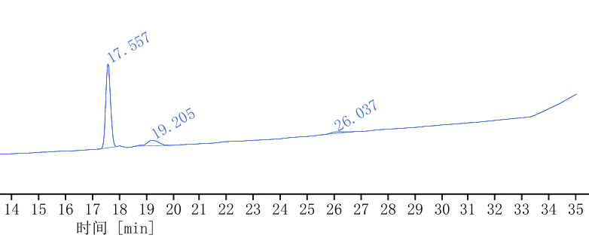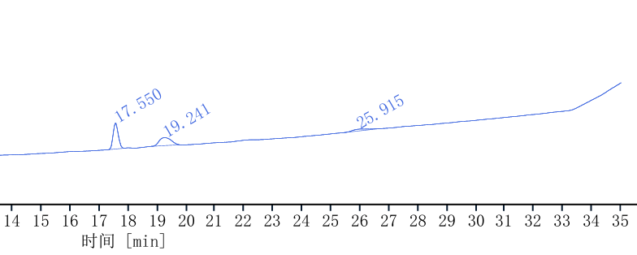
P24, t = 4 h

P24, t = 3 h

P24, t = 2 h

Figure S4. Stability of P24 in pH 10.0 buffer assessed by HPLC over 4 hours.

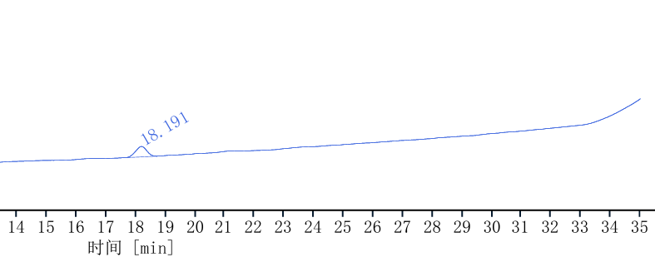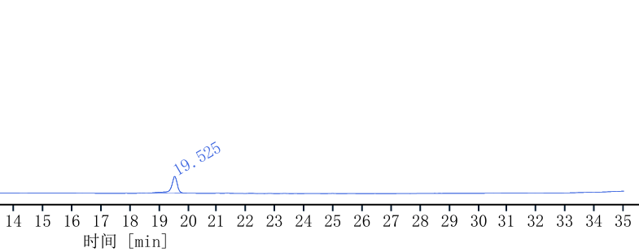
24b, t = 1 h

24b, t = 0 h

24a, t = 0 h

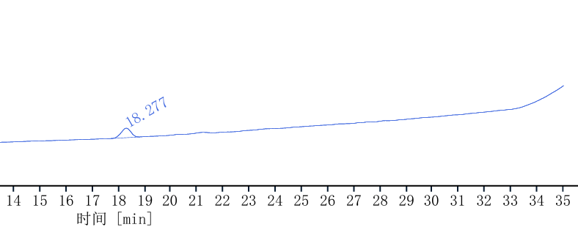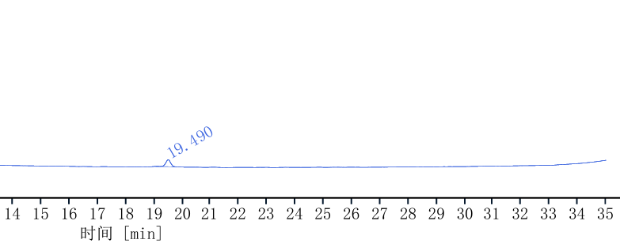
24a, t = 1 h

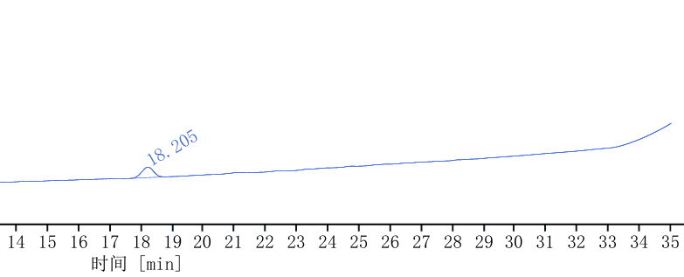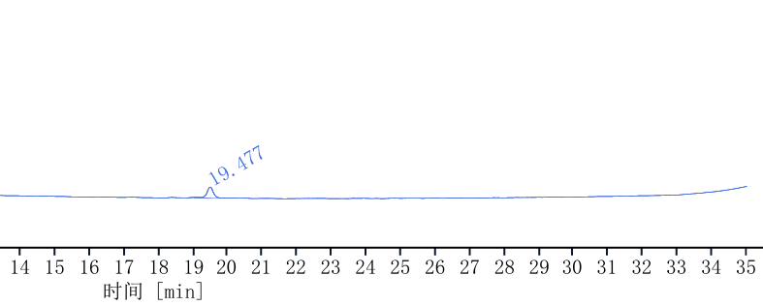
24b, t = 2 h

24a, t = 2 h

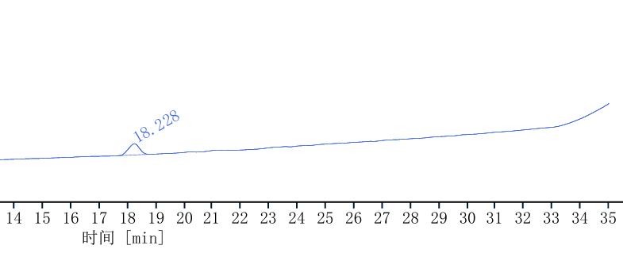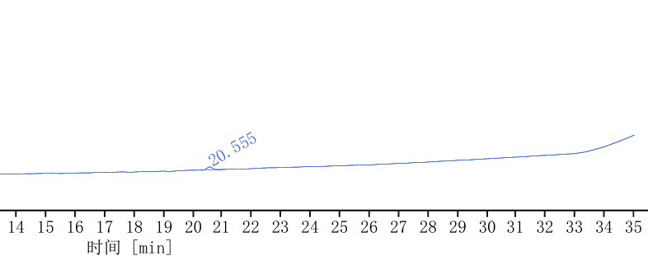
24b, t = 3 h

24a, t = 3 h

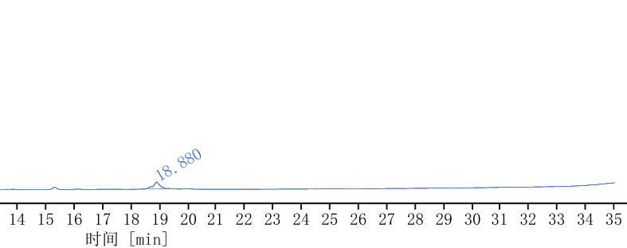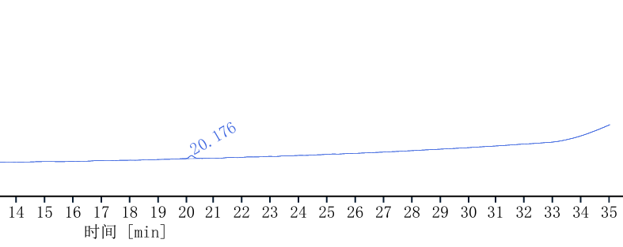
24b, t = 4 h

24a, t = 4 h

Figure S5. Stability of 24a and 24b in pH 10.0 buffer assessed by HPLC over 4 hours.
Stability under trypsin incubation
A 2 mL EP tube was charged with 196 µL of phosphate buffer pH 7.4, 2 µL of trypsin (0.05 mg/mL stock solution in phosphate buffer pH 7.4), 2 µL of peptide (10 mM stock solution). The resulting reaction mixture was capped and incubated at room temperature for 4 hours. At each time point from 0 to 4 hours, 5 μL of the crude reaction mixture was taken, quenched with 195 μL of a 50:50 (v/v) water/acetonitrile solution, and analyzed by HPLC.

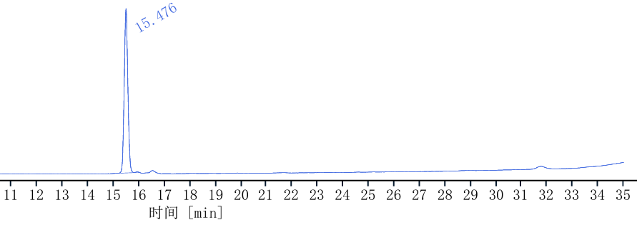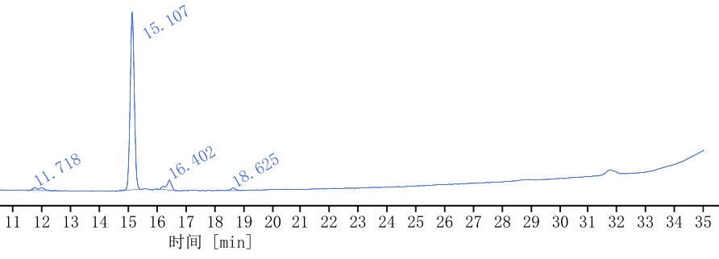
P24, t = 2 h

P24, t = 1 h

P24, t = 0 h

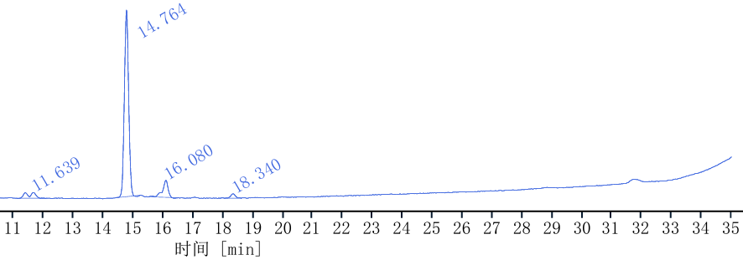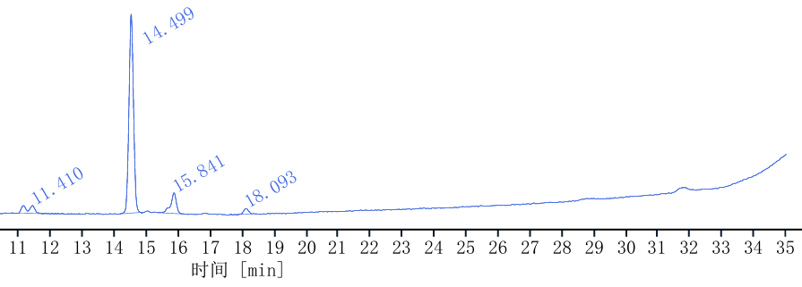
P24, t = 3 h

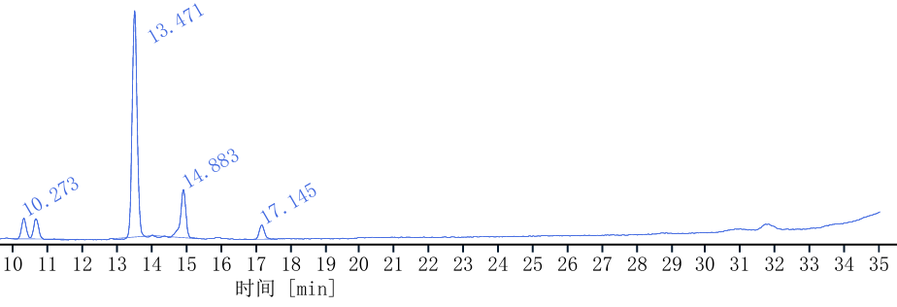
P24, t = 4 h

Figure S6. Stability of P24 during tryptic digestion assessed by HPLC over 4 hours.
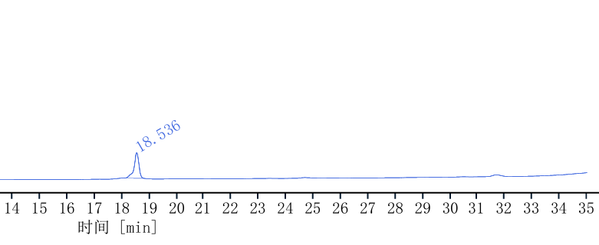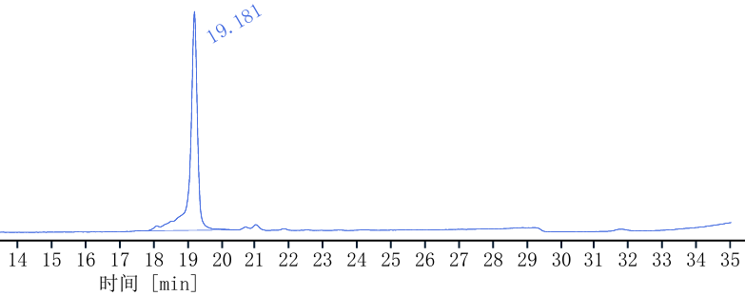
24b, t = 0 h

24a, t = 0 h

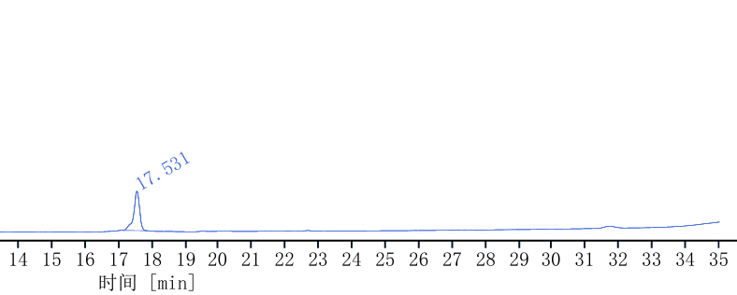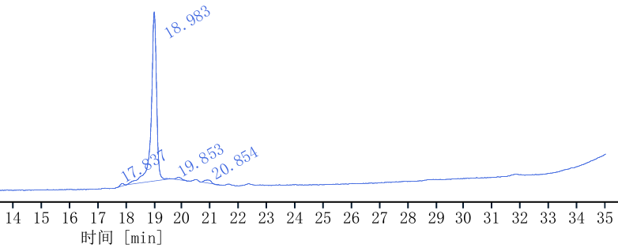
24b, t = 1 h

24a, t = 1 h

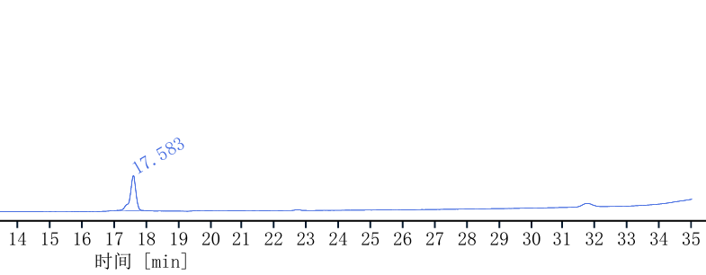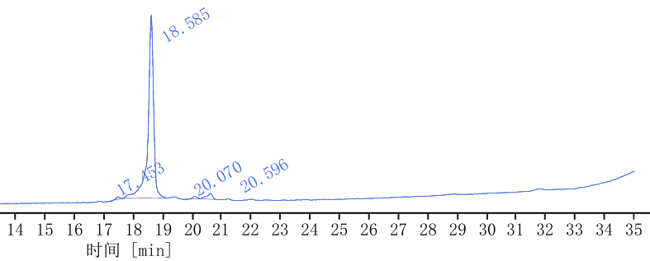
24b, t = 2 h

24a, t = 2 h

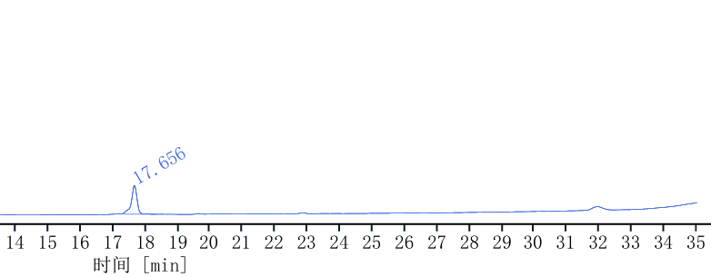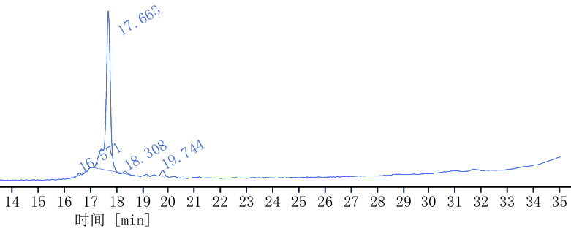
24b, t = 3 h

24a, t = 3 h

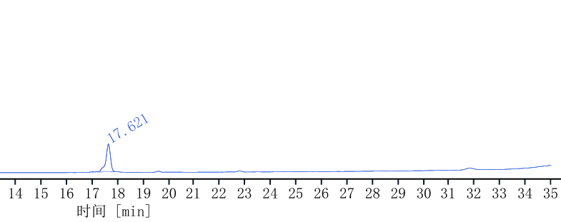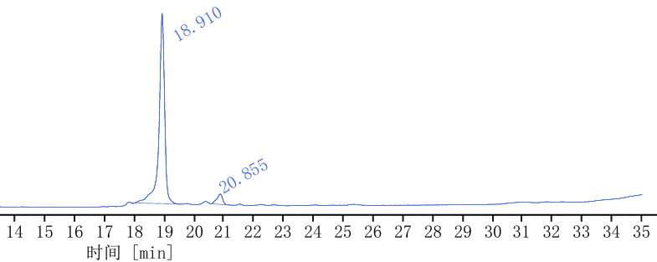
24b, t = 4 h

24a, t = 4 h

Figure S7. Stability of 24a and 24b during tryptic digestion assessed by HPLC over 4 hours.
Results of stability under H₂O_{2,} pH 10.0 buffer and trypsin incubation
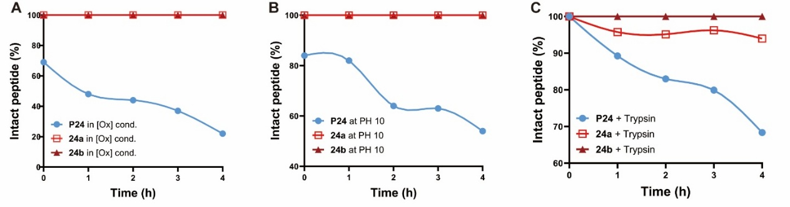
Fig. S8. Antimicrobial peptides of chemically stable macrocycles and proteolytic stability assay. A. Stability of P24, 24a, 24b at 0-4 h under H₂O₂ (80 mM); B. Stability of P24, 24a, 24b at 0-4 h in pH 10.0 buffer conditions; C. Stability of P24, 24a, 24b at 0-4 h under trypsin treatment.
Integrin binding assay
LAP(TGF-β1)-αvβ6 assay¹⁻²: Flat-bottom 96-well ELISA plates (Corning) were coated overnight at 4 °C with 100 μL/well of 0.4 μg/mL LAP(TGF-β1) (MCE) in carbonate buffer (15 mM Na₂CO₃, 35 mM NaHCO₃, pH 9.6). Each well was then washed with PBS-T buffer (PBS, 0.01% Tween 20, pH 7.4, 3 × 200 μL) and blocked for 1 h at room temperature with 150 μL/well of TSB-buffer (20 mM Tris-HCl, 150 mM NaCl, 1 mM CaCl₂, 1 mM MgCl₂, 1 mM MnCl₂, pH 7.5, 1% BSA). After being washed three times with PBS-T, equal volumes of test compounds were mixed with 1.0 μg/mL human integrin αvβ6 (MCE) giving a final dilution in TSB buffer of 0.0001–200 µM for the inhibitors and 0.5 μg/mL for integrin αvβ6. These solutions (100 μL/well) were incubated for 1 h at room temperature. The plate was washed three times with PBS-T buffer and 100 μL/well of 1:400 diluted mouse antihuman αv (Millipore) was added to the plate. After incubation for 1 h at room temperature, the plate was washed three times with PBS-T, and 100 μL/well of 4.0 μg/mL of secondary peroxidase-labeled antibody (anti-mouse IgG-POD, SigmaAldrich) was added to the plate and incubated for 1 h at room temperature. After the plate was washed three times with PBS-T, it got developed by adding 100 μL/well of TMB (Beyotime) and incubated for 1-5 min at room temperature. The reaction was stopped with 100 μL/well of 3 M H₂SO₄, and the absorbance was measured at 450 nm with a plate reader. The resulting inhibition curves were analyzed using Graphpad Prism 10.1.2 software.
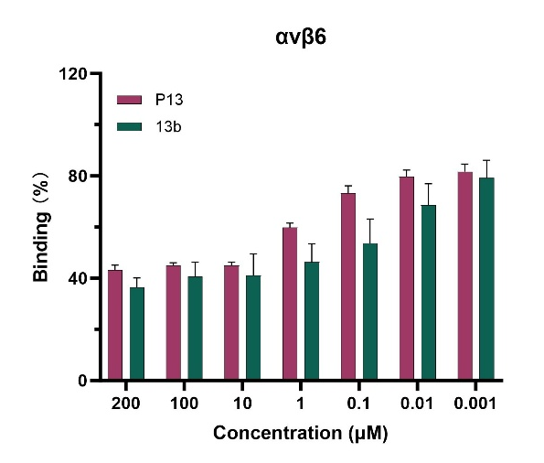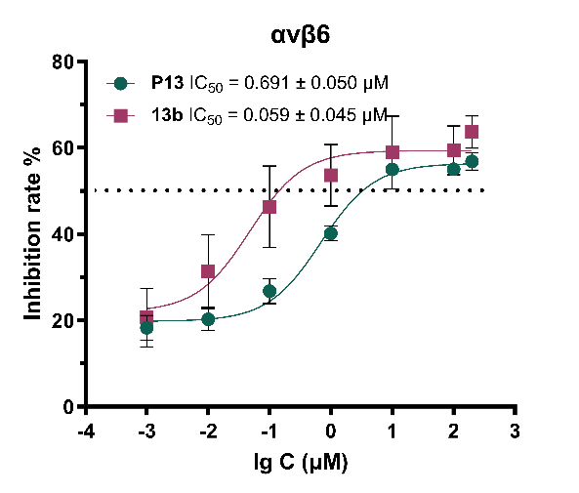
Figure S9. The integrin binding assay of P13, 13b.
The cytotoxicity of cyclopeptides on tumor cells
Cell cultures and cell viability assay:
Cell culture methodology
Cell Line and Culture Conditions: The human non-small cell lung cancer cell line (A549-luc), the human colorectal adenocarcinoma cell line (Caco-2) and the human kidney cancer cell line (A498) were obtained from the Cell Bank of Guangzhou Suyan Biotechnology Co., Ltd. (Guangzhou, China). The A549-luc and the Caco-2 were cultured in Roswell Park Memorial Institute (RPMI-1640) medium. The A498 was cultured in Minimum Essential Medium (MEM). The medium was supplemented with 10% fetal bovine serum (FBS), 100 units/ mL of penicillin-streptomycin, and incubated at 37 °C in a humidified atmosphere containing 5% CO₂.
General procedures for cell inhibitory assay:
The cell viability was determined by CCK-8 assay. Generally, cells (5000-8000/well) in the above-stated medium containing 10% FBS were cultured in a 96-well plate in a humidified atmosphere of 5% CO₂ at 37 °C for 24 h. Peptide was then added and diluted to final concentrations and incubated for 24 h. Then, 10 µL CCK-8 reagent added per well and incubated for another 1-4 h at 37°C. Next, the absorbance at 450 nm was measured by a microplate reader. The cell survival rate was calculated with the following formula ³:
$$Cell Viability\left(\%\right)=\frac{A_{s}-A_{b}}{A_{c}-A_{b}}×100\%$$
A_{s}: Absorbance of peptide-treated cells; A_{c}: Absorbance of control cells (no peptide); A_{b}: Absorbance of blank (medium)
Results of data processing
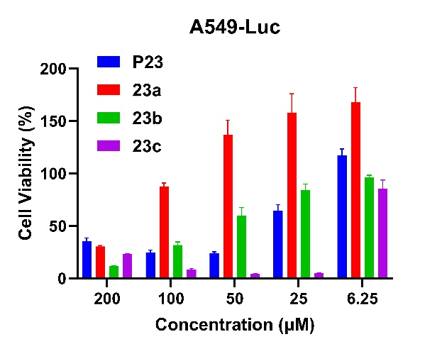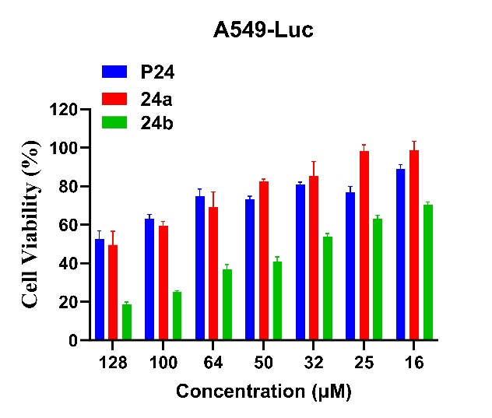
B
A
Figure S10. A. The A549-Luc cell viability assay of P23, 23a, 23b, 23c; B. The A549-Luc cell viability assay of P24, 24a, 24b.
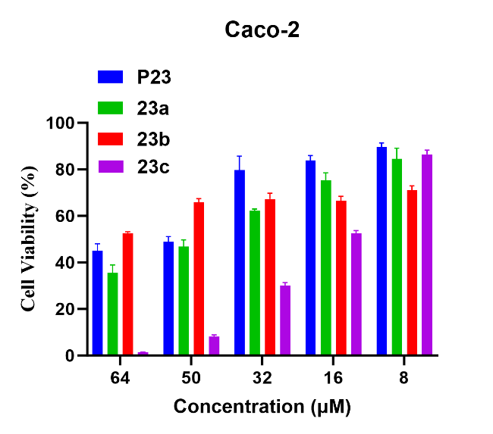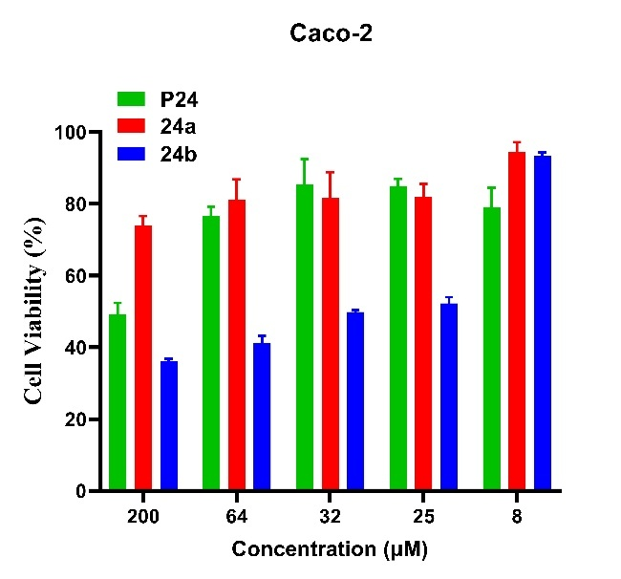
B
A
Figure S11. A. The Caco-2 cell viability assay of P23, 23a, 23b, 23c; B. The Caco-2 cell viability assay of P24, 24a, 24b.
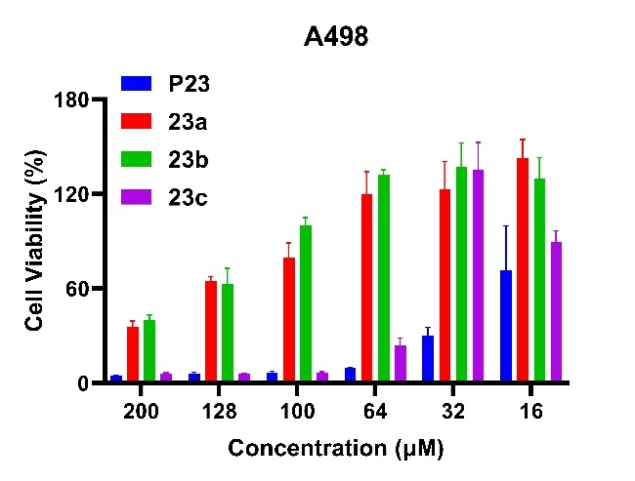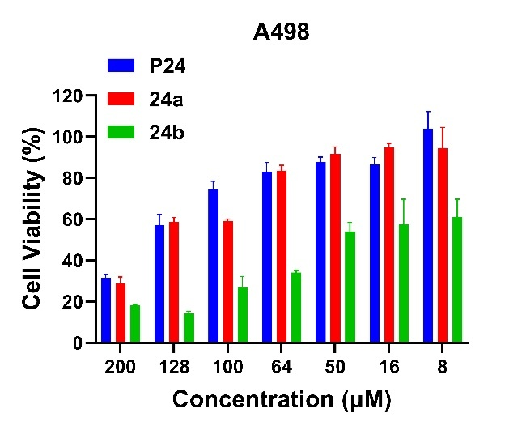
A
B
Figure S12. A. The A498 cell viability assay of P23, 23a, 23b, 23c; B. The A498 cell viability assay of P24, 24a, 24b.
MTT assay for cyclic peptides safety evaluation
General procedures for cyclic peptides safety evaluation
The cell viability was determined using MTT assay. Generally, cells (5000-10000/well) in the above-stated medium containing 10% FBS were cultured in a 96-well plate in a humidified atmosphere of 5% CO₂ at 37 °C for 24 h. Peptide was then added and diluted to final concentrations and incubated for 24 h. Then, 30 µL MTT solution (final concentration: 0.5 mg/mL) added per well and incubated for at 37°C in the dark for 3 hours to form purple formazan crystals. Next, carefully remove the supernatant and add 100 μL of DMSO each well. Shake the plate at low speed for 10–15 minutes to fully dissolve the crystals. Last, the absorbance at 570 nm was measured by a microplate reader. The cell survival rate was calculated with the following formula:
$$Cell Viability\left(\%\right)=\frac{A_{s}-A_{b}}{A_{c}-A_{b}}×100\%$$
A_{s}: Absorbance of peptide-treated cells; A_{c}: Absorbance of control cells (no peptide); A_{b}: Absorbance of blank (medium)
Results of data processing
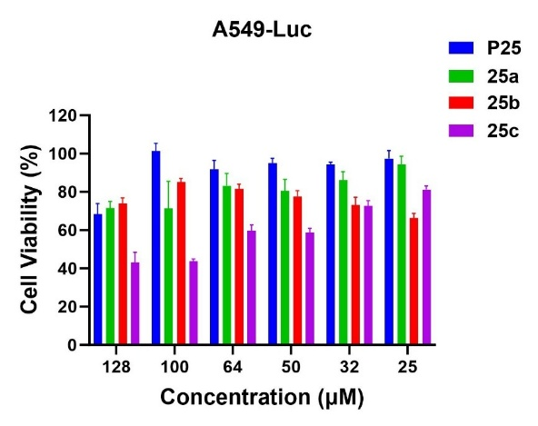
Figure S13. The A549-Luc cell viability assay of P25, 25a, 25b, 25c.
Flow cytometry of A549-Luc cell
A549-Luc cells were seeded in triplicate in 6-well plates at a density of 1.5×10⁶ cells/well and cultured to 90% confluence in RPMI-1640 medium supplemented with 10% fetal bovine serum. Peptides P25, 25a, 25b, 25c (dissolved in RPMI-1640 medium containing 0.1% DMSO via 5-minute sonication) were administered at a final concentration of 50 μM (1 mL/well). After 2, 4, 6, 8, 10 hours of incubation, the supernatant was aspirated, and cells were trypsinized with 0.25% trypsin-EDTA for 2 minutes at 37 °C under 5% CO₂. Detached cells were collected, centrifuged at 1000 rpm for 3 minutes at room temperature, washed three times with pre-warmed PBS, resuspended in 1 mL PBS, and filtered through a 40 μm nylon mesh. Flow cytometry analysis was performed on a BD LSRII system (excitation wavelength: 488 nm, detection channel: FITC) with 10,000 events acquired per sample. Data were analyzed using FlowJo v10.8.1^{4.}
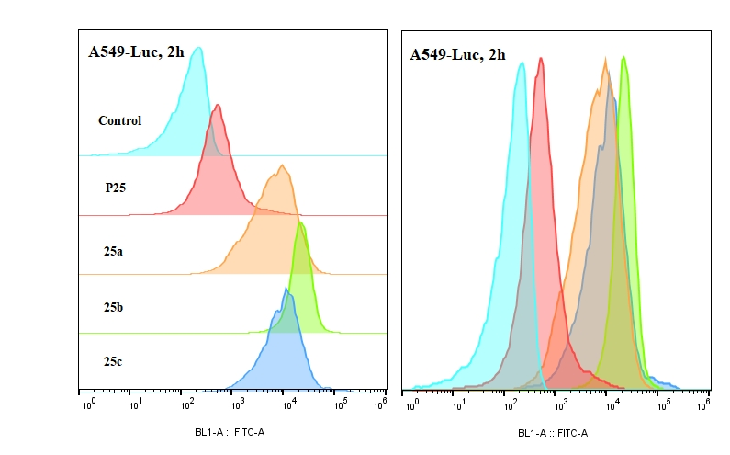
Figure S14. A549-Luc cell - Flowjo data obtained from the experiment with 50 μM peptide solution for 2 h.
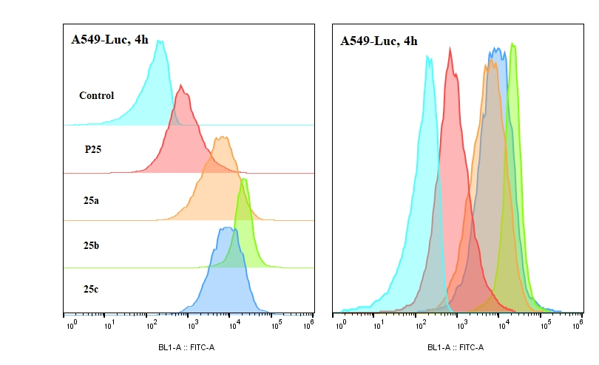
Figure S15. A549-Luc cell - Flowjo data obtained from the experiment with 50 μM peptide solution for 4 h.
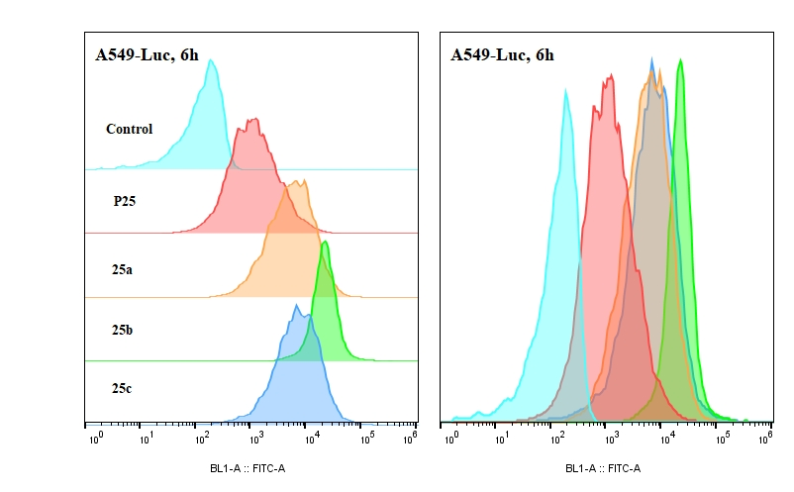
Figure S16. A549-Luc cell - Flowjo data obtained from the experiment with 50 μM peptide solution for 6 h.
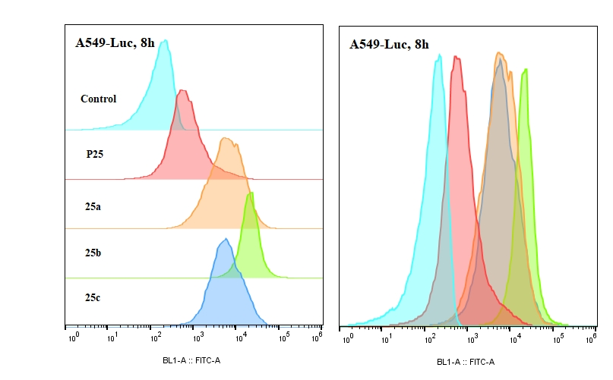
Figure S17. A549-Luc cell - Flowjo data obtained from the experiment with 50 μM peptide solution for 8 h.
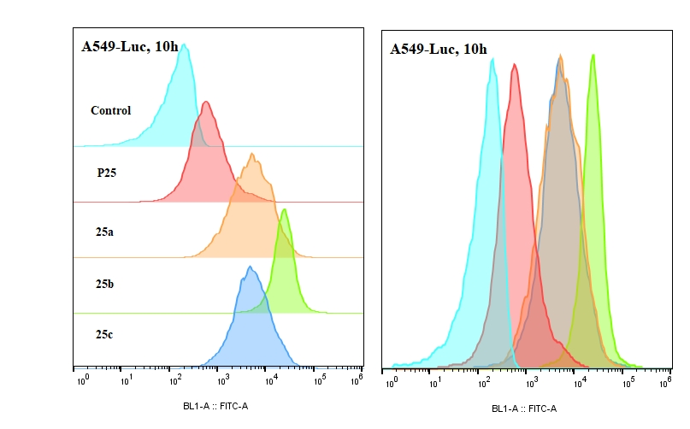
Figure S18. A549-Luc cell - Flowjo data obtained from the experiment with 50 μM peptide solution for 10 h.
Cellular uptake experiment
A549-Luc cells were seeded into confocal-specific glass-bottom dishes at a density of 100000 cells/well and cultured to 70-90% confluency. FITC-labeled peptides P25, 25a, 25b, 25c (dissolved in RPMI-1640 medium containing 0.1% DMSO via 5-minute sonication) were added to the cells and incubated at 37°C, 5% CO₂ for 6 hours. After incubation, the cells were fixed with 4% paraformaldehyde (PFA) for 10-15 minutes and washed twice with PBS. Subsequently, Hoechst 33258 (1-5 μg/mL) was added to stain nuclei, followed by a 20-minute incubation and two additional PBS washes. Finally, imaging was performed using a laser scanning confocal microscope equipped with a 63× oil-immersion objective⁵.
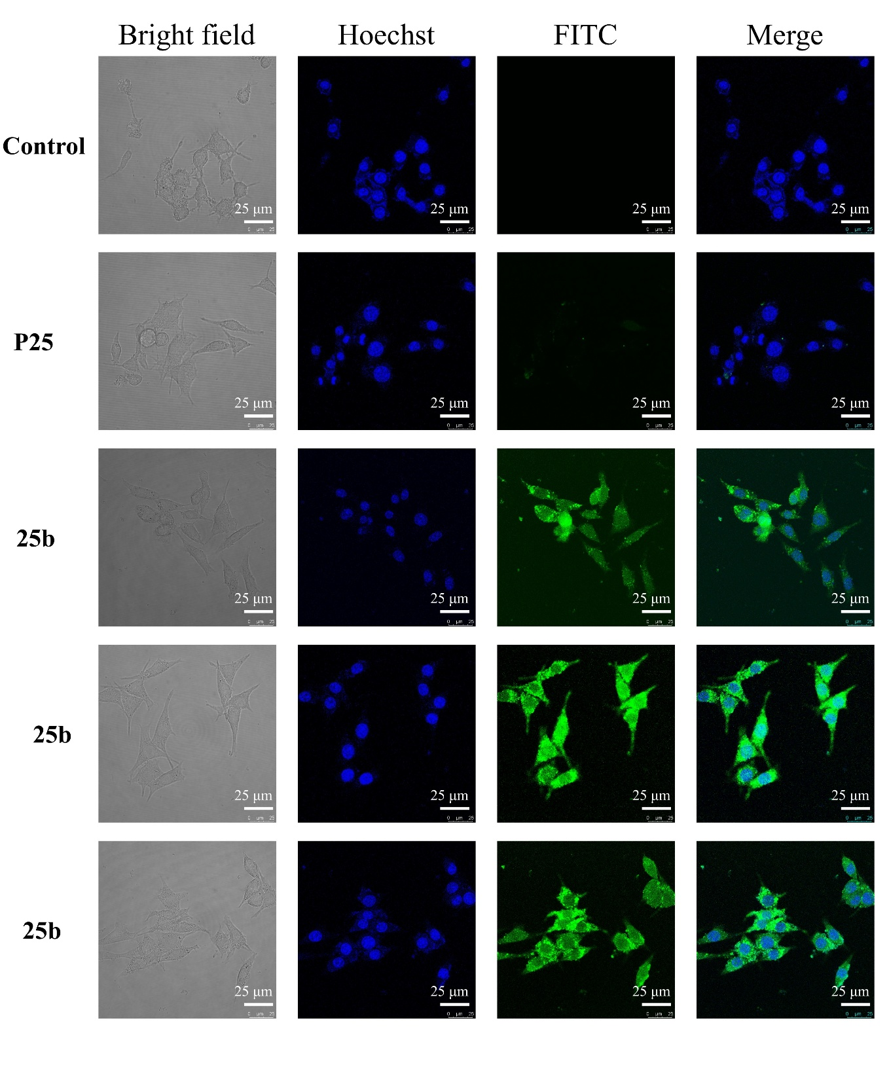
Figure S19. Confocal microscopy images of A549-Luc cells treated with 50 μM FITC-labeled peptides. Blue colour: membrane; green colour: FITC labeled peptides. Scale bar: 25 μm.
Cell apoptosis analysis.
A549-Luc and Caco-2 cells, cultured during the logarithmic growth phase, were plated into six-well plates at a seeding density of 1.5 × 10⁵ cells per well and incubated for 24 h. Thereafter, 23c was introduced to achieve drug concentrations of 0, 20 μM, 50 μM, and 70 μM for A549-Luc and 0, 20, 35, 60 μM for Caco-2 cells. Following a 48 h treatment period, the cells were centrifuged at 1000 rpm for 3 min and washed three times with cold PBS buffer. The cell apoptosis analysis was carried out using an Annexin V-FITC cell apoptosis kit. According to the manufacturer’s procedure, resuspend cells in 500 μL of 1× Binding Buffer and adjust the cell concentration to 1×10⁶ cells/mL. Prepare flow cytometry tubes labeled as blank control, single-positive controls (for compensation), and experimental samples. Add 500 μL of the filtered cell suspension (passed through a 200-mesh strainer) to each tube. For single-positive controls, add either 5 μL of Annexin V-Alexa Fluor™488 or 10 μL of propidium iodide (PI) to their respective tubes and mix gently. For sample tubes, first add 5 μL of Annexin V-FITC followed by 10 μL of PI, mixing gently after each addition. Incubate all tubes at room temperature in the dark for 10-20 minutes, then add 500 μL of 1× Binding Buffer and place on ice before flow cytometry analysis. The instrument settings should be configured as follows: Alexa Fluor™488 detection at 488 nm excitation with 530/30 nm emission collection, and PI detection at 561 nm excitation with 610/20 nm emission collection⁶.
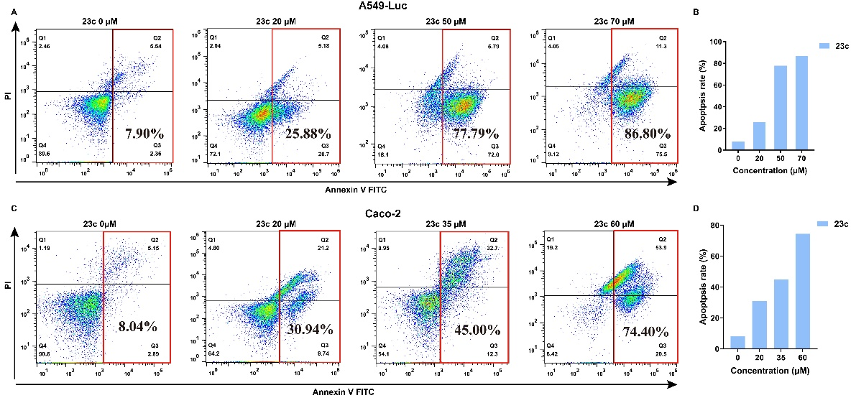
Figure S20. Flow cytometry analysis of cell apoptosis in A549-Luc and Caco-2 cells in the presence of 23c
Network pharmacology
Construction of protein interaction networks and screening of targets
The chemical structure of Anoplin was drawn using ChemDraw software to obtain their detailed structural representations. Obtain the targets of Anoplin using Anoplin’s SDF file or SMILES in SwissTargetPrediction (https://www.swisstargetprediction.ch/), Targetnet (https://targetnet.scbdd.com/), SEA (https://sea.bkslab.org/) and CHEMBL (https://www.ebi.ac.uk/chembl/). The obtained targets were translated into gene names through the UniProt database (https://www. uniprot.org/). The analysis was performed by limiting the species to “Homo sapiens”. Finally, the obtained target genes were combined and de-duplicated. The results were the potential targets of Anoplin.
The “non-small cell lung cancer (NSCLC)” keyword was used in the search keywords, and the organism “Homo sapiens” was chosen. This information was entered into four databases, the GeneCards database, the Online Mendelian Inheritance in Man (OMIM) database, the Disgenet database and the National Center for Biotechnology Information (NCBI) database in order to find NSCLC -related targets. The illness targets of this investigation were combined, and duplicate genes were removed. Using the Venny, we next combined the disease targets with the medication targets to identify the possible targets of Anoplin against NSCLC. The protein-protein interaction network data generated from the STRING database was imported into the Cytoscape software (version 3.7.1) for visualization and subsequent analysis. Network topology analysis was then performed using the built-in plugin, cytoNCA. The analysis parameters were set to include seven key centrality metrics: Degree Centrality (DC), Betweenness Centrality (BC), Closeness Centrality (CC), Eigenvector Centrality (EC), Local Average Connectivity based method (LAC) and Network Centrality (NC). The plugin calculated and generated a dataset containing all nodes and their corresponding centrality values. To identify hub nodes within the network, a multi-tiered screening strategy based on median values was employed: for each centrality metric, nodes with values not less than the median of that specific metric were independently selected. Finally, the intersection of these subsets was taken, yielding 21 key nodes that consistently exhibited prominence across multiple topological metrics⁷⁻⁸.
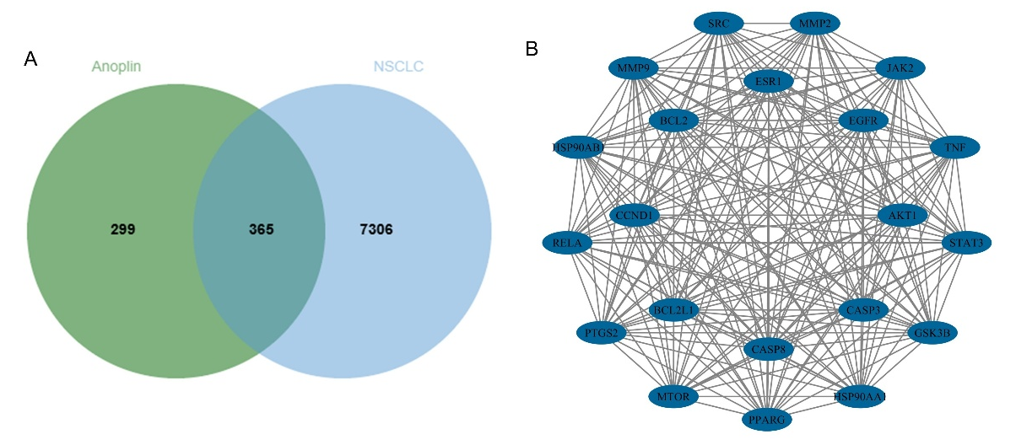
Figure S21. Venny and PPI network. A.Venny diagram showing the common part of Anoplin and NSCLC. B. PPI network of potential targets for Anoplin therapy of NSCLC.
Gene function and pathway enrichment analysis of target proteins
To investigate the biological function of potential targets of Anoplin and NSCLC, data were collected using the Metascape database for GO analysis and KEGG pathway enrichment analysis. We performed GO analysis including assessment of biological processes (BP), cellular components (CC) and molecular functions (MF) to elucidate their main biological functions. In addition, KEGG enrichment analysis was performed to identify important pathways associated with potential targets of NSCLC and to identify the major pathways that gained access to the targets.

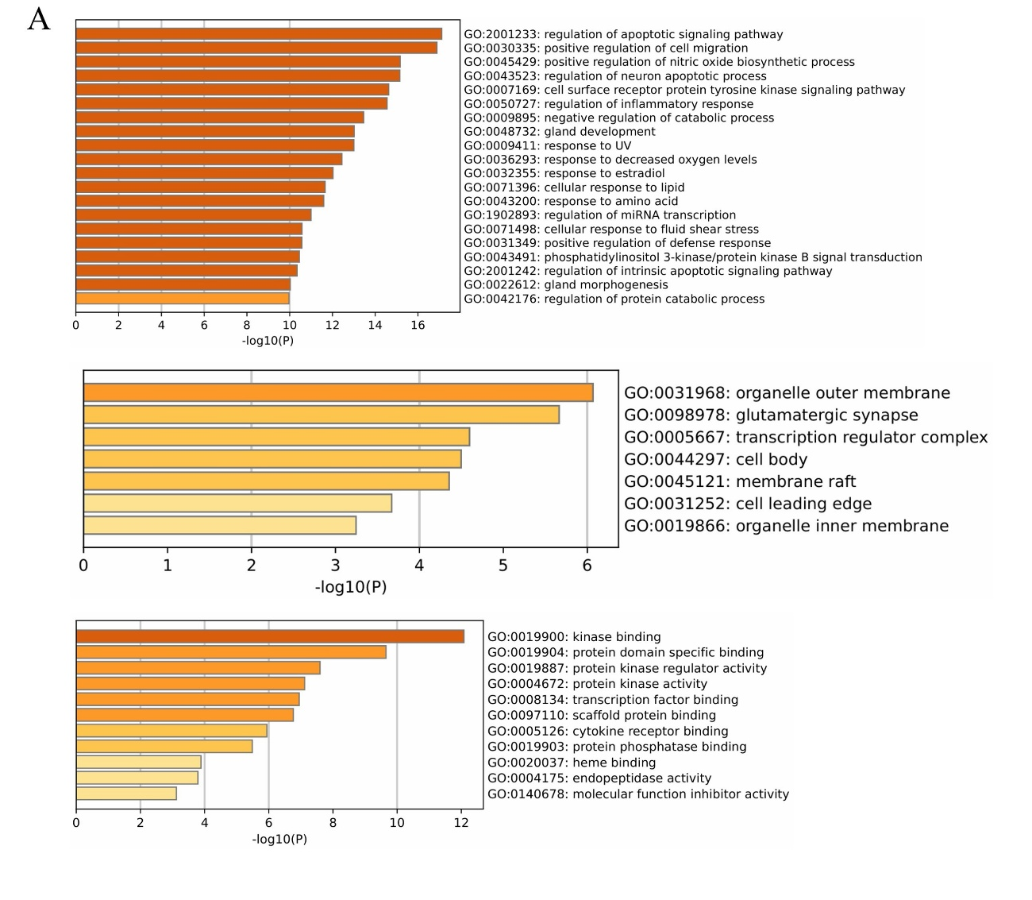
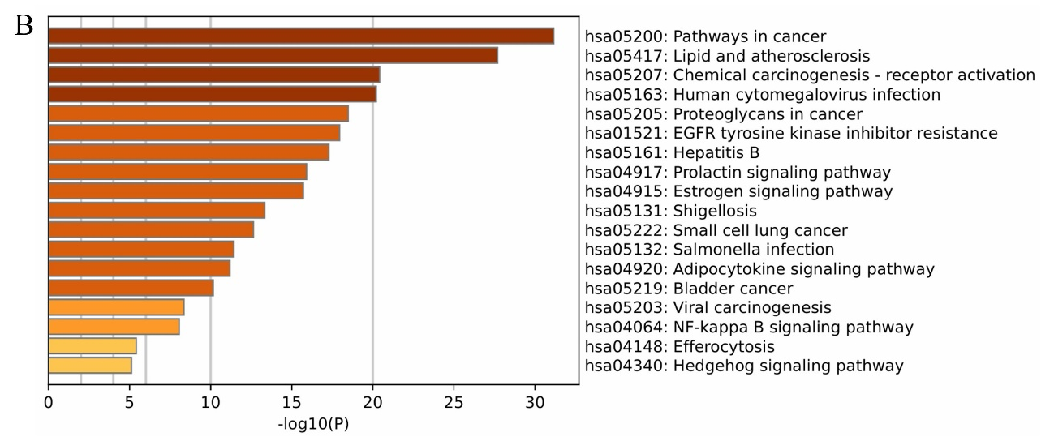
Figure S22. GO functional and KEGG pathway. A. GO functional enrichment analysis of Anoplin in NSCLC. B. KEGG pathway enrichment analysis of Anoplin in NSCLC.
Molecular docking
Molecular docking of P13 and 13b
Molecular docking method was used to further analyze the inter molecular interactions between αvβ6 and P13, 13b. The 2D structure of t P13, 13b were drawn using ChemDraw software, and the 2D structure was input into Molecular Operating Environment 2024 (MOE 2024) to produce its 3D structure and saved as a mdb file. Then, the RCSB PDB database (http://www.rcsb.org/) was used to search with the keyword αvβ6 to screen its protein crystal structures, PDB ID: 4UM9. MOE software was used to minimize the energy of the compounds, preprocess the target proteins and find the active pockets. Finally, MOE 2024 was run for molecular docking with the number of operations set to 30. The binding activity of both was evaluated according to the magnitude of binding energy and the results were visualized by PyMOL.
Molecular docking of P23 and 23c
Molecular docking method was used to further analyze the inter molecular interactions between NSCLC and P23, 23c. The 2D structure of t P23, 23c were drawn using ChemDraw software, and the 2D structure was input into Molecular Operating Environment 2024 (MOE 2024) to produce its 3D structure and saved as a mdb file. Then, based on the PPI interaction network, GO functional enrichment, and KEGG pathway analysis, the interaction between P23 and NSCLC can involve apoptosis pathways, kinase binding, and pathway in cancer. Therefore, we selected EGFR from the PPI network as the target protein for molecular docking to verify its interaction with P23 and 23c. The RCSB PDB database (http://www.rcsb.org/) was used to search with the keyword EGFR to screen its protein crystal structures, PDB ID: 9QXN. MOE software was used to minimize the energy of the compounds, preprocess the target proteins and find the active pockets. Finally, MOE 2024 was run for molecular docking with the number of operations set to 30. The binding activity of both was evaluated according to the magnitude of binding energy and the results were visualized by PyMOL.
Table S2. Basic information on the molecular docking of peptides and target proteins
Molecular name | Targets | PDB ID | Residue involved in H bonding | H-bond length(Å) | Docking scores (kcal·mol⁻¹)
P13 | αvβ6 | 4UM9 | Tyr-178; Thr- 221; Gln-317； Gln-316 | 2.20; 1.99;  1.98; 2.25; 2.61 | -10.71
13b | αvβ6 | 4UM9 | Ile-216; Asp-218; Asp-219; Arg-248; Glu-316; Lys-338 | 2.27; 2.38; 2.18; 2.33; 1.94; 2.04; 2.87; 2.57 | -10.81
P23 | EGFR | 9QXN | Asp-800; Asp-837; Asp-855; Glu-762; Lys-745 | 2.12; 1.96; 2.00; 2.01; 1.99; | -13.77
23c | EGFR | 9QXN | Leu-718; Phe-795; Cys-797; Thr-854 | 2.28; 2.09; 2.74; 2.05 | -14.66

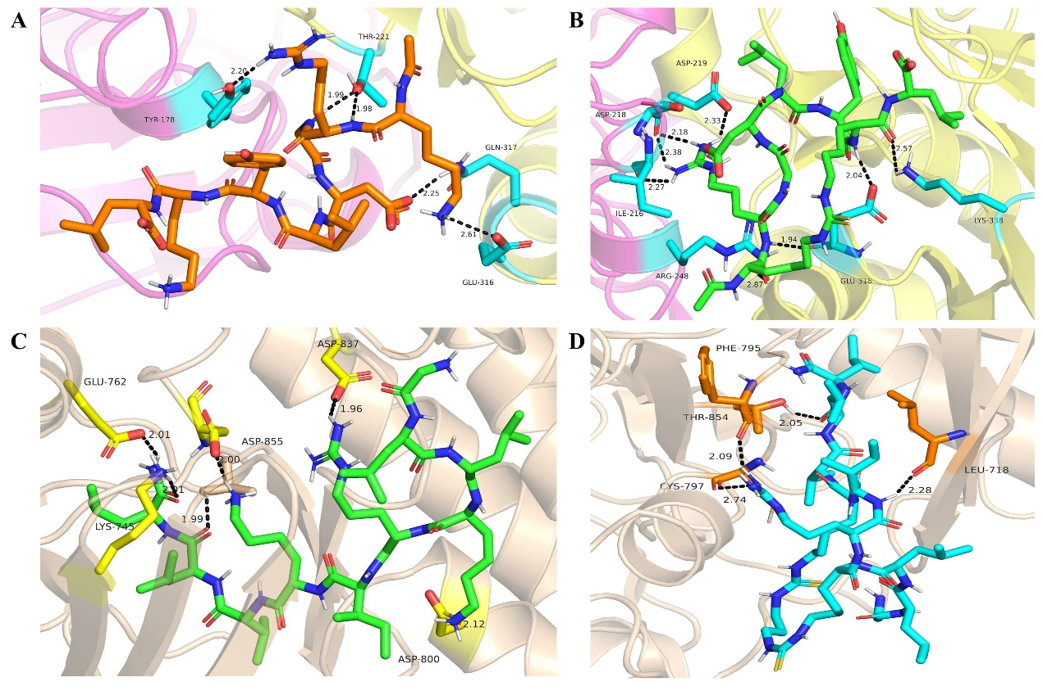
Fig. S23. Molecular docking analysis of P13, 23b, P23, 23c, hydrogen bonds are shown in black. A. The docking results indicate that the P13 compound interacts with the αvβ6 protein, where alphaV (magenta cartoon) and Beta6 (yellow cartoon) form hydrogen bonds. B. The docking results indicate that the 13b compound interacts with the αvβ6 protein, where alphaV (magenta cartoon) and Beta6 (yellow cartoon) form hydrogen bonds. C. The docking results indicate that the P23 compound interacts with the EGFR protein. D. The docking results indicate that the 23c compound interacts with the EGFR protein.
References
1. Kapp, T. G. et al. A Comprehensive Evaluation of the Activity and Selectivity Profile of Ligands for RGD-binding Integrins. Sci. Rep. 7, 39805 (2017).
2. Di Leva, F. S. et al. From a Helix to a Small Cycle: Metadynamics-Inspired αvβ6 Integrin Selective Ligands. Angew. Chem. Int. Ed. 57, 14645–14649 (2018).
3. Li, Z. et al. A Stapled Peptide Inhibitor Targeting the Binding Interface of N6-Adenosine-Methyltransferase Subunits METTL3 and METTL14 for Cancer Therapy. Angew. Chem. Int. Ed. 63, e202402611 (2024).
4. Lautrette, G., Touti, F., Lee, H. G., Dai, P. & Pentelute, B. L. Nitrogen Arylation for Macrocyclization of Unprotected Peptides. J. Am. Chem. Soc. 138, 8340–3 (2016).
5. Dougherty, P. G. et al. Enhancing the Cell Permeability of Stapled Peptides with a Cyclic Cell-Penetrating Peptide. J. Med. Chem. 62, 10098–10107 (2019).
6. Xu, L., Fan, X., He, Y., Xia, X. & Zhang, J. Design, Synthesis, and Biological Evaluation of Lysine-Stapled Peptide Inhibitors of p53-MDM2/MDMX Interactions with Potent Antitumor Activity In Vivo. J. Med. Chem. 67, 17893–17904 (2024).
7. Lan, Y., Peng, Q., Fu, B. & Liu, H. Effective analysis of thyroid toxicity and mechanisms of acetyltributyl citrate using network toxicology, molecular docking, and machine learning strategies. Toxicol. 511, 154029 (2025).
8. He, Q. et al. Exploring the mechanism of curcumin in the treatment of colon cancer based on network pharmacology and molecular docking. Front. Pharmacol. 14, 1102581 (2023).

NMR spectra
¹H NMR spectra of compound 1a
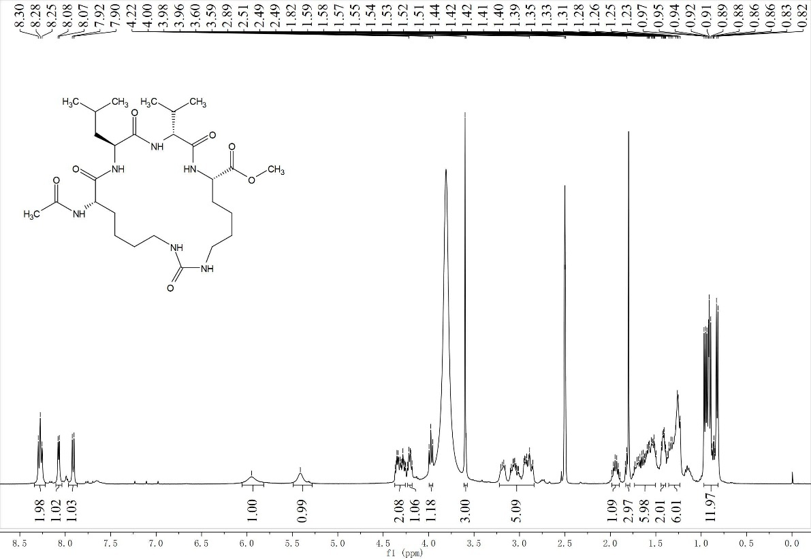
¹³C NMR spectra of compound 1a
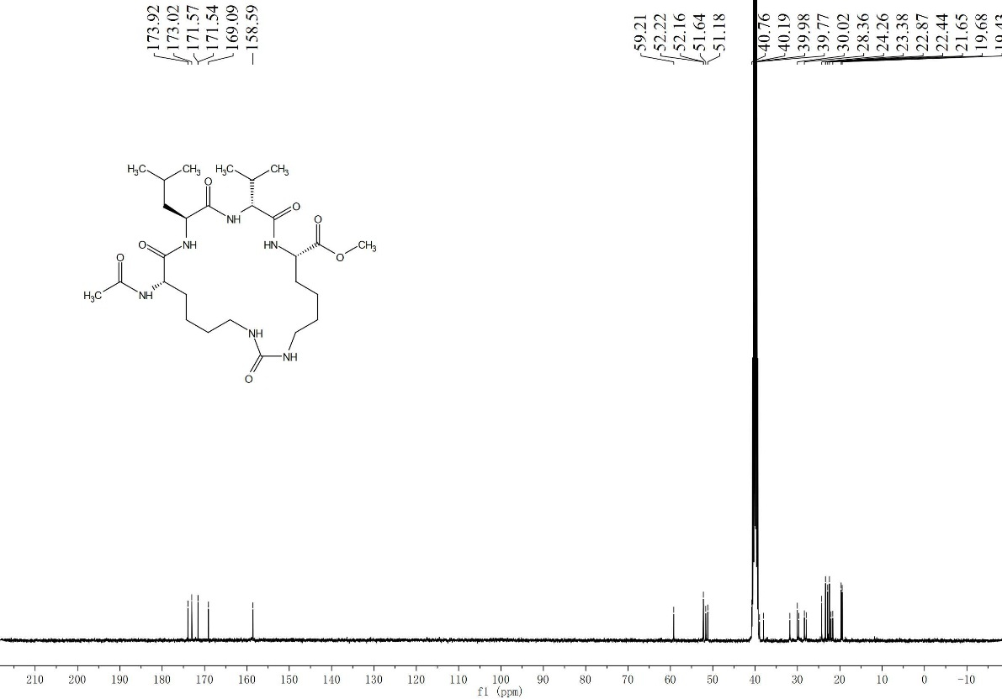
¹H NMR spectra of compound 1a
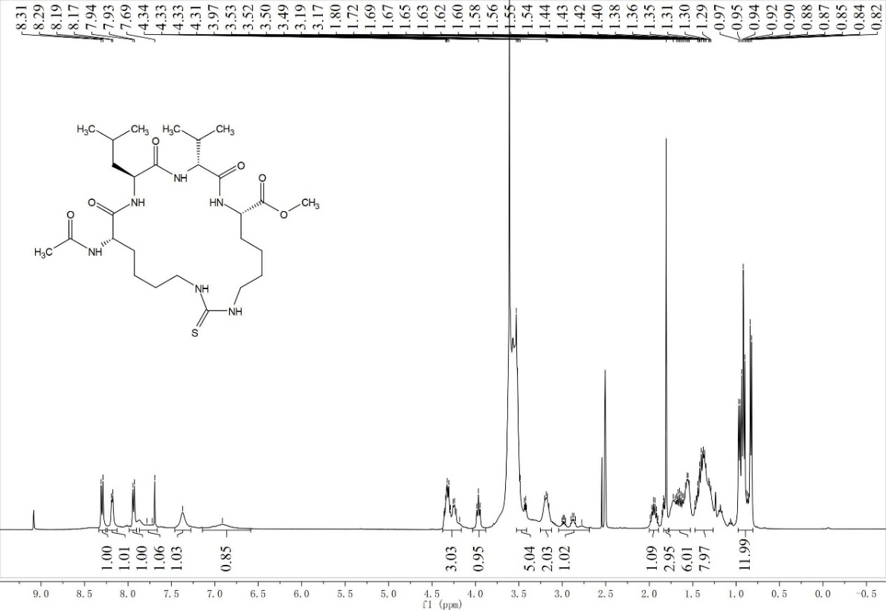
¹H NMR spectra of compound 6a
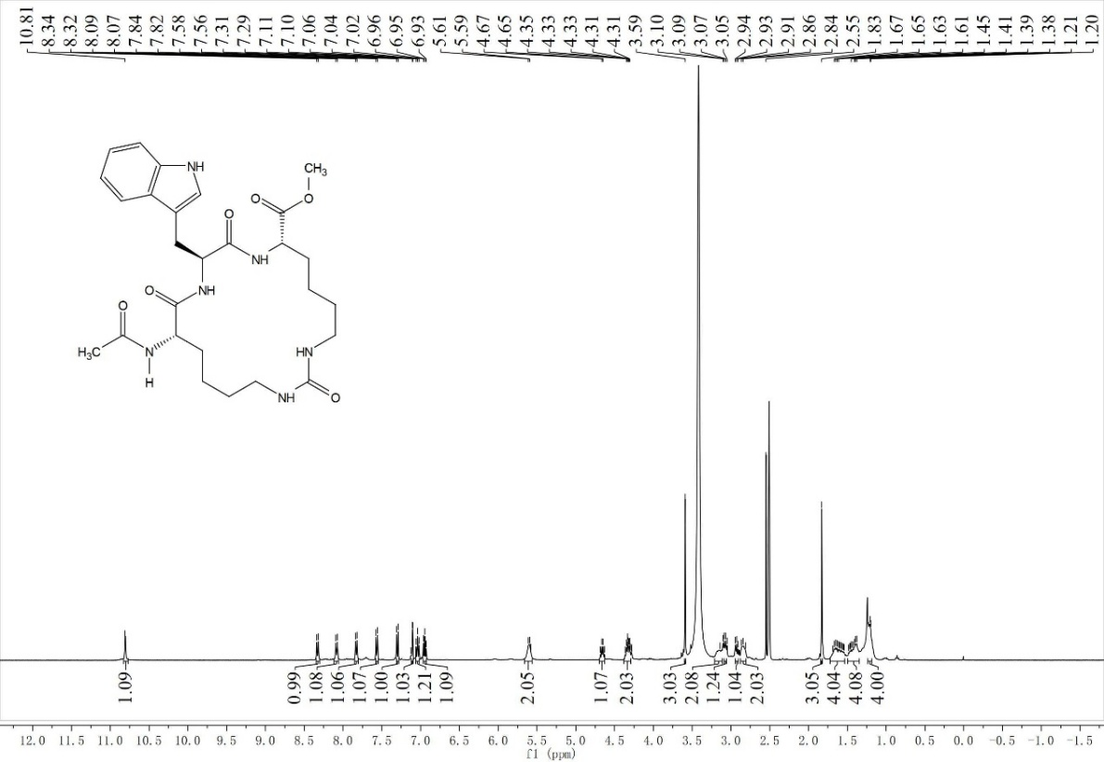
¹³C NMR spectra of compound 6a
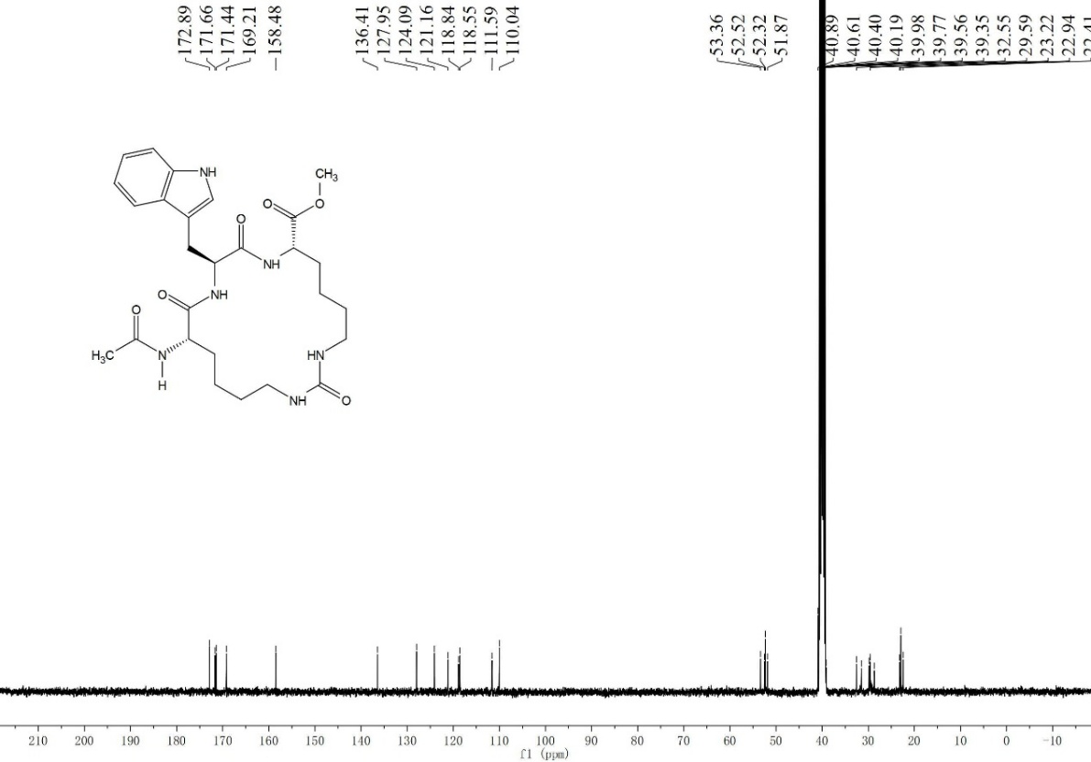
¹H NMR spectra of compound 6b
