Fully Non-conjugated Phosphorylated Chitosan Enhances Hole Injection for Efficient Perovskite Light-Emitting Diodes
Hao Yao ^{1,2,#}, Enbo Zhou^{1,2,#}, Xingye Zhang³, Xinhua Ouyang^{1,2,}*
¹ Laboratory for Green Photoelectronic Devices and Energy Storage Batteries, Fujian Agriculture&Foresty University, Fuzhou, 350108, PR China
² College of Material Engineering, Fujian Agriculture and Forestry University, Fuzhou, 350108, P. R. China
³ South China University of Technology Advanced Institute of Aggregation-Induced Light Emission, Guangzhou 510530, PR China
Email: ouyangxh@fafu.edu.cn (X. O.)

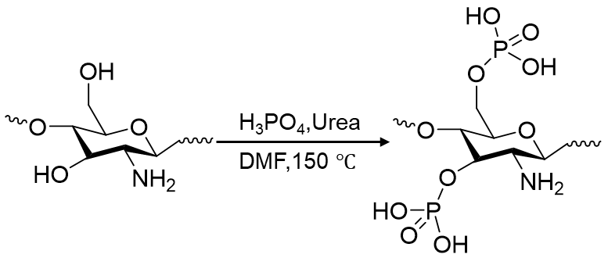

Supplementary Figure. 1 Illustration of synthetic routes to NCPC.

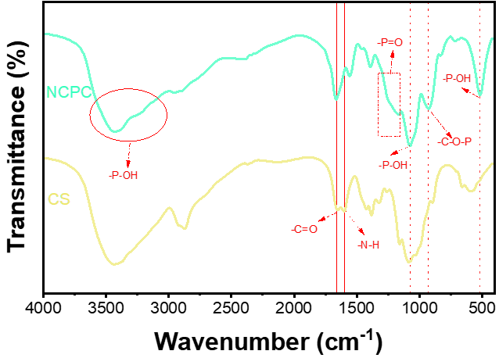

Supplementary Figure. 2 FTIR spectra of NCPC and CS.

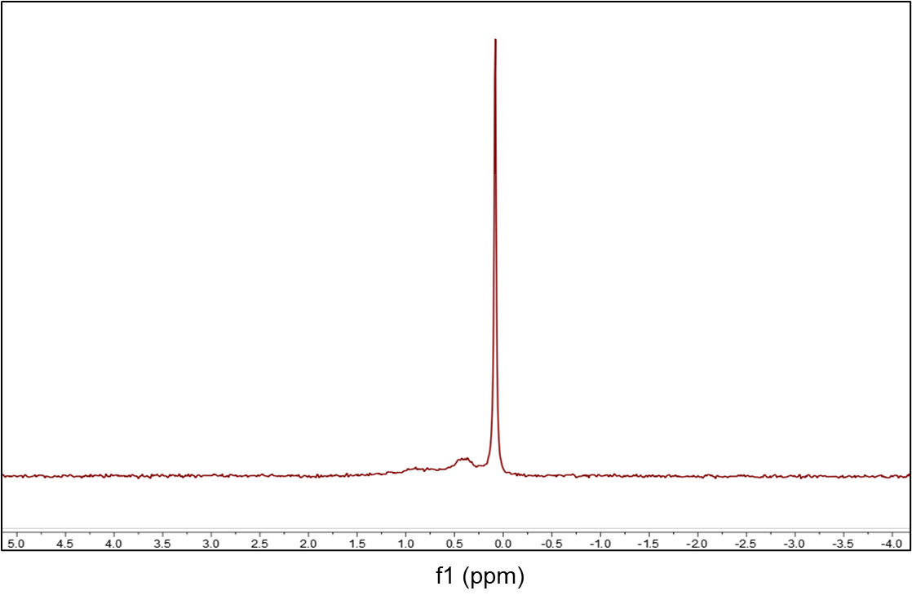

Supplementary Figure. 3 ³¹P NMR spectra of NCPC in D₂O.

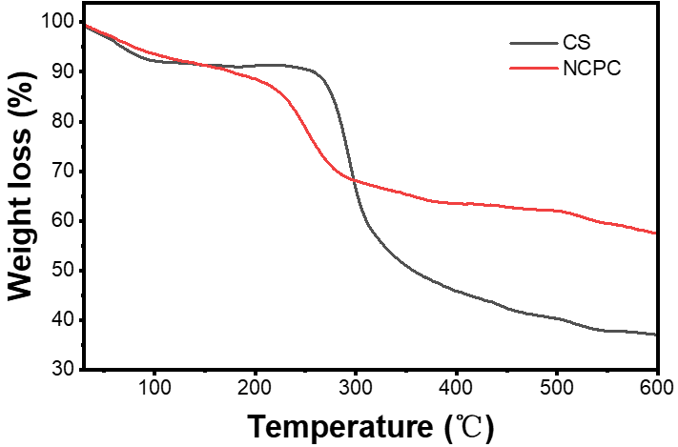

Supplementary Figure. 4 The TGA curve of NCPC and CS.

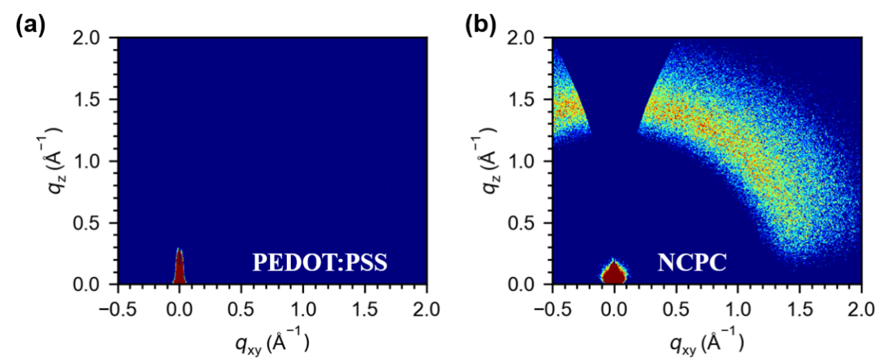

Supplementary Figure. 5 2D GIWAXS images of (a) PEDOT:PSS and (b) NCPC.

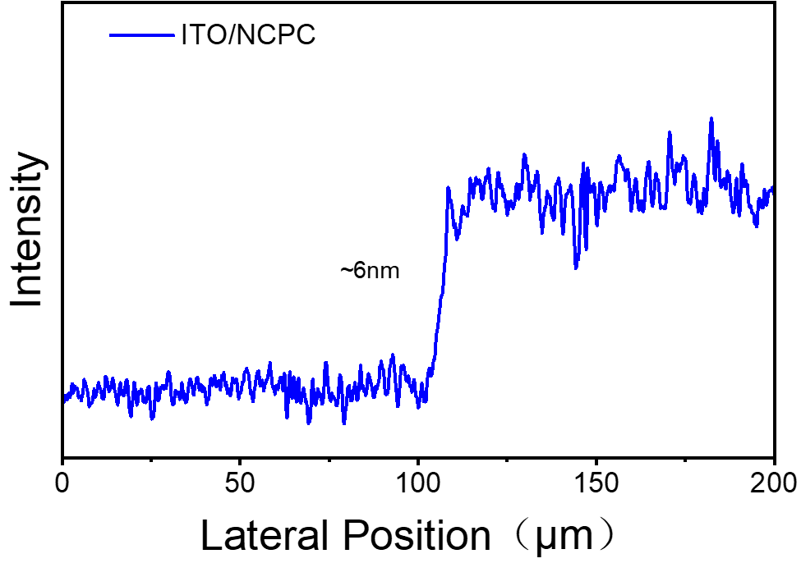

Supplementary Figure. 6 Film thickness of NCPC film.

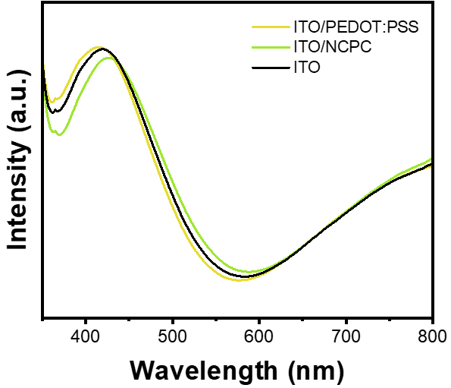

Supplementary Figure. 7 UV–vis absorption spectra of ITO、ITO/PEDOT:PSS and ITO/NCPC.

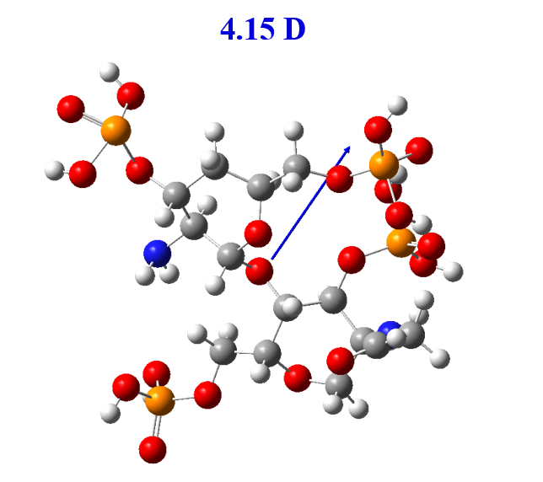

Supplementary Figure. 8 The optimized geometric molecular configuration and dipole moments of NCPC.

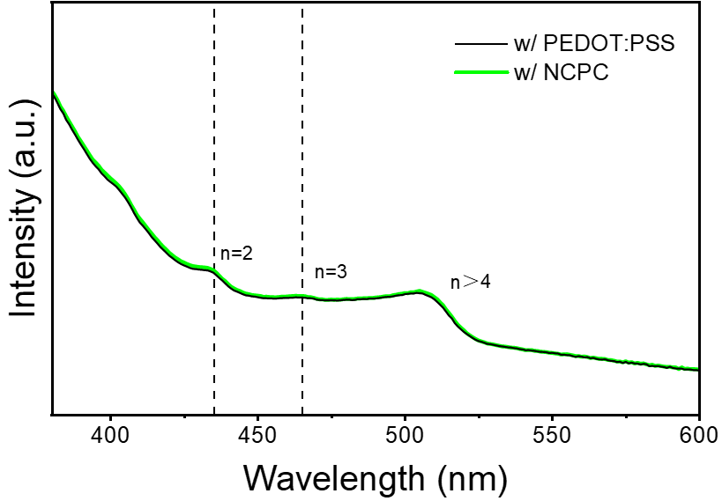
Supplementary Figure. 9 UV–vis absorption spectra of green perovskite film on NCPC/PVK and PEDOT:PSS/PVK.

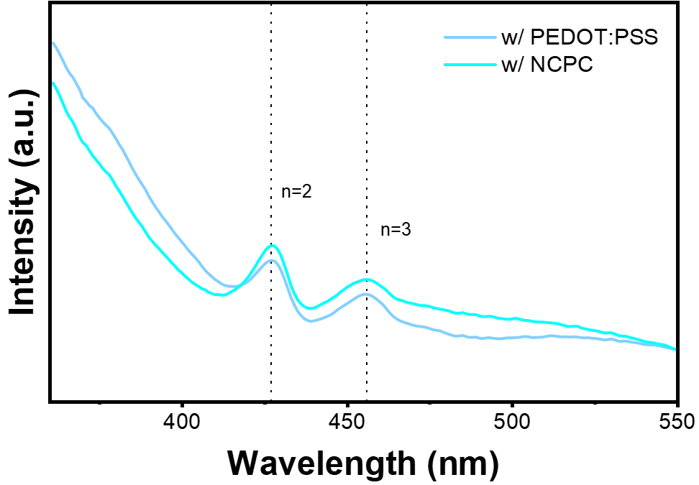
Supplementary Figure. 10 UV–vis absorption spectra of blue perovskite film on NCPC/PVK and PEDOT:PSS/PVK.

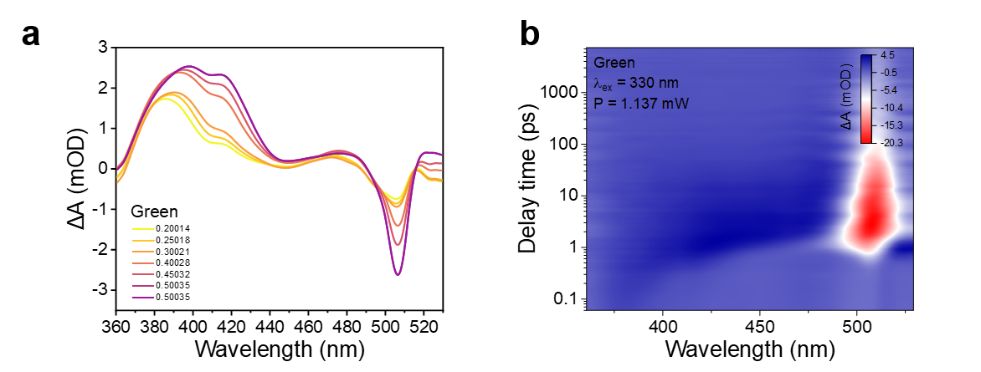

Supplementary Figure. 11 TA measurements for green perovskite film following excitation at 330 nm. (a) TA spectra at selected probe delay times. (b) Pseudocolar TA spectra.

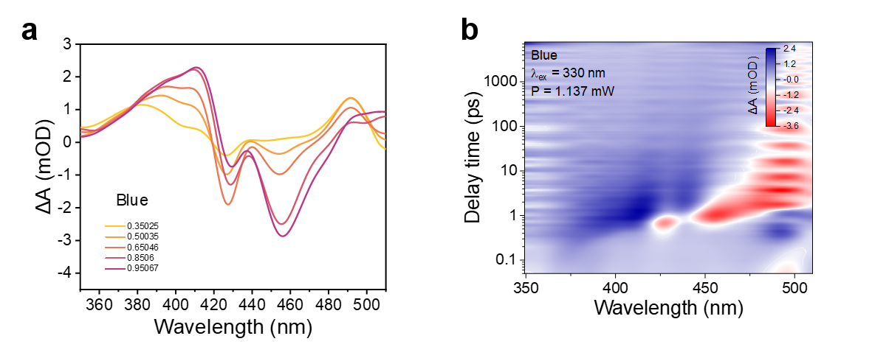

Supplementary Figure. 12 TA measurements for blue perovskite film following excitation at 330 nm. (a) TA spectra at selected probe delay times. (b) Pseudocolar TA spectra.

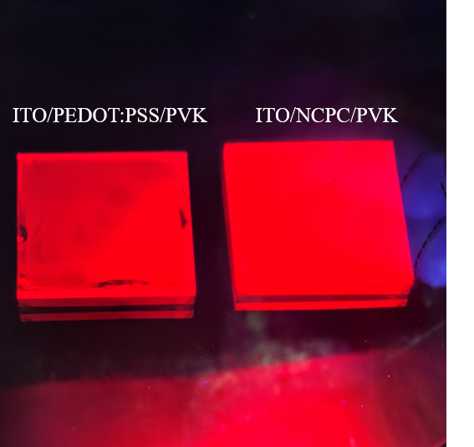

Supplementary Figure. 13 Fluorescence images of red perovskite films on ITO/NCPC/PVK and ITO/PEDOT:PSS/PVK under 365 nm UV excitation.

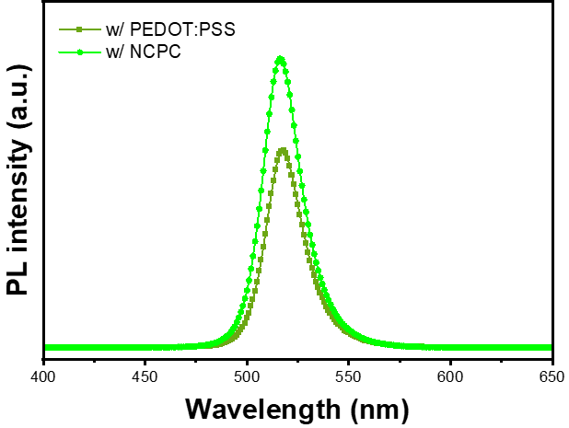

Supplementary Figure. 14 The PL spectra of green perovskite films deposited on different HILs.

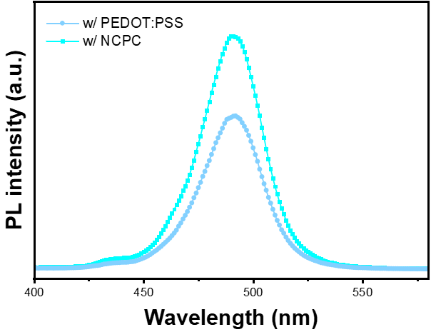
Supplementary Figure. 15 The PL spectra of blue perovskite films deposited on different HILs.

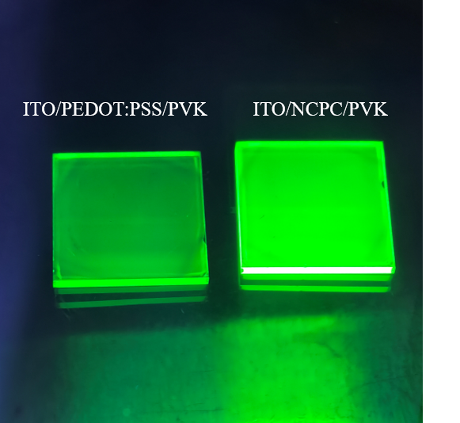
Supplementary Figure. 16 Fluorescence images of green perovskite films on ITO/NCPC/PVK and ITO/PEDOT:PSS/PVK under 365 nm UV excitation.

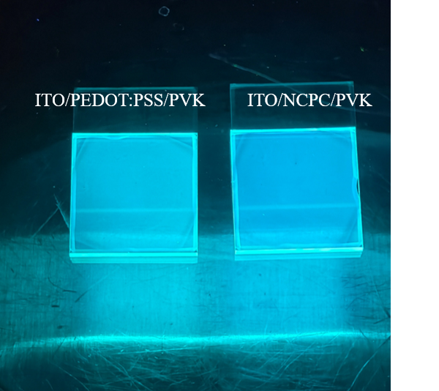

Supplementary Figure. 17 Fluorescence images of blue perovskite films on ITO/NCPC/PVK and ITO/PEDOT:PSS/PVK under 365 nm UV excitation.

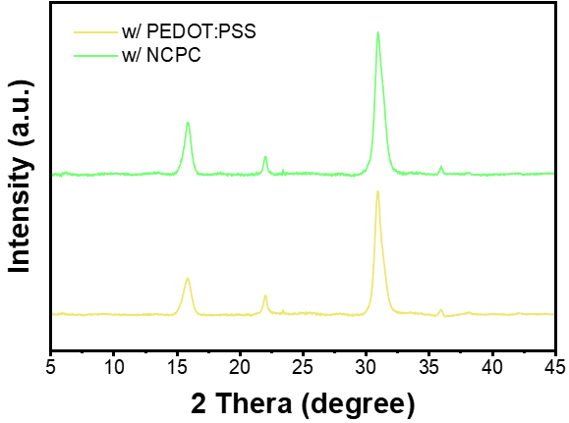
Supplementary Figure. 18 XRD patterns of green perovskite films on PEDOT:PSS/PVK and NCPC/PVK.

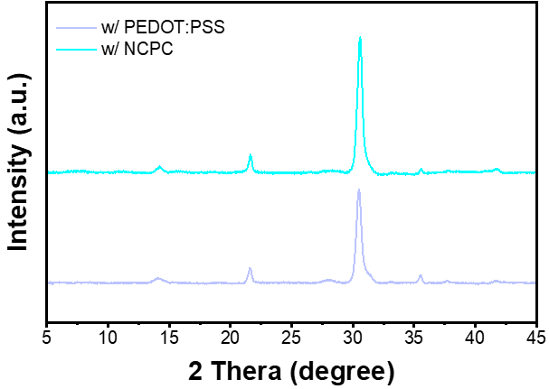

Supplementary Figure. 19 XRD patterns of blue perovskite films on PEDOT:PSS/PVK and NCPC/PVK.

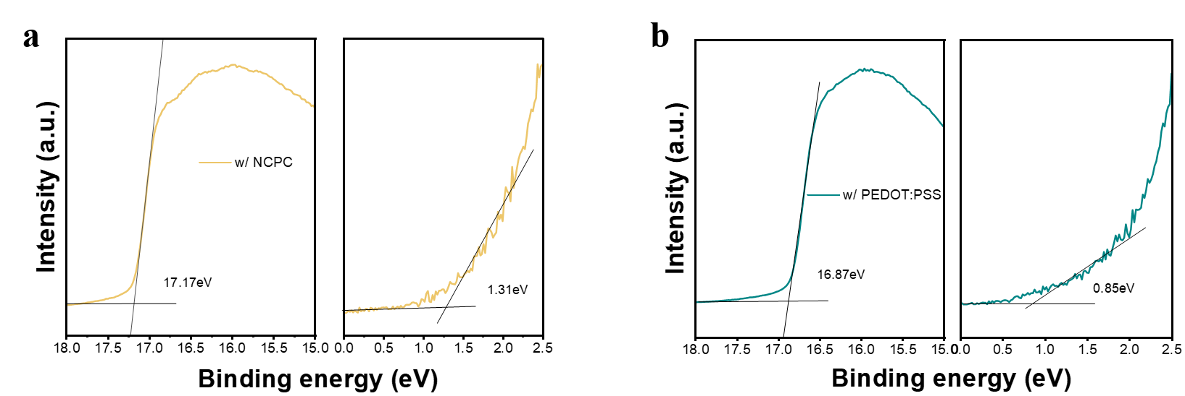

Supplementary Figure. 20 Ultraviolet photoelectron spectroscopy (UPS) spectra of the ITO/NCPC (a) and ITO/PEDOT:PSS (b) film surfaces.

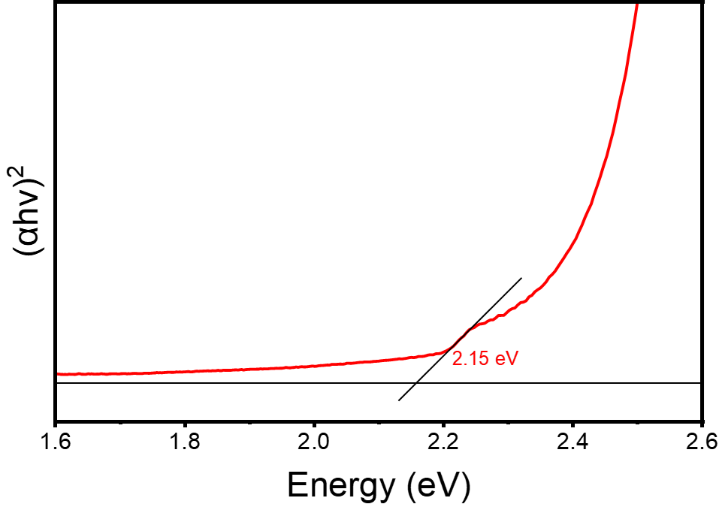

Supplementary Figure. 21 Tauc plot analysis of NCPC film.

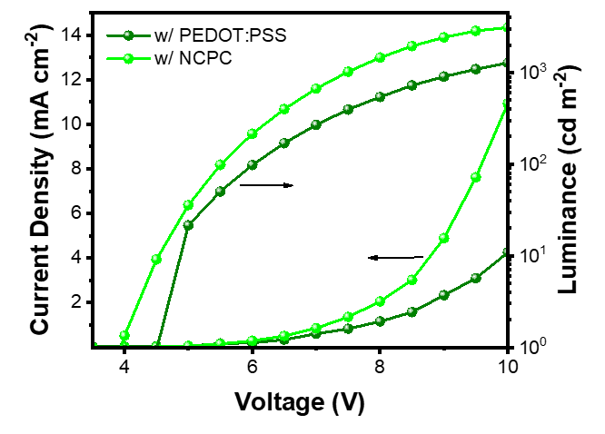
Supplementary Figure. 22 Current density–voltage–luminance (J–V–L) curves of green PeLEDs with different HILs.

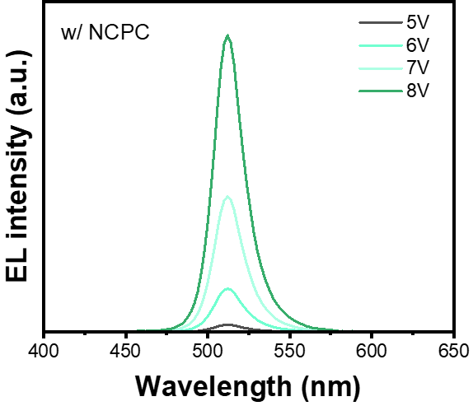

Supplementary Figure. 23 EL spectra of NCPC-based green PeLEDs under various bias voltages.

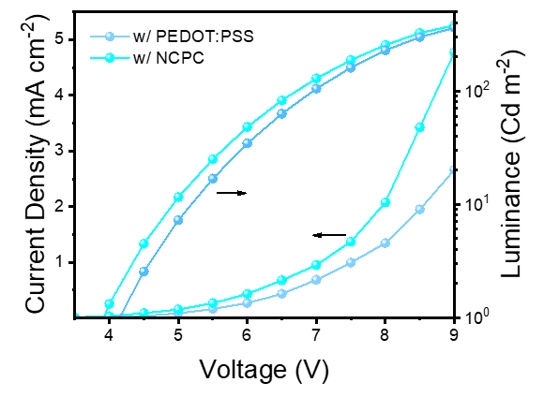

Supplementary Figure. 24 Current density–voltage–luminance (J–V–L) curves of blue PeLEDs with different HILs.

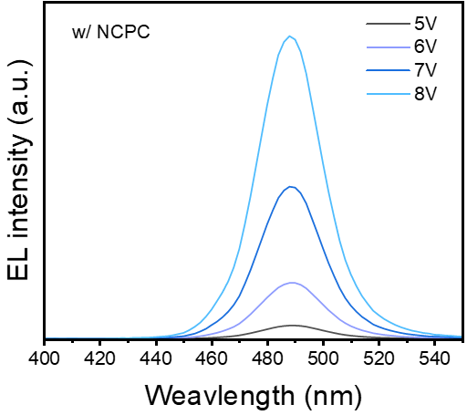

Supplementary Figure. 25 EL spectra of NCPC-based blue PeLEDs under various bias voltages.

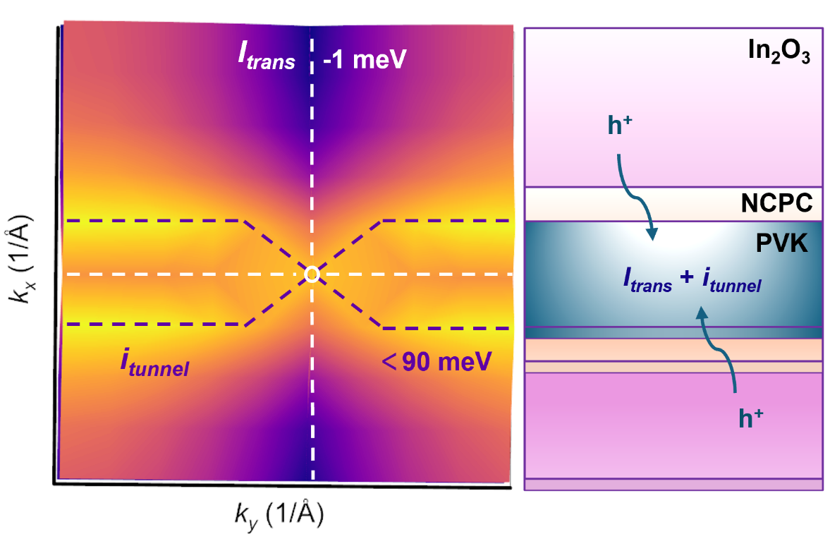

Supplementary Figure. 26 Electronic band structure top view and conduction schematic of ITO/NCPC/PVK, showing direct hole transport (white) and tunneling (purple) regions.

Table S1. PL lifetime fitting parameters of the red perovskite films on different substrates.
Sample | τ₁ (ns) | A₁ | τ₂ (ns) | A₂ | τ_{AVE} (ns)
w/ NCPC | 6.67 | 977.74 | 86.13 | 328.63 | 71.3
w/ PEDOT:PSS | 5.86 | 978.37 | 72.14 | 399.06 | 61.0
Table S2. An overview of the performance characteristics for red PeLEDs from previous literature and our work.
Emission layer | Emission peak [nm] | Maximum EQE [%] | Maximum Luminance  (cd m⁻² ) | Ref.
PEABr-CsPbI₃ | 672 | 19.6 | 6078 | [1]
Phenylbutanammonium iodide (PBAI)-CsPbBr_{0.6}I_{2.4}-PEOXA | 670 | 9.1 | 1359 | [2]
CsPbI₃ | 675 | 6.4 | 204 | [3]
FA_{x}Cs_{1−x}PbI_{y}Br_{3−y} | 670 | 9.0 | 1524 | [4]
PEIE-MA_{x}Cs_{1−x}Pb(I_{1−y}Br_{y})₃ | 670 | 16.0 | ~180 | [5]
CsPb(I_{0.8}Br_{0.2})-PEOXA | 668 | 6.55 | 338 | [6]
PEA₂Cs_{n−1}Pbn(Br/I)_{3n+1} | 668 | 30.08 | 140 | [7]
EDABr₂/CsPbI_{3−x}Br_{x} | 671 | 17.03 | 10745 | [8]
PEABr-CsPbI₃ | 670 | 25.35 | 222 | This work

Supplementary References
- Zhang, D. L. et al. Highly Efficient Red Perovskite Light-Emitting Diodes with Reduced Efficiency Roll-Off Enabled by Manipulating Crystallization of Quasi-2D Perovskites. Adv. Funct. Mater. 32, 2205707 (2022).
- Liu, P. et al. Quasi-2D CsPbBrxI_{3−x} Composite Thin Films for Efficient and Stable Red Perovskite Light-Emitting Diodes. Adv. Optical Mater. 9, 2101419 (2021).
- Yoo, J. H. et al. Park Room-temperature large-scale synthesis of black-phase CsPbI3 nanocrystals for red light-emitting diodes. ACS Appl. Nano Mater. 7, 28119-28130 (2024).
- Li, Y. et al. Sequential layer-by-layer deposition for high-performance fully thermal-evaporated red perovskite light-emitting diodes. Nature Communications. 16, 6908 (2025).
- Shao, Y. et al. Red Efficient Perovskite Light-Emitting Diodes Assisted with PEIE. ACS Appl. Electron. Mater. 6, 6140 (2024).
- Cai, W. et al. Polymer-Assisted In Situ Growth of All-Inorganic Perovskite Nanocrystal Film for Efficient and Stable Pure-Red Light-Emitting Devices. ACS Appl. Mater. Interfaces. 10, 42564-42572 (2018).
- Feng, S. C. et al. Efficient and Stable Red Perovskite Light-Emitting Diodes via Thermodynamic Crystallization Control. Adv. Mater. 36, 2410255 (2024).
- Li, N. et al. Diammonium-Mediated Perovskite Film Formation for High-Luminescence Red Perovskite Light-Emitting Diodes. Adv. Mater. 34, 2202042 (2022).

