Supporting Information
for
Clinically Interpretable Extracellular Vesicle Gene Model for Non-Invasive Liver Cancer Diagnosis
Yan Zhang^{1#}, Zhengying Mo^{2#}, Lei Zhang^{3#}, Zhangming Zhou^{4#}, Zhaohan Wei⁵, Yuan Zhu⁶, Yadong Wang⁶, Hu Wang⁷; Debing Xiang⁸, Jing Huang^{9*}, Qingle Liang^{1*}
1 Department of Clinical Laboratory Medicine, Chongqing University, Jiangjin Hospital, Chongqing, China.
2 Department of Oncology, Tai-He Hospital, Hubei University of Medicine, Shiyan, Hubei, China.
3 Department of Clinical Laboratory, Chongqing Health Center for Women and Children, Chongqing, China; Department of Clinical Laboratory, Women and Children’s Hospital of Chongqing Medical University, Chongqing, China; NHC Key Laboratory of Birth Defects and Reproductive Health，Chongqing, China.
4 Department of Neurosurgery, Dujiangyan Medical Center, Chengdu, China.
5. Marshall Laboratory of Biomedical Engineering, International Cancer Center, Laboratory of Evolutionary Theranostics (LET), School of Biomedical Engineering, Shenzhen University Medical School, Shenzhen University, Shenzhen, Guangdong, China.
6 Lun Lun Research Institute of AI FOR SCIENCE, Beijing Diji Technology Co., Ltd., Beijing, China.
7 Clinical Laboratory of Jingzhou Third People's Hospital, Jingzhou, Hubei, China.
8 Department of Oncology, Chongqing University Jiangjin Hospital, Chongqing, China.
9 Pediatrics Department, Chongqing University Jiangjin Hospital, Chongqing, China.
* Corresponding authors. Address: No. 725, Jiangzhou Avenue, Dingshan Subdistrict, Jiangjin District, Chongqing, China 86 (023)47518891 E-mail addresses: 157265743@qq.com (Jing Huang), liangqingle@126.com (Qing-le Liang).
# These authors are contributed equally to this work.

Supplementary Figures and Tables
Supplementary Figure 1
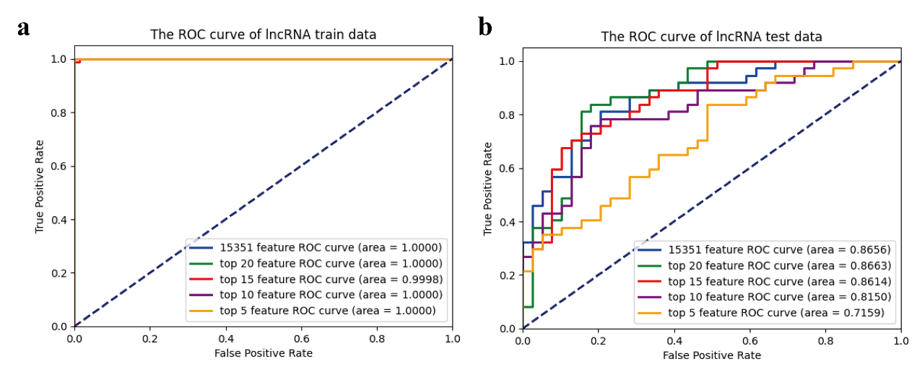
Supplementary Figure 1. ROC curves of HCC diagnostic model with lncRNAs signatures (a) training set (b) test set.

Supplementary Figure 2
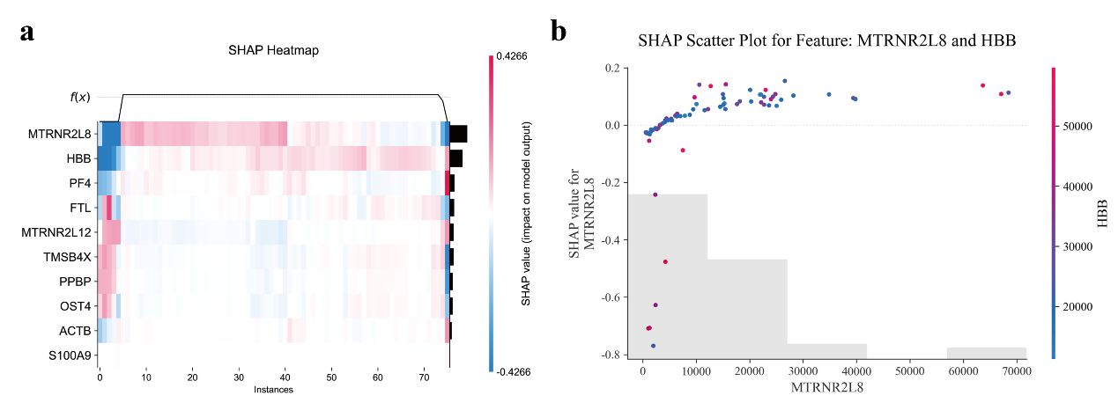
Supplementary Figure 2. SHAP global interpretation (a) SHAP heatmap (b) scatter plot for MTRNR2L8 and HBB.
Supplementary Figure 3
Supplementary Figure 3. The correlation heatmap of top 10 mRNA features.

Supplementary Figure 4
Supplementary Figure 4. The functional expression formula of the KAN model.
Supplementary Table 1. Model Comparisons based on mRNA signatures.
 | Accuracy | Precision | Recall | F1-Score | AUC
Logistic Regression | 0.7895 | 0.7442 | 0.8649 | 0.8000 | 0.8725
Random Forest | 0.8684 | 0.9355 | 0.7838 | 0.8529 | 0.9210
SVM | 0.8289 | 0.8529 | 0.7838 | 0.8169 | 0.8870
XGBoost | 0.8553 | 0.9062 | 0.7838 | 0.8406 | 0.9155
Decision Tree | 0.7500 | 0.7647 | 0.7027 | 0.7324 | 0.7488
Deep Neural Network | 0.8816 | 0.9375 | 0.8108 | 0.8696 | 0.9324

Supplementary Table 2. Model Comparisons based on lncRNA signatures.
 | Accuracy | Precision | Recall | F1-Score | AUC
Logistic Regression | 0.5132 | 0.5000 | 0.8919 | 0.6408 | 0.5295
Random Forest | 0.7763 | 0.8125 | 0.7027 | 0.7536 | 0.8326
SVM | 0.6053 | 1.0000 | 0.1892 | 0.3182 | 0.7290
XGBoost | 0.7632 | 0.7879 | 0.7027 | 0.7429 | 0.8898
Decision Tree | 0.6316 | 0.6286 | 0.5946 | 0.6111 | 0.6306
Deep Neural Network | 0.7500 | 0.6875 | 0.8919 | 0.7765 | 0.8656

 | AUC |  | Precision |  | Recall |  | F1-score
 | mRNA | lncRNA | mRNA | lncRNA | mRNA | lncRNA | mRNA | lncRNA
Top All | 0.9324 | 0.8556 | 0.8879 | 0.7746 | 0.8816 | 0.7500 | 0.8809 | 0.7457
Top 20 | 0.9279 | 0.8663 | 0.8671 | 0.8158 | 0.8553 | 0.8158 | 0.8537 | 0.8158
Top15 | 0.9089 | 0.8614 | 0.8188 | 0.7642 | 0.8158 | 0.7632 | 0.8150 | 0.7632
Top 10 | 0.8877 | 0.8150 | 0.8124 | 0.7000 | 0.8026 | 0.6842 | 0.8004 | 0.6798
Top 5 | 0.8628 | 0.7159 | 0.7634 | 0.6184 | 0.7500 | 0.6184 | 0.7456 | 0.6174
Supplementary Table 3. Model performance with different features.

