Supplemental
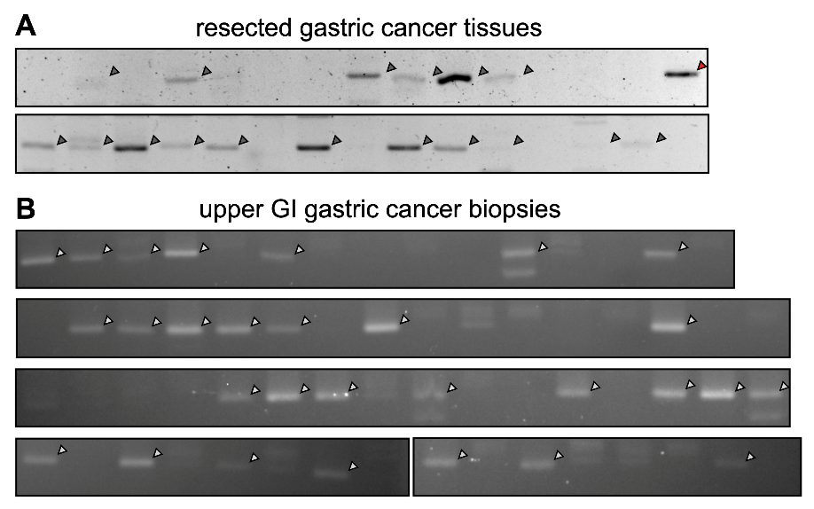
Figure S1. The presence of F. nucleatum NusG in the gastric cancer tissue. DNA was extracted from FFPE sections and analyzed by nested PCR. The PCR products was resolved in agarose electrophoresis and documented. (A) The analysis result of surgically resected specimens. (B) The analysis result of biopsies collected during upper GI endoscopic examination.

Table S1. Clinical characterization of H. pylori-negative resected specimens
stage | T | N | M | HER2 | H. pylori | F. nucleatum
1 | 2 | 0 | 0 | 0 | - | +
1 | 1b | 0 | 0 | 3+ | nd | +
1a | 1b | 0 | 0 | 0 | - | -
1a | 1b | 0 | 0 | 0 | - | -
1b | 2 | 0 | 0 | 0 | - | +
1b | 2 | 0 | 0 | 0 | - | -
2 | 3 | 1 | 0 | 0 | - | -
2b | 3 | 1 | 0 | 0 | - | +
3 | 4a | 1 | 0 | 0 | - | +
3 | 4a | 2 | 0 | 0 | nd | -
3 | 4a | 2 | 0 | 0 | - | +
3 | 3 | 3b | 0 | 0 | - | -
3a | 4a | 2 | 0 | 0 | - | +
3a | 4a | 1 | 0 | 0 | - | +
3b | 4a | 3a | 0 | 0 | - | +
3c | 4a | 3b | 0 | 0 | - | -
3c | 4b | 3a | 0 | 0 | - | +
3c | 3 | 3b | 0 | 3+ | - | +
4 | 4a | 0 | 1 | nd | - | +
4 | 4a | 2 | 1 | 0 | - | +
4 | 4a | 3a | 1 | 0 | - | -
4 | 4a | 3b | 1 | 3+ | nd | -
4 | 4a | 3a | 1 | 2+ | - | -

Table S2. Clinical characterization of H. pylori-negative biopsies
stage | T | N | M | HER2 | H. pylori | F. nucleatum
1 | 1a | 0 | 0 | nd | - | +
1 | 1b | 0 | 0 | 0 | - | +
1a | 1a | 0 | 0 | 0 | - | -
1a | 1b | 0 | 0 | 0 | nd | -
2 | 3 | 1 | 0 | 0 | - | -
2b | 3 | 1 | 0 | 0 | - | -
3 | 3 | 2 | 0 | nd | - | -
3 | 3 | 3b | 0 | 0 | - | +
3 | 3 | 1 | 0 | 3+ | nd | -
3 | 3 | 3b | 0 | 0 | - | -
3 | 4 | 1 | 0 | 3+ | nd | +
3 | 4a | 2 | 0 | 0 | - | +
3 | 4b | 2 | 0 | 1+ | - | -
3a | 3 | 2 | 0 | 0 | - | +
3a | 4a | 1 | 0 | 0 | - | -
3b | 3 | 3a | 0 | nd | nd | -
3c | 3 | 3b | 0 | 3+ | - | -
3c | 4a | 3b | 0 | 1+ | - | +
3c | 4b | 3b | 0 | nd | - | -
4 | nd | nd | nd | 0 | nd | -
4 | nd | nd | nd | 0 | nd | +
4 | nd | nd | nd | 0 | - | +
4 | nd | 0 | 1 | 0 | - | +
4 | 4 | 2 | 1 | 0 | - | -
4 | 4a | 3a | 1 | 1+ | - | +
4 | 4b | 3a | 1 | 0 | - | -
4 | 4b | nd | 1 | 3+ | - | +
4 | 4b | 0 | 1 | 0 | - | +
4 | 4b | 3 | 1 | 0 | nd | +
4b | 3 | 2 | 1 | 1+ | nd | -
4b | 4a | 3 | 1 | 0 | nd | +
4b | 4a | 3a | 1 | 2+ | - | +
4b | 4a | 3b | 1 | 0 | nd | +
4b | 4a | 2 | 1 | 0 | - | +
4b | 4a | 2 | 1 | 3+ | - | +
nd | nd | nd | nd | 0 | nd | +
nd | nd | nd | nd | 2+ | - | -
nd | nd | nd | nd | nd | - | -
nd | nd | nd | nd | nd | nd | -
nd | nd | nd | nd | nd | - | +
nd | nd | nd | nd | nd | nd | -
nd | nd | nd | nd | nd | - | -

