APPENDIX 1 Fit diagram of various indicators affected by the numbers of visits of 54 patients
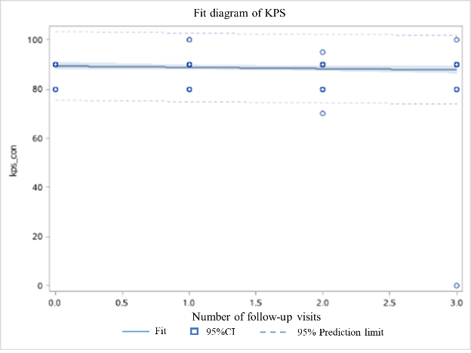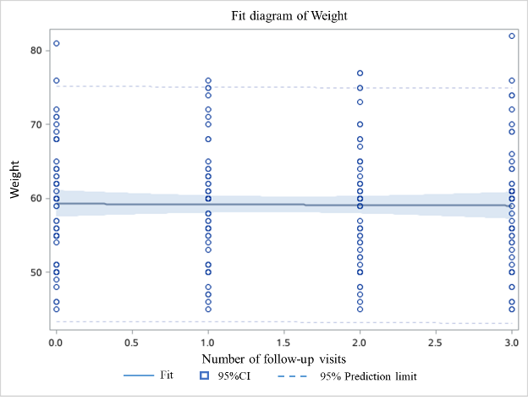
Fig. 3-1 Fit plot for KPS and the number of visits Fig. 3-2 Fit plot for weight and the number of visits
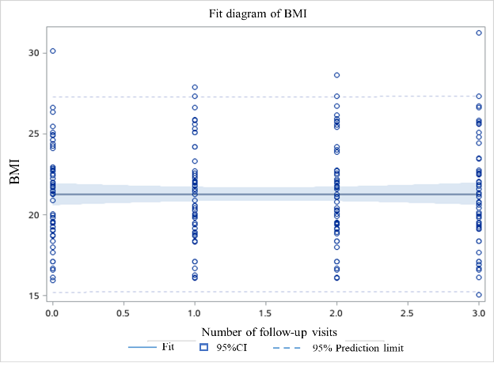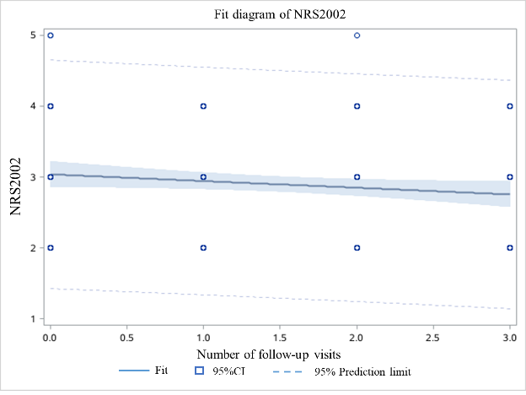
Fig. 3-3 Fit plot for BMI and the number of visits Fig. 3-4 Fit plot for NRS2002 and the number of visits
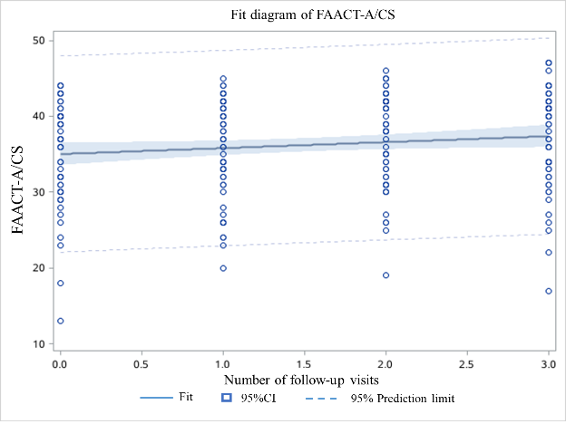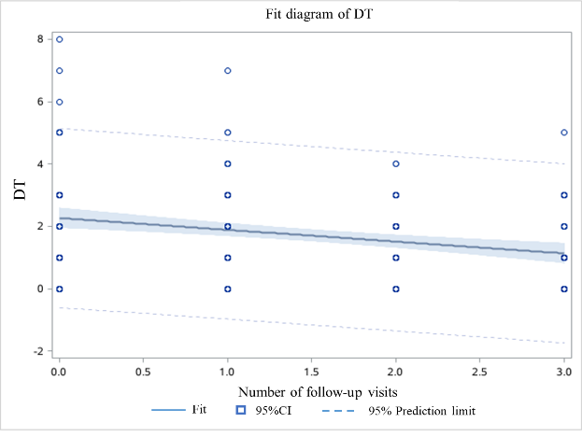
Fig. 3-5 Fit plot for FAACT-A/CS and the number of visits Fig. 3-6 Fit plot for DT and the number of visits
Fig. 3 Fit plot of various indicators and the number of follow-up visits (1-6)

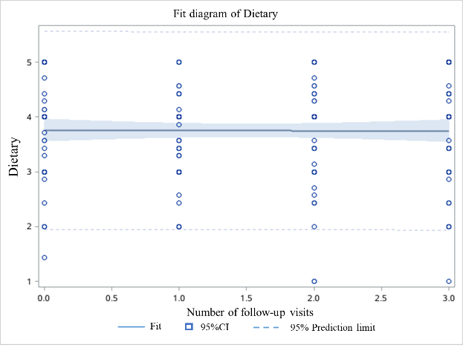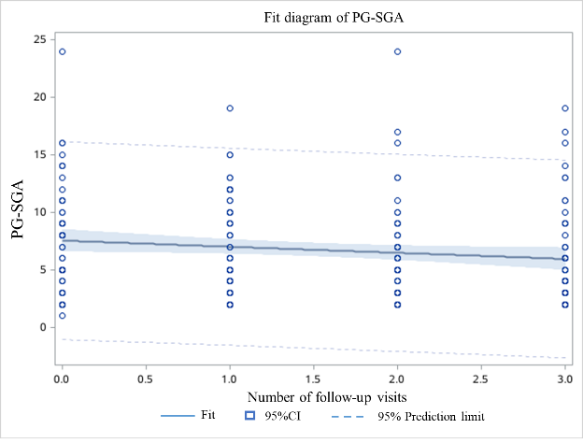
Fig. 3-7 Fit plot for dietary and the number of visits Fig. 3-8 Fit plot for PG-SGA and the number of visits
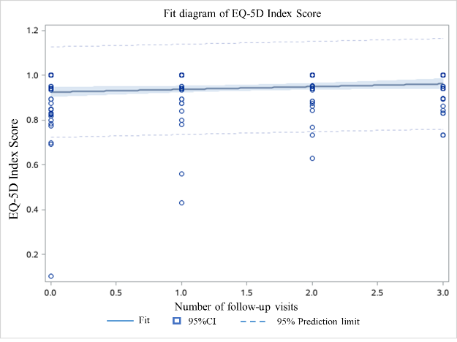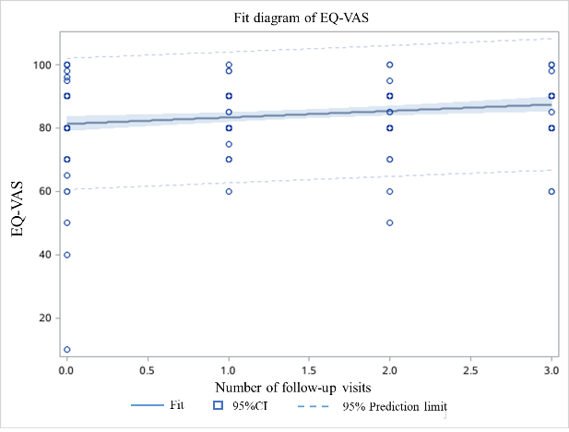
Fig. 3-9 Fit plot for index score and the number of visits Fig. 3-10 Fit plot for VAS with the number of visits
Fig. 3 Fit plot of various indicators and the number of follow-up visits (7-10)

