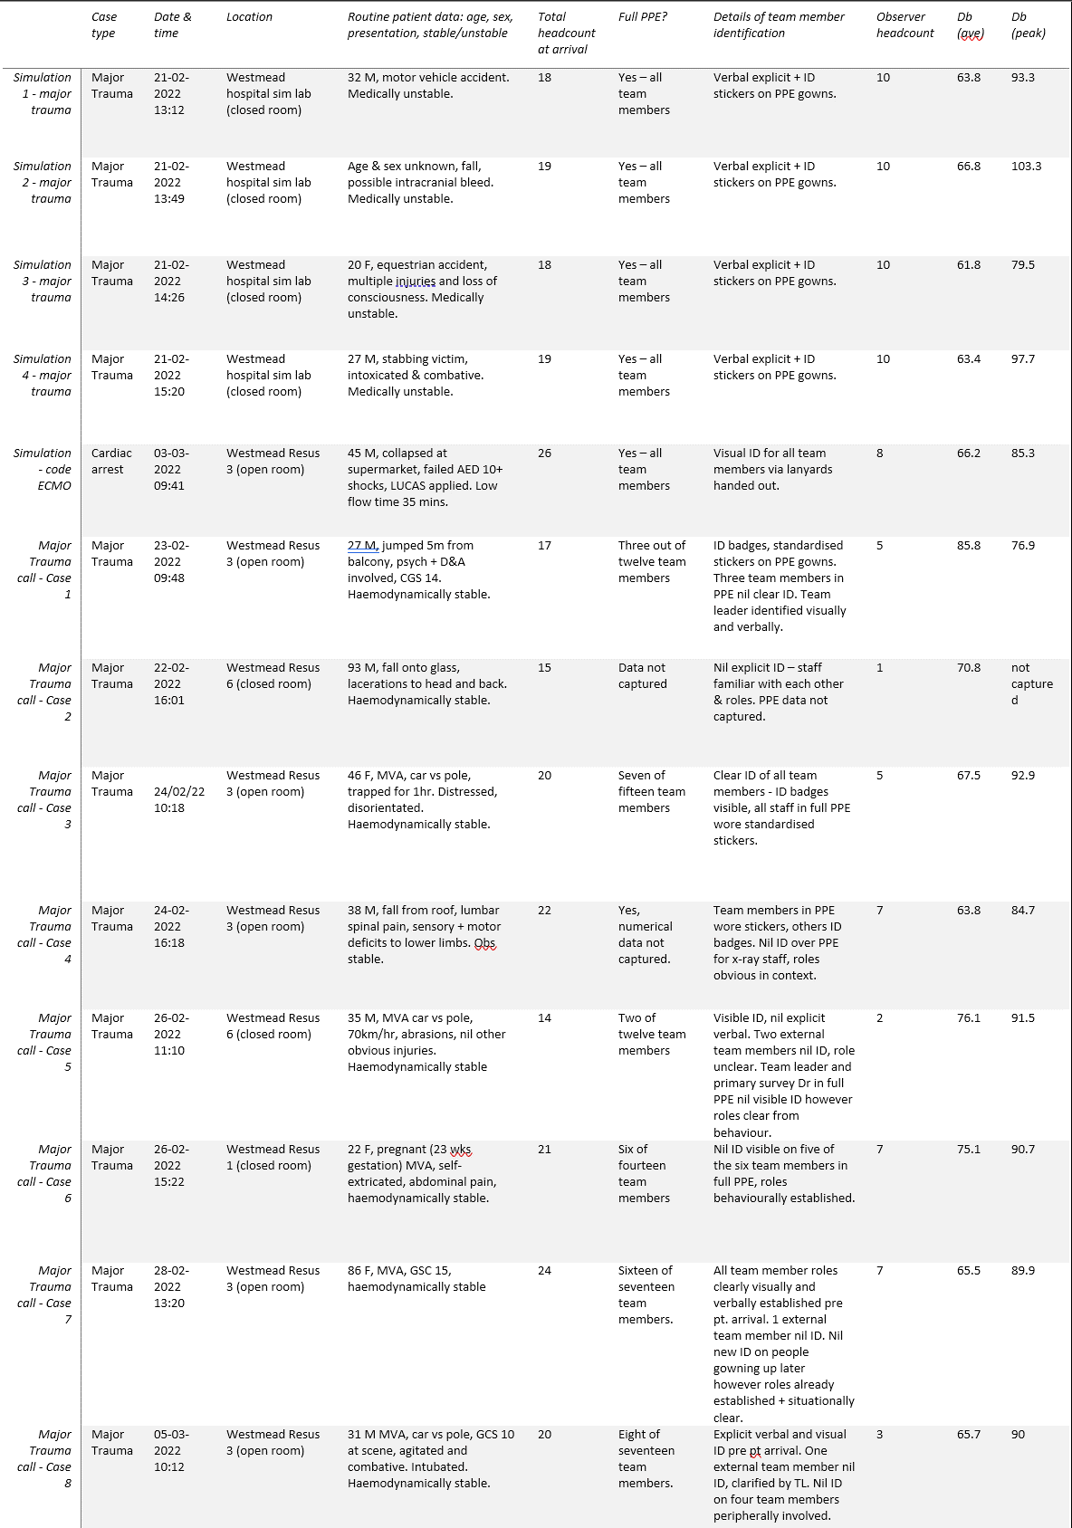
Appendix 1 - Pilot Study Dataset

