Supplementary Information of
High-energy, low-repetition broadband ultrafast lasers empowered by hollow-core fiber
Laiyang Dang^{1,2,5}, Xin Zhang^{3,5}, Yinghui Zhuang^{1,2}, Wenhao Zhu^{1,2}, Shuyuan Zhu³, Yihuan Shi^{1,2}, Feng Li², Pu Wang^{3,}*, Dongmei Huang^{1,2,4}*
¹ Photonics Research Institute, Department of Electrical and Electronic Engineering, The Hong Kong Polytechnic University, Hong Kong SAR, China
²The Hong Kong Polytechnic University Shenzhen Research Institute, Shenzhen 518057, China
³ Beijing Engineering Research Center of Laser Technology, Institute of Laser Engineering, Beijing University of Technology, Beijing, China
⁴Jinjiang Technology and Innovation Research Institute, The Hong Kong Polytechnic University, Quanzhou 362216, China

These authors contributed equally: Laiyang Dang, Xin Zhang
Corresponding author: wangpuemail@bjut.edu.cn; meihk.huang@polyu.edu.hk

This Supplementary Information consists of the following sections
S1. Structure and polarization of AR-HCF
S2. Numerical simulation of mode-locked fiber laser
S3. Spectral amplification of time-stretched swept laser
S4. Coherence of time-stretched swept laser
S5. Characterization of SS-OCT system
S6. Fast spectral measurement
S7. Fast vibration measurement
Supplementary Figures S1-S10
Supplementary References S1-S20

Supplementary note S1: Structure and polarization of AR-HCF
Figure S1a shows the design structure of a antiresonant hollow-core fiber (AR-HCF) and the distribution of various parameters. This fiber consists of six nested cladding tubes, and the cladding structure has been homogenized to eliminate resonance effects and enhance stability. The structural parameters of this AR-HCF are shown in Fig. S1b. The refractive index of the cladding silica material is 1.45, and the core radius of the fiber is R = 19.25 μm. In the doubly nested cladding structure, the radius r₁ and wall thickness t₁ of the outer tubes are 14.58 μm and 1.09 μm, respectively, and the radius r₂ and wall thickness t₂ of the inner tubes are 8.38 μm and 1.06 μm, respectively.
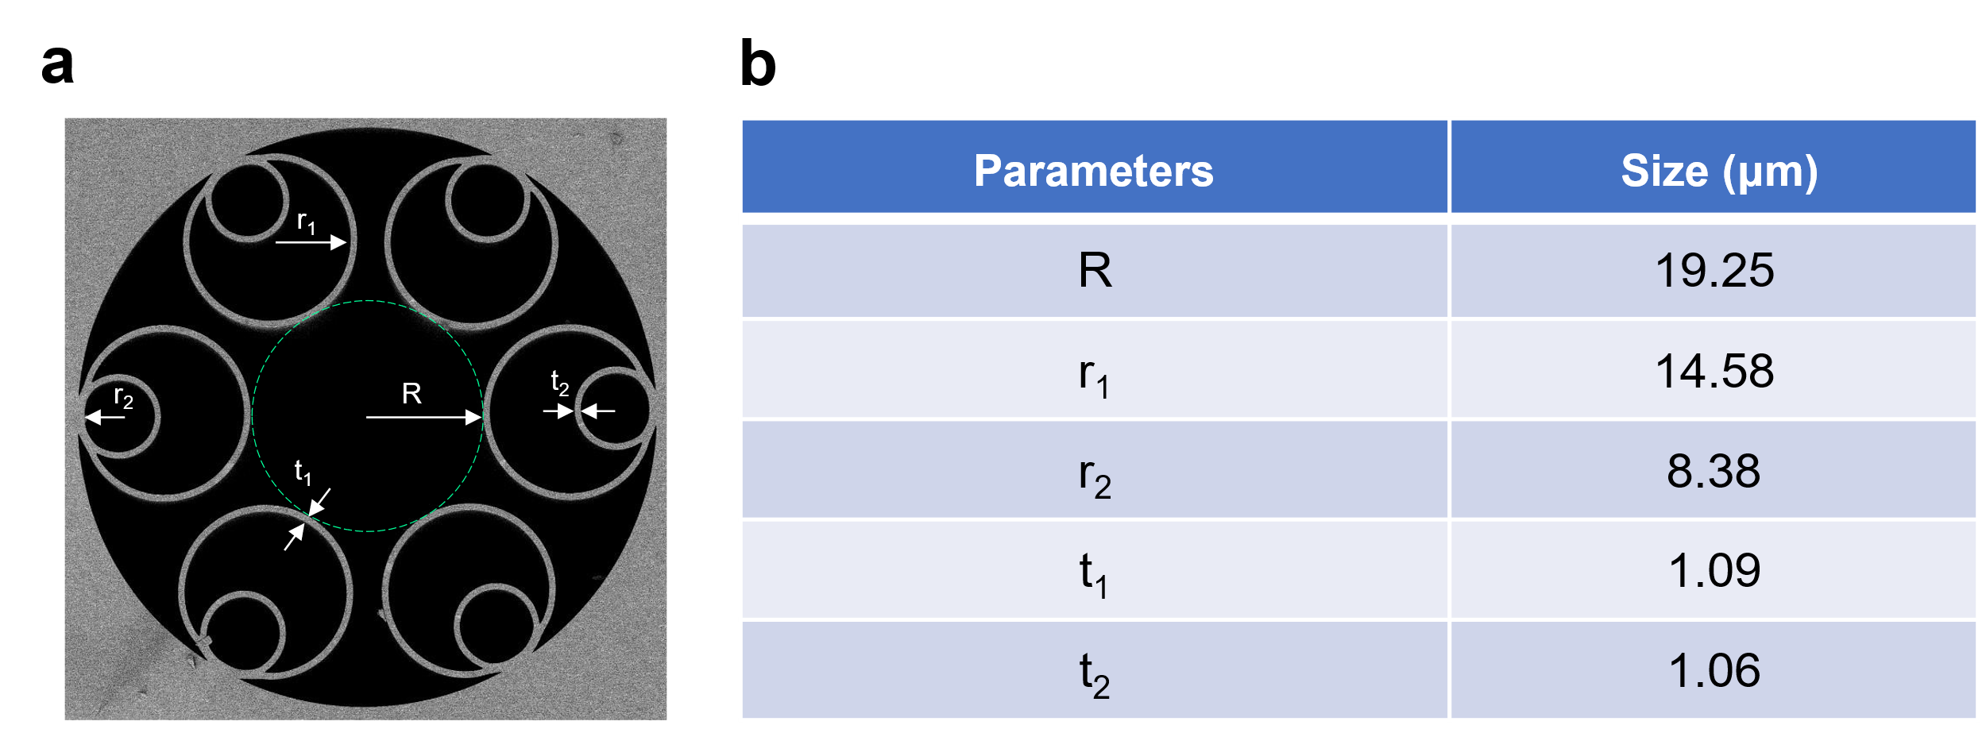
Fig. S1. Design details of AR-HCF. a. The geometric structure and distribution of various parameters. b. Table of values for each parameter.
Furthermore, a polarization beam splitter (PBS) is used to evaluate the linear polarization performance of the homemade AR-HCF.The experimental setup is shown in Fig. S2a. The light from the tunable laser (TL, TOPTICA, CTL 1550_27564) is injected into the AR-HCF, and the maximum and minimum output powers of the P-port and S-port of the PBS can be obtained by fine-tuning the polarization controller (PC), as shown in Fig. S2b. For different wavelengths, the output power at the S port is nearly completely eliminated, while the P port maintains the optimal output power. The polarization extinction ratio (PER) of the laser output is calculated using the maximum power difference obtained from the PBS, as presented in Fig S2c. The PER exceeds 30.96 dB, fluctuating between 30.96 dB and 39.64 dB for different wavelengths. The high PER indicates that AR-HCF can effectively ensure linear polarization characteristics during laser transmission.
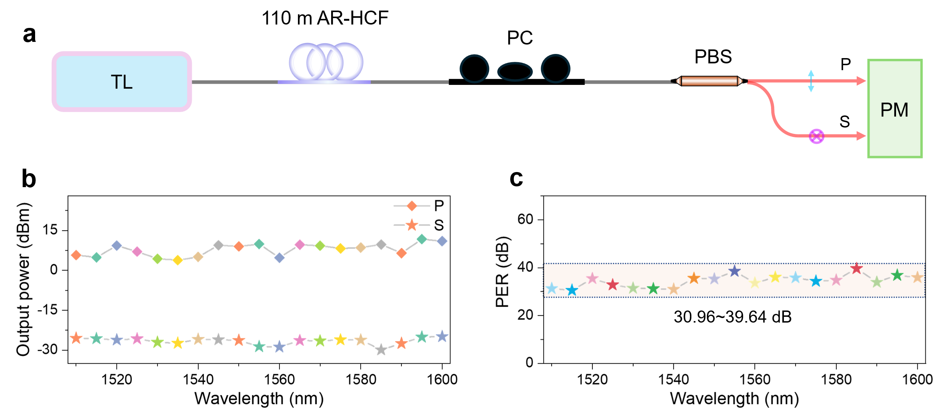
Fig. S2. Linear polarization characteristics of AR-HCF. a. Experimental setup for measuring the polarization extinction ratio. TL tunable laser,PC polarization controller, PBS polarization beam splitter, PM Power meter. b. Output power the PBS (P-port and S-port) versus operating wavelength. c. Variation of polarization extinction ratio (PER) with tuning wavelength.

Supplementary note S2: Numerical simulation of mode-locked fiber laser
To theoretically reveal the relationship between soliton formation, excitation, pulse time-domain splitting, and fiber nonlinearity coefficients and pump power, it is necessary to utilize the Ginzburg-Landau equation (GGLE) combined with the split-step Fourier method. Here, we restrict the model to include only third-order dispersion and neglect the Raman effect, thus the equation describing propagation takes the form [s1, s2]:
(S1)
Where A is the complex amplitude of the electric field, g is the gain coefficient of the optical fiber, α is the transmission loss, Ω_{g} is the gain bandwidth, and γ is the nonlinear coefficient. β₂ is the group velocity dispersion (GVD), and β₃ is the third-order dispersion (TOD). In the model, erbium-doped fiber (EDF) is selected as the gain fiber, and the corresponding parameters are shown in Table S1.
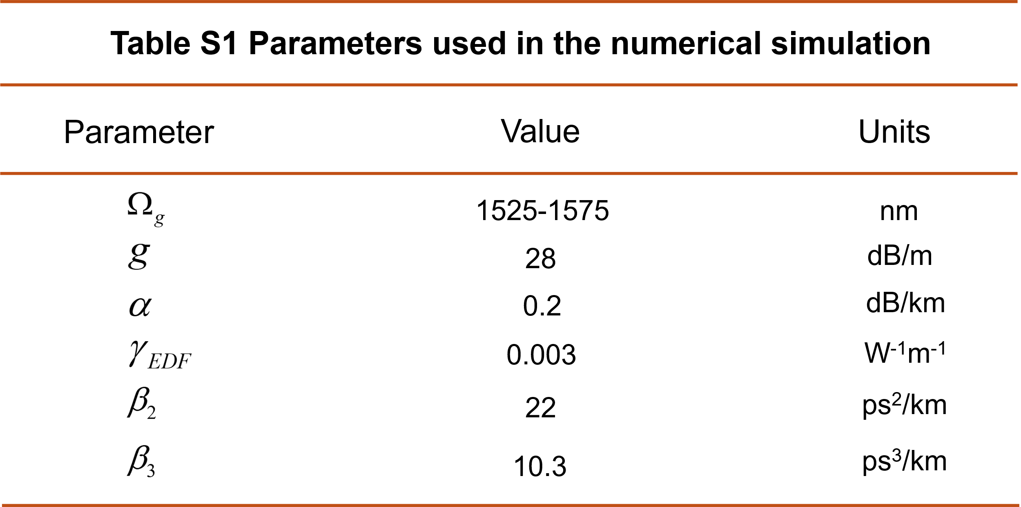
The laser output characteristics caused by different pump energies and the nonlinear coefficients of the undoped fiber in the laser cavity are investigated using a simulation program. Figure S3a-c illustrate the spectral and time-domain pulse evolution when the nonlinear coefficient is 0.0013 W⁻¹m⁻¹, with the pump energy being 0.1 nJ, 0.2 nJ, and 0.3 nJ. It can be observed that when the pump energy is 0.2 nJ, the laser pulse splits and forms soliton molecules, and the spectrum also exhibits jitter. Additionally, it can be concluded that the higher the energy, the more severe the splitting. To investigate the impact of reducing fiber nonlinearity on pulse splitting, the fiber nonlinearity is reduced by an order of magnitude to 0.00013 W⁻¹m⁻¹ in the simulation. The spectral and temporal pulse evolution with increasing pump energy are shown in Fig. S3d-f. Notably, no pulse splitting occurred at a pump energy of 0.2 nJ, and the spectrum remained stable. These simulations demonstrate that reducing fiber nonlinearity effectively suppresses pulse splitting, providing a theoretical basis for reducing the repetition rate of mode-locked lasers using low-nonlinearity AR-HCF.
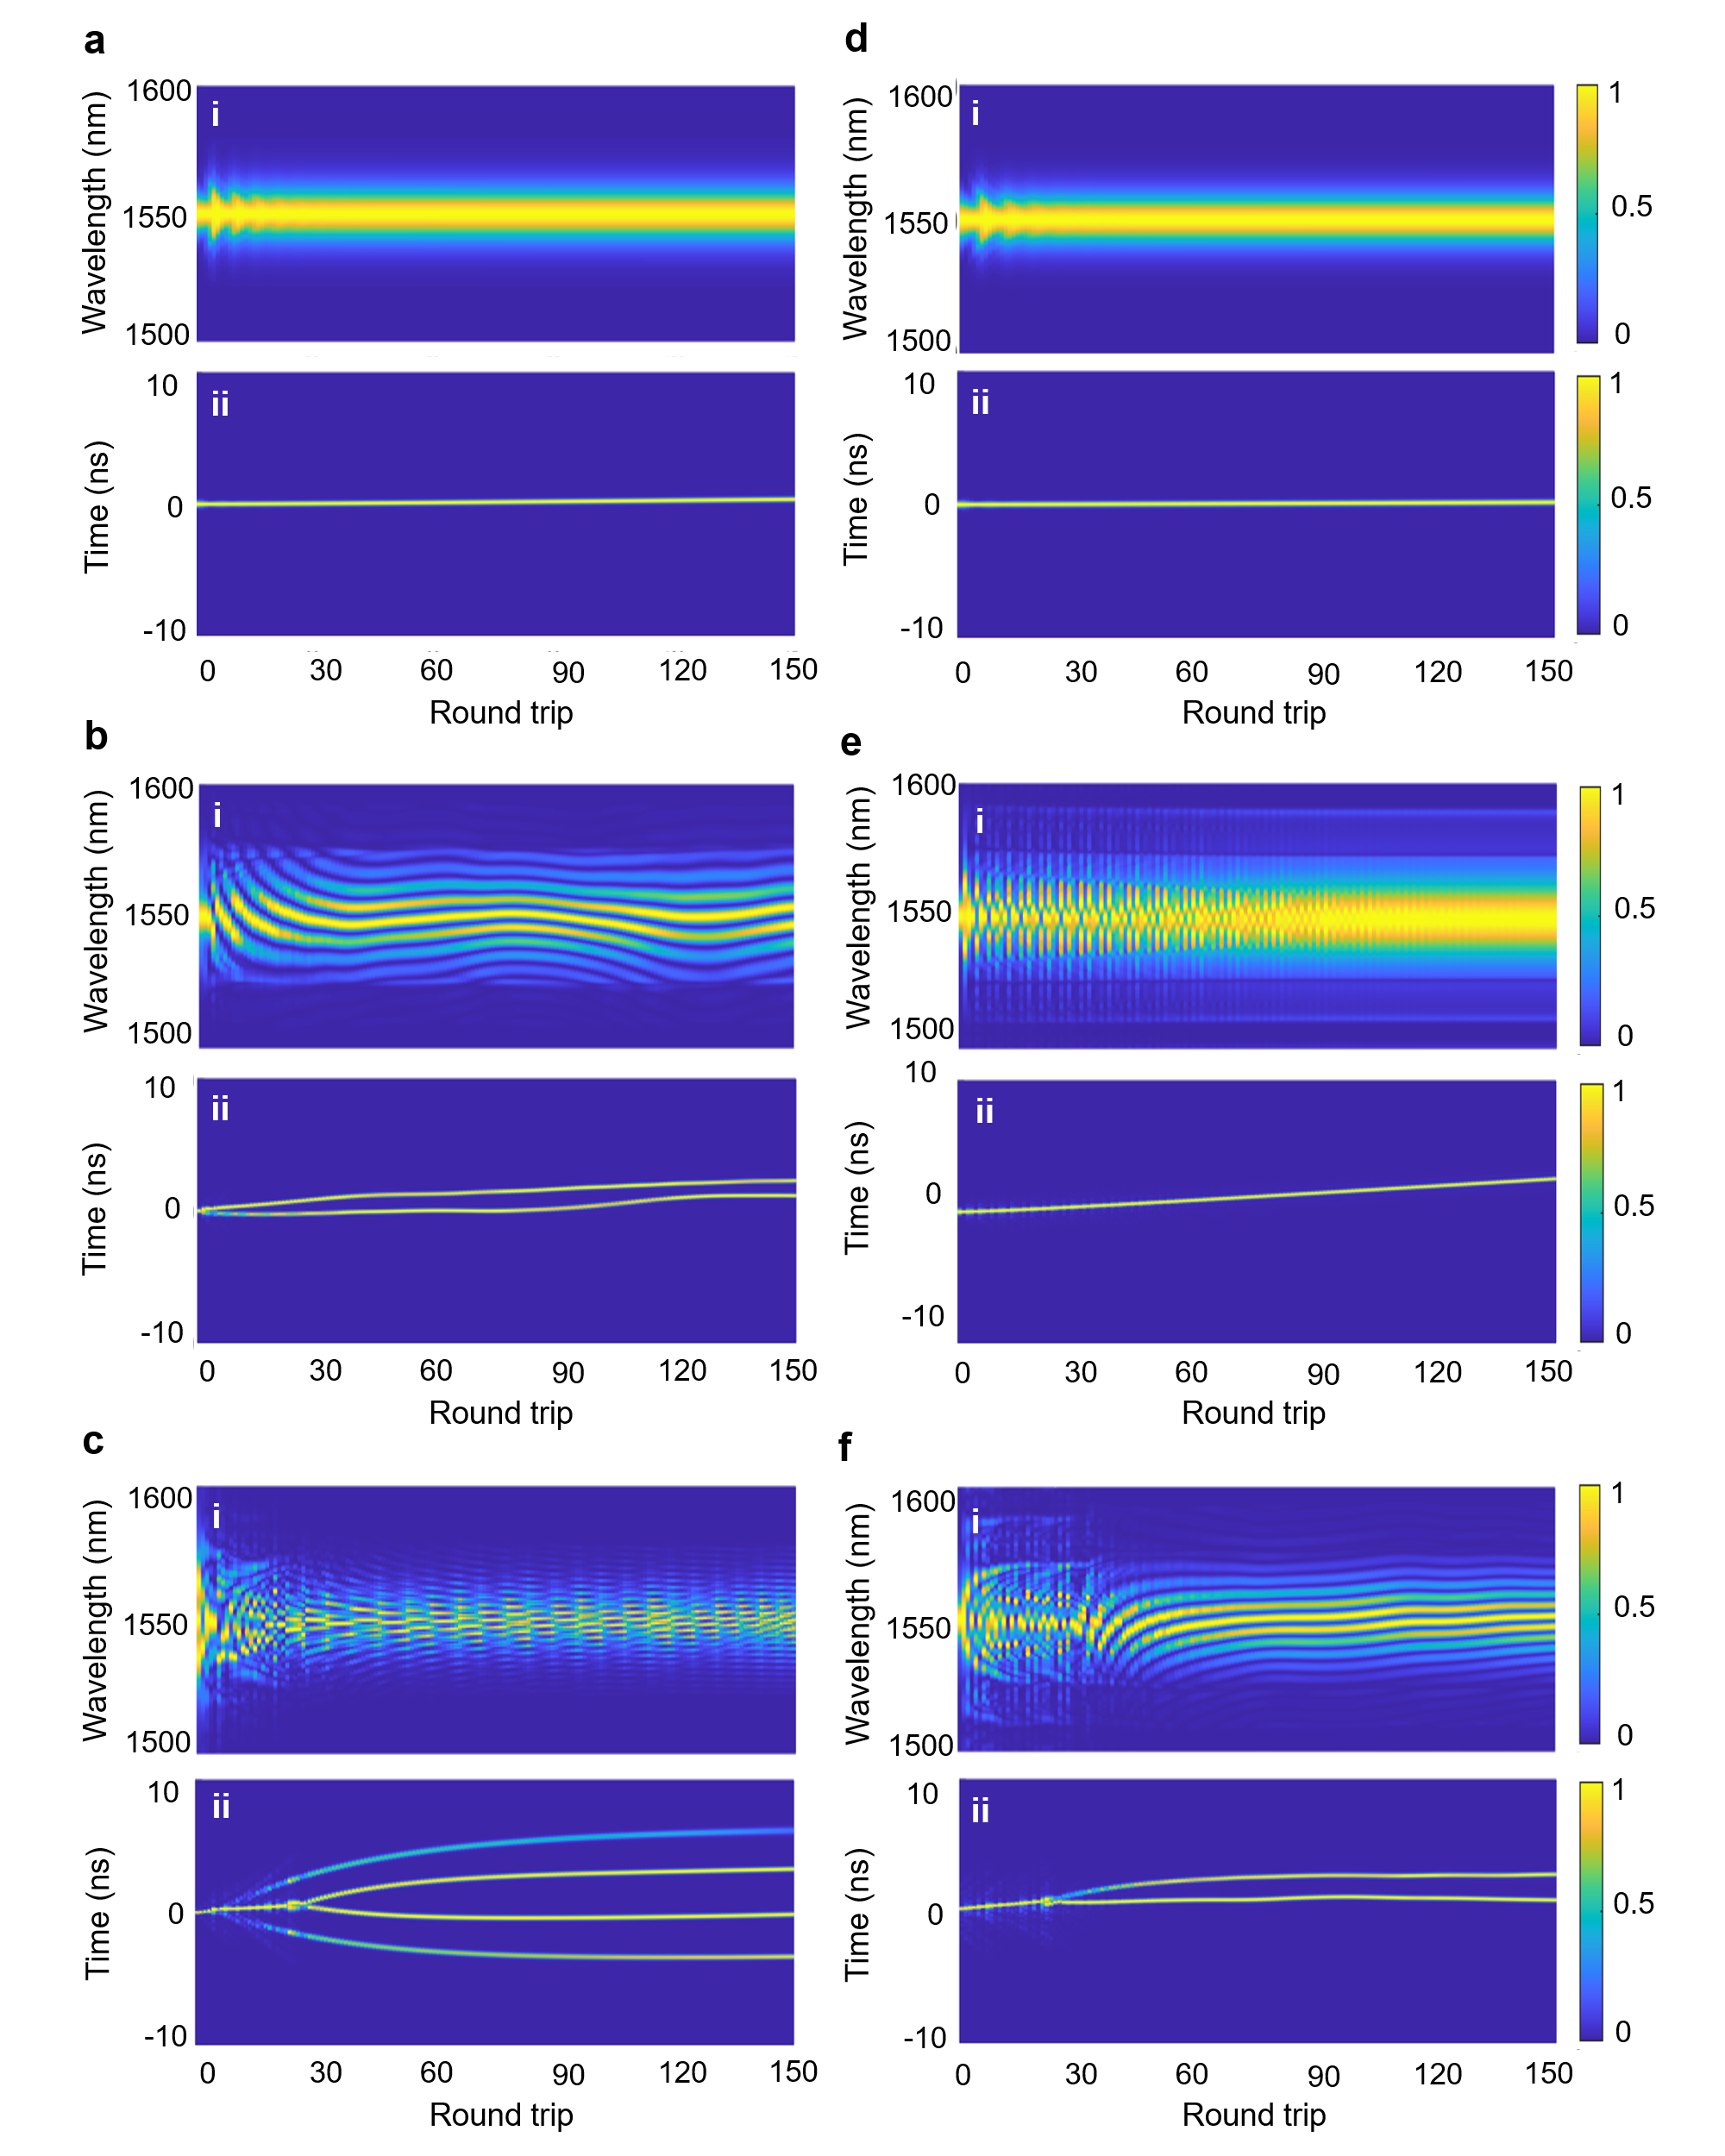
Fig. S3. Numerical simulation of dynamic evolution with different nonlinear coefficients and pump energies. Spectral (i) and temporal pulse (ii) of pump energies are a. 0.1 nJ, b. 0.2 nJ and c. 0.3 nJ when the fiber nonlinearity coefficient is 0.0013 W⁻¹m⁻¹. Spectral (i) and temporal pulse (ii) of pump energies are d. 0.1 nJ, e. 0.2 nJ and f. 0.3 nJ when the fiber nonlinearity coefficient is 0.00013 W⁻¹m⁻¹.
Supplementary note S3: Spectral amplification of time-stretched swept laser
The evolution of the optical amplifier with different pump powers (pump 2) is shown in Fig. S4a. As the pump power increases, the energy of the spectrum increases. To ensure the coherence and performance of the spectrum after amplification, EDFC is carefully designed to avoid nonlinear amplification with new frequencies. Figure S4b shows the output power by increasing pump power, where the slope of the curve gradually decreases due to the saturation. The output power continues to increase until the pump power reaches 515 mW, where power fluctuations occur. Inset i in Fig. S4b shows the spectrum at a pump power of 450 mW. Inset ii in Fig. S4b shows the spectrum at a pump power of 515 mW, where a direct current (DC) peak appears due to the saturation of the amplification.
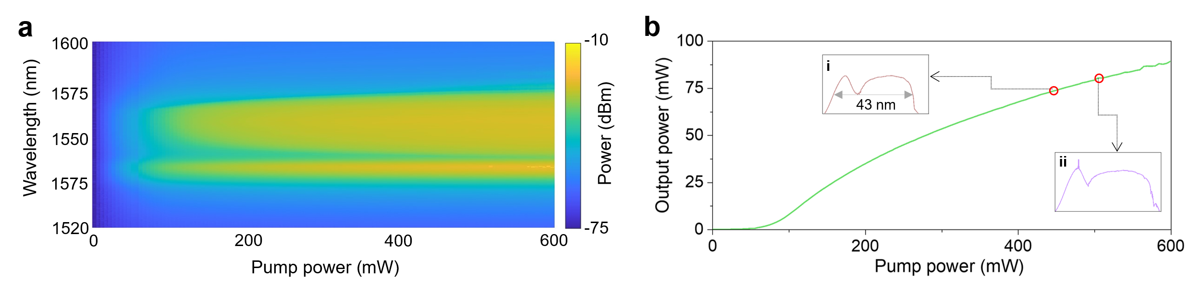
Fig. S4. Spectral amplification of time-stretched swept laser. a. Spectrum charaterization with different pump powers (Pump2) of the EDFC amplification. b. Evolution curve of the output power of the amplifier system with pump power (Pump2). Inset: (i) 450 mW and (ii) 515 mW of amplified optical spectra.
Supplementary note S4: Coherence of time-stretched swept laser
S4.1 Principle of coherence characterization
Time streching is a key technique to generate frequency-swept signal by stretching an ultrashort broadband pulse to a long chirped pulse assisted by dispersion module. The time to wavelength mapping relationship (k) depends on the dispersion, which can be expressed as [s3, s4]:
(S2)
where c is the speed of light in vacuum, L is the length of the dispersion element, and is the dispersion parameter of the dispersion element at different wavelengths. The electric field of the time-stretched swept source can be expressed as:
(S3)
where t is time, A(t) is the amplitude of the signal, ω₀ is the initial optical carrier frequency of the swept source, and φ(t) is the residual phase caused by noise. Here, a delayed self-heterodyne interferometer is used to down-convert the optical frequency of the swept source. The sweep signal passing through the reference arm is defined as:
(S4)
where A₁(t) is the amplitude of the swept laser passing through the reference arm. In addition, the swept laser signal passing through the delay light path should be expressed as:
(S5)
Here, τ is the delay time compared to the reference signal, and A₁(t-τ) is the amplitude of the swept laser signal passing through the delayed optical path. The beat signal of the interferometer by the photodetector can be expressed as:
(S6)
According to the Eq. (S6), the phase of the beat signal can be obtained as:
(S7)
The phase accumulated by the frequency sweep of the time-stretched swept laser deterministically changes over time, and random white noise can be eliminated by averaging multiple measurements [s5,s6]. Therefore, the accumulated phase can be expressed as:
(S8)

where N represents the number of phase measurements. Note that a larger value of N results in higher accuracy. The beat phase can be obtained by unwrapping the detected interference signal using the Hilbert transform. Therefore, the residual phase jitter (RPJ) can be obtained by deducting the accumulated phase from the frequency scanning as:
(S9)
Here, Δφ_{k} is the RPJ of the k-th sample signal. The instantaneous frequency jitter can be obtained by taking the derivative of RPJ as:
(S10)
Therefore, the power spectral density (PSD) of the frequency noise can be obtained by Fourier transform as [s7-s9]:
(S11)
Where S_{Δφ}(f) is the single-sideband PSD of phase noise, and k and S₀ are constants. In laser linewidth measurement, the Lorentzian spectrum caused by high-frequency white noise is usually used as the basis for characterizing the intrinsic linewidth of the laser. Therefore, the high-frequency white noise in the frequency noise PSD can be used to accurately calculate the intrinsic linewidth of the laser, which can be expressed as [s10]:
(S12)
S4.2 Experimental measurement of RPJ and intrinsic linewidth
Based on the above principle, the phase information can be demodulated from the interference signal. Then, the RPJ is calculated using the average deduction method of Eq. (S8) to obtain the unwrapped phase of multiple cycles. In the experiment, the number of averages N = 50 is sufficient to obtain accurate phase difference information [s6]. Figures S5ai-ei show the temporal evolution of the measured RPJs at delay of 0.26 m, 0.52 m, 0.78 m, 1.04 m, and 1.30 m, respectively. It can be seen that RPJ fluctuates around zero and increases with distance. This is because a long delay distance increases the statistical duration of noise in the time domain and then increases low-frequency phase noise components (such as 1/f noise). Figures S5aii-eii show the statistical probability density functions (PDFs) of the RPJ for different delays, respectively. The red curves represents a Gaussian fitting of the PDFs. The RPJ distribution becomes wider and the R² value approaches 1 as the delay increases, which demonstrates that the phase noise is caused by Gaussian noise in the low-frequency band. Therefore, it is necessary to further characterize the frequency noise power spectral density (FNPSD) in the high-frequency band to measure the noise level and coherence of the swept laser. Figures S5aiii-eiii show the PSD at different delays. The high-frequency noise of the proposed swept laser is measured to range from 2870 Hz/Hz to 97 Hz²/Hz. Figure S5f shows the relationship between the average standard deviation of the RPJ and the delays after 50 averaging times. The intrinsic linewidth of the time-stretched swept laser can be estimated from the high-frequency noise using Eq. (S12), which is shown in Fig. S5g. The results show that frequency noise and intrinsic linewidth are highly correlated with the delay. As the distance increases, the noise floor decreases and the intrinsic linewidth becomes narrower. This is because increasing the delay improves the resolution of the frequency noise measurement. However, too long length difference will also introduce a greater RPJ and deterirate the measurement results. Therefore, a reasonable delay should be selected to acuuratetely measure the frequency noise. Typically, a delay between 1 m and 10 m is used for laser frequency noise measurement. Here, the high-frequency noise floor of the swept laser is 97 Hz²/Hz, corresponding to an intrinsic linewidth of 305 Hz, comparable to the measured linewidth of a mode-locked fiber optic transmitter [s11, s12].
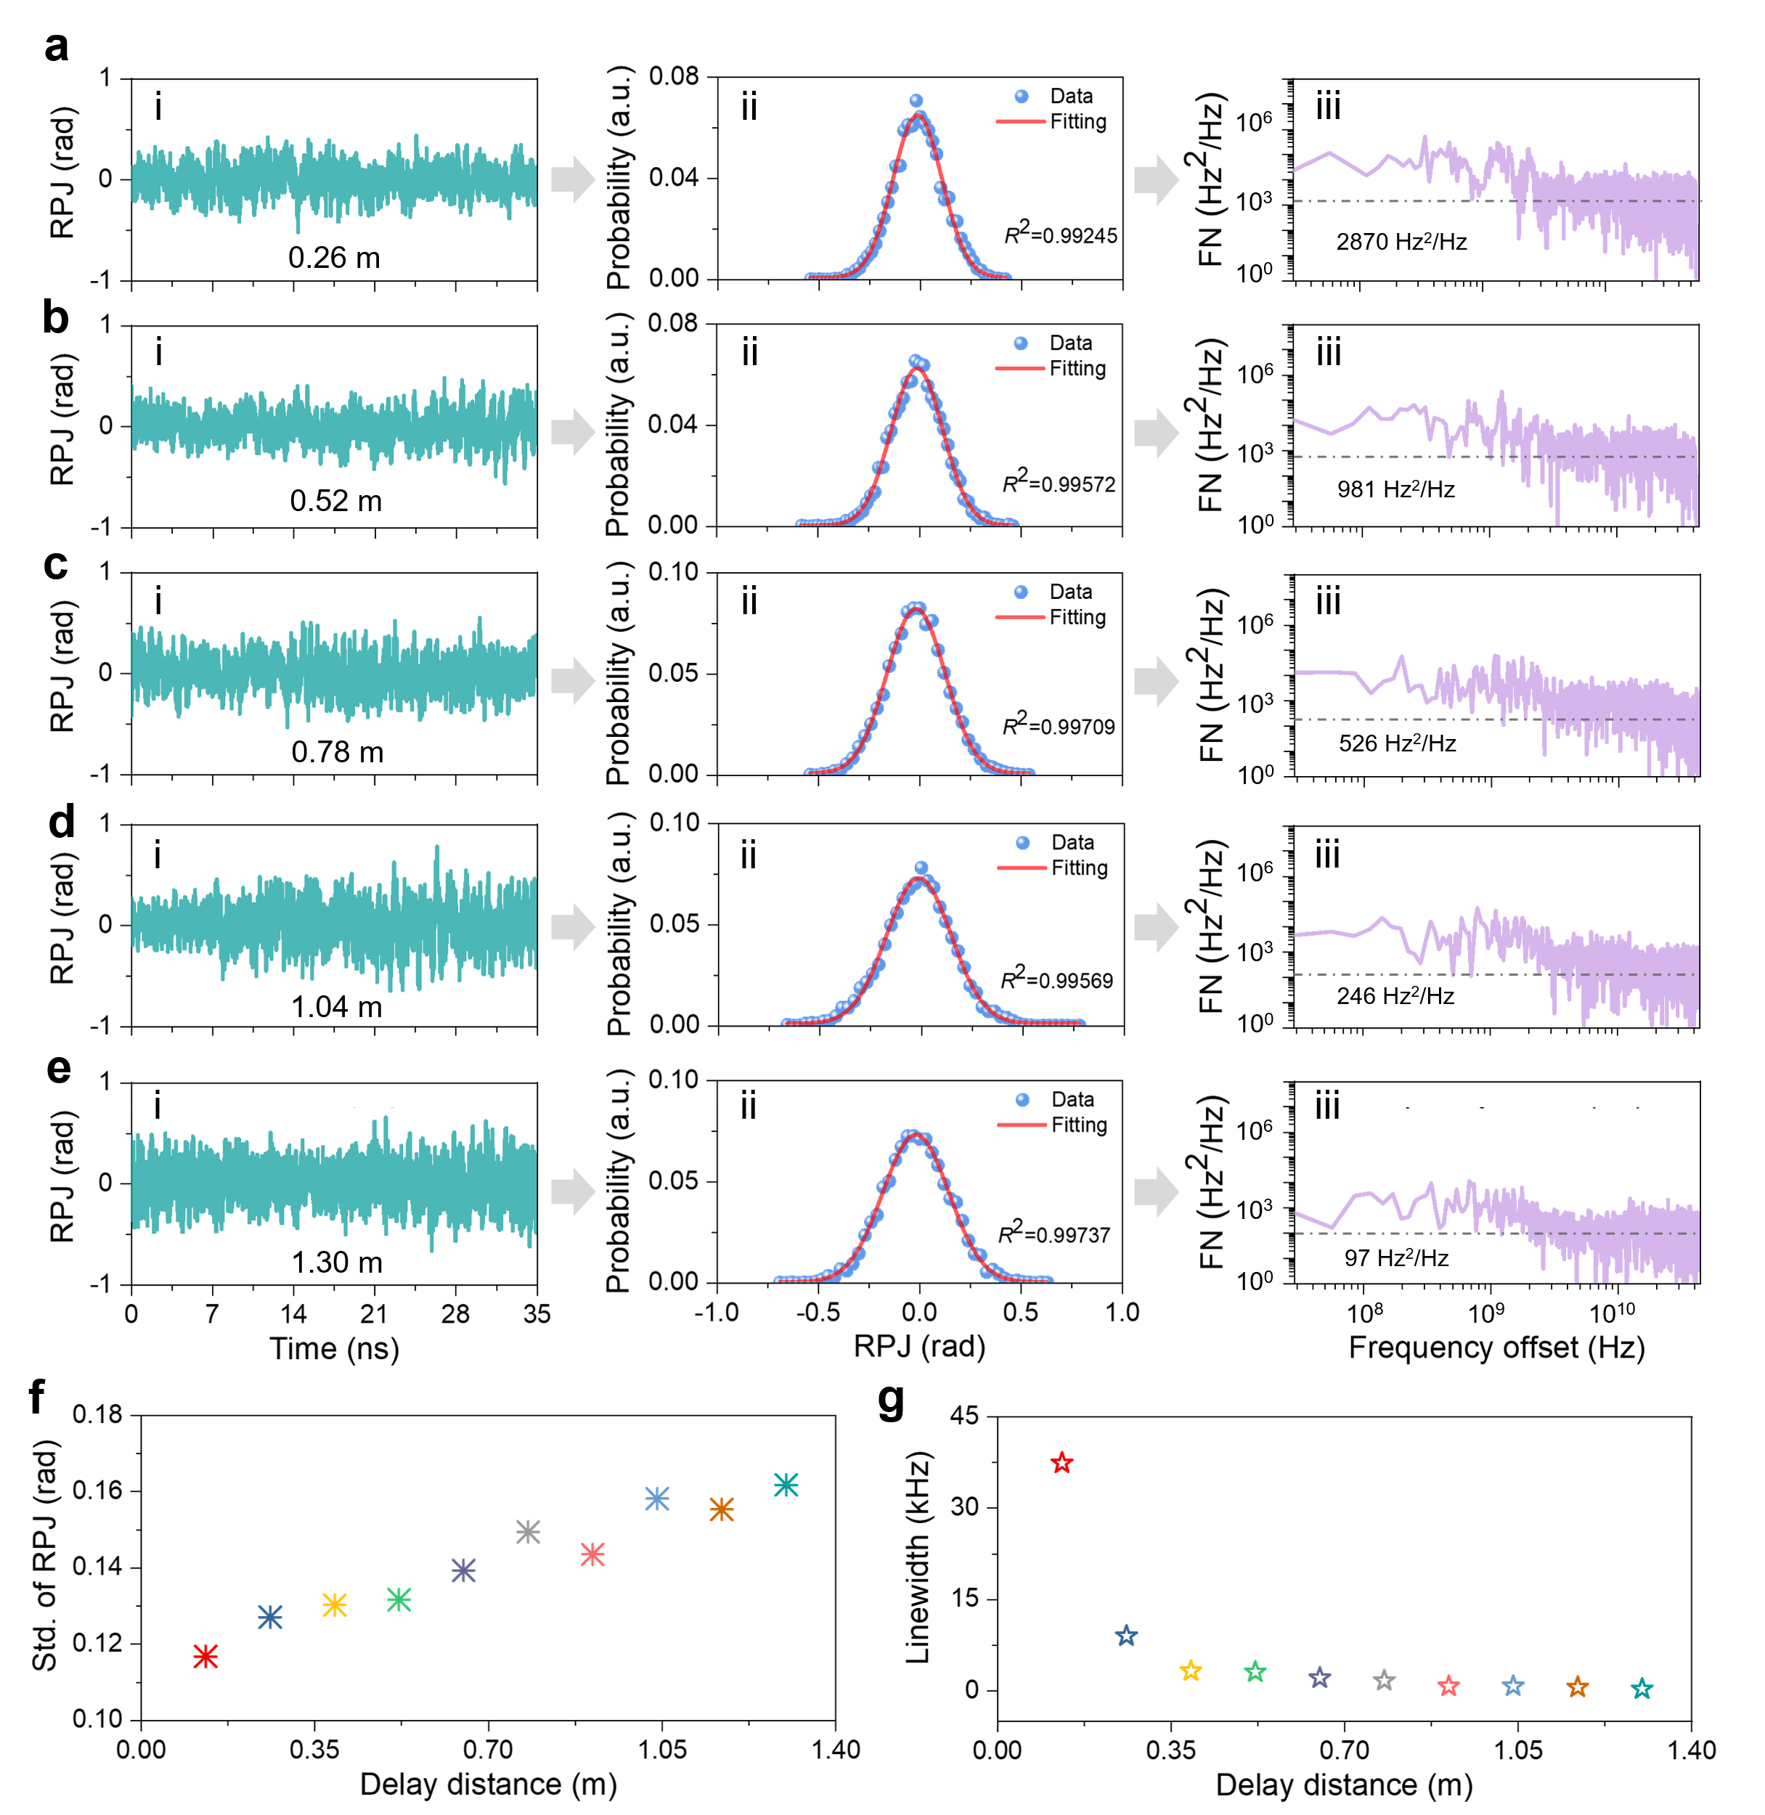
Fig. S5. Experimental study of RPJ and frequency noise of time-stretched swept laser. ai-ei. The single-shot RPJs obtained through the 50-times average deduction method, aii-eii. the corresponding PDFs of the RPJs , and aiii-eiii the corresponding frequency noise PSD curves at the delay distance of 0.26 m, 0.52 m, 0.78 m, 1.04 m and 1.30 mm, respectively. f. The average standard deviations of RPJs and g. intrinsic linewidths versus the delay distance.

Supplementary note S5: Characterization of SS-OCT system
S5.1 Detailed measurement distance
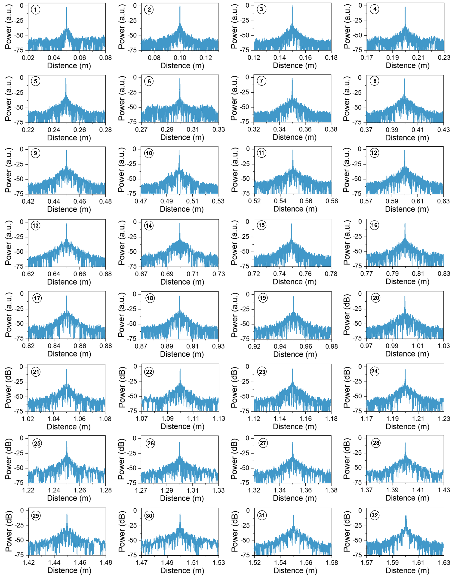
Fig. S6. Experimental measurement of various distances. The measured PSFs at different positions.
To comprehensively verify the performance of the constructed swept source in OCT system, 32 sets of point spread functions (PSFs) are measured within the range of 0.05 m to 1.60 m, as shown in Fig. S6. These results demonstrate the promising for long-range OCT imaging with megahertz imaging speed, which will contribute to the applications of OCT especially for large organ diagnosis and industrial inspection. However, the signal-to-noise ratio (SNR) will decrease as the distance increases due to the accumulation of the noise.
S5.2 Sensitivity of SS-OCT system
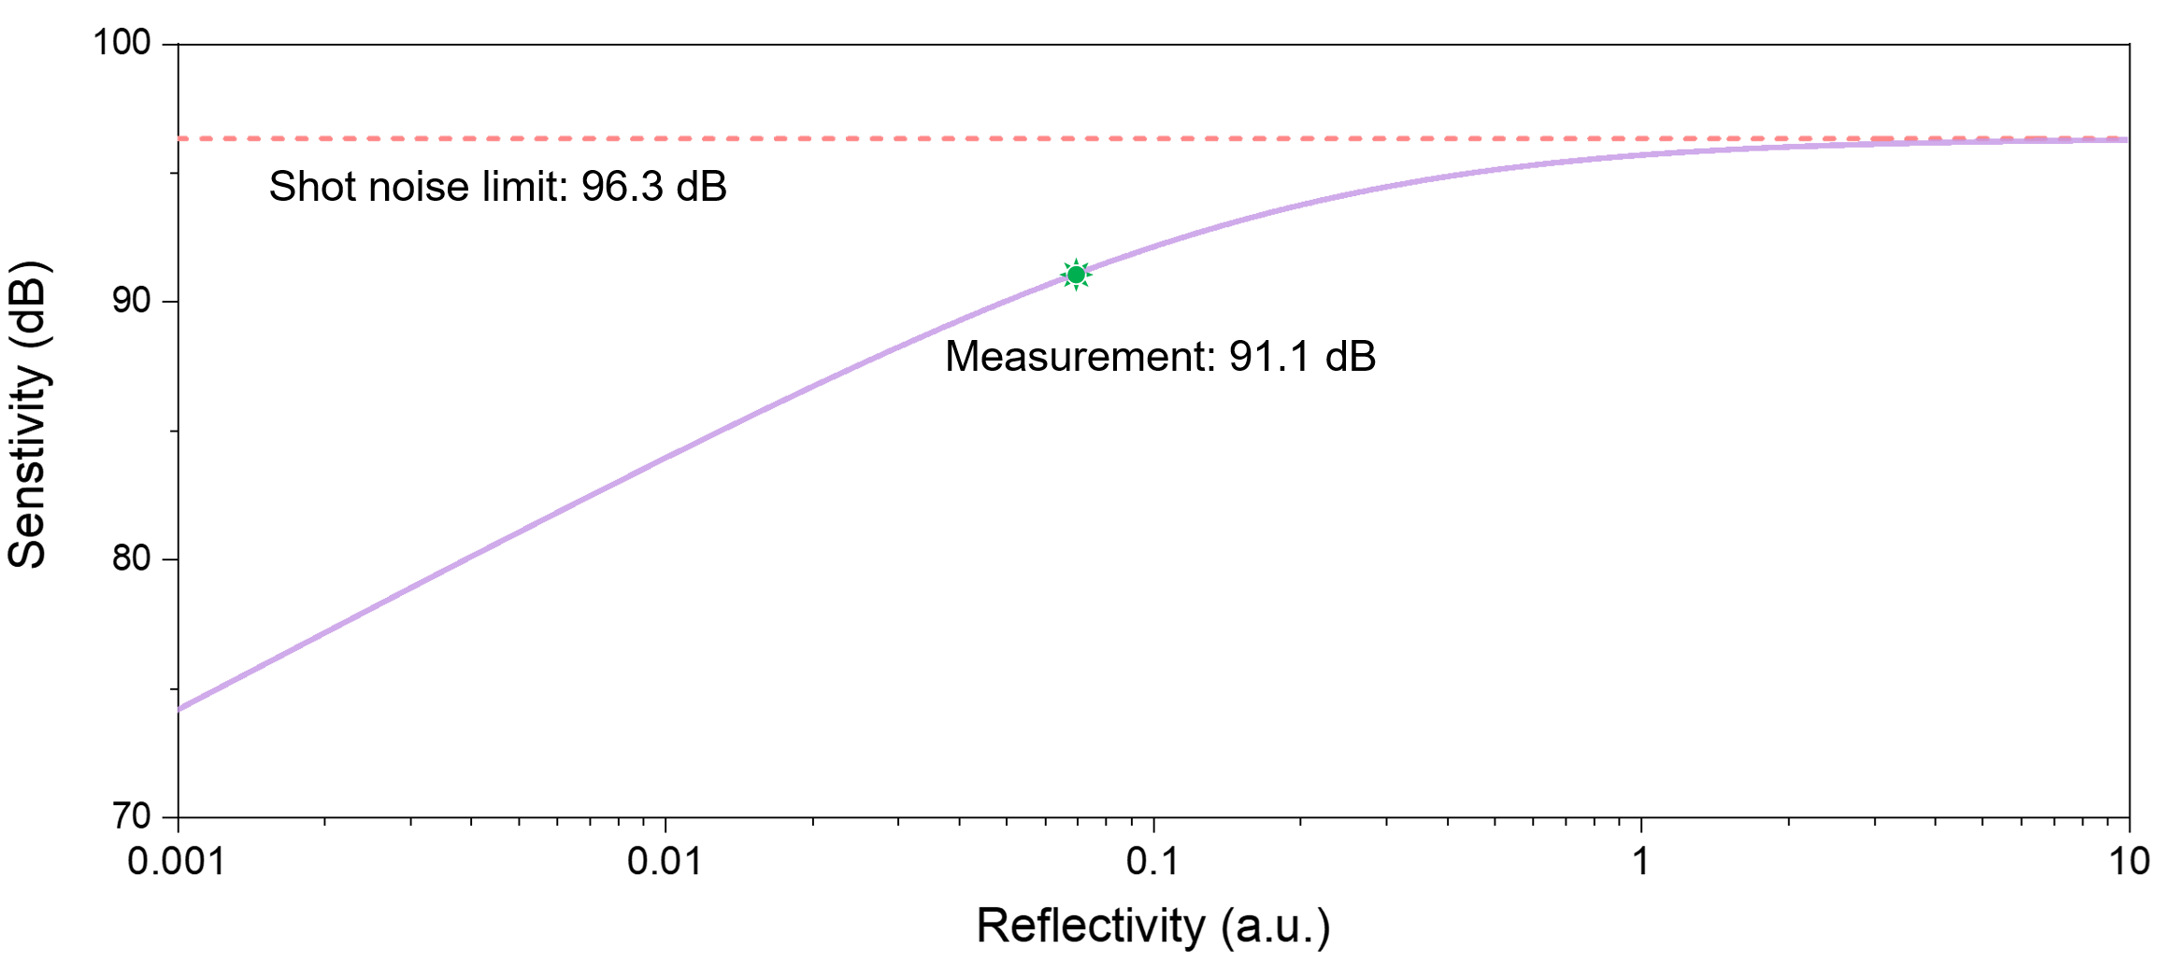
Fig. S7. sensitivity of the SS-OCT system. The theoretical sensitivity with respect to reflectivity and the shot noise limit of the detection system.
The sensitivity of the SS-OCT system with 2.63 MHz imaging speed is measured using a self-built coherent detection system. Theoretically, the sensitivity of the detection system is a function of the reflectivity R_{s} of the signal arm, which can be expressed as [s13, s14]:
(S13)
where the number of sampling points per round trip for a single-shot interferometer spectrum N =75772, the quantum efficiency of the photodetector (PD) η = 0.32, the sampling time τ_{s}= 378 ns, the output power of the swept laser P₀ = 75 mW, The frequency of the central wavelength ν₀ = 1.935×10¹⁴ Hz, and the transmission efficiency ratios of the reference and sample arms γ_{r} = 0.1 and γ_{s} = 0.06, respectively. The PD receiver noise σ_{rec} = 6.32×10⁶. When the relative intensity noise (RIN) of the detection systemis is less than 1×10⁻⁴, the measured value agrees well with the theoretical value. h is Planck constant. The calculated shot noise limit of this SS-OCT system is as high as 96.3 dB, as shown in Fig. S7. Due to optical coupling losses and the influence of environmental noise in the experiment, the measurment sensitivity is 91.1 dB. This sensitivity demonstrates that the developed time stretched swept source has low noise.
Supplementary note S5: Fast spectral measurement
Real-time high-resolution measurement of fast non-repetitive events is desirable and challenging for the field of measurement [s15, s16]. Traditional spectrometers are limited by mechanical scanning and can only measure static or slowly varying spectrum (kHz level), making it difficult to capture the fast dynamic processes of the spectrum. Fast spectrum detection provides a way to characterize the transient parameters, which test the performance and dynamics of the optical passive devices. The dispersive Fourier transform (DFT) overcomes the speed bottleneck of traditional spectrometers, enabling high-speed, real-time spectral detection [s17]. which has been widely applied in sensing. One typical application of DFT is real-time capture of the dynamic characteristics of absorption and Raman spectra, which cannot be obtained by traditional spatial spectrometers. The time-frequency spectrum of a pulse propagating through a group velocity dispersive (GVD) element is mapped into a time-domain waveform, whose intensity envelope precisely matches with the spectral characteristics. However, the spectral detection resolution of current DFT spectrometer is limited by the detector bandwidth and dispersion, which is still far below the resolution of traditional spectrometers [s18, s19]. Large dispersion module has high loss, so high-energy pulses are required as the input for DFT system. Secondly, to achieve broadband spectral detection, coherent broadband pulse is also required. To solve the limited bandwidth of the photodetector, low-repetition-rate pulse and large dispersion are required to realize high spectral resolution. Therefore, it is desirable to develop high-energy, low-repetition-rate and broadband mode-locked light sources.
This fast and high-resolution spectrometer is demonstrated for the measurement of optical devices. Figures S8a, c show the spectral evolution of 500 round trips when the FFP-TF is driven by a 42.4 kHz sinusoidal signal at the driving voltages of 2 vpp and 6 vpp, respectively. Furthermore, increasing the voltage expands the spectral sweep range. To verify the accuracy of the DFT spectrometer measurements, the transient spectra measured are averaged and compared with those obtained by the OSA. The results are shown in Fig. S8b, d. At different driving voltages, the average spectrum measured by the DFT method matches well with all OSA measurements. The wavelength scanning ranges of the FFP-TF under the two voltages are 3.48 nm and 9.72 nm, respectively, which is consistent with the expectation that the scanning range will be larger as the voltage increases.
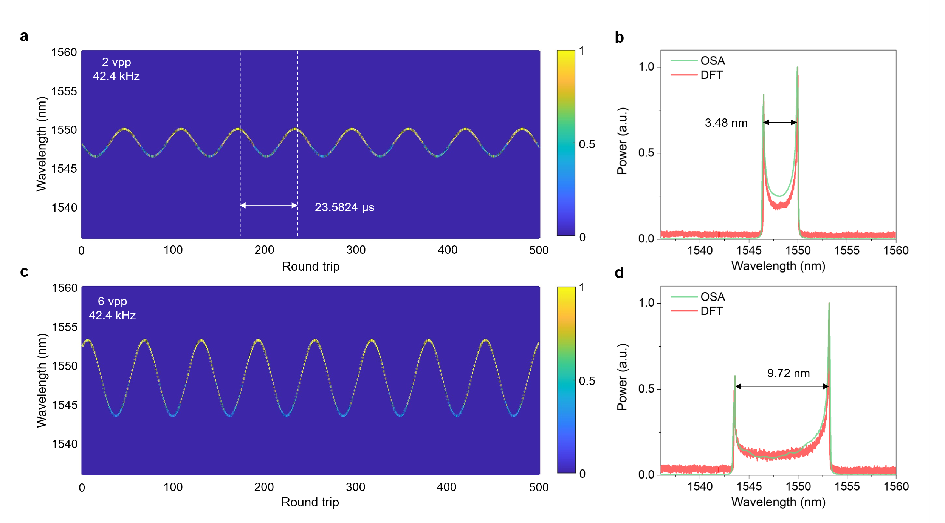
Fig. S8. Fast high-resolution spectral characterization based on dispersive Fourier transform assisted by a self-built MHz-level swept source. Single-shot spectral evolution of the FFT-TF with a driving frequency of 42.4 kHz under the driving voltages of a. 2 vpp and c. 6 vpp. b, d, Comparison of the average spectra obtained by DFT and OSA at different driving voltages.
Supplementary note S7: Fast vibration measurement
S7.1 Principle of vibration measurement
Here, we utilize a coherent detection system to detect weak vibration signals. To improve the SNR of the measured signal, a balanced detection approach is used to eliminate the DC component and suppress common-mode noise. Based on Eq. (S6), the interference signal generated by the balanced detection of the two arms can be expressed as:
(S14)
Here, the RPJ φ(t)- φ(t-τ) ˂˂ 2πkτt, assuming ω₁=2πkτ, φ₀=ω₀τ-πkτ², and I₀(t)=4A₁(t)A₂(t) which is the time domain envelope of the interference signal. Therefore, Eq. (S14) can be simplified as:
(15)
Performing Fourier transform on the interference signal I(t) yields:
(16)
where F₀(ω) is the Fourier transform of I(t). The detection frequency range of F₀(ω) is inversely proportional to the sweep duration with the MHz level. kτ is the frequency of the beat signal and is in the GHz level, which is much larger than the detection frequency range of F₀(ω). It can be obtained that F₀(ω₁) and F₀(-ω₁), F₀(2ω₁) and F₀(-2ω₁) are all extremely small values approaching zero. Therefore, two components appear in the Fourier transform spectrum at ω=ω₁ and ω=-ω₁, eliminating the influence of the zero-frequency DC component. Finally, based on Eq. (S16), it can be derived that:
(17)
Therefore, the phase change introduced by the vibration signal can be expressed as:
(18)
Accordingly, the timing jitter caused by the fast vibration signal can be calculated as the phase change, which can be expressed as [s20]:
(19)
The PSD of timing jitter can be obtained through Fourier transform:
(20)
where T is the duration of the timing jitter signal.
S7.2 Experimental measurement of fast vibration
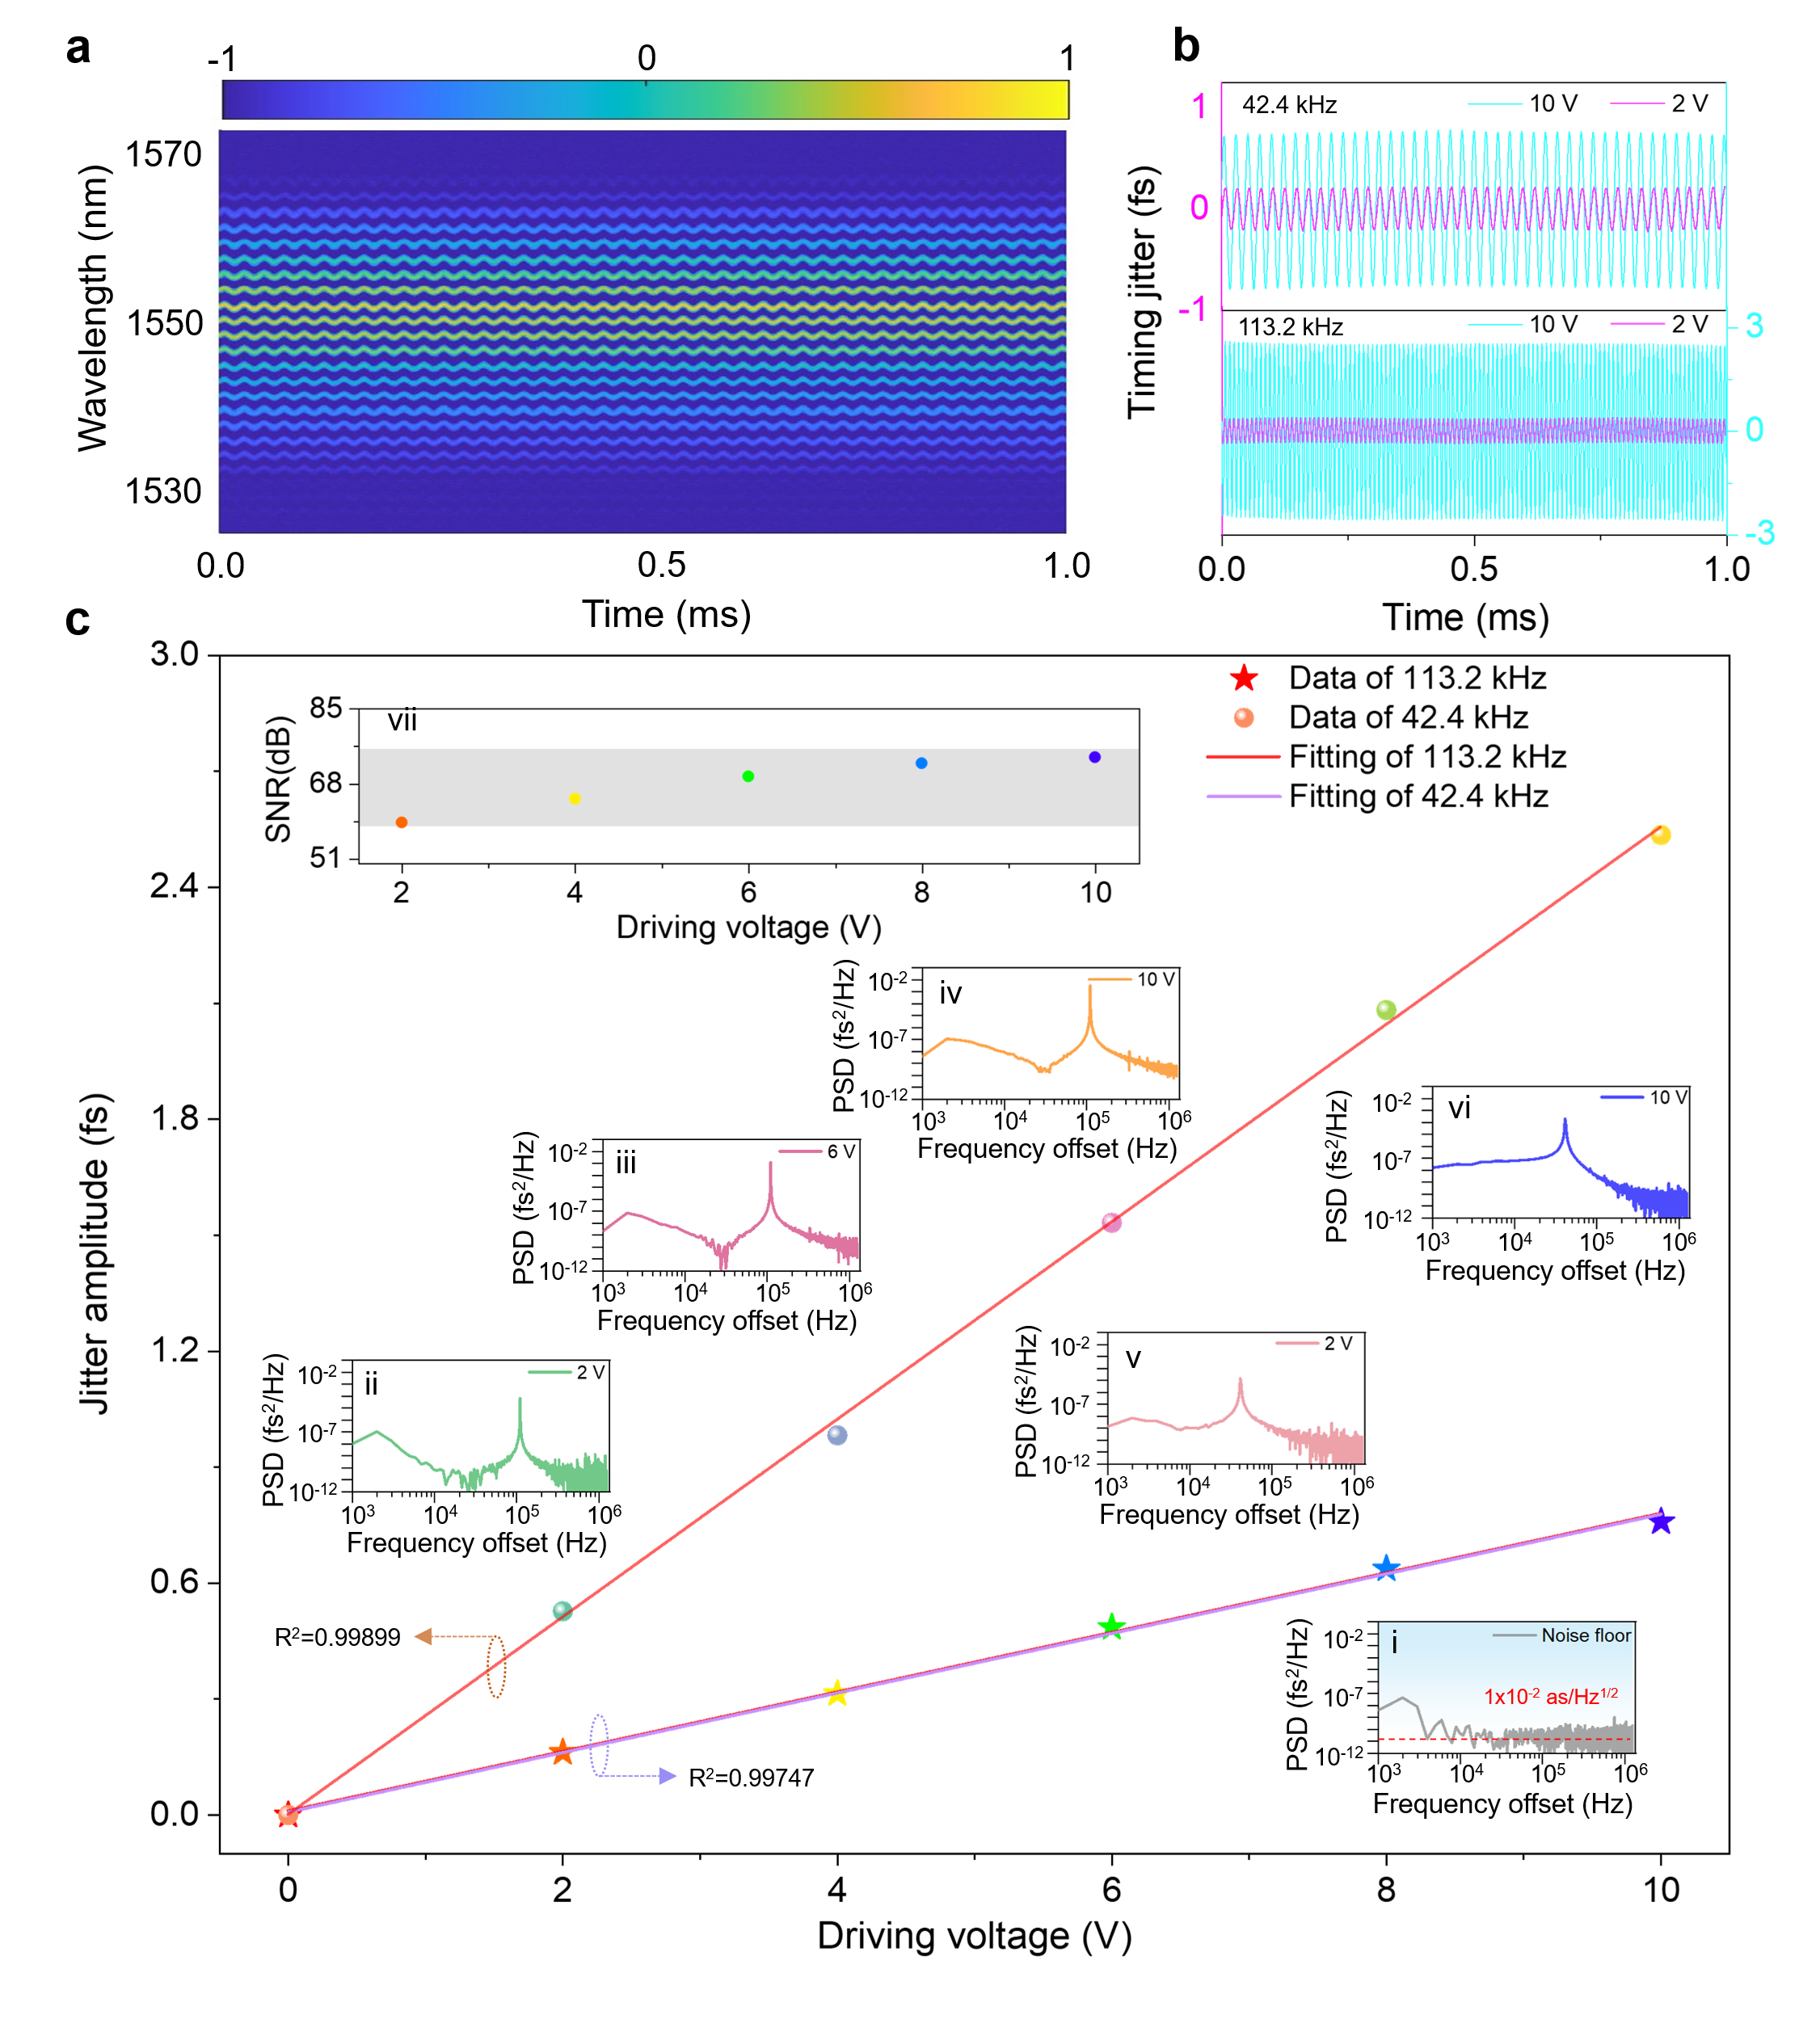
Fig. S9. Fast high-resolution spectral characterization based on dispersive Fourier transform assisted by a self-built MHz-level swept source. Single-shot spectral evolution of the FFT-TF with a driving frequency of 42.4 kHz under the driving voltages of a. 2 vpp and c. 10 vpp. b, d, Comparison of the average spectra obtained by DFT and OSA at different driving voltages.
Then, a sinusoidal electrical signal is applied to the piezoelectric transducer (PZT) to introduce vibrations. The single-shot spectroscopy detection technique based on the fast swept source can obtain a 2D interferogram generated from 2634 consecutive measurements within 1 ms (Fig. S9a), with a spectral refresh rate of 2.63 MHz. We can demodulate the timing jitter signals with driving frequencies of 42.4 kHz and 113.2 kHz from the evolution interference spectra (Fig. S9b). When the driving voltage is 2V and 10V, the signal amplitude increases with the voltage peak-to-peak (Vpp) value. The evolution curve of the timing jitter amplitude as the driving voltage increases is further calculated, as shown in Fig. S9c. The linear fitting degrees are 0.99747 (42.4 kHz) and 0.99899 (113.2 kHz), and the fitted measurement sensitivities are 77 as/V (42.4 kHz) and 256 as/V (113.2 kHz). It can be inferred that the response of the PZT at a frequency of 113.2 kHz is superior to that at 42.4 kHz. The corresponding PSD can also be calculated using the obtained timing jitter signal. To demonstrate that the method used can accurately detect vibration signals, the noise floor of the system is further characterized (inset i of Fig. 5g), with a minimum detection limit of 1×10⁻² as/Hz^{1/2}. We present the PSDs of the two driving frequencies at a specific voltage (the inset ii-vi in Fig. S9c), from which all the signal peaks are above the noise floor, thus ensuring that the signals have been effectively detected. When the driving frequency is 113.2 kHz, the SNR of the PSDs for detecting the vibration signal increases from 59 dB to 74 dB (inset vii of Fig. S9c). The results confirm that the test system can achieve accurate detection of as-level timing jitter signals, with a resolution sufficient to perceive nanometer length difference in the signal arm.
Figures S10ai-fi show the statistical histograms of 2634 beat-frequency interference spectra generated by the coherent detection system within 1 ms under different drive voltages. The shape of the interference pattern changes significantly with increasing the driving voltage, indicating that vibration signals of different amplitudes cause varying degrees of jitter in the interference pattern. The interference spectrum is Fourier transformed to obtain the first-order autocorrelation spectrum. The corresponding autocorrelation spectrum is statistically analyzed, as shown in Fig. S10aii-fii. Here, balanced detection results in only two components in the autocorrelation spectrum without a zero-frequency component, which is consistent with the description in Eq. (S16). Since it is a weak vibration signal, it is impossible to directly observe the obvious changes in the correlation peaks from the auto-correlation spectra of different vibration amplitudes. Therefore, to precisely detect fast weak vibration signals, the phase information from the correlation peaks is further extracted, thereby calculating the timing jitter signal, as shown in Fig. S10aiii-fiii. In particular, the noise floor of the timing jitter can be calculated as shown in Fig. S10aiii when no driving voltage is applied. The standard deviation of the noise floor is as low as 6.8 as, indicating that the system could detect as-level timing jitter. To provide a more intuitive and detailed analysis of the vibration signal, the PSDs of the timing jitter for different driving voltages are calculated according to Eq. (S20), as shown in Fig. S10aiv-fiv. To estimate the detection limit, the PSD of the noise floor is plotted in Fig. S10aiv. The noise distribution becomes relatively flat in the frequency range of 10 kHz to 1.315 MHz. As shown by the gray dashed line, the average noise baseline in this frequency offset region is approximately 1×10⁻² as/Hz^{1/2}.
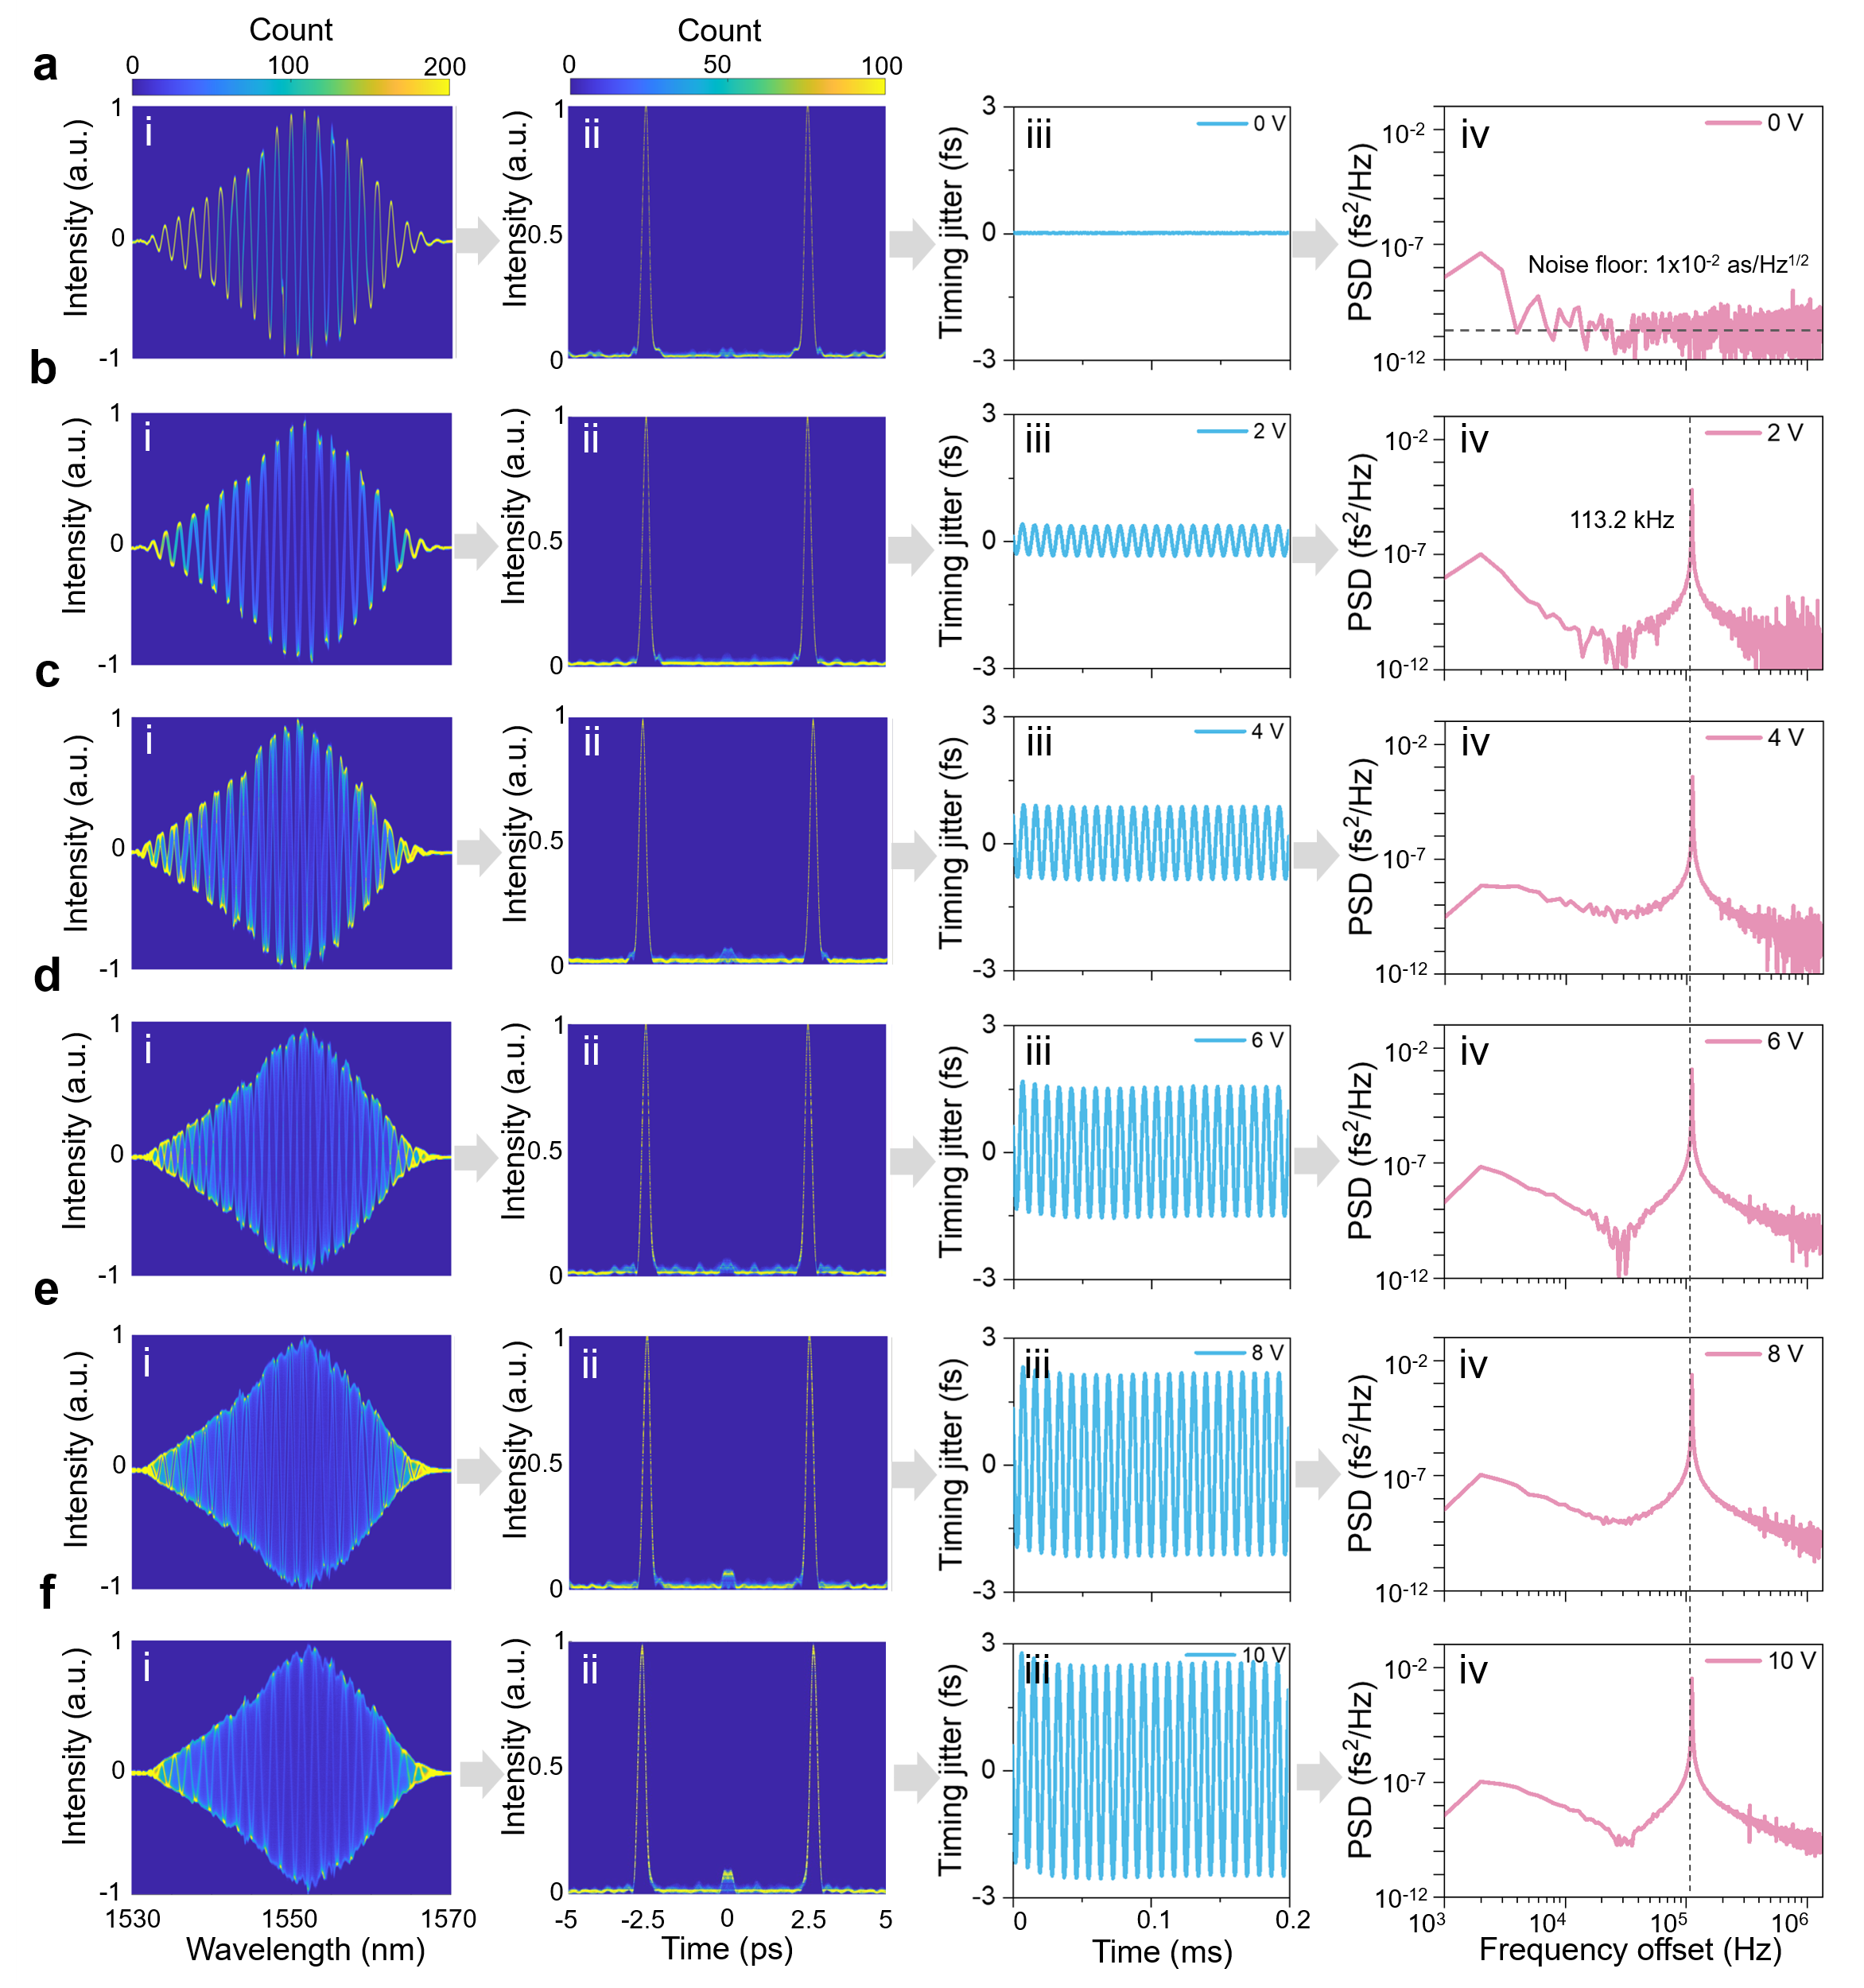
Fig. S10. Experimental measurement of vibration signals induced by PZT in the coherent detection system. ai-fi. 2D statistical histogram of interference signals under different driving voltages. aii-fii. Statistical pseudo-color maps of the Fourier transform of the interference spectra. aiii-fiii. The detected timing jitter induced by the vibration signal. aiv-fiv. PSDs of the timing jitter with various driving voltages.
Supplementary reference
- Liu, X. Dynamic evolution of temporal dissipative-soliton molecules in large normal path-averaged dispersion fiber lasers. Phys. Rev. A 82, 063834 (2010).
- Bale, B. G., Kieu, K., Kutz, J. N. & Wise, F. Transition dynamics for multi-pulsing in mode-locked lasers. Opt. Express 17, 23137-23146 (2009).
- Huang, D., Li, F., Shang, C., Cheng, Z. & Wai, P. K. A. Reconfigurable time-stretched swept laser source with up to 100 MHz sweep rate, 100 nm bandwidth, and 100 mm OCT imaging range. Photonics Res. 8, 1360-1367 (2020).
- Song, H., Cho, S. B., Kim, D. U., Jeong, S. & Kim, D. Y. Ultra-high-speed phase-sensitive optical coherence reflectometer with a stretched pulse supercontinuum source. Appl. Opt. 50, 4000-4004 (2011).
- Zhou, Q. et al. Dynamic frequency-noise spectrum measurement for a frequency-swept DFB laser with short-delayed self-heterodyne method. Opt. Express 23, 29245-29257 (2015).
- Li, Y., Huang, D., Chen, H., Li, F. & Wai, P. K. A. Phase noise of fourier domain mode locked laser based coherent detection systems. J. Lightwave Technol. 40, 615-623 (2021).
- Zhou, Q. et al. Dynamic frequency-noise spectrum measurement for a frequency-swept DFB laser with short-delayed self-heterodyne method. Opt. Express 23, 29245-29257 (2015).
- Di Domenico, G., Schilt, S., & Thomann, P. Simple approach to the relation between laser frequency noise and laser line shape. Appl. Optics 49, 4801-4807 (2010).
- Yuan, Zhiquan, et al. Correlated self-heterodyne method for ultra-low-noise laser linewidth measurements. Opt. Express 30, 25147-25161 (2022).
- Hao, Liyun, et al. Narrow-linewidth single-polarization fiber laser using non-polarization optics. Opt. Lett. 46, 3769-3772 (2021).
- Fatemi, F. K., Lou, J. W., & Carruthers, T. F. Frequency comb linewidth of an actively mode-locked fiber laser. Opt. Lett. 29, 944-946 (2004).
- Ito, I., Takahashi, T., Fujiwara, K., Ishida, Y., & Kobayashi, Y. 200-Hz longitudinal-mode linewidth found in a free-running mode-locked Yb: fiber laser. Opt. Express 30, 28182-28189 (2022).
- Leitgeb, R., Hitzenberger, C. K. & Fercher, A. F. Performance of fourier domain vs. time domain optical coherence tomography. Opt. Express 11, 889-894 (2003).
- Jensen, Mikkel, et al. Noise of supercontinuum sources in spectral domain optical coherence tomography. J. Opt. Soc. Am. B 36, A154-A160 (2019).
- Jalali, B., Solli, D. R., Goda, K., Tsia, K. & Ropers, C. Real-time measurements, rare events and photon economics. Eur. Phys. J. Spec. Top. 185, 145-157 (2010).
- Li, Y. et al. Fast spectral characterization of optical passive devices based on dissipative soliton fiber laser assisted dispersive Fourier transform. Phys. Rev. Appl. 14, 024074 (2020).
- Goda, K., Solli, D. R., Tsia, K. K. & Jalali, B. Theory of amplified dispersive Fourier transformation. Phys. Rev. A 80, 043821 (2009).
- Runge, A. F., Aguergaray, C., Broderick, N. G. & Erkintalo, M. Coherence and shot-to-shot spectral fluctuations in noise-like ultrafast fiber lasers. Opt. Lett. 38, 4327-4330 (2013).
- Zhang, Y. et al. Ultra-fast optical time-domain transformation techniques." Nat. Rev. Method. Prime. 5, 11 (2025).
- Li, Y. et al. Fast measurement of attosecond-level relative timing jitter by a time-stretched self-coherent detection system. Phys. Rev. Appl. 24, 024005 (2025).

