Supplementary Information

Laser enabled ultra-high doping patterns in graphene for rewritable photodetectors

Yoonsoo Rho¹‡, Kyunghoon Lee²‡, Letian Wang¹, Changhyun Ko^{3,4}, Yabin Chen^{3,5}, Penghong Ci^{3,6}, Jiayun Pei^{1,7}, Alex Zettl², Junqiao Wu⁶ and Costas P. Grigoropoulos¹*

¹ Laser Thermal Laboratory, Department of Mechanical Engineering, University of California, Berkeley, California, 94720, United States.
² Department of Physics, University of California, Berkeley, California, 94720, United States.
³ Department of Materials Science & Engineering, University of California, Berkeley, California, 94720, United States
⁴ Department of Applied Physics, Sookmyung Women's University, Seoul, 04310, Republic of Korea
⁵ School of Aerospace Engineering, Beijing Institute of Technology, Beijing 100081, China.
⁶ Institute for Advanced Study, Shenzhen University, Guangdong 518060, China.
⁷Department of Mechanical Engineering, Tsinghua University, Beijing 100084, People’s Republic of China

‡Both authors equally contributed to this work.
*Corresponding Authors: Costas P. Grigoropoulos, cgrigoro@berkeley.edu

- Electrical transfer curves obtained by graphene on SiO₂(300 nm)/Si wafer
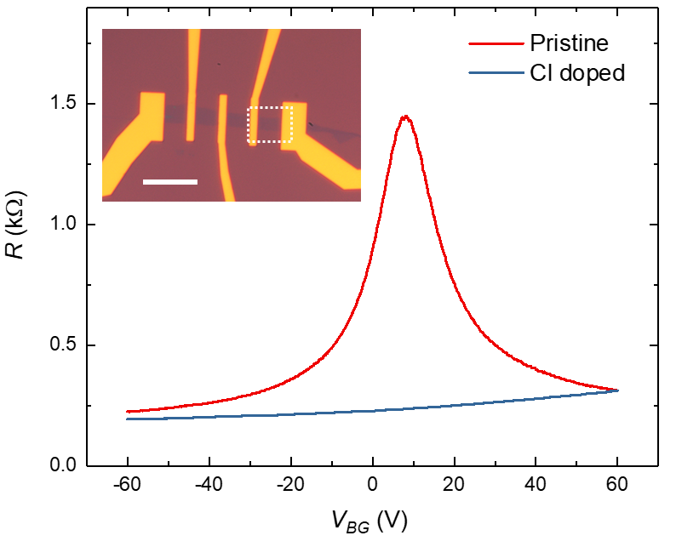
Figure S1. Electrical transfer curves of graphene monolayer on SiO₂ (300 nm)/Si substrate before and after chlorination process. The inset shows the optical microscope image of the device and the measured channel is indicated with the white dashed line. The scale bar is 10 μm.

As shown in Figure S1, graphene on SiO₂ (300 nm)/Si substrate has limited access to doping concentration (~5$×$10¹² cm⁻²) set by dielectric breakdown. After laser assisted chlorination process (2 min), although it has not reached the saturation point (>5 min), Dirac point shifted beyond the accessible gate voltage, while showing significantly decreased sheet resistance below 250 Ω. According to the Raman study performed based on graphene on the same substrate (Figure 2b in the main manuscript), this condition indicates significant doping condition, which is consistent with the presented electrical transfer curve.

- Plotting the phonon limited model in Figure 1d in the main manuscript
The phonon limited model in Figure 1d in the main manuscript was calculated based on the method in Ref(1). According to this theory, at 300K, the phonon scattering limited mobility µ without all extrinsic scattering mechanisms including charged impurities, neutral defects, interface roughness, graphene ripples, etc., can be obtained by $μ\sim 3.7×{10}^{7}/D_{A}^{2}n cm^{2}/V s$, where D_{A} and n are acoustic deformation constant (eV) and charge density (10¹² cm⁻²). Recent experimental works extracted the value of D_{A} as 18.7 eV~ 20.5 eV based on boron nitride (BN)/graphene/BN heterostructure using temperature dependent sheet resistance measurement^{2, 3}, which is close to the value (19 eV) used in theoretical calculation in Ref(1). In this regard, we used this value (19 eV) for our calculation.
- Detailed Raman study for chlorination process

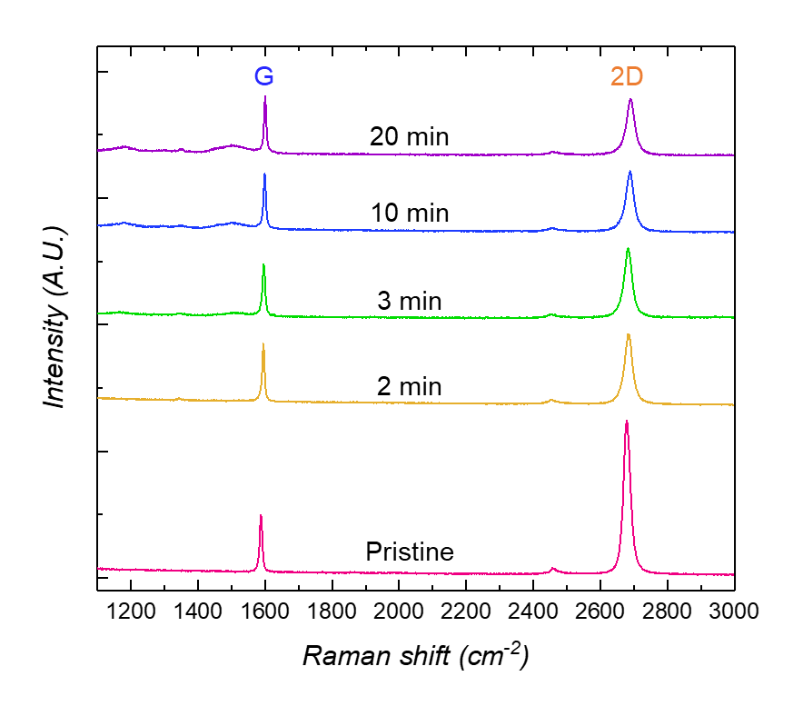
Figure S2. Raman spectra of pristine and chlorinated graphene monolayer at various doping time.

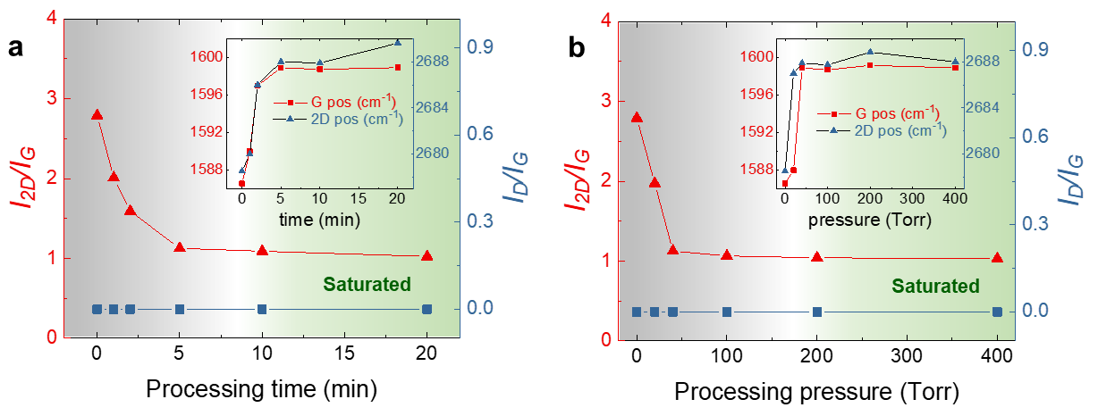
Figure S3. Raman 2D and G peak intensity ratios and their peak positions (inset) depending on chlorination processing time 1, 2, 6, 10, and 20 min at constant pressure 400 Torr a), and processing pressure 20, 40, 100, 200, and 400 Torr at fixed time 5 min b).

Cl₂ pressure dependent Raman analysis showed saturation behavior of chlorination of graphene. The Raman I_{2D}/I_{G} ratio monotonically increased at higher pressure but saturated at ~100 torr. At higher pressure, the number density of Cl₂ molecules increases due to the higher optical absorbance of Cl₂ gas medium and therefore, larger number of Cl radicals could be generated at constant laser irradiation as the pressure increases. Then, at pressure of 100 Torr, the Cl coverage ratio reached saturation point.

- XPS analysis to extract C:Cl elemental ratio
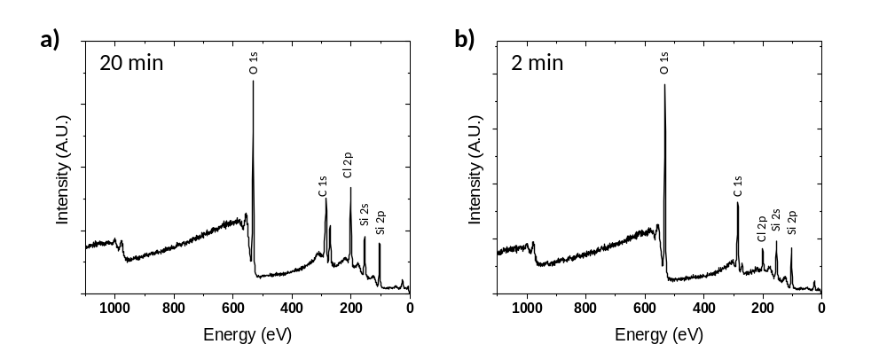
Figure S4. XPS Spectra of energy range from 0 to 1100 eV after 20 min of chlorination a) and 2 min of chlorination at 400 Torr. The C:Cl elemental ratio can be calculated as 43.5 % and 13.4 %, respectively.
- Detailed Raman study for Cl-removal process
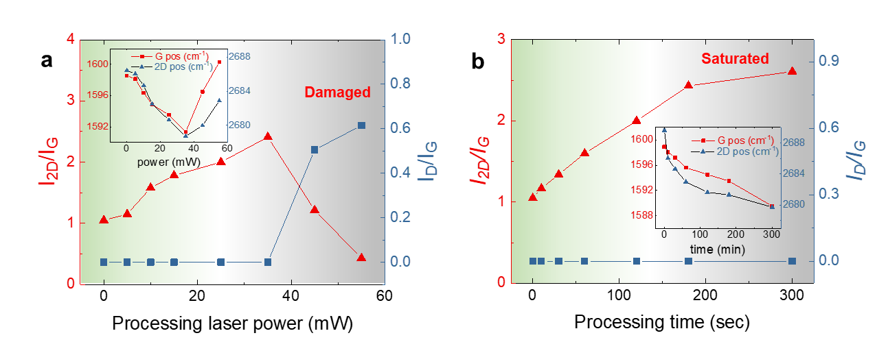
Figure S5. Raman 2D and G peak intensity ratios and their peak positions (inset) depending on a) the processing laser power from 5 to 55 mW at constant processing time, 2 min and b) processing time at fixed laser power, 25 mW.

As the processing laser power was raised with the fixed irradiation time at 2 min, the I_{2D}/I_{G} ratio gradually increased and the Raman peak positions (G and 2D) red shifted, indicating Cl desorption and recovery of its pristine state (Figure S5). Meanwhile, the change in I_{D}/I_{G} was almost negligible indicating non-invasive processing. However, after exceeding 35 mW of laser power, the I_{D}/I_{G} value appeared while I_{2D}/I_{G} dropped significantly due to the formation of defects, possibly including oxidation.

- Large area surface functionalization by UV nanosecond laser beam
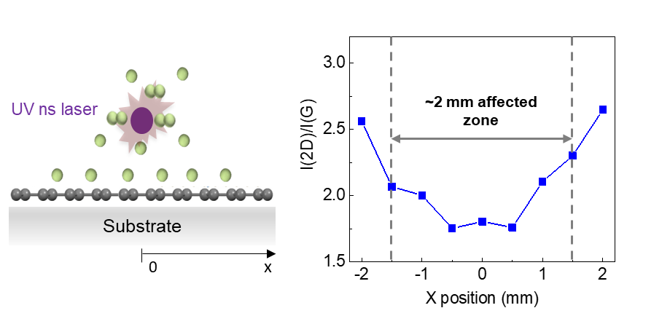
Figure S6. Raman mapping intensity ratio I_{2D}/I_{G} along with the line perpendicular to direction of UV nanosecond pulsed laser after chlorination process at 400 Torr for 5 min. The data were obtained from CVD grown large area graphene.

The parallelly irradiated UV ns laser can induce chlorination in relatively large area of about 2 mm in lateral scale, when the distance between the laser focal spot and the graphene surface was maintained at 0.5 mm. This implies that the method has potential to be scaled up for large area doping by employing stronger laser pulse energy to shorten the chlorination time and translation stage to move the sample. In this way, uniformly induced highly doped state graphene in large area can be obtained.

- Fitting methods of electrical transfer curve to extract mobility
The resistance of the device depending on the gate voltage ($V_{g}$) can be fit using following equation⁴.
$$R_{t}=R_{c}+\frac{L}{W}\frac{1}{μ*n(V_{g}-V_{D})} ,$$
where $R_{t}$ and $R_{c}$ represent total and contact resistance, respectively. The second term in the right-hand side indicate the channel resistance attributed to the gate dependent carrier density change. The dimension of channel area is reflected by length $L$ and width $W$, and $μ$ indicates the mobility of carriers in channel region. $n(V_{g}-V_{D})$ is gate dependent carrier density and expressed as $\sqrt{n_{0}^{2}+{\left(C_{gate}\left(V_{gate}-V_{Dirac}\right)\right)}^{2}}$, where $n_{0}$ residual impurity charge density. $C_{gate}$ is dielectric layer capacitance. By fitting this equation to our transfer curve, we can extract the values of both $μ$ and $n_{0}$.

- Method to extract absorbance of graphene and substrate for heat transfer simulation.
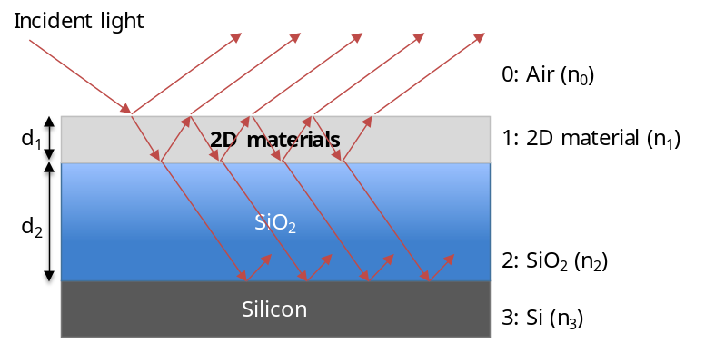
Figure S7. Schematic image of multiple reflection and transmission in the system of 2D materials (graphene), SiO₂ and Si substrate.

We use notations 0,1,2 and 3 for Air (Vacuum), graphene, SiO₂ and Si respectively. The refractive indices of layers are indicated as follow. $n_{0}=1$, $n_{1}=2.6-1.3i$⁵, $n_{2}=1.4$ and $n_{3}=4.2-0.4i$.
By using Fresnel’s equation, the reflectivity and transmissivity at each boundary can be obtained.⁶ (1,2 and 3 indicate Air(vacuum) and graphene, graphene and SiO₂, and SiO₂ and Si interfaces, respectively)
$r_{1}=\frac{n_{0}-n_{1}}{n_{0}+n_{1}}$ $r_{2}=\frac{n_{1}-n_{2}}{n_{1}+n_{2}}$ $r_{3}=\frac{n_{2}-n_{3}}{n_{2}+n_{3}}$
$t_{1}=\frac{{2n}_{0}}{n_{0}+n_{1}}$ $t_{2}=\frac{{2n}_{1}}{n_{1}+n_{2}}$ $t_{3}=\frac{{2n}_{2}}{n_{2}+n_{3}}$
Considering multi reflection and transmission at the interfaces, by using transfer matrix calculation, the total reflectivity, $r_{Graphene}$ and absorptivity of Silicon, $a_{Si}$ can be obtained as follow.
$$r_{Graphene}=\frac{r_{1}+r_{2}Z_{1}^{-2}+r_{1}r_{2}r_{3}Z_{2}^{-2}+r_{3}Z_{1}^{-2}Z_{2}^{-2}}{1+r_{1}r_{2}Z_{1}^{-2}+r_{2}r_{3}Z_{2}^{-2}+r_{1}r_{3}Z_{1}^{-2}Z_{2}^{-2}}$$
$$a_{Si}=\frac{t_{1}t_{2}t_{3}Z_{1}^{-1}Z_{2}^{-1}}{1+r_{1}r_{2}Z_{1}^{-2}+r_{2}r_{3}Z_{2}^{-2}+r_{1}r_{3}Z_{1}^{-2}Z_{2}^{-2}}$$
Where $Z_{1}=e^{\frac{2π{n_{1}d}_{1}}{λ}}$, $Z_{2}=e^{\frac{2π{n_{2}d}_{2}}{λ}}$ and $d_{1}$ and $d_{2}$ are thickness of 2D materials and SiO₂ layer, respectively and $λ$ is wavelength of incoming light.
Finally, the total reflectance, $R_{Graphene}$ and absorbance $A_{Si}$ can be calculated as follow.
$$R_{Graphene}=\left|r_{Graphene}^{*}{∙r}_{Graphene}\right|$$
$$A_{Si}=Re\left(\frac{n_{3}}{n_{0}}\right)\left|a_{Si}^{*}{∙a}_{Si}\right|$$
If we consider the energy conservation and assume no power dissipation in SiO₂ layer, the absorbance power ratio of graphene $A_{Graphene}$ can be expressed as follow.
$$A_{Graphene}=1-R_{Graphene}-A_{Si}$$
By taking 532 nm of wavelength, 0.3 Å of graphene thickness and 300 nm of SiO₂ layer, 3.8 % and 78.9 % of absorbances can be obtained for graphene and silicon, respectively.

- Heat transfer simulation method for continuous wave (CW) green laser induced Cl-removal process

Table S1. Thermal properties of Graphene, SiO₂ and silicon. $k$, $ρ$, and $C_{p}$ indicate thermal conductivity, density, and heat capacity, respectively. We consider the temperature dependent thermal conductivity of SiO₂ and Si.
 | $k$  (W/mK) | $ρ$ (kg/m³) | $C_{p}$ (J/kg·K)
Graphene | 370 ^{ref.7} | 2250 | 538 ^{ref.8}
SiO₂ | $3×{10}^{4}/T$^{ref.9} | 2650 | 680
Si | $\ln\left(T^{0.52}\right)-1.6$^{ref.10} | 2329 | 700

The graphene thickness, $t_{graphene}$ was taken as ~3 Å and the thermal boundary conductance, $g$ between graphene and SiO₂ was taken as ~30 MW/m²·K⁷. The governing equation, boundary condition, initial condition for thermal simulation are as follow.
Governing Equation: $ρC_{p}\frac{∂T}{∂t}=k∇^{2}T+Q$
Initial Condition: $T\left(t=0\right)=T_{0}$
Boundary Condition: a) $T_{bottom surface}=T_{0}$, b) ${\left.k\frac{∂T}{∂r}\right|}_{r=R}=εσ(T^{4}-T_{0}^{4})$,
c) ${\left.k\frac{∂T}{∂z}\right|}_{Top Surface}=εσ_{s}(T^{4}-T_{0}^{4})$
Where $ε$ and $σ_{s}$ are emissivity (assumed as 1) and Stefan Boltzmann constant (5.67 $×$10⁻⁸ W/m²·K⁴).

In addition, the laser flux absorbed by graphene in Gaussian laser beam profile was expressed as
$$Q=α_{graphene}I_{peak}e^{- \frac{2r^{2}}{w^{2}}}$$

Where $α_{graphene}$, $I_{peak}$ and $w$ indicate absorbance by graphene, laser peak intensity and laser beam size, respectively. Also, Beer Lambert Law was considered in this simulation. The absorption coefficient of silicon, $a_{Si}$ at 532 nm is ~ 7.85 $×$10³ cm⁻¹ and this can be reflected by following equation.
$$\frac{∂I}{∂z}=-a_{Si}I$$
Cylindrical coordinate with steady state condition was applied to get three-dimensional temperature profile.
- Heat transfer simulation results for continuous wave (CW) green laser induced Cl-removal process
The time scale of the laser irradiation was much longer than the thermal time constant of the system (O(ms)) and therefore an essentially steady state temperature distribution was established. The induced steady state peak temperature at graphene developed under the CW laser beam irradiation of 35 mW (a threshold power to induce defects (Figure 3c in the main manuscript)) was estimated as ~470 K, which is lower than the oxidation temperature of monolayer graphene at ambient conditions (473K ~ 523 K)¹¹. In addition, the full width half maximum (FWHM) of developed temperature profile was estimated as ~1.2 μm.

- Demonstration of electrical junction by FET device
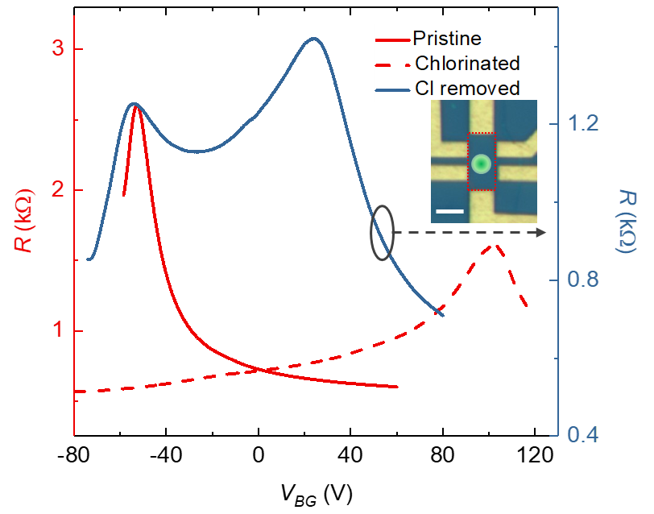
Figure S8. Electrical transfer curves of graphene on hBN/SiO₂(300 nm) device at pristine, after chlorination, and after local Cl-removal. The inset in panel f) shows the optical microscope image of fabricated device. The red dashed lines delineate the graphene monolayer and the green circle indicates the area where CW laser irradiated for Cl-removal. The scale bar is 3 μm.

The electrical transfer curve obtained from graphene FET device also suggests local Cl-removal. We employed graphene device fabricated on hexagonal boron nitride (hBN)/SiO₂ (300 nm)/Si wafer to demonstrate higher mobility of chlorinated graphene (Figure S8)¹². The pristine device in heterostructure possessed n-type doped state by intentional photo-induced trapped charge in hBN layer by white light illumination at negatively biased back gate¹³. Upon chlorination process, within the dielectric breakdown of SiO₂ layer, we observed high-mobility (6,026 cm²/V s) at high-doping-concentration (~1$×$10¹³ cm⁻²). Then, we subsequently applied CW laser irradiation at the center of the channel area (Figure S8). We observed clear double-peak feature, manifesting the formation of local electrical junction, including the recovered pristine state at center area and the surrounding p-type doped region.

- Kelvin probe force microscopy (KPFM) measurement
KPFM is a technique to probe the local surface potential using AFM system. The Au coated tip was grounded, and the sample biased. AC voltage was applied to the sample at 1st mechanical resonant frequency of the AFM tip ($V_{AC}×\sin{ωt}$) while the tip dithers at 2nd mechanical resonant mode. The force exerted at the tip at 1st mechanical resonant frequency is proportional to $(V_{DC}-V_{S})×V_{AC}\sin{ωt}$ where $V_{DC}$ and $V_{s}$ are applied DC voltage and surface potential, respectively. The system feedback controls to adjust $V_{DC}$ to make the force exerted on the cantilever to be zero, which is directly connected to the surface potential information of the sample.

- Discussion on the origin of photocurrents observed in metal/graphene junction
We attribute the observed photocurrent in graphene channel area to the photothermoelectric (PTE) effect, which originates from the local non-uniformity in Seebeck coefficient modulated by the gradient of density of states, represented by Mott formula^{14, 15}. As the narrow Fermi surface imposed by linear band structure of graphene significantly suppresses hot-carrier relaxation pathways, PTE effect typically dominates photocurrent mechanism over other mechanisms including photovoltaic (PV) and bolometric effects at graphene channel area. It has been reported that PTE effect at graphene unipolar junctions (i.e., p-p’ or n-n’ junctions) imposes opposite photocurrent directions to photovoltaic (PV) effect¹⁶, where the excited charges are drifted by built-in chemical potential. Considering the chemical potentials developed in p-p’-p junctions as illustrated in the energy band diagram in Figure 4d in the main manuscript, if the PV effect dominates the photocurrent, the photocurrent should flow in opposite directions to our experimental results, implying that the observed photocurrent at doped junctions is occurred by PTE effect.
On the other hand, at metal/graphene junction, the photocurrent mechanism cannot be differentiated solely by its flow direction. Considering the shallow optical penetration depth of Pd electrode, the high absorption of laser power at Pd electrode raises temperature significantly. The thermally excited charges at graphene/metal junction are separated at built-in potential of metal/graphene junction, which has a same direction of PV effect^{17, 18}. This photocurrent mechanism is also called as photoemission/thermal injection. Thus, although the band bending directions of metal/graphene junction and graphene channel area are apposite, the observed photocurrents are in the same direction.

- Built-in potential at metal (Pd)/graphene junctions
It has been known that Pd/graphene contact forms low built-in potential, typically in the range of 40~80 meV. Although Pd has appreciably larger work function (5.22 eV) than that of graphene (~4.6 eV), the charge transfer from metal to graphene induce doping of graphene under metal electrode, significantly reducing Schottky barrier and contact resistance. Detailed experimental and theoretical results regarding Pd/graphene contact resistance can be found in elsewhere^{18, 19, 20}. Considering the doping concentration of pristine graphene and chlorinated graphene, 4$×$10⁻¹² cm⁻² (pristine) and 3$×$10⁻¹³ cm⁻² (doped) E_{CNP} of corresponding state of graphene locates 0.1 eV (pristine) to 0.64 eV (doped) above E_{F}, respectively, which is depicted in the energy band diagrams shown in Figure 4c in the main manuscript.

- Single CW laser irradiation on graphene in the presence of Cl₂ gas flow damages graphene
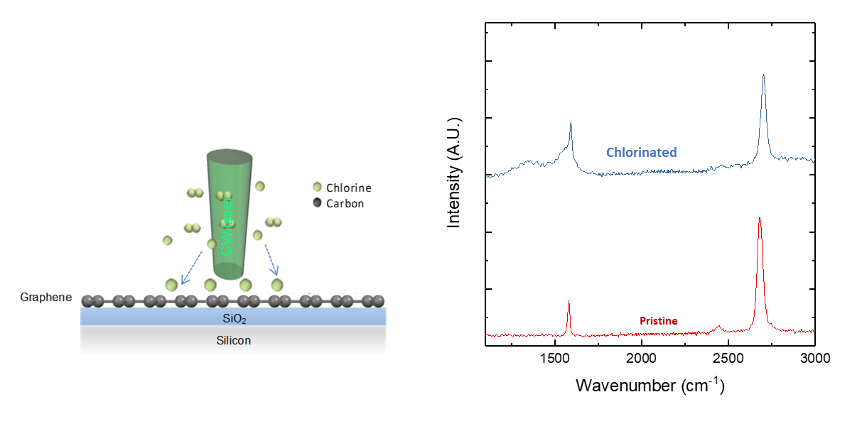
Figure S9. Schematics and Raman spectra of conventional laser assisted chemical doping by single laser (CW) beam irradiated on graphene in Cl₂ environment. Raman spectra of pristine and chlorinated graphene after irradiation of CW laser beam.

Here, although the utilized laser power was well below the damage threshold of graphene in ambient condition, significant distortion of Raman peak near D band was clearly observed, manifesting defect generation of graphene. The direct laser illumination could induce unwanted chemical reaction between graphene and Cl₂. This result shows the effectiveness of the proposed dual-laser-beam assisted surface functionalization process.

References
1. Hwang E, Sarma SD. Acoustic phonon scattering limited carrier mobility in two-dimensional extrinsic graphene. Physical Review B 77, 115449 (2008).
2. Shi W, et al. Reversible writing of high-mobility and high-carrier-density doping patterns in two-dimensional van der Waals heterostructures. Nature Electronics 3, 99-105 (2020).
3. Wang L, et al. One-dimensional electrical contact to a two-dimensional material. Science 342, 614-617 (2013).
4. Kim S, et al. Realization of a high mobility dual-gated graphene field-effect transistor with Al2O3 dielectric. Applied Physics Letters 94, 062107 (2009).
5. Yoon D, et al. Interference effect on Raman spectrum of graphene on SiO2. Physical Review B 80, 125422 (2009).
6. Reitz J, Milford F, Christy R. Foundations of Electromagnetic Theory 4th ed Addison-Wesley. Reading, (1993).
7. Cai W, et al. Thermal Transport in Suspended and Supported Monolayer Graphene Grown by Chemical Vapor Deposition. Nano Letters 10, 1645-1651 (2010).
8. Ma F, Zheng H, Sun Y, Yang D, Xu K, Chu PK. Strain effect on lattice vibration, heat capacity, and thermal conductivity of graphene. Applied Physics Letters 101, 111904 (2012).
9. Chien H-C, Yao D-J, Huang M-J, Chang T-Y. Thermal conductivity measurement and interface thermal resistance estimation using SiO2 thin film. Review of Scientific Instruments 79, 054902 (2008).
10. Asheghi M, Kurabayashi K, Kasnavi R, Goodson KE. Thermal conduction in doped single-crystal silicon films. Journal of Applied Physics 91, 5079-5088 (2002).
11. Liu L, et al. Graphene oxidation: thickness-dependent etching and strong chemical doping. Nano letters 8, 1965-1970 (2008).
12. Dean CR, et al. Boron nitride substrates for high-quality graphene electronics. Nature nanotechnology 5, 722 (2010).
13. Ju L, et al. Photoinduced doping in heterostructures of graphene and boron nitride. Nature Nanotechnology 9, 348 (2014).
14. Hwang E, Rossi E, Sarma SD. Theory of thermopower in two-dimensional graphene. Physical Review B 80, 235415 (2009).
15. Gabor NM, et al. Hot carrier–assisted intrinsic photoresponse in graphene. Science 334, 648-652 (2011).
16. Song JC, Rudner MS, Marcus CM, Levitov LS. Hot carrier transport and photocurrent response in graphene. Nano letters 11, 4688-4692 (2011).
17. Echtermeyer TJ, et al. Photothermoelectric and photoelectric contributions to light detection in metal–graphene–metal photodetectors. Nano letters 14, 3733-3742 (2014).
18. Park J, Ahn YH, Ruiz-Vargas C. Imaging of Photocurrent Generation and Collection in Single-Layer Graphene. Nano Letters 9, 1742-1746 (2009).
19. Xia F, Perebeinos V, Lin Y-m, Wu Y, Avouris P. The origins and limits of metal–graphene junction resistance. Nature Nanotechnology 6, 179-184 (2011).
20. Song SM, Park JK, Sul OJ, Cho BJ. Determination of work function of graphene under a metal electrode and its role in contact resistance. Nano letters 12, 3887-3892 (2012).

