Supplemental Figure 1.
Green and roasted coffee beans. From left to right: green, light-roasted, and Italian roasted beans. Roasting was performed according to the manufacturer's instructions.

Supplemental figure 2
Box-and-whisker plot of SERT mRNA expression in Caco-2 cells according to passage number. Vertical axis: Relative mRNA expression of GAPDH. Horizontal axis: 'P' denotes passage. Each with n = 3.

Supplemental figure 3
Changes in SERT uptake activity due to acidic and osmotic stimuli
Left: Effect of acidity (pH6) on SERT uptake. The vertical axis represents SERT uptake activity relative to the control group at a coffee concentration of 10 (v/v%). Three independent experiments, Mean ± SD, Dunnet post-hoc test, **p < 0.01.
Right: Effect of osmolarity (5 mM) on SERT uptake. The vertical axis represents SERT uptake activity relative to the control group. Three independent experiments, Mean ± SD, Two-sample t-test.

Supplemental figure 1
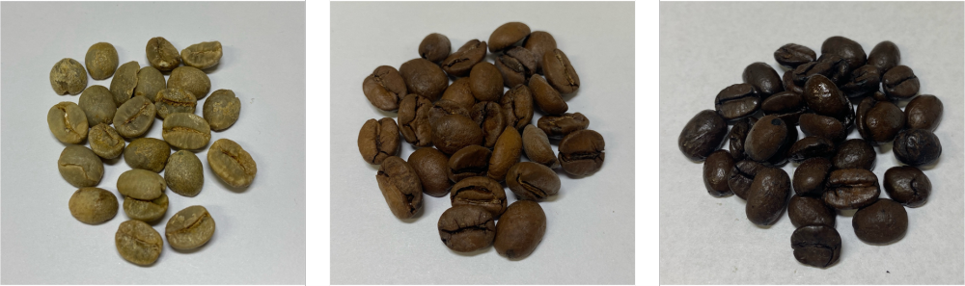

Supplemental figure 2
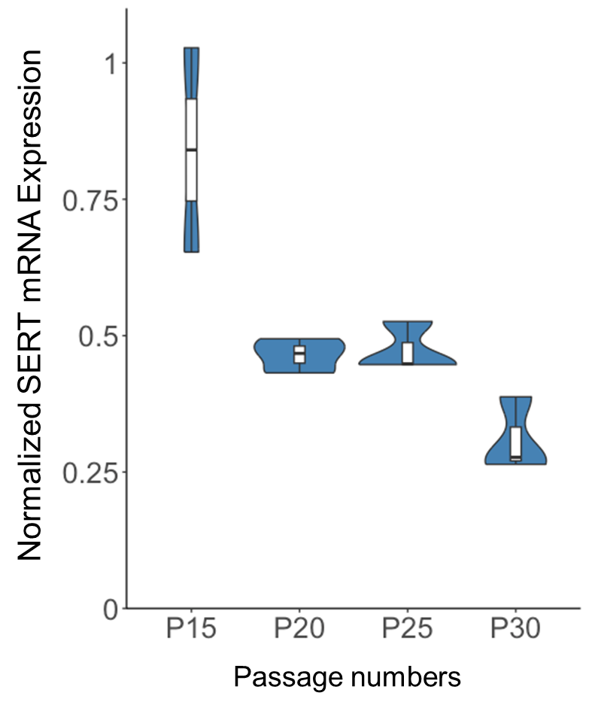

Supplemental figure 3
