Supplementary Information
Winners and losers: post-fire European forest taxa abundance meta-analysis
Gemma Gerber^{a*}, Martin Jungª, Piero Viscontiª
ªInternational Institute for Applied Systems Analysis, Biodiversity, Ecology, and Conservation Research Group, Laxenburg, Austria. *gerber@iiasa.ac.at

Literature survey
Identification of studies via databases and registers

Records removed before screening:
Duplicate records removed (n = 520)
Retracted records removed (n = 1)
Records identified from:
- Scopus (n = 3762)
- Bieber et al. (2023) (n = 130)
- Geary et al. (2020) (n = 160)
- Giorgis et al. (2021) (n = 158)
- González et al. (2022) (n = 161)
- Grau-Andrés et al. (2024) (n = 394)
- Mason et al. (2021) (n = 91)
- Moyo, (2022) (n = 208)
- Pastro et al. (2014) (n = 87)
- Vasconcelos et al. (2017) (n = 50)

Identification

Records excluded:
Not relevant (n = 3731)
Records screened (n = 4703)

Reports not retrieved (n = 0)
Reports sought for retrieval (n = 48)

Screening

Studies excluded:
Metric type not ‘abundance’ (n = 1)
Mean not reported (n = 8)
Few observations, methodological inconsistencies (n = 8)
Fire type ‘experiment’ (n = 1)
‘Double zero’ treatment and control (n = 0)
Highly heterogenous data/methodology unclear (n = 1)
Reports assessed for eligibility (n = 48)

Studies included in analysis (n = 29)
Included

Figure S 1: PRISMA 2020 flow diagram for new systematic reviews. Format layout as per (Page et al., 2021).
Table S 1: List of source articles which were suitable for inclusion in the meta-analysis (n =29).
# | Reference
1 | Adámek, M., Hadincová, V., Wild, J., 2016. Long-term effect of wildfires on temperate Pinus sylvestris forests: Vegetation dynamics and ecosystem resilience. Forest Ecology and Management 380, 285–295. https://doi.org/10.1016/j.foreco.2016.08.051
2 | Bogusch, P., Blažej, L., Trýzna, M., 2015. Forgotten role of fires in Central European forests: critical importance of early post-fire successional stages for bees and wasps (Hymenoptera: Aculeata). European Journal of Forest Research 134, 153–166. https://doi.org/10.1007/s10342-014-0840-4
3 | Čuchta, P., Miklisová, D., Kováč, Ľ., 2012. Changes within collembolan communities in windthrown European montane spruce forests 2 years after disturbance by fire. Annals of Forest Science 69, 81–92. https://doi.org/10.1007/s13595-011-0114-y
4 | Ecke, F., Nematollahi Mahani, S.A., Evander, M., Hörnfeldt, B., Khalil, H., 2019. Wildfire‐induced short‐term changes in a small mammal community increase prevalence of a zoonotic pathogen? Ecology and Evolution 9, 12459–12470. https://doi.org/10.1002/ece3.5688
5 | Fayt, P., 2003. Insect prey population changes in habitats with declining vs. stable Three-toed Woodpecker Picoides tridactylus populations. Ornis Fennica 80, 182–192.
6 | Garcia-Villanueva, J., Ena, V., Tarrega, R., Mediavilla, G., 1998. Recolonization of Two Burnt Quercus pyrenaica Ecosystems by Coleoptera. International Journal of Wildland Fire 8, 21–27. https://doi.org/10.1071/WF9980021
7 | Gongalsky, K.B., Wikars, L.-O., Persson, T., 2008. Ground beetle (Coleoptera: Carabidae) responses to a forest wildfire in northern Europe. Russian Entomological Journal 17, 273–282.
8 | Herrando, S., Brotons, L., Llacuna, S., 2003. Does fire increase the spatial heterogeneity of bird communities in Mediterranean landscapes? Ibis 145, 307–317. https://doi.org/10.1046/j.1474-919X.2003.00155.x
9 | Hylander, K., 2011. The response of land snail assemblages below aspens to forest fire and clear-cutting in Fennoscandian boreal forests. Forest Ecology & Management 261, 1811–1819. https://doi.org/10.1016/j.foreco.2011.02.003.
10 | Jonsson, L., Dahlberg, A., Nilsson, M., Zackrisson, O., Kårén, O., 1999. Ectomycorrhizal fungal communities in late‐successional Swedish boreal forests, and their composition following wildfire. Molecular Ecology 8, 205–215. https://doi.org/10.1046/j.1365-294x.1999.00553.x
11 | Köster, K., Berninger, F., Heinonsalo, J., Lindén, A., Köster, E., Ilvesniemi, H., Pumpanen, J., 2016. The Long-Term Impact of Low-Intensity Surface Fires on Litter Decomposition and Enzyme Activities in Boreal Coniferous Forests. International Journal of Wildland Fire 25, 618–618. https://doi.org/10.1071/WF14217.
12 | Malmström, A., Persson, T., Ahlström, K., 2008. Effects of Fire Intensity on Survival and Recovery of Soil Microarthropods after a Clearcut Burning. Canadian Journal of Forest Research 38. https://doi.org/10.1139/X08-094
13 | Malmström, A., Persson, T., Ahlström, K., Gongalsky, K.B., Bengtsson, J., 2009. Dynamics of Soil Meso- and Macrofauna during a 5-Year Period after Clear-Cut Burning in a Boreal Forest. Applied Soil Ecology 43. https://doi.org/10.1016/j.apsoil.2009.06.002
14 | Mantero, G., Morresi, D., Negri, S., Anselmetto, N., Lingua, E., Bonifacio, E., Garbarino, M., Marzano, R., 2023. Short-term drivers of post-fire forest regeneration in the Western Alps. Fire Ecology 19, 23. https://doi.org/10.1186/s42408-023-00182-7
15 | Marozas, V., Armolaitis, K., Aleinikovienė, J., 2013. Changes of ground vegetation, soil chemical properties and microbiota following the surface fires in Scots pine forests. Journal of Environmental Engineering and Landscape Management 21, 67–75. https://doi.org/10.3846/16486897.2012.663087
16 | Moreno Rueda, G., Melero, E., Reguera, S., Zamora-Camacho, F.J., Comas, M., 2019. Short-term impact of a small wildfire on the lizard Psammodromus algirus (Linnaeus, 1758): a before-after-control-impact study (Squamata: Sauria: Lacertidae). Herpetozoa 31, 173–182.
17 | Moretti, M., Duelli, P., Obrist, M.K., 2006. Biodiversity and resilience of arthropod communities after fire disturbance in temperate forests. Oecologia 149, 312–327. https://doi.org/10.1007/s00442-006-0450-z
18 | Moretti, M., Obrist, M.K., Duelli, P., 2004. Arthropod biodiversity after forest fires: winners and losers in the winter fire regime of the southern Alps. Ecography 27, 173–186. https://doi.org/10.1111/j.0906-7590.2004.03660.x
19 | Pitzalis, M., Bologna, M.A., Luiselli, L., 2013. Is evenness altered by fire in natural assemblages of soil arthropods? Acta Oecologica 49, 64–70. https://doi.org/10.1016/j.actao.2013.03.001
20 | Puga, J.R.L., Abrantes, N.J.C., Moreira, F., Keizer, J.J., 2024. Short-term impacts of wildfires on the diversity and activity patterns of medium-sized mammals in Mediterranean coastal pine forests. Forest Ecology and Management 562, 121940. https://doi.org/10.1016/j.foreco.2024.121940
21 | Santos, X., Mateos, E., Bros, V., Brotons, L., De Mas, E., Herraiz, J.A., Herrando, S., Miño, À., Olmo-Vidal, J.M., Quesada, J., Ribes, J., Sabaté, S., Sauras-Yera, T., Serra, A., Vallejo, V.R., Viñolas, A., 2014. Is Response to Fire Influenced by Dietary Specialization and Mobility? A Comparative Study with Multiple Animal Assemblages. PLoS ONE 9, e88224. https://doi.org/10.1371/journal.pone.0088224
22 | Santos, X., Poquet, J.M., 2010. Ecological succession and habitat attributes affect the postfire response of a Mediterranean reptile community. European Journal of Wildlife Research 56, 895–905. https://doi.org/10.1007/s10344-010-0387-8
23 | Scandurra, A., Magliozzi, L., Aria, M., D’Aniello, B., 2014. Short-term effects of fire on Papilionoidea (Lepidoptera) communities: a pilot study in Mediterranean maquis shrubland. Italian Journal of Zoology 81, 599–609. https://doi.org/10.1080/11250003.2014.953218
24 | Sokos, C., Birtsas, P., Papaspyropoulos, K.G., Tsachalidis, E., Giannakopoulos, A., Milis, C., Spyrou, V., Manolakou, K., Valiakos, G., Iakovakis, C., Athanasiou, L.V., Sfougaris, A., Billinis, C., 2016. Mammals and habitat disturbance: the case of brown hare and wildfire. Curr Zool 62, 421–430. https://doi.org/10.1093/cz/zow020
25 | Stinca, A., Ravo, M., Marzaioli, R., Marchese, G., Cordella, A., Rutigliano, F.A., Esposito, A., 2020. Changes in Multi-Level Biodiversity and Soil Features in a Burned Beech Forest in the Southern Italian Coastal Mountain. Forests 11, 983. https://doi.org/10.3390/f11090983
26 | Toivanen, T., Heikkilä, T., Koivula, M.J., 2014. Emulating natural disturbances in boreal Norway spruce forests: Effects on ground beetles (Coleoptera, Carabidae). Forest Ecology and Management 314, 64–74. https://doi.org/10.1016/j.foreco.2013.11.028
27 | Torre, I., Díaz, M., 2004. Small mammal abundance in Mediterranean post-fire habitats: a role for predators? Acta Oecologica 25, 137–142. https://doi.org/10.1016/j.actao.2003.10.007
28 | Ukmar, E., Battisti, C., Luiselli, L., Bologna, M.A., 2008. The effects of fire on communities, guilds and species of breeding birds in burnt and control pinewoods in central Italy, in: Hawksworth, D.L., Bull, A.T. (Eds.), Biodiversity and Conservation in Europe, Topics in Biodiversity and Conservation. Springer Netherlands, Dordrecht, pp. 45–58. https://doi.org/10.1007/978-1-4020-6865-2_4
29 | Versluijs, M., Hjältén, J., Roberge, J.-M., 2019. Ecological restoration modifies the value of biodiversity indicators in resident boreal forest birds. Ecological Indicators 98, 104–111. https://doi.org/10.1016/j.ecolind.2018.10.020

Table S 2: Variables extracted from each study
Variable category | Variable name | Description | Method of calculation
Metadata | Author, year | String | Obtained from study metadata
Metadata | Publication type | String | Obtained from study metadata
Metadata | DOI | String | Obtained from study metadata
Metadata | Language | String | Obtained from study metadata
Metadata | Coordinates | String | Obtained from text
Metadata | Area size (ha) | Numeric; continuous | Obtained from text
Metadata | Country | String | Obtained from text
Metadata | Biome | Multiple | Coordinates matched to WWF biome (Olson et al., 2001)
Metadata | Ecoregion | Multiple | Coordinates matched to WWF ecoregion (Olson et al., 2001)
Study | Plot sizes | Numeric; continuous | Obtained from text.
Study | Sample size (n) | Numeric; discrete | Number of replicates in each group (control, treatment). Obtained from text, figures and tables
Study | Comparison design | String; categorical: (1) unburned site vs single burned site, (2) unburned site vs multiple burned site, (3) same site before and after fire | Obtained from text.
Fire | Fire type | String; categorical: (1) wildfire, (2) prescribed burning | Obtained from text.
Fire | Fire severity | String; categorical: (1) high, (2) medium, (3) low. | Categorized according to the information provided in each study or description of the habitat. An example of a low severity fire is one that only consumed the leaf litter, middle severity fires consumed the leaf litter and the understory, and high severity fires consumed the canopy and/or was a stand replacing fire. Where severity was not reported for prescribed fires, we assigned “low” severity, as it is generally assumed that prescribed fires are lower severity than wildfires (Niwa and Peck, 2002)
 | Post-fire assessment time | String; categorical:  < 1 yr  1-5 yr  5-10 yr  10 + yrs | Obtained from text or calculated based on the time between the reported initial fire date and sampling date.
Biodiversity | Taxa names | String | Obtained from text, updated from online databases.
Biodiversity | Mean abundances | Numeric; continuous | Obtained from text, tables, or figures. Or, calculated from total values and number of replicates.
Biodiversity | Variability abundances | Numeric; continuous | Obtained from text, tables, or figures. Where not reported, SD determined from SE, or estimated using MLMA methods (Nakagawa et al., 2023)

Table S 3: Aggregation of taxonomic groups and effect sizes included in the meta-analysis. The table lists each taxon, grouped by broad taxonomic category (Taxonomic Group), and sorted by family, order, kingdom, and taxon name. The number of effect sizes for each taxon illustrates the distribution of data across taxonomic groups and levels.
Taxonomic Group | Number of taxa | Number of effect sizes | Taxa List
Arthropoda: Arachnida | 51 | 167 | Alopecosa sp2 (2), Araneae (7), Brachychthoniidae (5), Callilepis sp (2), Chamobates borealis (5), Coelotes mediocris (4), Euophrys herbigrada (1), Gnaphosidae sp1 (1), Gnaphosidae sp10 (2), Gnaphosidae sp11 (1), Gnaphosidae sp12 (2), Gnaphosidae sp13 (2), Gnaphosidae sp14 (1), Gnaphosidae sp2 (2), Gnaphosidae sp4 (2), Gnaphosidae sp8 (2), Gnaphosidae sp9 (2), Hahnia sp1 (2), Haplodrassus umbratilis (1), Hogna radiate (2), Lauroppia neerlandica (5), Lepthyphantes flavipes (4), Linyphiidae (8), Liocranidae (5), Medioppia subpectinata (5), Mesostigmata (13), Micaria formicaria (1), Neaetha membranosa (1), Nomisia sp (2), Oonops sp1 (1), Oppiella nova (5), Oribatida (13), Parazercon radiatus (5), Pardosa sp1 (2), Pardosa sp4 (2), Phelgra fasciata (2), Pholcus opilionoides (2), Phrurolithus festivus (1), Pseudoscorpiones (2), Salticidae sp4 (1), Selamia reticulata (2), Suctobelbidae (5), Tapinocyba maureri (4), Tectocepheus velatus (5), Tegenaria fuesslinni (2), Theridiidae (4), Trachytes sp. (5), Trochosa hispanica (4), Veigaia nemorensis (5), Zodarion pseudoelegans (2), Zoropsis (1)
Arthropoda: Entognatha | 90 | 187 | Allacma fusca (1), Allacma gallica (1), Anurophorus cuspidatus (2), Anurophorus laricis (3), Anurophorus septentrionalis (5), ArchaphoruraÂ sp.Â juv. (1), Caprainea marginata (1), Ceratophysella armata (3), Ceratophysella. denticulata (2), Collembola (16), Cryptopygus thermophilus (1), Cyphoderus albinus (1), Desoria duodecemoculata (2), Desoria violacea (1), Dicyrtomina saundersi (1), Endonura tatricola (1), Entognatha (8), Entomobrya marginata (1), Entomobrya muscorum (1), Entomobrya nivalis (1), Entomobryidae juv. (2), Folsomia candida (1), Folsomia inoculata (1), Folsomia manolachei (2), Folsomia penicula (2), Folsomia quadrioculata (1), Folsomia sensibilis (2), Friesea mirabilis (7), Friesea truncata (2), Heteromurus major (1), Hymenaphorura dentifera (1), Isotoma notabilis (1), Isotomiella minor (7), Isotomurus maculatus (1), Isotomurus pseudopalustris (1), Lepidocyrtus curvicollis (1), Lepidocyrtus cyaneus (1), Lepidocyrtus instratus (1), Lepidocyrtus lignorum (8), Lepidocyrtus nigrescens (1), Lepidocyrtus serbicus (2), Lepidocyrtus violaceus (1), LepidocyrtusÂ cf. cyaneus (1), LepidocyrtusÂ sp. (1), Lipothrix lubbocki (1), Megalothorax minimus (1), Mesaphorura hylophila (2), Mesaphorura sp. (5), Mesaphorura yosii (2), Mesaphorura. Florae (2), Mesaphorura. Macrochaeta (1), Mesaphorura. Tenuisensillata (2), Micranurida granulata (1), Micranurida pygmaea (7), Micraphorura absoloni (2), Neelus murinus (1), OdontellaÂ sp. (1), Orchesella bifasciata (2), Orchesella cincta (1), Orchesella flavescens (1), Orchesella villosa (1), Parisotoma notabilis (3), Pogonognathellus (1), Protaphorura armata (2), Protaphorura aurantiaca (2), Protaphorura campata (2), Protaphorura fimata (1), Protaphorura gisini (1), Protaphorura pannonica (2), Pseudachorutes laricis (1), Pseudanurophorus binoculatus (6), Pseudisotoma monochaeta (1), Pseudosinella fallax (1), Pseudosinella horaki (2), Pseudosinella sexoculata (1), Pseudosinella sp. 1 (1), Pseudosinella zygophora (1), Ptenothrix italica (1), Sminthurinus aureus (1), Sminthurinus elegans (2), Sminthurus viridis (1), Sphaeridia pumilis (1), Stenognathellus denisi (1), Tetracanthella fjellbergi (1), Tomocerus flavescens (5), Tomocerus minor (1), Tomocerus vulgaris (1), Willemia anophthalma (7), Willemia denisiÂ (1), Xenylla maritima (1)
Arthropoda: Isopoda | 14 | 18 | AcaeroplastesÂ sp. (1), Armadillidium depressum (1), Armadillidium nasatum (1), Chaetophiloscia cellaria (1), Chaetophiloscia elongata (1), Chaetophiloscia sicula (1), Isopoda (2), Orthometopon planum (4), Philoscia muscorum (1), Porcellio dilatatus (1), Porcellio pumicatus (1), Porcellionides pruinosus (1), PorcellioÂ sp (1), Trachelipus arcuatus (1)
Birds: Non-Passeriformes | 13 | 25 | Alectoris rufa (4), Aves (1), Columba palumbus (4), Cuculus canorus (2), Dendrocopos major (2), Dryocopus martius (1), Falco tinnunculus (1), Picoides minor (1), Picoides tridactylus (1), Picus canus (1), Picus viridis (3), Streptopelia decaocto (1), Streptopelia turtur (3)
Birds: Passeriformes | 50 | 142 | Aegithalos caudatus (5), Anthus campestris (3), Carduelis carduelis (5), Carduelis chloris (3), Certhia brachydactyla (5), Certhia familiaris (1), Cettia cetti (4), Emberiza cia (2), Emberiza cirlus (3), Emberiza hortulana (3), Erithacus rubecula (5), Fringilla coelebs (3), Galerida theklae (2), Garrulus glandarius (6), Hippolais polyglotta (2), Lanius meridionalis (2), Lanius senator (1), Lophophanes cristatus (1), Lullula arborea (2), Luscinia megarhynchos (5), Miliaria calandra (1), Monticola saxatilis (2), Motacilla alba (1), Muscicapa striata (1), Oenanthe hispanica (2), Oriolus oriolus (3), Parus caeruleus (5), Parus cristatus (4), Parus major (6), Passer italiae (1), Periparus ater (3), Perisoreus infaustus (1), Phylloscopus bonelli (4), Phylloscopus collybita (1), Pica pica (2), Poecile montanus (1), Pyrrhula pyrrhula (1), Regulus ignicapillus (5), Regulus regulus (1), Saxicola torquatus (4), Serinus serinus (5), Sitta europaea (1), Sturnus vulgaris (1), Sylvia atricapilla (3), Sylvia cantillans (3), Sylvia melanocephala (3), Sylvia undata (3), Troglodytes troglodytes (5), Turdus merula (5), Turdus viscivorus (1)
Insecta: Hymenoptera | 59 | 185 | Andrena dorsata (4), Andrena fulvata (4), Andrena haemorrhoa (4), Andrena nigroaenea (4), Aphaenogaster gibbosa (2), Aphaenogaster subterranea (6), Apis mellifera (4), Apocrita (2), Bombus hypnorum (4), Camponotus cruentatus (2), Camponotus lateralis (4), Camponotus piceus (3), Camponotus pilicornis (3), Camponotus sylvaticus (2), Chalepoxenus kutteri (2), Crematogaster scutellaris (4), Formica gagates (4), Formica gerardi (4), Formica subrufa (4), Formicidae (2), Hylaeus communis (4), Hylaeus gibbus (4), Hymenoptera (2), Lasioglossum fulvicorne (4), Lasioglossum morio (4), Lasioglossum politum (4), Lasioglossum pygmaeum (4), Lasioglossum rufitarse (4), Lasius cinereus (4), Lasius grandis (4), Leptanilla revelierii (1), Leptothorax nylanderi (4), Leptothorax parvulus (4), Leptothorax unifasciatus (4), Myrmecina graminicola (4), Myrmica specioides (2), Myrmica spinosior (4), Passaloecus corniger (4), Passaloecus gracilis (4), Passaloecus insignis (4), Pemphredon inornata (4), Pheidole pallidula (2), Plagiolepis pygmaea (4), Plagiolepis xene (2), Polyergus rufescens (2), Solenopsis sp (2), Stenamma striatulum (4), Strongylognatus testaceus (1), Tapinoma ambiguum (3), Tapinoma nigerrimum (4), Temnothorax gredosi (2), Temnothorax lichtensteini (2), Temnothorax niger (2), Temnothorax parvulus (2), Temnothorax rabaudi (2), Temnothorax racovitzai (1), Tetramorium caespitum (2), Tetramorium forte (2), Tetramorium impurum (1)
Insecta: Coleoptera | 196 | 415 | Acmaeodera nigellata (1), Acupalpus flavicollis (1), Acupalpus parvulus (1), Agapanthia cardui (1), Agonum fuliginosum (1), Agonum sexpunctatum (2), Agonum thoreyi (1), Agonum viduum (1), Agrilus hyperici (2), Aleochara bipustulata (1), Alleculinae (2), Amara brunnea (2), Amara cursitans (2), Amara lunicollis (2), Anisodactylus (1), Anisodactylus binotatus (1), Anthaxia godeti (2), Anthicidae (2), Anthrenus museorum (2), Aphthona lutescens (2), Aplocnemus virens (1), Aredolpona cordigera (2), Arthrolips convexiuscula (2), Athous godarti (2), Attalus amictus (2), Attalus pictus (2), Axinotarsus marginalis (2), Badister lacertosus (1), Bembidion lampros (3), Bembidion obliquum (1), Bembidion quadrimaculatum (2), Bembidion rupestre (2), Blaps lusitanica (2), Brachyderes incanus (1), Brachyderes suturalis (2), Bradycellus caucasicus (1), Buprestidae (2), Calathus (2), Calathus micropterus (3), Calomicrus circumfusus (2), Cantharidae (5), Carabidae (7), Carabus glabratus (1), Carabus hortensis (3), Carabus violaceus (2), Cathormiocerus curvipes (2), Cephennium thoracicum (2), Cerambycidae (4), Cerambycidae, Buprestidae, Lucunidae (2), Charopus pallipes (2), Chrysolina americana (2), Chrysomelidae (2), Cicindela campestris (1), Coccinella septempunctata (1), Coleoptera (26), Colotes javeti (2), Colotes maculatus (2), Coniocleonus tabidus (1), Coptocephala scopolina (2), Corticaria ferruginea (4), Corticarina similata (2), Cryptocephalus nitidulus (1), Cryptocephalus ramburii (2), Cryptocephalus sulphureus (1), Curculionidae (6), Cychrus caraboides (3), Cycloderes hirtellus (2), Cycloderes latitorax (2), Danacaea longiceps (2), Dasytes subaeneus (1), Dasytidae (1), Dicheirotrichus placidus (1), Dicladispa testacea (1), Dienerella clathrata (4), Dienerella elongata (2), Dromis schneideri (1), Drusilla canaliculata (2), Dyschirius globosus (3), Elateridae (11), Enicmus minutus (4), Enicopus vittatus (4), Epaphius secalis (2), Evaniocera duforti (1), Exosoma lusitanicum (3), Harpalus attenuatus (3), Harpalus laevipes (1), Harpalus quadripunctatus (1), Harpalus rubripes (2), Hylastes attenuatus (2), Hylurgus miklitzi (2), Hysteridae (2), Ips typographus (4), Labidostomis lusitanica (1), Lachnaia pubescens (2), Lagria hirta (2), Lamprias rufipes (1), Lasioderma serricorne (2), Lasiorhynchites coeruleocephalus (2), Lasiorhynchites sericeus (4), Lathridius nodifer (4), Leistus (1), Leistus ferrugineus (1), Leistus terminatus (1), Leptura maculata (4), Lobonix aeneus (1), Longitarsus pellucidus (2), Loricera pilicornis (3), Malthinus seriepunctatus (2), Mantura rustica (4), Melanobaris morio (3), Melanophthalma taurica (2), Meliboeus aeratus (2), Microhoria fasciata (4), Microlestes minutulus (1), Miscodera arctica (1), Mordellistena sp. (2), Mycetoporus rufescens (2), Mycterus curculioides (2), Mylabris quadripunctata (1), Nebria (1), Nebria brevicollis (2), Nevraphes sp. (2), Notiophilus aquaticus (1), Notiophilus biguttatua (2), Notiophilus biguttatus (1), Notiophilus germinyi (1), Notiophilus palustris (2), Ochodaeus chrysomeloides (1), Ocypus olens (2), Oedemera barbara (2), Oedemera flavipes (4), Oedemera lateralis (2), Olisthopus rotundatus (1), Omiamima concinna (2), Onthophagus furcatus (1), Onthophagus punctatus (1), Oryzaephilus surinamensis (1), Otiorhynchus difficilis (4), Oxythyrea funesta (1), Pachrybrachis antigae (1), Patrobus assimilis (3), Phylan abbreviatus (2), Phyllobius argentatus (4), Phyllotreta vittula (1), Platynus mannerheimii (1), Podagrica fuscicornis (1), Poecilus (1), Poecilus versicolor (1), Polydrusus confluens (3), Psilothrix viridicoerulea (1), Pterosstichus oblongopunctatus (2), Pterostichus (1), Pterostichus adstrictus (1), Pterostichus diligens (2), Pterostichus melanarius (1), Pterostichus micans (4), Pterostichus niger (3), Pterostichus nigrita (3), Pterostichus oblongopunctatus (1), Pterostichus quadrifoveolatus (2), Pterostichus strenuus (1), Ptinus bidens (4), Ptinus timidus (2), Rhizotrogus marginipes (1), Rhyzobius chrysomeloides (2), Scraptia dubia (2), Scydmaenus ibericus (2), Scymnus frontalis (4), Scymnus interruptus (2), Scymnus suturalis (2), Sepedophilus testaceus (2), Sericoda quadripunctata (2), Sericoderus pecirkanus (2), Silphidae (1), Sitona macularis (2), Spermophagus sericeus (2), Sphenophorus striatopunctatus (1), Staphylinidae (5), Staphylinidae sp. (2), Staphylinidae sp1 (2), Staphylinidae sp2 (2), Staphylinidae sp3 (1), Staphylinidae sp4 (2), Stenopterus rufus (2), Steropus (2), Stomis pumicatus (1), Strophosoma flavipes (1), Synuchus vivalis (1), Tachyporus nitidulus (2), Tenebrionidae (2), Trechus rivularis (1), Trechus rubens (1), Trechus secalis (1), Trichodes leucopsideus (1), Tychius argentatus (2), Zabrus (1)
Insecta: Diptera | 7 | 27 | Diptera (5), Melangyna lasiophthalma (4), Melanostoma scalare (4), Platycheirus scutatus (4), Sphaerophoria scripta (4), Syrphidae (2), Xylota segnis (4)
Insecta: Hemiptera | 28 | 60 | Aphidinea (2), Beosus maritimus (1), Bothrostethus annulipes (2), Cicadellidae (4), Coranus griseus (1), Cydnus aterrimus (1), Dicyphus errans (4), Emblethis duplicatus (1), Geotomus punctulatus (1), Harpocera thoracica (4), Heteroptera (5), Ischnocoris angustulus (1), Kleidocerys resedae (4), Lasiocoris anomalus (1), Leptopus marmoratus (1), Lygaeosoma sardeum (2), Megalonotus sabulicola (1), Melanocoryphus albomaculatus (2), Odontoscelis fuliginosa (2), Odontoscelis lineola (2), Orius horvathi (4), Ortheziidae (5), Peirates stridulus (1), Phytocoris vittiger (1), Plinthisus magnieni (2), Ploiaria putoni (2), Rhynocoris cuspidatus (2), Tropistethus holosericeus (1)
Insecta: Lepidoptera | 56 | 58 | Anthocharis cardamines (1), Aporia crataegi (1), Argynnis paphia (1), Aricia agestis (1), Brenthis daphne (1), Cacyreus marshalli (1), Callophrys rubi (1), Carcharodus alceae (1), Celastrina argiolus (1), Coenonympha arcania (1), Coenonympha pamphilus (1), Colias croceus (1), Cupido minimus (1), Cyaniris semiargus (1), Glaucopsyche alexis (1), Gonepterix cleopatra (1), Gonepterix rhamni (1), Hipparchia fagi (1), Hipparchia semele (1), Hipparchia statilinus (1), Inachis io (1), Iolana iolas (1), Iphiclides podalirius (1), Issoria lathonia (1), Lampides boeticus (1), Lasiommata maera (1), Lasiommata megera (1), Leptidea sinapis (1), Leptotes pirithous (1), Maniola jurtina (1), Melanargia arge (1), Melanargia galathea (1), Melitaea athalia (1), Melitaea didyma (1), Melitaea phoebe (1), Noctuidae (3), Nymphalis polychloros (1), Ochlodes sylvanus (1), Papilo machaon (1), Pararge aegeria (1), Pieris brassicae (1), Pieris mannii (1), Pieris napi (1), Pieris rapae (1), Plebejus argus (1), Polyommatus icarus (1), Polyommatus thersites (1), Pontia edusa (1), Pyronia cecilia (1), Satyrium ilicis (1), Spialia sertorius (1), Thymelicus acteon (1), Thymelicus sylvestris (1), Vanessa atalanta (1), Vanessa cardui (1), Zerynthia cassandraa (1)
Insecta: Other | 3 | 10 | Neuroptera (2), Semidalis aleyrodiforis (4), Thysanoptera (4)
Insecta: Orthoptera | 14 | 24 | Barbitistes fischeri (2), Calliptamus barbarus (2), Decticus albifrons (1), Euchorthippus chopardi (2), Eugryllodes pipiens (1), Oedipoda caerulescens (1), Phaneroptera nana (2), Platycleis albopunctata (2), Ramburiella hispanica (1), Steropleurus perezi (2), Tettigonia viridissima (2), Thyreonotus corsicus (2), Tylopsis liliifolia (2), Yersinella raymondi (2)
Mammals | 8 | 25 | Apodemus flavicollis (1), Apodemus sylvaticus (2), Clethrionomys glareolus (9), Crocidura russula (2), Hares (5), Mammals (2), Mus spretus (2), Rodents (2)
Mollusca: Gastropoda | 27 | 52 | Abida polyodon (2), Cecilioides acicula (2), Cepaea nemoralis (2), Cernuella virgata (2), Cornu aspersum (2), Deroceras altimirai (2), Euconulus fulvus (2), Ferussacia folliculus (2), Gastropoda (1), Helicigona lapicida (2), Jaminia quadridens (2), Monacha cartusiana (2), Montserratina bofilliana (1), Otala punctata (2), Oxychilus courquini (2), Oxychilus draparnaudi (2), Paralaoma servilis (2), Pomatias elegans (2), Pseudotachea splendida (2), Punctum pygmaeum (2), Rumina decollate (2), Truncatellina callicratis (2), Vallonia costata (2), Vitrea sp (2), Xerocrassa montserratensis (2), Xerocrassa penchinati (2), Xerosecta arigonis (2)
Reptiles | 11 | 33 | Anguis fragilis (2), Coronella girondica (2), Malpolon monspessulanus (3), Natrix maura (1), Podarcis hispanica (4), Psammodromus algirus (8), Psammodromus hispanicus (1), Rhinechis scalaris (3), Tarentola mauritanica (4), Timon lepidus (4), Vipera latastei (1)
Plants: Conifers | 7 | 110 | Abies alba (16), Larix decidua (21), Picea abies (19), Pinus sp (4), Pinus strobus (16), Pinus sylvestris (28), Pseudotsuga menziesii (6)
Plants: Dicot Herbs | 87 | 228 | Anemonoides nemorosa (1), Calluna vulgaris (9), Carduus nutans (1), Carum carvi (1), Cerastium holosteoides (2), Chamaenerion angustifolium (4), Chenopodium album (2), Cirsium arvense (2), Cirsium vulgare (2), Crataegus sp (1), Crepis biennis (1), Crepis capillaris (2), Digitalis grandiflora (1), Digitalis purpurea (4), Epilobium montanum (2), Epilobium parviflorum (1), Epilobium tetragonan (2), Erigeron canadensis (1), Eupatorium cannabinum (2), Filago arvenis (2), Fragaria moschata (1), Frangula alnus (10), Galeopsis sp. (4), Galium saxatile (5), Genista germanica (1), Geranium pusillum (1), Gnaphalium sylvaticum (2), Hieracium lachenalii (1), Hieracium sabaudum (1), Hypericum maculatum (1), Hypericum perforatum (1), Hypochaeris radicata (1), Lactuca serriola (1), Leontodon hispidus (1), Lotus corniculatus (1), Lysimachia vulgaris (5), Melampyrum pratense (9), Moehringia trinervia (3), Mycelis muralis (1), Orthilia secunda (5), Oxalis acetosella (5), Persicaria lapathifolia (1), Peucedanum oreoselinum (3), Pilosella officinarum (1), Plantago major (1), Polygonum aviculare (1), Potentilla anglica (1), Prenanthes purpurea (2), Prunus avium (1), Prunus spinosa (1), Pyrus sp (1), Ranunculus repens (1), Rhododendron tomentosum (5), Rubus idaeus (6), Rubus saxatilis (4), RubusÂ sect.Â Rubus (5), Rumex acetosa (2), Rumex acetosella (3), Rumex obtusifolius (1), Scorzonera humilis (4), Senecio ovatus (1), Senecio sylvaticus (5), Senecio viscosus (2), Senecio vulgaris (1), Shrub (1), Solidago canadensis (1), Solidago virgaurea (2), Sonchus asper (1), Sonchus oleraceus (1), Sorbus aucuparia (11), Spergula morisonii (1), Stellaria aquatica (1), Stellaria graminea (1), Stellaria media (5), Taraxacum sect. Ruderalia (1), Trientalis europaea (9), Trifolium dubium (1), Tussilago farfara (1), Ulmus glabra (1), Urtica dioica (3), Vaccinium myrtillus (9), Vaccinium uliginosum (5), Vaccinium vitis-idaea (9), Veronica chamaedrys (1), Veronica officinalis (1), Viola palustris (5), Viola riviniana (1)
Plants: Broadleaved Trees | 15 | 110 | Acer platanoides (1), Acer pseudoplatanus (1), Betula pendula (15), Betula pendula/pubescens (4), Carpinus betulus (6), Fagus sylvatica (15), Fraxinus excelsior (1), Other broadleaves (6), Populus alba (6), Populus tremula (14), Quercus petraea (10), Quercus rubra (15), Quercus sp. (5), Salix caprea (10), Tree (1)
Plants: Ferns & Horsetails | 8 | 26 | Athyrium filix-femina (1), Dryopteris carthusiana (5), Dryopteris dilatata (1), Dryopteris filix-mas (3), Equisetum hyemale (4), Gymnocarpium dryopteris (2), Pteridium aquilinum (9), Struthiopteris spicant (1)
Plants: Monocots | 30 | 100 | Agrostis capillaris (4), Agrostis stolonifera (1), Alopecurus pratensis (1), Calamagrostis arundinacea (7), Calamagrostis epigejos (9), Calamagrostis villosa (5), Carex canescens (1), Carex leporina (2), Carex nigra (5), Carex pilulifera (5), Carex sp. (5), Convallaria majalis (4), Deschampsia flexuosa (5), Festuca ovina (5), Holcus lanatus (1), Juncus bufonius (1), Juncus effusus (3), Juncus tenuis (1), Luzula campestris (1), Luzula luzuloides (1), Luzula pilosa (5), Maianthemum bifolium (5), Milium effusum (1), Molinia (5), Phragmites australis (5), Poa annua (5), Poa nemoralis (1), Poa pratensis (1), Poa trivialis (1), Polygonatum odoratum (4)
Plants: Non-Vascular | 42 | 187 | Atrichum undulatum (5), Aulacomnium androgynum (2), Aulacomnium palustre (5), Bazzania trilobata (5), Brachythecium rutabulum (5), Brachythecium velutinum (5), Bryophytes (1), Bryum sp. (2), Calypogeia integristipula (5), Campylopus flexuosus (5), Campylopus introflexus (5), Cephalozia bicuspidata (5), Ceratodon purpureus (6), Dicranella heteromalla (5), Dicranodontium denudatum (2), Dicranum polysetum (6), Dicranum scoparium (6), Funaria hygrometrica (1), Hylocomium splendens (9), Hypnum cupressiforme (5), Lepidozia reptans (5), Leucobryum glaucum (5), Lophocolea bidentata (5), Marchantia polymorpha (1), Moss (1), Mylia taylorii (5), Plagiomnium affine (5), Plagiomnium cuspidatum (1), Plagiothecium sp. (5), Plagiothecium undulatum (5), Pleurozium schreberi (9), Pogonatum urnigerum (1), Pohlia nutans (5), Polytrichum commune (5), Polytrichum formosum (6), Polytrichum juniperinum (5), Polytrichum piliferum (3), Pseudoscleropodium purum (5), Ptilidium ciliare (5), Sphagnum sp (5), Tetraphis pellucida (5), Thuidium tamariscinum (5)
Plants: Other | 3 | 3 | Herbs (1), Total plants (1), vascular_plants (1)

Meta-analysis

Base model
Table S 4: Three-level meta-analysis on the effects of fire on taxa abundances. The heterogeneity components show the results of the I² multi-level test (Cheung, 2014) for three model levels. Level 1 is the typical within-study sampling variance. Level 2 is the within-study variance (i.e., variance between multiple effect sizes within the same study). Level 3 is the between-study variance.
Parameter | Estimate | SE | 95% CI | p-value
Overall effect (lnRR) | 0.1856 | 0.3111 | [-0.4241, 0.7952] | 0.5508
Heterogeneity components
Total heterogeneity (I²) | 99.29 % | - | - | -
Level 2: Within studies (I²) | 93.49 % | - | - | -
Level 3: Between studies (I²) | 5.81 % | - | - | -
Variance components
σ² between studies | 1.5966 | 1.2636 | - | -
σ² within studies | 25.7123 | 5.0707 | - | -
Model fit
Q-test for heterogeneity | 230997.04 | - | - | <0.0001
AIC | 13436.03 | - | - | -
BIC | 13453.11 | - | - | -
LRT (vs. two-level model) | 60.82 | - | - | <0.0001
Sample size
Number of studies | 29 | - | - | -
Number of effect sizes | 2192 | - | - | -
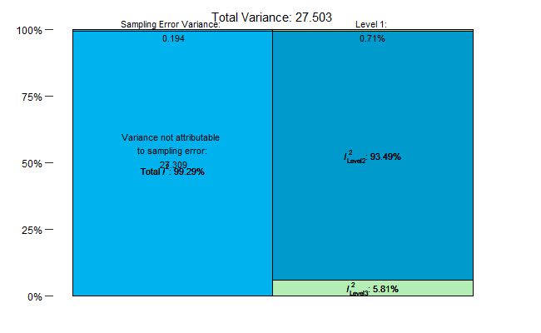
Figure S 2: Visualized results of the heterogeneity indicator I² multi-level test (Cheung, 2014). Level 1 is the typical within-study sampling variance. Level 2 is the within-study variance (i.e., variance between multiple effect sizes within the same study). Level 3 is the between-study variance.

Publication bias & sensitivity analysis

Methods
We assessed potential publication bias using complementary approaches adapted for multilevel meta-analytic models. We created funnel plots to visually inspect the distribution of effect sizes against their standard error (Harrer et al., 2021; Viechtbauer, 2010). We inspected the funnel plot for symmetrical distribution of points around the mean effect (indicates absence of bias) and asymmetry (suggests potential publication bias where certain studies are underrepresented in literature).
We also conducted formal tests including a modified Egger's regression test (Egger et al., 1997), by incorporating precision as a predictor in our multilevel model. We calculated precision as the inverse of the standard error (1/SE) for each effect size, with higher precision values indicating more reliable effect size estimates, typically resulting from studies with larger sample sizes or lower variance. The modified Egger’s regression then tests whether smaller studies (with lower precision) showed systematically different effects than larger studies (with higher precision).
To address the challenge of non-independent effect sizes, we conducted an aggregated analysis where we combined multiple effect sizes from each study into single precision-weighted means. This allowed us to apply conventional publication bias tests to the simplified dataset, including standard Egger's regression test and Begg and Mazumdar's rank correlation test (Begg and Mazumdar, 1994). We also performed trim-and-fill analysis (Duval and Tweedie, 2000), which identified potentially missing studies and provided an adjusted effect size that accounted for these studies. Lastly, we calculated Rosenberg’s fail-safe N (Rosenberg, 2005) to determine the number of null studies needed to nullify the observed effect, though this analysis is only applicable when the original meta-analytic effect is statistically significant.
For sensitivity analyses, we attempted to calculate influence diagnostics to identify potentially influential studies, though this was limited by the complexity of our multilevel model. Instead, we conducted leave-one-out analyses (Viechtbauer and Cheung, 2010) by systematically removing each study and recalculating the overall effect size to determine whether any single study substantially altered our conclusions. We compared the original versus trim-and-fill adjusted effect sizes to assess the impact of potential publication bias on our findings.

Results
Table S 5: Summary of publication bias analyses for the meta-analysis of fire effects on taxa abundance. * indicates statistical significance at p < 0.05.
Method | Result | Interpretation
Modified Egger's test (multilevel model) | coefficient = 0.1541, p = 0.194 | No significant evidence of small-study effects in multilevel model
Egger's regression test (aggregated data) | z = -0.167, p = 0.8674 | No significant asymmetry in study-level effects
Begg & Mazumdar's rank correlation test | Kendall's tau = -0.0542, p = 0.6962 | No significant correlation between effect size and precision
Trim-and-fill analysis | 6 missing studies estimated  (SE = 3.5864) | Evidence of potential missing studies with positive effects
Rosenberg's fail-safe N | Not applicable | Not applicable as base model showed statistical insignificance
Original effect size (aggregated data) | 0.2232 (95% CI: -0.2729 to 0.7193, p = 0.3778) | Non-significant overall effect in original analysis
Adjusted effect size  (after trim-and-fill) | 0.6741 (95% CI: 0.1446 to 1.2036, p = 0.0126)* | Significant effect after adjustment for potential bias

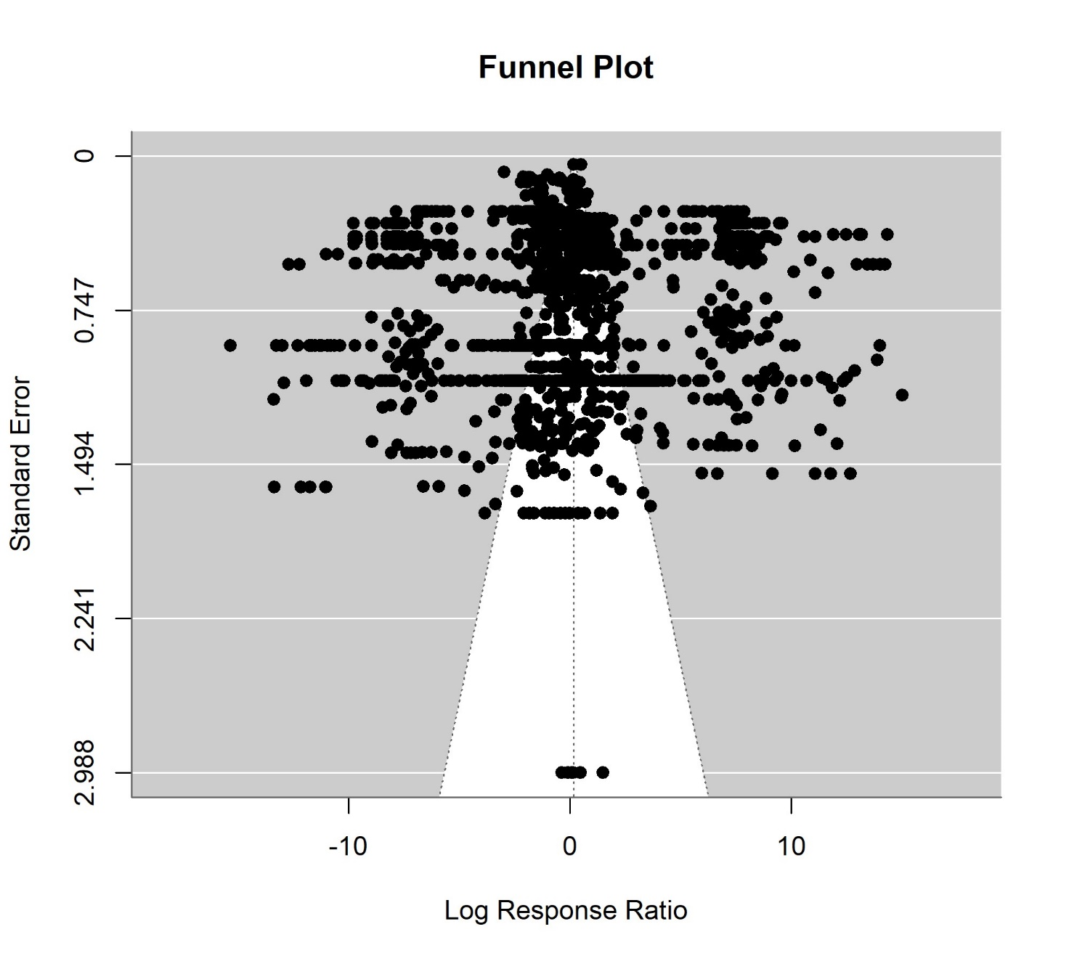
Figure S 3:Funnel plot showing the relationship between effect sizes (log response ratios) and their standard errors. Each point represents an individual effect size. The distribution shows a rectangular pattern at the top with most points outside the expected funnel shape, and only a handful of points in the middle at the bottom. This unusual pattern suggests high heterogeneity in the dataset rather than conventional publication bias. The lack of a symmetrical funnel shape may reflect the complex ecological responses to fire across diverse taxonomic groups and environments.
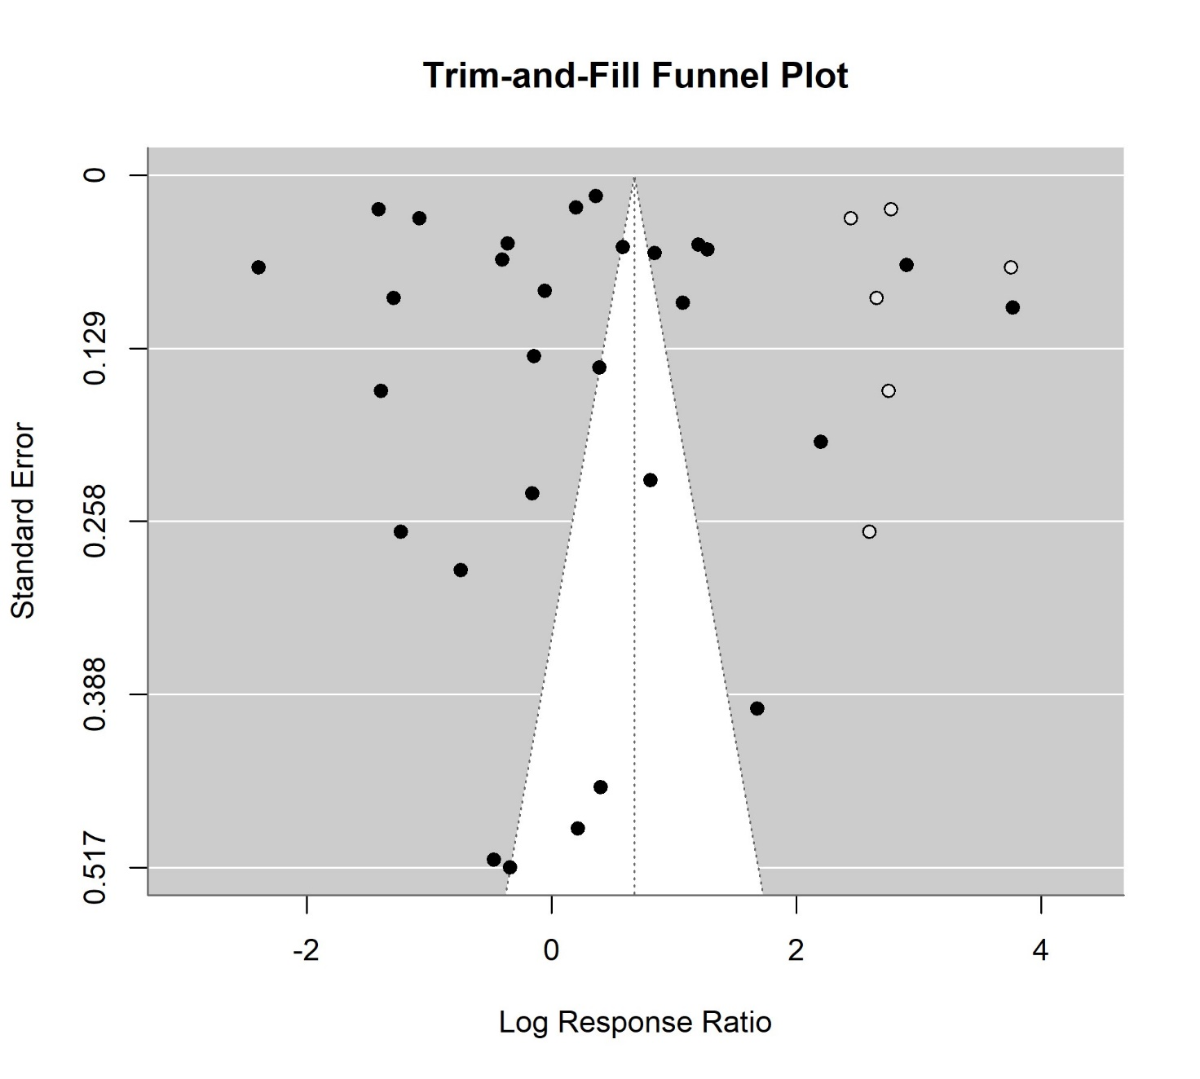
Figure S 4:Funnel plot with trim-and-fill adjustment. Open circles represent observed studies, while filled circles represent potentially missing studies imputed by the trim-and-fill algorithm. Points are widely scattered, with most concentrated toward the top of the plot rather than following the expected funnel pattern. The trim-and-fill analysis estimated 6 potentially missing studies with positive effect sizes. The vertical solid line represents the original mean effect size (0.22), while the dashed line represents the adjusted mean effect size (0.67) after accounting for potentially missing studies.
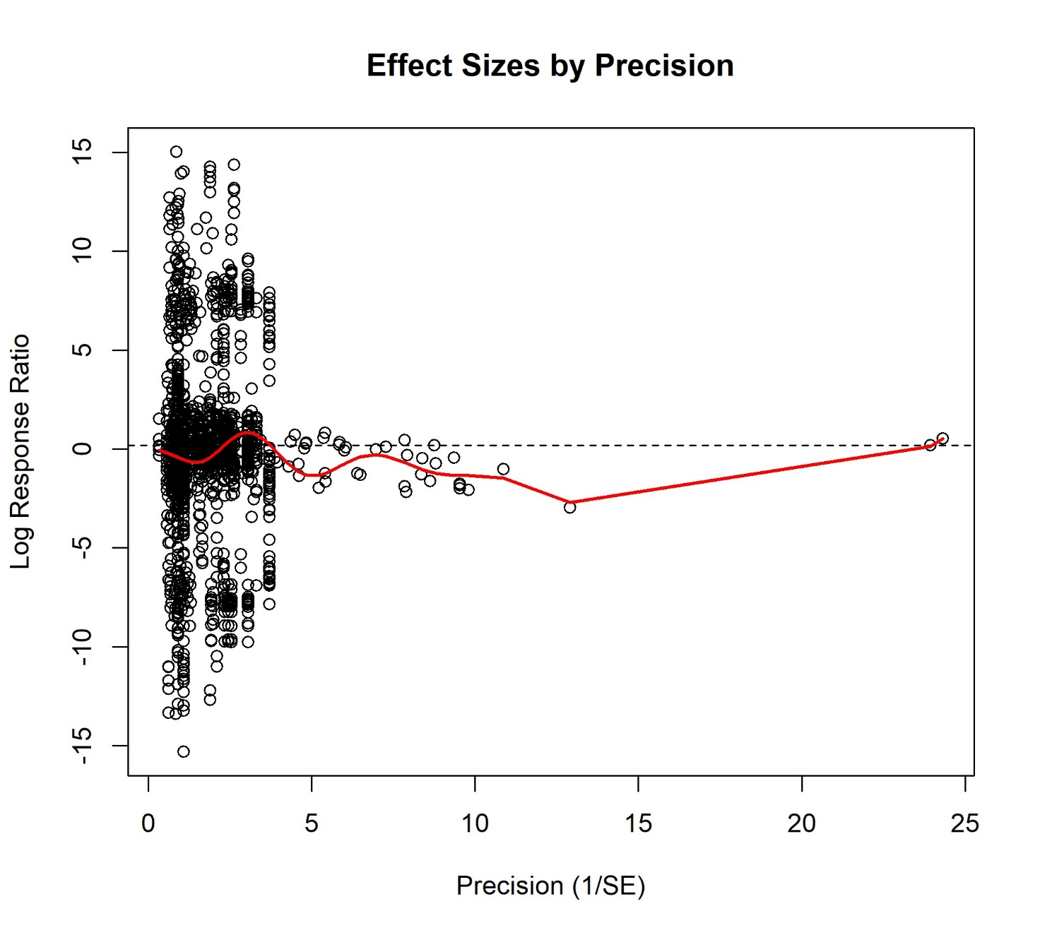
Figure S 5: Scatter plot showing the relationship between study precision (1/standard error) and effect size (log response ratio). The horizontal dashed line represents the overall mean effect size from the multilevel meta-analysis model. The red curve represents a smoothed trend line. In the absence of publication bias, there should be no systematic relationship between precision and effect size. This plot supplements standard publication bias tests which are not directly applicable to multilevel meta-analysis models.
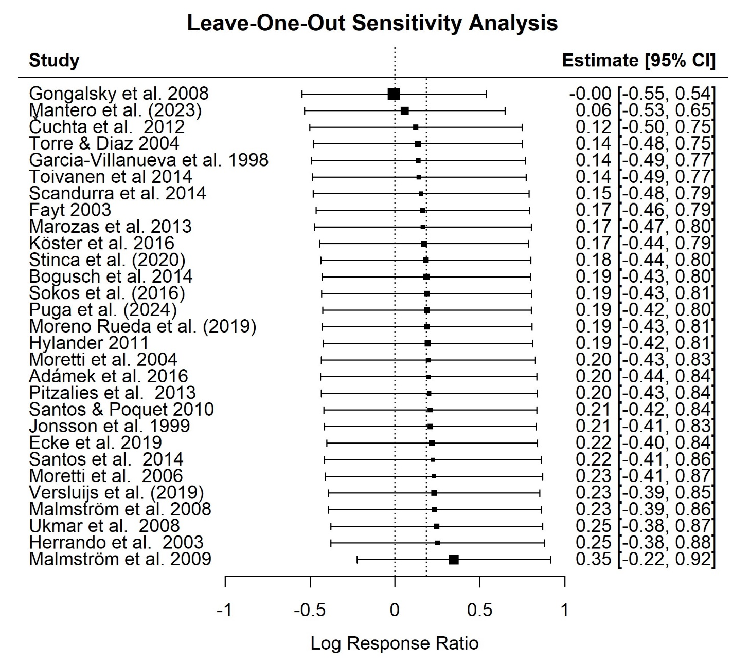
Figure S 6: Results of the leave-one-out analysis visualizing the summary effect sizes for meta-analyses without the study named in each row. The dotted vertical line shows the reference line at zero. The original summary effect size (including all studies) is shown as the dotted vertical line to the left of zero.
Table S 6: Leave-one-out sensitivity analysis results for the effect of fire on taxa abundance in European forests. The table shows how the overall effect size (log response ratio, lnRR) changes when each individual study is removed from the meta-analysis. Positive values indicate increases in organism abundance after fire, while negative values indicate decreases. The original effect size with all studies included was 0.186 (95% CI: -0.424 to 0.795, p = 0.551). No single study removal changed the statistical significance of the overall effect, demonstrating the robustness of our findings to the influence of individual studies.
Study | Effect Size (lnRR) | 95% CI Lower | 95% CI Upper | p-value
Adámek et al. 2016 | 0.199 | -0.437 | 0.836 | 0.54
Bogusch et al. 2014 | 0.185 | -0.428 | 0.799 | 0.554
Čuchta et al. 2012 | 0.124 | -0.501 | 0.749 | 0.697
Ecke et al. 2019 | 0.219 | -0.402 | 0.839 | 0.489
Fayt 2003 | 0.165 | -0.464 | 0.795 | 0.607
Garcia-Villanueva et al. 1998 | 0.138 | -0.492 | 0.768 | 0.667
Gongalsky et al. 2008 | -0.005 | -0.548 | 0.538 | 0.986
Herrando et al. 2003 | 0.251 | -0.376 | 0.879 | 0.433
Hylander 2011 | 0.194 | -0.423 | 0.81 | 0.538
Jonsson et al. 1999 | 0.21 | -0.413 | 0.833 | 0.509
Köster et al. 2016 | 0.171 | -0.443 | 0.786 | 0.585
Malmström et al. 2008 | 0.235 | -0.393 | 0.863 | 0.464
Malmström et al. 2009 | 0.347 | -0.222 | 0.917 | 0.232
Mantero et al. 2023 | 0.058 | -0.532 | 0.648 | 0.847
Marozas et al. 2013 | 0.166 | -0.472 | 0.803 | 0.611
Moreno Rueda et al. 2019 | 0.19 | -0.427 | 0.807 | 0.546
Moretti et al. 2004 | 0.196 | -0.435 | 0.827 | 0.542
Moretti et al. 2006 | 0.23 | -0.41 | 0.87 | 0.481
Pitzalies et al. 2013 | 0.203 | -0.433 | 0.839 | 0.532
Puga et al. 2024 | 0.189 | -0.424 | 0.803 | 0.546
Santos & Poquet 2010 | 0.209 | -0.418 | 0.836 | 0.514
Santos et al. 2014 | 0.225 | -0.414 | 0.863 | 0.49
Scandurra et al. 2014 | 0.154 | -0.482 | 0.789 | 0.635
Sokos et al. 2016 | 0.188 | -0.431 | 0.806 | 0.552
Stinca et al. 2020 | 0.183 | -0.435 | 0.801 | 0.562
Toivanen et al. 2014 | 0.142 | -0.487 | 0.772 | 0.657
Torre & Diaz 2004 | 0.136 | -0.479 | 0.751 | 0.664
Ukmar et al. 2008 | 0.246 | -0.377 | 0.869 | 0.439
Versluijs et al. 2019 | 0.231 | -0.39 | 0.852 | 0.466

References
Begg, C.B., Mazumdar, M., 1994. Operating Characteristics of a Rank Correlation Test for Publication Bias. Biometrics 50, 1088. https://doi.org/10.2307/2533446
Cheung, M.W.-L., 2014. Modeling dependent effect sizes with three-level meta-analyses: A structural equation modeling approach. Psychological Methods 19, 211–229. https://doi.org/10.1037/a0032968
Duval, S., Tweedie, R., 2000. Trim and Fill: A Simple Funnel‐Plot–Based Method of Testing and Adjusting for Publication Bias in Meta‐Analysis. Biometrics 56, 455–463. https://doi.org/10.1111/j.0006-341X.2000.00455.x
Egger, M., Smith, G.D., Schneider, M., Minder, C., 1997. Bias in meta-analysis detected by a simple, graphical test. BMJ 315, 629–634. https://doi.org/10.1136/bmj.315.7109.629
Harrer, M., Cuijpers, P., Furukawa, T.A., Ebert, D.D., 2021. Doing Meta-Analysis With R: A Hands-On Guide, 1st ed. Chapman & Hall/CRC Press, Boca Raton, FL and London.
Nakagawa, S., Noble, D.W.A., Lagisz, M., Spake, R., Viechtbauer, W., Senior, A.M., 2023. A robust and readily implementable method for the meta‐analysis of response ratios with and without missing standard deviations. Ecology Letters 26, 232–244. https://doi.org/10.1111/ele.14144
Niwa, C.G., Peck, R.W., 2002. Influence of prescribed fire on carabid beetle (Carabidae) and spider (Araneae) assemblages in forest litter in southwestern Oregon. ENVIRONMENTAL ENTOMOLOGY.
Olson, D.M., Dinerstein, E., Wikramanayake, E.D., Burgess, N.D., Powell, G.V.N., Allnut, T.F., Ricketts, T.H., Kura, Y., Lamoreux, J.F., Wettengel, W.W., Hedao, P., Kassem, K.R., 2001. Terrestrial ecoregions of the world: a new map of life on Earth. BioScience 51, 933–938.
Page, M.J., McKenzie, J.E., Bossuyt, P.M., Boutron, I., Hoffmann, T.C., Mulrow, C.D., Shamseer, L., Tetzlaff, J.M., Akl, E.A., Brennan, S.E., Chou, R., Glanville, J., Grimshaw, J.M., Hróbjartsson, A., Lalu, M.M., Li, T., Loder, E.W., Mayo-Wilson, E., McDonald, S., McGuinness, L.A., Stewart, L.A., Thomas, J., Tricco, A.C., Welch, V.A., Whiting, P., Moher, D., 2021. The PRISMA 2020 statement: an updated guideline for reporting systematic reviews. BMJ n71. https://doi.org/10.1136/bmj.n71
Rosenberg, M.S., 2005. THE FILE-DRAWER PROBLEM REVISITED: A GENERAL WEIGHTED METHOD FOR CALCULATING FAIL-SAFE NUMBERS IN META-ANALYSIS. Evol 59, 464. https://doi.org/10.1554/04-602
Viechtbauer, W., 2010. Conducting Meta-Analyses in R with the metafor Package. J. Stat. Soft. 36. https://doi.org/10.18637/jss.v036.i03
Viechtbauer, W., Cheung, M.W.-L., 2010. Outlier and influence diagnostics for meta-analysis. Res. Synth. Method 1, 112–125. https://doi.org/10.1002/jrsm.11

