Table S1. The DDH, ANI and AAI values between strain MI7-26^{T} (NCBI accession number JAPFFT000000000) and the related strains.
Taxon name | Strain name | NCBI accession number | MI7-26T
Taxon name | Strain name | NCBI accession number | dDDH (%) | ANI (%) | AAI（％）
Arthrobacter gyeryongensis | DCY72^{T} | GCF_039543785 | 34.2 | 87.57 | 90.85
Arthrobacter bambusae | DP-A9 | GCF_022606295 | 32.9 | 87.19 | 90.67
Arthrobacter ramosus | CCM1646^{T} | GCF_039535095 | 35.7 | 88.17 | 91.2
Arthrobacter methylotrophus | TGA^{T} | GCF_039539965 | 31.2 | 86.22 | 89.8
Arthrobacter cupressi | CGMCC 1.10783^{T} | GCF_013409905 | 22.1 | 78.88 | 80.22
Paenarthrobacter nicotinovorans | DMS420^{T} | GCF_021919345 | 21 | 77.37 | 78.81
Paenarthrobacter nitroguajacolicus | G2-1^{T} | GCF_050413655 | 21.1 | 77.02 | 78.95
Paenarthrobacter aurescens | NBRC12136^{T} | GCF_041549525 | 20.8 | 76.89 | 79.04
Pseudarthrobacter phenanthrenivorans | Sphe3^{T} | GCF_000189535 | 20.9 | 76.36 | 76.15
Arthrobacter globiformis | NBRC12137^{T} | GCF_000238915 | 21.6 | 77.08 | 76.47
Pseudarthrobacter equi | IMMIBL-1606^{T} | GCF 900105535 | 21.2 | 76.61 | 75.72
Pseudarthrobacter chlorophenolicus | A6^{T} | GCF 000022025 | 21.3 | 76.56 | 75.26
Pseudarthrobacter siccitolerans | 4J27^{T} | GCF 001046895 | 21.4 | 76.48 | 75.75
Pseudarthrobacter enclensis | NIO-1008^{T} | GCF_001457025 | 21.2 | 76.53 | 75.8
Arthrobacter woluwensis | NBRC107840^{T} | GCF_001552095 | 20.6 | 74.21 | 68.84
Pseudarthrobacter scleromae | YH-2001^{T} | GCF_014644515 | 21.2 | 76.58 | 76.17
Arthrobacter terricola | JH1-1^{T} | GCF_004354015 | 24.7 | 81.33 | 84.66
Arthrobacter cavernae | PO-11^{T} | GCF_017368795 | 23.2 | 80.05 | 81.69
Sinomonas mesophila | MPKL26^{T} | GCF_001999765 | 20.3 | 73.69 | 68.79

Fig. S1. Maximum-likelihood phylogenetic tree of strain MI7-26^{T} and its relatives based on the comparison of the 16S rRNA gene sequences. Genbank accession numbers were given in parentheses.
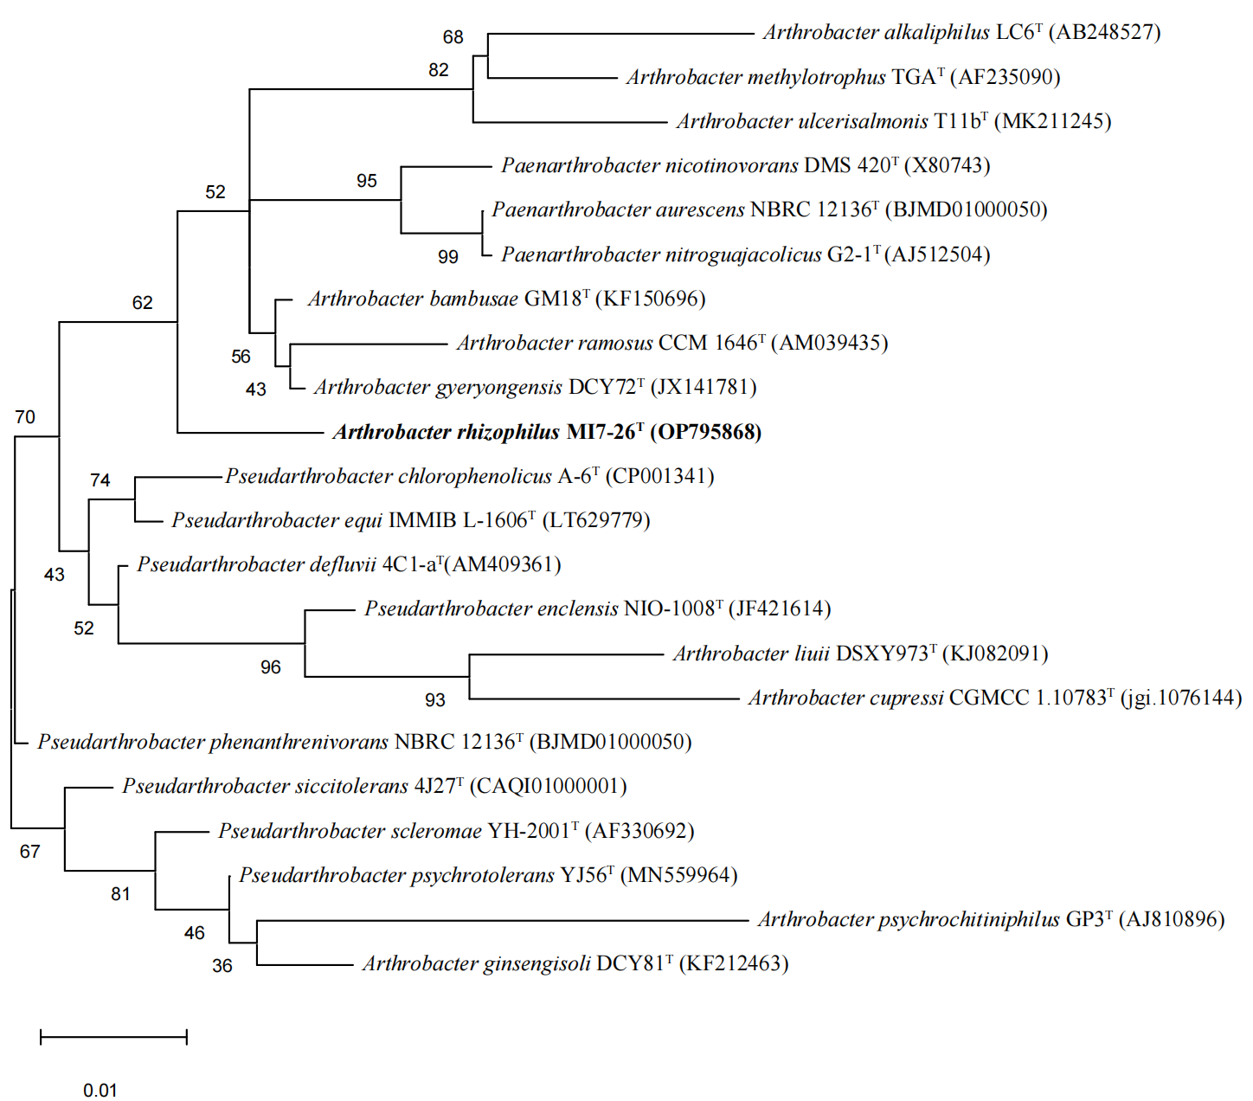

Fig. S2. Maximum-parsimony phylogenetic tree of strain MI7-26^{T} and its relatives based on the comparison of the 16S rRNA gene sequences. Genbank accession numbers were given in parentheses.
Arthrobacter alkaliphilus LC6^{T} (AB248527)
Arthrobacter methylotrophus TGA^{T} (AF235090)
Arthrobacter ulcerisalmonis T11b^{T} (MK211245)
Pseudarthrobacter enclensis NIO-1008^{T} (JF421614)
Arthrobacter liuii DSXY973^{T} (KJ082091)
Arthrobacter cupressi CGMCC 1.10783^{T} (jgi.1076144)
Pseudarthrobacter defluvii 4C1-a^{T}(AM409361)

Pseudarthrobacter equi IMMIB L-1606^{T} (LT629779)
Pseudarthrobacter chlorophenolicus A-6^{T} (CP001341)
Pseudarthrobacter siccitolerans 4J27^{T} (CAQI01000001)

Paenarthrobacter aurescens NBRC 12136^{T} (BJMD01000050)
Paenarthrobacter nitroguajacolicus G2-1^{T} (AF512504)
Paenarthrobacter nicotinovorans DMS 420^{T} (X80743)
Arthrobacter rhizophilus MI7-26^{T} (OP795868)

Arthrobacter ramosus CCM 1646^{T} (AM039435)
Arthrobacter bambusae GM18^{T} (KF150696)
Arthrobacter gyeryongensis DCY72^{T} (JX141781)
Pseudarthrobacter phenanthreniv orans NBRC 12136^{T} (BJMD01000050)
Pseudarthrobacter scleromae YH-2001^{T} (AF330692)
Pseudarthrobacter psychrotolerans YJ56^{T} (MN559964)
Arthrobacter ginsengisoli DCY81^{T} (KF212463)
Arthrobacter psychrochitiniphilus GP3^{T} (AJ810896)
93
39
87
79
78
72
61
60
45
38
32
26
26
26
22
16
4
4
17

Fig. S3. Phylogenetic tree was inferred from whole-genome comparative analysis, illustrating the relationship between strain MI7-26^{T} and its related species, and was constructed by AutoMLST pipeline (https://automlst.ziemertlab.com). Bootstrap values based on 1000 replicates are shown at the branch nodes. The scale bar represents 0.2 substitutions per nucleotide site.
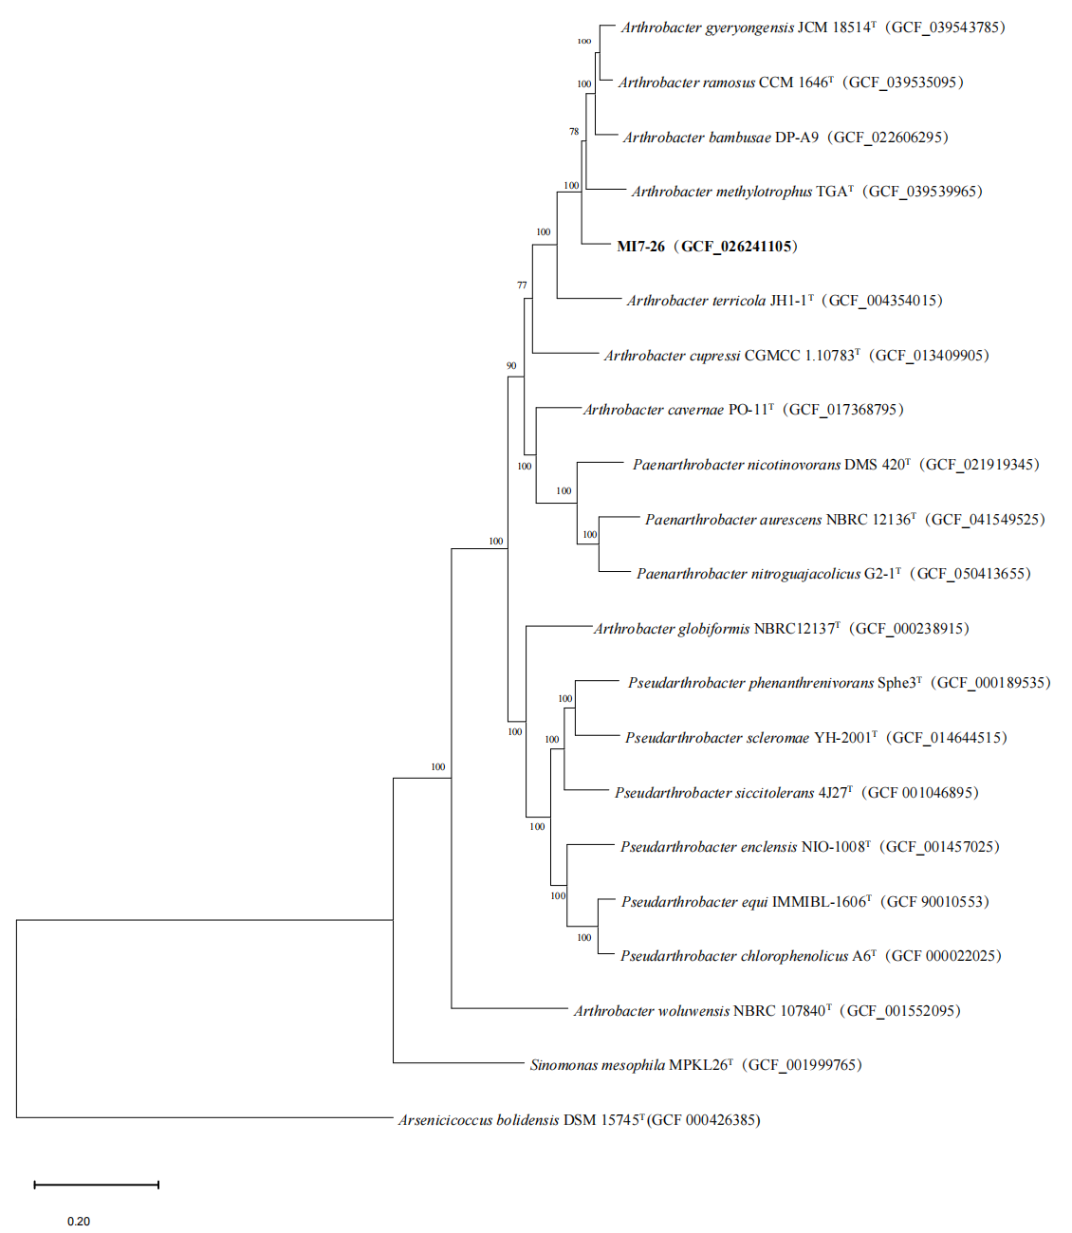
Fig. S4. The polar lipids of strain MI7-26^{T}. Polar lipids profiles of strain separated by two-dimensional TLC, which were detected by spraying with molybdatophosphoric acid reagent. (a), molybdophosphoric acid was used to reveal total polar lipids; (b), ninhydrin reagent for aminolipids; (c), ammonium molybdate reagent for phospholipids; (d), a-naphthol reagent for glycolipids. DPG, diphosphatidylglycerol; PG, phosphatidylglycerol; PI, Phosphatidylinositol; PL (1-2), unidentified phospholipids; AL, unidentified aminolipids; GL (1-2), unidentified glycolipids.
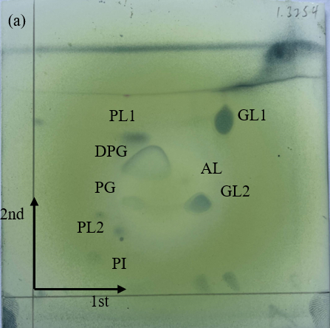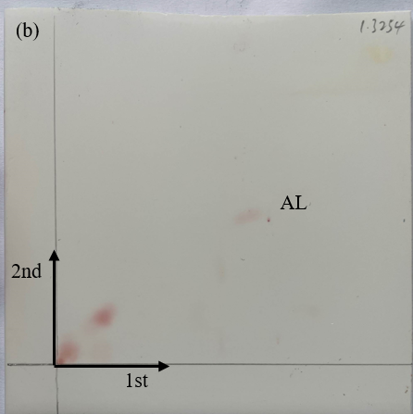
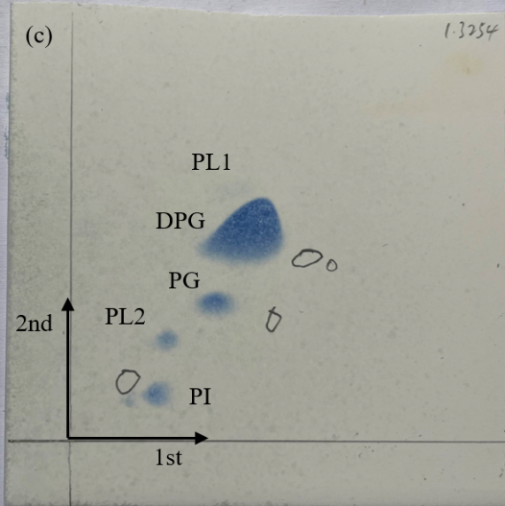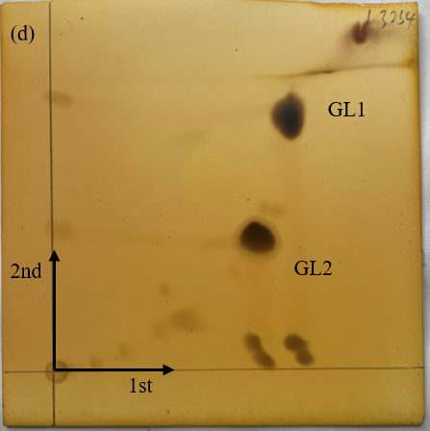

Fig. S5. Effect diagram of dissolving organic phosphate of strain MI7-26^{T}. (a), the front of the medium; (b), the back of the medium.

Fig. S6. Annotation of the genome of MI7-26^{T} through Proksee. CARD: The comprehensive antibiotic resistance database.
