Electronic Supplementary Material
Engineering a Gd₂(WO₄)₃–P@rGO heterostructure for enhanced electrochemical sensing and therapeutic drug monitoring of erdafitinib
Rasha M. K. Mohamedª, Rania H Tahaª, Ibrahim Hotan Alsohaimiª, Khulaif Alshammari^{b}, Hassan M. A. Hassanª, Hossieny Ibrahim^{c}, Mohamed M. El-Wekil*^{d}
ª Department of Chemistry, College of Science, Jouf University, Sakaka, Aljouf 72341, Saudi Arabia
^{b} Department of Physics, College of Science, Jouf University, Sakaka, Aljouf 72341, Saudi Arabia
^{c} Department of Chemistry, Faculty of Science, Assiut University, Assiut 71516, Egypt
^{d} Department of Pharmaceutical Analytical Chemistry, Faculty of Pharmacy, Assiut University, Assiut, Egypt
*Correspondence
mohamed.elwakeel@pharm.aun.edu.eg, mohamed.mohamoud@ymail.com

Instrumentation
The morphology and microstructural architecture of the synthesized nanocomposite were examined using field-emission scanning electron microscopy (FE-SEM, JEOL JSM-6700F) to visualize surface topology, while transmission electron microscopy (TEM, JEOL JEM-100CX II) provided high-resolution insights into the internal structural order. Crystallinity and phase purity were verified by powder X-ray diffraction (PXRD, Philips-FEI PW 1710), and diffraction profiles were compared with standard JCPDS references to confirm successful formation of the targeted phase. X-ray photoelectron spectroscopy (XPS, PHI 5700 ESCA) was employed to probe the material’s surface chemistry, enabling quantitative determination of elemental composition, oxidation states of metal centers, and the degree of nitrogen/oxygen functionalization introduced during composite formation. Electrochemical behavior was systematically evaluated using cyclic voltammetry (CV) and differential pulse voltammetry (DPV) on a VersaSTAT MC workstation equipped with a conventional three-electrode configuration. A Gd₂(WO₄)₃–P@rGO@GCE served as the working electrode, while a platinum wire and Ag/AgCl (3 M KCl) acted as the counter and reference electrodes, respectively. All measurements were performed in phosphate buffer electrolyte under controlled conditions to assess charge-transfer kinetics, electrocatalytic activity, and analytical response toward ERDF.

Electrochemical measurements
The electrochemical behavior of the fabricated electrodes was comprehensively evaluated using multiple voltammetric and impedance techniques. Cyclic voltammetry (CV) was performed within a potential range of −0.2 to 0.6 V at a scan rate of 150 mV s⁻¹ to investigate the inherent redox activity and electron-transfer kinetics of the modified surfaces. Electrochemical impedance spectroscopy (EIS), recorded over a frequency domain of 0.1–10⁶ Hz at an applied bias of 0.5 V, was used to determine the charge-transfer resistance (Rct), capacitive behavior, and interfacial electron-transport efficiency of the composite-modified electrode. For quantitative analysis, differential pulse voltammetry (DPV) was employed using the Gd₂(WO₄)₃–P-rGO/GCE, taking advantage of its enhanced catalytic sites and high electrical conductivity. Detection of ERDF was carried out under optimized analytical conditions, including a 0.1–1.3 V scanning window, 120 s pre-accumulation time to enrich analyte adsorption, a modulation amplitude of 0.055 V, a pulse width of 0.075 s, and a potential step of 0.004 V. These parameters collectively ensured maximum signal amplification and improved sensitivity for trace-level determination.

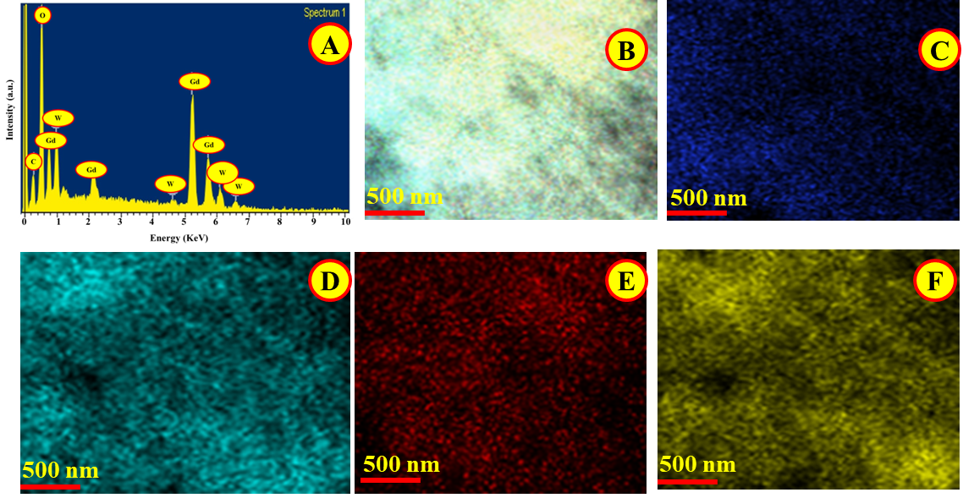

Fig. S1 EDX of Gd₂(WO₄)₃–P@rGO (A); Elemental mapping (B) and mapping analysis of carbon (C), oxygen (D), tungsten (E), and gadolinium (F).

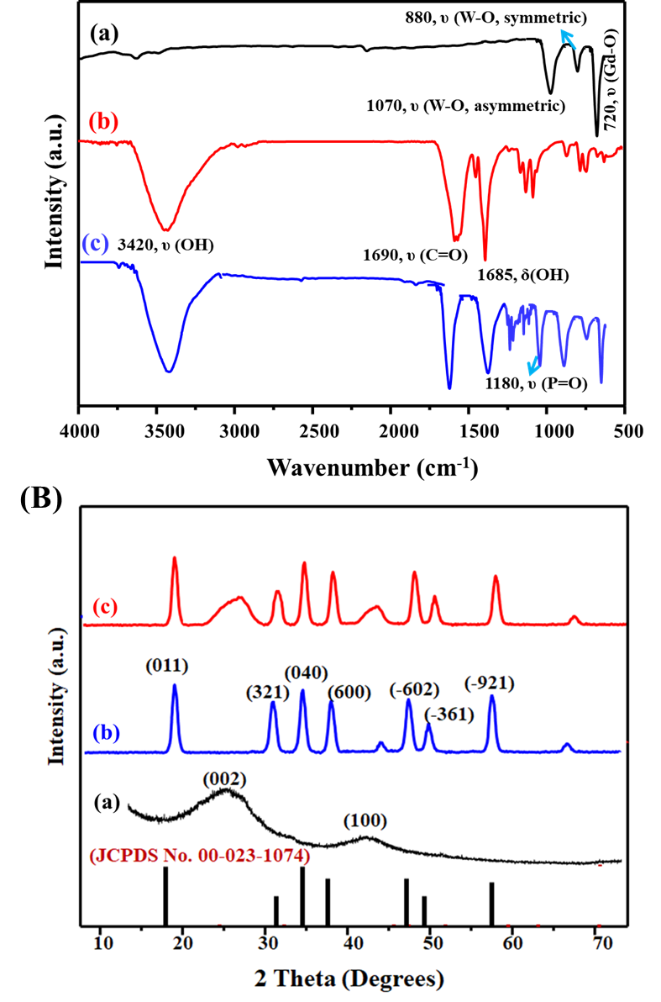

Fig. S2 (A) FTIR spectra of Gd₂(WO₄)₃ (a), P@rGO (b), and Gd₂(WO₄)₃–P@rGO (c). (B) XRD pattern of P@rGO (a), Gd₂(WO₄)₃ (b), and Gd₂(WO₄)₃–P@rGO (c).

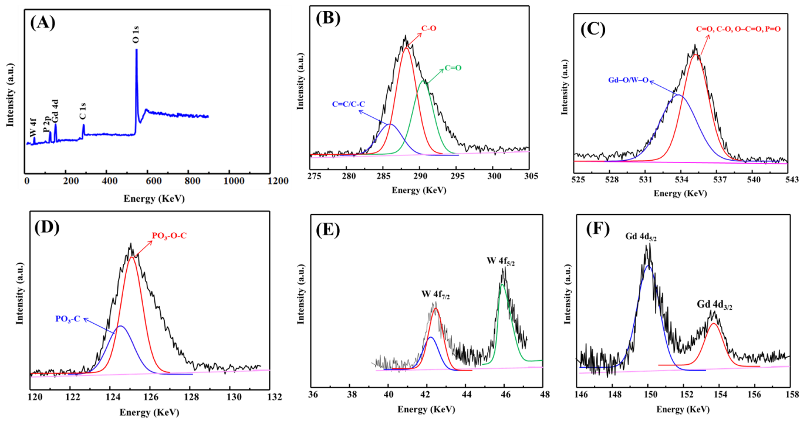

Fig. S3 (A) XPS survey of Gd₂(WO₄)₃–P@rGO; (B-F) Deconvoluted spectra of XRD pattern of C 1s (B), O 1s (C), P 2p (D), W 4f (E), and Gd 4d (F).

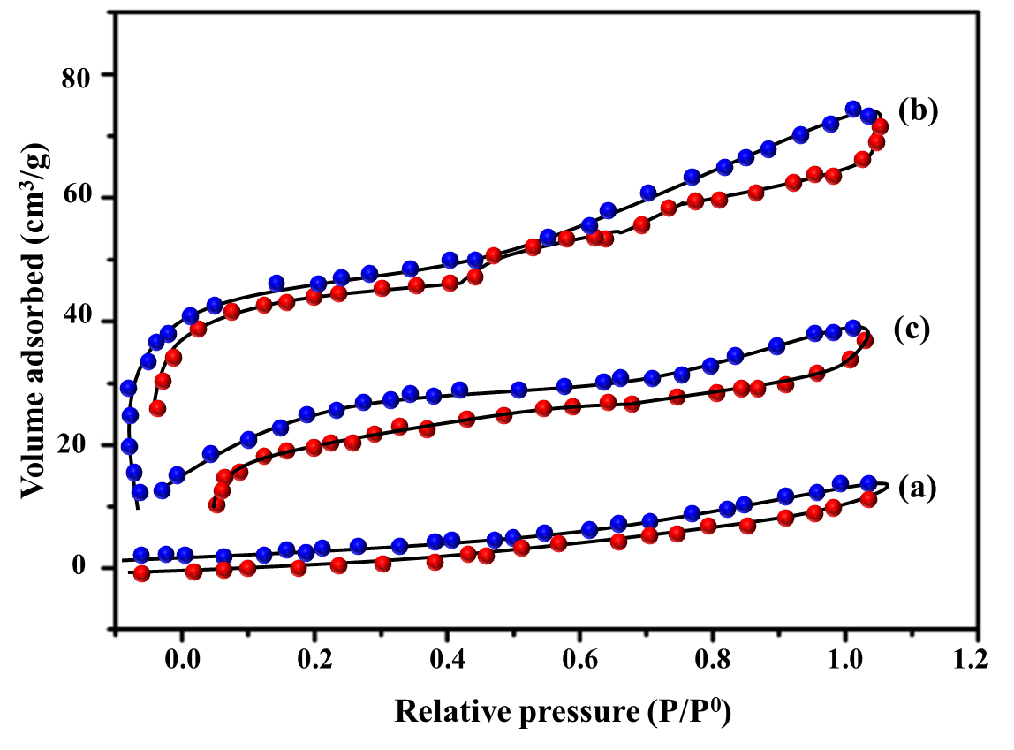

Fig. S4 Nitrogen adsorption-desorption isotherm of Gd₂(WO₄)₃ (a), P@rGO (b), and Gd₂(WO₄)₃–P@rGO (c).

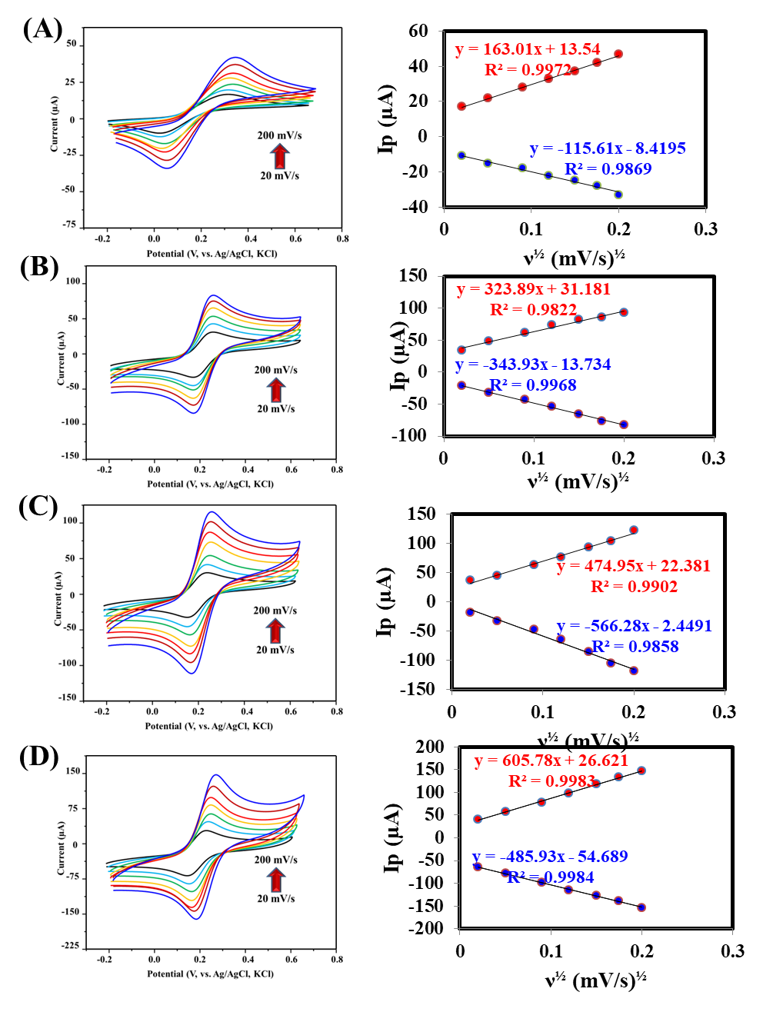

Fig. S5 CV scans and corresponding plots between ν½ and Ip for bare GCE, Gd₂(WO₄)₃/GCE, P@rGO/GCE, and Gd₂(WO₄)₃–P@rGO/GCE. Concentration of Fe(CN)₆³⁻/⁴⁻ redox probe is 5.0 mM.

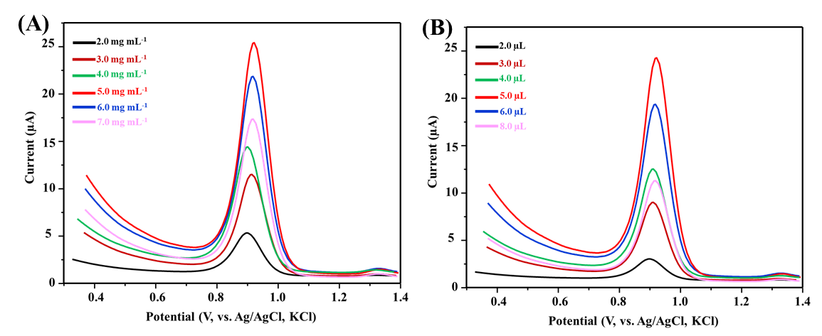

Fig. S6 Effect of Gd₂(WO₄)₃–P@rGO concentration (A) and casting volume (B) on the DPV responses of 100.0 nM ERDF.

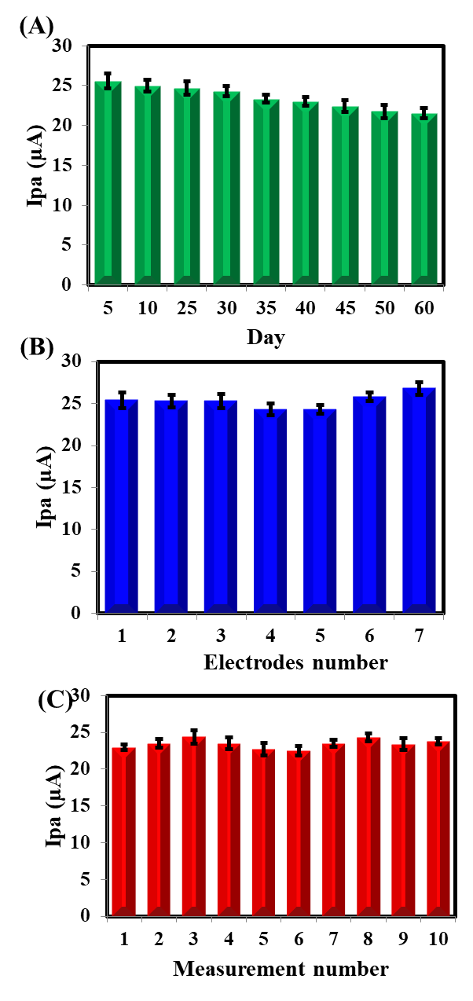

Fig. S7 (A) Stability, (B) reproducibility, and (C) repeatability after measuring 100 nM ERDF in phosphate buffer (pH 5.5) at the Gd₂(WO₄)₃–P@rGO/GCE.

