Supplementary Information
Ultrafast Mechanisms of Femtosecond Laser-Induced Structural Reconfiguration in Fluoride Glasses

Liming Mao¹, Jiawei Wu^{2,3,4}, Jiabao Du^{2,3,4}, Changhui Liu¹, Lin She¹, Shijie Jia^{1,*}, Shunbin Wang¹, Shusen Zhao², Xuechun Lin^{2,3,4,*}, Pengfei Wang^{5,6,*} and Yichun Liu^{5,6}

¹College of Physics and Optoelectronic Engineering, Harbin Engineering University, Harbin 150001, China
²Laboratory of All-solid-state Light Sources, Institute of Semiconductors, Chinese Academy of Sciences, Beijing 100083, China
³Center of Materials Science and Optoelectronics Engineering, University of Chinese Academy of Sciences, Beijing 100049, China
⁴College of Electronic, Electrical and Communication Engineering, University of Chinese Academy of Sciences, Beijing 101408, China
⁵School of Physics, State Key Laboratory of Integrated Optoelectronics, Northeast Normal University, Changchun 130024, China
⁶School of Physics, Key Laboratory of UV-Emitting Materials and Technology, Northeast Normal University, Changchun 130024, China
⁷These authors contributed equally: Liming Mao, Jiawei Wu.
Email: jiasj@hrbeu.edu.cn; xclin@semi.ac.cn; pfwang@nenu.edu.cn.

Content
Note 1: Electron density calculation 1
Note 2: Phase delay and stress direction calculation 2
Note 3: Raman characterization of waveguide region 3
Note 4: Electron probe analysis 4
Note 5: Thermal erasure comparisons 5
Note 6: Carrier–stress coupled model for femtosecond laser-induced stress waves in fluoride glasses 6
6.1 Physical background and motivation 6
6.2 Rate equation for carrier generation 6
6.3 Free-carrier absorption and energy deposition 6
6.4 Temperature rise and thermoelastic pressure 7
6.5 Stress-wave propagation 7
6.6 Analytical summary 7
6.7 Numerical implementation 8
6.8 Discussion and physical implications 8
6.8.1 Ultrafast carrier generation and energy coupling 8
6.8.2 Stress-wave formation and structural modification 8
6.8.3 Scaling laws and generalization 9
6.8.4 Implications for laser microstructuring and photonics 9
6.8.5 Summary 10
Note 7: Fluoride glass fabrication parameters 11
7.1 Glass compositions 11
7.2 Preparation temperatures 11
Reference 12

Note 1: Electron density calculation
This Note details the calculation process for plasma electron density.
To characterize the time evolution of femtosecond laser-induced plasma within the sample, we performed calculations using the Drude model^{1,2}. Two images (background and signal) were collected before and after femtosecond irradiation, from which the transmission intensities at 520 nm probe wavelength were extracted. Denoting the transmittances of the background and signal images as I₀ and I₁ respectively, the transient transmittance T at different time delays is expressed as:
$\text{T} \text{= }\frac{{\text{I}}_{\text{1}}}{{\text{I}}_{\text{0}}}$ (1-1)
The laser intensity I_{c} at the center of the pump-probe beam is given by:
$\frac{\text{d}{\text{I}}_{\text{c}}}{\text{dx}}\text{ = -}\text{α}{\text{I}}_{\text{c}}$ (1-2)
where α is the absorption coefficient, obtained via integration:
$\text{α}\text{ = -(}\text{ln}{\text{T}}\text{)/}\text{x}$ (1-3)
Here, x denotes the length of the electron plasma along the propagation direction of the probe beam, determined by the plasma width at each time delay (assuming plasma symmetry). The absorption coefficient is directly related to the plasma frequency ω_{p}:
$\text{α}\text{ = }\frac{\text{τ}}{\text{nc}}\frac{{\text{ω}}_{\text{p}}^{\text{2}}}{\text{1+}{\text{ω}}^{\text{2}}{\text{τ}}^{\text{2}}}$ (1-4)
where n is the material refractive index at the probe wavelength, c is the vacuum speed of light, ω is the laser frequency, and τ is the electron collision time. The plasma frequency ω_{p} depends on the free electron density, as described by:
${\text{ω}}_{\text{p}}\text{ = }\sqrt{\frac{{\text{n}}_{\text{e}}{\text{e}}^{\text{2}}}{{\text{m}}_{\text{e}}{\text{ε}}_{\text{0}}}}$ (1-5)
with e as the electron charge, me as the electron mass, and ε₀ as the vacuum permittivity. The final electron density is thus:
${\text{n}}_{\text{e}}\text{ =}\frac{ \text{αnc}{\text{m}}_{\text{e}}{\text{ε}}_{\text{0}}\text{(1+}{\text{ω}}^{\text{2}}{\text{τ}}^{\text{2}}\text{)}}{{\text{e}}^{\text{2}}\text{τ}}$ (1-6)
A summary of the parameters is provided in the table below.
Name | Symbol | Value | Literature
Refractive index | n | 1.542 | This work
Laser frequency | ω | 5.77×10¹⁴ Hz | This work
electronic collision time | τ | 1.7 fs | Ref. 3

Note 2: Phase delay and stress direction calculation
This Note describes the calculation procedures for optical retardance and birefringence distribution.
Fluoride glasses can be considered isotropic materials at room temperature. When a laser is focused inside the sample, transient stress is induced, disrupting the isotropic properties of the glass. This leads to a refractive index difference between the two principal stress directions, resulting in a birefringence effect. We derived the photoelastic equation using Stokes vectors and Mueller matrices^{4,5}.The Stokes vector of light detected by the polarization camera after passing through the optical path is expressed as:
${\text{I}}_{\text{i}}\text{ =}{ \text{P}}_{\text{i}}\text{M}{\text{S}}_{\text{1 }}\text{(}\text{i}\text{=1,2,3,4)}$ (2-1)
The angle between the horizontal polarizer and the x-axis is β, given by:
${\text{P}}_{\text{i}}\text{ =}\frac{\text{1}}{\text{2}}\left[\begin{matrix}\text{1} & \text{cos}{\text{2(}{\text{β}}_{\text{i}}\text{)}} & \text{sin}{\text{2(}{\text{β}}_{\text{i}}\text{)}} & \text{0} \\ \text{cos}{\text{2(}{\text{β}}_{\text{i}}\text{)}} & {\text{cos}}^{\text{2}}{\text{2(}{\text{β}}_{\text{i}}\text{)}} & \text{sin}{\text{2(}{\text{β}}_{\text{i}}\text{)}}\text{cos}{\text{2(}{\text{β}}_{\text{i}}\text{)}} & \text{0} \\ \text{sin}{\text{2(}{\text{β}}_{\text{i}}\text{)}} & \text{sin}{\text{2}{\text{(}\text{β}}_{\text{i}}\text{)}}\text{cos}{\text{2(}{\text{β}}_{\text{i}}\text{)}} & {\text{sin}}^{\text{2}}{\text{2(}{\text{β}}_{\text{i}}\text{)}} & \text{0} \\ \text{0} & \text{0} & \text{0} & \text{0}\end{matrix}\right]$ (2-2)
where β_{i}=0º, 45º, 90º, 135º. M is the Mueller matrix of the material induced by transient stress, expressed as:
$\text{M = }\left[\begin{matrix}\text{1} & \text{0} & \text{0} & \text{0} \\ \text{0} & {\text{cos}}^{\text{2}}{\text{2}\text{θ}\text{+}{\text{sin}}^{\text{2}}{\text{2}\text{θ}\text{cos}{\text{φ}}}} & \left(\text{1-}\text{cos}{\text{φ}}\right)\text{sin}{\text{2}\text{θ}\text{cos}{\text{2}\text{θ}}} & \text{-}\text{sin}{\text{2}\text{θ}\text{sin}{\text{φ}}} \\ \text{0} & \left(\text{1-}\text{cos}{\text{φ}}\right)\text{sin}{\text{2}\text{θ}\text{cos}{\text{2}\text{θ}}} & {\text{sin}}^{\text{2}}{\text{2}\text{θ}\text{+}{\text{cos}}^{\text{2}}{\text{2}\text{θ}}}\text{cos}{\text{φ}} & \text{cos}{\text{2}\text{θ}\text{sin}{\text{φ}}} \\ \text{0} & \text{sin}{\text{2}\text{θ}\text{sin}{\text{φ}}} & \text{-}\text{cos}{\text{2}\text{θ}\text{sin}{\text{φ}}} & \text{cos}{\text{φ}}\end{matrix}\right]$ (2-3)
Here, θ is the angle between the glass material and the x-axis, and φ is the retardation. The Stokes vector of an ideal circularly polarized light field is:
${\text{S}}_{\text{1 }}\text{= }\text{Q}{\text{P}}_{\text{0}}{\text{S}}_{\text{0}}\text{ = }\text{I}\text{ [1 0 0 1}{\text{]}}^{\text{T}}$ (2-4)
Q denotes the Mueller matrix of the quarter-wave plate, which can be neglected when matched to the light source wavelength. From the above equations, the stress expression in a circularly polarized field is derived as:
$\text{φ=acrsin }\sqrt{\frac{{\left({\text{I}}_{\text{3}}\text{-}{\text{I}}_{\text{1}}\right)}^{\text{2}}\text{+}\left({\text{I}}_{\text{2}}\text{-}{\text{I}}_{\text{4}}\right)}{\left({\text{I}}_{\text{1}}\text{+}{\text{I}}_{\text{3}}\right)\left({\text{I}}_{\text{2}}\text{+}{\text{I}}_{\text{4}}\right)}}$ (2-5)
$\text{θ}\text{ = }\frac{\text{1}}{\text{2}}\text{arctan (}\frac{{\text{I}}_{\text{3}}\text{-}{\text{I}}_{\text{1}}}{{\text{I}}_{\text{2}}\text{-}{\text{I}}_{\text{4}}}\text{)}$ (2-6)

Note 3: Raman characterization of waveguide region
This Note presents Raman characterization results of femtosecond laser-modified regions in INF glass.
Channel waveguides were fabricated in INF glass (260 μm below the surface) using femtosecond laser repeated scanning, with single-pulse energies ranging from 0.2 to 0.7 μJ; single-scan reference lines (3 μJ) were inscribed on both sides. Fig. S3-1a shows a cross-sectional micrograph of the waveguide, where Regions I, II, and N denote the positive refractive index modified region, negative refractive index modified region, and femtosecond laser-unirradiated region (laser incident along the Z-direction), respectively. Along the laser incidence direction, the channel waveguide exhibits a ‘sandwich-like’ contrast pattern with a ‘bright-dark-bright’ sequence, attributed to glass network polarizability changes induced by low-repetition-rate pulses⁶.
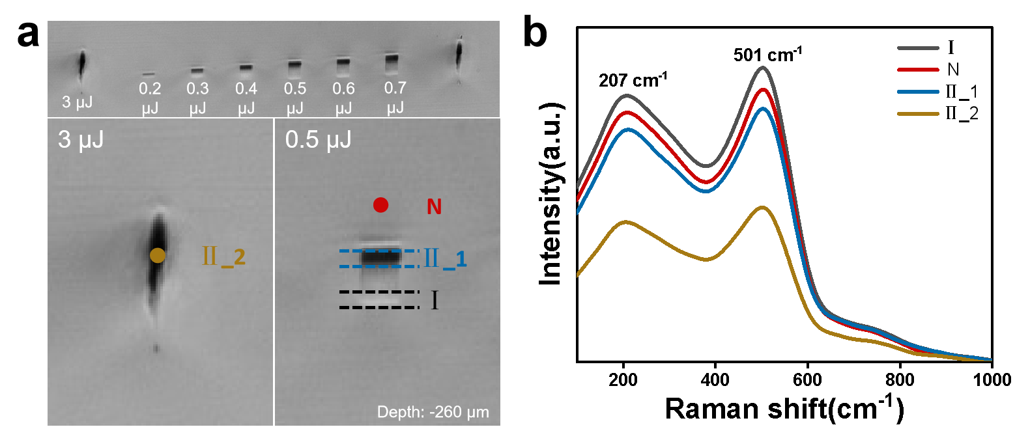
Fig. S3-1 | Raman characterization of femtosecond laser direct-written waveguide regions (INF glass). a Micrograph of a femtosecond laser direct-written waveguide region. The laser repetition rate and scanning speed are 1 kHz and 500 μm/s, respectively, with a waveguide width of 10 μm (scan interval: 1 μm). b Comparison of Raman spectra in waveguide regions. Regions I, II, and N denote the positive refractive index modified region, negative refractive index modified region, and unmodified region, respectively.
Raman spectroscopy was performed on these three regions using a 633 nm laser, with results shown in Fig. S3-1b. The Raman spectra exhibit two distinct peaks: asymmetric Zn-F and Ba-F stretching vibrations at 207 cm⁻¹, and 501 cm⁻¹ for octahedral [InF₆] stretching vibrations⁷⁻⁹. Relative to the unirradiated region (N), the Raman intensity increased by ~7% in the positive refractive index modified region and decreased by ~7% in the negative refractive index modified region. A significant intensity reduction (40%) was observed in the high-power modified region, confirming glass network densification and rarefaction induced by femtosecond laser irradiation^{10,11}.

Note 4: Electron probe analysis
This Note characterizes elemental redistribution in ABYPM glass under high repetition rates.
In the fluoroaluminate glass (ABYPM), single line scanning was performed using the same femtosecond laser parameters to observe the characteristics of element redistribution (femtosecond laser incident along the Z direction), as shown in Fig. S4-1. From the cross-sectional microscope images of the modified area, it can be seen that the modified profiles of ABYPM and INF glass are very similar, both exhibiting a 'droplet shaped' profile. The main body of the contour has a brighter contrast compared to the modified area, which corresponds to an increase in refractive index.
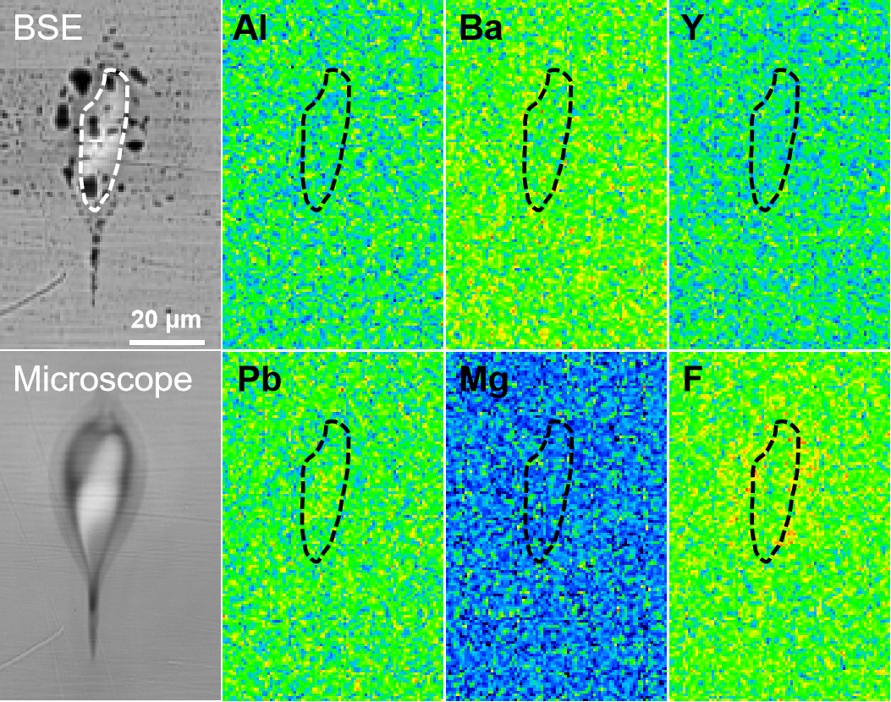
Fig. S4-1 | Elemental distribution in the cross-section of femtosecond laser-modified regions (ABYPM glass). a Backscattered electron (BSE) image, micrograph, and corresponding elemental distribution maps (from electron probe microanalysis). This region was fabricated via single-line scanning with a femtosecond laser (repetition rate: 50 kHz, scanning speed: 500 μm/s, single-pulse energy: 3 μJ).
The backscatter (BSE) image also shows the same contrast pattern, with the black area due to the expansion of the gold film on the glass surface under high-energy electron beam bombardment (which does not affect the distribution test of glass composition elements). The wavelength dispersive spectrometer (WDS) mapping results intuitively display the element redistribution under high repetition rate femtosecond laser pulses. Pb element is enriched in the high refractive index modified zone, while Ba and F elements migrate to the negative refractive index modified zone outside the modified zone. It exhibits good consistency with the element redistribution of INF glass.

Note 5: Thermal erasure comparisons
This Note provides details of thermal erasure phenomena in regions modified by femtosecond laser pulses with different single-pulse energies.
Under identical femtosecond laser pulse parameters, we compare thermal erasure phenomena across a broader range of single-pulse energies (Fig. S5-1). Given that excessively high heat-treatment temperatures can induce crystallization in fluoride glasses, the maximum heat-treatment temperature was set near the glass transition temperature (T_{g} ~257ºC).
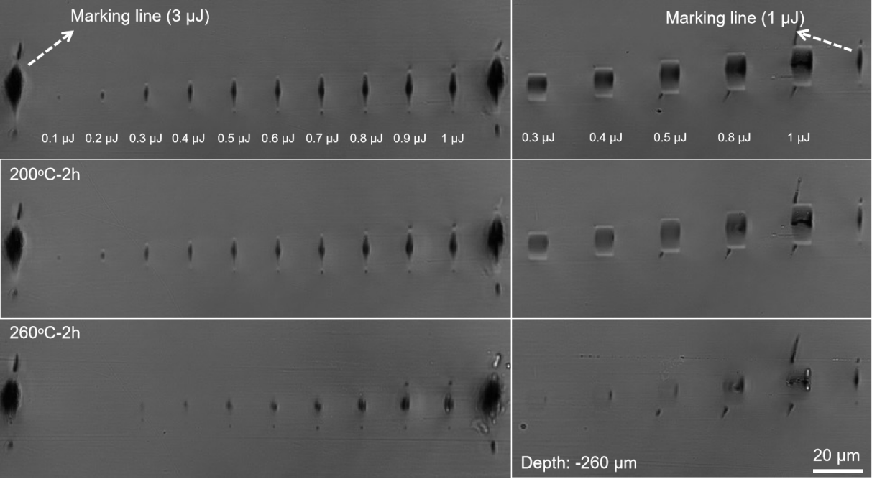
Fig. S5-1 | Thermal erasure in femtosecond-modified regions. Comparative micrographs of single-line scanned and multi-scan waveguide regions at different heat-treatment temperatures (200ºC, 260ºC). Laser parameters: 1 kHz repetition rate, 500 μm/s scanning speed. Multi-scan waveguide width: 8 μm (scan interval: 0.5 μm).

Cross-sectional images of the modified zones reveal that contrast between modified and unmodified regions gradually diminishes with increasing temperature. The modified region fabricated with single-pulse energy <0.3 μJ is completely erased at 260ºC, while bright-contrast modified regions at higher energies are also erased. As single-pulse energy increases, the erasure degree of dark-contrast zones decreases progressively (without complete erasure) and more severe damage—including cracks and nanocavities—appears (e.g., in regions modified with 1 μJ single-pulse energy). Thus, excessive single-pulse energy should be avoided for fabricating low-loss optical waveguides.

Note 6: Carrier–stress coupled model for femtosecond laser-induced stress waves in fluoride glasses
The goal of this note is to quantitatively link carrier dynamics, energy dissipation, and stress-wave generation through a simplified but physically grounded model.

6.1 Physical background and motivation
When a femtosecond laser pulse is tightly focused into a transparent fluoride glass, an ultrafast sequence of electronic and structural events unfolds.
- Carrier generation (fs–ps) occurs via multiphoton and avalanche ionization, creating a dense plasma of free electrons and holes.
- Energy transfer (ps) from hot carriers to the lattice proceeds through Drude absorption and electron–phonon coupling, leading to rapid local heating.
- Stress-wave formation (ps–ns) follows as the localized energy deposition induces thermal expansion and launches a high-amplitude longitudinal acoustic wave.
This sequence couples femtosecond-scale electron dynamics with picosecond-scale mechanical response. The localized plasma acts as a transient pressure source—often described as a “plasma piston”—which generates GPa-level stress waves observable via birefringence and pump–probe imaging.

6.2 Rate equation for carrier generation
The temporal evolution of free-electron density n_{e}(t) follows the rate equation:
$\frac{\text{d}{\text{n}}_{\text{e}}}{\text{dt}}\text{=}{\text{W}}_{\text{MPI}}\left(\text{I} \right)\left[{\text{N}}_{\text{0}}\text{-}{\text{n}}_{\text{e}}\right]\text{+}{\text{σ}}_{\text{av }}\text{I}\left(\text{t}\right){\text{n}}_{\text{e}}\text{-}\frac{{\text{n}}_{\text{e}}}{{\text{τ}}_{\text{r}}}$ (6-1)
where
- N₀ – atomic density of the glass,
- W_{MPI}(I )=σ_{K}I^{K} – multiphoton ionization rate,
- σ_{av} – avalanche ionization coefficient,
- τ_{r} – electron recombination time,
- I(t) – instantaneous laser intensity.
The laser pulse is modelled as a Gaussian envelope¹²:
$\text{I}\text{(}\text{t}\text{)=}{\text{I}}_{\text{0}}\text{exp [-4}\text{ln}{\text{2}\frac{{\text{t}}^{\text{2}}}{{\text{τ}}_{\text{p}}^{\text{2}}}}\text{]}$ (6-2)
where τ_{p} is the pulse duration (400 fs). For femtosecond timescales (t < 2 ps), recombination is negligible, giving:
$\frac{\text{d}{\text{n}}_{\text{e}}}{\text{dt}}\text{≈}{\text{W}}_{\text{MPI}}\left(\text{I} \right)\left[{\text{N}}_{\text{0}}\text{-}{\text{n}}_{\text{e}}\right]\text{+}{\text{σ}}_{\text{av }}\text{I}\left(\text{t}\right){\text{n}}_{\text{e}}$ (6-3)
This equation is numerically integrated to obtain n_{e}(t), as shown in Fig. S6-1a.

6.3 Free-carrier absorption and energy deposition
The absorption coefficient due to free carriers, from the Drude model, is:
$\text{α}\left(\text{t}\right)\text{=}\frac{{\text{ω}}_{\text{p}}^{\text{2}}\text{τ}}{\text{nc}{\text{ε}}_{\text{0}}\left(\text{1+}{\text{ω}}^{\text{2}}{\text{τ}}^{\text{2}}\right)}\text{≈}{\text{σ}}_{\text{fc}}{\text{n}}_{\text{e}}\left(\text{t}\right)$ (6-4)
where ${\text{ω}}_{\text{p}}^{\text{2}}\text{=}\frac{{\text{n}}_{\text{e}}{\text{e}}^{\text{2}}}{{\text{m}}^{\text{*}}{\text{ε}}_{\text{0}}}$, and σ_{fc} is the effective free-carrier absorption cross-section.
The local volumetric power absorbed per unit time is:
$\text{q}\left(\text{t}\right)\text{=}\text{α}\left(\text{t}\right)\text{I}\left(\text{t}\right)\text{≈}{\text{σ}}_{\text{fc}}{\text{n}}_{\text{e}}\left(\text{t}\right)\text{I}\left(\text{t}\right)$ (6-5)
Integrating over the pulse yields the energy density deposited in the focal volume:
$\text{Q}\text{=}\int_{\text{-∞}}^{\text{+∞}}{\text{q}\text{(}\text{t}\text{)}\text{dt}\text{=}{\text{σ}}_{\text{fc}}\text{F}\text{ ∫}}{\text{n}}_{\text{e}}\text{(}\text{t}\text{)}\frac{\text{I}\text{(}\text{t}\text{)}}{{\text{I}}_{\text{0}}}\text{dt}$ (6-6)
where F is the local fluence. For simplicity, n_{e}(t) can also be approximated as a Gaussian peak centered at t=0.

6.4 Temperature rise and thermoelastic pressure
The lattice temperature increase is determined by:
$\text{Δ}\text{T}\text{=}\frac{\text{Q}}{\text{ρ}{\text{C}}_{\text{v}}}$ (6-7)
Where ρ and C_{v} are density and specific heat capacity.
The thermoelastic pressure-the source term of the stress wave—is expressed via the Grüneisen parameter Γ¹³:
$\text{Δ}\text{p}\text{=}\text{Γ}\text{Q}\text{=3}\text{K}{\text{α}}_{\text{T}}\frac{\text{Q}}{\text{ρ}{\text{C}}_{\text{v}}}$ (6-8)
Thus, the pressure amplitude scales linearly with both peak electron density and laser fluence:
$\text{Δ}\text{p}∝{\text{n}}_{\text{e}\text{,peak}}\text{F}$ (6-9)
For typical parameters of fluoroindate glass (n_{e,peak}~5×10²⁰ cm⁻³, F~1 J/cm²), Q~5×10⁹ J/m³, yielding Δp~1-5 GPa, consistent with experimental birefringence measurements.

6.5 Stress-wave propagation
The acoustic pressure field satisfies the inhomogeneous wave equation¹⁴:
$\frac{{\text{∂}}^{\text{2}}\text{p}}{\text{∂}{\text{t}}^{\text{2}}}\text{-}{\text{c}}_{\text{s}}^{\text{2}}∇^{\text{2}}\text{p}\text{=}\text{S}\left(\text{r}\text{,}\text{t}\right)$ (6-10)
where c_{s} is the sound speed (~4.3 μm/ns in fluoroindate glass), and S is the pressure source term.
Approximating the excitation as a localized spherical source of radius $\text{a}$ yields:
$\text{p}\text{(}\text{r}\text{,}\text{t}\text{ )=}\frac{\text{Δ}\text{p}}{\text{4}\text{πr}}\text{g}\text{(}\text{t}\text{-}\frac{\text{t}}{{\text{r}}_{\text{s}}}\text{)}$ (6-11)
where g(t) represents the temporal profile of the source (typically a Gaussian of duration τ_{s}~1 ps). The stress amplitude thus decays as 1/r with propagation distance.

6.6 Analytical summary
Combining the above relationships, the chain of processes is shown as follows:
$\text{I}\text{(}\text{t}\text{)}\text{⇒}{\text{n}}_{\text{e}}\text{(}\text{t}\text{)}\text{⇒}\text{Q}\text{(}\text{t}\text{)}\text{⇒}\text{∆}\text{T}\text{(}\text{t}\text{)}\text{⇒}\text{∆}\text{p}\text{(}\text{t}\text{)}\text{⇒}\text{p(}\text{r}\text{, }\text{t}\text{ )}$ (6-12)
The peak stress at a distance r₀ from the focus can be estimated as:
${\text{p}}_{\text{max}}\left({\text{r}}_{\text{0}}\right)\text{≈}\frac{\text{Γ}{\text{σ}}_{\text{fc}}{\text{n}}_{\text{e}\text{,peak}}\text{F}}{\text{4}\text{π}{\text{r}}_{\text{0}}}$ (6-13)
This compact scaling quantitatively connects plasma energy dissipation to stress-wave amplitude.
6.7 Numerical implementation
Numerical integration of Eq. (6-3) was performed using explicit Euler stepping. The customised script computes the evolution of n_{e}(t), energy deposition Q(t), temperature rise ∆T(t), and pressure ∆p(t) for representative parameters (τₚ = 400 fs, λ = 1040 nm). The resulting Fig. S6-1 displays normalized intensity and carrier dynamics, lattice heating, and stress-wave formation.
Typical simulation output is shown as follows:
Quantity | Symbol | Typical Value | Physical Meaning
Peak electron density | n_{e,peak} | 1×10²¹ cm⁻³ | Near critical plasma
Peak temperature | ∆T_{max} | 10³–10⁴ K | Local lattice heating
Peak pressure | P_{max} | 1–5 GPa | Thermoelastic stress amplitude
These magnitudes agree with optical birefringence experiments and validate the coupled model.

6.8 Discussion and physical implications
The simulation results shown in Fig. S6-1 confirm that ultrafast plasma formation and relaxation act as the principal drivers of thermoelastic stress generation in fluoride glasses. The coupling between electronic excitation, energy dissipation, and mechanical response bridges femtosecond and nanosecond regimes, forming a complete picture of femtosecond laser–matter interaction.

6.8.1 Ultrafast carrier generation and energy coupling
Within sub-picosecond timescales, multiphoton and avalanche ionization produce dense plasmas with n_{e}~10²⁰–10²¹ cm⁻³, comparable to the critical density at 1040 nm. The transient plasma modifies the dielectric constant via the Drude term, leading to a drop in refractive index and intense free-carrier absorption. The electron–phonon coupling transfers energy to the lattice within several picoseconds, forming a localized plasma piston that exerts impulsive mechanical pressure on the surrounding matrix.
The absorbed energy density (Q~10⁹⁻¹⁰ J/m³) yields thermoelastic pressures on the order of gigapascals, consistent with experimental birefringence-derived stresses.

6.8.2 Stress-wave formation and structural modification
The calculated pressure profile follows the cumulative absorbed energy, propagating as a longitudinal acoustic wave at c_{s}≈4.3 μm/ns.
The resulting transient strain is sufficient to locally reorganize the glass network without fracture. The hot focal volume behaves as an expanding inclusion embedded in an elastic matrix, generating alternating compressive and tensile zones that permanently imprint density variations.
These density gradients translate directly into refractive index changes through the Lorentz–Lorenz relation¹⁵:
$\frac{\text{Δ}\text{n}}{\text{n}}\text{≈}\frac{\left(\text{n}\text{-1}\right)\left({\text{n}}^{\text{2}}\text{+2}\right)}{\text{6}{\text{n}}^{\text{2}}}\frac{\text{Δ}\text{ρ}}{\text{ρ}}$ (6-14)
Thus, compressive densification yields positive ∆n, while tensile rarefaction produces negative ∆n, explaining the polarity of refractive index modifications observed experimentally.

6.8.3 Scaling laws and generalization
From Eqs. (6-6)–(6-9), simple scaling laws emerge:
$\text{Δ}\text{p}∝{\text{n}}_{\text{e}\text{,peak}}\text{F}\text{, Δ}\text{T}∝\frac{{\text{n}}_{\text{e}\text{,peak}}\text{F}}{\text{ρ}{\text{C}}_{\text{v}}}\text{, }\text{n}∝\frac{\text{∂}\text{n}}{\text{∂}\text{ρ}}\frac{\text{Δ}\text{p}}{\text{K}}$ (6-15)
These relations reveal that:
- Fluence and carrier density control stress amplitude linearly until plasma shielding dominates.
- Elastic constants-bulk modulus and Grüneisen parameter-govern stress conversion efficiency.
- Thermal diffusivity and coupling time determine whether modification remains localized or evolves into microexplosion regimes.
This framework applies broadly to fluoride, silicate, borate, and chalcogenide systems, confirming that carrier–stress coupling is a universal pathway in ultrafast laser modification.

6.8.4 Implications for laser microstructuring and photonics
The established quantitative link between plasma dissipation and stress-wave formation provides a mechanistic foundation for precision laser microfabrication. By tuning pulse energy, focusing conditions, and repetition rate, one can engineer the balance between compressive and tensile stress fields to tailor the sign and magnitude of the refractive index change.
For mid-infrared photonic devices, controlled stress-induced densification in fluoride glasses enables low-loss waveguides, gratings, and microresonators with Δn up to 10⁻². The model also guides optimization of multi-pulse writing regimes, predicting thresholds where cumulative heating or stress relaxation alters modification morphology.
Beyond fluoride systems, these results provide a transferable framework for diverse transparent dielectrics. Incorporating carrier-stress coupling into hydrodynamic and finite-element models will enhance predictive control over ultrafast structural modification, facilitating rational design of next-generation 3D photonic architectures and hybrid glass–crystal platforms.

6.8.5 Summary
The carrier-stress coupled model unifies ultrafast plasma evolution, thermoelastic energy transfer, and mechanical response into a single quantitative framework. It demonstrates how femtosecond plasma dissipation generates GPa-level stresses that imprint permanent structural and optical changes.
This mechanistic understanding not only explains observed refractive index variations in fluoride glasses but also establishes general design principles for high-precision femtosecond laser engineering across transparent materials.
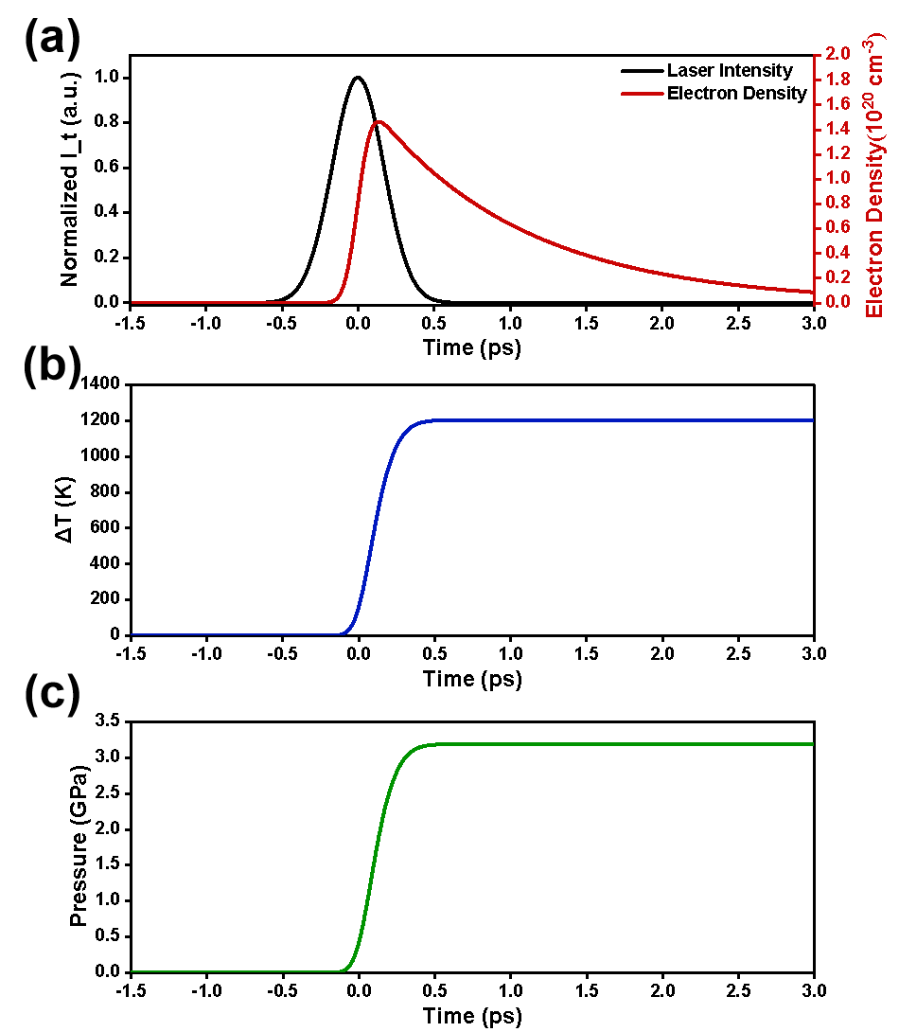
Fig. S6-1 | Simulated carrier dynamics, lattice heating, and transient pressure induced by a 400 fs Gaussian laser pulse in fluoroindate glass. a Temporal evolution of laser intensity (in black) and electron density n_{e}(t) (in red). b Corresponding lattice temperature rise ΔT(t). c Resulting thermoelastic pressure P(t) serving as the stress-wave source. The pressure reaches GPa levels consistent with experimentally observed birefringence fields, validating the carrier–stress coupling mechanism.

Note 7: Fluoride glass fabrication parameters
This Note includes fabrication details of the various fluoride glass materials used in this study.
Fluoroaluminate (ABYPM) and fluorozincate glasses (AZF/AZFD) are prepared using a melt-quenching method, similar to fluoroindate (INF) glass, with the key difference being the annealing temperature. The specific preparation procedure for fluoroindate glass is provided in the main text; here, we focus on the compositions and preparation temperatures of fluoroaluminate and fluorozincate glasses.

7.1 Glass compositions
ABYPM: 30 AlF₃-12 BaF₂-20 YF₃-28 PbF₂-10 MgF₂
AZF: 32 ZnF₂-12 BaF₂-11 YF₃-13 SrF₂-32 AlF₃
AZFD: 32 ZnF₂-12 BaF₂-10 YF₃-13 SrF₂-32 AlF₃- 1 DyF₃

7.2 Preparation temperatures
Name | Fluorination temperature/time | Firing temperature/time | Annealing temperature/time
ABYPM | 400ºC/0.5h | 950ºC/3h | 360ºC/5h
AZF/AZFD | 400ºC/0.5h | 950ºC/3h | 350ºC/5h

Reference
- B. C. Stuart, M. D. Feit, S. Herman, A. M. Rubenchik, B. W. Shore & M. D. Perry. Nanosecond-to-femtosecond laser-induced breakdown in dielectrics. Phys. Rev. B 53, 1749-1761 (1996).
- B. H. Christensen & P. Balling. Modeling ultrashort-pulse laser ablation of dielectric materials. Phys. Rev. B 79, 155424 (2009).
- Q. Sun, H. Jiang, Y. Liu, Z. Wu, H. Yang & Q. Gong. Measurement of the collision time of dense electronic plasma induced by a femtosecond laser in fused silica. Opt. Lett. 30, 320-322 (2005).
- M. S.-B. Fernández. Metrological considerations in the measurement of contact stress parameters using photoelasticity. Opt. Lasers Eng. 117, 29-39 (2019).
- Y. Satoru, K. Hisao & M. Kosuke. Simultaneous observation of phase-stepped photoelastic fringes using a pixelated microretarder array. Opt. Eng. 45, 083604 (2006).
- D. J. Little, M. Ams, P. Dekker, G. D. Marshall & M. J. Withford. Mechanism of femtosecond-laser induced refractive index change in phosphate glass under a low repetition-rate regime. J. Appl. Phys. 108, 033110 (2010).
- B. Bendow, P. K. Banerjee, M. G. Drexhage, J. Goltman, S. S. Mitra & C. T. Moynihan. Comparative Study of Vibrational Characteristics of Fluorozirconate and Fluorohafnate Glasses. J. Am. Ceram. Soc. 65, C‐8-C‐9 (1982).
- B. Bendow, P. K. Banerjee, J. Lucas, G. Fonteneau & M. G. Drexhage. Polarized Raman Scattering in Rare-Earth Fluoride Glasses. J. Am. Ceram. Soc. 68, C‐92-C‐95 (1985).
- R. M. Almeida, J. C. Pereira, Y. Messaddeq & M. A. Aegerter. Vibrational spectra and structure of fluoroindate glasses. J. Non-Cryst. Solids 161, 105-108 (1993).
- Y. Liu, M. Shimizu, X. Wang, B. Zhu, M. Sakakura, Y. Shimotsuma, J. Qiu, K. Miura & K. Hirao. Confocal Raman imaging of femtosecond laser induced microstructures in germanate glasses. Chem. Phys. Lett. 477, 122-125 (2009).
- L. B. Fletcher, J. J. Witcher, W. B. Reichman, A. Arai, J. Bovatsek & D. M. Krol. Changes to the network structure of Er–Yb doped phosphate glass induced by femtosecond laser pulses. J. Appl. Phys. 106, 083107 (2009).
- Z. Lin, L. Xu, J. Wu, X. Zhang, M. Ren, L. Zhu, Y. Hayasaki, H. Zhang & P. Wang. Investigation of the influence of nonlinear absorption properties on glass modification induced by femtosecond laser irradiation. J. Non-Cryst. Solids 672, 123867 (2026).
- J. M. Brown, J. W. Shaner & C. A. Swenson. Shock determination of the Grüneisen parameter for lanthanum and the 6s-5d transition. Phys. Rev. B 32, 4507-4512 (1985).
- L. M. B. C. Campos. On 36 Forms of the Acoustic Wave Equation in Potential Flows and Inhomogeneous Media. Appl. Mech. Rev. 60, 149-171 (2007).
- T. G. Mayerhöfer & J. Popp. Beyond Beer's Law: Revisiting the Lorentz-Lorenz Equation. ChemPhysChem 21, 1218-1223 (2020).

