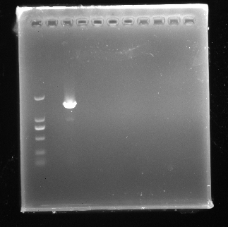
Fig. 1-F
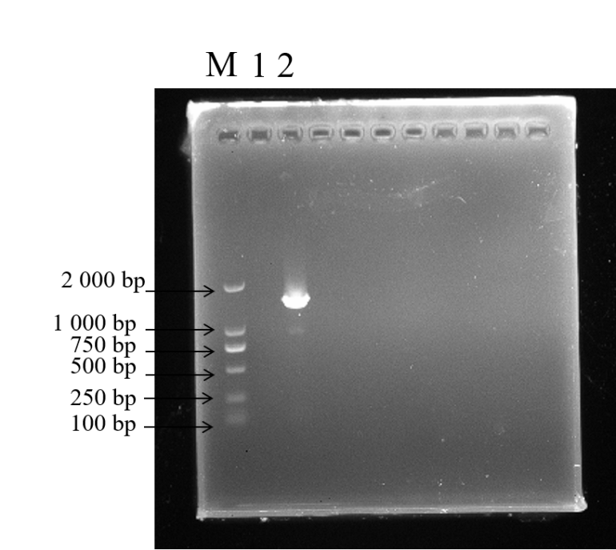
Note: M: marker; 1: blank; 2: A1
Here I have included two electrophoresis gel images, both representing F in Figure 1. The first image is the unlabeled original without any processing, while the second image has been annotated.

