Detection of Mycobacterium tuberculosis Antigens in Urinary Extracellular Vesicles
using Real-Time Immuno-PCR: A Non-Invasive Diagnostic Approach for Pulmonary Tuberculosis
Ayushi Kaur Bedi¹, Bhawna Dahiya², Monika Sharma¹, Parul Mrigpuri³, Nitin Goel³,
Mandira Varma-Basil⁴, Promod K. Mehta², Sadhna Sharma¹*
¹DSKC BioDiscovery Laboratory and Department of Zoology, Miranda House, University of Delhi, Delhi, India
²Faculty of Allied Health Sciences, Shree Guru Gobind Singh Tricentenary University, Gurugram 122505, India
³Department of Pulmonary Medicine, Vallabhbhai Patel Chest Institute, University of Delhi, Delhi, India
⁴Department of Microbiology, Vallabhbhai Patel Chest Institute, University of Delhi, Delhi, India
*Corresponding author
E-mail addresses:
ayushikaur.bedi@mirandahouse.ac.in (Ayushi Kaur Bedi)
sadhna.sharma@mirandahouse.ac.in (Sadhna Sharma)
SUPPLEMENTARY FIGURES
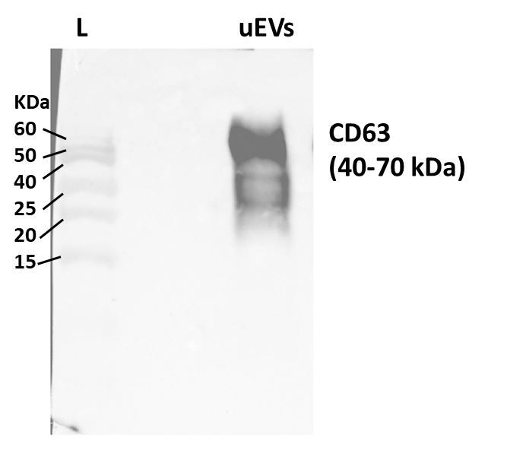
Supplementary Fig. 1 Full uncropped western blot showing CD63 (~40–70 kDa) expression as an extracellular vesicle (EV) marker. L represents protein molecular weight marker.


Supplementary Fig. 2 Schematic representation of the methodology employed for detecting Mtb antigens (MPT-64+LAM) within urinary extracellular vesicles (uEVs). The assays were applied to uEVs isolated from pulmonary tuberculosis (PTB) patients, latent TB infection (LTBI) subjects, other respiratory disease (ORD) cases, and healthy controls. Created with BioRender.com.
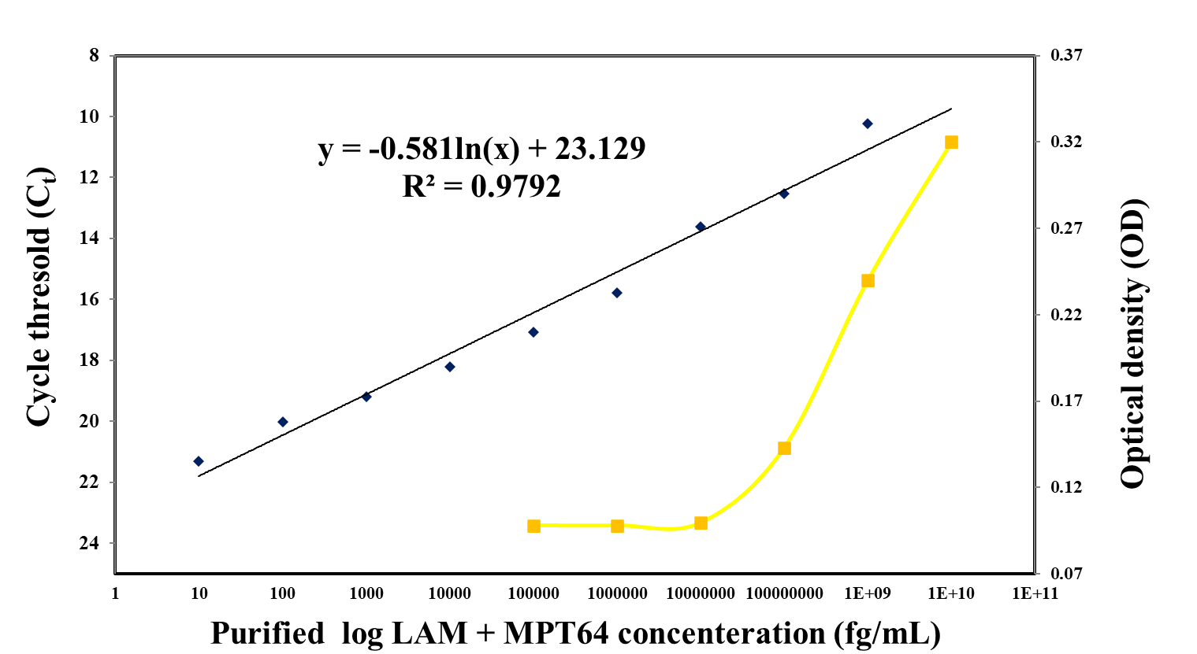
Supplementary Fig. 3 Standard curve(s) for healthy control uEVs spiked with purified MPT64+LAM using RT-I-PCR (10 fg/mL to 1 μg/mL) and indirect ELISA (100 pg/mL to 10 μg/mL). The regression equation for RT-I-PCR was C_{t} = −0.581 × ln(conc.) + 23.129 with an R² of 0.9792. The mean C_{t} values (RT-I-PCR) and OD values (indirect ELISA) were obtained from two independent experiments; each performed in duplicate. Data points represent mean values.

