Supplementary information
 | Strain | Slope | R² | efficiency
 | L. rhamnosus  GG | cT = 42.9 – 3.27 * Log(Concentration) | 74% | 102%
 | L. plantarum  WCFS1 | cT = 45.95 - 3.39* Log(Concentration) | 98% | 97%
 | L. reuteri  AMBV038 | cT = 34.98 - 3.24* Log(Concentration) | 99% | 104%
 | L. reuteri  AMBF471 | cT = 46.84 - 3.2* Log(Concentration) | 100% | 105%
 | S. salivarius  AMBR024 | cT = 43.36 - 3.28* Log(Concentration) | 100% | 102%
 | S. salivarius  AMBR158 | cT = 42.88 - 3.4* Log(Concentration) | 100% | 97%
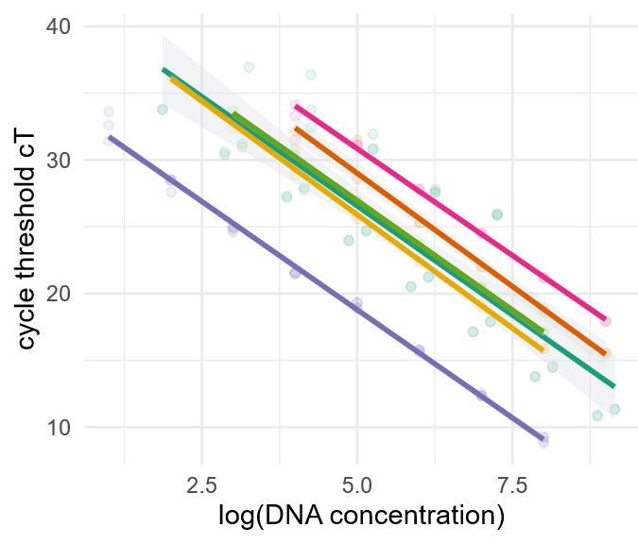
Figure S1: Standard curves for all designed qPCR primers with their according slope and efficiencies.

Table S1: Overview of the sequenced publicly available genomes that are too similar with their accession number and the average nucleotide identity (ANI) with the reference strain.
accession number | Ani | species | Removed
GCF_000026505.1 | 100 | L. rhamnosus | Reference
GCF_902381635.1 | 100 | L. rhamnosus | TRUE
GCF_003353455.1 | 99.9989 | L. rhamnosus | TRUE
GCF_017795605.1 | 99.9908 | L. rhamnosus | TRUE
GCF_015238575.1 | 99.9903 | L. rhamnosus | TRUE
GCF_000203855.3 | 100 | L. plantarum | Reference
GCF_017798305.1 | 99.9984 | L. plantarum | TRUE

