Durable Nanocomposite Face Masks with High Particulate Filtration and Rapid Inactivation of Coronaviruses

Andrew Gonzalez¹, Hamada A. Aboubakr², John Brockgreitens¹, Weixing Hao³, Yang Wang³, Sagar M. Goyal², Abdennour Abbas^{1,4}*

¹ Claros Technologies Inc.
1000 Westgate Drive
Suite 1005
St. Paul, MN 55114, USA
² Department of Veterinary Population Medicine,
University of Minnesota Twin Cities
1333 Gortner Ave.
St. Paul, MN 55108, USA

³ Department of Civil, Architectural, and Environmental Engineering
Missouri University of Science and Technology
1401 N Pine St.
Rolla, MO 65409, USA

⁴ Department of Bioproducts and Biosystems Engineering
University of Minnesota-Twin Cities
2004 Folwell Ave
St. Paul, MN 55108, USA

A.E.G and H.A.A. contributed equally to this study

Corresponding author: Dr. Abdennour Abbas
Email: aabbas@umn.edu, dennor@clarostech.com
Phone #: +1 (612) 624-4292

Supplementary Information
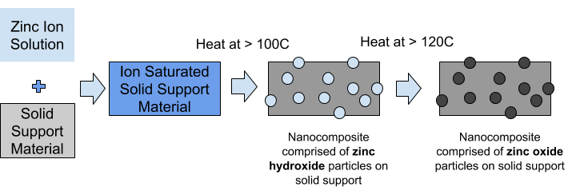
Step 1. Hydrolysis:
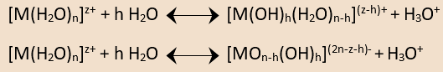
Step 2. Hydroxo bridging–oxolation:
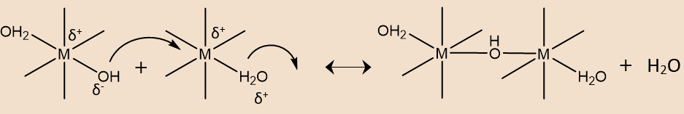
Step 3. Oxo bridging–oxolation:
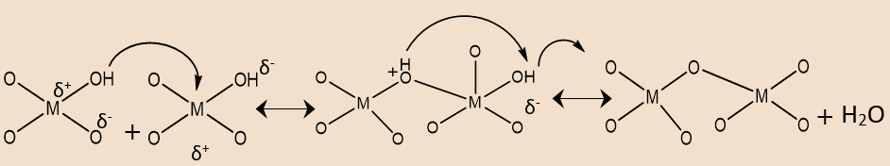

Figure 1: Schematic of the zinc oxide formation process, starting from submersion of the textile in a precursor solution with M denoting the metal atom. The textile undergoes two changes under heat, the first being a hydrothermal growth process during which hydroxide intermediates are formed (Step 1) from the initial metal salt, followed by decomposition of zinc hydroxides into zinc oxide at higher temperatures by oxolation (Step 2 and 3).
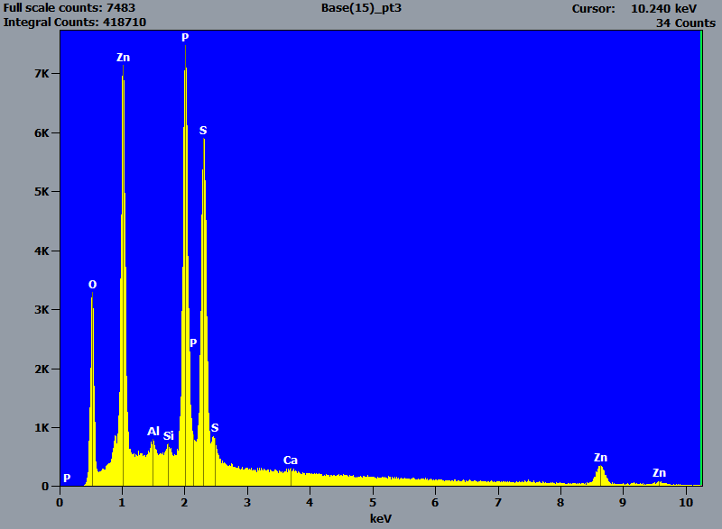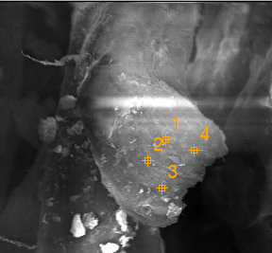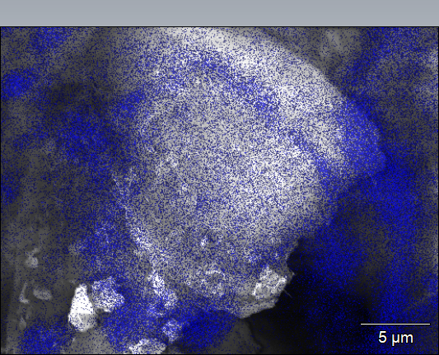
B
A
Figure 2: EDX images of a nylon/cotton fabric cross-section showing the elemental analysis of the fiber (A) and an overlay of the SEM image with Zinc signal (B). The high levels of zinc present demonstrate the formation of a nanocomposite where nanoparticles have been distributed throughout the bulk of the fiber and not simply deposited on the surface.

Table A: Loading of zinc nanoparticles in the bulk and surface of the nylon/cotton textile fibers.
 | Atomic weight (%) | Atoms (%)
Zinc nanoparticles grown inside the textile fibers | 27 ± 3 | 12 ± 2
Zinc nanoparticles grown on the surface of the textile fibers | 42 ± 2 | 20 ± 4
Analysis of the EDX measurements reveals higher levels of zinc nanoparticles on the surface compared to within the bulk of the material.

Table B: Synthetic Precipitate Leachate Procedure results from Pace Analytical from three different cotton samples obtained from an industry partner. Each sample was washed 1, 50, and 100 times from the point of functionalization.
Zinc Discharge (µg/L)
 | # of Washes
 | 1 |  |  | 50 |  |  | 100
Cot #1 | 5030 | 5610 | 4680 | 543 | 575 | 366 | 1150 | 848 | 1160
Cot #2 | 12800 | 11100 | 9350 | 519 | 371 | 352 | 571 | 558 | 544
Cot #3 | 57100 | 106000 | N/A | 1500 | 1180 | 1930 | 1180 | 1140 | 961

We observe that most of the Zinc leaching occurs after the first wash, likely when larger, loosely bound surface particles are easily washed away. After this initial wash, there is significantly lower leaching throughout the life of the fabric.

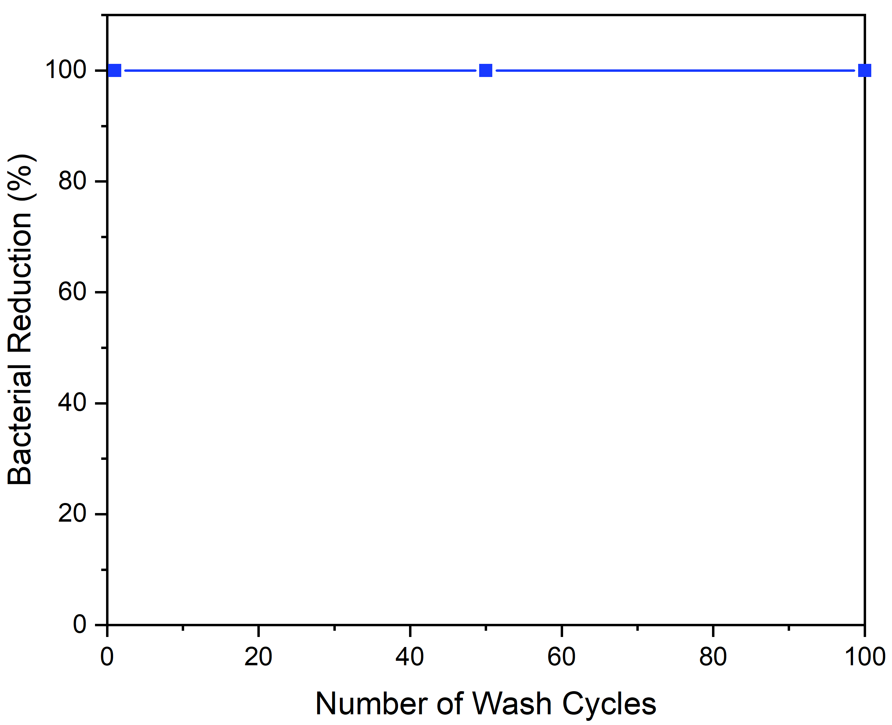
Figure 3: Bacterial reduction of gram-positive bacteria Staphylococcus aureus using a modified AATCC 100 method on a treated cotton nanocomposite. The results indicate that even after 100 washes the antibacterial efficacy remains unaffected due to the growth mechanism of the nanoparticles.

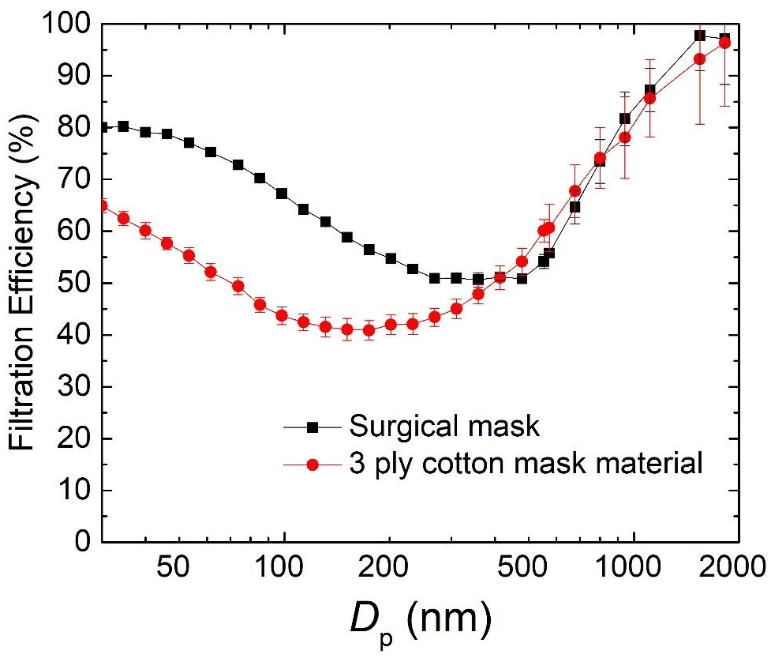
Figure 4: Size-dependent filtration of LOG3Mask and standard surgical mask under a face velocity of 9.2 cm s⁻¹. Filtration efficiency is similar for particles larger than 500nm, however for particles with smaller sizes, it is likely that particle residence time is not long enough for particle collection via Brownian motion under the provided velocity.
