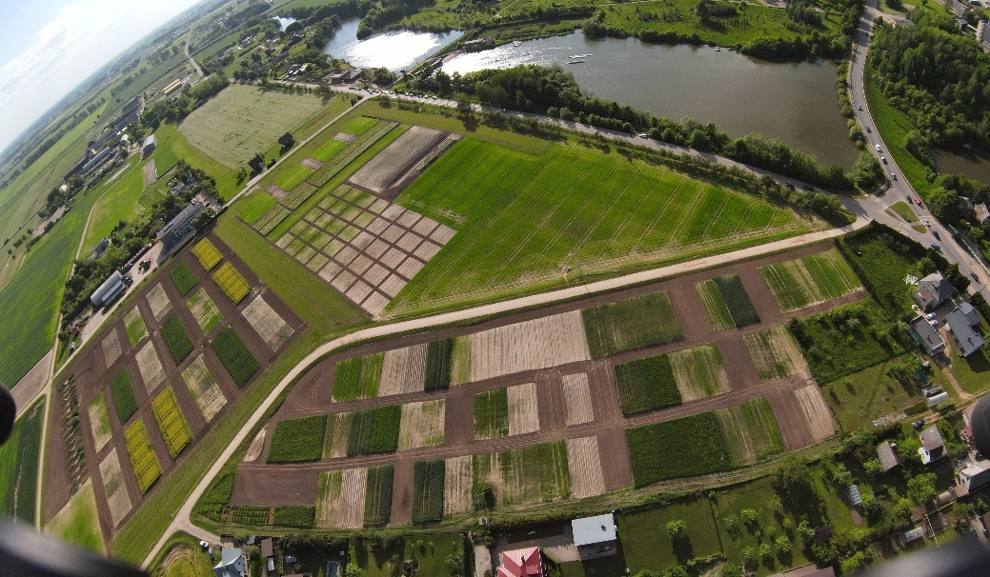
Figure 1. Fields of VMU AA Experimental Station.

a)

b)
Figure 2. Meteorological conditions during the experiment, Kaunas Meteorological Station.

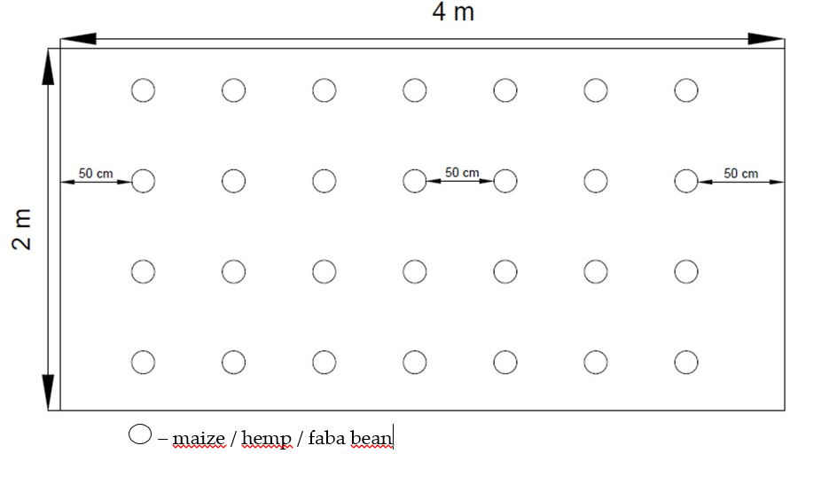
(a)
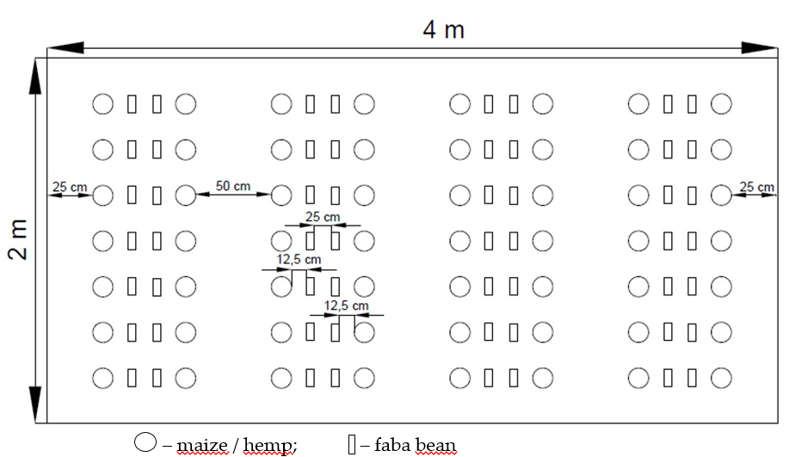
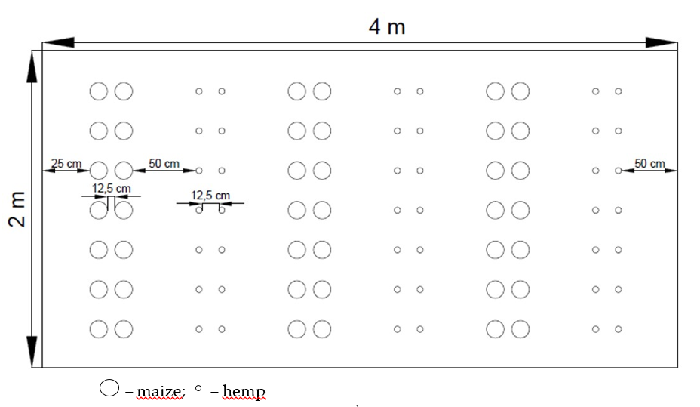
(b)
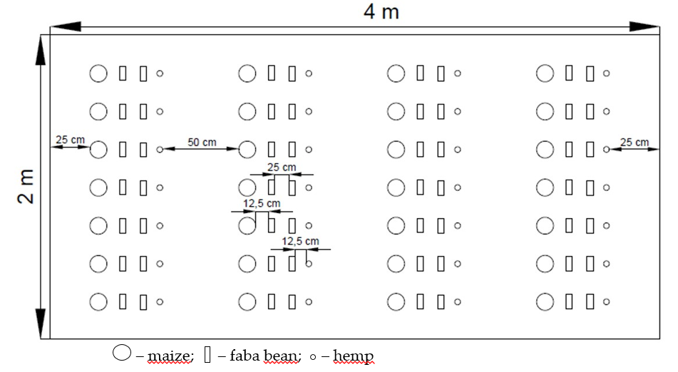
(c)

Figure 3. The sowing scheme of single (a), binary (b) and ternary (c) cultivations [22].

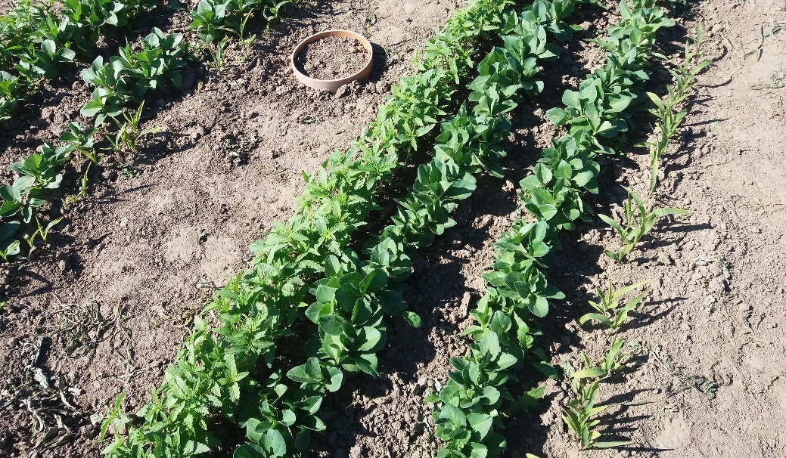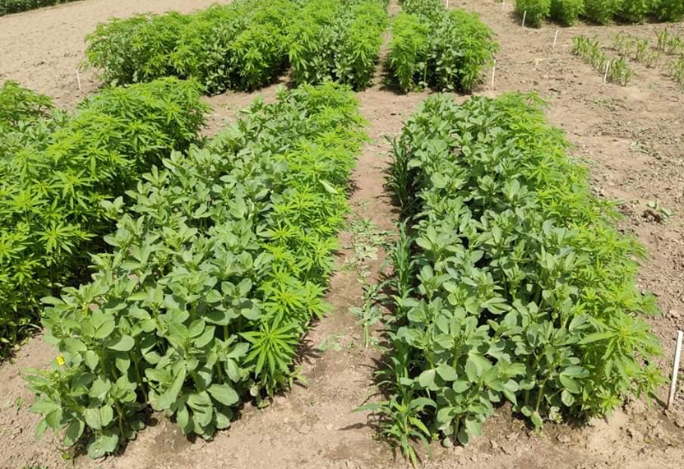
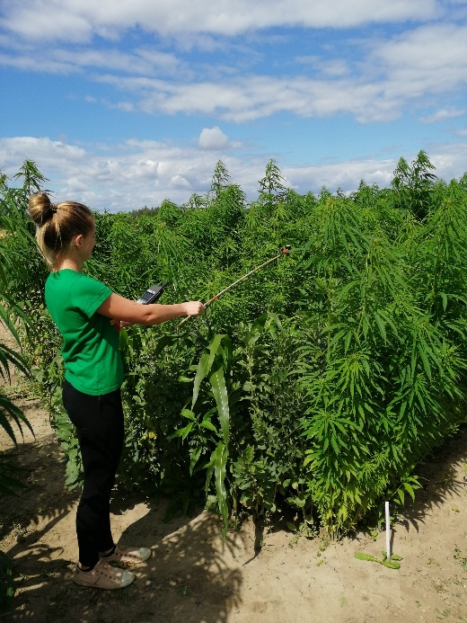
Figure 4. Development of ternary technical hemp, maize and faba bean crop.

Crop diversification
M | M + H | M + FB | M + H + FB
63.5 | 68.8 | 90.7 | 36.2
H | M + H | H + FB | M + H +FB
22.3 | 14.9 | 21.0 | 13.7
FB | M + FB | H + FB | M + H + FB
362.9 | 397.9 | 369.4 | 375.8
Note: M – maize single crop, H – hemp single crop, FB – faba bean single crop, M+H – binary maize and hemp crop, M+FB – binary maize and faba bean crop, H+FB – binary hemp and faba bean crop, M+H+FB – ternary maize, hemp and faba bean crop.

Table 1. Seed rates, kg ha⁻¹.

Crop operations | Execution time
 | 2020 | 2021 | 2022
Seedbed preparation | 22/04/2020 | 22/04/2021 | 18/04/2022
Seeding | 30/04/2020 | 28/04/2021 | 22/04/2022
Interrow tillage | 29/05/2020  15/06/2020 | 08/06/2021  25/07/2021 | 18/05/2022  08/06/2022
Biomass harvest | 03/09/2020 | 24/08/2021 | 29/08/2022

Table 2. Crop operations.

Biomass chemical composition | M | H | FB | M +H | M +FB | H + FB | M + H + FB
pH | 6.51 | 7.07 | 6.63 | 6.66 | 6.43 | 7.09 | 6.87
Total nitrogen % | 0.92 | 0.64 | 2.12 | 0.84 | 1.48 | 1.22 | 0.98
Available phosphorus % | 0.20 | 0.16 | 0.38 | 0.20 | 0.32 | 0.28 | 0.22
Available potassium % | 1.20 | 0.76 | 0.78 | 0.98 | 1.04 | 0.98 | 0.87
Note: M – maize single crop, H – hemp single crop, FB – faba bean single crop, M+H – binary maize and hemp crop, M+FB – binary maize and faba bean crop, H+FB – binary hemp and faba bean crop, M+H+FB – ternary maize, hemp and faba bean crop.

Table 3. Biomass chemical composition.

Parameter | M | H | FB | M+H | M+FB | H+FB | M+H+FB
Density, kg m⁻³ | 1077.67 ± 90.73 | 249.78 ± 80.08 | 1210.04 ± 109.72 | 1164.78 ± 159.60 | 1160.21 ± 39.95 | 1211.54 ± 77.51 | 1238.20 ± 104.57
Ash content, % | 5.75 ± 0.07 | 8.57 ± 0.14 | 8.02 ± 0.07 | 6.87 ± 0.10 | 6.03 ± 0.14 | 7.12 ± 0.18 | 5.98 ± 0.10
LCV, MJ kg⁻¹ | 16.99 ± 0.34 | 16.73 ± 1.11 | 16.72 ± 0.18 | 16.87 ± 0.58 | 16.95 ± 0.41 | 16.81 ± 0.04 | 16.79 ± 0.76
SST,° C | 948 ± 0.82 | 798 ± 1.42 | 810 ± 2.00 | 822 ± 0.34 | 923 ± 0.77 | 723 ± 0.20 | 1042 ± 0.14
Note: M – maize single crop, H – hemp single crop, FB – faba bean single crop, M+H – binary maize and hemp crop, M+FB – binary maize and faba bean crop, H+FB – binary hemp and faba bean crop, M+H+FB – ternary maize, hemp and faba bean crop. LCW—lower calorific value, SST—ash shrinkage starting temperature.

Table 4. Main characteristics of multi crop solid fuel pellets (according to Petlickaitė et al., [48]).

Note: M–maize single crop, H–hemp single crop, FB–faba bean single crop, M+H–binary maize and hemp crop, M+FB–binary maize and faba bean crop, H+FB–binary hemp and faba bean crop, M+H+FB–ternary maize, hemp and faba bean crop. CEI–complex evaluation index, * – average of evaluation points (EPs), ** – standard deviation of EPs, *** – standard deviation of the average of the evaluation points below the evaluation threshold.

Figure 5. Comprehensive assessment of crop diversification in terms of crop total dried biomass (according to Balandaitė et al., [29]).

Treatments | Diesel fuel consumption L ha⁻¹ | Energy input  MJ ha⁻¹ | Energy output  MJ ha⁻¹ | Net energy  MJ ha⁻¹
M | 70.7 | 10178.7 | 78959.7 | 68781.0
H | 79.0 | 10176.6 | 150030.8 | 139854.2
FB | 70.7 | 16745.5 | 166787.0 | 150041.5
M+H | 84.8 | 11511.0 | 205080.5 | 193569.5
M+FB | 76.5 | 19348.6 | 134842.3 | 115493.7
H+FB | 84.8 | 18266.6 | 183074.0 | 164807.4
M+H+FB | 103.3 | 20162.9 | 387831.0 | 367668.1
Note: M–maize single crop, H–hemp single crop, FB–faba bean single crop, M+H–binary maize and hemp crop, M+FB–binary maize and faba bean crop, H+FB–binary hemp and faba bean crop, M+H+FB–ternary maize, hemp and faba bean crop.

Table 5. Fuel consumption and energy indices of cropping systems (according to the Romaneckas et al., [23]).

