Supplementary Information

High-Brightness Self-seeded X-ray Free Electron Laser to Precisely Map Macromolecular Structure

Chang-Ki Min^{1,4}, Inhyuk Nam^{1,4}, Bonggi Oh^{1,4}, Gyujin Kim¹, Donghyun Na¹, Young Jin Suh¹, Haeryong Yang¹, Myung-Hoon Cho¹, Changbum Kim¹, Min Jae Kim¹, Chi Hyun Shim¹, Jun Ho Ko¹, Hoon Heo¹, Jaehyun Park¹, Jangwoo Kim¹, Sehan Park¹, Gisu Park¹, Sunghan Kim¹, Sae Hwan Chun¹, HyoJung Hyun¹, Jae Hyuk Lee¹, Kyung-Sook Kim¹, Intae Eom¹, Seungyu Rah¹, Deming Shu², Kwang-Je Kim², Sergey Terentyev³, Vladimir Blank³, Yuri Shvyd’ko^{2*}, Sang Jae Lee^{1*}, Heung-Sik Kang^{1*}

¹Pohang Accelerator Laboratory, Pohang, Gyeongbuk 37673, Republic of Korea
²Argonne National Laboratory, Argonne, IL, 60439-4815, USA
³Technological Institute for Superhard and Novel Carbon Materials, Troitsk, Moscow 142190, Russian Federation
⁴These authors contributed equally: Chang-Ki Min, Inhyuk Nam, Bonggi Oh

* Correspondence e-mails: sangjaelee@postech.ac.kr, shvydko@aps.anl.gov, hskang@postech.ac.kr,

Contents

- Crystal planes for forward Bragg diffraction
- Spectrum measurement
- Saturation of the self-seeded FEL
- Effects of the self-seeded FEL mode on the electron density maps and preparation of omit maps

- Crystal planes for forward Bragg diffraction
The Pohang Accelerator Laboratory hard X-ray self-seeded (HXRSS) free-electron laser (PAL-XFEL HXRSS) (Figure 1 in main text) includes twenty 5-m-long out-vacuum undulators; the diamond-crystal monochromator is located directly after the eighth undulator. The mechanical design of the monochromator is based on one developed by the Advanced Photon Source at Argonne National Laboratory for the Linac Coherent Light Source (LCLS) HXRSS project^{17,52}. An improved diamond crystal holder is used; it accommodates two thin diamond crystals, one with thickness of 100 μm (crystal cut C*[100]) and one with thickness of 30 μm (crystal cut C*[110])^{53,54}.
The forward Bragg diffraction (FBD) characteristic time is defined as $T_{0}= 2Λ_{H}^{2}\sin\left.θ /(cd\right)$, where $Λ_{H}$ is the extinction length. The wake duration is proportional to ${ T}_{0}$ (${\sim 16T}_{0}$ for the first wake), and the spectral FBD bandwidth is $∆E \sim ℏ/(π{ T}_{0})$.^{15,16} The C*[100] crystal was used for 9.7-keV self-seeding, with parameters specific to each crystal plane (Supplementary Table 1). The FBD time response functions differ among the (115), (33-3), and (004) three crystal planes (Supplementary Fig. 1). The (33-3) and (115) planes have a larger extinction length than the (004) plane, so the (33-3) and (115) planes generate a wake that has longer duration than the (004) plane. The FBD time response function is given by
$${|G_{00}(t)|}^{2}∝ {\left[\frac{1}{{2T}_{0}}\frac{J_{1} \left(\sqrt{\frac{t}{T_{0}}}\right)}{\sqrt{\frac{t}{T_{0}}}}\right]}^{2}$$
. (1)

Supplementary Table 1: FBD parameters of C*[100] crystal for 9.7 keV self-seeding
Crystal plane | 115 | 33-3 | 004
Extinction length, μm | 7.83 | 7.83 | 3.63
Pitch angle, degrees | 84.4 | 56.6 | 45.8
FBD characteristic time (${ T}_{0}$), fs | 4.07 | 3.41 | 0.63
Duration of the 1st wake, fs | 65.1 | 54.6 | 10.1
Spectral FBD bandwidth, eV | 0.05 | 0.06 | 0.33

The appropriate delay of the electron bunch (e-bunch) with respect to the self-amplified spontaneous emission (SASE) signal allows full separation of the seed signal from the SASE signal. A single-shot spectrometer measurement clearly shows (Supplementary Fig. 2) that the seed pulse and e-bunch are both well-separated from the background SASE. A 30-fs delay of the e-bunch allows it and the seed pulse to be separated temporally from the background SASE; with a 15-fs delay, they overlap the background SASE. The optimum delay of the e-bunch was found to be ~ 35 fs. The duration of the SASE FEL pulse generated upstream of the FBD monochromator is measured to be 20 fs in FWHM for a 180-pC charge bunch that has a length of 42 fs FWHM. With the crystal planes of (115) and (33-3), the e-bunch delay of ~ 30 fs is long enough to separate the seed pulse from the SASE while still generating enough seed power because the 0th wake trail, which extends to 50 fs, can be chosen rather than the 1st wake trail. However, for the (004) plane at 9.7 keV, the peak of the 1st wake trail is located around the delay of 15 fs, where the seed pulse partially overlaps the SASE background (Supplementary Fig. 1). As long as the seed signal dominates the sidebands, the small difference in the wake amplitude (Supplementary Fig. 1) does not make a big difference because, eventually, the seed signal will grow to dominate the other frequency sources.
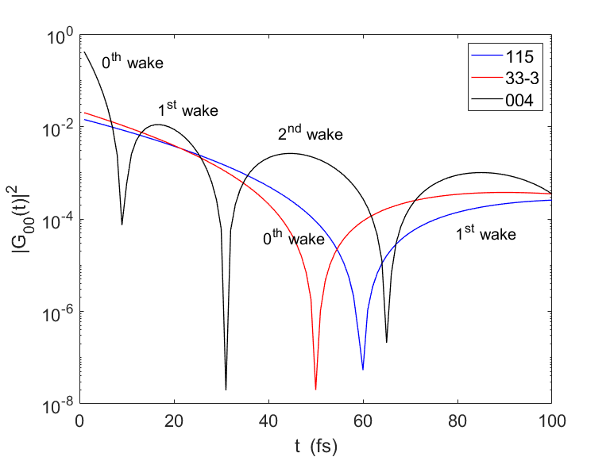
Supplementary Fig. 1: The FBD time response function for three crystal planes [(115), (33-3), and (004)]. The horizontal axis, t, represents the time delay relative to the SASE pulse. The crystal cut is C*[100], and its thickness is 100 μm.

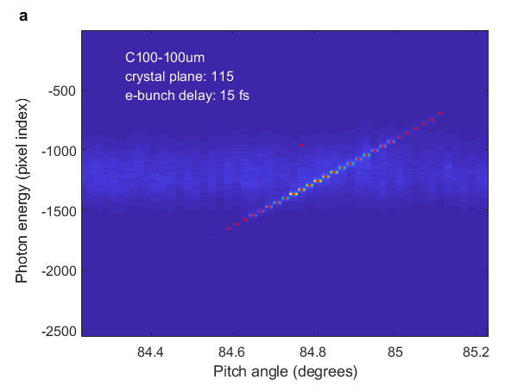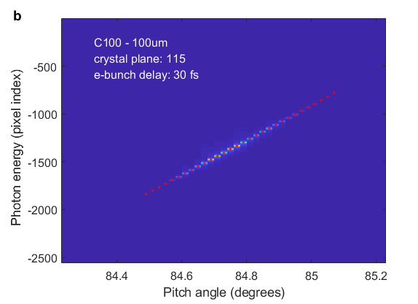
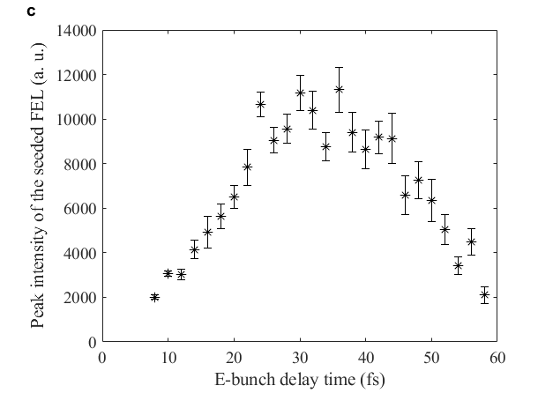
Supplementary Fig. 2: Single-shot spectrometer measurement for the 9.7 keV self-seeded FEL as a function of the crystal pitch angle for e-bunch delay of (a) 15 fs and (b) 30 fs. c, Peak intensity of the 9.7 keV self-seeded FEL as a function of e-bunch delay. The crystal cut is C*[100], and the crystal plane is (115). The whitish band in a is the background SASE, and the straight line in a and b represents the Bragg angles that correspond to photon energy. In c, the minimum of peak intensity at the e-bunch delay time of 60 fs exactly matches the FBD time-response function for the (115) plane of Supplementary Fig. 1.

- Spectrum measurement
Spectra for SASE and self-seeding were measured using a single-shot spectrometer that uses a curved Si crystal. The spectrometer was calibrated by collecting single-shot images of the seed pulse from a (115) diamond crystal plane; this pulse has a seed bandwidth of 0.05 eV (Supplementary Fig. 3). In this measurement, the eight undulators upstream of the diamond crystal are used, with the downstream twelve undulators remaining open. The dip in the curve corresponds to the seed pulse and E_{c} = 9.7 keV. The measured bandwidth of the single-shot spectrometer is 0.26 ± 0.04 eV.
A flat-crystal scanning spectrometer was used to improve the resolution of single-shot spectrum measurement, rather than the curved spectrometer. A flat Si-333 crystal is used, with an angle-scanning device. The angle of the crystal is finely changed to measure the spectrum. The minimum step of the crystal angle is 0.0001°, which corresponds to 0.022 eV. The measured bandwidth of the self-seeded mode is 0.21 ± 0.01 eV FWHM (Fig. 3c in main text), and the de-convoluted width is 0.19 eV, taking into account the Si-333 bandwidth of 0.086 eV.

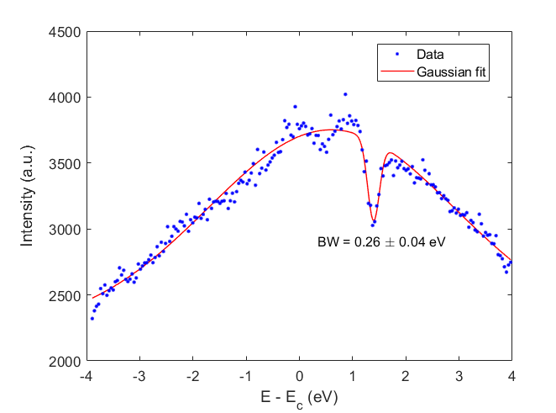
Supplementary Fig. 3: Resolution measurement of a curved Si crystal single-shot spectrometer. The single-shot image of the seed pulse from a (115) diamond crystal plane, which has a seed bandwidth (BW) of 0.05 eV. The dip corresponds to the seed pulse and E_{c} = 9.7 keV. The measured bandwidth of the single-shot spectrometer is 0.26±0.04 eV.

- Saturation of the self-seeded FEL

The average pulse energy of the self-seeded XFEL is 0.85 mJ at 9.7 keV using the crystal planes of (115) or (33-3). The use of a laser heater (LH) increases the intensity of the self-seeded FEL pulse and reduces its gain length from 6.8 m to 4.7 m (Supplementary Fig. 4). At the beginning of amplification of the self-seeded FEL pulse (undulators 9 to 13), the LH ON intensity is weaker, but it overtakes the LH OFF intensity at undulator 15 and then increases steadily along the five remaining undulators (16–20). This trend suggests that increasing the number of undulators would further increase the intensity of the self-seeded FEL pulse.
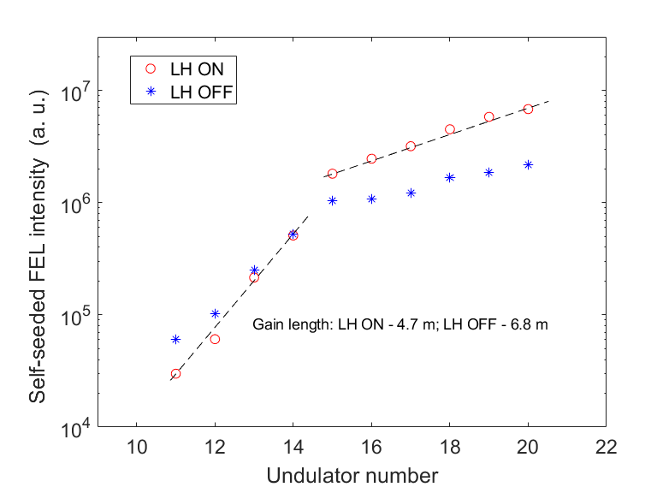
Supplementary Fig. 4: Self-seeded FEL intensity as a function of undulator number for the cases of laser heater (LH) ON and OFF. The photon energy is 9.7 keV, and the crystal plane is (115). The self-seeded FEL pulse starts to grow at the No. 9 undulator (the first undulator after the diamond crystal monochromator), and the peak becomes defined after the No. 11 undulator. Gain lengths are given in the exponential growth regime for the two cases.

- Effects of the self-seeded FEL mode on the electron density maps and preparation of omit maps

Statistics for data collection, phasing, and model refinement for both data derived from self-seeded and SASE modes are presented. To show each value plotted in Fig. 4 of the main text, we present overall statistics for the three sets of the self-seeded and SASE modes as a function of resolution range (Supplementary Table 2). The statistics are in good agreement with the results that are presented reflected in the electron density maps given in the main text.
After refinement, when we compare the models with their structure maps (SS1 and SASE1), we found apparent improvements in the 2mFo-DFc maps of the self-seeded compared to SASE modes (Fig. 5a). Therefore, we have calculated the omit maps of each residue. To clearly find the differences, we obtained each omit map (mFo-DFc) and sorted the residues to show the effect of the self-seeded mode. The refinement statistics (Supplementary Table 3) were obtained for the residues that were deleted from the original structure. Omit maps (mFo-DFc electron density maps) for the ten residues that are calculated from the other self-seeding data sets (SS2/SS2 vs. SASE2/SASE3) are shown in the Supplementary Fig. 5.

Supplementary Table 2: Raw data tables of each three set for self-seeded and SASE modes as a function of resolution range. The data are also plotted in Fig. 4 in the main text.
Multiplicity for six calculated data sets (averages in parentheses)
Resolution (Å) | SS1 (269.2) | SS2 (108.0) | SS3 (49.9) | SASE1 (162.4) | SASE2 (55.98) | SASE3 (28.2)
7.20 | 564.7 | 221.1 | 102.9 | 341.1 | 118.6 | 59.6
3.34 | 349.8 | 137 | 64.1 | 212.4 | 73.4 | 36.7
2.79 | 298.8 | 116.7 | 54.2 | 176.3 | 60.2 | 30.2
2.49 | 267.7 | 104.6 | 47.9 | 155.7 | 53.7 | 26.9
2.29 | 245.5 | 95.8 | 44.3 | 142.1 | 48.9 | 24.7
2.14 | 229.8 | 89.3 | 41.2 | 132.1 | 45.4 | 22.8
2.02 | 216.6 | 84.3 | 38.8 | 124.6 | 42.7 | 21.6
1.93 | 205.5 | 79.7 | 36.6 | 117.7 | 40.5 | 20.5
1.85 | 196.2 | 76.7 | 35.4 | 112.7 | 38.4 | 19.7
1.78 | 189.6 | 73.6 | 34.1 | 108.9 | 37.5 | 18.8

The signal-to-noise ratio for six calculated data sets (averages in parentheses).
Resolution (Å) | SS1 (6.18) | SS2 (4.01) | SS3 (2.90) | SASE1 (5.58) | SASE2 (3.13) | SASE3 (2.32)
7.20 | 9.74 | 6.16 | 4.47 | 9.29 | 5.34 | 4.00
3.34 | 9.28 | 5.84 | 4.35 | 9.26 | 5.57 | 4.14
2.79 | 8.34 | 5.31 | 3.98 | 8.37 | 5.23 | 3.87
2.49 | 7.89 | 5.03 | 3.67 | 7.47 | 4.77 | 3.54
2.29 | 7.41 | 4.68 | 3.44 | 6.46 | 4.00 | 2.97
2.14 | 6.74 | 4.17 | 2.99 | 5.21 | 2.92 | 2.15
2.02 | 5.87 | 3.4 | 2.39 | 3.86 | 1.82 | 1.38
1.93 | 4.64 | 2.52 | 1.72 | 2.8 | 0.98 | 0.74
1.85 | 3.52 | 1.78 | 1.17 | 1.85 | 0.49 | 0.33
1.78 | 2.39 | 1.17 | 0.77 | 1.29 | 0.22 | 0.15

CC* for six calculated data sets (averages in parentheses).
Resolution (Å) | SS1 (0.992) | SS2 (0.979) | SS3 (0.971) | SASE1 (0.993) | SASE2 (0.981) | SASE3 (0.963)
7.20 | 0.984 | 0.955 | 0.945 | 0.985 | 0.957 | 0.917
3.34 | 0.984 | 0.959 | 0.950 | 0.989 | 0.967 | 0.936
2.79 | 0.987 | 0.963 | 0.953 | 0.990 | 0.972 | 0.944
2.49 | 0.985 | 0.965 | 0.949 | 0.986 | 0.969 | 0.936
2.29 | 0.987 | 0.967 | 0.950 | 0.986 | 0.971 | 0.924
2.14 | 0.982 | 0.959 | 0.937 | 0.982 | 0.952 | 0.899
2.02 | 0.980 | 0.952 | 0.917 | 0.975 | 0.921 | 0.773
1.93 | 0.971 | 0.930 | 0.901 | 0.957 | 0.816 | 0.772
1.85 | 0.953 | 0.889 | 0.799 | 0.906 | 0.571 | 0.523
1.78 | 0.901 | 0.824 | 0.814 | 0.856 | 0.353 | 0.238
R_{split} (%) for six calculated data sets (averages in parentheses).
Resolution (Å) | SS1 (12.83) | SS2 (20.92) | SS3 (25.01) | SASE1 (12.67) | SASE2 (21.31) | SASE3 (30.52)
7.20 | 10.61 | 17.93 | 21.5 | 11.21 | 19.32 | 27.38
3.34 | 11.23 | 18.09 | 21.52 | 11.28 | 18.98 | 26.95
2.79 | 12.27 | 20.82 | 23.78 | 11.91 | 19.80 | 29.02
2.49 | 13.42 | 20.66 | 26.12 | 13.89 | 21.53 | 30.34
2.29 | 13.63 | 22.71 | 27.80 | 15.46 | 24.10 | 35.95
2.14 | 16.46 | 25.25 | 32.21 | 18.38 | 32.95 | 46.17
2.02 | 18.80 | 30.18 | 38.78 | 24.31 | 49.32 | 76.18
1.93 | 23.88 | 37.95 | 49.46 | 32.73 | 91.10 | 100
1.85 | 33.64 | 51.37 | 68.89 | 50.03 | 100 | 100
1.78 | 52.57 | 79.16 | 100 | 73.98 | 100 | 100

Completeness for six calculated data sets (averages in parentheses).
Resolution (Å) | SS1 (100) | SS2 (100) | SS3 (100) | SASE1 (100) | SASE2 (100) | SASE3 (100)
7.20 | 100 | 100 | 100 | 100 | 100 | 100
3.34 | 100 | 100 | 100 | 100 | 100 | 100
2.79 | 100 | 100 | 100 | 100 | 100 | 100
2.49 | 100 | 100 | 100 | 100 | 100 | 100
2.29 | 100 | 100 | 100 | 100 | 100 | 100
2.14 | 100 | 100 | 100 | 100 | 100 | 100
2.02 | 100 | 100 | 100 | 100 | 100 | 100
1.93 | 100 | 100 | 100 | 100 | 100 | 100
1.85 | 100 | 100 | 100 | 100 | 100 | 100
1.78 | 100 | 100 | 100 | 100 | 100 | 100

Supplementary Table 3: 10 deleted-mutant models with structural refinement statistics. To calculate each omit map, we built each structure model without a specific residue and calculated the omit map for each of the two FEL modes for four data sets (SS2, SASE2, SS3, and SASE3) to inspect the effects of each mode (self-seeded or SASE mode). In the cases of SS3 and SASE3, we used higher resolution shells ranged from 1.93 Å to 1.85 Å, to obtain certainty of the calculation results.
Δ-mutant models | SS1 | SASE1 | SS2 | SASE2 | SS3 | SASE3
Δ-mutant models | R_{work} / R_{free} (%)ª | R_{work} / R_{free} (%)ª | R_{work} / R_{free} (%)ª | R_{work} / R_{free} (%)ª | R_{work} / R_{free} (%)ª | R_{work} / R_{free} (%)ª
Δ-mutant models | Bond lengths (Å)  / bond angles (°) | Bond lengths (Å)  / bond angles (°) | Bond lengths (Å)  / bond angles (°) | Bond lengths (Å)  / bond angles (°) | Bond lengths (Å)  / bond angles (°) | Bond lengths (Å)  / bond angles (°)
Phe21 | 22.3 / 25.5 | 21.6 / 25.5 | 23.2 / 26.0 | 22.3 / 26.7 | 22.9 / 26.2 | 22.4 / 27.0
Phe21 | 0.011 /1.303 | 0.008 / 0.929 | 0.012 / 1.386 | 0.011 / 1.150 | 0.011 / 1.161 | 0.007 / 0.910
Ala28 | 22.1 / 25.7 | 21.9 / 23.8 | 22.7 / 25.8 | 22.1 / 26.4 | 22.4 / 25.5 | 22.8 / 26.8
Ala28 | 0.010 / 1.138 | 0.009 / 1.200 | 0.008 / 1.118 | 0.007 / 0.985 | 0.012 / 1.261 | 0.007 / 0.955
Tyr41 | 22.8 / 26.2 | 22.4 / 24.7 | 23.4 / 25.8 | 22.7 / 26.6 | 22.9 / 26.1 | 22.8 / 27.1
Tyr41 | 0.011 / 1.216 | 0.008 / 1.125 | 0.008 / 1.139 | 0.008 / 1.014 | 0.008 / 1.103 | 0.007 / 0.947
Trp46 | 22.7 / 26.0 | 22.5 / 26.1 | 23.5 / 25.5 | 22.7 / 26.8 | 23.2 / 26.7 | 23.6 / 27.6
Trp46 | 0.010 / 1.193 | 0.008 / 0.869 | 0.011 / 1.211 | 0.007 / 0.881 | 0.008 / 1.014 | 0.008 / 0.981
Phe52 | 22.2 / 25.5 | 22.5 / 25.1 | 23.2 / 26.7 | 22.8 / 28.4 | 22.9 / 26.1 | 23.2 / 27.0
Phe52 | 0.009 / 1.136 | 0.009 / 1.044 | 0.009 / 1.121 | 0.008 / 1.318 | 0.008 / 1.157 | 0.008 / 1.052
Asn62 | 22.4 / 25.6 | 21.8 / 23.8 | 22.9 / 26.0 | 22.0 / 26.3 | 22.6 / 25.3 | 23.3 / 26.9
Asn62 | 0.009 / 1.314 | 0.009 / 1.101 | 0.010 / 1.233 | 0.008 / 1.016 | 0.008 / 1.127 | 0.008 / 1.147
Tyr71 | 22.4 / 25.9 | 22.2 / 24.4 | 23.4 / 26.3 | 22.8 / 28.2 | 22.9 / 25.8 | 23.6 / 28.6
Tyr71 | 0.008 / 1.050 | 0.010 / 1.235 | 0.009 / 1.425 | 0.007 / 1.091 | 0.008 / 1.010 | 0.008 / 1.089
Trp81 | 22.6 / 25.2 | 22.6 / 24.0 | 23.3 / 26.3 | 22.6 / 26.8 | 23.1 / 25.7 | 23.4 / 27.9
Trp81 | 0.009 / 1.178 | 0.008 / 1.141 | 0.009 / 1.179 | 0.007 / 0.969 | 0.008 / 1.196 | 0.008 / 1.018
Trp126 | 22.4 / 26.0 | 21.6 / 23.8 | 23.0 / 25.8 | 22.8 / 28.4 | 22.9 / 27.1 | 23.5 / 27.4
Trp126 | 0.009 / 1.105 | 0.008 / 0.901 | 0.008 / 0.995 | 0.008 / 1.019 | 0.008 / 1.200 | 0.008 / 1.043
Trp141 | 22.4 / 26.4 | 22.0 / 24.2 | 22.9 / 25.8 | 22.4 / 27.1 | 23.1 / 26.3 | 23.4 / 27.2
Trp141 | 0.009 / 1.191 | 0.009 / 1.138 | 0.008 / 1.016 | 0.008 / 1.065 | 0.009 / 1.231 | 0.008 / 1.001
ª R = Σ | |F_{obs}| – |F_{calc}| | / Σ |F_{obs}|, where R_{free} and R_{work} are calculated for a randomly chosen 5% of reflections that were not used for refinement and for the remaining reflections, respectively.

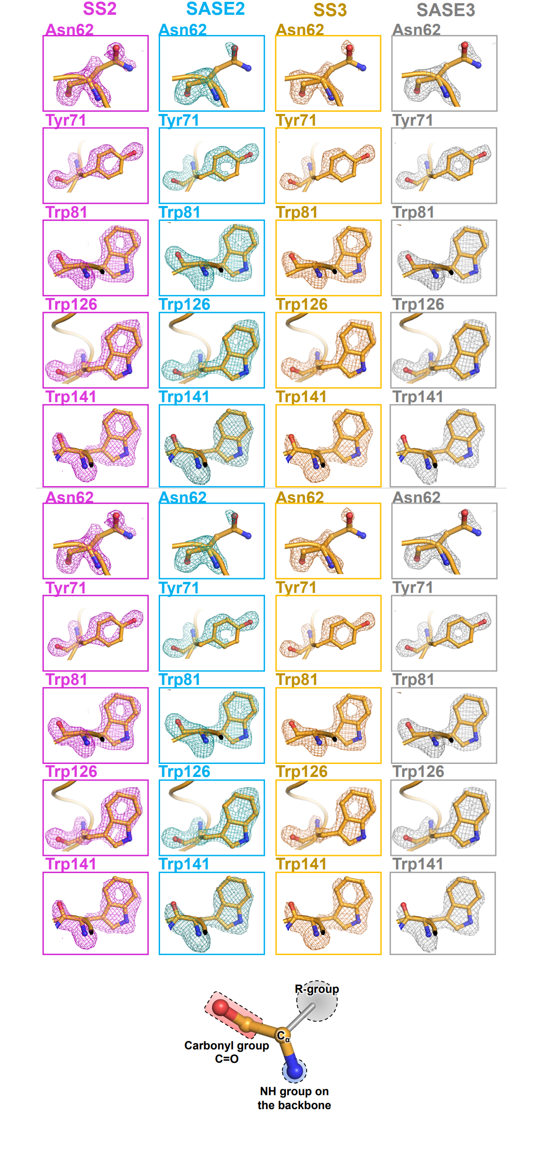
Supplementary Fig. 5: Overall mFo-DFc electron density maps of the lysozyme models (self-seeding and SASE modes) from chicken eggwhite at 1.75-Å resolution (SS2 and SASE2) and 1.85-Å resolution (SS3 and SASE3). 2mFo-DFc electron density maps on 10 residues (Phe21, Ala28, Tyr41, Trp46, Phe52, Asn62, Tyr71, Trp81, Trp126, and Trp141) are presented with the residue models. The omit maps and labels for the self-seeded and SASE modes are colored in magenta (SS2), teal (SASE2), orange (SS3), and grey (SASE3). The mFo-DFc maps are calculated in an identical way and contoured to 3.0σ for an unbiased and fair decision. The structure of an amino acid is shown in the black rectangular box at the bottom. An amino acid on a protein is composed of a carbonyl group, NH group, alpha-carbon atom (Cα), and R-group. Detailed comparative analysis on was perfomed both the maps derived from self-seeded and SASE modes (Table 2). The structure was visualized using the program PyMOL (The PyMOL Molecular Graphics System, Version 2.0 Schrödinger, LLC, Cambridge, MA, USA).

References

- Shu, D. et al. Design of a diamond-crystal monochromator for the LCLS hard x-ray self-seeding project. J. Phys.: Conf. Ser. 425, 052004 (2013).
- Shu, D. et al. In Proc. 2019 Particle Accelerator Conference 554 (JACOW, 2019).
- Shvyd’ko, Y. V., Anton, J. W. J., Kearney, S. P., Kim, K.-J., Kolodziej, T., Shu, D., Blank, V. D., Terentiev, S., Kang, H.-S., Min, C.-K., Oh, B.G. & Vodnala, P. Diamond double-crystal system for a forward Bragg diffraction X-ray monochromator of the self-seeded PAL XFEL, Proceedings of the 38th International Free-Electron Laser Conference (FEL2017), Santa Fe, New Mexico, USA, MOP001, pp. 29–33 (2017).

