Supplementary Information
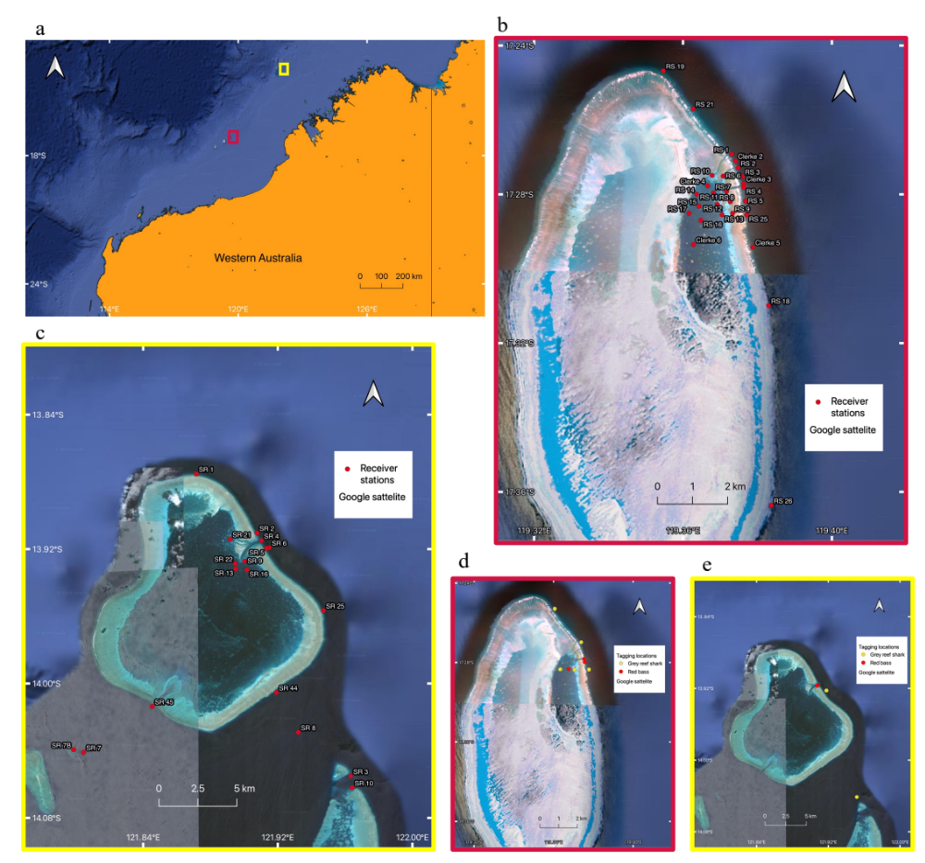
Figure 1. Map of Western Australia (a) indicating the passive acoustic receiver locations used to monitor tagged red bass and grey reef sharks at (b) the Rowley Shoals and (c) Scott Reefs. Tagging locations for red bass are shown in (d) for Rowley Shoals and (e) for Scott Reefs.

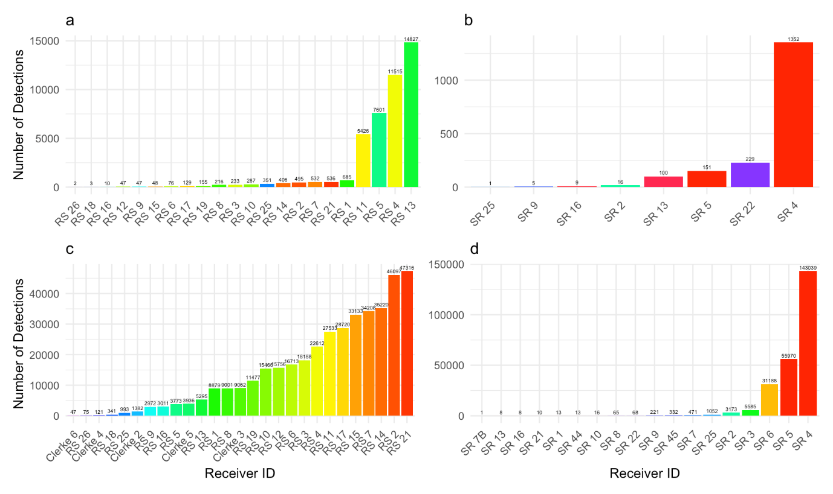Figure 2. Total number of detections per receiver for red bass at (a) the Rowley Shoals and (b) the Scott Reefs, and grey reef sharks at (c) the Rowley Shoals, and (d) Scott Reefs.

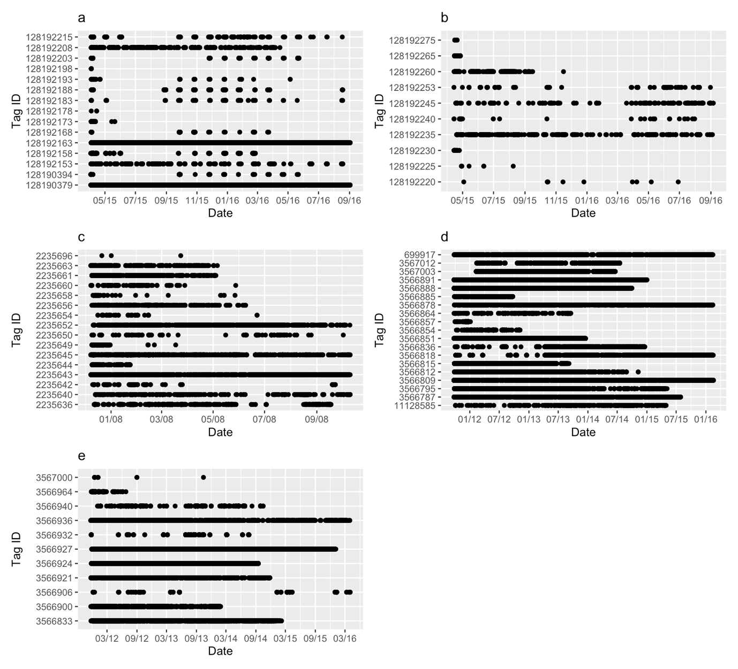
Figure 3. Abacus plots showing the temporal patterns in detections (each black dot represents a detection for each individual of red bass (a) at the Rowley Shoals and (b) the Scott Reefs between 2015-2016, and grey reef sharks at (c) the Rowley Shoals from 2007-2008, and (d) from 2011-2016, and (e) at the Scott Reefs from 2011-2016. The y-axis shows individual tag id numbers and time (month-year) is shown on the x-axis.

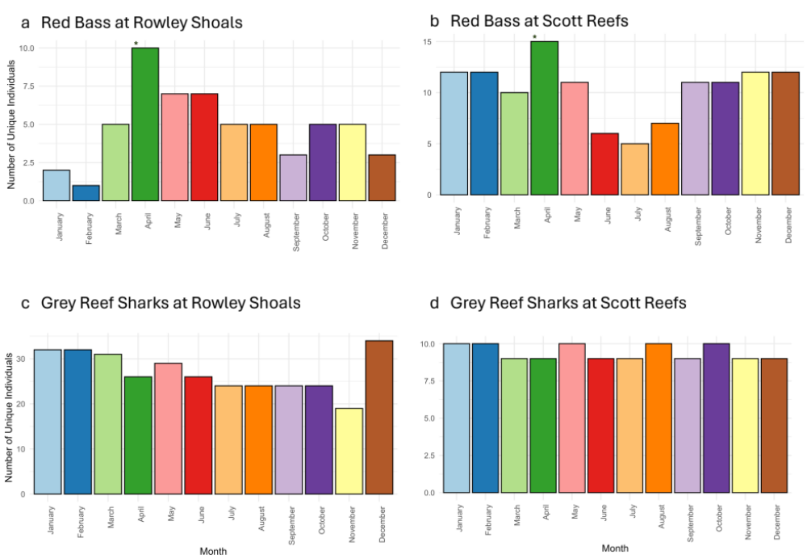
Figure 4. Number of individuals detected per month for red bass at the (a) Rowley Shoals and the (b) Scott Reefs and grey reef sharks at the (c) Rowley Shoals and (d) Scott Reefs. * Tagging was done in April.

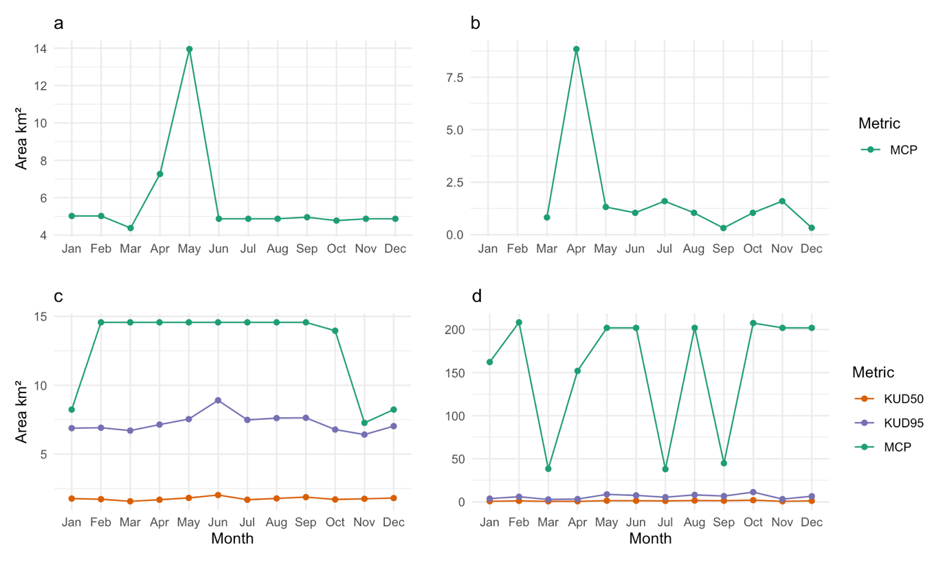
Figure 5. Monthly trends in Minimum Convex Polygon (MCP, green line) and 50% (red line) and 95% (purple line) Kernel Utilization Distributions (KUD) of red bass at (a) the Rowley Shoals, (b) the Scott Reefs, and grey reef sharks at (c) the Rowley Shoals, and (d) at the Scott Reefs.

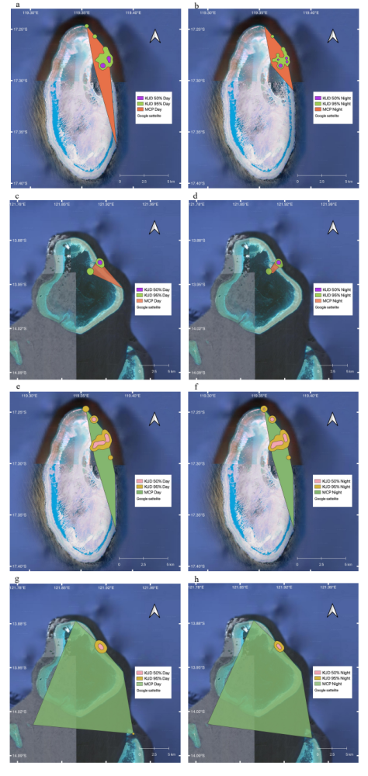
Figure 6. Minimum Convex Polygons (MCP) and 50% and 95% Kernel Utilization Distributions (KUD) for red bass at the Rowley Shoals (a) during the day, (b) night, and at the Scott Reefs (c) during the day and, (d) night, and for grey reef sharks at the Rowley Shoals during (e) the day and (f) the night, and at the Scott Reefs during the (g) day and (h) the night, displayed in QGIS.

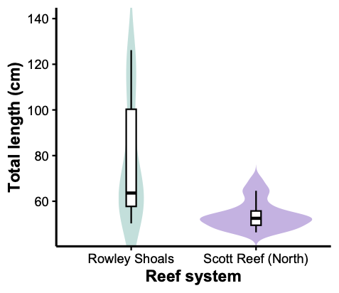
Figure 7. Size distributions of grey reef sharks (Carcharhinus amblyrhynchos) at the Rowley Shoals and North Scott Reef. Violin plots illustrate the kernel density of total length (cm) for each reef system, with wider sections indicating higher frequencies of individuals at those lengths. Superimposed boxplots show the interquartile range and median values. Sharks at the Scott Reefs were predominantly small juveniles (~50–70 cm), whereas those at the Rowley Shoals spanned a broader size range (50–130 cm), including larger sub-adult and adult individuals. Data are available from the Global FinPrint repository (https://globalfinprint.org).

Table 1. Meta-data from IMOS-ATF dataset of tagged red bass and grey reef sharks at the Rowley Shoals and the Scott Reefs showing tag deployment year, total length of tagged animals, number of detections, number of Receivers, and number of individuals. Total length is given as mean ± standard deviation (SD).
Reef System | Species | Deployment  (year) | Total length (cm) | Detections  (n) | Receiver  (n) | Detections/ Receiver  (n) | Individuals  (n)
Rowley | Red bass | 2015 | 58.7 ± 4.8 | 43,627 | 22 | 1983 | 15
Scott | Red bass | 2015 | 48.8 ± 16.0 | 1,863 | 8 | 233 | 10
Rowley | Grey reef shark | 2007, 2011, 2012 | 146.1 ± 19.5 | 409,626 | 27 | 15171 | 35
Scott | Grey reef shark | 2011 | 131.1 ± 30.7 | 241,233 | 18 | 13402 | 11

Table 2. Minimum Convex Polygon (MCP) and 50% and 95% Kernel Utilization Distributions (KUD) in km² of red bass and grey reef sharks (species) at the Rowley Shoals and the Scott Reefs (reef system) by day and split into the night/day cycle. Time of day (ToD).
Reef system | Species | ToD | MCP (km²) | KUD 50 (km²) | KUD 95 (km²)
Rowley Shoals | Red bass | Combined | 13.95 | 0.38 | 2.99
Rowley Shoals | Red bass | Day | 11.99 | 0.57 | 3.73
Rowley Shoals | Red bass | Night | 7.27 | 0.36 | 2.72
Scott Reefs | Red bass | Combined | 8.84 | 0.44 | 2.77
Scott Reefs | Red bass | Day | 8.84 | 0.59 | 3.64
Scott Reefs | Red bass | Night | 2.26 | 0.50 | 3.01
Rowley Shoals | Grey reef shark | Combined | 14.57 | 1.25 | 4.89
Rowley Shoals | Grey reef shark | Day | 14.57 | 1.40 | 5.48
Rowley Shoals | Grey reef shark | Night | 14.57 | 1.40 | 5.44
Scott Reefs | Grey reef shark | Combined | 214.94 | 0.64 | 3.15
Scott Reefs | Grey reef shark | Day | 201.92 | 0.84 | 4.53
Scott Reefs | Grey reef shark | Night | 214.94 | 0.59 | 2.97

Table 3. Monthly spatial metrics of red bass at Rowley Shoals. The table details the location, species, and month, presenting metrics for Minimum Convex Polygon (MCP) in km², and Kernel Utilization Distribution (KUD) 50% and 95% in km². * Tagging was done in April.
Location | Species | Month | MCP (km²) | KUD 50 (km²) | KUD 95 (km²)
Rowley Shoals | Red bass | Jan | 5.02 | 0.95 | 5.24
Rowley Shoals | Red bass | Feb | 5.02 | 1.03 | 5.18
Rowley Shoals | Red bass | Mar | 4.38 | 0.83 | 3.78
Rowley Shoals | Red bass | Apr* | 7.27 | 1.04 | 5.24
Rowley Shoals | Red bass | May | 13.95 | 0.66 | 3.94
Rowley Shoals | Red bass | Jun | 4.87 | 0.53 | 3.15
Rowley Shoals | Red bass | Jul | 4.87 | 0.32 | 2.28
Rowley Shoals | Red bass | Aug | 4.87 | 0.38 | 2.74
Rowley Shoals | Red bass | Sep | 4.96 | 0.62 | 4.21
Rowley Shoals | Red bass | Oct | 4.77 | 0.91 | 4.83
Rowley Shoals | Red bass | Nov | 4.87 | 1.22 | 6.15
Rowley Shoals | Red bass | Dec | 4.87 | 1.25 | 6.36

Table 4. Monthly spatial metrics of red bass at Scott Reefs. The table details the location, species, and month, presenting metrics for Minimum Convex Polygon (MCP) in km², and Kernel Utilization Distribution (KUD) 50% and 95% in km². * Tagging was done in April.
Location | Species | Month | MCP (km²) | KUD 50 (km²) | KUD 95 (km²)
Scott Reefs | Red bass | Jan | - | 3.55 | 13.70
Scott Reefs | Red bass | Feb | - | - | -
Scott Reefs | Red bass | Mar | 0.82 | 3.36 | 12.74
Scott Reefs | Red bass | Apr * | 8.84 | 0.43 | 2.92
Scott Reefs | Red bass | May | 1.32 | 1.04 | 5.15
Scott Reefs | Red bass | Jun | 1.04 | 0.52 | 3.14
Scott Reefs | Red bass | Jul | 1.60 | 0.63 | 4.33
Scott Reefs | Red bass | Aug | 1.04 | 0.58 | 3.51
Scott Reefs | Red bass | Sep | 0.31 | 2.14 | 9.25
Scott Reefs | Red bass | Oct | 1.04 | 1.75 | 8.21
Scott Reefs | Red bass | Nov | 1.60 | 2.60 | 11.40
Scott Reefs | Red bass | Dec | 0.33 | 2.40 | 10.43

Table 5. Monthly spatial metrics of grey reef sharks at Rowley Shoals. The table details the location, species, and month, presenting metrics for Minimum Convex Polygon (MCP) in km², and Kernel Utilization Distribution (KUD) 50% and 95% in km².
Location | Species | Month | MCP (km²) | KUD 50 (km²) | KUD 95 (km²)
Rowley Shoals | Grey reef shark | Jan | 8.23 | 1.77 | 6.89
Rowley Shoals | Grey reef shark | Feb | 14.57 | 1.72 | 6.92
Rowley Shoals | Grey reef shark | Mar | 14.57 | 1.57 | 6.71
Rowley Shoals | Grey reef shark | Apr | 14.57 | 1.69 | 7.14
Rowley Shoals | Grey reef shark | May | 14.57 | 1.82 | 7.54
Rowley Shoals | Grey reef shark | Jun | 14.57 | 2.03 | 8.91
Rowley Shoals | Grey reef shark | Jul | 14.57 | 1.69 | 7.48
Rowley Shoals | Grey reef shark | Aug | 14.57 | 1.78 | 7.62
Rowley Shoals | Grey reef shark | Sep | 14.57 | 1.88 | 7.64
Rowley Shoals | Grey reef shark | Oct | 13.96 | 1.71 | 6.78
Rowley Shoals | Grey reef shark | Nov | 7.27 | 1.76 | 6.42
Rowley Shoals | Grey reef shark | Dec | 8.23 | 1.81 | 7.03

Table 6. Monthly spatial metrics of grey reef sharks at Scott Reef. The table details the location, species, and month, presenting metrics for Minimum Convex Polygon (MCP) in km², and Kernel Utilization Distribution (KUD) 50% and 95% in km².
Location | Species | Month | MCP (km²) | KUD 50 (km²) | KUD 95 (km²)
Scott Reefs | Grey reef shark | Jan | 162.20 | 0.76 | 3.74
Scott Reefs | Grey reef shark | Feb | 208.33 | 1.14 | 5.93
Scott Reefs | Grey reef shark | Mar | 38.40 | 0.63 | 2.74
Scott Reefs | Grey reef shark | Apr | 152.02 | 0.68 | 3.20
Scott Reefs | Grey reef shark | May | 201.92 | 1.36 | 8.71
Scott Reefs | Grey reef shark | Jun | 201.92 | 1.32 | 7.47
Scott Reefs | Grey reef shark | Jul | 37.98 | 1.11 | 5.37
Scott Reefs | Grey reef shark | Aug | 201.92 | 1.54 | 8.09
Scott Reefs | Grey reef shark | Sep | 44.82 | 1.32 | 6.70
Scott Reefs | Grey reef shark | Oct | 207.52 | 1.96 | 11.31
Scott Reefs | Grey reef shark | Nov | 201.92 | 0.66 | 3.17
Scott Reefs | Grey reef shark | Dec | 201.92 | 1.19 | 6.51

Table 7. Individual variability in space use metrics for red bass and grey reef sharks at Rowley Shoals and Scott Reefs The table details the location, species, and the individual variation quantified in mean ± standard deviation and range values for Minimum Convex Polygon (MCP) in km², and Kernel Utilization Distribution (KUD) 50% and 95% in km².
Location | Species | MCP (km²) | KUD 50 (km²) | KUD 95 (km²)
Rowley Shoals | Red bass | Mean ± SD = 3.89 ± 1.13, R = 3.99 | Mean ± SD = 1.54 ± 1.04  R = 3.15 | Mean ± SD = 8.81 ± 5.56  R = 16.70
Rowley Shoals | Grey reef shark | Mean ± SD = 6.36 ± 5.67  R = 13.82 | Mean ± SD = 0.83 ± 1.02  R = 5.47 | Mean ± SD = 4.97 ± 6.62  R = 38.22
Scott Reefs | Red bass | Mean ± SD = 1.32 ± 0.36  R = 0.89 | Mean ± SD = 0.33 ± 0.30  R = 0.76 | Mean ± SD = 2.02 ± 1.93  R = 4.34
Scott Reefs | Grey reef shark | M ± SD = 11.04 ± 4.78  R = 13.61 | M ± SD = 1.78 ± 2.54  R = 6.68 | M ± SD = 10.55 ± 16.05  R = 47.48

