SUPPLEMENTARY MATERIALS
Table S1. The Hyperparameters for RegionAMP
Figure S1. CRF decoder outputs with the true antimicrobial regions
Figure S2. Sequence and residue label statistics
Table S1. The Hyperparameters for RegionAMP
Hyperparameters | Search space | Best hyperparameters
crf_head_lr_multiplier | {2.0, 5.0,10.0,20.0} | 10.0
num_train_epochs | {10,15,20,25,30} | 15
per_device_train_batch_size | {4,8,16,32} | 8
weight_decay | {0.1,0.01,0.001} | 0.01
Learning rate | {1e-3,1e-4,1e-5,2e-5,1e-6} | 2e-5

Figure S1. CRF decoder outputs with the true antimicrobial regions
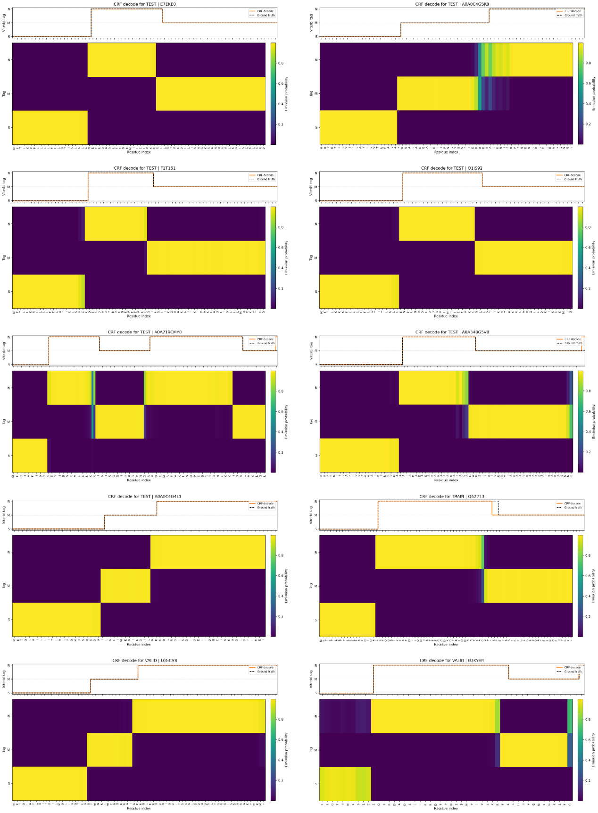
FigureS2. Sequence and residue label statistics

