Corresponds to Manuscript Fig. 7A FXR (Target Protein 70kDa) + GAPDH (36kDa)”；
The left lane corresponds to the target band, while the right lane represents the internal reference band.

lane
3
1
2
3
2
1
1
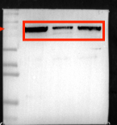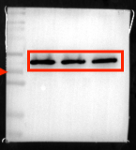
FXR:70kDa
GAPDH：36kDa
25
35
25
100
100
70
70
55
55
40
35
40
35

Replicate experiments of FXR protein expression:
2
1
3
3
2
1
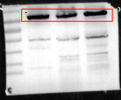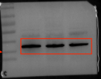
FXR:70kDa
GAPDH：36kDa
100
100
70
70
55
55
40
40
35
35
3
3
2
2
1
1
FXR:70kDa
GAPDH：36kDa
100
70
70
100
55
55
40
40
35
35

Corresponds to Manuscript Fig. 7A NFKB P65 (Target Protein 65kDa) + GAPDH (36kDa)”；The left lane corresponds to the target band, while the right lane represents the internal reference band.

lane
3
3
2
2
1
1
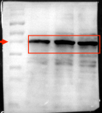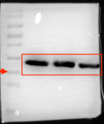
NF-κB P65:
65kDa
GAPDH：36kDa
130
130
100
100
70
70
55
55
40
40
35
35

Replicate experiments of NFKB P65 protein expression:
1
3
3
2
2
1
NF-κB P65:
65kDa
GAPDH：36kDa
130
130
100
100
70
70
55
55
40
40
35
35
3
3
2
2
1
1
NF-κB P65:
65kDa
GAPDH：36kDa
130
130
100
100
70
70
35
55
55
40
40
35

Corresponds to Manuscript Fig. 7A TLR4 (Target Protein 95kDa) + GAPDH (36kDa)”；The left lane corresponds to the target band, while the right lane represents the internal reference band.
1
Lane
3
2
2
1
3
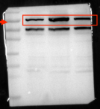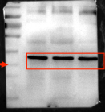
TLR4：
95kDa
GAPDH：36kDa
35
35
40
40
55
55
70
70
100
130
100
130

Replicate experiments of TLR4 protein expression:
2
1
3
2
1
3
TLR4：
95kDa
GAPDH：36kDa
35
35
40
40
55
55
70
70
100
100
130
130
2
1
3
2
1
3
TLR4：
95kDa
GAPDH：36kDa
35
40
35
55
55
70
70
100
130
100
130

