Supplementary Information for:
“Reduced commissural connectivity of the habenula in depression: Translational evidence from human DTI and rodent ultrastructural analyses”

Authors:
Esther Yang^{1,†}, Hyeijung Yoo^{1,†}, Woo-Suk Tae^{2,†}, Soo Hyun Yang¹, Hyun-Wook Kim³, Byung-Joo Ham⁴, Im Joo Rhyu^{1,5}, Kyu-Man Han^{4,#}, Hyun Woo Lee^{1,#}, and Hyun Kim^{1,#}

Affiliations:
¹Department of Anatomy, College of Medicine, Korea University, Seoul 02841, Korea.
²Brain Convergence Research Center, Korea University Anam Hospital, Seoul 02841, Korea.
³Medical Science Research Center, College of Medicine, Korea University, Seoul 02841, Korea.
⁴Department of Psychiatry, Korea University Anam Hospital, Korea University College of Medicine, Seoul 02841, Korea.
⁵Department of Biomedical Sciences, Brain Korea 21 FOUR, College of Medicine, Korea University, Seoul 02841, Korea.

†These authors contributed equally to this work.
#Co-corresponding authors
To whom correspondence should be addressed:

Kyu-Man Han, MD., Ph.D.
Address: Department of Psychiatry, Korea University Anam Hospital, Korea University College of Medicine, Seoul 02841, Korea.
Tel: +82-2-920-5815
E-mail: han272@korea.ac.kr

Hyun Woo Lee, Ph.D.
Address: Room 511, Department of Anatomy, College of Medicine, Korea University, Anam-Dong, Seongbuk-Gu, Seoul 02841, Korea.
Tel: +82-2-2286-1385
E-mail: biocais@korea.ac.kr

Hyun Kim, MD., Ph.D.
Address: Room 512, Department of Anatomy, College of Medicine, Korea University, Anam-Dong, Seongbuk-Gu, Seoul 02841, Korea.
Tel: +82-2-2286-1153
E-mail: kimhyun@korea.ac.kr

Supplementary Figures
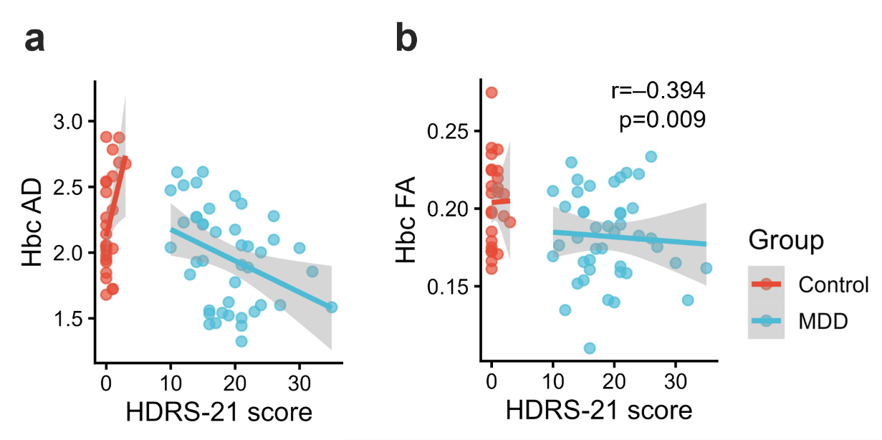
Fig. S1. Diffusion tensor imaging (DTI) parameters of the habenular commissure. (a) Relationship between fractional anisotropy (FA) of the habenular commissure (Hbc) and the HDRS-21 score in patients with major depressive disorder (MDD; blue) and healthy controls (red). (b) Relationship between axial diffusivity (AD) of the Hbc and HDRS-21 score. Hbc AD was significantly negatively correlated with HDRS-21 score (r = -0.394, p = 0.009). Shaded areas represent 95% confidence intervals. (CON, n = 25; MDD, n = 43).

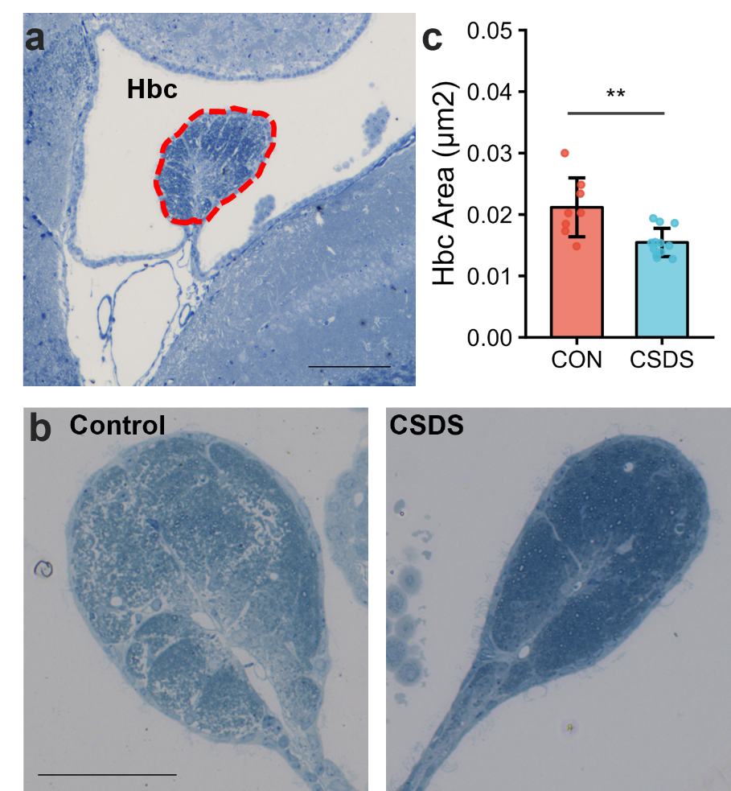
Fig. S2. Morphological alterations of the habenular commissure following chronic social defeat stress (CSDS).
(a) Representative Nissl-stained coronal section showing the habenular commissure (Hbc; outlined by a red dashed line). (b) Representative images of the Hbc in control (CON) and CSDS mice. (c) Quantification of the Hbc area showed a significant reduction in CSDS mice compared with controls. Data are presented as mean ± SEM (CON, n = 8; CSDS, n = 12; **p < 0.01). Scale bar = 100 µm.

Supplementary Methods
Light microscopic analysis
For light microscopy, semi-thin sections (1 μm) were cut using a Leica EM UC6 ultramicrotome (Lecia Microsystems, Wetzlar, Germany) and stained with 1% toluidine blue in 1% sodium borate. The sections were examined using an EVOS M5000 Imaging System (Thermo Fisher Scientific, Waltham, MA, USA). From each section, five images were randomly acquired for quantitative analysis using Image J software (NIH, Bethesda, MD, USA).

