Supplemental information
Supplemental methods
Synthesis and characterization of WK500B
2-chloro-5-fluoro-N-(4-nitrophenyl) pyrimidin-4-amine (1). A mixture compounds 4-nitroaniline (276.26 mg, 2.0 mmol), 2,4-dichloro-5-fluoropyrimidine (400.73 mg, 2.4 mmol) and cesium carbonate (1954 mg, 6.0 mmol) were dissolved in 3 mL of anhydrous DMF, the mixture was stirred at 85 ℃ for overnight. After the reaction was complete detected by TLC (PE/EA=4:1), the mixture was poured into 10 mL of H₂O, and a lot of solid will be precipitated. The mixture was filtered and the filter cake was washed with 10 mL of H₂O, dried in vacuum to give crude product. Then the crude product was purified by column chromatography (eluting with PE/EA by 8:1) to give compound 1 (227 mg, 42% yield).
2-((3S,5R)-3,5-dimethyl-1-piperazinyl)-5-fluoro-N-(4-nitrophenyl) pyrimidin-4-amine (2). A mixture of compounds 1 (227 mg, 0.85 mmol) and (2S,6R)-2,6-dimethylpiperazine (289 mg, 2.54 mmol) in n-BuOH (10 mL), then DIEA (1.91 mL, 2.54 mmol) was added. The mixture was stirred at 120 ℃ for overnight. After the reaction was complete detected by TLC (CH₂Cl₂/MeOH=10:1), the solvent was removed by evaporation. Then the residue was partitioned between CH₂Cl₂ and H₂O. The separated organic layer was washed with water, dried over Na₂SO₄ and evaporated to dryness, and was purified by column chromatography (eluting with PE/EA by 8:1) to give compound 2 (173 mg, 59% yield).
N¹-(2-((3S,5R)-3,5-dimethyl-1-piperazinyl)-5-fluoro-4-pyrimidinyl) benzene-1,4-diamine (3). To a solution of compound 2 (173 mg, 0.5 mmol) in MeOH (10 mL) was added catalytic quantity Pd/C under N₂. The suspension was degassed under vacuum and purged with H₂ several times. After the reaction was complete detected by TLC (CH₂Cl₂/MeOH=10:1), the solvent was removed by evaporation to give crud compound 3 (151 mg, 96% yield).
6-bromo-N-(4-((2-((3S,5R)-3,5-dimethyl-1-piperazinyl)-5-fluoro-4-pyrimidinyl)-amino) phenyl) picolinamide (WK500B). A mixture of compounds 6-bromopicolinic acid (114.7 mg, 0.54 mmol), EDC.HCl (180.2 mg, 0.94 mol) and HoBt (77.0 mg, 0.57 mmol) in 3 mL of anhydrous DMF, after stirred at 0 ℃ for 5 min, compound 3 (151 mg, 0.47 mmol) was added and the mixture was continue stirred at 0 ℃ for overnight. After the reaction was complete detected by TLC (CH₂Cl₂/EA=10:1), the mixture was poured into 10 mL of H₂O, and a lot of solid will be precipitated. The mixture was filtered and the filter cake was washed with 10 mL of H₂O, dried in vacuum to give crude product. Then the crude product was purified by column chromatography (eluting with CH₂Cl₂/MeOH by 100:1-20:1) to give WK500B (119 mg, 51% yield). ¹H NMR (500 MHz, DMSO-d₆) δ 10.37 (s, 1H), 9.27 (s, 1H), 8.13 (d, J = 7.4 Hz, 1H), 8.01 (d, J = 7.7 Hz, 1H), 7.99 (s, 1H), 7.91 (d, J = 7.9 Hz, 1H), 7.81 (d, J = 8.8 Hz, 2H), 7.73 (d, J = 8.9 Hz, 2H), 4.35 (d, J = 12.5 Hz, 2H), 2.71-2.64 (m, 2H), 2.30 (t, J = 11.5 Hz, 2H), 1.00 (d, J = 6.1 Hz, 6H). ¹³C NMR (125 MHz, DMSO-d₆) δ 161.16, 157.21, 151.66, 149.20, 141.17, 140.64, 140.22, 138.56, 135.54, 133.06, 131.23, 122.07, 120.80, 51.00, 50.15, 19.39. HR MS (ESI): calcd for C₂₂H₂₄BrFN₇O [M + H] ⁺; 500.1204; found 500.1208.
FX1 was synthesized according to the methods described in the literature (Cardenas et al., 2016).
Molecular Docking
A molecular docking study was performed by employing the crystal structures of the BCL6 BTB domain co-crystallized with the ligand pyrazolo-pyrimidine macrocyclic (PDB ID code: 5N1Z) by searching the Protein Data Bank (McCoull et al., 2017). Docking assays were performed by using AutoDock4.2.6 (Morris et al., 2009), and the parameter files and the binding poses were obtained by using AutoDockTool 1.5.6 and the Lamarckian genetic algorithm, respectively. The co-crystallized ligand was used to define the active sites for docking, and the size of the box was 60*60*60. The number of conformational docking simulations was 200, and the lowest binding energy was selected for analysis.
Supplemental references
Cardenas MG, Yu W, Beguelin W, Teater MR, Geng H, Goldstein RL, et al. (2016). Rationally designed BCL6 inhibitors target activated B cell diffuse large B cell lymphoma. J Clin Invest 126: 3351-3362.
McCoull W, Abrams RD, Anderson E, Blades K, Barton P, Box M, et al. (2017). Discovery of Pyrazolo[1,5-a]pyrimidine B-Cell Lymphoma 6 (BCL6) Binders and Optimization to High Affinity Macrocyclic Inhibitors. J Med Chem 60: 4386-4402.
Morris GM, Huey R, Lindstrom W, Sanner MF, Belew RK, Goodsell DS, et al. (2009). AutoDock4 and AutoDockTools4: Automated docking with selective receptor flexibility. J Comput Chem 30: 2785-2791.
Supplementary Figures
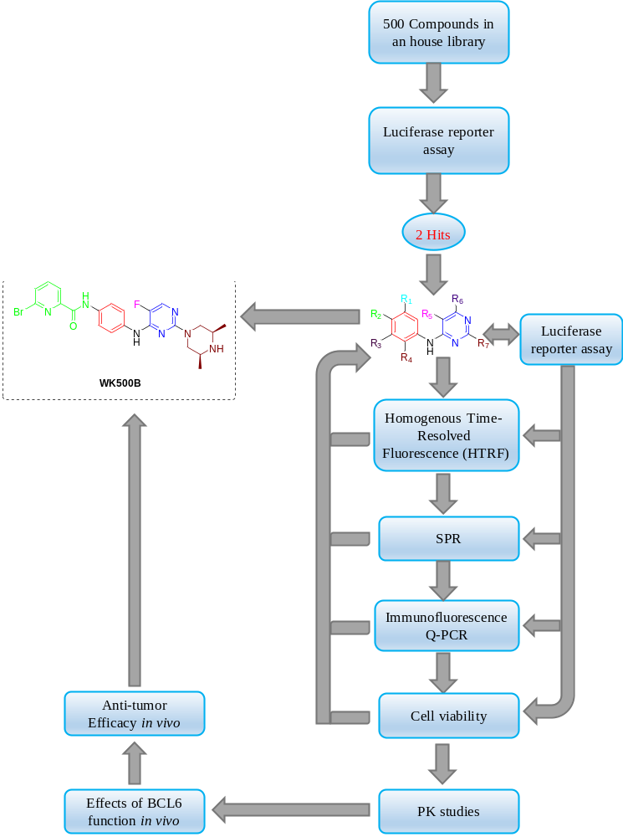

Figure S1. BCL6 inhibitor screening strategy.

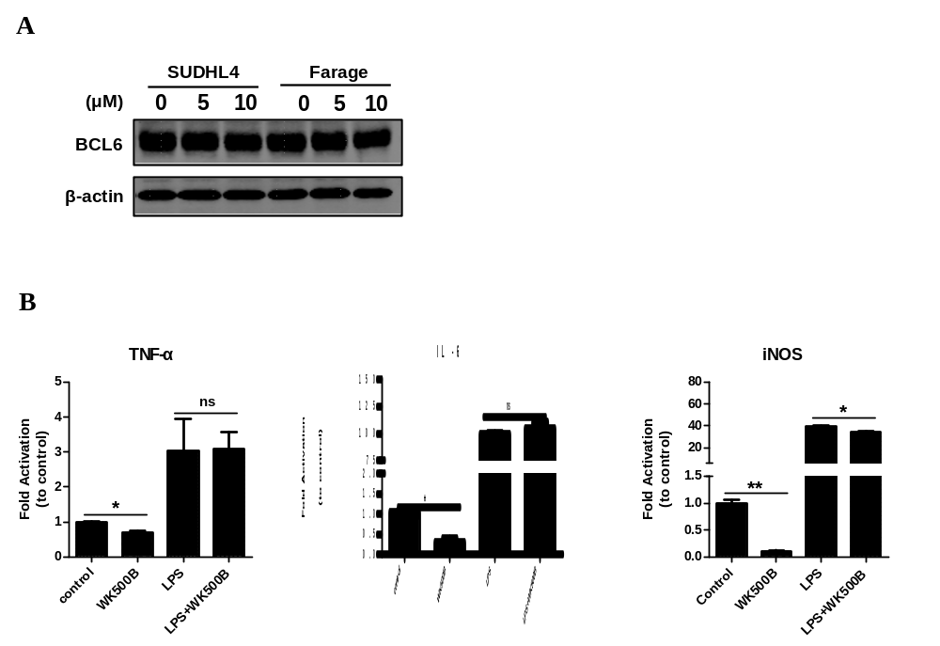
Figure S2. WK500B has no effect on BCL6 protein expression and inflammatory responses. (A) BCL6 protein expression was not affected by treatment with WK500B for 24 h. (B) WK500B had no effect on inflammatory responses. mRNA abundance of TNF-α, IL-6 and iNOS in RAW264.7 cells treated with 10 μM WK500B or 100 ng/ml LPS or a combination for 12 h. (*, P < 0.05; **, P < 0.01 versus control).

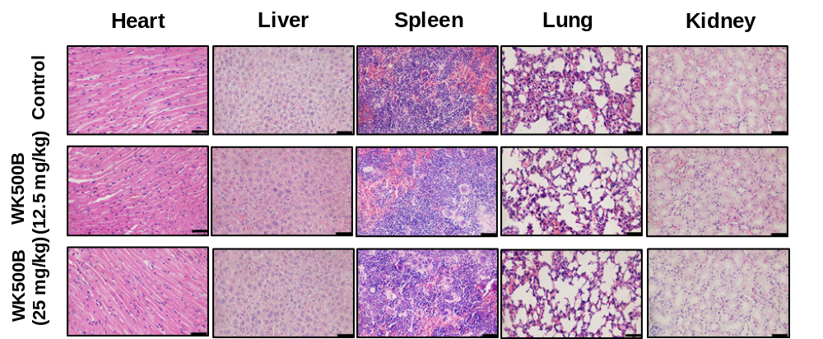

Figure S3. No cases of toxic effects were noted in WK500B treated groups. In a subcutaneous SUDHL4 xenograft animal model, after the mice were sacrificed, the hearts, livers, spleens, lungs and kidneys from mice were harvested for H&E staining and imaged. Scale bars, 50 μm.

A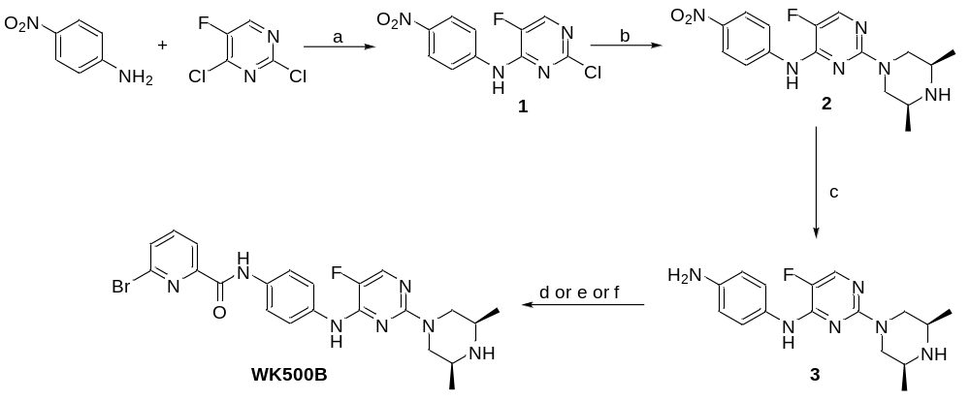
B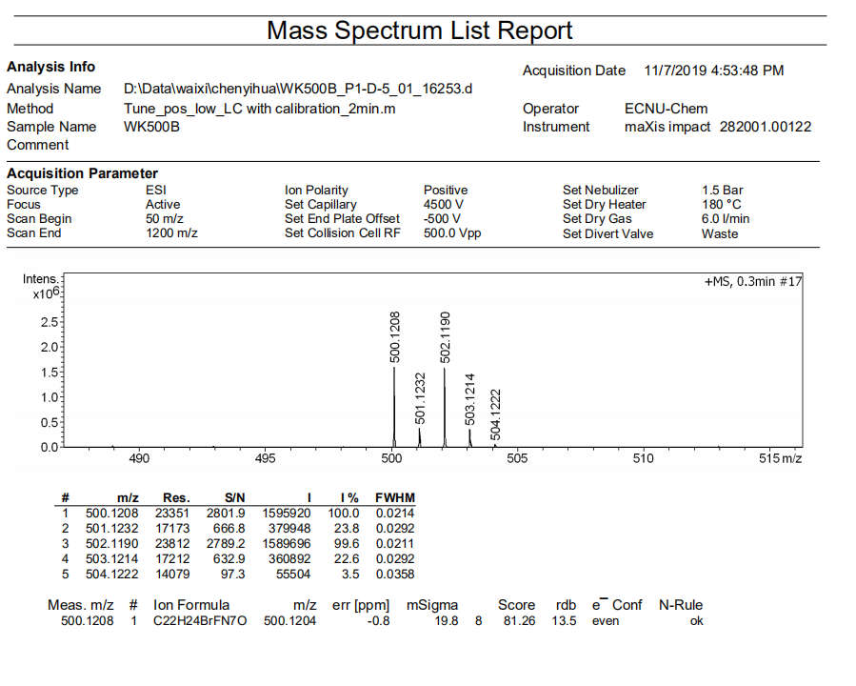
Figure S4. (A) The synthesis scheme of WK500B. ^{α}Reagents and conditions: a Cs₂CO₃, DMF, 85 ℃; b (2S,6R)-2,6-dimethylpiperazine, DIEA, n-BuOH, reflux; c Pd/C, H₂, MeOH; d EDC.HCl, HOBt, DMF, 0 ℃ then to r.t; e HATU, DMF, 0 ℃ then to r.t; f CDI, DMF, 0 ℃ then to r.t. (B) The high-resolution mass spectrum (HR MS) of WK500B.
A ¹H NMR
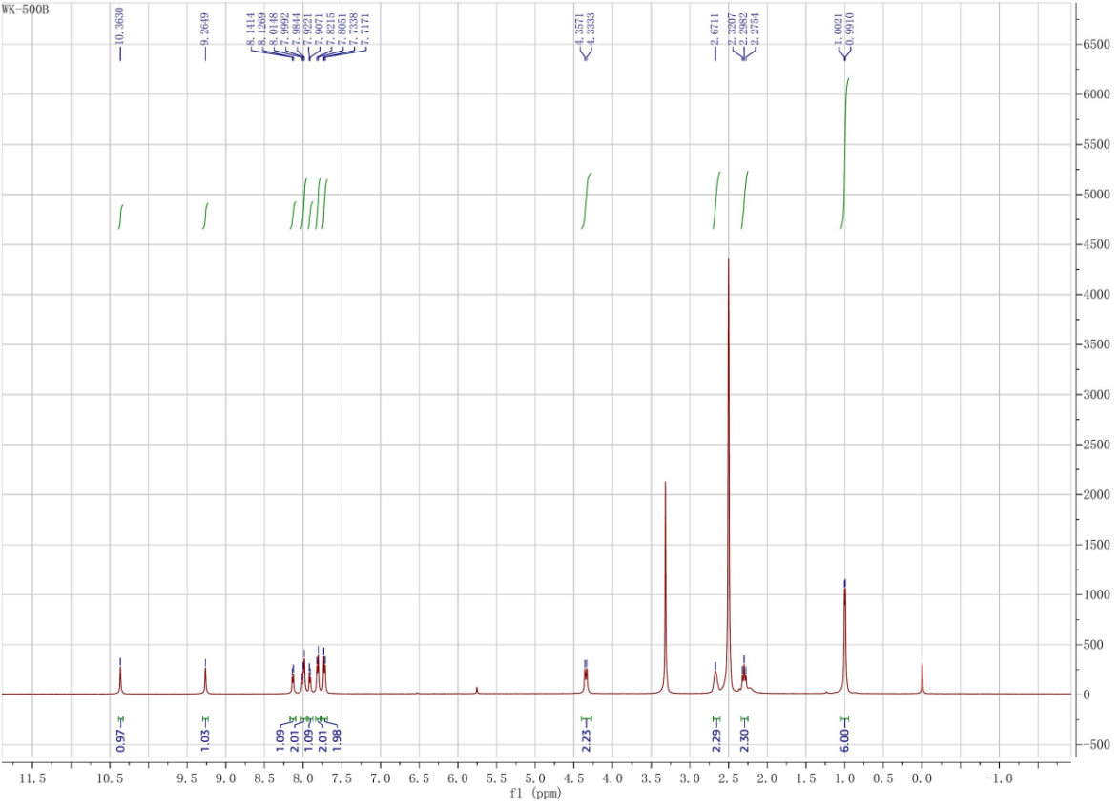
B ¹³C NMR
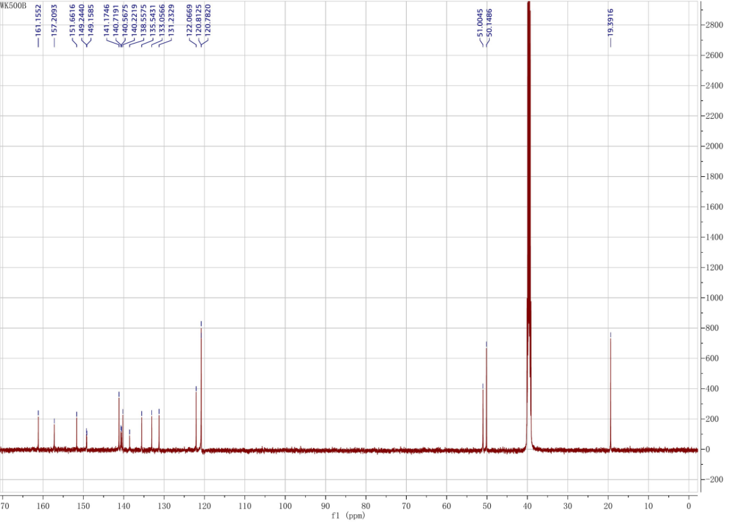
Figure S5. (A) ¹H-NMR of WK500B; (B) ¹³C-NMR of WK500B.

Supplementary tables
Table S1. The half-lives of WK500B elimination in the incubation system.
 | Human Liver Microsomal Stability
 | ª CL_{int(mic)} (μL/min/mg) | ^{b} CL_{int(liver)}  (mL/min/kg) | ^{c} T_{1/2} (min) | Remaining(T = 60 min)
WK500B | < 9.6 | < 38.0 | > 60 | 89.43%
ªCL_{int(mic)} is the intrinsic clearance; CL_{int(mic)} = 0.693/half-life/mg of microsome protein per mL. ^{b}CL_{int(liver)} = CL_{int(mic)} × mg of microsomal protein/g liver weight × g of liver weight/kg body weight; mg of microsomal protein/g of liver weight: 45 mg/g; liver weight: 20 g/kg. ^{c}T_{1/2} is half-life.

Table S2. Main pharmacokinetic parameters of WK500B after oral administration or intravenous injection in rats (mean ± SD).
 | po (n = 4) | iv (n = 4)
dose (mg/kg) | 10 | 5
t_{1/2} (h) | 7.93±0.81 | 6.41±0.87
C_{max} (ng/mL) | 527.73±108.92 | ___
C₀ (ng/mL) | ___ | 954.68±199.39
AUC0-t₀₋₂₄ (h*ng/mL) | 7004.06±1411.95 | 4245.53±664.93
AUC0-∞ (h*ng/mL) | 83118.29 | 4636.88
V_{d} (mL/kg) | 14174.48 | 10072.14
Cl (mL/min/kg) | 1252.67 | 1106.85
MRT_{0-t} (min) | 9.75 | 7.28
F | 82.49%
Table S3. Biochemical parameters of C57BL/6 mice treated with 50 mg/kg/day WK500B.
Parameter | Vehicle | WK500B | Units
GLU | 4.52 | 5.71 | mmol/L
T-BIL | 3.1 | 3.0 | μmol/L
D-BIL | 0.6 | 0.7 | μmol/L
I-BIL | 2.5 | 2.3 | μmol/L
TP | 53.5 | 56.0 | g/L
ALB | 27.1 | 25.1 | g/L
GLB | 26.4 | 28..4 | g/L
A/G | 1.0 | 1.2 | /
AST | 121 | 154 | U/L
ALT | 23 | 18 | U/L
AST/ALT | 5.26 | 8.56 | /
ALP | 55 | 89 | U/L
γ-GT | <3 | <3 | U/L
LDH | 544 | 480 | U/L
CK | 713 | 1202 | U/L
AFU | 20 | 14 | U/L
TBA | 3.9 | 3.4 | μmol/L
GPDA | 25 | 35 | U/L
AMY | 2737 | 2083 | U/L
Urea | 10.43 | 7..89 | mmol/L
Cr | 11 | 12 | μmol/L
UA | 313 | 209 | μmol/L
TG | 0.81 | 0.75 | mmol/L
TC | 2.75 | 1.96 | mmol/L
HDL-C | 1.89 | 1.41 | mmol/L
LDL-C | 0.70 | 0.54 | mmol/L

Table S4. Whole blood cell counts of C57BL/6 mice treated with 50 mg/kg/day WK500B.
Parameter | Vehicle | WK500B | Units
RBC | 9.07 | 9.93 | 10¹²/L
Hb | 134 | 145 | g/L
HCT | 0.46 | 0.48 | L/L
MCV | 51.0 | 48.2 | f1
MCH | 14.8 | 14.6 | pg
MCHC | 289 | 303 | g/L
RDW-CV | 24.5 | 23.0 | %
WBC | 2.70 | 1.31 | 10⁹/L
NEUT | 0.07 | 0.02 | 10⁹/L
EO | 0.00 | 0.00 | 10⁹/L
BASO | 0.42 | 0.16 | 10⁹/L
LYMPH | 1.74 | 1.11 | 10⁹/L
MONO | 0.47 | 0.02 | 10⁹/L
NEUT% | 2.6 | 2.5 | %
EO% | 0.0 | 0.0 | %
BASO% | 15.6 | 12.2 | %
LYMPH% | 81.6 | 84.7 | %
MONO% | 2.3 | 1.5 | %
PLT | 1690 | 1554 | 10⁹/L
PCT | 1.23 | 1.20 | %
MPV | 7.3 | 7.7 | f1
PDW | 7.5 | 8.8 | %

