Supporting Information

Influence of Composition, Layer Thickness, and 2D Layer Coupling on Electrochemical Manufacturing
Bright Ngozichukwu¹, Eugenie Pranada^{,2}, Ray Yoo¹, Niels Kubitza³, Christina S. Birkel^{3,4} , Abdoulaye Djire^{1,2*}
¹Artie McFerrin Department of Chemical Engineering, Texas A&M University, College Station, TX 77843, USA
²Department of Materials Science & Engineering, Texas A&M University, College Station, TX 77843, USA
³Department of Chemistry and Biochemistry, Technische Universitat Darmstadt, Darmstadt, 64287, Germany
⁴School of Molecular Sciences, Arizona State University, Tempe AZ-85282, USA

*Corresponding Author: adjire@tamu.edu
Chemicals
All reagents were used as received without any additional purification. Potassium bicarbonate (KHCO₃), dimethyl sulfoxide (DMSO), formic acid, and deuterium oxide (D₂O) were obtained from Sigma-Aldrich. The hydrophobic gas diffusion layer (GDL) employed as the electrode substrate was sourced from Fuel Cell Store, and the Nafion 117 proton-exchange membrane was supplied by Ion Power Inc.
Product Detection Analysis
A sampling line was connected from the headspace of the catholyte reservoir to a gas chromatograph (GC-QP2020 NX, Shimadzu) to enable continuous monitoring of gaseous products. Gas-phase species were analyzed after 1 hour of electrolysis. The chromatograph was fitted with a MolSieve 5A packed column and operated with the detector and column maintained at 220 °C and 400 °C, respectively. Argon (Airgas, 99.999%) was used as the carrier gas under constant pressure. Carbon monoxide was detected using a flame-ionization detector (FID) equipped with a methanizer. Instrument calibration was performed using certified multicomponent calibration mixtures from Air Liquide (Scott Mini-Mix), covering concentrations between 100 and 16 900 ppm. Faradaic efficiencies for the gaseous products were obtained using the equation:
$$FE_{gas}=\frac{n*F*x* V_{m}}{I} x 100\%$$
The transfer electron number is denoted by n, and the Faraday constant by F, which has a value of 96485 C mol-1. The generated mole fraction of each gas is given by x, and the molar flowrate in mol/s is represented by $V_{m}=\frac{P*v_{o}}{R*T}$ where $v_{o}$ is the volumetric flowrate P, T and R represent pressure (Pa), temperature (K), and gas constant of 8.314 J/mol K, respectively. The total amount of current is denoted by I (A). These measurements were performed under room temperature and ambient pressure.
Liquid-phase products were analyzed by nuclear magnetic resonance (NMR) spectroscopy using a water-suppression method. For each measurement, 0.5 mL of the post-electrolysis electrolyte was combined with 100 μL of D₂O (Sigma-Aldrich, 99.9%) and 0.03 μL of dimethyl sulfoxide (Sigma-Aldrich, 99.9%), which served as the internal standard. The Faradaic efficiency of the detected liquid product was calculated using the equation:
$$FE=\frac{n*F*V*C}{Q} x 100\%$$
which includes the transfer electron number (n), Faraday efficiency constant (F), concentration of the liquid product determined by ¹H NMR (c), electrolyte solution volume (V), and total charge consumed by the reaction (Q), measured by the electrochemical workstation in coulombs.

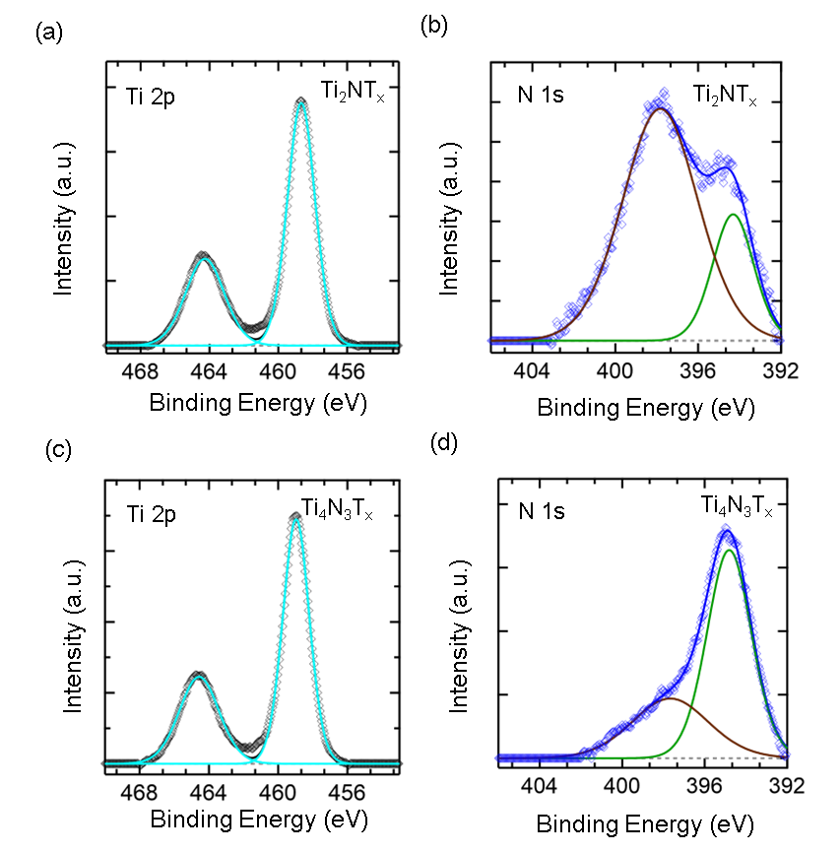

Figure S1. High-resolution Ti 2p and N1S XPS spectra of the hybridized (a,b) MoS₂/Ti₂NT_{x} and (c.d) MoS₂/Ti₄N₃T_{x} heterostructures.

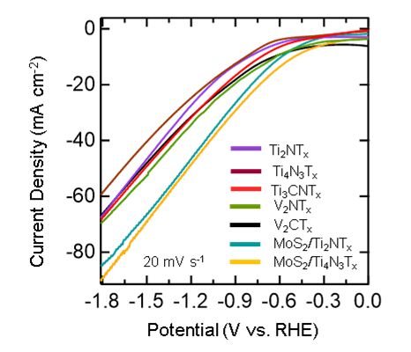
Figure S2. Linear sweep voltammograms (LSVs) of various electrodes recorded in CO₂-purged 1 M KHCO₃ electrolyte at a scan rate of 20 mV s⁻¹.

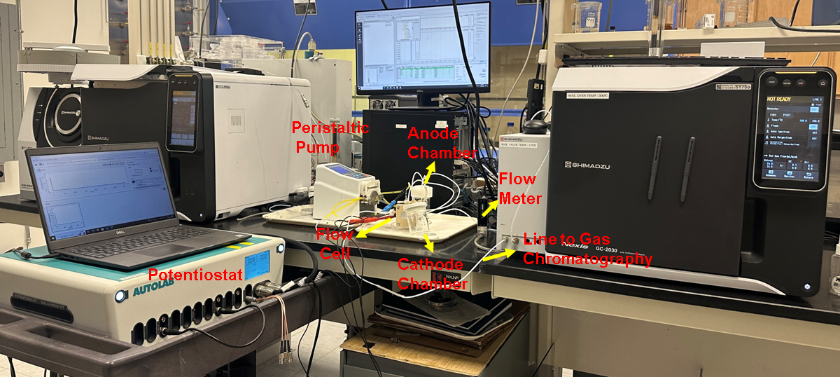
Figure S3. Setup for the continuous-flow electrochemical CO₂ reduction (CO₂RR) experiments and real-time gas product analysis.

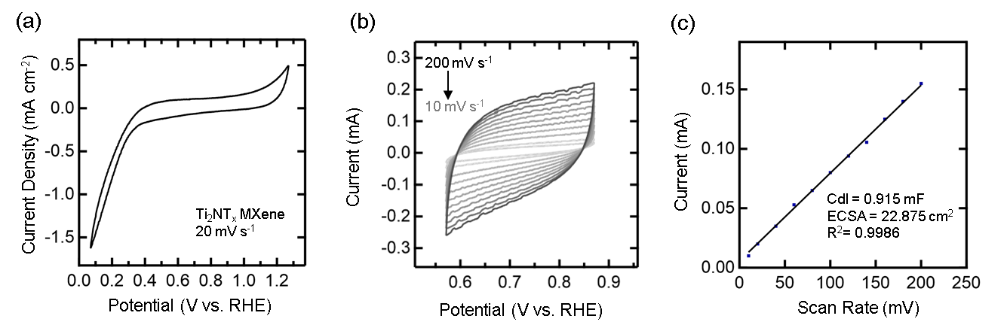
Figure S4. Electrochemical measurement of hydrothermally synthesized Ti₂NT_{x} MXene in 1M KHCO₃. (a) Cyclic voltammogram (CV) curve of Ti₂NT_{x} MXene (b) CV at non-faradaic region performed at various scan rates used to determine the double layer capacitance of Ti₂NT_{x} MXene (c) linear fit curve used for ECSA calculations at different scan rates. Cyclic voltammogram scans were taken in the non-faradaic region.

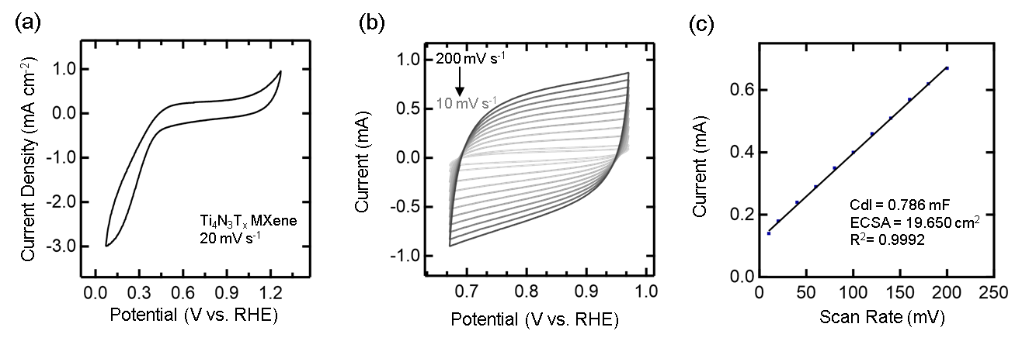
Figure S5. Electrochemical measurement of hydrothermally synthesized Ti₄N₃T_{x} MXene in 1M KHCO₃. (a) Cyclic voltammogram (CV) curve of Ti₄N₃T_{x} MXene (b) CV at non-faradaic region performed at various scan rates used to determine the double layer capacitance of Ti₄N₃T_{x} MXene (c) linear fit curve used for ECSA calculations at different scan rates. Cyclic voltammogram scans were taken in the non-faradaic region.

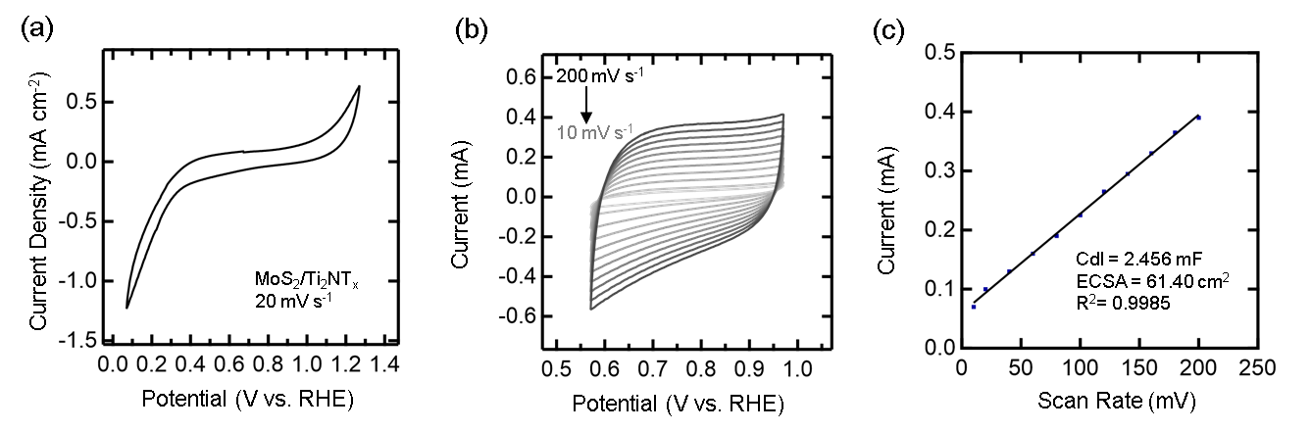
Figure S6. Electrochemical measurement of hydrothermally synthesized MoS₂/Ti₂NT_{x} composites in 1M KHCO₃. (a) Cyclic voltammogram (CV) curve of MoS₂/Ti₂NT_{x} composites (b) CV at non-faradaic region performed at various scan rates used to determine the double layer capacitance of MoS₂/Ti₂NT_{x} composites (c) linear fit curve used for ECSA calculations at different scan rates. Cyclic voltammogram scans were taken in the non-faradaic region.

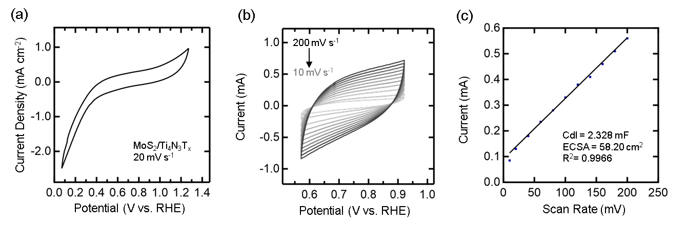
Figure S7. Electrochemical measurement of hydrothermally synthesized MoS₂/Ti₄N₃T_{x} composites in 1M KHCO₃. (a) Cyclic voltammogram (CV) curve of MoS₂/Ti₄N₃T_{x} composites (b) CV at non-faradaic region performed at various scan rates used to determine the double layer capacitance of MoS₂/Ti₄N₃T_{x} composites (c) linear fit curve used for ECSA calculations at different scan rates. Cyclic voltammogram scans were taken in the non-faradaic region.

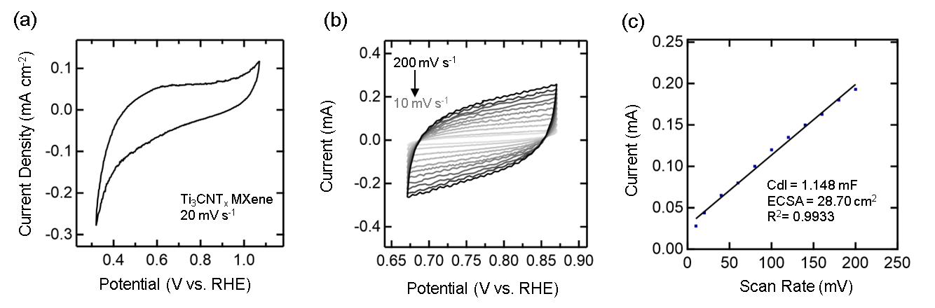
Figure S8. Electrochemical measurement of hydrothermally synthesized Ti₃CNT_{x} MXene in 1M KHCO₃. (a) Cyclic voltammogram (CV) curve of Ti₃CNT_{x} MXene (b) CV at non-faradaic region performed at various scan rates used to determine the double layer capacitance of Ti₃CNT_{x} MXene (c) linear fit curve used for ECSA calculations at different scan rates. Cyclic voltammogram scans were taken in the non-faradaic region.

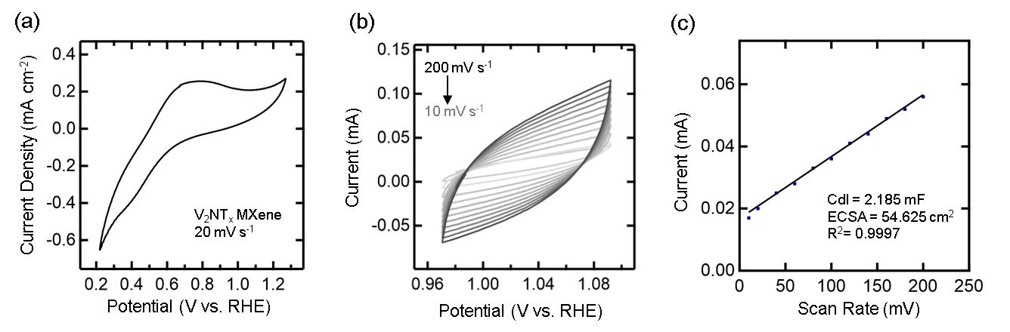
Figure S9. Electrochemical measurement of hydrothermally synthesized V₂NT_{x} MXene in 1M KHCO₃. (a) Cyclic voltammogram (CV) curve of V₂NT_{x} MXene (b) CV at non-faradaic region performed at various scan rates used to determine the double layer capacitance of V₂NT_{x} MXene (c) linear fit curve used for ECSA calculations at different scan rates. Cyclic voltammogram scans were taken in the non-faradaic region.

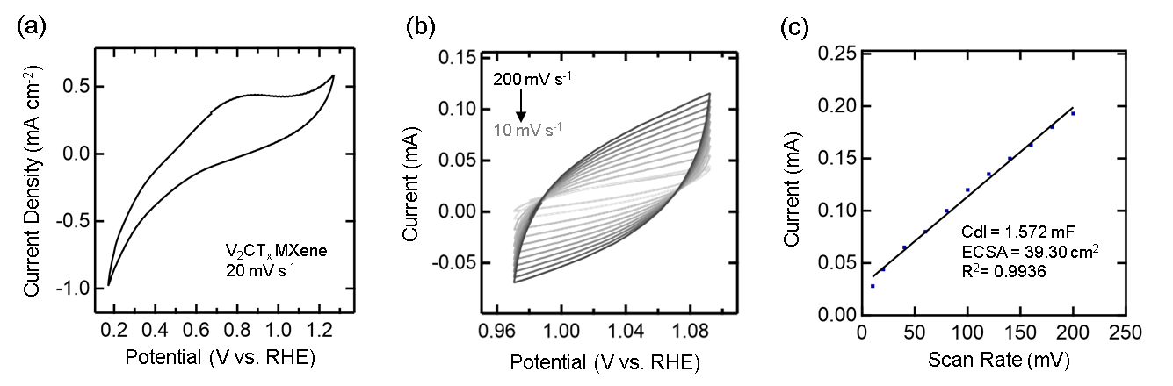
Figure S10. Electrochemical measurement of hydrothermally synthesized V₂CT_{x} MXene in 1M KHCO₃. (a) Cyclic voltammogram (CV) curve of V₂CT_{x} MXene (b) CV at non-faradaic region performed at various scan rates used to determine the double layer capacitance of V₂CT_{x} MXene (c) linear fit curve used for ECSA calculations at different scan rates. Cyclic voltammogram scans were taken in the non-faradaic region.

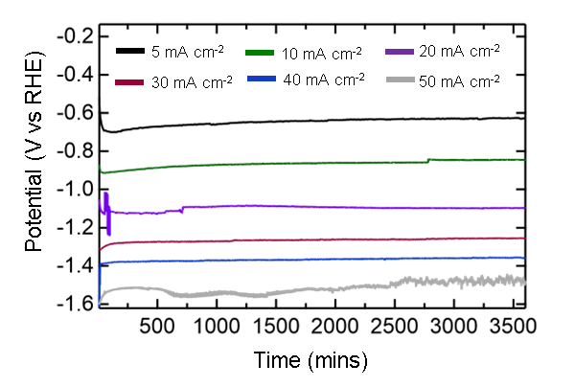
Figure S11. Chronopotentiometry test curve for Ti₂NT_{x} MXene at various current densities in 1M KHCO₃

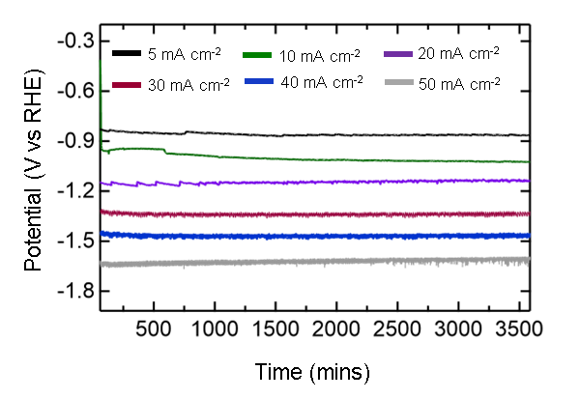
Figure S12. Chronopotentiometry test curve for Ti₄N₃T_{x} MXene at various current densities in 1M KHCO₃

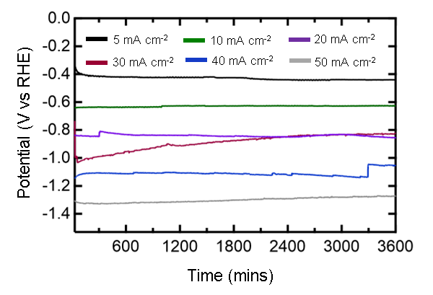
Figure S13. Chronopotentiometry test curve for MoS₂/Ti₂NT_{x} at various current densities in 1M KHCO₃

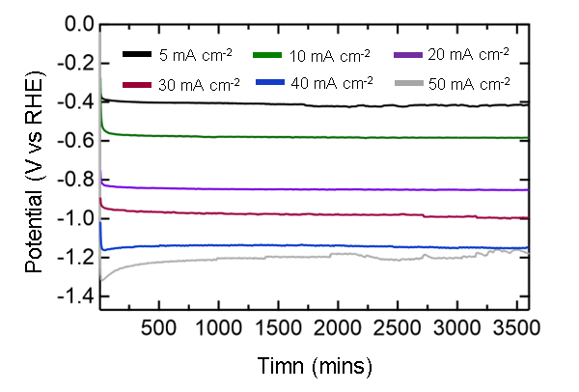
Figure S14. Chronopotentiometry test curve for MoS₂/Ti₄N₃T_{x} at various current densities in 1M KHCO₃
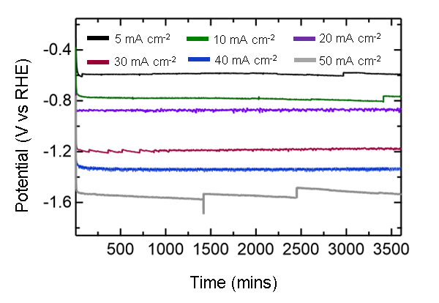
Figure S15. Chronopotentiometry test curve for Ti₃CNT_{x} at various current densities in 1M KHCO₃

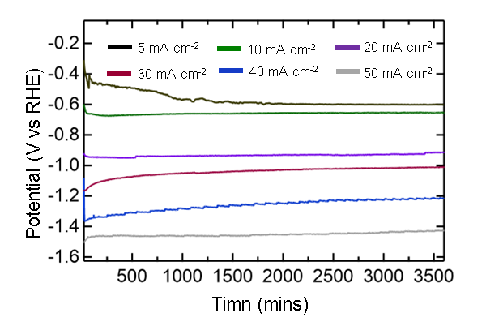
Figure S16. Chronopotentiometry test curve for V₂NT_{x} MXene at various current densities in 1M KHCO₃
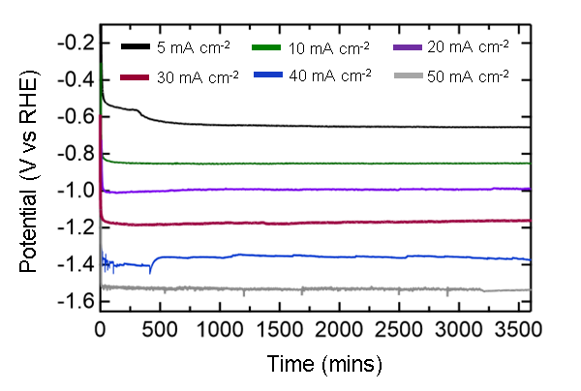
Figure S17. Chronopotentiometry test curve for V₂CT_{x} MXene at various current densities in 1M KHCO₃

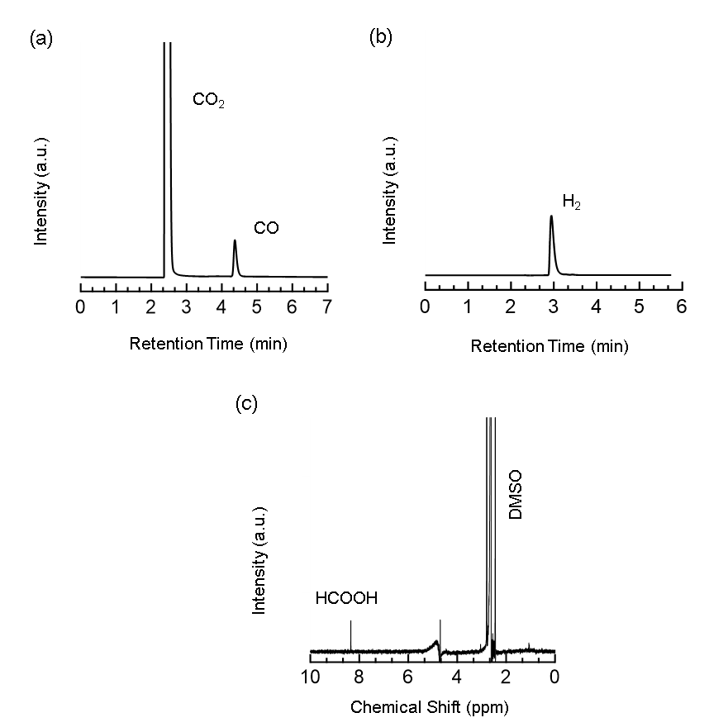
Figure S18. Typical CO₂RR product analysis over V-based catalyst after 1 h of electrolysis at 30 mA cm⁻². GC chromatogram showing (a) CO and (b) H₂ as the only gaseous products.
(c) ¹H NMR spectrum of the electrolyte after electrolysis, showing formate as the liquid product.

